Supporting Information

Highly Efficient and SO₂ resistance of Pr-doped OMS-2 catalyst for CO oxidation
Huanran Deng^{a§}, Yuntao Hu ^{a§}, Li Yang^{a*}, Zhen Chen^{a*}, Yuanhang Qin^{a*}, Tielin Wangª, Wei Sunª, Cunwen Wangª
- State Key Laboratory of Green and Efficient Development of Phosphorus Resources, Key Laboratory of Green Chemical Process of Ministry of Education, Hubei Key Laboratory of Novel Reactor & Green Chemical Technology, School of Chemical Engineering and Pharmacy, Wuhan Institute of Technology, Wuhan 430205, China
Experimental
Physical characterization
X-ray diffraction analysis: An X-ray powder diffractometer (XRD, Smartlab SE, Japan) was utilized to analyze the crystal structure of the catalysts. A Cu-Kα target was employed as the X-ray source (λ = 0.154 nm), with a test angle range set from 5° to 90°. The crystal phases were identified using the International Center for Diffraction Data (ICDD) database.
Nitrogen Adsorption and Desorption Analysis: This study investigated the structural characteristics of the samples through nitrogen adsorption at a low temperature of -196 °C, utilizing the ASAP 2460 Specific Surface Area and Porosity Analyzer from Micromeritics. Prior to analysis, the samples were degassed with the VacPrep 061 (Micromeritics, USA) under vacuum at 150 °C for 7 hours. The specific surface area (SSA) was determined using the Brunauer-Emmett-Teller (BET) method. Additionally, the mesopore size distribution was calculated using the Barrett-Joyner-Halenda (BJH) method, based on the desorption branch of the isotherm.
X-ray Photoelectron Spectroscopy: An X-ray photoelectron spectrometer (Thermo Fisher ESCALAB Xi+) was employed in this experiment. Prior to testing, the samples were vacuum-dried at 60 °C for 12 hours and load-corrected using a C1s binding energy of 284.80 eV.
H₂-TPR: Hydrogen-programmed temperature reduction (H₂-TPR) experiments were conducted using a ChemBET pulse TPR/TPD chemisorption apparatus from Quantachrome Instruments, USA. The catalyst was pretreated with a gas mixture of 50% O₂ and He at a temperature of 350 °C for 1 hour. Following this, the gas flow was switched to a mixture of 10% H₂ and Ar to purge the sample for 20 minutes, allowing the detector baseline to stabilize. The catalyst was then heated from 30 °C to 700 °C at a rate of 10 °C·min⁻¹.
TG Thermogravimetric Curve: Thermogravimetric (TG) analysis was conducted using a simultaneous thermal analyzer (Netzsch STA 449 F3, Germany) over a temperature range from room temperature to 900 °C under a nitrogen atmosphere, with a heating rate of 10 °C/min.
Catalyst activity
A quartz fixed-bed reactor with an internal diameter of 6 mm was employed for carbon monoxide (CO) oxidation tests. The exhaust gases were analyzed using a gas chromatograph (GC9790plus, Zhejiang Fuli Analytical Instruments Co. Ltd.) equipped with a flame ionization detector and a methylator. A mass of 100 mg of catalyst, with a particle size ranging from 40 to 60 mesh, was utilized in the experiment. The reactor was packed with quartz wool both below and above the catalyst. The reaction temperature was monitored by placing a thermocouple in direct contact with the catalyst bed, which was initially treated at 300 °C for 30 minutes in a nitrogen gas stream. For the CO oxidation test, a gas mixture consisting of 1% CO, 10% O₂, and N₂ was employed, with the weight hourly space velocity (WHSV) set at 60,000 mL·g⁻¹·h⁻¹.The conversion of CO was calculated using Equation S1:
$X_{CO}\left(\%\right)=\frac{C_{{CO}_{2}}}{C_{CO}+C_{{CO}_{2}}}×100\%$ (S1)
$X_{CO}$ is the CO conversion rate, $C_{CO}$ and $C_{{CO}_{2}}$ are the concentrations of CO and CO₂ in the exit gas, respectively.

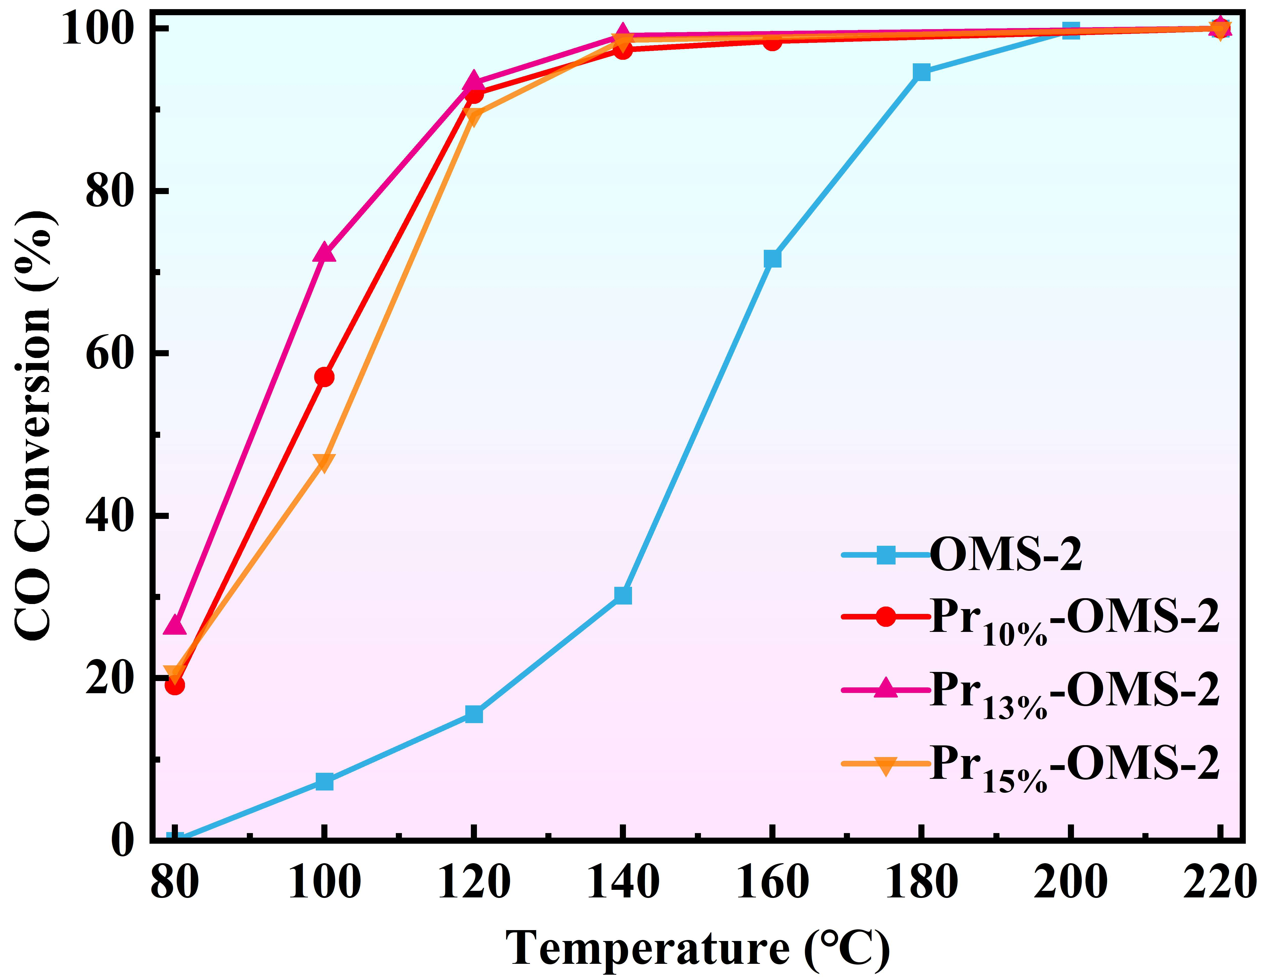
Fig. S1 Effect of Pr doping amount on removal performance of CO over OMS-2 catalyst. (Reaction Conditions: CO=1%, O₂ =10%, N₂ =balance and WHSV=60 L·g⁻¹·h⁻¹)
Figure Legend section
Figure. S1 Effect of Pr doping amount on removal performance of CO over OMS-2 catalyst

* Author to whom correspondence should be addressed to L. Yang email: liyang@wit.edu.cn, Z. Chen email: zhende_888@126.com, and Y. Qin email: qyhsir@qq.com §Equally contributing authors

