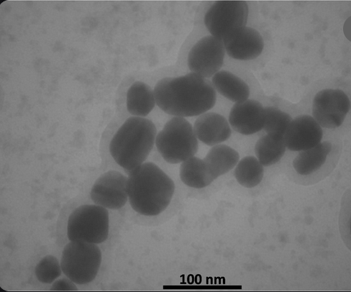

Picture 1. The Ag spherical NPs picture by TEM

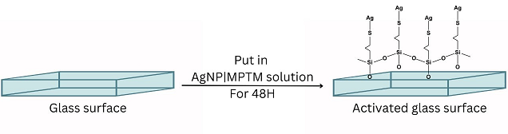
Picture 2. Covering the glass with AgNPs-MPTM solution

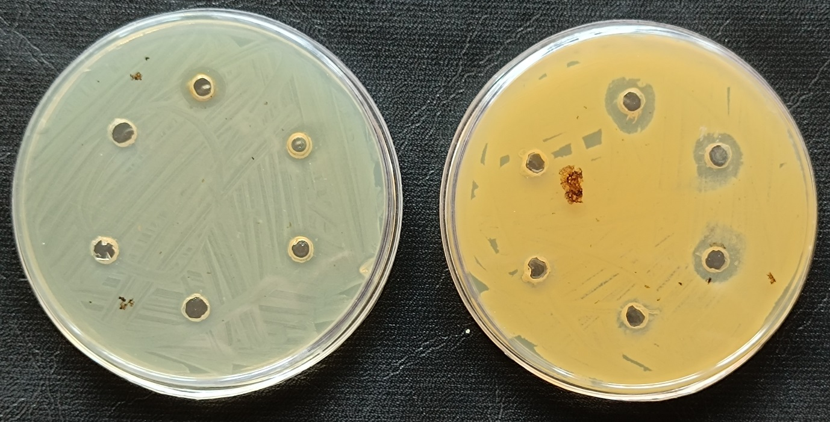

Picture 3: Antimicrobial properties of AgNP/ MPTM on S. aureus (right) and E. coli (left) bacteria by well diffusion method.

