LN | Ligand structure | 3D image | 2D image | H.S  (KJ/  mol) | L.E. | LIPO | AMBIG | CLASH
1. |  | 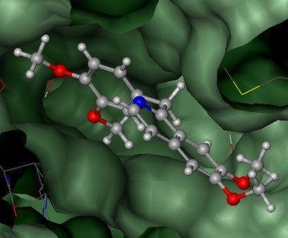 | 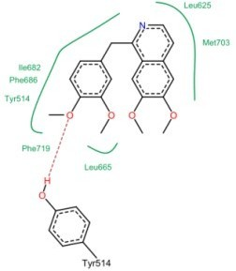 | -34 | 0.32 | -12.3248 | -3.5323 | 3.3895
2. |  | 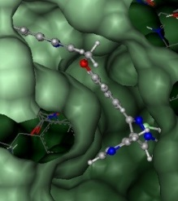 | 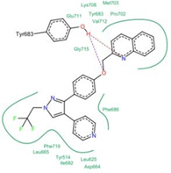 | -55 | 0.39 | -21.9623 | -9.8998 | 8.9917
3. |  | 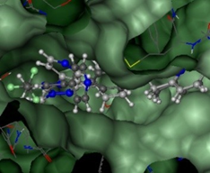 | 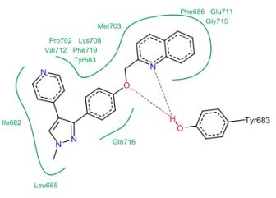 | -46 | 0.36 | -18.7460 | -9.5699 | 9.6045
4. |  | 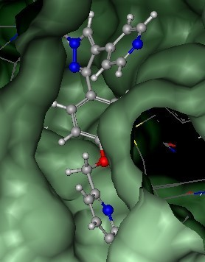 | 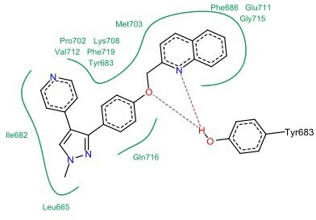 | -56 | 0.45 | -19.8936 | -8.9957 | 8.0668
5. |  | 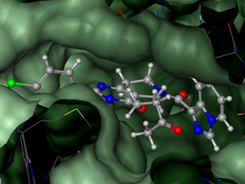 | 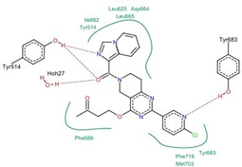 | -22 | 0.15 | -16.7136 | -9.0961 | 6.3666
6. |  | 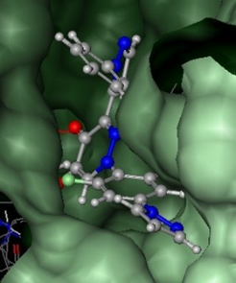 | 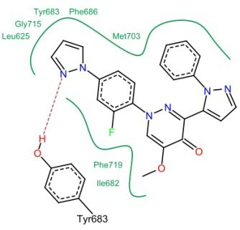 | -49 | 0.36 | -16.1625 | -7.1804 | 11.1140
7. |  | 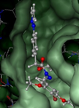 | 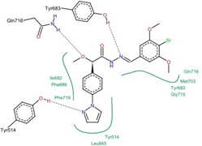 | -26 | 0.20 | -14.6262 | -8.0702 | 5.1380
8. |  | 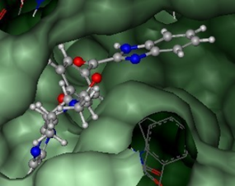 | 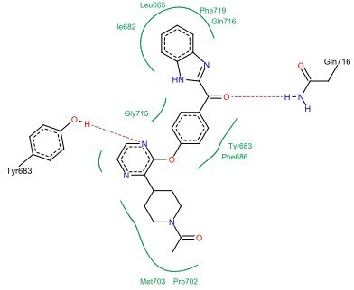 | -41 | 0.30 | -15.5927 | -8.0741 | 3.9173
9. |  | 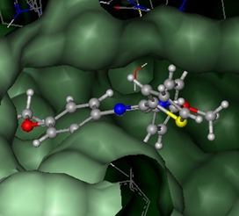 | 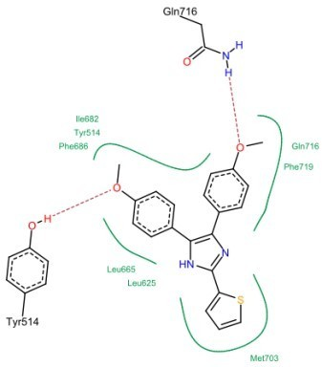 | -36 | 0.33 | -12.2370 | -3.8079 | 3.7773
10. |  | 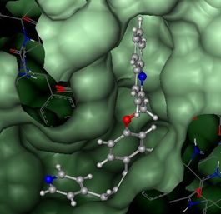 | 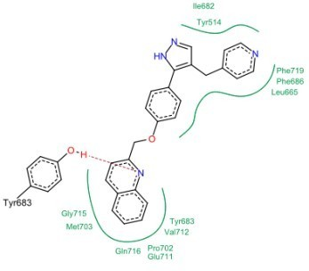 | -54 | 0.43 | -19.0045 | -7.3832 | 2.7135
11. |  | 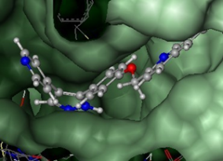 | 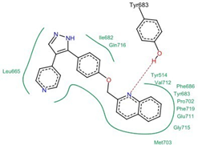 | -48 | 0.39 | -17.4675 | -7.7328 | 2.4646
12. |  | 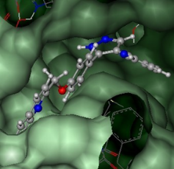 | 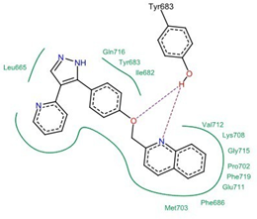 | -47 | 0.39 | -19.3780 | -8.3523 | 3.5980
13. |  | 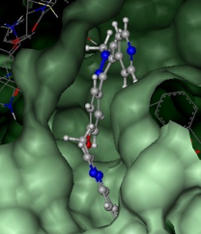 | 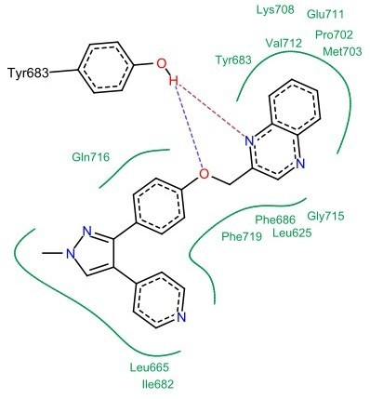 | -52 | 0.42 | -18.7483 | -8.1763 | 7.3513
14. |  | 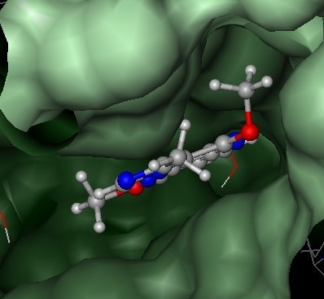 | 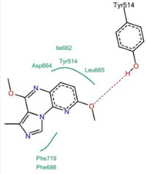 | -23 | 0.30 | -9.8017 | -5.5324 | 3.5303
15. |  | 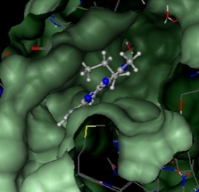 | 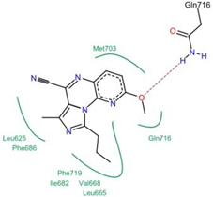 | -33 | 0.38 | -10.9162 | -5.2773 | 3.0832
16. |  | 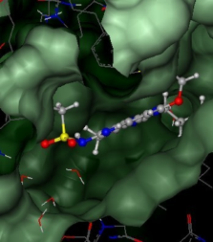 | 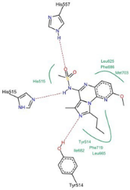 | -32 | 0.32 | -10.2614 | -4.7245 | 6.6594
17. |  | 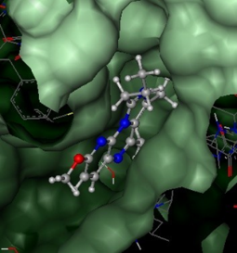 | 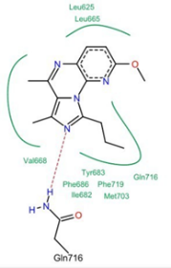 | -37 | 0.44 | -11.9187 | -5.6009 | 3.6759
18. |  | 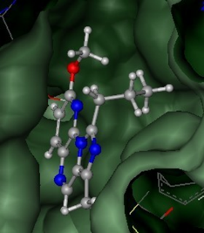 | 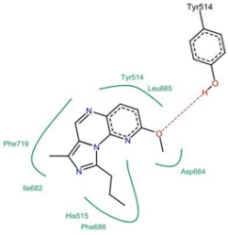 | -32 | 0.41 | -9.5664 | -5.3465 | 3.9031
19. |  | 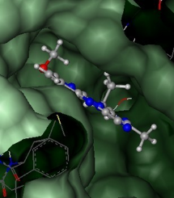 | 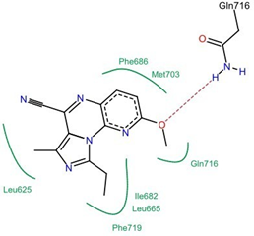 | -31 | 0.37 | -9.9566 | -3.5118 | 1.5788
20. |  | 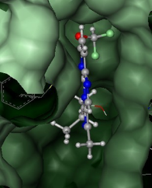 | 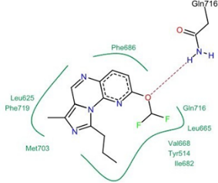 | -36 | 0.41 | -10.0179 | -4.6538 | 3.0065
21. |  | 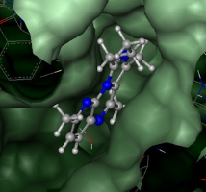 | 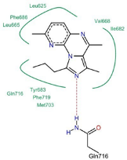 | -40 | 0.50 | -11.0932 | -5.3725 | 3.8464
22. |  | 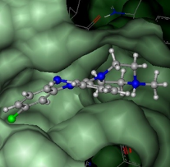 | 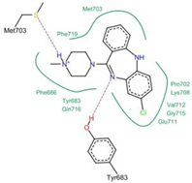 | -32 | 0.33 | -13.5977 | -7.3765 | 7.7653
23. |  | 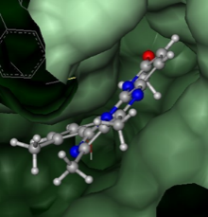 | 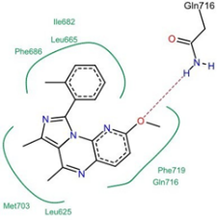 | -34 | 0.34 | -12.5727 | -4.7366 | 3.8709
24. |  | 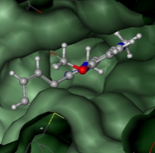 | 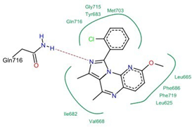 | -46 | 0.46 | -13.4403 | -6.1701 | 7.1149
25. |  | 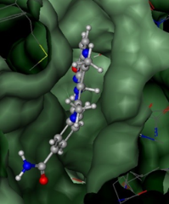 | 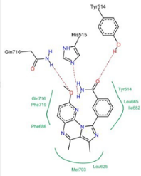 | -31 | 0.29 | -12.9520 | -5.8385 | 5.2308
26. |  | 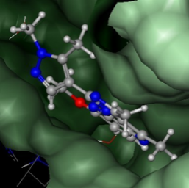 | 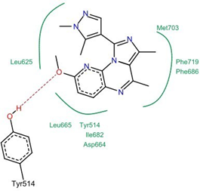 | -31 | 0.31 | -11.8068 | -5.4751 | 4.8556
27. |  | 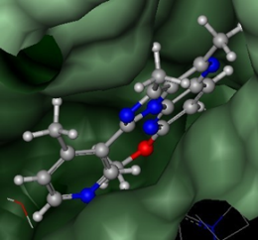 | 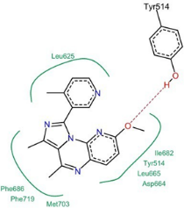 | -34 | 0.33 | -12.3053 | -4.8440 | 4.5816
28. |  | 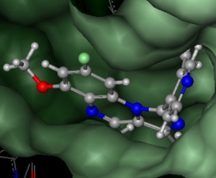 | 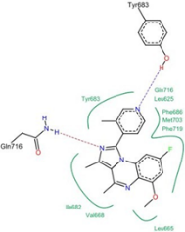 | -47 | 0.45 | -13.8797 | -5.9978 | 8.2227
29. |  | 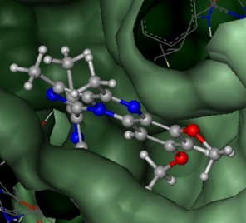 | 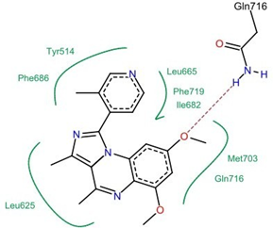 | -45 | 0.42 | -13.5092 | -4.9775 | 6.1113
30. |  | 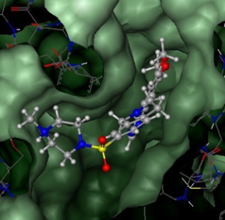 | 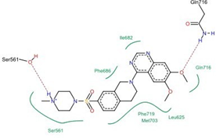 | -42 | 0.30 | -12.9489 | -4.7615 | 3.9000
31. |  | 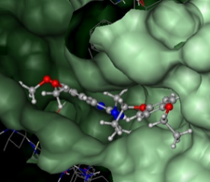 | 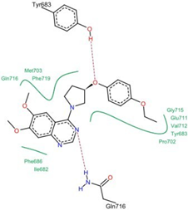 | -46 | 0.38 | -16.9239 | -7.5286 | 7.5868
32. |  | 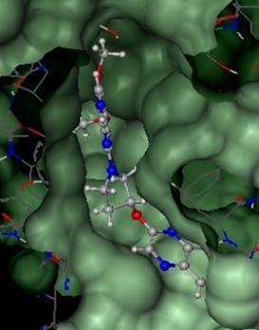 | 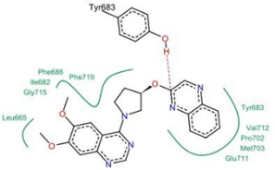 | -46 | 0.37 | -17.0237 | -8.1936 | 7.0871
33. |  | 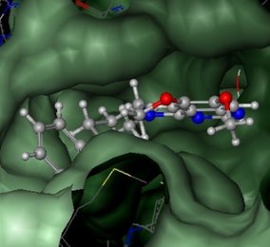 | 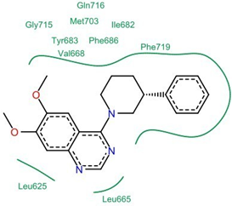 | -35 | 0.33 | -13.5330 | -4.8715 | 4.5523
34. |  | 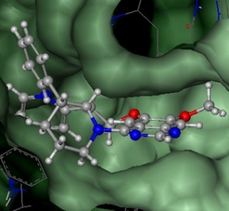 | 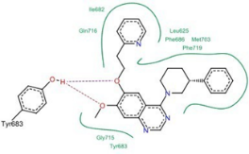 | -48 | 0.35 | -19.0965 | -6.1005 | 3.5516
35. |  | 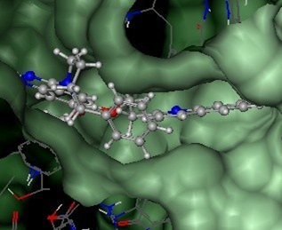 | 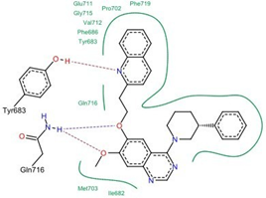 | -60 | 0.39 | -19.1865 | -9.1879 | 8.6474
36. |  | 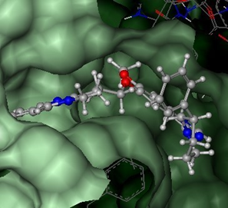 | 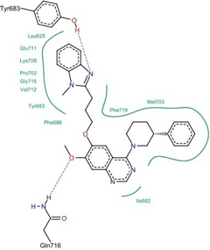 | -62 | 0.39 | -21.1720 | -8.8751 | 4.6082
37. |  | 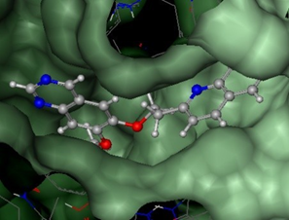 | 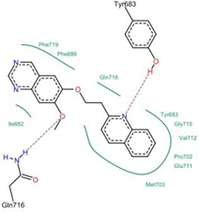 | -49 | 0.47 | -18.0356 | -7.7602 | 6.5841
38. |  | 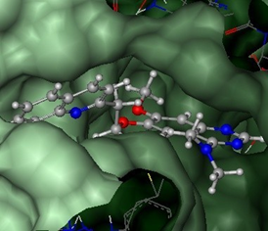 | 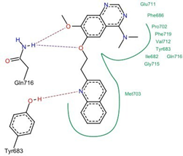 | -51 | 0.49 | -16.5503 | -8.4697 | 7.3443
39. |  | 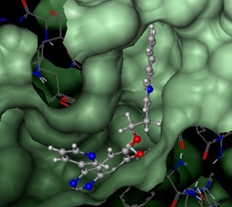 | 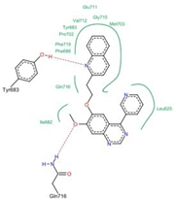 | -56 | 0.43 | -19.0302 | -8.2933 | 4.3541
40. |  | 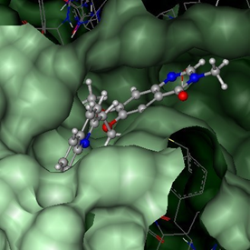 | 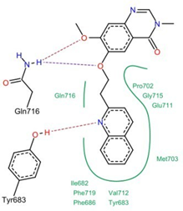 | -50 | 0.44 | -16.5872 | -8.2918 | 5.4790
41. |  | 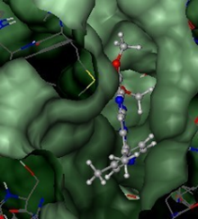 | 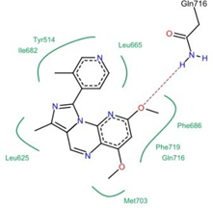 | -42 | 0.40 | -12.8953 | -5.8073 | 5.4327
42. |  | 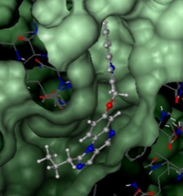 | 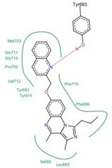 | -49 | 0.39 | -18.0594 | -7.6386 | 5.4532
43. |  | 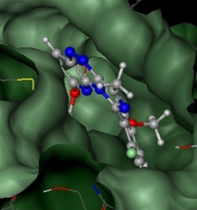 | 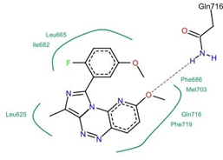 | -38 | 0.36 | -11.5757 | -5.2354 | 5.3663
44. |  | 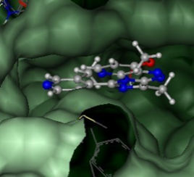 | 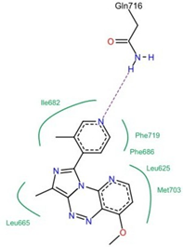 | -31 | 0.32 | -10.2718 | -3.6027 | 1.9631
45. |  | 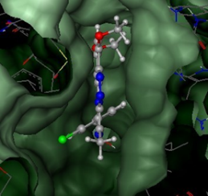 | 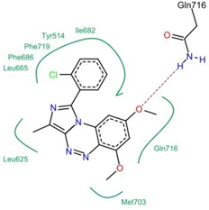 | -38 | 0.37 | -14.4242 | -5.1875 | 6.8150
46. |  | 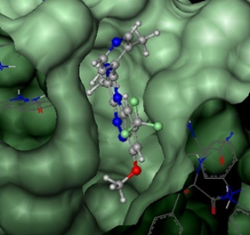 | 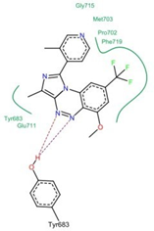 | -27 | 0.24 | -10.5581 | -7.5041 | 2.4363
47. |  | 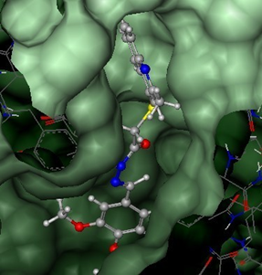 | 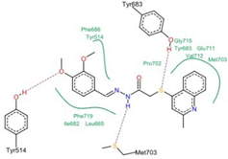 | -40 | 0.34 | -16.0746 | -7.9637 | 10.1144
48. |  | 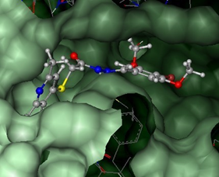 | 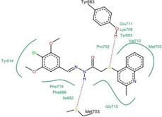 | -35 | 0.29 | -16.2157 | -8.3371 | 6.8796
49. |  | 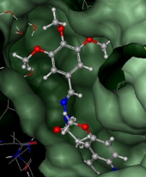 | 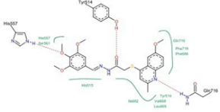 | -28 | 0.21 | -15.2485 | -11.7221 | 7.2419
50. |  | 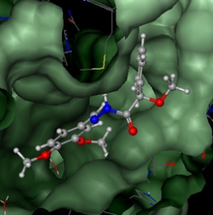 | 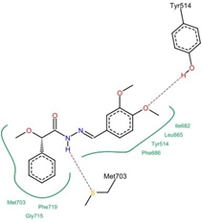 | -24 | 0.24 | -13.0555 | -7.9622 | 7.5354
51. |  | 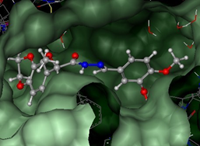 | 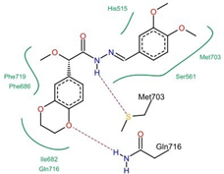 | -19 | 0.16 | -13.0258 | -8.6871 | 6.6827
52. |  | 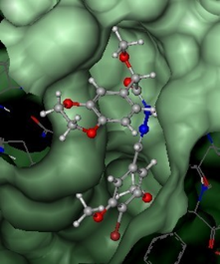 | 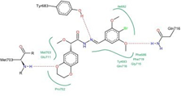 | -34 | 0.28 | -14.3512 | -8.3461 | 10.1894
53. |  | 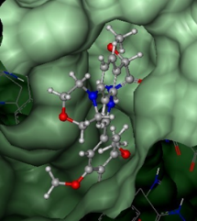 | 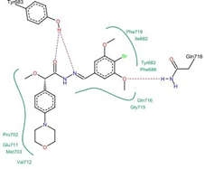 | -19 | 0.15 | -15.2925 | -6.8988 | 7.6223
54. |  | 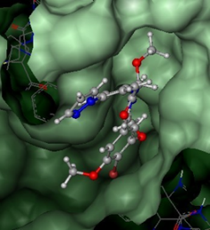 | 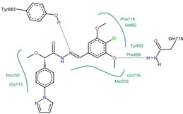 | -30 | 0.24 | -14.5513 | -6.1394 | 5.5783
55. |  | 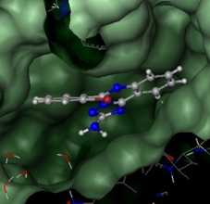 | 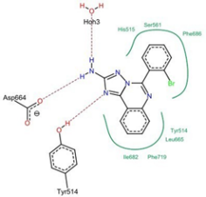 | -16 | 0.18 | -9.3050 | -3.8638 | 2.2186
56. |  | 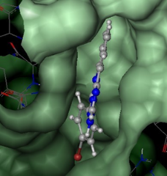 | 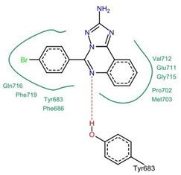 | -37 | 0.42 | -12.5619 | -6.9502 | 2.6923
57. |  | 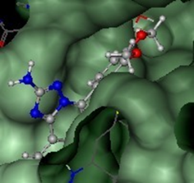 | 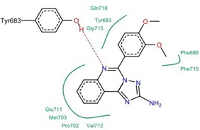 | -35 | 0.35 | -15.1748 | -9.1140 | 5.6016
58. |  | 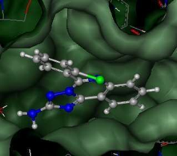 | 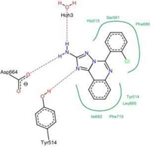 | -15 | 0.17 | -9.2021 | -3.8618 | 2.2225
59. |  | 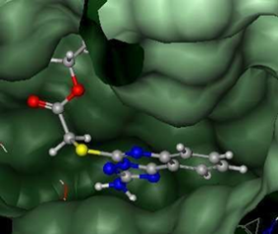 | 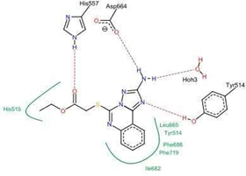 | -12 | 0.14 | -7.9612 | -5.5383 | 2.5658
60. |  | 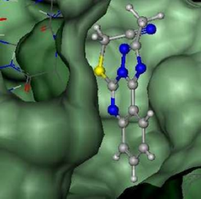 | 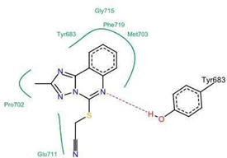 | -31 | 0.42 | -9.8071 | -6.8258 | 1.4460
61. |  | 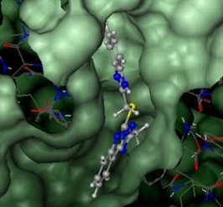 | 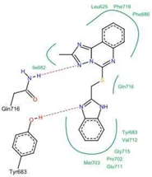 | -47 | 0.45 | -16.0478 | -8.4560 | 4.1848
62. |  | 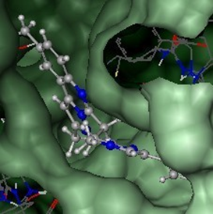 | 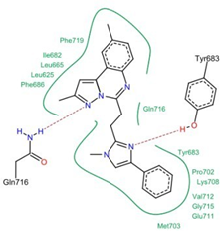 | -53 | 0.44 | -19.6974 | -8.7448 | 7.0453
63. |  | 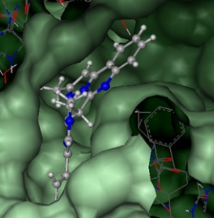 | 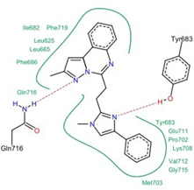 | -54 | 0.46 | -19.4057 | -8.7504 | 6.4298
64. |  | 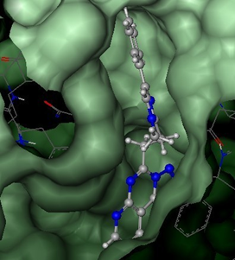 | 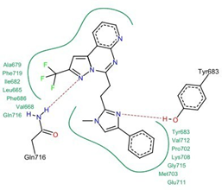 | -53 | 0.41 | -19.2823 | -9.7232 | 7.6648
65. |  | 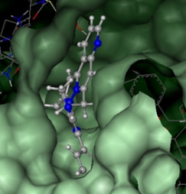 | 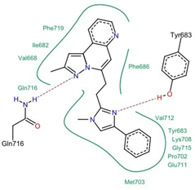 | -59 | 0.51 | -18.9370 | -8.4303 | 5.9119
66. |  | 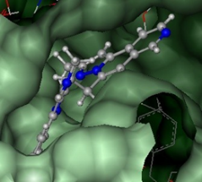 | 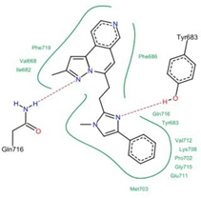 | -60 | 0.51 | -19.4875 | -8.8961 | 6.3741
67. |  | 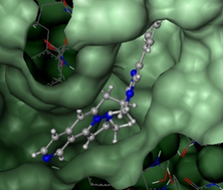 | 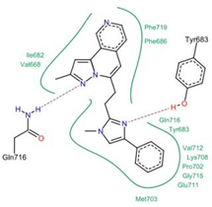 | -59 | 0.51 | -19.5586 | -9.2680 | 6.5745
68. |  | 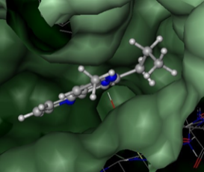 | 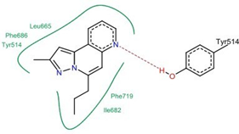 | -19 | 0.26 | -8.7072 | -4.1162 | 2.4580
69. |  | 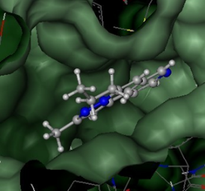 | 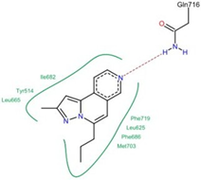 | -29 | 0.40 | -9.3983 | -2.1273 | 1.4346
70. |  | 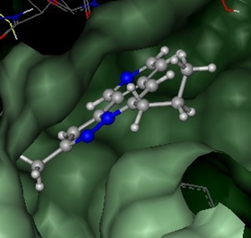 | 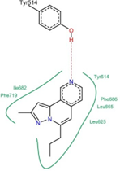 | -21 | 0.30 | -9.3179 | -2.9419 | 0.7800
71. |  | 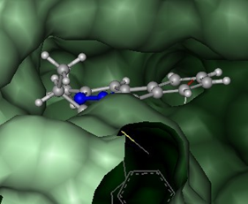 | 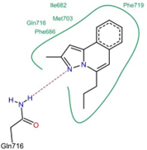 | -36 | 0.51 | -10.7157 | -2.5414 | 2.5552
72. |  | 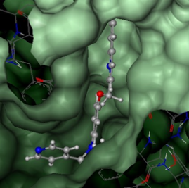 | 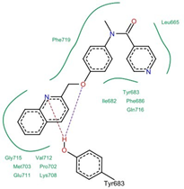 | -50 | 0.43 | -18.6699 | -8.2163 | 4.6456
73. |  | 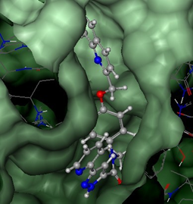 | 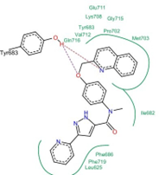 | -52 | 0.38 | -19.1535 | -8.9864 | 6.7511
74. |  | 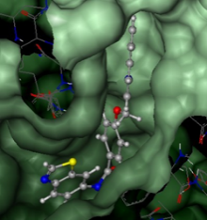 | 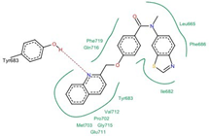 | -56 | 0.43 | -18.0885 | -8.1875 | 4.0541
75. |  | 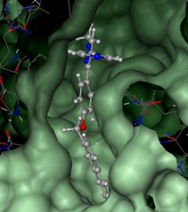 | 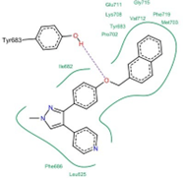 | -56 | 0.44 | -18.1940 | -7.5429 | 8.0889
76. |  | 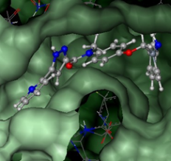 | 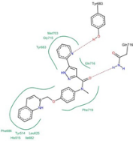 | -45 | 0.32 | -15.8267 | -6.5074 | 7.2048
77. |  | 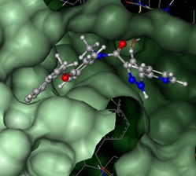 | 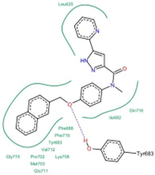 | -53 | 0.38 | -21.0870 | -8.0782 | 6.0574
78. |  | 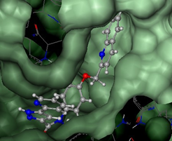 | 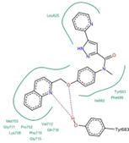 | -54 | 0.39 | -19.5927 | -9.4649 | 6.1430
79. |  | 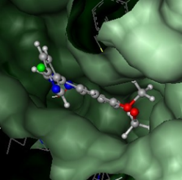 | 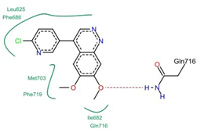 | -35 | 0.40 | -11.4781 | -2.3967 | 2.6082
80. |  | 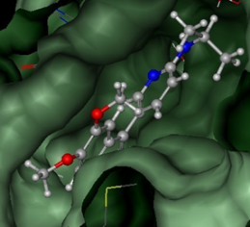 | 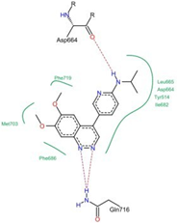 | -16 | 0.16 | -12.1220 | -6.8333 | 4.9933
81. |  | 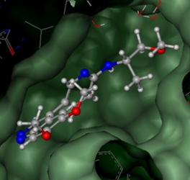 | 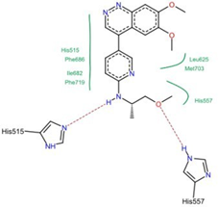 | -28 | 0.26 | -10.6825 | -5.1894 | 4.1575
82. |  | 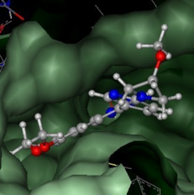 | 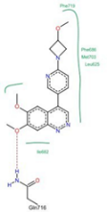 | -34 | 0.31 | -11.5069 | -2.8731 | 1.7952
83. |  | 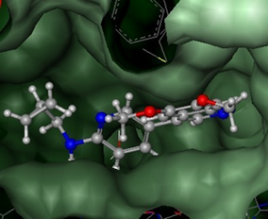 | 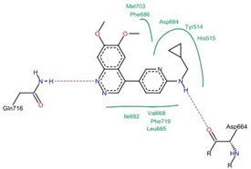 | -18 | 0.17 | -14.7691 | -7.4277 | 7.9248
84. |  | 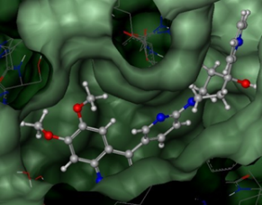 | 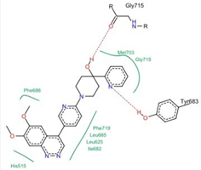 | -17 | 0.13 | -12.7852 | -7.7721 | 4.5948
85. |  | 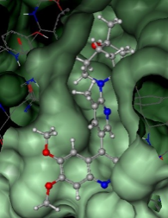 | 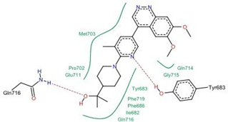 | -37 | 0.29 | -16.0985 | -8.4421 | 7.0166
86. |  | 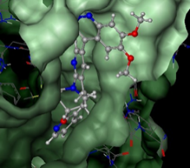 | 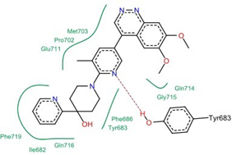 | -33 | 0.24 | -17.4716 | -10.8816 | 8.6693
87. |  | 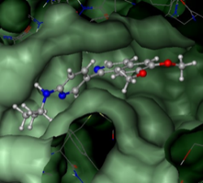 | 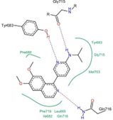 | -39 | 0.39 | -13.5592 | -5.3954 | 5.4201
88. |  | 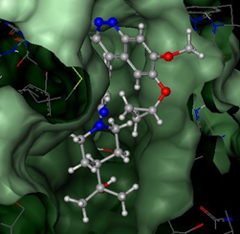 | 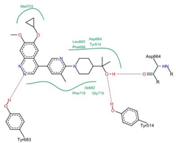 | -28 | 0.21 | -16.5465 | -6.3903 | 5.8089
89. |  | 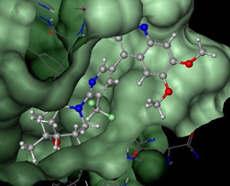 | 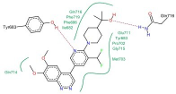 | -39 | 0.28 | -16.8872 | -8.8152 | 6.6230
90. |  | 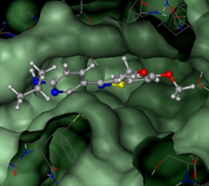 | 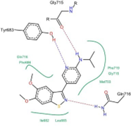 | -31 | 0.32 | -12.4942 | -4.5474 | 6.7690
91. |  | 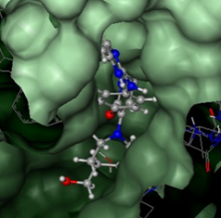 | 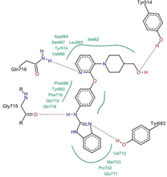 | -59 | 0.45 | -18.2129 | -10.7909 | 14.0178
92. |  | 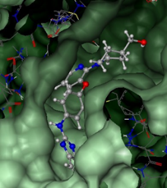 | 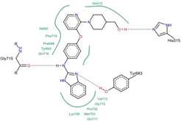 | -55 | 0.42 | -19.1650 | -10.2798 | 6.9461
93. |  | 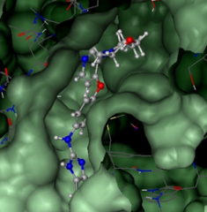 | 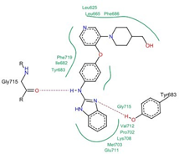 | -51 | 0.39 | -18.6352 | -8.4427 | 4.2010
94. |  | 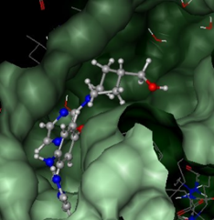 | 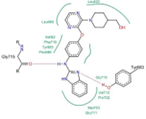 | -54 | 0.42 | -16.6913 | -8.8028 | 3.0318
95. |  | 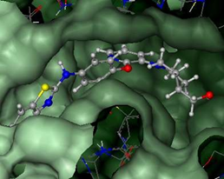 | 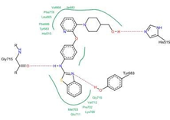 | -59 | 0.46 | -17.8514 | -9.5954 | 4.6477
96. |  | 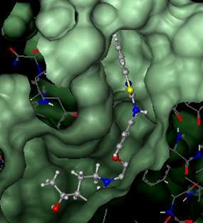 | 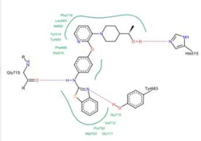 | -60 | 0.44 | -17.5705 | -8.6344 | 3.7620
97. |  | 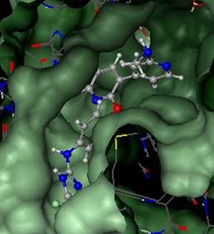 | 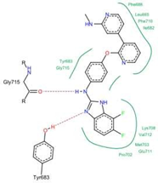 | -53 | 0.38 | -19.1324 | -8.9027 | 6.4727
98. |  | 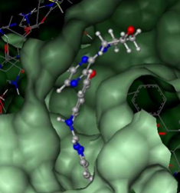 | 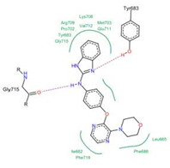 | -51 | 0.42 | -17.9856 | -10.3533 | 5.2483
99. |  | 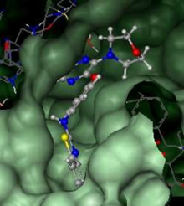 | 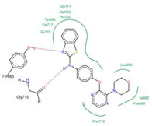 | -51 | 0.42 | -17.9554 | -9.4619 | 3.9648
100. |  | 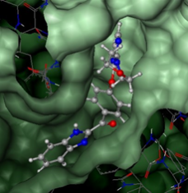 | 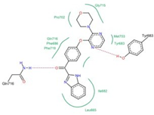 | -44 | 0.35 | -14.8422 | -9.0853 | 4.6661
Author information
Authors and Affiliations
Department of Chemistry, Babasaheb Bhimrao Ambedkar University (A Central University) Lucknow, Uttar Pradesh, 226025, India
Ashutosh Kharwar & Anjani Kumar Tiwari
Author Contributions
All the authors read and approved the final manuscript. AK: writing, designing, visualization; AKT: formal analysis and supervisor
Corresponding author
Correspondence to Anjani Kumar Tiwari.
Ethics declarations
Ethical approval
None to report.
Disclosure statement
Conflict of Interest
The authors declare that there are no conflicts of interest.
Compliance with Ethical Standards
This article does not contain any studies involving human or animal subjects.

