Supplementary Notes

Disentangling population-specific genetic traits in type 2 diabetes by 600,000 East-Asians

Kohei Saito^{1,2,3,4,5,19}, Hsing-Fang Lu^{6,7,19}, Tatsuhide Inoue², Takeshi Usui^{3,8}, Toshihiro Shirai⁹, Tatsuo Ogawa², Rieko Kosugi^{2,8}, Chika Kyo², Keiko Hikino⁷, Yun Li ^{10,11,12}, Momoko Horikoshi⁷, Hiroshi Itoh⁴, Kaori Hayashi⁴, Toshio Shimada¹, Koichi Ozaki¹³, Issei Tanaka², Wen-Ling Liao^{6,14}, Ting-Yuan Liu⁶, Fuu-Jen Tsai^{6,15,16}, Chikashi Terao^{1,17,18}

Supplementary Text
Japanese GWAS
We conduct a genome-wide association study (GWAS) with DNA samples from Japan's Shizuoka General Hospital (SGH). The clinical information was extracted from electronic medical records. Between 2019 and 2020, the SGH study enrolled 3,144 participants, of which 1,506 individuals were diagnosed with type 2 diabetes (T2D) by SGH's specialized clinical endocrinologists. SNP data for these individuals. As additional control samples, we included 7,887 DNA samples from the National Center for Geriatrics and Gerontology (NCGG), were acquired using the Infinium Asian Screening Array-24 v1.0 BeadChip, which is a common resource utilized in both SGH and NCGG. These two datasets were subsequently integrated using Plink 1.9 (1).

A total of 10,562 individuals underwent genotyping. Following quality control procedures, including variant and sample quality checks, 32 individuals were excluded due to failing quality criteria, resulting in a final dataset of 10,532 individuals (1,488 cases and 9,044 controls). The mean age of the participants was 70 years (SD= 13.8), and 51.9% of the population comprised females (Supplemenatry Table 11). To account for potential confounding by population structure, genetic analyses included adjustments for sex and the first ten principal components derived from genome-wide data.

For variant quality control, parameters were set to Minor Allele Frequency (MAF)>1%, call rate≥98%, and Hardy-Weinberg equilibrium P>10⁻⁶ (--hwe 0.000001). Hardy-Weinberg equilibrium testing was performed on women's autosomal chromosomes and X chromosomes in the NCGG sample before merging with SGH data. Hardy-Weinberg equilibrium testing was not performed on the SGH data to prevent over-elimination due to the high proportion of diabetic patients. Sample quality control was set to a call rate of <97%, and individuals with unresolved sex discrepancies were excluded. The KING program (2) was utilized to calculate identity-by-descent estimates and to identify clusters of identical samples, such as identical twins or duplicates, retaining only one individual from each cluster. Then, A principal component analysis (PCA) was conducted on the GWAS data, and PCA outliers were excluded. 1000 Genomes Phase 3 data was used to generate an ancestry map. Before the PCA, data pruning was carried out using the PLINK "indep-pairwise" option, retaining only LD-independent variants. Specifically, variants with a pairwise R²<0.2 within a window size of 50 were included (-indep-pairwise 50 5 0.2). The HLA regions (25M to 35M of chromosome 6) were excluded during pruning. Post-pruning, Principal Components (PCs) were constructed using the LD-independent variants, and two-dimensional plots were created using PC1 and PC2 to identify individuals not clustered in the Japanese ancestry cluster; these were subsequently removed as PCA outliers.

Following the quality control, 424,582 SNPs from 10,532 samples remained (Neff=5111: Case=1488, Control=9044), with a total genotype rate of 0.9988. All the SNPs of autosomal chromosomes within the cohort were then imputed on the Michigan Imputation Server (3). Post-further quality control (MAF>0.01 and imputation quality score R²>0.3), the sample set was composed of 10,532 individuals (1,488 cases and 9,044 controls), with an effective sample size (Neff) of 5,111 (Neff = 4/(1/Control + 1/Case)). The final dataset contained 9,607,262 SNPs.

For the genetic data analysis of T2D in the JPN dataset, BOLT-LMM v2.4.1 was utilized (4). The analysis entailed filtering variants with a minimum MAF of 0.01 and a minimum INFO of 0.3 and adjusting for covariates, including sex and the first ten principal components derived from all JPN samples. The chip information was used for LD score computation using the standard Linear Mixed Model (LMM) implementation, adjusting for covariates, including sex and the first ten principal components of genetic ancestry. The log-odds ratio (log OR) was calculated by transforming the beta value using the formula provided in the BOLT-LMM v2.4.1 User Manual: log OR = β / (µ * (1-µ)), where µ represents the case fraction.

The most significantly associated variant in the JPN study was rs2237896. This top variant's effect size (log OR) was -0.205 (SE=0.034; P-value=6.6x10⁻⁸). This variant is located within KNCQ1, a known T2D-associated gene, consistent with previous results in literature (5) and further suggesting its potential role in disease etiology in Japanese populations. The genomic inflation factor (lambda) for the JPN study was 1.034.

Taiwanese GWAS
The China Medical University Hospital Precision Medicine Biobank, also named the Taiwan Genome-Wide Association Study (TW Study) in this study, is a large-scale genetic analysis initiated in 2018 and conducted at the China Medical University Hospital in Taichung, Taiwan. It parallels the objectives of the JPN study and aims to perform comprehensive genetic association analyses for various traits among the participants. T2D cases (N=13,770) were defined based on at least three clinical encounters with recorded ICD-9-CM or ICD-10-CM diagnostic codes for T2D. Controls (N=138,936) included individuals without any T2D or type 1 diabetes diagnostic codes and who were not prescribed any antidiabetic medications using ATC codes (Supplementary Table 11). To account for potential confounding due to population stratification, GWAS analyses were adjusted for sex, age, and the first ten principal components derived from genome-wide genotype data.

The genomic build utilized for the TW Study was hg38. For comparability and subsequent meta-analysis with the JPN study, the genomic build was converted to hg19 using the LiftOver tool available from the UCSC Genome Browser (6). This ensured direct comparison and combination of the genetic data from both studies.

The TW study included a total of 709,332 genotyped SNPs. The variant inclusion parameters for genotyped variants were set to a call rate≥98%, MAF≥0.01, HWE p-value<1x10⁻¹⁰, and limited to autosomal, non-indel variants. For the sample-level quality control process, parameters included a call rate<98%, a heterozygosity rate more than five standard deviations from the mean, sex mismatch, and duplicate samples or twins (kinship>0.354) were excluded. The PCA outliers from 1000 genome EAS were also excluded (n=4,887). Phasing and imputation were carried out using SHAPEIT4 and BEAGLE, based on the Taiwan Biobank (TWB) 1495 WGS data (n=1495) as the reference panel. After imputation, the imputed SNPs with INFO<0.8, MAF<0.005, or HWE P<1 x 10⁻¹⁰ were excluded from the subsequent analysis. In total, the number of imputed SNPs amounted to 7,894,786, with an effective sample size (Neff) of 49,998, which included 13,736 cases and 138,858 controls.

These imputed SNPs were subsequently employed for association analysis using SAIGE (7), considering factors such as sex, age, and the first ten principal components, mirroring the methodology used in the JPN study. For a meta-analysis with the JPN dataset, the imputed SNPs were transitioned from the hg38 to the hg19 build using the LiftOver tool.

The TW study's most significantly associated variant was 11:2858295:C: T (rs2299620:C>T: KCNQ1), also found within the same T2D-associated locus as the JPN study. The beta value for this variant was -0.196 (SE=0.015; p.value=2.91x10⁻³⁷). A total of 229 variants in the TW study reached genome-wide significance, with a lambda of 0.993.

Pre-process for the integration with Spracklen's Study
METAL (8) was utilized to perform a fixed-effects meta-analysis using the inverse variance-weighted average.
To conduct our meta-analysis in line with the study by Spracklen et al. (9) —a T2D GWAS meta-analysis representing the most extensive East Asian sample size to date—we harmonized SNPs from both the JPN and TW studies. We focused on the common variants reported in Spracklen's study (9), encompassing 433,540 East Asian individuals. This process incorporated 7,972,355 SNPs out of the 8,139,678 SNPs from the JPN study and 7,149,898 SNPs from the 7,878,482 SNPs in the TW study for further analysis.

To assess the heterogeneity between our studies (JPN and TW GWAS) and Spracklen's study (9), we employed the Cochrane Q test, applying a significance threshold of Het P-value<1x10⁻⁸ decided based on the distribution of Het P-values (not shown). In comparing the JPN study to Spracklen's (9), we excluded 156 SNPs presenting substantial heterogeneity. Likewise, when comparing the TW study with Spracklen's study (9), 2,142 SNPs showing significant heterogeneity were omitted.

Reasons for choosing the Spracklen's Study as our EAS-meta basement
The Spracklen's study includes 23 East Asian GWAS with 77,418 cases and 356,122 controls (10). They specifically focused on East Asians and better alignment with our new Taiwanese and Japanese GWAS compared to the currently largest cross-ancestry meta-analysis (14), including 40 East Asian GWAS with 88,109 cases and 339,395 controls. Our aim is consistent with Spracklen’s study more than Suzuki’s study. Moreover, the variants in the JPN and TW GWAS data were more aligned with Spracklen’s study. For the JPN GWAS, we aligned 7,972,355 SNPs with the Spracklen’s study, while 6,370,500 SNPs with Suzuki’s study. For the TW GWAS, we aligned 7,149,898 SNPs with the Spracklen’s study, while 6,375,467 SNPs with Suzuki’s study. The EAS-meta identified 196 T2D-associated loci, including two previously unreported loci. We complementary showed two and eight unreported loci from the meta-analysis with Spracklen’s and Suzuki’s studies, respectively (Supplementary Table 12). To identify these novel variants, we sought those not previously recorded as GWAS significant (P<5x10⁻⁸). We used the GWAS catalog (MONDO_0005148; 2023-4-5) and the associated loci information from Spracklen's study (9), which is not yet reflected in the current GWAS catalog.

Cross-Ancestry Meta-Analysis
A cross-ancestry GWAS meta-analysis, referred to as "Cross-meta," was performed by combining the EAS-meta results with the DIAMANTE European GWAS dataset (10). This analysis included 10,454,876 SNPs from 80,154 cases and 853,816 controls (Neff=294,303). The Cross-meta yielded a comprehensive dataset consisting of 15,625,282 SNPs, 172,546 cases, and 1,357,840 controls (Neff=518,642). This analysis identified 415 significant loci, and subsequent GCTA-COJO conditional analysis (Methods) identified an additional 129 independent T2D-associated signals (Pcojo<5x10⁻⁸).

To pinpoint or narrow down candidates for putative causal variants, we employed the Approximate Bayes Factor (ABF) fine-mapping approach (Supplementary Methods). This resulted in the identification of 63 lead SNPs with more than 95% PIP in Cross-meta (Supplementary Figure 3). Among these, rs2233580 (PAX4), rs78193826 (GP2), rs1260326 (GCKR), rs13266634 (SLC30A8), and rs429358 (APOE) were located in known loci and were functionally classified as ‘medium’ or ‘low’ by the VEP (Supplementary Table 13).

We further evaluated whether this cross-ancestry meta-analysis could refine the candidates for putative causal variants compared to ABF fine-mapping among 100 commonly shared T2D-associated loci in each population (Supplementary Methods). As a result, Cross-meta provided a more refined set of regions: 30 regions with a 95% credible set containing a single variant, compared to 10 in EAS and 15 in EUR, and 27 regions with 2-5 variants, compared to 21 and 22 regions in EAS and EUR, respectively (Supplementary Tables 14). For example, the cross-ancestry meta-analysis pinpointed the GCKR variant rs1260326 with a high PIP of 0.99, in contrast to lower PIPs in the EAS and EUR analyses (Supplementary Figure 3). These findings underscore the utility of Cross-meta in identifying or refining candidates for putative causal variants in T2D and other complex traits.

Association in Pancreatic Cells in T2D Susceptibility
Given the significant heritability enrichment observed in pancreatic alpha and delta cells through stratified LDSC analyses using single-cell ATAC-seq (Figure 1C), we investigated whether open chromatin regions, which do not overlap with those in beta cells, exhibit heritability enrichment for T2D susceptibility. We integrated ATAC peaks into the background annotations of LDSC and assessed the potential enrichment of open chromatin regions in non-beta cells. While not reaching a level of statistical significance, we observed a suggestive trend toward positive enrichment of T2D heritability in the open chromatin regions of delta and gamma cells (Supplementary Table 4). Additionally, the nominal associations observed in alpha cells appear dependent on beta cells.

Identification of Candidate Genes by the ABC Model Compared to Nearest Gene Annotation
From 544 T2D-associated lead and secondary SNPs, Cross-META, we identified T2D association signals linked to non-nearest genes in 78/544 T2D-associated variants (59 lead and 19 secondary SNPs). These non-nearest genes are considered more plausible candidates for T2D susceptibility. On the other hand, approximately 85% of candidates of responsible genes were the nearest genes. This finding matches with a previous study (11), which, while emphasizing the accuracy of the ABC model — an approach using activity-by-contact measurements to link genome-wide enhancer elements with potential target genes — also showed substantial 81% precision and 81% recall of the Nearest Gene Annotation approach (11).

Rationale for Selecting a Single Gene per Locus in FUMA Analysis
In constructing our gene sets for FUMA pathway analysis, we selected exactly one ‘prioritized gene’ per T2D-associated locus—particularly at those displaying heterogeneous effect sizes between EAS and EUR. Although multiple putative genes might exist in a single genomic region, including all of them could disproportionately inflate or bias pathway signals in cross-locus comparisons. For instance, if one locus harbors three putative genes all associated with HDL-C levels, while another locus has only a single HDL-C–related gene, counting every candidate gene at the first locus could artificially amplify the enrichment signal. By designating a single highest-scoring ‘prioritized gene’ (based on our four-category annotation system) at each locus, we ensure a fair, locus-by-locus comparison in the FUMA gene set analysis. While this approach may exclude other potentially relevant genes, it avoids over-counting effects that might obscure cross-population patterns. Future work may apply more advanced multi-gene or network-based approaches, but our current goal is a balanced, consistent comparison across T2D loci in East Asians and Europeans.

Supplementary Methods

Approximate Bayes Factor Fine-mapping
In our fine-mapping approach, we employed the Approximate Bayes Factor (ABF) (12) to quantify the evidence for the association of each SNP with the trait of interest. This method calculates the strength of the evidence supporting a particular hypothesis against a null hypothesis by assessing the effect size and uncertainty. The Z-score was calculated for each SNP by dividing the estimated effect size (beta) by its standard error (SE). We assumed that the prior effect size variance (V) follows a normal distribution with a zero mean and a predetermined prior variance (τ^2) set at 0.04. This balance helps in detecting true associations while limiting the rate of false positives. The ABF for each SNP was computed using the formula: $ABF={\left(1+ \frac{V}{τ^{2}}\right)}^{-\frac{1}{2}}×exp\left(\frac{Z^{2}×V}{2 ×\left(τ^{2}+V\right)}\right)$

Subsequently, to determine the relative importance of each SNP in the context of all considered SNPs, we calculated the Posterior Inclusion Probability (PIP). The PIP for each SNP was determined by dividing its ABF by the sum of ABFs for all SNPs within the considered region:
$PIP= \frac{ABF}{\sum{ABF}}$

Variant Effect Predictor Annotation
We utilized the Variant Effect Predictor (VEP) (13) to analyze the functional implications of SNPs. 'High impact' variants were identified by VEP-impact as stop-gained, frameshift, and splice site-disrupting. 'Medium impact' variants were classified by VEP-impact as moderate, including missense variants or inframe insertions/deletions, further refined as deleterious by Sorting Intolerant From Tolerant (SIFT) or potentially damaging by Polymorphism Phenotyping 2 (PolyPhen-2). 'Low impact' variants, also moderate by VEP-impact, included missense variants or inframe changes but were considered benign by SIFT or tolerant by PolyPhen-2. Additionally, SpliceAI scores (14) were combined to predict splice-altering variants, categorizing them as 'Medium impact' if scores exceeded 0.2 and 'High impact' if over 0.5, indicating stronger splicing alterations. To identify variants with strong linkage to both primary lead and secondary SNPs, we employed TopLD (15), focusing on those with an R² value greater than 0.8, and updated genetic variant coordinates between GRCh38 and GRCh37 using the UCSC LiftOver tool.

Summary-data-based Mendelian Randomization
To further understand the biological implications of our genetic findings, we employed a Summary-data-based Mendelian Randomization (SMR) approach (16). This technique combines expression quantitative trait loci (eQTL) data with our genotype data, offering insights into potential causal relationships between genes and the trait. We selected eQTL datasets from 23 tissues, prioritized for their relevance to the pathophysiology of diabetes, including 12 from GTEx v8 (17) and 10 brain regions from Brainmeta (18), supplemented by comprehensive whole blood data from the eQTLGen consortium (31,684 samples). Each dataset underwent rigorous statistical correction using the Bonferroni method to adjust for multiple testing (Adjusted P-value < 0.05), ensuring robustness in our identification of genes potentially implicated in diabetes.

Activity-by-Contact Model Predictions
We incorporated the Activity-by-Contact model (11) to explore the regulatory potential of DNA elements impacted by associated variants, focusing on non-coding regions. This model integrates two key metrics: 'Activity,' quantified by ATAC-Seq read counts reflecting chromatin accessibility, and 'Contact,’ indicated by Hi-C contact frequencies demonstrating the interactions between regulatory elements and gene promoters. We calculated ABC scores for enhancer regions linked to each variant, including those in high linkage disequilibrium (R2>0.8) from TopLD, adopting a significance threshold of 0.02 as recommended by Nasser et al (11). We drew on pre-existing, tissue-specific ABC score datasets and augmented our analysis with pancreatic-specific data, given the organ's pivotal role in diabetes. Specifically, we computed ABC scores for individual pancreatic cells (beta, alpha, ductal, and acinar) using single-cell ATAC-seq (scATAC-seq) data (19, 20). The computation employed the ABC-Enhancer-Gene-Prediction tool, with methodological specifics outlined in Nasser et al (11).

Candidate gene prioritization strategy
We developed a scoring algorithm to rank candidate genes based on their genomic location, functional relevance, and tissue-specific significance of variants. This algorithm integrates results from four annotation sources: nearest gene annotation, VEP, SMR, and the ABC model. The scoring details are as follows:

i) Genomic Location and Functional Relevance:
- Lead and secondary T2D-associated SNPs are scored based on the nearest protein-coding gene and the impact of functional variants.
- Protein-coding genes containing high-impact functional variants (e.g., missense, 5' UTR, 3' UTR) receive a score of 3.
- Genes with moderate-impact mutations (e.g., intronic, downstream, upstream) are awarded a score of 2.
- Intergenic mutations are scored as 1, with the nearest gene being allocated the score.
ii) VEP Scores:
- Scores are assigned based on the functional impact of variants determined by VEP.
- High-impact variants earn a score of 3.
- Medium-impact variants receive a score of 2.
- Low-impact variants are given a score of 1.
- Variants with no known impact receive a score of 0.
iii) SMR Approach:
- Scores are based on the significance level in eQTL data integration.
- A score of 2 is assigned for significance in pancreatic tissue.
- A score of 1 is given for significance in any other tissue.
- No evidence results in a score of 0.
iv) ABC Model:
- Scores are derived from the prediction of enhancer-gene interactions.
- Interactions in beta cells are scored as 6, reflecting their critical role in diabetes pathophysiology.
- Interactions in other pancreatic cells (alpha, acinar, ductal) receive a score of 4.
- Pancreatic islet tissue interactions, as provided by Nasser, are scored as 2.
- Interactions in other tissues receive a score of 1.
- No evidence results in a score of 0.
- The higher scores for the ABC model, especially for beta cells, are based on comparative analysis and previous study findings (11), which indicate the model's superior reliability in identifying functionally relevant genetic interactions. Additionally, single-cell data provides a more specific view of diabetes-related cellular interactions, justifying the differentiated scoring.

We summed these four scores to identify up to five putative genes per lead and secondary SNP based on the total score. In cases of identical scores, proximity to the SNP was prioritized. The gene with the highest score and nearest to the SNP was designated as the "prioritized gene."

Functional Mapping and Annotation of Genome-Wide Association Studies
Functional Mapping and Annotation of Genome-Wide Association Studies (FUMA) is a comprehensive, web-based platform designed to facilitate the interpretation of GWAS (https://www.nature.com/articles/s41467-017-01261-5). Our research used FUMA's powerful toolset to systematically analyze genetic variations within a specific gene set. FUMA integrates MAGMA (Multi-marker Analysis of GenoMic Annotation) for gene set analysis, enabling a structured examination of genetic variations, such as SNPs, and their linkage to pertinent gene functions. Within FUMA, pathway analysis with MAGMA allows us to refer to various data sets such as "GWAS-catalog," "GO bp," "Hallmark gene sets," and "Reactome." We focused on the GWAS Catalog due to its extensive data volume and clear categorization of genes related to T2D-specific phenotypes, facilitating straightforward interpretation across diverse populations.

Quality Control and Disease Definition for Type 2 Diabetes in the UK Biobank Dataset
We employed data from the UK Biobank (UKB) comprising autosomal SNPs to perform Genetic Risk Score (GRS) comparison analyses. Variant quality control criteria were applied, selecting SNPs with an MAF greater than 0.005 and imputation quality (INFO) score over 0.3, as per UKB Imputation MAF+Info files (UKB Resource 531). From the UKB, we chose a subset of 320,000 unrelated White British controls and 15,600 cases in compliance with UKB's internal QC standards (Field 22020). The participants were selected based on the following criteria:

To investigate the GRS distribution of T2D-related traits and the fittingness of T2D PRS to the European population, UKB data of autosomal SNPs from the imputation data, applying Variant QC criteria based on minor allele frequency (MAF > 0.005) and imputation information content (INFO > 0.3) using UKB Imputation MAF+Info files (UKB Resource 531). We selected a pre-curated subset of unrelated White British (320,000 controls and 15,600 cases) who met UKB's internal quality control standards (Field 22020). According to the protocol detailed in Bycroft et al (21), the selected participants meet the following criteria:

- Autosomal SNP missing rate ≤ 0.02
- Absence of outliers in missingness or heterozygosity
- Inclusion in a maximal set of unrelated individuals
- Concordance of sex information

To define T2D, we adopted the previously reported UKB algorithms based on self-reported medical history and medication usage during baseline assessment, as outlined in previous research (22). This study validated confirming a high accuracy rate (96%) for self-reported diabetes status among a subset of UKB participants by cross-referencing with primary and secondary medical records,

Supplementary Figure 1. The Image of East Asian Meta-Analysis.

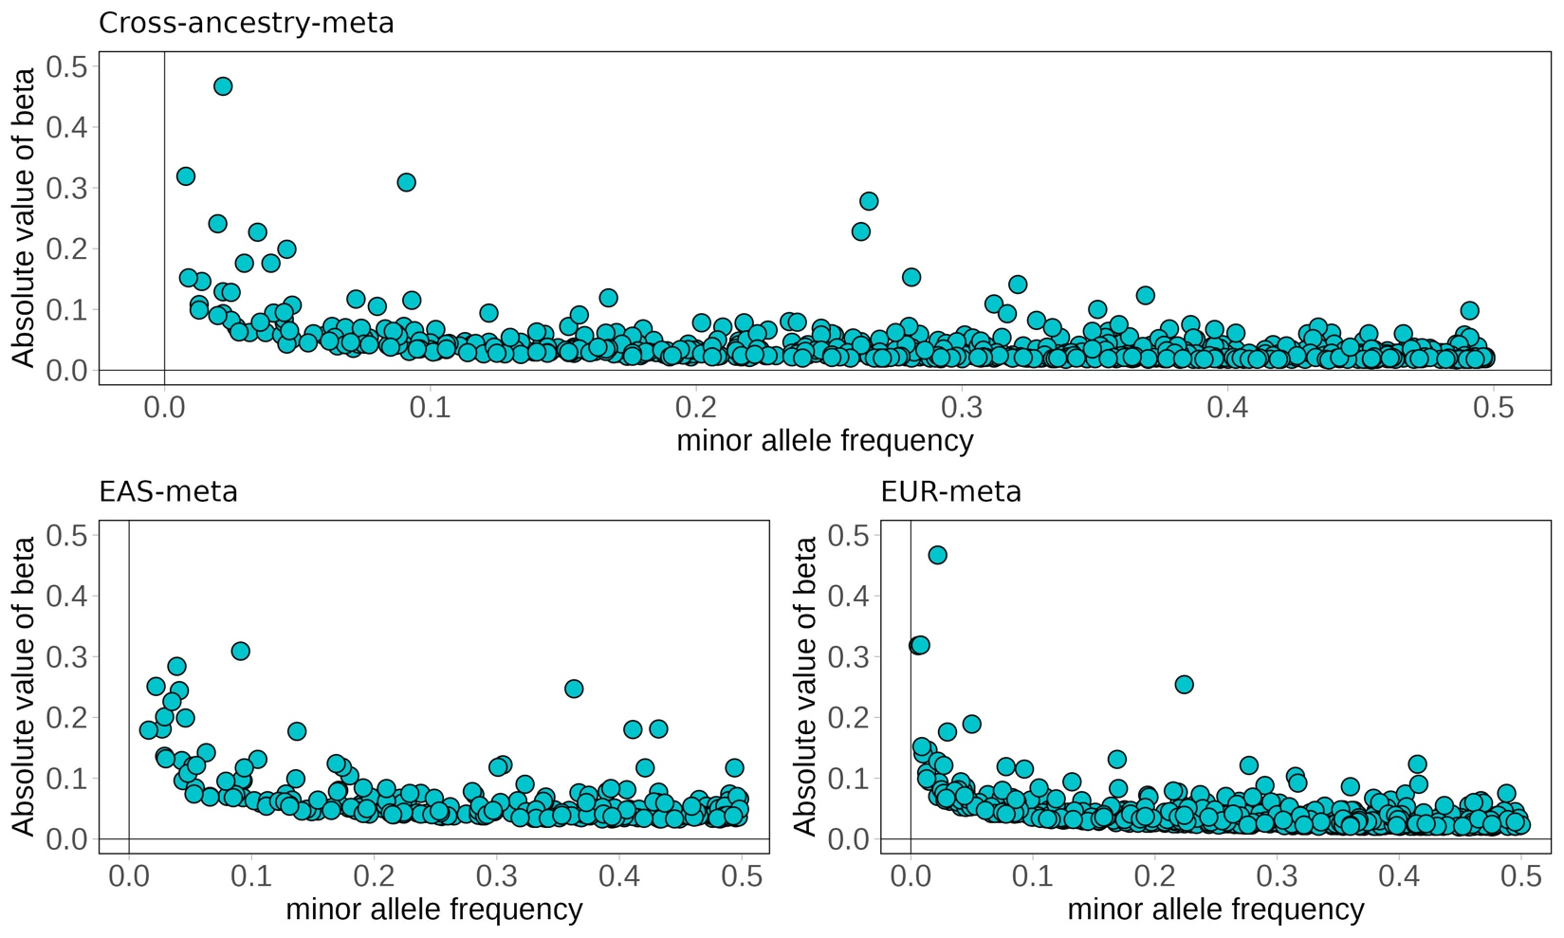
Supplementary Figure 2. Minor Allele Frequency vs Effective Size across Populations for T2D Lead SNPs: The figures present a comparative analysis of the minor allele frequency (MAF) against the effective size (beta) for lead SNPs across three meta-analysis datasets: Points represent lead variant loci, with novel variants depicted by triangle-shaped points in red and known variants depicted by circular points in blue.
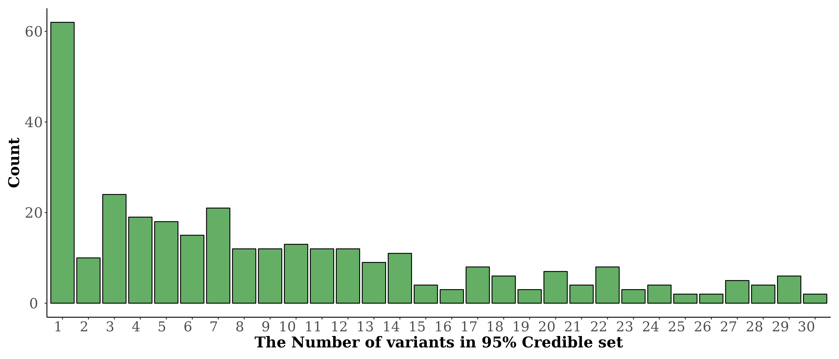
Supplementary Figure 3. The distribution of variants in the 95% Credible set for T2D-associated regions in the Cross-ancestry-meta: Data was restricted to T2D-associated loci with 30 or fewer variants. There were 94 loci with more than 30 variants. Figure 2. Trans-ancestry meta-analysis refines causal variant candidates in T2D: (A) The bar graph shows the distribution of the number of variants within the 95% credible sets across 100 T2D-associated loci that are significant in both East Asian and European single-ancestry meta-analyses. The bar chart categorizes the loci into groups (containing 1, 2-5, or >5 variants in each of the 95% credible sets) based on their likelihood of being causal as determined by Approximate Bayes Factors used for fine-mapping analysis (Methods). (B) Locus plots with a focus on the GCKR gene: the left plot centers on the lead SNP rs1260326. The right plot displays the PIPs for SNPs in the same region.

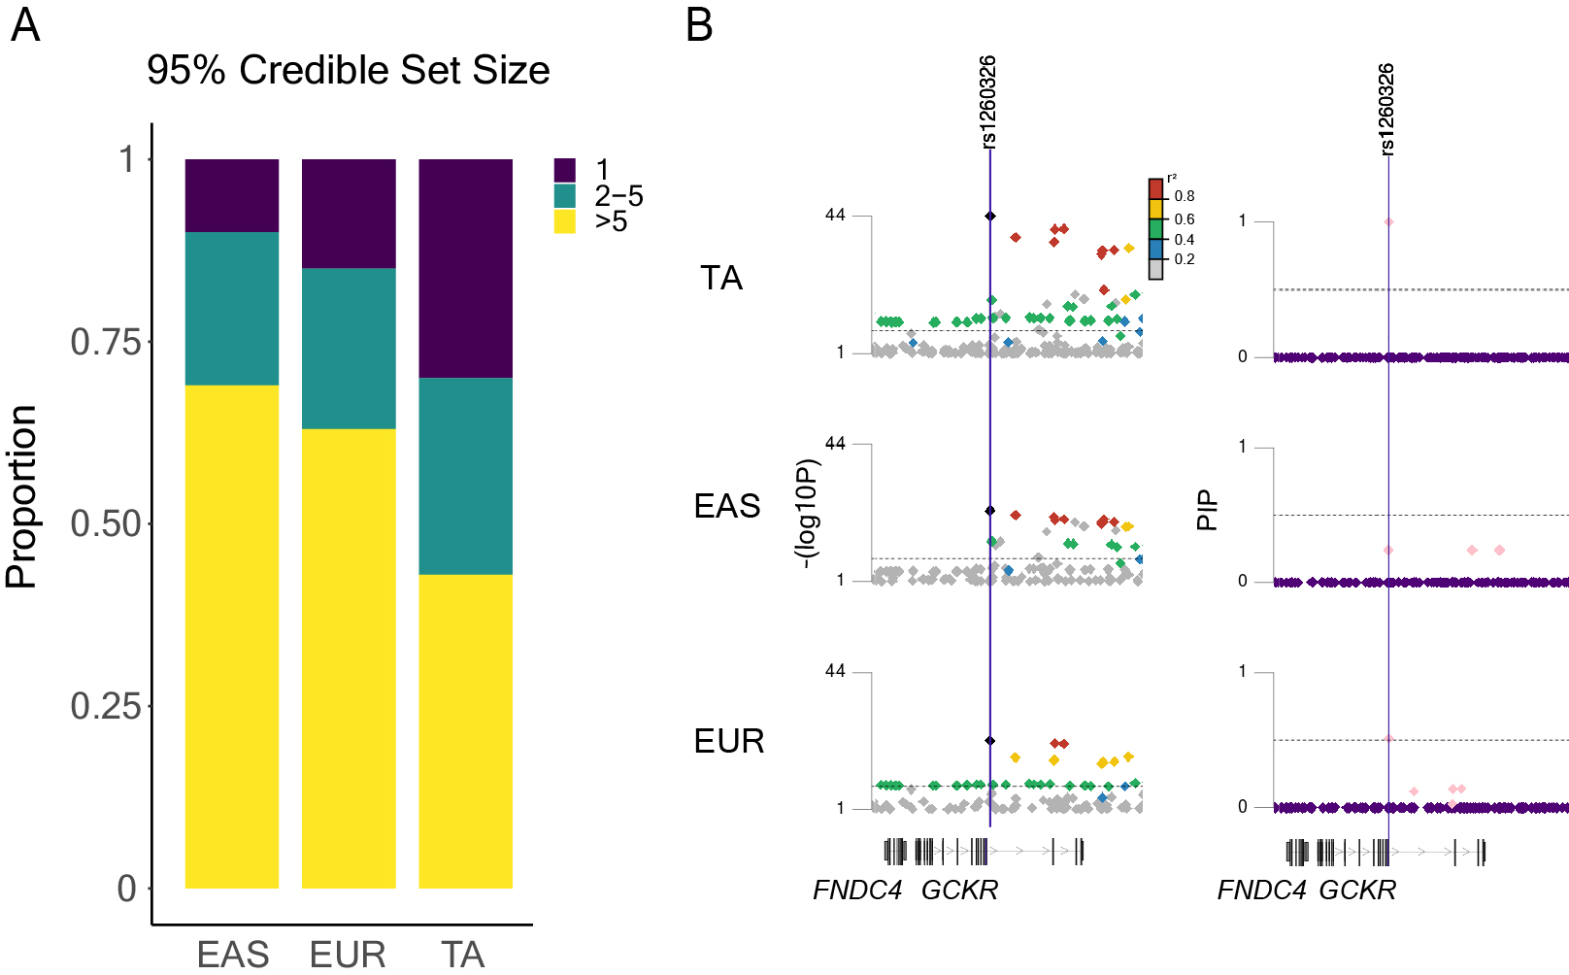
Supplementary Figure 4. Cross-ancestry meta-analysis refines causal variant candidates in T2D: (A) The bar graph shows the distribution of the number of variants within the 95% credible sets across 100 T2D-associated loci that are significant in both East Asian and European single-ancestry meta-analyses. The bar chart categorizes the loci into groups (containing 1, 2-5, or >5 variants in each of the 95% credible sets) based on their likelihood of being causal as determined by Approximate Bayes Factors used for fine-mapping analysis (Methods). (B) Locus plots with a focus on the GCKR gene: the left plot centers on the lead SNP rs1260326. The right plot displays the PIPs for SNPs in the same region.

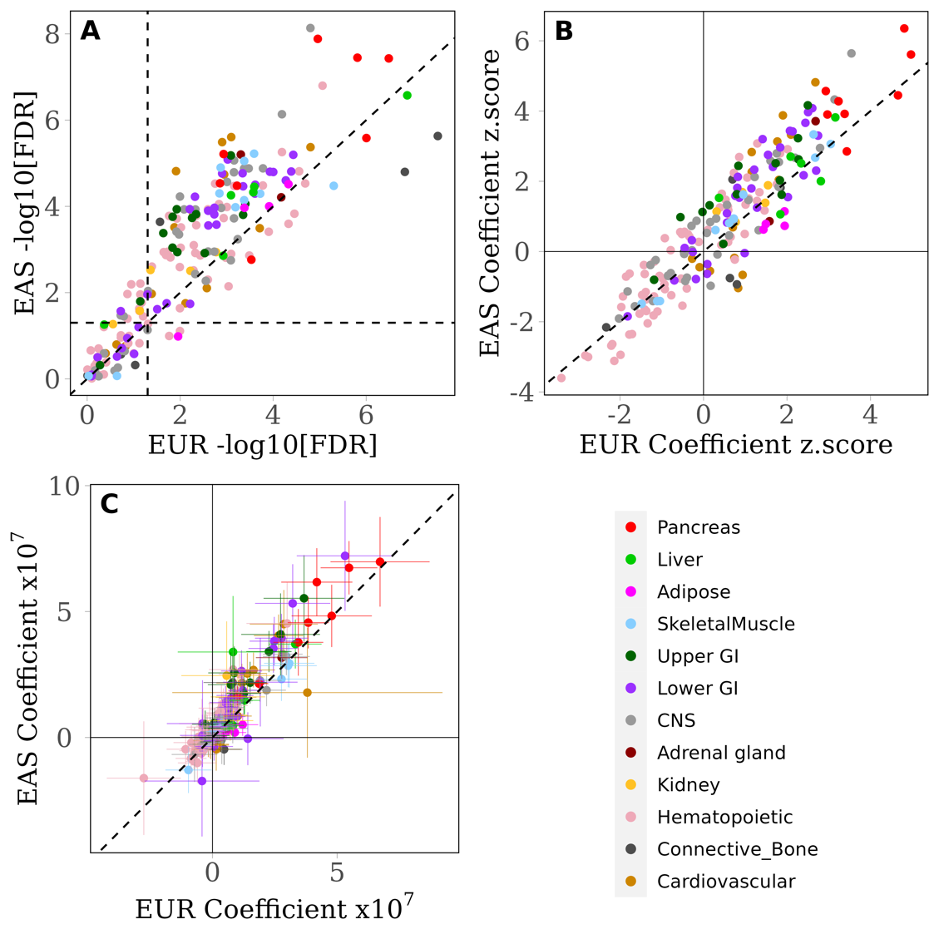
Supplementary Figure 5. Heritability enrichment analysis in EAS and EUR Populations – A Stratified LD Score Regression Analysis.
This figure presents stratified LD score regression analysis results (Methods), elucidating the cell-type enrichment of T2D heritability in the EAS-meta and the EUR-meta. The scatter plots are color-coded by cell-type categories, with diagonal dashed lines indicating equivalence in values or significance levels. (A) This plot illustrates the coefficient z-scores for various cell types. (B) This plot emphasizes the -log10 FDR-adjusted p-values of heritability enrichment across different cell types. (C) This plot delves deeper into the regression analysis by comparing T2D-associated coefficients across 220 specific cell types. The axes display each group's coefficient values, scaled by 10⁷. Error bars indicate coefficient standard errors.

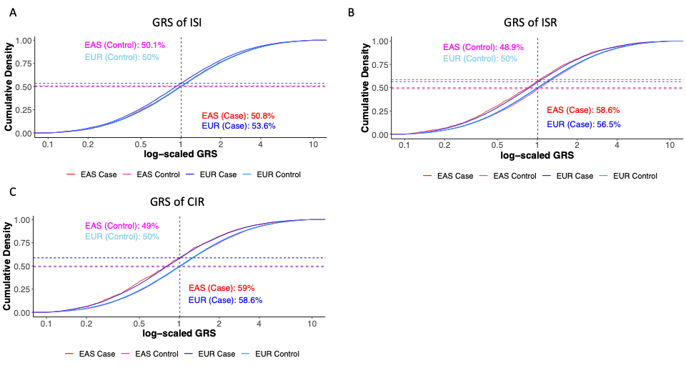

Supplementary Figure 6. Comparative Distribution of Genetic Risk Scores based on Prokopenko’s study
(A) This graph illustrates the Insulin Sensitivity Index (ISI), which reflects insulin resistance. (B, C) The Capacity of Insulin Response (CIR) and Insulin Secretion Rate (ISR), respectively, reflect pancreatic beta cell functionality in insulin secretion. Elevated CIR, ISR, and ISI values signify enhanced insulin function and glucose control.
References
1. Purcell S, Neale B, Todd-Brown K, Thomas L, Ferreira MA, Bender D, et al. PLINK: a tool set for whole-genome association and population-based linkage analyses. The American journal of human genetics. 2007;81(3):559-75.
2. Manichaikul A, Mychaleckyj JC, Rich SS, Daly K, Sale M, Chen W-M. Robust relationship inference in genome-wide association studies. Bioinformatics. 2010;26(22):2867-73.
3. Das S, Forer L, Schönherr S, Sidore C, Locke AE, Kwong A, et al. Next-generation genotype imputation service and methods. Nature genetics. 2016;48(10):1284-7.
4. Loh P-R, Tucker G, Bulik-Sullivan BK, Vilhjálmsson BJ, Finucane HK, Salem RM, et al. Efficient Bayesian mixed-model analysis increases association power in large cohorts. Nature genetics. 2015;47(3):284-90.
5. Imamura M, Takahashi A, Yamauchi T, Hara K, Yasuda K, Grarup N, et al. Genome-wide association studies in the Japanese population identify seven novel loci for type 2 diabetes. Nature communications. 2016;7(1):10531.
6. Nassar LR, Barber GP, Benet-Pagès A, Casper J, Clawson H, Diekhans M, et al. The UCSC Genome Browser database: 2023 update. Nucleic acids research. 2023;51(D1):D1188-d95.
7. Zhou W, Nielsen JB, Fritsche LG, Dey R, Gabrielsen ME, Wolford BN, et al. Efficiently controlling for case-control imbalance and sample relatedness in large-scale genetic association studies. Nature genetics. 2018;50(9):1335-41.
8. Willer CJ, Li Y, Abecasis GR. METAL: fast and efficient meta-analysis of genomewide association scans. Bioinformatics. 2010;26(17):2190-1.
9. Spracklen CN, Horikoshi M, Kim YJ, Lin K, Bragg F, Moon S, et al. Identification of type 2 diabetes loci in 433,540 East Asian individuals. Nature. 2020;582(7811):240-5.
10. Mahajan A, Spracklen CN, Zhang W, Ng MC, Petty LE, Kitajima H, et al. Multi-ancestry genetic study of type 2 diabetes highlights the power of diverse populations for discovery and translation. Nature genetics. 2022;54(5):560-72.
11. Nasser J, Bergman DT, Fulco CP, Guckelberger P, Doughty BR, Patwardhan TA, et al. Genome-wide enhancer maps link risk variants to disease genes. Nature. 2021;593(7858):238-43.
12. Wakefield J. Bayes factors for genome‐wide association studies: comparison with P‐values. Genetic Epidemiology: The Official Publication of the International Genetic Epidemiology Society. 2009;33(1):79-86.
13. McLaren W, Gil L, Hunt SE, Riat HS, Ritchie GR, Thormann A, et al. The ensembl variant effect predictor. Genome biology. 2016;17(1):1-14.
14. Jaganathan K, Panagiotopoulou SK, McRae JF, Darbandi SF, Knowles D, Li YI, et al. Predicting splicing from primary sequence with deep learning. Cell. 2019;176(3):535-48. e24.
15. Huang L, Rosen JD, Sun Q, Chen J, Wheeler MM, Zhou Y, et al. TOP-LD: A tool to explore linkage disequilibrium with TOPMed whole-genome sequence data. The American Journal of Human Genetics. 2022;109(6):1175-81.
16. Zhu Z, Zhang F, Hu H, Bakshi A, Robinson MR, Powell JE, et al. Integration of summary data from GWAS and eQTL studies predicts complex trait gene targets. Nature genetics. 2016;48(5):481-7.
17. Li YI, Knowles DA, Humphrey J, Barbeira AN, Dickinson SP, Im HK, Pritchard JK. Annotation-free quantification of RNA splicing using LeafCutter. Nature genetics. 2018;50(1):151-8.
18. Qi T, Wu Y, Fang H, Zhang F, Liu S, Zeng J, Yang J. Genetic control of RNA splicing and its distinct role in complex trait variation. Nature Genetics. 2022;54(9):1355-63.
19. Chiou J, Geusz RJ, Okino M-L, Han JY, Miller M, Melton R, et al. Interpreting type 1 diabetes risk with genetics and single-cell epigenomics. Nature. 2021;594(7863):398-402.
20. Costanzo MC, von Grotthuss M, Massung J, Jang D, Caulkins L, Koesterer R, et al. The Type 2 Diabetes Knowledge Portal: An open access genetic resource dedicated to type 2 diabetes and related traits. Cell metabolism. 2023;35(4):695-710. e6.
21. Bycroft C, Freeman C, Petkova D, Band G, Elliott LT, Sharp K, et al. The UK Biobank resource with deep phenotyping and genomic data. Nature. 2018;562(7726):203-9.
22. Eastwood SV, Mathur R, Atkinson M, Brophy S, Sudlow C, Flaig R, et al. Algorithms for the capture and adjudication of prevalent and incident diabetes in UK Biobank. PloS one. 2016;11(9):e0162388.

