Supplementary material for
Direct Measurement of Zak Phase and Higher Winding Numbers in an Electroacoustic Cavity System
Guang-Chen He¹, Zhao-Xian Chen^{2,3}, Xiao-Meng Zhang¹, Ze-Guo Chen^{1,3, *}, Ming-Hui Lu^{2,3}
¹School of Materials Science and Intelligent Engineering, Nanjing University, Suzhou 215163, China
²College of Engineering and Applied Sciences, Nanjing University and Collaborative Innovation Center of Advanced Microstructures, Nanjing 210093, China
³National Laboratory of Solid State Microstructures, Nanjing University, Nanjing 210093, China
*Corresponding author.
E-mail addresses: zeguoc@nju.edu.cn (Ze-Guo Chen).
Ⅰ. Computation and Analysis of the Zak Phase
As discussed in the Methods section, the $ρ$ mapping transforms the original complex-valued state into a four-dimensional real vector, in which the amplitude and phase information originally encoded in the complex state are represented separately. Only by recombining the corresponding two real components into the form$a+ib$ can one ensure that the phase information $θ(t)$, contained in $d_{x}\left(t\right)+id_{y}\left(t\right)=r(t)e^{iθ(t)}$, is fully preserved. In addition, the $SU(2)$ gauge degrees of freedom are effectively fixed in this block‑diagonal form, thereby eliminating the redundant phase they introduce. Thus, for the same initial state evolving along different paths, the final states are reconstructed as
$\left|Ψ_{A}\right\rangle =e^{i\left(ϕ_{d,A}+ϕ_{g,A}\right)}\left(\left|Ψ_{A_{1},end}\right\rangle +i\left|Ψ_{A_{2},end}\right\rangle \right)=e^{i\left(ϕ_{d,A}+ϕ_{g,A}\right)}\left|u_{n}\right\rangle$,
$\left|Ψ_{B}\right\rangle =e^{i\left(ϕ_{d,B}+ϕ_{g,B}\right)}(\left|Ψ_{B_{1},end}\right\rangle +i\left|Ψ_{B_{2},end}\right\rangle )$= $e^{i\left(ϕ_{d,B}+ϕ_{g,B}\right)}\left|u_{n}\right\rangle$, (S1)
where, $ϕ_{d}$ denotes the dynamical phase, $ϕ_{g}$ denotes the geometric phase. Then, by extracting the phase difference
$arg\left(\left|Ψ_{A}\right\rangle \right)-arg\left(\left|Ψ_{B}\right\rangle \right)=ϕ_{g,A}-ϕ_{g,B}$. (S2)
The dynamical phase cancel out completely, and the resulting phase difference reflects solely the contribution from the geometric phase, thereby more accurately characterizing the topological features of the band structure (see Figs. S1(a) and (b)).
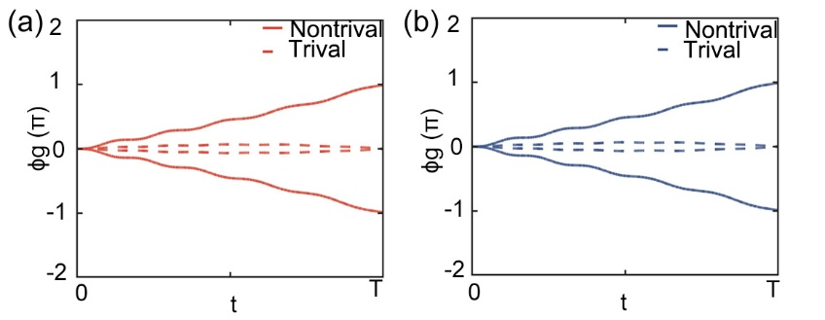
Fig. S1(a) and (b) present the phase differences obtained from the evolution solutions of the 2×2 model and the 4×4 model, respectively.
Ⅱ. Experimental System
The acoustic cavity used in the experiment is a rectangular metal cavity made of precision-machined stainless steel, with internal dimensions of 55 $mm$ (width) × 87 $mm$ (height) (see Fig. S2(a)), and its first-order resonant frequency is selected as the operating frequency. The top cover plate is made of acrylic, which effectively reduces interference with the internal sound field of the cavity. Using hot melt glue, five speakers and a microphone are fixed to the top cover plate for signal excitation and acquisition, while ensuring the cavity's sealing.
The experimental system is primarily composed of a self-feedback gain circuit and a coupling circuit (see Fig. S2(c)). The self-feedback gain circuit collects the cavity's signal, amplifies it, and sends it back to the same cavity's speaker, achieving closed-loop gain control. However, the controllable voltage amplifier (VCA821) in the primary amplifier board and gain circuit introduces a certain phase offset, causing a phase difference between the original signal and the feedback signal. To address this, the system introduces a phase shifter (MCP4110) as a phase compensation module to precisely adjust the phase of the feedback signal, aligning it with the original signal, thereby reducing the cavity's inherent loss from 10 Hz to 0.7 Hz (see Fig. S2(b)). Meanwhile, the coupling circuit collects the excitation signal from cavity 1, processes it through the controllable voltage amplifier and phase shifter, and transmits the signal to the speaker of cavity 2; the signal from cavity 2 is then returned to cavity 1 through the same coupling circuit, achieving signal exchange between the two cavities.
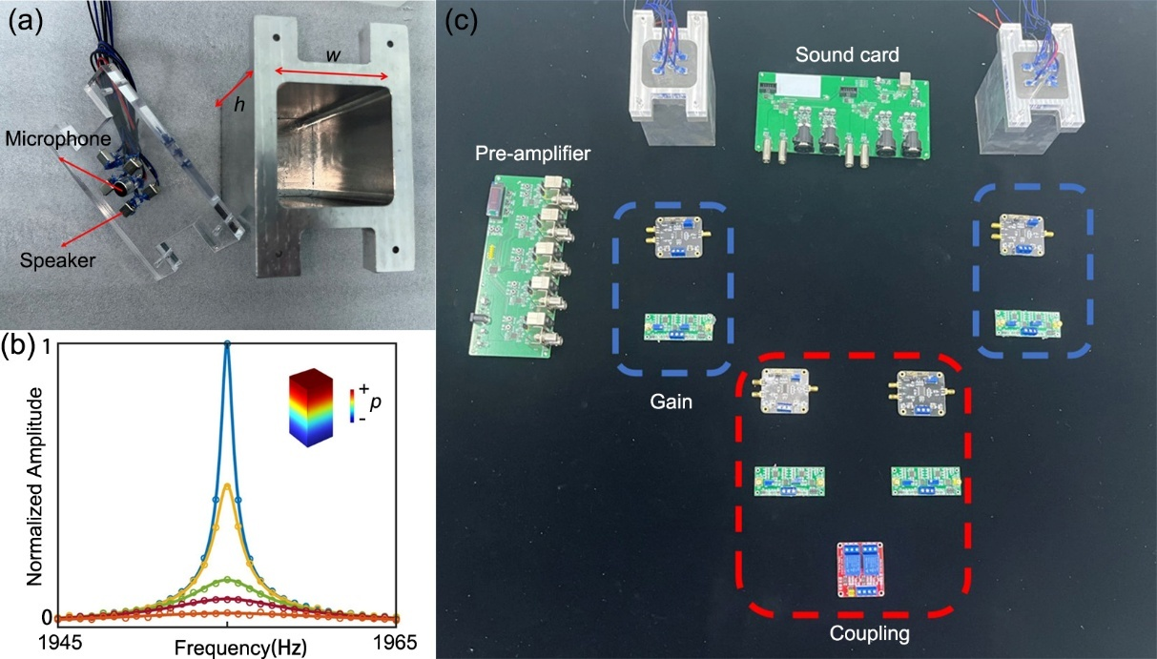
Fig. S2(a) Photograph of the acoustic cavity. (b) The self-feedback gain circuit improves the system’s Q factor;(c) Schematic of the experimental setup.
Ⅲ.Dynamical Equations
As shown in Fig. S3, the dynamical equation of the dual-cavity system with a constant coupling $κ_{0}$is described by the following equation:
$i\frac{d}{dt}\left[\begin{matrix}V_{1} \\ V_{2}\end{matrix}\right]=2π\left[\begin{matrix}f_{0}-iΓ & κ_{0} \\ κ_{0} & f_{0}-iΓ\end{matrix}\right]\left[\begin{matrix}V_{1} \\ V_{2}\end{matrix}\right]+s\left(t\right)$, (S3)
where, $V_{1}$and $V_{2}$ represent the measured voltages in cavity 1 and cavity 2, respectively; $f_{0}$ is the resonant frequency of the two cavities; $Γ$ represents the loss; and $s\left(t\right)=[\begin{matrix}V_{in}e^{-i2πft} \\ 0\end{matrix}]$ represents the input signal. This dynamical equation model describes the dynamic signal transfer between the two coupled cavities under the combined effects of coupling and loss.
By solving the above-coupled wave equations, the frequency-domain voltage responses of cavity 1 and cavity 2 can be expressed as:
$V_{1}\left(f\right)=\frac{(f-f_{0}+iΓ)V_{in}}{{\left(f-f_{0}+iΓ\right)}^{2}-{κ_{0}}^{2}}$,
$V_{2}\left(f\right)=\frac{κ_{0}V_{in}}{{\left(f-f_{0}+iΓ\right)}^{2}-{κ_{0}}^{2}}.$ (S4)
In addition, the phase difference between the two cavities can be defined as:
$S_{21}\left(f\right)=\frac{κ_{0}}{f-f_{0}+iΓ}.$ (S5)
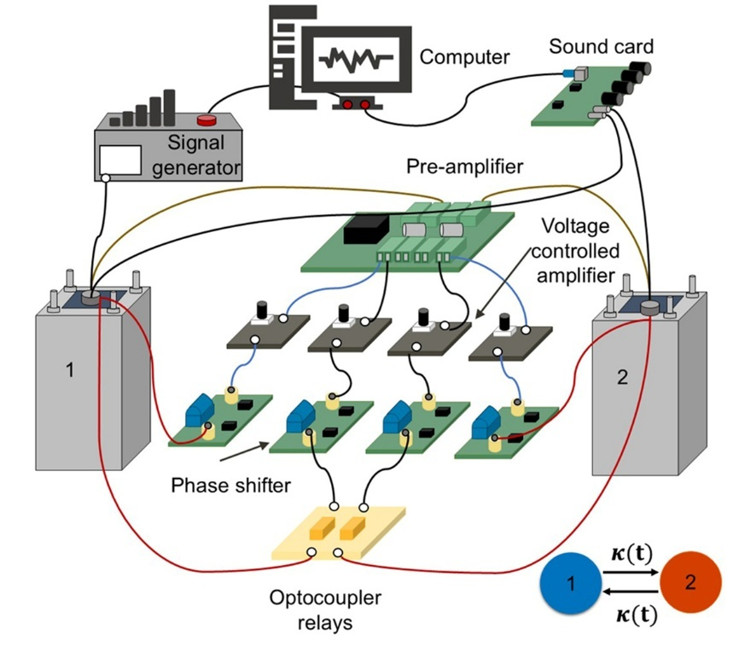
Fig. S3 Schematic of the dual-cavity experimental system.
When setting the system parameters according to the actual characteristics of the cavities, the Hamiltonian can be written as
$H=2π\left[\begin{matrix}1955-0.7i & κ_{0} \\ κ_{0} & 1955-0.7i\end{matrix}\right].$ (S6)
This model describes two acoustic cavities with eigenfrequencies of 1955 Hz and a loss coefficient of$0.7i$. The two cavities interact through a time-varying coupling strength $κ$​. When an external excitation is applied to cavity 1, the system's resonant response is simultaneously influenced by both the coupling and loss characteristics. As the coupling strength $κ$ increases, the originally degenerate resonant frequencies split into two distinct frequencies, with the splitting amplitude being proportional to the coupling strength $κ$ (see Fig. S4(a)). The phase difference between the two cavities provides a key parameter for determining whether the system is in a positive or negative coupling state (see Fig. S4(b)). By adjusting the phase shifter, the coupling state can be freely switched between positive and negative.
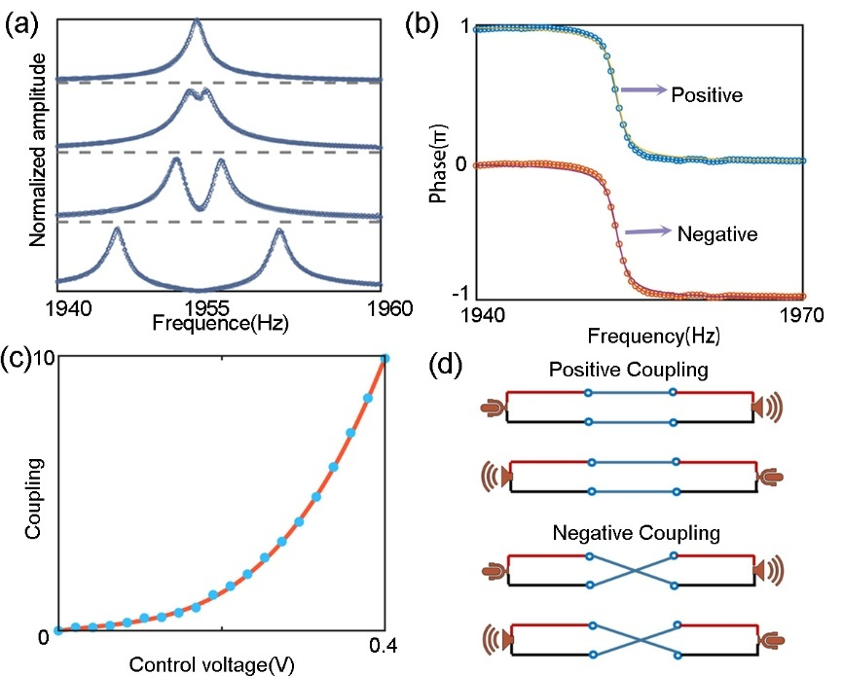
Fig. S4(a) The splitting and frequency shift of the resonance peak under different coupling strengths $κ$, demonstrating that coupling strength can be flexibly adjusted in the experiment via external voltage control. (b) The phase characteristics of the dual-cavity system under positive and negative coupling. (c) The response curve showing the variation of coupling strength with voltage, indicating a nonlinear relationship over a wide range that allows for fine control. (d) Two connection modes for positive and negative coupling, achieved by controlling the phase shifter in the circuit to realize in-phase or anti-phase coupling.
In the electromechanical cavity experimental system, dynamic modulation of $κ$ is achieved through programming control of the VCA to simulate the time-dependent evolution in the theoretical model. Under the conditions of a fixed acoustic cavity resonant frequency and loss, the control voltage of the VCA is gradually increased to obtain data on the variation of $κ$with voltage (see Fig. S4(c)). The fitting equation and the solution of $κ=\left(d_{x}\left(t\right),{±d}_{y}\left(t\right)\right)$ are used as control signals, which are programmed and loaded in real-time into the VCA, allowing the system's coupling strength to be dynamically adjusted according to a preset functional relationship. Considering that the coupling relationship of $κ=\left(d_{x}\left(t\right),{±d}_{y}\left(t\right)\right)$ not only reflects the dynamic modulation of coupling amplitude but also involves switching between positive and negative coupling states, an additional phase shifter and relay are introduced to achieve precise phase control of the signal (see Fig. S4(d)), ensuring consistency between the experimental conditions and the theoretical model.

