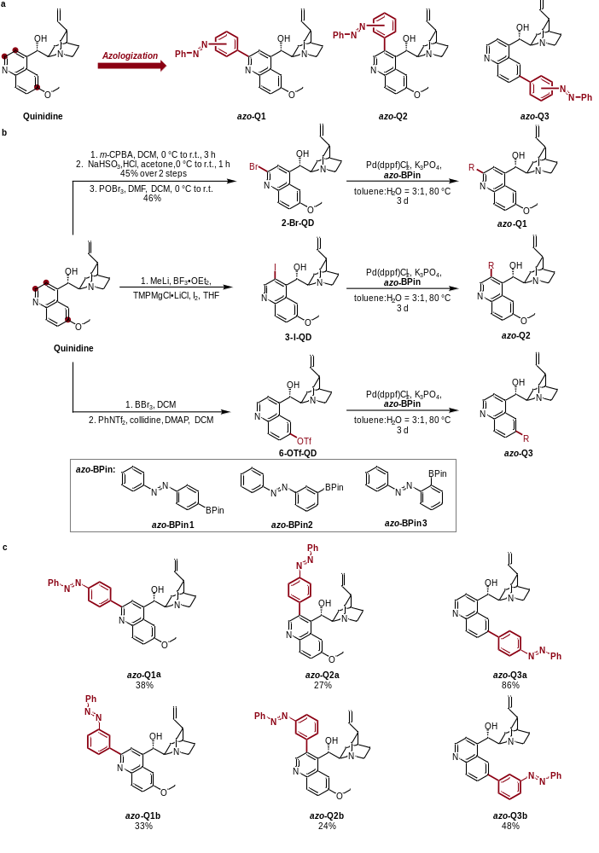
Scheme 1 | Design and synthesis of quinidine azobenzene derivatives.
a, Azologization strategy for the design of quinidine-based Na_{V}1.5 photoswitchable inhibitors. b, Synthesis of quinidine azobenzene derivatives azo-Q1-3. c, The structures and yields of quinidine azobenzene derivatives azo-Q1-3.

