Supplemental information
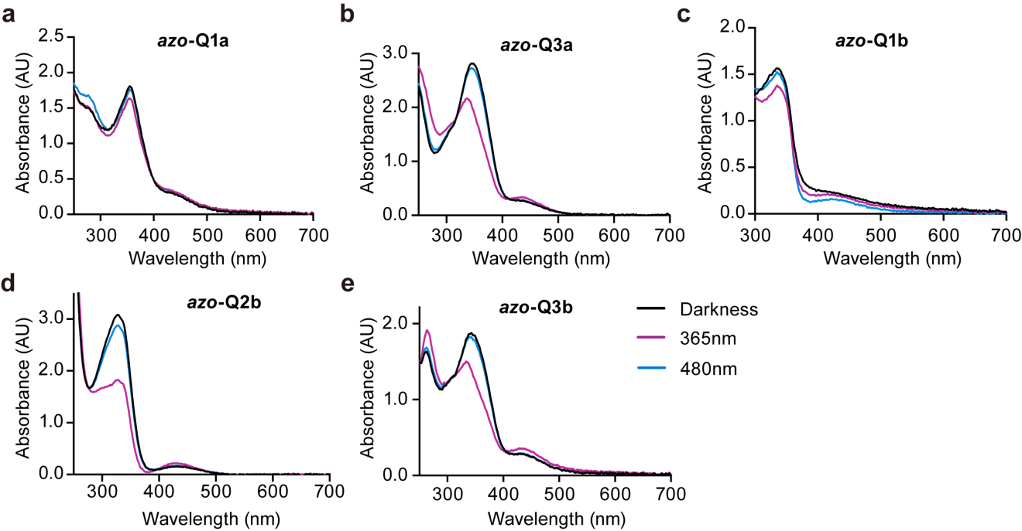Supplementary Figure 1 | UV-Vis absorption spectra of azobenzene-quinidines.
a-e, The UV-Vis absorption spectra of azobenzene-quinidines (10 μM in DMSO, rt) in darkness (black, trans) or at 365 nm (violet, cis) and 480 nm (blue, trans) illuminations. a, azo-Q1a. b, azo-3a. c, azo-1b. d, azo-2b. e, azo-3b.
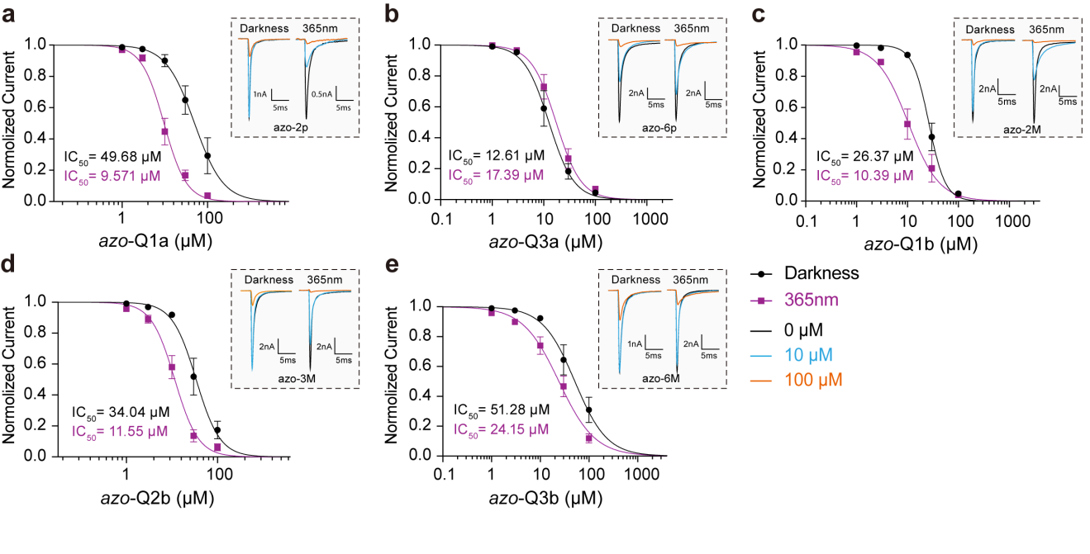Supplementary Figure 2 | Azobenzene-quinidines reversibly inhibit Na_{V}1.5 channels with light in HEK293T Cells.
a-e, Dose-dependent response curves and representative current traces (dotted rectangle) of azobenzene-quinidines on Na_{V}1.5 in darkness (black) or at 365 nm (violet) illumination using whole-cell patch clamp. a, azo-1a, n = 6, 7. b, azo-3a, n = 8, 5. c, azo-1b, n = 6, 6. d, azo-2b, n = 6, 6. e, azo-3b, n = 7, 6. Error bars represent mean ± SEM.
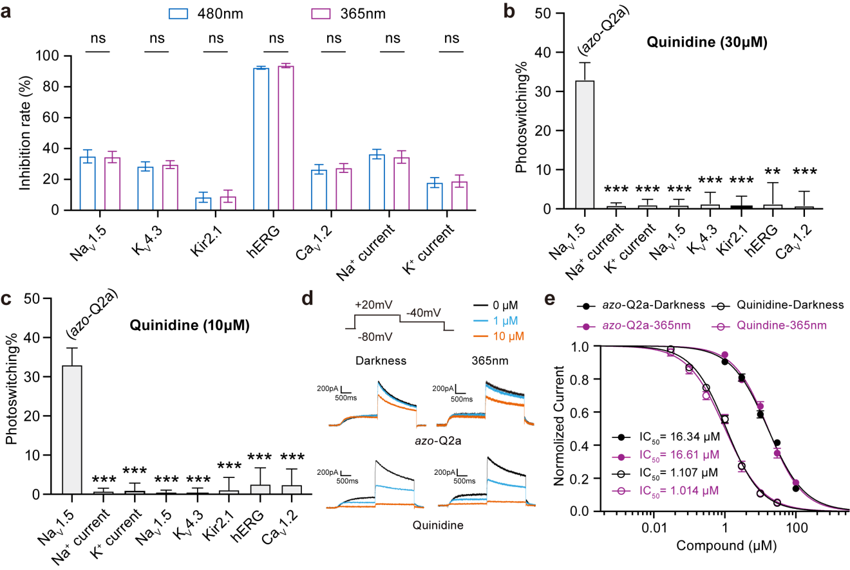

Supplementary Figure 3 | Quinidine does not possess photoswitching properties.
a-c, Whole-cell patch clamp recordings of Na_{V}1.5, K_{V}4.3, K_{ir}2.1, hERG, Ca_{V}1.2 currents in cultured cell lines and Na⁺, K⁺ currents in primary ventricular myocytes at 480 nm (blue), 365 nm (violet) illumination or with no inhibition (control, black). a, Normalized inhibition rate through the application of quinidine (30 µM), n=5-7. b,c, Quantification of photoswitching induced by quinidine in 10 µM (c, n = 4-7) and 30 µM (b, n = 4-7). Data are statistically compared with the efficiency of treating 10µM azo-Q2a on Na_{V}1.5 (the first column on the left) by unpaired t test. **P < 0.01, ***P < 0.001. d,e, Representative current traces (d) and dose-dependent response curves (e) of azo-Q2a (filled dot, n=9, 11) and quinidine (hollow dot, n=9, 9) on hERG in darkness (black) or at 365 nm (violet) light. 0 μM, 10 μM and 100 μM in black, azure and orange respectively. All error bars represent mean ± SEM.
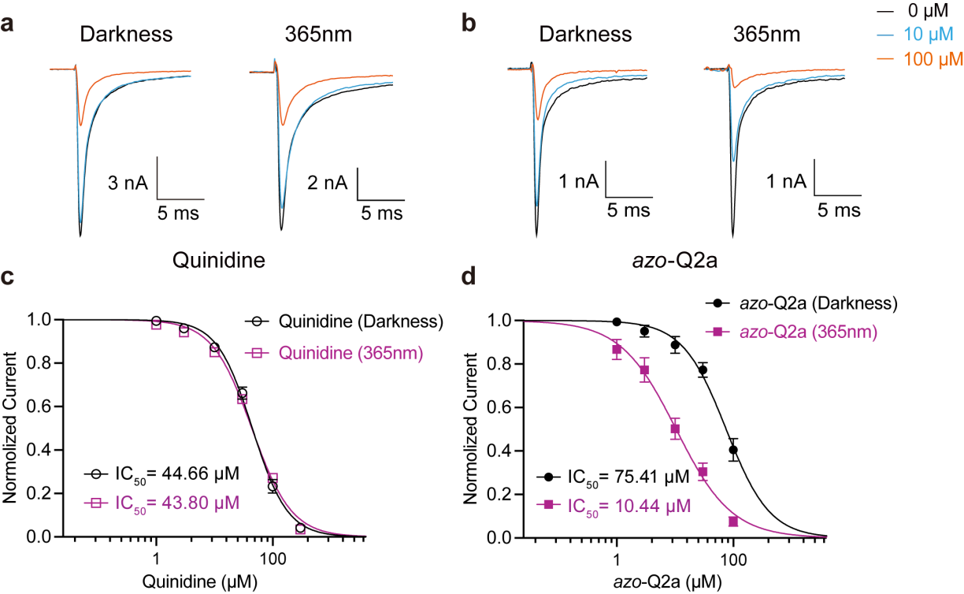
Supplementary Figure 4 | Na_{V}1.5S demonstrate no significance difference on the interaction of quinidine and azo-Q2a compared with Na_{V}1.5^{WT}.
a,b, Representative current traces of Na_{V}1.5 blocked by varied concentrations of quinidine (a) and azo-Q2a (b) in darkness or at 365 nm light. 0 μM, 10 μM and 100 μM in black, azure and orange respectively. c,d, Dose-dependent response curve of quinidine (c; n = 7, 7) and azo-Q2a (d; n = 7,8) in the dark (black) or at 365 nm (violet) light. All error bars represent mean ± SEM.
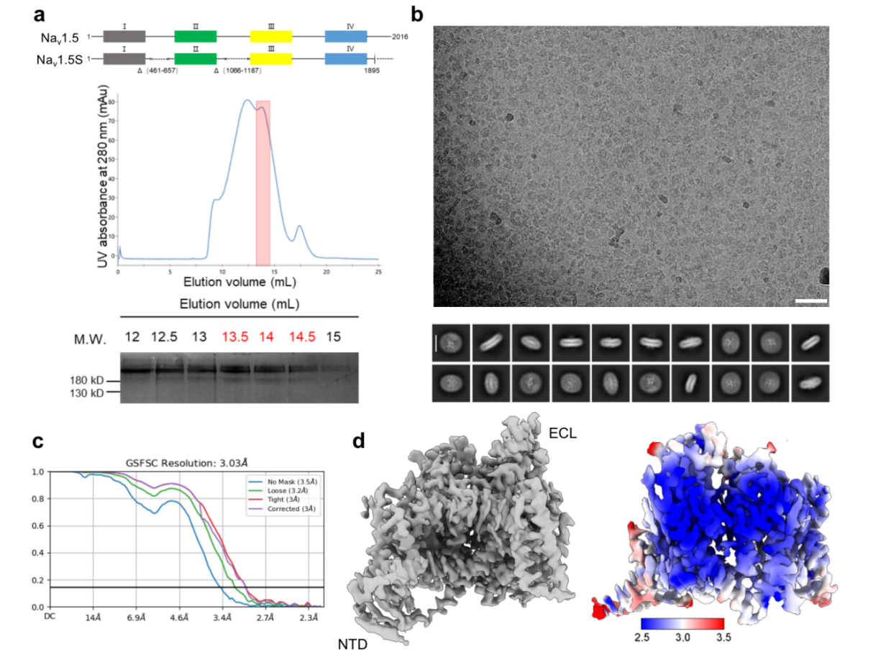
Supplementary Figure 5 | Cryo-EM analysis of human Na_{V}1.5S in complex with azo-Q2a.
a, Protein purification of human Nav1.5 co-expressed with the β1 subunit in HEK293F cells. Shown here is the illustration of the constructs of full length and truncated Na_{V}1.5 (Na_{V}1.5S), along with a representative chromatogram of gel filtration purification. The indicated fractions were concentrated for cryo-EM sample preparation. b, Representative micrograph and 2D class averages of Na_{V}1.5S in complex with azo-Q2a. The white scale bar for micrograph represents 50 nm, for 2D class averages represents 11 nm. c, Gold-standard Fourier shell correlation (FSC) curve for the 3D reconstruction of Na_{V}1.5S in complex with azo-Q2a. d, The 3D reconstruction and local resolution distribution of Na_{V}1.5S in complex with azo-Q2a. The maps are contoured at 6 σ in ChimeraX.

Supplementary Table 1 | The IC₅₀ values of quinidine and quinidine-azobenzenes on Na_{V}1.5^{WT}
Compound | IC₅₀ (µM) | 95 % CI | n
quinidine (Darkness) | 35.87 | [31.97, 40.26] | 7
quinidine (365 nm) | 41.21 | [36.71, 46.31] | 8
azo-Q1a(Darkness) | 49.68 | [37.98, 67.36] | 6
azo-Q1a (365 nm) | 9.57 | [7.98, 11.49] | 7
azo-Q2a (Darkness) | 81.85 | [70.49, 97.38] | 9
azo-Q2a (365 nm) | 11.76 | [9.77, 14.19] | 12
azo-Q6a (Darkness) | 12.61 | [10.05, 15.98] | 8
azo-Q6a (365 nm) | 17.39 | [14.64, 20.79] | 5
azo-Q1b (Darkness) | 26.37 | [23.73, 29.21] | 6
azo-Q1b (365 nm) | 10.39 | [7.86, 13.94] | 6
azo-Q2b (Darkness) | 34.04 | [28.02, 41.96] | 6
azo-Q2b (365 nm) | 11.55 | [10.10, 13.21] | 6
azo-Q3b (Darkness) | 51.28 | [38.36, 72.08] | 7
azo-Q3b (365 nm) | 24.15 | [19.87, 29.46] | 6

Supplementary Table 2 | The steady-state activation of Na_{V}1.5 regulated by 10 μM azo-Q2a
Group | V₅₀ (mV) | SEM | n
Control | - 44.96 | 1.02 | 49
480 nm | - 47.96 | 1.95 | 12
365 nm | - 45.68 | 1.96 | 15
Supplementary Table 3 | The inhibition rate of quinidine and azo-Q2a on caridiac ion channels currents
Ion channel | Condition | Inhibition rate (%) | SEM
Na_{V}1.5 | 10 µM quinidine（Darkness） | 8.84 | 2.90
Na_{V}1.5 | 10 µM quinidine (365 nm) | 9.40 | 2.66
Na_{V}1.5 | 30 µM quinidine（Darkness） | 34.98 | 4.29
Na_{V}1.5 | 30 µM quinidine (365 nm) | 34.56 | 3.67
Na_{V}1.5 | 10 µM azo-Q2a（Darkness） | 2.51 | 1.62
Na_{V}1.5 | 10 µM azo-Q2a (365 nm) | 61.10 | 4.85
K_{V}4.3 | 10 µM quinidine（Darkness） | 8.61 | 2.22
K_{V}4.3 | 10 µM quinidine (365 nm) | 9.80 | 1.70
K_{V}4.3 | 30 µM quinidine（Darkness） | 28.50 | 2.94
K_{V}4.3 | 30 µM quinidine (365 nm) | 29.65 | 2.54
K_{V}4.3 | 10 µM azo-Q2a（Darkness） | 4.61 | 2.74
K_{V}4.3 | 10 µM azo-Q2a (365 nm) | 4.89 | 2.97
K_{ir}2.1 | 10 µM quinidine（Darkness） | 8.89 | 1.50
K_{ir}2.1 | 10 µM quinidine (365 nm) | 5.22 | 2.21
K_{ir}2.1 | 30 µM quinidine（Darkness） | 11.39 | 3.57
K_{ir}2.1 | 30 µM quinidine (365 nm) | 9.17 | 3.93
K_{ir}2.1 | 10 µM azo-Q2a（Darkness） | 8.77 | 1.46
K_{ir}2.1 | 10 µM azo-Q2a (365 nm) | 2.40 | 2.85
hERG | 10 µM quinidine（Darkness） | 71.71 | 2.04
hERG | 10 µM quinidine (365 nm) | 70.45 | 2.38
hERG | 30 µM quinidine（Darkness） | 92.37 | 0.95
hERG | 30 µM quinidine (365 nm) | 93.77 | 1.36
hERG | 10 µM azo-Q2a（Darkness） | 40.40 | 5.51
hERG | 10 µM azo-Q2a (365 nm) | 45.47 | 7.52
Ca_{V}1.2 | 10 µM quinidine（Darkness） | 7.46 | 2.78
Ca_{V}1.2 | 10 µM quinidine (365 nm) | 10.13 | 2.28
Ca_{V}1.2 | 30 µM quinidine（Darkness） | 26.57 | 3.06
Ca_{V}1.2 | 30 µM quinidine (365 nm) | 27.44 | 2.85
Ca_{V}1.2 | 10 µM azo-Q2a（Darkness） | 13.36 | 3.45
Ca_{V}1.2 | 10 µM azo-Q2a (365 nm) | 23.27 | 6.92
Na⁺ current | 10 µM quinidine（Darkness） | 7.65 | 2.25
Na⁺ current | 10 µM quinidine (365 nm) | 9.62 | 3.53
Na⁺ current | 30 µM quinidine（Darkness） | 36.43 | 3.10
Na⁺ current | 30 µM quinidine (365 nm) | 34.54 | 4.02
Na⁺ current | 10 µM azo-Q2a（Darkness） | 1.18 | 2.32
Na⁺ current | 10 µM azo-Q2a (365 nm) | 42.96 | 6.93
K⁺ current | 10 µM quinidine（Darkness） | 6.56 | 3.21
K⁺ current | 10 µM quinidine (365 nm) | 8.02 | 4.02
K⁺ current | 30 µM quinidine（Darkness） | 17.96 | 3.23
K⁺ current | 30 µM quinidine (365 nm) | 18.92 | 3.98
K⁺ current | 10 µM azo-Q2a（Darkness） | 9.34 | 3.61
K⁺ current | 10 µM azo-Q2a (365 nm) | 11.87 | 4.17

Supplementary Table 4 |The quantification of photoswitching induced by quinidine and azo-Q2a on caridiac ion channels currents
Ion channel | Condition | Photoswitching (%) | SEM
Na_{V}1.5 | 10 µM quinidine | 0.55 | 0.53
Na_{V}1.5 | 30 µM quinidine | 1.03 | 1.41
Na_{V}1.5 | 10 µM azo-Q2a | 33.02 | 4.32
K_{V}4.3 | 10 µM quinidine | 0.30 | 1.29
K_{V}4.3 | 30 µM quinidine | 1.36 | 2.87
K_{V}4.3 | 10 µM azo-Q2a | 5.21 | 1.67
K_{ir}2.1 | 10 µM quinidine | 1.12 | 3.18
K_{ir}2.1 | 30 µM quinidine | 0.74 | 2.50
K_{ir}2.1 | 10 µM azo-Q2a | 3.65 | 4.21
hERG | 10 µM quinidine | 2.56 | 4.23
hERG | 30 µM quinidine | 1.31 | 5.37
hERG | 10 µM azo-Q2a | 7.99 | 4.47
Ca_{V}1.2 | 10 µM quinidine | 2.42 | 4.06
Ca_{V}1.2 | 30 µM quinidine | 0.87 | 3.62
Ca_{V}1.2 | 10 µM azo-Q2a | 7.76 | 5.34
Na⁺ current | 10 µM quinidine | 0.77 | 0.78
Na⁺ current | 30 µM quinidine | 0.93 | 0.59
Na⁺ current | 10 µM azo-Q2a | 24.34 | 3.26
K⁺ current | 10 µM quinidine | 0.92 | 1.95
K⁺ current | 30 µM quinidine | 1.11 | 1.32
K⁺ current | 10 µM azo-Q2a | 2.95 | 2.36

Supplementary Table 5 |The IC₅₀ values of quinidine and azo-Q2a on Na_{V}1.5S
Compound | IC₅₀ (µM) | 95 % CI | n
quinidine (Darkness) | 44.66 | [41.03, 48.62] | 7
quinidine (365 nm) | 43.80 | [39.84, 48.16] | 7
azo-Q2a (Darkness) | 75.41 | [62.76, 94.21] | 7
azo-Q2a (365 nm) | 10.44 | [8.20, 13.30] | 8

Supplementary Table 6 |The IC₅₀ values of azo-Q2a on Na_{V}1.5 variants
Variant | Compound | IC₅₀ (µM) | 95 % CI | n
V405A | azo-Q2a (Darkness) | 382.9 (N.D.) | [244.7, 705.4] | 7
V405A | azo-Q2a (365 nm) | 205.1 (N.D.) | [120.3, 527.9] | 7
F1760A | azo-Q2a (Darkness) | 173.6 (N.D.) | [121.4, 327.6] | 7
F1760A | azo-Q2a (365 nm) | 157.3 (N.D.) | [110.5, 270.1] | 7

Supplementary Table 7 | Cryo-EM data collection, refinement and validation statistics
 | Na_{V}1.5S
Data collection and processing
Magnification | 64,000
Voltage (kV) | 300
Electron exposure (e–/Å²) | 50
Defocus range (μm) | -1.3 to -1.8
Pixel size (Å) | 1.0979
Symmetry imposed | C1
Movies  Final particle images (no.) | 9,406  287,376
Map resolution (Å)  FSC threshold | 3.03  0.143
Refinement
Map sharpening B factor (Å²) | 122.4
Model resolution (Å) | 3.4
FSC threshold | 0.5
Model composition  Non-hydrogen atoms | 9,401
Protein residues  Ligands | 1,151  10
B factors (Å²)  Protein | 101.21
Ligand | 125.87
R.m.s. deviations  Bond lengths (Å) | 0.003
Bond angles (°) | 0.765
Validation
MolProbity score | 2.32
Clashscore  Poor rotamers (%) | 10.67  3.16
Ramachandran plot  Favored (%)  Allowed (%)  Outliers (%) | 94.24  5.59  0.17

Supplementary Table 8 | Heart rates regulated by quinidine and azo-Q2a of zebrafish
Group | Light condition | Heart rate (bpm)  Mean ± SEM | Heart rate (%)  Mean ± SEM | n
Control | Darkness | 160.00 ± 2.29 | 100.00 ± 1.43 | 22
Control | 365 nm | 158.60 ± 3.56 | 99.10 ± 2.22 | 18
Control | 365 nm + 480 nm | 155.90 ± 3.21 | 97.42 ± 2.00 | 16
100 µM  quinidine | Darkness | 146.00 ± 2.17 | 90.83 ± 1.35 | 21
100 µM  quinidine | 365 nm | 150.40 ± 1.56 | 93.98 ± 0.97 | 22
100 µM  quinidine | 365 nm + 480 nm | 146.60 ± 2.14 | 91.61 ± 1.34 | 21
10 µM  azo-Q2a | Darkness | 160.00 ± 2.60 | 98.85 ± 1.39 | 25
10 µM  azo-Q2a | 365 nm | 84.18 ± 7.48 | 56.46 ± 4.29 | 11
10 µM  azo-Q2a | 365 nm + 480 nm | 165.10 ± 3.14 | 103.20 ± 1.96 | 11

