Table 1. Participant Demographics
 |  | Mean (SD) | n (%)
Demographics
 | % Male |  | 2 (22%)
 | % African American |  | 9 (100%)
 | Age, adults (years) | 44.83 (24.52)
 | Age, adolescents (years) | 14.67 (0.57)
 | Household size | 3.16 (0.98)
 | Education level, adults (% some college or higher) |  | 5 (83%)
 | Parental education level, adolescents (% some college or higher) |  | 3 (100%)
Health
 | Body Mass Index, adults (kg/m2) | 29.59 (6.57)
 | Body Mass Index, adolescents (kg/m2) | 24.66 (4.22)
 | Tobacco use (% reporting) |  | 0 (0)
 | Perceived health status (% reporting Very Good or Excellent) |  | 4 (44.4%)
 | Meeting PA recommendations, adults (% reporting) |  | 3 (50%)
 | Meeting PA recommendations, adolescents (% reporting) |  | 2 (66.6%)
 | Active travel minutes/week | 20 (56.56)
Neighborhood
 | Average length of residence in neighborhood, adults (years) | 9.2 (4.60)
 | Average length of residence in neighborhood, adolescents (years) | 11.33 (5.51)
 | Residential density summary score (range 173-865) | 217 (77.36)
 | Land-Use Mix Diversity summary score (range 1-5) | 2.05 (1.69)
 | Land-Use Mix Access summary score (range 1-5) | 2.39 (0.59)
 | Street Connectivity summary score (range 1-5) | 2.45 (0.75)
 | Infrastructure and Safety for Walking summary score (range 1-5) | 2.21 (0.92)
 | Aesthetics summary score (range 1-5) | 2.28 (0.57)
 | Traffic Hazards summary score (range 1-5) | 2.25 (0.47)

Table 2. Themes, quotes and photos for positive neighborhood attributes for physical activity
Theme | Illustrative Quotes | Photos
Parks and trails | “There's actually a basketball court down the street from my church. A lot of people are always there. Not as much this summer, but normally like a lot of people are always out in that court.” African American adult female  “This space is actually on the same street that I live on. It's just a little further down the street. And I see this space as a space where like, you have kids playing in the street, playing basketball, playing football, like they could do that right there, It's a big open space. For the most part, it’s always cut. We have girls having cheerleading practice in parking lots. That's a nice big green space that they could have those practices in, but no one utilizes that space.” African American adult female  “I really think it gives the youth a place to play to spend their time, that’s open so they’re not in the street playing in a place where they can get hurt at or hit by car or anything like, they're just safe in this space there [Participant Photo 1]. It also can be used for other physical activity, if they wanted to do yoga on the street or line dancing. Anything, like this is space there for it.” African American adult female  “It [Trail Name] leads all the way to [road name]. I've rode there about a couple of times. So, it’s essentially relaxing. If you want to run, a lot of people with bikes go. Yeah. Some people go to the creek because they like the noises. It's like creeky a little bit. It's just nice. I don't know how to explain it. It makes me feel calm.” African American adolescent female | Participant photo 1  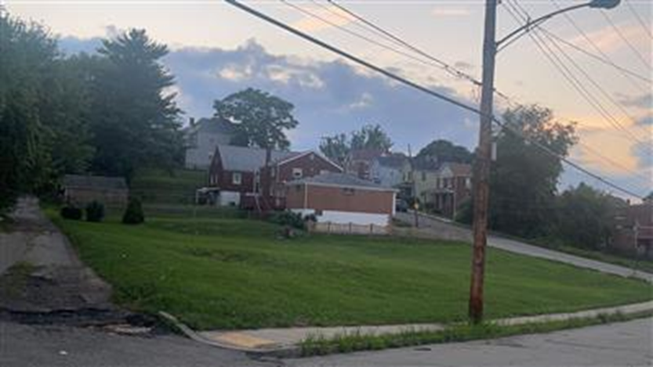
Facility for activity | “Okay, this was a positive. That was a gym in their neighborhood that they could walk to [Participant Photo 2]. And it's very nice to have the swimming pool. a gymnasium. They have information of healthy eating and classes, all kinds of classes you could take. You had to pay for membership, but other than that, it was very accessible. Free parking. And while I was there, you could see the people really utilize that.” African American adult female  “So, in [Name] Park [Participant Photo 3] we have two baseball fields, and a mini volleyball court and sports use physical activity. It's a fun game for some people who's into sports. It's fun to just have a big patch of grass. You go run around. You can bring your own equipment. You can have your own game. You did play with friends, and obviously, if you're running around, if you're moving around sweating, you're active and you're moving. So, you're doing some sort of activity.” African American adolescent female | Participant photo 2  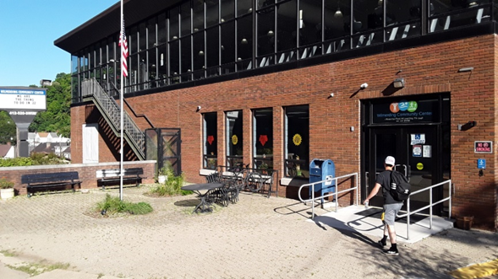  Participant photo 3  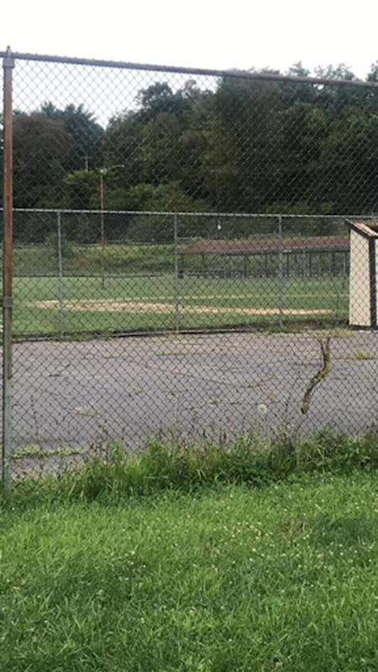
Playground | “This playground [Participant Photo 4] here is nice and it's for kids from 4, 5, 6 years old-- 7 years old, but that's nice. But the kids go to the park, and you look at the crowd. If they are not with their parents, they won’t come out. Because you know some of these other kids hanging around and doing all other crazy stuff. They intimidate them. They just upgraded these facilities. These two are here in one part of the city, and then got a few more in a different part of the community.” African American adult male | Participant photo 4 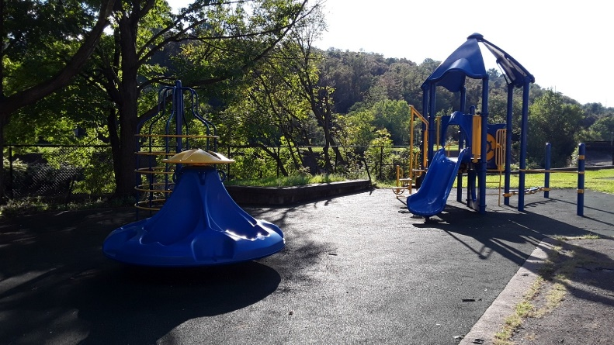

Table 3. Themes, quotes and photos for negative neighborhood attributes for physical activity
Theme | Illustrative Quotes | Photos
No facilities | “There's more like streets, like back streets and pathways. There's not really a lot of sidewalks. There might be a little bit of sidewalks, but they don't cut the grass enough. If there's empty abandoned lots, all of the grass is coming in covering the sidewalks. So, people—are pushing to walk in the streets.” African American adult female  “Oh, I took a picture of the sidewalk [Participant photo 5]. I’m just to show that there were not enough sidewalks because there's a lot of cars that's parking on a curb. A lot of houses don't have parking lots or a garage. So, they're taking a lot of the sidewalks, so people have to walk in the street. If people had more garages, they didn't have to park on the sidewalks. Then it would be safer for people to walk on that.” African American adult female | Participant photo 5  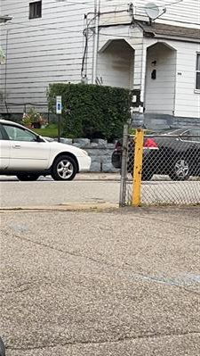
Poor conditions | “Well, if you go to the basketball court [Participant photo 6]. No paintings, though they don't even have a rim up there, the backboards and no nets. And then have no balls for the kids to go with there and play, so most of them just hang up in trouble. The facilities around here have been just terrible. In fact, it’s been like that for the last 10 years.” African American adult male  “This is pitiful to have a basketball court like that, no rims, no net. The markings on the ground need to be fixed. But then you got one spot over the other side that kids can go over and play. The little kids are only interested in the slides and stuff. The place just ran down. It's been like this probably about 15 years. When mills close down there, it’s just been decaying every year, run down every year.” African American adult male  “They're relatively the same as that one [Participant Photo 7]. I don't think I’ve ever, in my years of living here, seen a sidewalk without cracks or not much of a dip to transition from streets to sidewalk or overgrown grass, or some sort of something broken. Broken glass, cigarette butts, or something. It's just a lot of overgrown and over-run sidewalks. So, if they could probably work on the sidewalks the way they work on the streets like make them flat and even, fill in the cracks, and, like you know, bushes on sidewalk how bushes overgrow onto the sidewalks, so there's no walking space. You have to step on to the street to walk, just to have a sidewalk, if they were to probably cut down bushes, and, like, I said, fix up the sidewalks the way they do streets. Maybe they'll be easily and more accessible.” African American adolescent female | Participant Photo 6  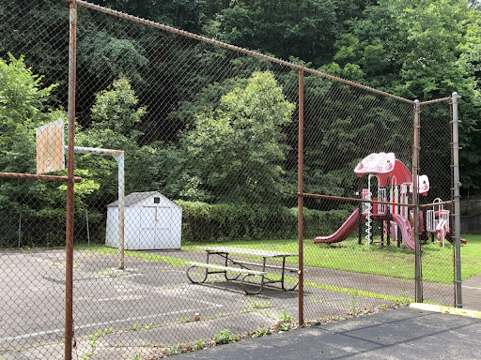  Participant photo 7  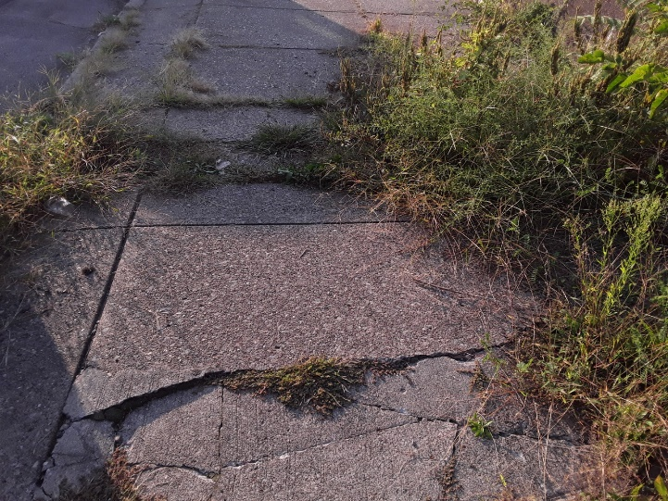
Social issues | "Certain areas and certain streets, you know not to go down in there. Certain streets you know to go down. Once out for a while, you realize: “Oh, let me not go that way.” Or if you see something happening, just keep walking, don't even look at them so. You can tell by the smell if you get what I’m getting at. If you sniff, and you know that’s not a good smell you like to smell. So, turn around and don’t go that way. It's weed. A lot of weed or alcohol don't go that way, you go the other way. You know a drug deal is going down. So, you know not to go that way, just mind your own business, because if you don't mind your own business, something wrong will happen to you and you don’t want that to happen to you.” African American adult female  “Um it does it just makes you have to be more careful... of where you're walking, how you walk, how far you walk. Even at night, you don't want to go after a certain time because it's dark outside so you don't have anything to walk on to protect you as you're walking.” African American adult female  "It can make it a little different just trying to make sure your surroundings are safe for you for your mental health, it all depends on what you are doing. I’ll just say walking the neighborhood, for instance, is okay, can I get to this destination best or which route, should I take, how long it would take me to get there, how fast can I get back home, what time of the day should I go to do it, that also plays into the clothing that you wear you know it's like making a whole bunch of decisions to me. Though, that can clutter your mind as well. And not necessarily mess with your mental health, but it just messes with your psyche because you're like okay; I need to put this on what's the weather like here. Okay, this is my route okay. This that we have to do I had everything. What bag do I take one while walking and I don't need a big bag to see my keys and my phone, and ID. You know those type of different things, that play in when you're leaving your household for that.” African American adult female
Unaesthetic | “I was there [Participant Photo 8]. They just did a remodeling, however. it's an eyesore to have all that debris just sitting out there. And it didn't seem like it was just for one day, you know, like a worker was gonna come back and pick it up. It seemed to be, you know, because I drove by after that, and it was still like that. It’s an eyesore, and it's something that needs to be cleaned up. It feels like the community doesn't care, or the people that own that building. don't care about their property. Especially the toilet.” African American adult female | Participant Photo 8  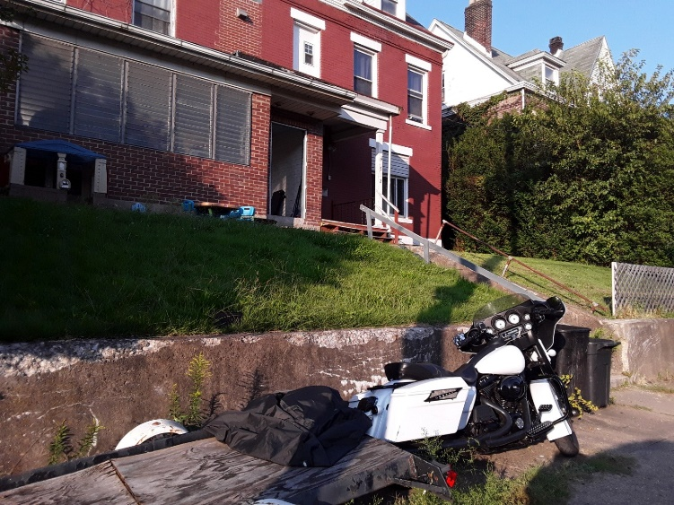

Table 4. Themes and quotes for desire to change the neighborhood
Theme | Illustrative Quotes
New facilities | “With some facilities around here, we can improve our health. Go and create an atmosphere that will inspire and motivate, so they want to participate. Once you get one and two go and they go spread the word and then the rest of them will follow, like the baggy pants, they all followers. Especially the kids. But for sure we could get some facilities up and get a baseball team, get a basketball team. They will come up.” Adult African American male  “I would definitely add a gym. Even if it's a small one. I do think, especially for kids who are in high school, or want to be go off to place for a college and understanding weightlifting and stuff like that, especially because high school harp on it, I think that's one thing for them, like a steppingstone for them. That'd be kind of nice to see.” African American adult female
Programming | “What I have done? I work out for a reason. At my age, if I didn't work out, I probably would be walking with a cane. So, what I do is I work out, and use the weights to walk with them and also run or jog a little bit. That's what's needed for the older people, I wish I could get a group together and that would-- I think they wouldn't be falling into stuff. A lot of what they do is they don't do anything with the muscle at old age. They don't do anything and that's the time that you really want to start working your muscles when you get up in the sixty and seventy. You want to keep up strength in your muscles stuff. So that you have that flexibility, and you can walk, and you can even run.” African American adult male  “[referring to specific spot on the map] sometimes they used to have years ago they used to have a summer program on her too, but there's somewhere where the kids can hang out. On the main avenue in a community for physical activity both physical activity to me just means walking, running; Just being outside just gave is getting up and moving around. It’s just you know something to give your body, a jolt of movement.” African American adult female
Parks and playgrounds | “I am trying to get a small playground for the kids. I am trying to coach. Well, we just don’t have a place available where you can do that. So, you get some empty buildings and stuff around there, but they are pretty decayed. They are not kept well. You certainly can’t do anything about them. Maybe one of these days soon, so we could go back and get stuff going.” African American adult male
Repair/fix current resources | “I would have brighter, you know, street light, so you could see. Because in the winter, it's very dark. and that's one reason why I've limited our services at night, because of…I don't consider [Name of community] a real dangerous place per se. However, you want to have lighting, I mean, I use the light from my phone, but I would like more lighting.” African American adult female  “Probably fix up the sidewalks and get sidewalks for neighborhoods and communities that don't have sidewalks, and just consist of streets. I would probably get somebody to tidy up the bushes, and the greenery in the area so sidewalks are more accessible.” African American adolescent female

