Supplementary S1. Départements, sample size and FNBCSP participation rates
Départements | Sample size | Participation rate
01 – Ain | 7,745 | 56.5%
02 – Aisne | 7,837 | 46.2%
06 – Alpes-Maritimes | 17,926 | 40.9%
14 – Calvados | 10,357 | 57.4%
17 – Charente-Maritime | 11,011 | 52.6%
19 – Corrèze | 3,723 | 64.8%
21 – Côte-d’Or | 6,844 | 61.0%
23 – Creuse | 2,108 | 50.1%
24 – Dordogne | 6,984 | 58.8%
25 – Doubs | 7,112 | 62.5%
27 – Eure | 8,445 | 59.0%
29 – Finistère | 14,604 | 64.0%
37 – Indre-et-Loire | 8,508 | 68.3%
38 – Isère | 15,561 | 57.7%
39 – Jura | 3,856 | 59.7%
47 – Lot-et-Garonne | 5,492 | 62.7%
50 – Manche | 7,488 | 62.2%
51 – Marne | 7,963 | 60.3%
54 – Meurthe-et-Moselle | 10,600 | 52.8%
56 – Morbihan | 11,902 | 68.2%
57 – Moselle | 15,427 | 48.8%
62 – Pas-de-Calais | 20,053 | 54.0%
63 – Puy-de-Dôme | 9,515 | 59.9%
64 – Pyrénées-Atlantiques | 10,107 | 62.4%
66 – Pyrénées-Orientales | 7,559 | 58.4%
69 – Rhône | 24,570 | 49.9%
70 – Haute-Saône | 3,627 | 60.3%
71 – Saône-et-Loire | 8,326 | 65.2%
73 – Savoie | 6,265 | 63.3%
76 – Seine-Maritime | 18,196 | 59.6%
80 – Somme | 7,955 | 57.4%
81 – Tarn | 6,149 | 56.6%
82 – Tarn-et-Garonne | 3,675 | 60.3%
84 – Vaucluse | 8,753 | 50.2%
86 – Vienne | 5,995 | 56.9%
87 – Haute-Vienne | 6,262 | 60.4%
89 – Yonne | 5,421 | 59.5%
90 – Territoire de Belfort | 1,880 | 60.2%
91 – Essonne | 16,401 | 40.8%
93 – Seine-Saint-Denis | 19,324 | 40.8%
95 – Val-d’Oise | 16,072 | 45.8%
Total | 397,598 | 55.1%

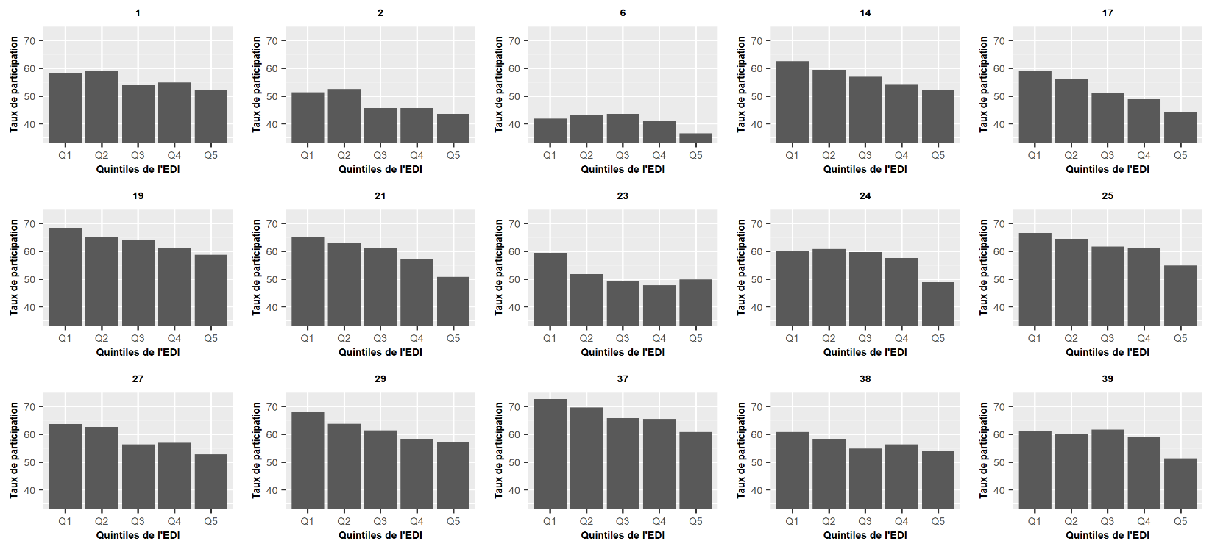
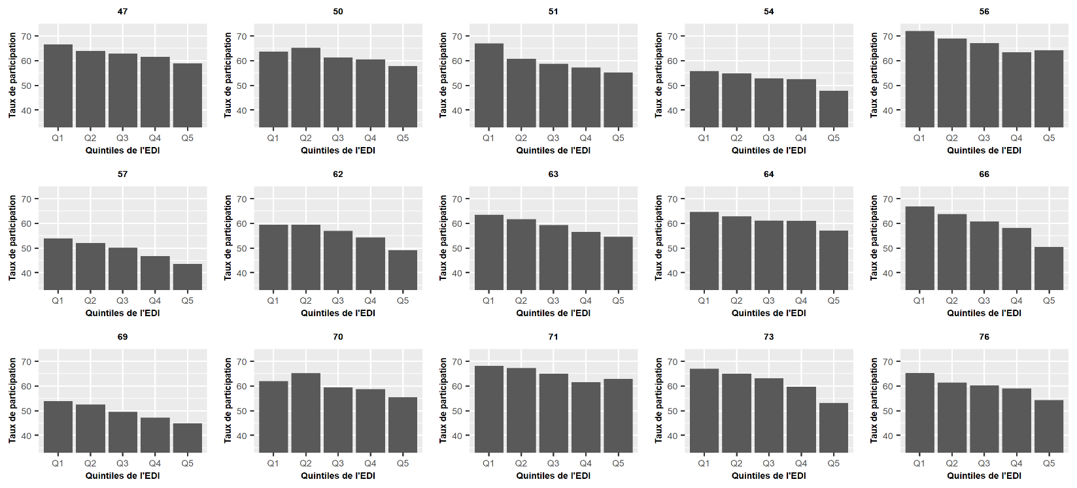
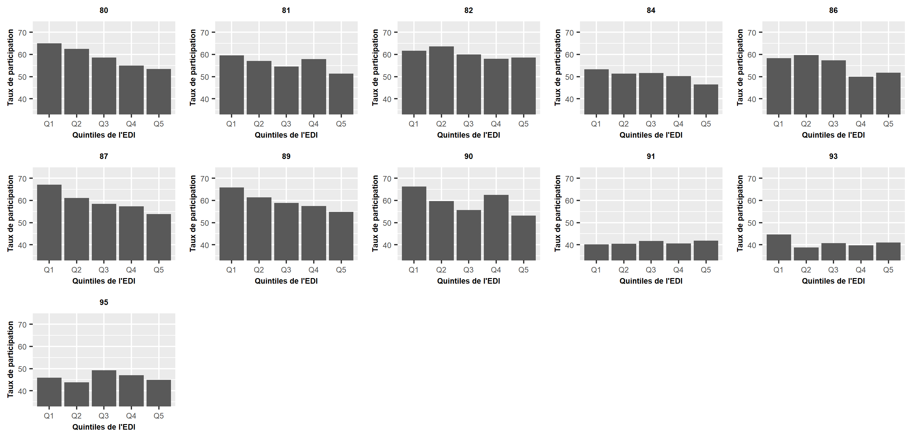
Supplementary S2. Participation rates by départements by European Deprivation Index population’s quintiles
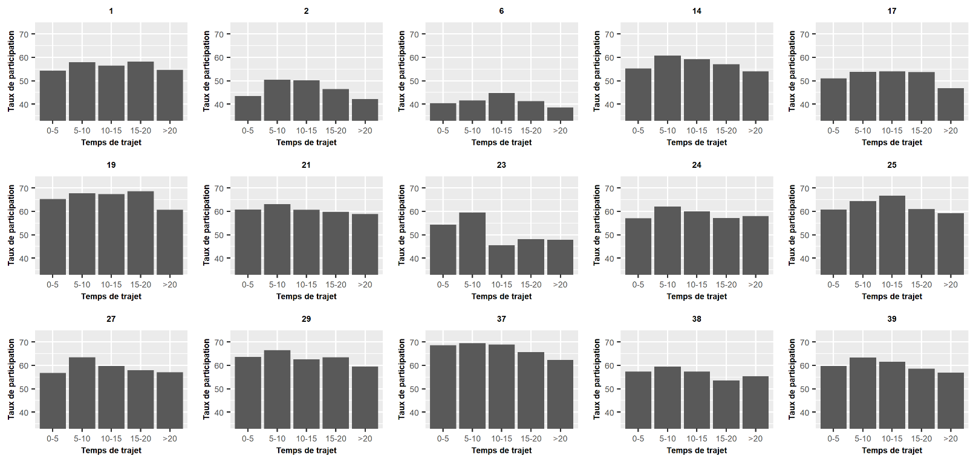
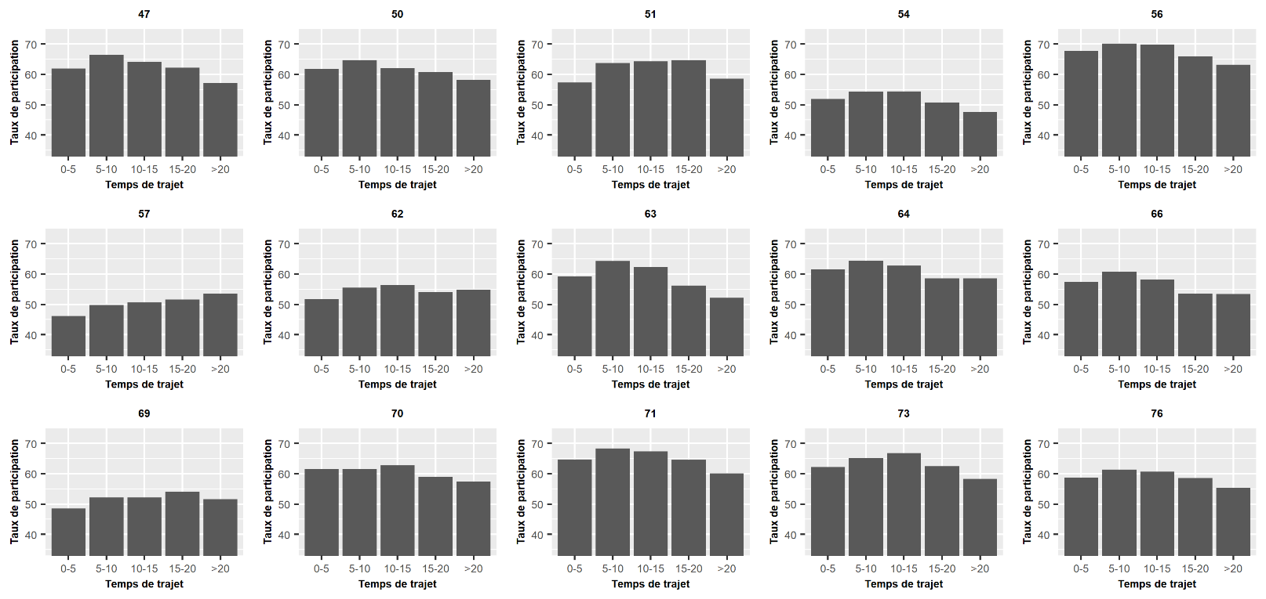
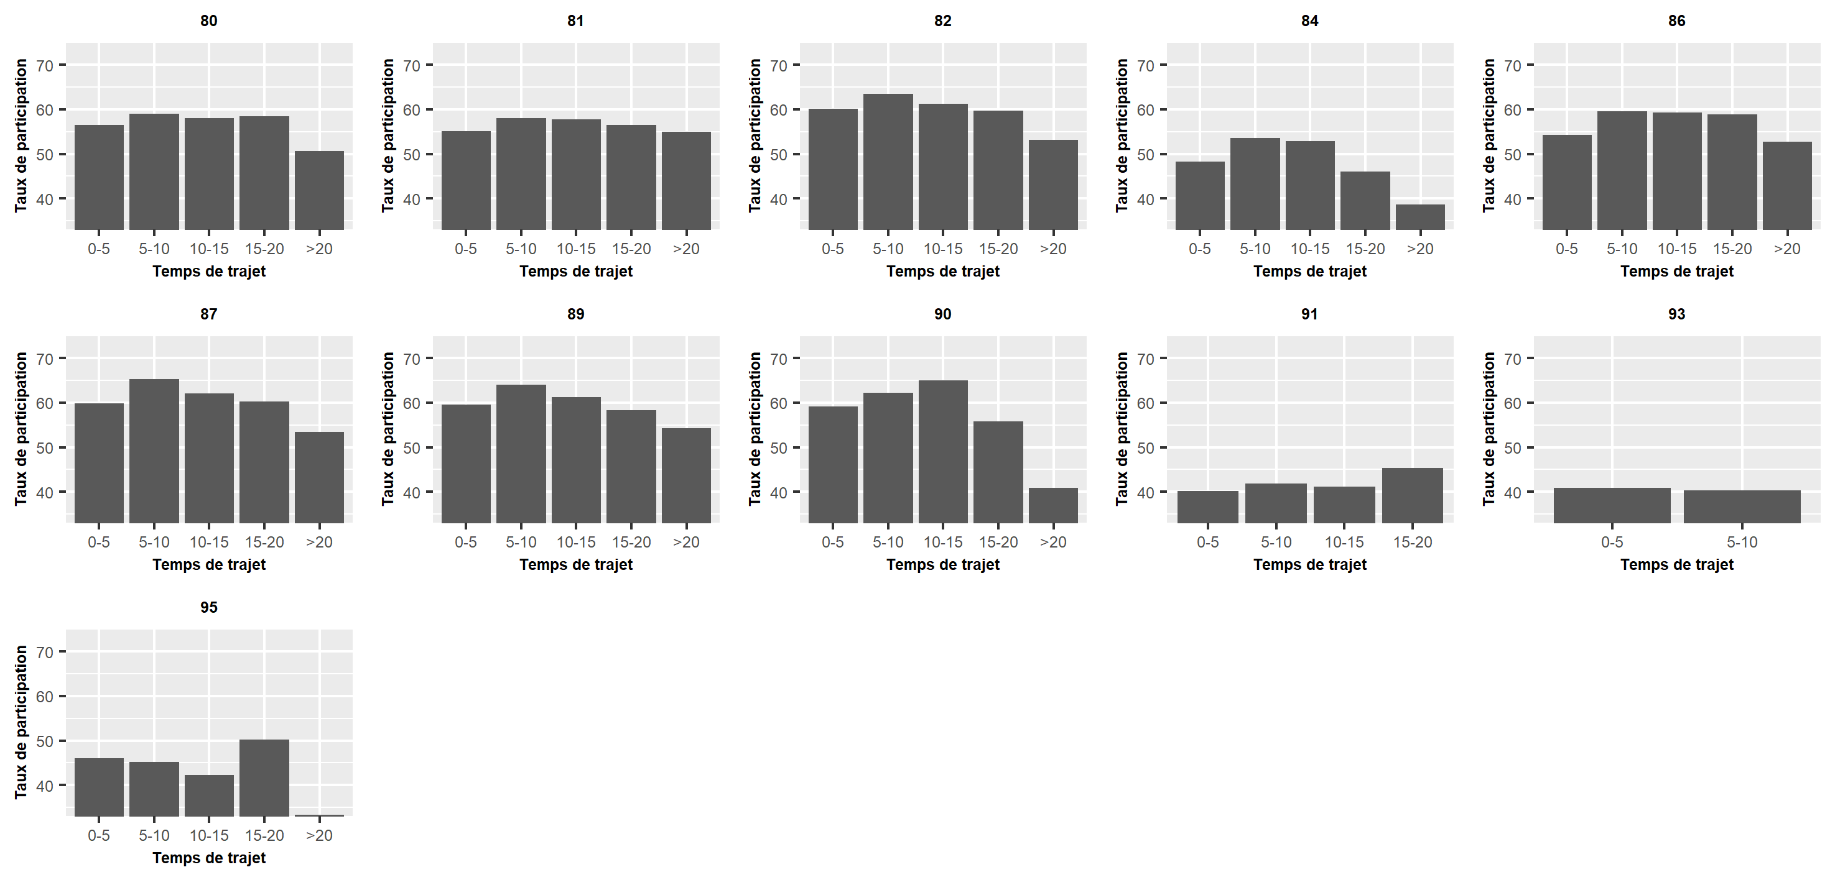
Supplementary S3. Participation rates by départements by travel time
Supplementary S4. STROBE Statement—Checklist of items that should be included in reports of cross-sectional studies
 | Item No | Recommendation | Page  No
Title and abstract | 1 | (a) Indicate the study’s design with a commonly used term in the title or the abstract | 1
Title and abstract | 1 | (b) Provide in the abstract an informative and balanced summary of what was done and what was found | 2
Introduction
Background/rationale | 2 | Explain the scientific background and rationale for the investigation being reported | 4-5
Objectives | 3 | State specific objectives, including any prespecified hypotheses | 5
Methods
Study design | 4 | Present key elements of study design early in the paper | 5-8
Setting | 5 | Describe the setting, locations, and relevant dates, including periods of recruitment, exposure, follow-up, and data collection | 5-6
Participants | 6 | (a) Give the eligibility criteria, and the sources and methods of selection of participants | 5-6
Variables | 7 | Clearly define all outcomes, exposures, predictors, potential confounders, and effect modifiers. Give diagnostic criteria, if applicable | 5-8
Data sources/ measurement | 8* | For each variable of interest, give sources of data and details of methods of assessment (measurement). Describe comparability of assessment methods if there is more than one group | 6-8
Bias | 9 | Describe any efforts to address potential sources of bias | /
Study size | 10 | Explain how the study size was arrived at | 5-6
Quantitative variables | 11 | Explain how quantitative variables were handled in the analyses. If applicable, describe which groupings were chosen and why | 6-8
Statistical methods | 12 | (a) Describe all statistical methods, including those used to control for confounding | 7-8
Statistical methods | 12 | (b) Describe any methods used to examine subgroups and interactions | 7-8
Statistical methods | 12 | (c) Explain how missing data were addressed | 5-6
Statistical methods | 12 | (d) If applicable, describe analytical methods taking account of sampling strategy | 5-6
Statistical methods | 12 | (e) Describe any sensitivity analyses | /
Results
Participants | 13* | (a) Report numbers of individuals at each stage of study—eg numbers potentially eligible, examined for eligibility, confirmed eligible, included in the study, completing follow-up, and analysed | 5-6
Participants | 13* | (b) Give reasons for non-participation at each stage | 5-6
Participants | 13* | (c) Consider use of a flow diagram | Figure 1
Descriptive data | 14* | (a) Give characteristics of study participants (eg demographic, clinical, social) and information on exposures and potential confounders | 9
Descriptive data | 14* | (b) Indicate number of participants with missing data for each variable of interest | /
Outcome data | 15* | Report numbers of outcome events or summary measures | 9
Main results | 16 | (a) Give unadjusted estimates and, if applicable, confounder-adjusted estimates and their precision (eg, 95% confidence interval). Make clear which confounders were adjusted for and why they were included | 9-10
Main results | 16 | (b) Report category boundaries when continuous variables were categorized | /
Main results | 16 | (c) If relevant, consider translating estimates of relative risk into absolute risk for a meaningful time period | 9-10
Other analyses | 17 | Report other analyses done—eg analyses of subgroups and interactions, and sensitivity analyses | 9-10
Discussion
Key results | 18 | Summarise key results with reference to study objectives | 10-12
Limitations | 19 | Discuss limitations of the study, taking into account sources of potential bias or imprecision. Discuss both direction and magnitude of any potential bias | 12-13
Interpretation | 20 | Give a cautious overall interpretation of results considering objectives, limitations, multiplicity of analyses, results from similar studies, and other relevant evidence | 10-14
Generalisability | 21 | Discuss the generalisability (external validity) of the study results | 13
Other information
Funding | 22 | Give the source of funding and the role of the funders for the present study and, if applicable, for the original study on which the present article is based | 15

*Give information separately for exposed and unexposed groups.

Note: An Explanation and Elaboration article discusses each checklist item and gives methodological background and published examples of transparent reporting. The STROBE checklist is best used in conjunction with this article (freely available on the Web sites of PLoS Medicine at http://www.plosmedicine.org/, Annals of Internal Medicine at http://www.annals.org/, and Epidemiology at http://www.epidem.com/). Information on the STROBE Initiative is available at www.strobe-statement.org.

