Extended Data
Water Mass | Temperature |  | Salinity
uCDW | 0.2 ± | +0.18  -0.06 | 0.014 ± | +0.018  -0.010
Intermediate | 0.22 ± | +0.31  -0.14 | 0.02 ± | +0.045  -0.019
WW | -0.17 ± | +0.02  -0.12 | -0.06 ± | +0.015  -0.032
Extended Data Table 1: Mean differences and asymmetric standard deviations of temperature and salinity between the December 2014 occupation of section A12 and the climatology, for each water mass (Fig. 3c). The standard deviation is calculated separately for positive and negative anomalies to account for asymmetry, and is reported as "+(positive SD) / –(negative SD)".

Section | Date | Winter Water |  | Upper Circumpolar Deep Water
Section | Date | Temperature | Salinity | Temperature | Salinity
S04I | January 2013 | T < -1.5 |  | T > 1.5 | S > 34.5
P16S | April 2014 | T < -1.3 | S > 34 |  | S > 34.68
A12 | December 2014 | T < -1.5 |  | T > 0.7 | S > 34.68
I08S | February 2016 | T < -1 |  |  | S > 34.6
P18 | Dec 2016 / Jan 2017 | T < -1.3 |  |  | S > 34.65
S04P | March 2018 | T < -1.5 | S > 33.9 | T > 1.5 | S > 34.5
I06S | April/May 2019 | T < -1.3 |  |  | S > 34.65
Extended Data Table 2: Definition of the water masses for each section studied.

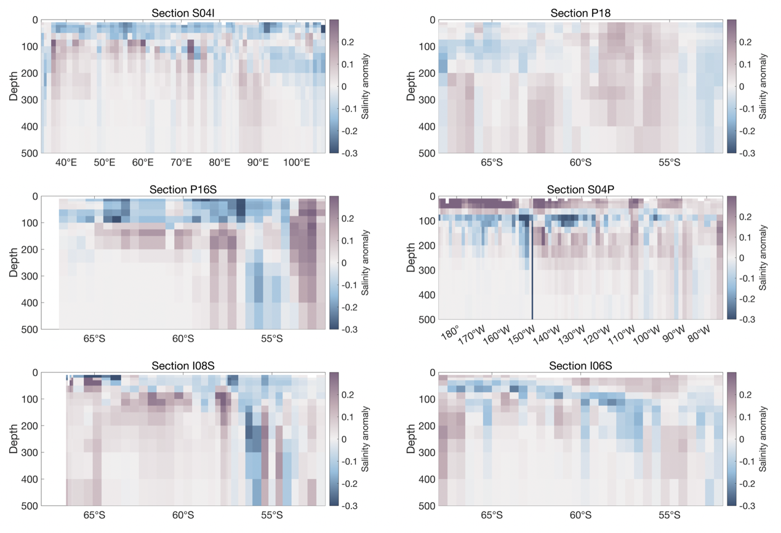
Extended Data Figure 1: Salinity anomalies between the 1972-2013 climatology and the post-2013 sections.

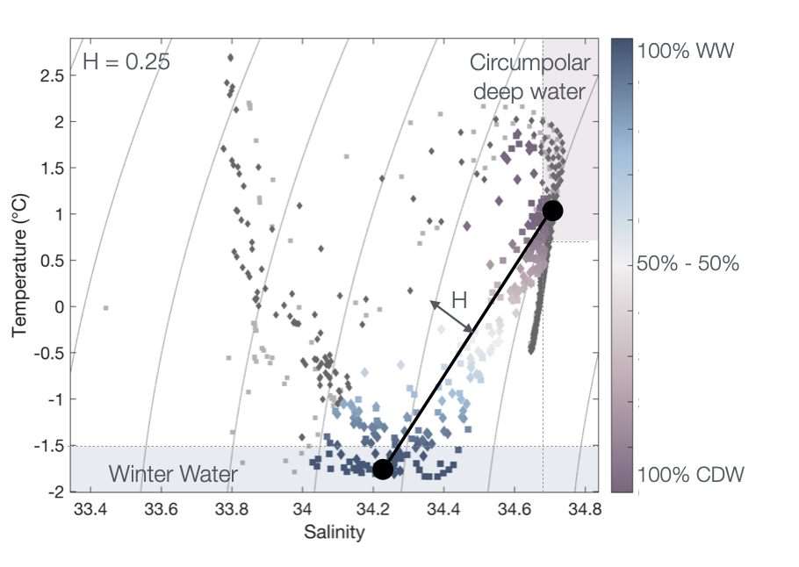
Extended Data Figure 2: Temperature-salinity diagram for section A12. The core of the Winter Water and upper Circumpolar Deep Water is indicated by the dot. H indicates the distance from the WW-uCDW mixing line.

