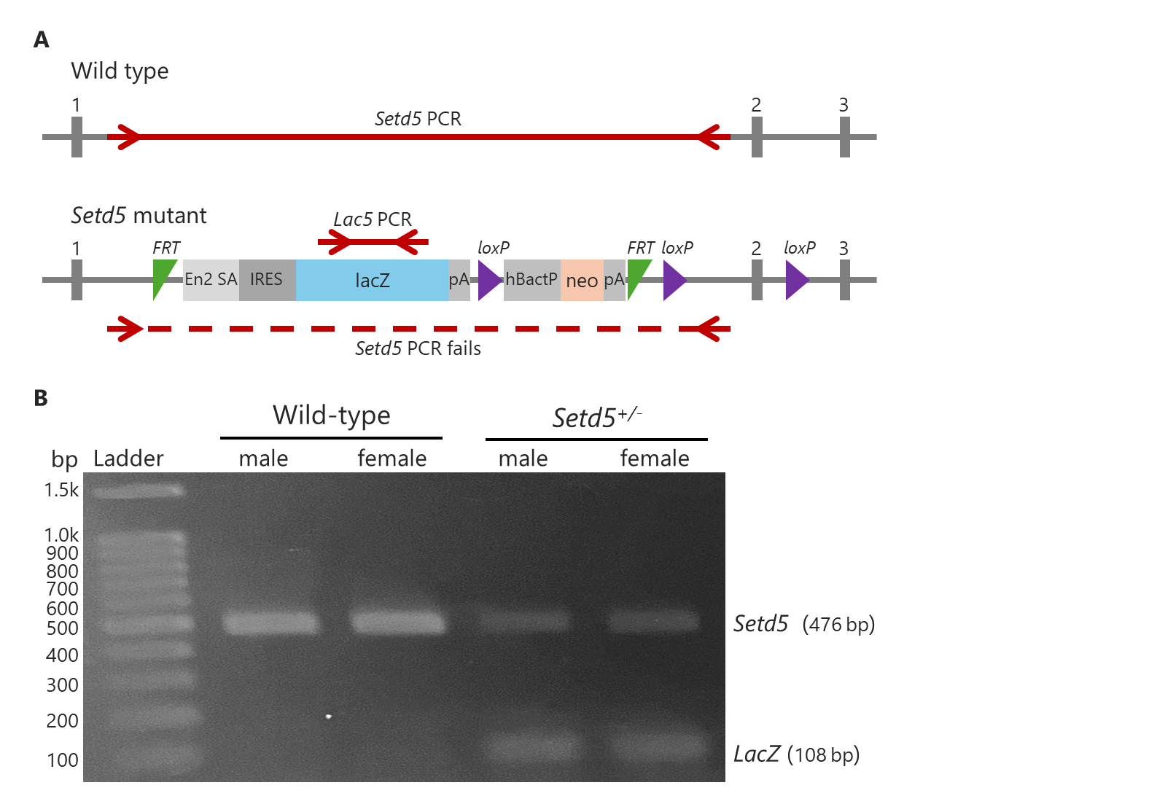
Additional file 1. Characterization of the Setd5 knockout-first allele.
(A) Schematic diagram of the disrupted Setd5 allele (Setd5^{tm1a(EUCOMM)Wtsi}) showing the insertion of a lacZ-neomycin resistance (neo) cassette (promoter-driven targeting vector). This allele is a knockout-first design with reporter-tagged insertion and conditional potential. This figure was adapted from the datasheet provided by the Wellcome Trust Sanger Institute and the International Mouse Phenotyping Consortium website with modifications. (B) Representative polymerase chain reaction (PCR) analysis of Setd5 and lacZ in adult mice in the wild-type (Setd5^{+/+}) and Setd5^{+/−} groups. The difference in Setd5 band intensity, combined with the presence or absence of the lacZ band, confirmed the successful disruption of one Setd5 allele in heterozygous (Setd5^{+/−}) mice. Abbreviations: bp, base pairs; En2 SA, Engrailed 2 splice acceptor; FRT, FLP recombination target; hBactP, human β-actin promoter; IRES, Internal Ribosome Entry Site; lacZ, β-galactosidase; loxP, locus of crossover (x) in P1; neo, neomycin phosphotransferase II (nptII); pA, polyadenylation signal; PCR, polymerase chain reaction; Setd5+/−, SET domain-containing 5 heterozygous knockout; WT, wild-type.

