Supplementary Information
Proliferating droplets formed via prebiotic polymerisation:
the missing link between chemistry and biology on the origin of life
Muneyuki Matsuo & Kensuke Kurihara

INDEX
Supplementary Methods
Chemicals and apparatus
General preparation and purification of oligomer
Turbidity measurement
Recursive growth and division of LLPS droplets
Confocal laser scanning microscopy observation of RNA, DNA, and/or lipid incorporation into droplets
Flow cytometry analysis of droplets incorporating RNA, DNA, and/or lipid
Raman spectroscopy analysis of droplets and droplets with/without DNA and/or phospholipid
Spectrofluorometric measurement of phase transfer of RNA, DNA, or lipid

Supplementary Figures
S1. Scheme of synthesis of monomer precursor M_{pre} and thioesterified glysine (Gly-SBn∙HCl)
S2. ¹H NMR spectrum of (Boc-Cys-SBn)₂ with CD₃OD
S3. ¹H NMR spectra of M_{pre} with CD₃OD and D₂O
S4. Differential interference contrast (DIC) microscopy images of aqueous solutions after addition of M_{pre}, or DTT, cystine dihydrochloride and BnSH
S5. ¹H NMR spectra of Boc-Gly-SBn with CDCl₃ and Gly-SBn∙HCl with CD₃OD
S6. Photographs of solutions after addition of M_{pre} and DTT, and Gly-SBn and DTT
S7. Photographs of solutions after addition of M_{pre} and DTT under various aqueous conditions
S8. ¹H NMR spectrum of CD₃CN phase used for purification of reaction product
S9. ¹H NMR spectrum of purified product with DMSO-d₆ and comparison with Mpre and oligopeptides
S10. ESI-TOF mass spectra and analysis of reaction products
S11. DIC microscopy images of solutions dissolving oligopeptides and BnSH with/without DTT
S12. Monitoring of droplet formation reaction by fluorescence spectroscopies and ¹H NMR
S13. Monitoring of autocatalytic reaction progress by ¹H NMR
S14. Monitoring of LLPS droplet size during the growth-division process, induced by repeated nutrient addition and stimulus cycles
S15. Time-course changes in droplet size and reaction rate
S16. Control experiment for growth of droplet
S17. Raw image of Fig.4e
S18. CLS fluorescence microscopy images of the LLPS droplet dispersion after addition of the fluoresce probes tagged-nucleic acids or lipids solutions
S19. Raman microspectrometry of a LLPS droplet
S20. FACS analysis on particle size distribution after addition of BODIPY-HPC and/or TAMRA-RNA
S21. Raman microscopy and spectroscopy on LLPS droplet incorporation DNA and/or lipids
S22. Fluorescence spectroscopy analysis of the concentration of biopolymers by oligopeptide

Supplementary Table
S1. Summary of Raman microspectroscopy of a LLPS droplet with/without DNA and/or lipids.

Supplementary Movie
S1. Droplet formation
S2. Droplet fusion

Supplementary References

Supplementary Methods
Chemicals and apparatus. L-cysteine hydrochloride monohydrate, L-cystine dihydrochloride, N,N′-bis(tert-butoxycarbonyl)-L-cystine [(Boc-Cys-OH)₂], benzyl mercaptan (BnSH), dithiothreitol (DTT), fluorescamine and 1,2-dipalmitoyl-sn-glycero-3-phosphocholine (DPPC) were purchased from Tokyo Chemical Industry Co., Ltd. (Tokyo, Japan). N,N′-dicyclohexylcarbodiimide, 1-hydroxybenzotriazole, N,N-diisopropylethylamine, hexane, ethyl acetate, super-dehydrated dimethyl sulfoxide and rhodamine-labelled lipid Texas Red⁻DHPE (N-(Texas Red sulfonyl)-1,2-dihexadecanoyl-sn-glycero-3-phosphoethanolamine, triethylammonium salt) were purchased from Fujifilm Wako Pure Chemical Corp. (Osaka, Japan). Hydrogen chloride in ethyl acetate (4N HCl/ethyl acetate) was purchased from Kokusan Chemical Co., Ltd. (Kanagawa, Japan). Tenfold concentrated phosphate buffer solution (pH 7.4, 67 mM after dilution) was purchased from Kanto chemical Co., Inc. (Tokyo, Japan). BODIPY-labelled lipid 2-(4,4-difluoro-5,7-dimethyl-4-bora-3a,4a-diaza-s-indacene-3-dodecanoyl)-1-hexadecanoyl-sn-glycero-3-phosphocholine (β-BODIPY-FL-C₁₂-HPC) was obtained from Thermo Fisher Scientific Inc. (Tokyo, Japan). Synthesised fluorescent-labelled single-stranded RNAs (5′-FITC-GACAGCAUCGCCAGUCACUA-3′ and 5′-TAMRA-GACAGCAUCGCCAGUCACUA-3’) and DNAs (5′-FITC-GACAGCATCGCCAGTCACTA-3′ and 5′-TAMRA-GACAGCATCGCCAGTCACTA-3′) were obtained from FASMAC (Kanagawa, Japan). RNase-free water (Water for Molecular Biology) was purchased from Merck Japan (Tokyo, Japan) and used for water of all of the RNA experiments and these control experiments. Tuning solution for mass spectrometry (Standards Chemical Kit PN4456735, part number: 4457953, MW 829.0) was purchased from AB Sciex Pte. Ltd. (Framingham, MA, U.S.A.)
¹H NMR and ¹³C NMR spectra were recorded using a spectrometer (JNM-ECS400, JEOL, Tokyo, Japan). Chemical reactions were monitored with a spectrometer (JNM-ECM600, JEOL, Tokyo, Japan). Flash column chromatography was performed using silica gel columns (RediSep® Normal-phase Silica Flash Columns, 20–40 μm mesh, pore size 60 Å, Teledyne Isco, Inc., Lincoln, NE, USA) on a medium-pressure liquid chromatography purification system (CombiFlash Rf 150, Teledyne Isco, Inc., Lincoln, NE, USA). The crude product was purified using a preparative high-performance liquid chromatography system (LC-Forte/R, YMC Co., Kyoto, Japan). Electrospray ionisation time-of-flight mass spectrometry measurements were carried out using a mass spectrometer (TripleTOF 5600, AB Sciex Pte. Ltd, MA, USA) The turbidity of the solution was measured with a microvolume UV-Vis spectrophotometer (Nano Drop 2000c, Thermo Fisher Scientific, MA, USA). The hydrodynamic diameter of the molecular assemblies in the solution was measured with a dynamic light-scattering particle-size analyser (ELSZ-1000, Otsuka Electronics Co., Ltd., Osaka, Japan). Microscopic observations were made with an inverted microscope (Eclipse Ti-E, Nikon Instruments Inc., Tokyo, Japan) equipped with a confocal laser scanner unit (CSU-W1, Yokogawa Electric Corp., Tokyo, Japan) and a sCMOS camera unit (Zyla 4.2 plus, Andor Technology Ltd., Belfast, United Kingdom) with 1024 × 1024 active pixels (λ_{ex} = 488 nm, λ_{em} = 500–550 nm). The microscopic images were recorded using NIS-Elements imaging software (Nikon Instruments Inc., Tokyo, Japan). A spectrofluorometer (SPEX Fluorolog 3-21, Horiba, Kyoto, Japan) was used for photon counting. Raman images and spectra were obtained using a laser Raman microscope system (RAMAN-11, Nanophoton Corp., Osaka, Japan) equipped with an upright metallurgical microscope (Eclipse LV150, Nikon Co., Tokyo, Japan) with a 600 g/mm grating and neutral-density filter (255, transmittance: 99%). The laser beam was focused on a sample with an objective lens (60×/1.0NA water immersion). The central wavenumbers were 2000 cm⁻¹ for wavenumber range width 700-3000 cm⁻¹, and 2800 cm⁻¹ for wavenumber range width 1500-3500 cm⁻¹. The droplet dispersion was placed in a chamber on a slide glass, and a cover glass was put on the dispersion. Raman spectra from each of four points in the core and shell of the droplets were measured to obtain a single Raman image. The irradiated laser intensity and exposure time at each point were 0.57–0.59 mW (532 nm) and 15 s, respectively.

General preparation and purification of oligomer. M_{pre} [(Cys-SBn)₂∙2HCl] was synthesised as shown in Fig. S1. M_{pre} (11 mg, 20 mmol) and reductant dithiothreitol (DTT, 8 mg, 50 mmol) were added to the deionised water (2 mL) and shaken for 15 s. M_{pre} was reduced to M (Cys-SBn∙HCl) to initiate polymerisation. At 24 h after mixing M_{pre} and DTT, the solution (500 µL) was lyophilised to remove both water and BnSH. The resultant powder was washed with 500 µL of acetonitrile five times to remove DTT and oxidised DTT; the precipitate was then obtained as a white powder.

Turbidity measurement. M_{pre} (5 mg, 10 mmol) and/or a reductant DTT (4 mg, 25 mmol) were added to 1 mL of deionised water and shaken for 15 s. Two microliters of aqueous solution were removed from the solution and assayed. The same procedure was repeated for 24 h. Absorbances at 400 nm were measured with a microvolume UV-Vis spectrophotometer (Nano Drop 2000c) and were equated to the turbidities of the cell cultures. Turbidity measurements of Gly-SBn∙HCl and DTT were performed under the conditions of M_{pre} as described above.

Recursive growth and division of LLPS droplets. M_{pre} (11 mg, 20 mmol) and DTT (8 mg, 50 mmol) were added to deionised water (2 mL) and vortexed at room temperature for 15 s. One-hundred microliters of the solution were poured into a quartz cuvette. The particle size distribution of first-generation LLPS droplets was monitored with a particle size analyser at room temperature every 10 min for 24 h. The remaining dispersion was incubated for 24 h. To analyse the particle size of second-generation LLPS droplets, the dispersion was extruded through a Nuclepore® Polycarbonate filter (pore size 100 nm, Whatman) five times 24 h after mixing. Immediately after extrusion, deionised water was added to make the concentrations of M_{pre} and DTT in the dispersion the same as the initial concentrations, and the same amounts of M_{pre} and DTT were added again for self-reproduction of LLPS droplets. The particle size change was monitored by the particle analyser at room temperature for 24 h immediately after vortex mixing. The series of processes was repeated six times.
Confocal laser scanning microscopy observation of RNA, DNA, and/or lipid incorporation into droplets. An LLPS droplet dispersion was prepared by mixing M_{pre} and DTT and incubating the mixture for 24 h. A 13-µL droplet of the dispersion and 13 µL of TAMRA or FITC-tagged single strand RNA (ssRNA) or single strand DNA (ssDNA) solution (1 µM) were placed on a glass plate and then mixed. The plate was then immediately covered with a cover glass using a spacer. The specimen was observed with a confocal laser scanning fluorescence microscope. Similarly, either (1) 13 µL of the LLPS droplet dispersion and 13 µL of Texas Red–tagged or BODIPY-tagged phospholipid solution (1 µM) or (2) 9 µL of the LLPS droplet dispersion, 9 µL of ssRNA solution, and 9 µL of lipid solution were mixed and obtained as a sample.

Flow cytometry analysis of droplets incorporating RNA, DNA, and/or lipid. Three kinds of biomolecular solutions (TAMRA-tagged RNA aq., 1 µM, 500 µL; BODIPY-tagged HPC aq., 1 µM, 500 μL; an equivolume mixture of TAMRA-tagged RNA aq. and BODIPY-tagged HPC aq., 0.5 µM each, 1000 μL) were prepared. A sample solution was prepared by mixing each of the above biomolecular solutions and 500 μL of an LLPS droplet dispersion consisting of M_{pre} (10 mM) and DTT (25 mM). The mixture at 5 min and 24 h after adding was transferred to a fluorescence activated cell sorter (FACS). The intensities of scattered light and fluorescence were detected by the FACS on a mass scale (counting 10,000 droplets, TAMRA, λ_{ex} = 561 nm, λ_{em} = 600 ± 30 nm; FITC, λ_{ex} = 488 nm, λ_{em} = 525 ± 25 nm; Texas Red, λ_{ex} = 561 nm, λ_{em} = 600 ± 30 nm; BODIPY, λ_{ex} 488 nm, λ_{em} = 525 ± 25 nm). The FACS operation and analysis procedures were based on a previous study¹. The probability density of each population was calculated with a kernel density estimation method.

Raman spectroscopy analysis of droplets and droplets with/without DNA and/or phospholipids.
In order to investigate the ratio of hydrophobic and hydrophilic components in both the central and peripheral parts of the LLPS droplets, the Raman spectra of each part were measured by laser Raman microscopy. M_{pre} (2.5 mg, 4.5 mmol) and DTT (2 mg, 12.5 mmol) were mixed, and then 100 μL of deionised water was added immediately. The mixture was stirred with vortex for 15 seconds. After 1 hour of stirring, the droplet dispersion (25 µL) were observed with a laser Raman microscope. Raman imaging was performed at 3050 cm⁻¹ to optimise the imaging. The benzene ring-derived peak of benzyl mercaptan (~1000 cm⁻¹) as the hydrophobic component and the water-derived peak (~3400 cm⁻¹) as the hydrophilic component were detected and the benzene ring/water ratio (B/W) was compared at between the central part (defined as C(B/W)) and the peripheral part (defined as P(B/W)). In the case of the droplet containing DNA, a 100 μL solutions of DNA (1 μM, 20 mer) were mixed with the 100 μL of droplet dispersion more than 1 hour after the mixing M_{pre} and DTT. A 25 µL of the droplet dispersion dispensed from the mixed dispersion were observed. In the case of the droplet containing phospholipids, a 100 μL solutions of DPPC (1 μM) were mixed with the 100 μL of droplet dispersion more than 1 hour after the mixing M_{pre} and DTT. A 25 µL of the droplet dispersion dispensed from the mixed dispersion were observed. In the case of the droplet containing DNA and phospholipids, each 100 μL solution of DNA (1 μM) and DPPC (1 μM) were mixed with the 100 μL of droplet dispersion more than 1 hour after the mixing M_{pre} and DTT. A 25 µL of the droplet dispersion dispensed from the mixed dispersion were observed.

Spectrofluorometric measurement of phase transfer of RNA, DNA, or lipid. Four kinds of biomolecule-containing solutions (TAMRA-tagged RNA aq., FITC-tagged RNA aq., Texas Red–tagged lipid aq. or BODIPY-tagged lipid aq.; 1 μM each) were prepared. An aqueous oligopeptide solution (with oligopeptides or without oligopeptides) was prepared by redispersing the extracted oligopeptides in the RNase-free water according to the above protocols (See Preparation and purification of oligomer). A biomolecule-containing solution (100 μL) and an aqueous oligopeptide solution (100 μL) were mixed and then incubated for 24 h on the BnSH layer solution (200 μL). After incubation, 100 μL of aqueous solution was dispensed into a cuvette, and the fluorescence spectrum was measured by counting photons with a spectrofluorometer. The measurement wavelengths of each fluorescent molecule were as follows: TAMRA, λ_{ex} = 525 nm, λ_{em} = 535–800 nm; FITC, λ_{ex} = 485 nm, λ_{em} = 500–800 nm; Texas Red, λ_{ex} = 565 nm, λ_{em} = 575–800 nm; BODIPY, λ_{ex} 485 nm, λ_{em} = 500–800 nm).
Supplementary Figures
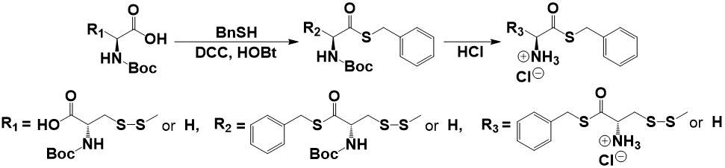
Figure S1 | Scheme of synthesis of monomer precursor M_{pre} and thioesterified glycine (Gly-SBn∙HCl) The actual synthesis process was described in Method section of the article.
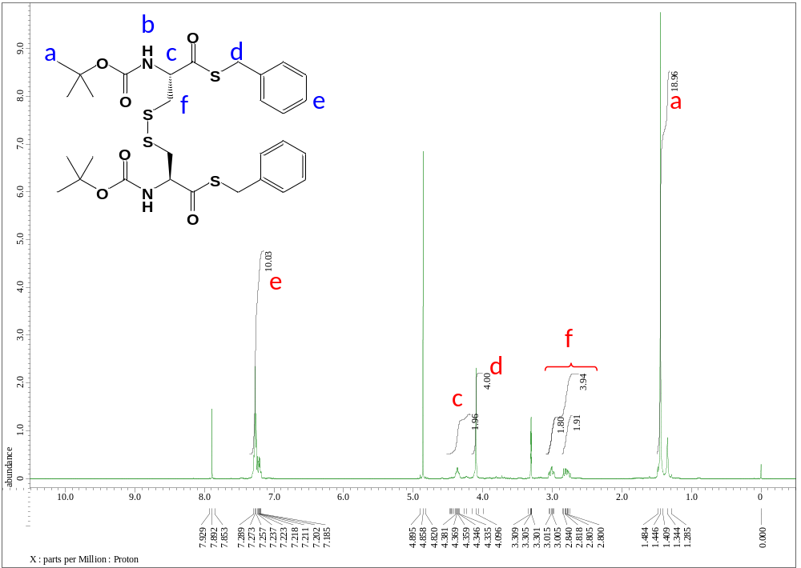
Figure S2 | ¹H NMR spectrum of (Boc-Cys-SBn)₂ with CD₃OD. The synthesis process was described in Method section of the article.
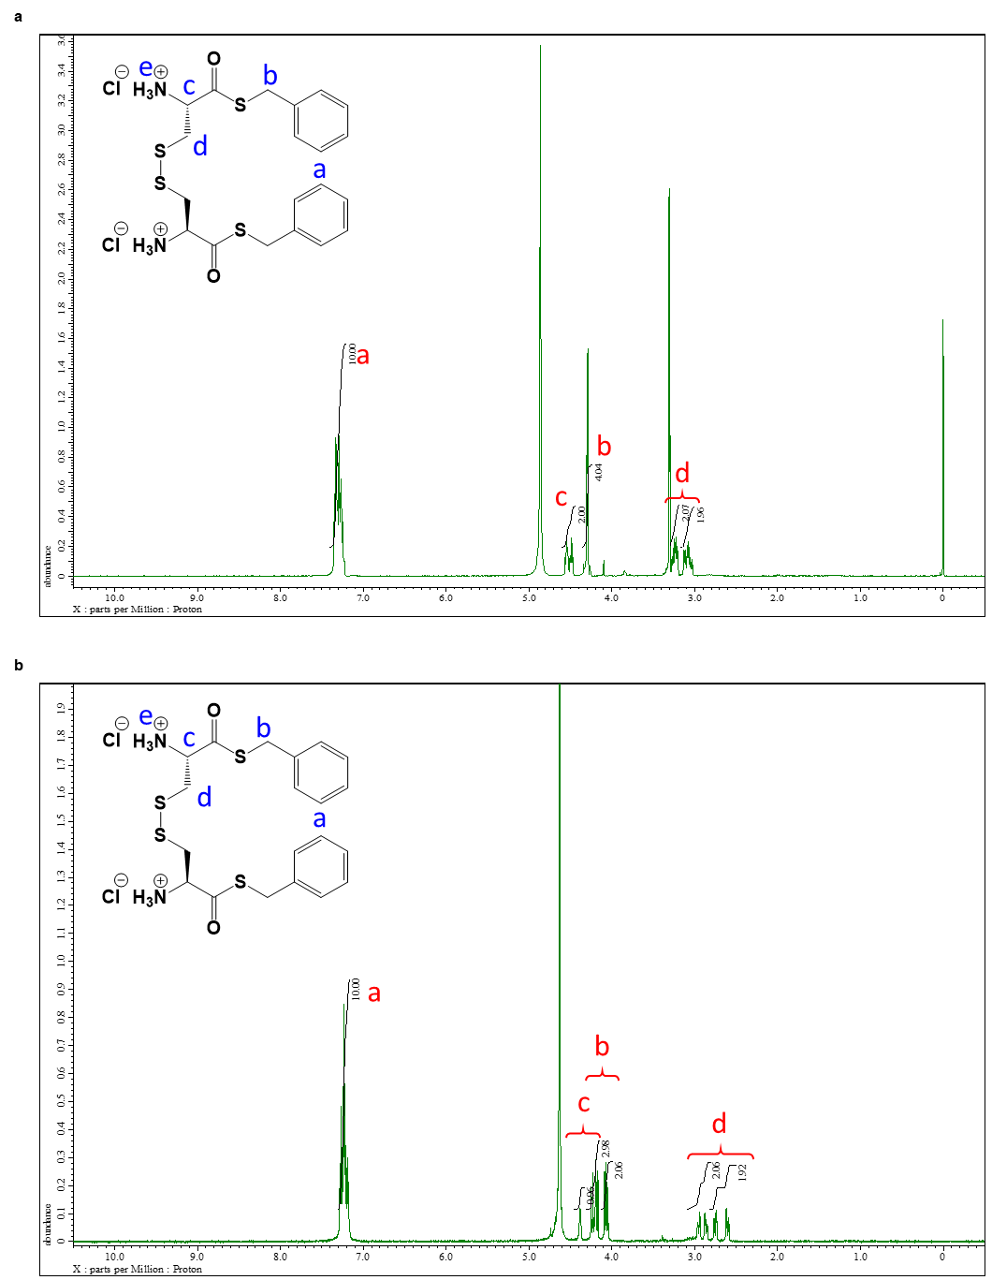
Figure S3 | ¹H NMR spectra of M_{pre} with a, CD₃OD or b, D₂O. The synthesis process was described in Method section of the article.
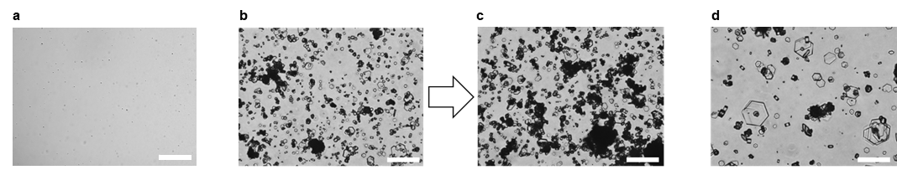
Figure S4 | DIC microscopy images of solutions after addition of a, 10 mM M_{pre}, b, after addition of a cystine dihydrochloride (10 mM), BnSH (20 mM) and DTT (25 mM) at 5 min and c, at 12 h, and d, after addition of a cystine dihydrochloride (10 mM) to deionised water. Scale bars represent 50 μm.

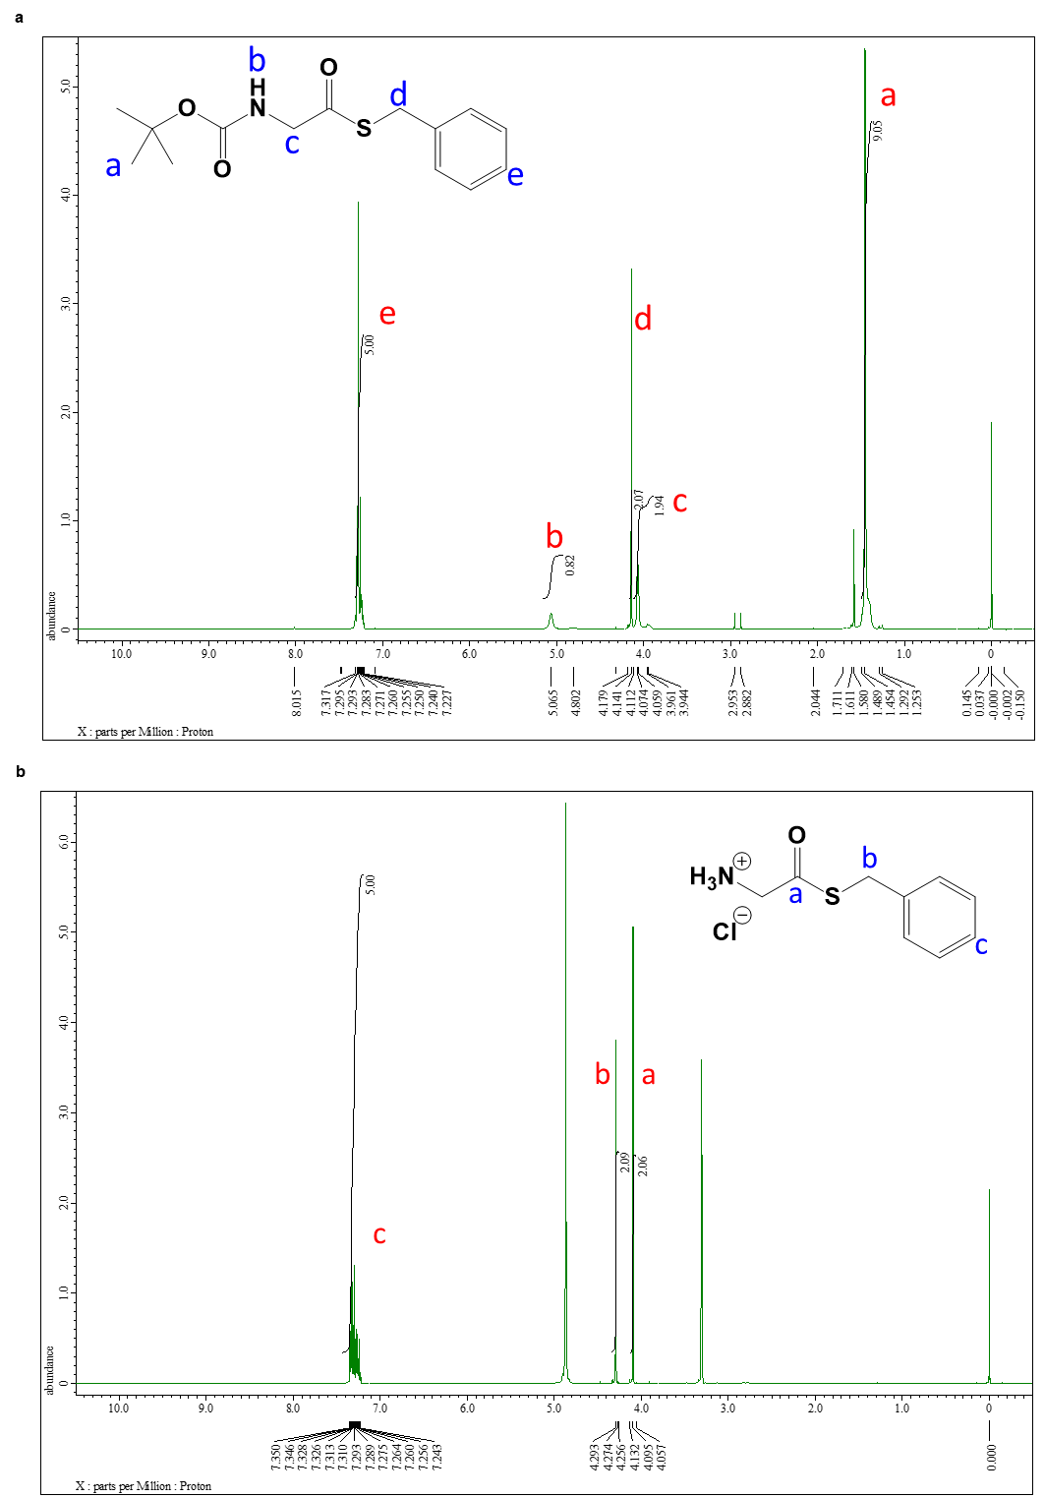
Figure S5 | ¹H NMR spectra of a, Boc-Gly-SBn with CDCl₃ and b, Gly-SBn∙HCl with CD₃OD. The synthesis process was described in Method section of the article.

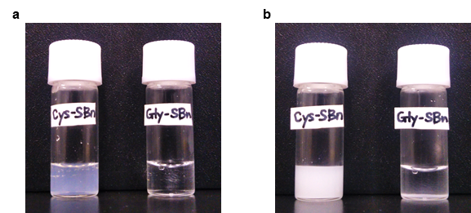
Figure S6 | Photographs of solutions at a, 5 min and b, 24 h after addition of M_{pre} (10 mM) and DTT (25 mM) (left vial) or Gly-SBn∙HCl (20 mM) and DTT (25 mM) (right vial).

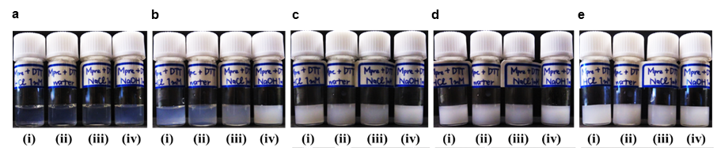
Figure S7 | The photographs of the solution of M_{pre} (10 mM) and DTT (25 mM) with various pH values and ion concentration. a, 5 min after mixing, b, 30 min after, c, 1.5 h after, d, 3 h after, e, 12 h after, respectively. Each aqueous solution was prepared containing (i) hydrochloric acid (1 mM, pH = 3), (ii) deionised water (pH = 7), (iii) sodium chloride (1 mM, pH = 7), and (iv) sodium hydroxide (1 mM, pH = 11).

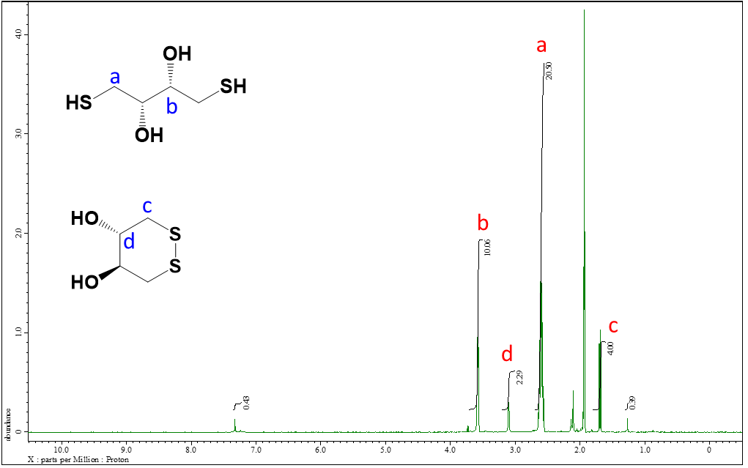
Figure S8 | ¹H NMR spectrum of CD₃CN phase used for purification of reaction product to assign. The eluates were identified as DTT and oxidised DTT.
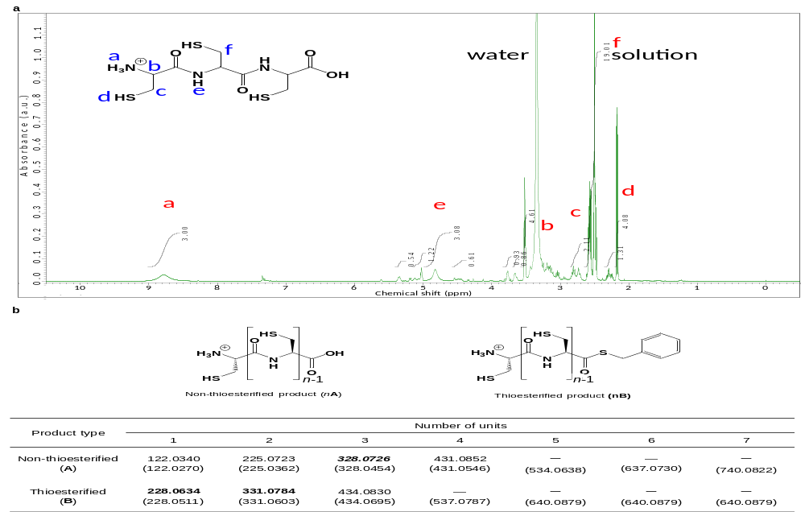
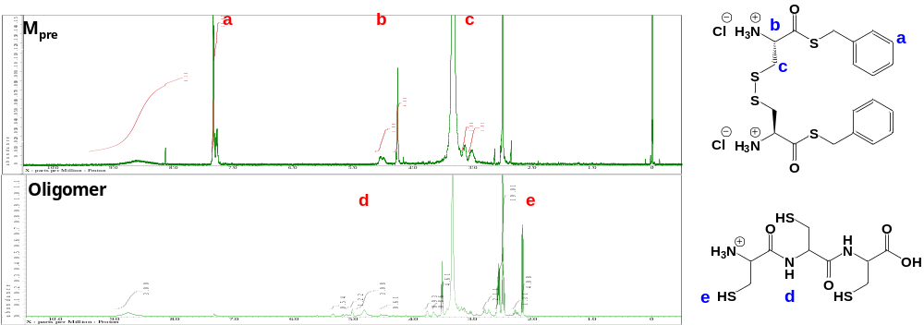
b
Figure S9 | ¹H NMR spectrum of purified product. a, ¹H NMR spectrum with DMSO-d₆ of the purified reaction product, identified as oligopeptides. b, Comparison with ¹H NMR spectra of M_{pre} and oligopeptide. The peak of the benzene ring (peak a in Fig. S9b) and the peaks near the disulfide (b, c) almost disappeared, while the amide proton (d) and thiol proton (e) were newly detected. The same small letters in the structural formula (blue) and spectrum (red) represent protons and their corresponding peaks.
a
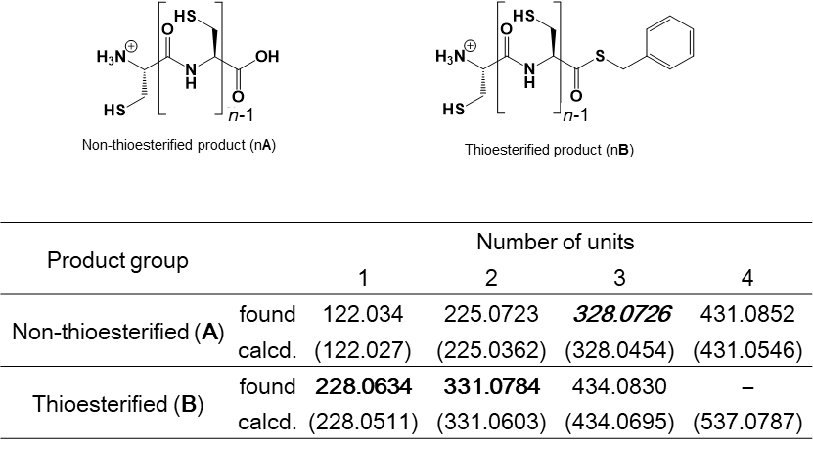

b
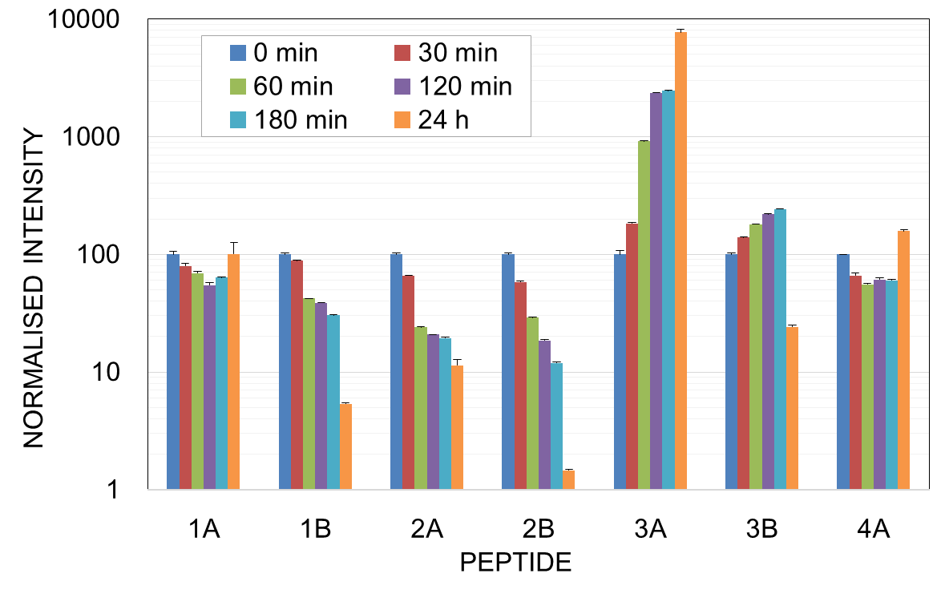
c
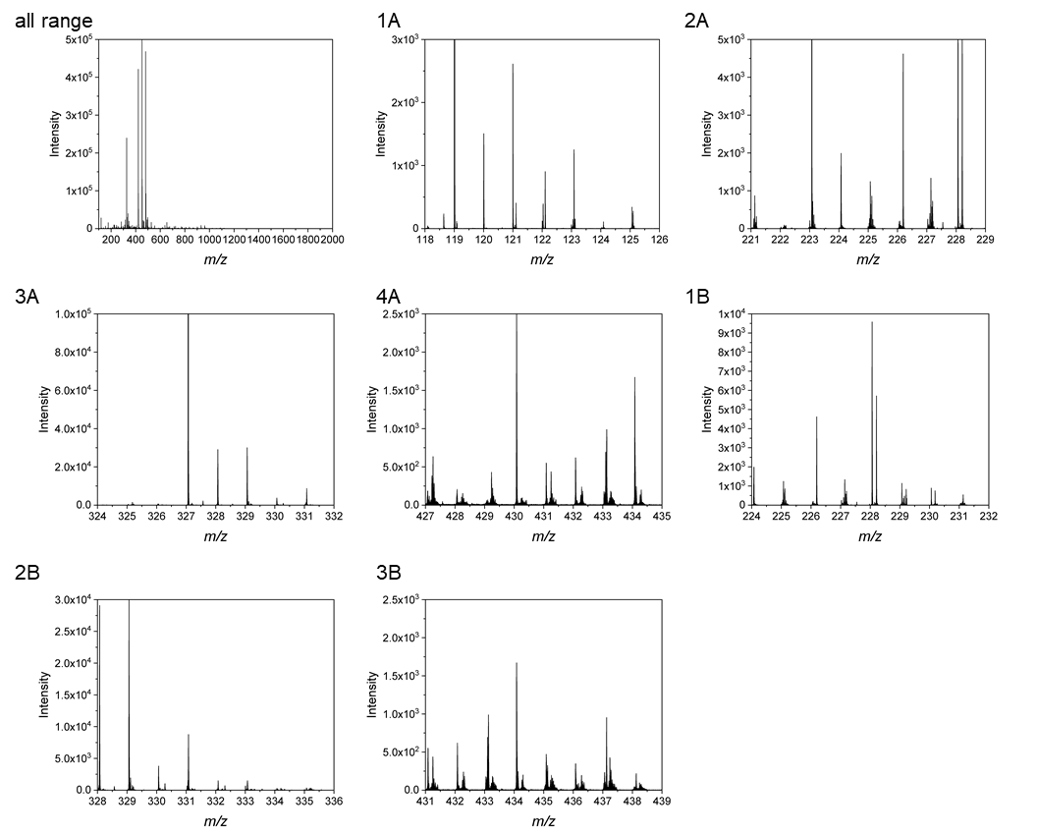
Figure S10 | ESI-TOF mass spectra and analysis of reaction products. a, The upper scheme indicates the molecular structures of the non-thioesterified (left) and thioesterified (right) product. Here, n is an integer of 1 or more, and n-1 means the number of units. The lower table shows the detected mass-to-charge ratio (m / z) values in the ESI-TOF mass spectrum. For the products 3 h after mixing M_{pre} and DTT, the m / z value of the monomers, dipeptides, tripeptides, tetrapeptides, pentapeptides and hexapeptides of non-thioesterified and thioesterified products were assigned by focusing on the only m / z value with more than 200 intensity values in the ESI-TOF mass spectrum. In the table, bold numbers indicate intensity values of 2000 or more, italic numbers indicate intensity values of 20000 or more, and - indicates no detection. b, The intensity changes over time of non-thioesterified peptide As and thioesterified peptide Bs in the dispersion were measured by ESI-TOF mass spectrometry. The vertical axis is the normalized intensity of each peptide (left to right, 1A, 1B, ...) detected in the sample at 0 min, where the initial intensity was set to 100. Smaller degrees of polymerisation (n = 1, 2) are decreasing with time, whereas larger degree of polymerisation (n = 3, 4) was found to increase at 24 h after. These results suggest that the peptide monomers were gradually polymerised to form oligopeptides. c, All m / z values obtained from the ESI-TOF mass spectrum were shown.
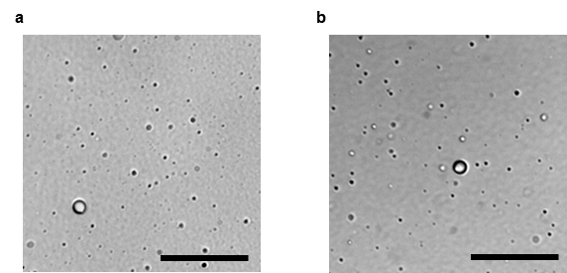
Figure S11 | DIC microscopy images of solutions. a, mixtures of oligopeptides (10 mM) and BnSH (10 mM). b, mixtures of oligopeptides (10 mM), BnSH (10 mM) and DTT (25 mM). The concentration of the these molecules were calculated from the conversion from M_{pre}. Both solutions formed droplets, indicating that the oligopeptides and BnSH were required for droplet formation. Scale bars represent 20 μm.

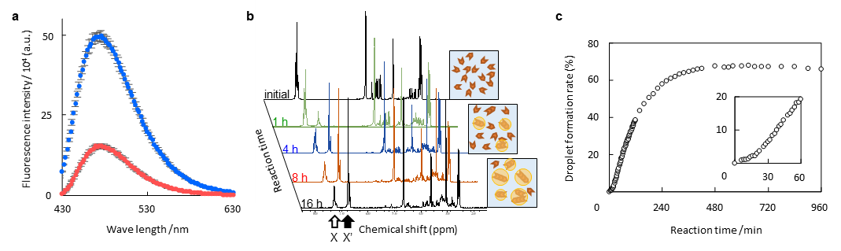
Figure S12 | Monitoring of droplet formation reaction by fluorescence spectroscopy and ¹H NMR. a, Fluorescence spectrum of fluorescamine in the solution 24 h after mixing 10 mM M_{pre} and 25 mM DTT (red), and in the solution of cysteine hydrochloride (20 mM, blue). The M_{pre} residual rate was calculated from the fluorescence intensity of the solution relative to that measured immediately after mixing M_{pre} and DTT, which was designated as 100%. b, Time evolution of ¹H NMR spectra of aqueous solution of M_{pre} (10 mM) and DTT (25 mM), monitored for 16 h after mixing. Peaks X and X' were assigned to the benzyl moieties before and after BnSH was removed, respectively. The droplet formation rate (%) was estimated from the integrated peak areas as 100 × X' / (X + X'). The ranges of chemical shifts for X and X' were 7.0-7.5 and 6.5-7.0, respectively. c, A plot of the droplet formation rate from 0 h to 16 h after addition.

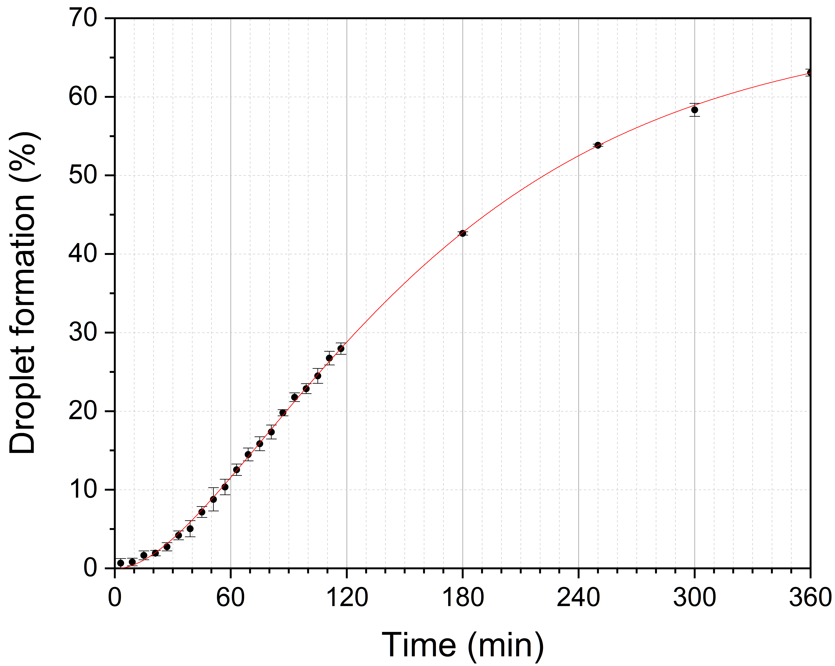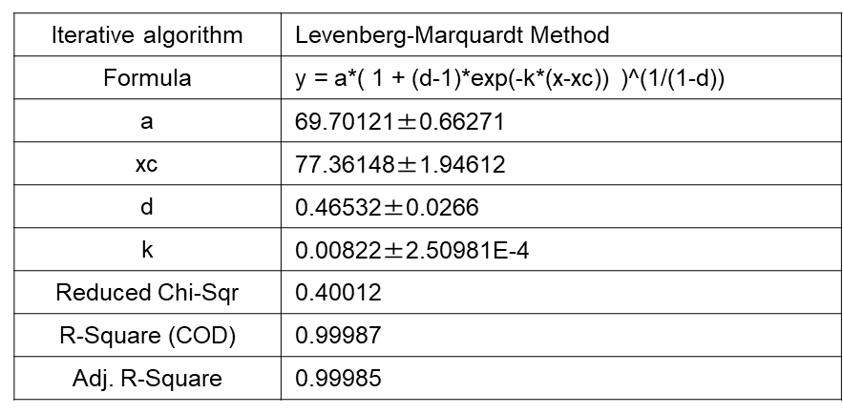
Figure S13 | Droplet formation rate from NMR measurement and the formula of sigmoidal curve. After adding 5 mg of M_{pre} and 4 mg of DTT to 1 mL of D₂O, the change in droplet formation rate was examined from ¹H NMR. The droplet formation rate was calculated from the integrated value (I) of the proton of the benzene ring with the peak shifted from 7.2 ppm-7.6 ppm (x) to 6.6 ppm-7.1 ppm (y). Droplet formation rate: =100×Iy/(Ix+Iy) %. Number of samples is 3, error bars represent standard deviation.

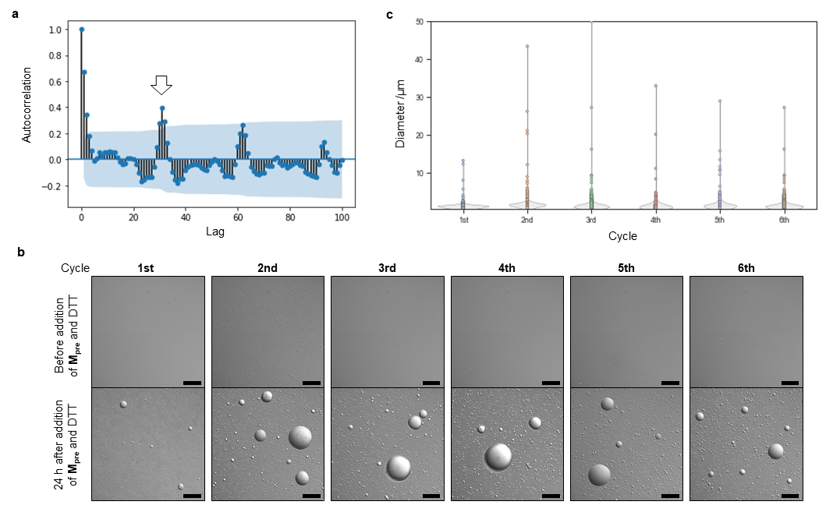
Figure S14 | Changes in LLPS droplet size during the growth-division process, induced by repeated nutrient addition and stimulus cycles. a, Correlogram of the LLPS droplet size changes with time shown in Fig. 4e. No significant differences emerged between the size distributions of the droplets measured in each cycle. The lag means how many measurement points were shifted in calculating the autocorrelation coefficient. (If lag = 0, that is no shift, the autocorrelation coefficient is 1.) Since the number of measurement points per period was 33 in this study, the significant maximum correlation exceeding the 95% confidence interval at lag 33 for the first time implies a high particle size recursiveness for each cycle. b, DIC microscopy images before and 20 h after addition of M_{pre} and DTT in each cycle. Sale bars represent 50 μm. c, Particle size distributions obtained from the analysis of DIC microscopy images 20 h after addition of nutrient in each cycle.

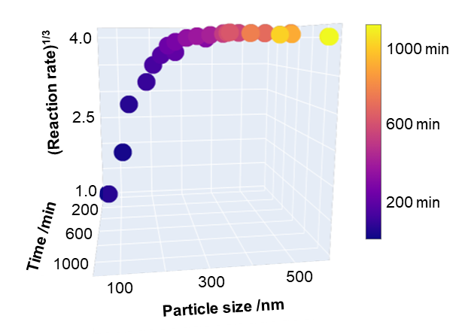
Figure S15 | Time-course changes in droplet size and reaction rate. Change in particle size and reaction rate over time. The cube root of the reaction rate was calculated from the droplet formation rate (Fig 3b). The reaction rate reached flat at about 3 h, whereas the increase in droplet size continued thereafter, although the growth rate of particle size was significantly lower.

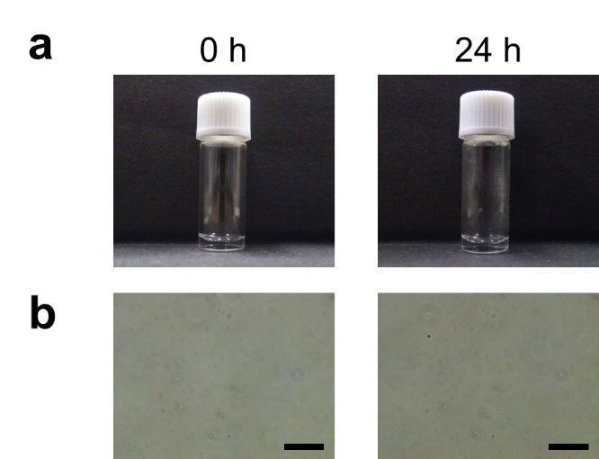
Figure S16 | a, Comparison of droplet dispersion in vial at 0 and 24 h. b, Comparison of phase contrast microscopy images of droplet dispersion at 0 and 24 h. Scale bars represent 50 μm. To show that the increase in size of the droplets is not a growth due to fusion, we performed the experiment that droplets does not increase in size in the case of droplet only. A droplet dispersion was prepared 24 h after the addition of M_{pre} (5 mg) and DTT (4 mg) to water (1 mL). The droplet dispersion was filtered through a 100 nm pore size membrane filter, and the solutions were compared between immediately and 24 h after the addition of an equal amount of water.
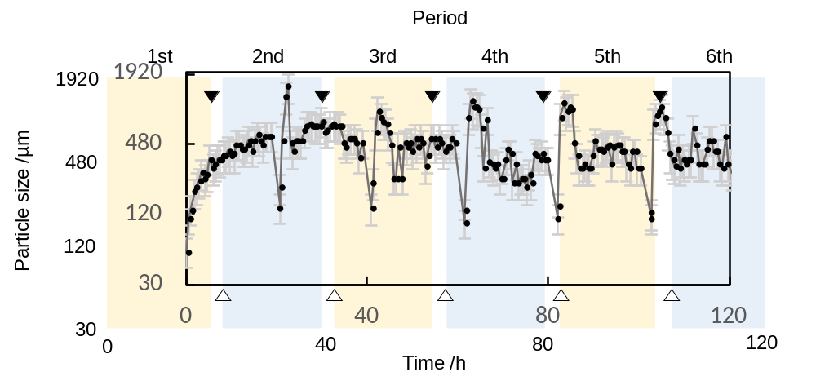 Figure S17 | A raw image of Figure 4e.

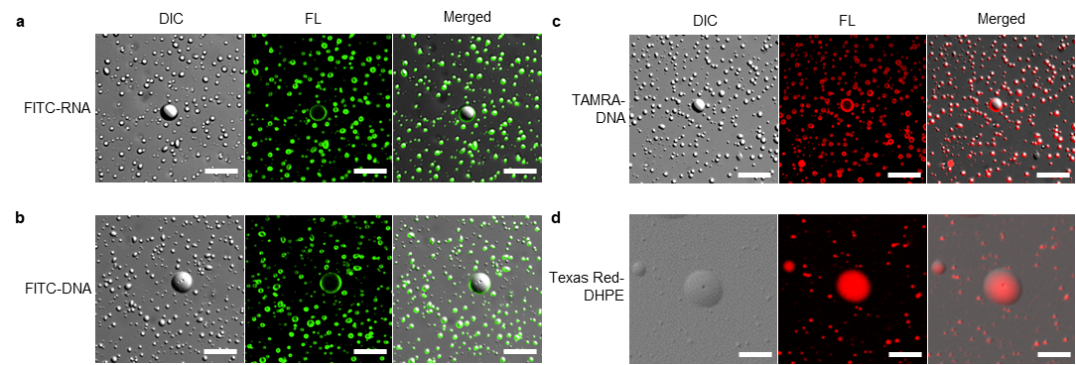
Figure S18 | CLS fluorescence microscopy images of the LLPS droplet dispersion after addition of a, the FITC-RNA, b, FITC-DNA, c,TAMRA-DNA, or d, Texas Red-DHPE (1,2-dihexadecanoyl-sn-glycero-3-phosphoethanolamine) solutions; both the individual (FL) and merged signals are shown. Concentration of all solutions were 1 μM. The LLPS droplet dispersions were captured at 30 min after addition of nucleic acid solutions (a-c) and at 16 h after addition of the lipid solution (d). The scale bars represent 20 μm.

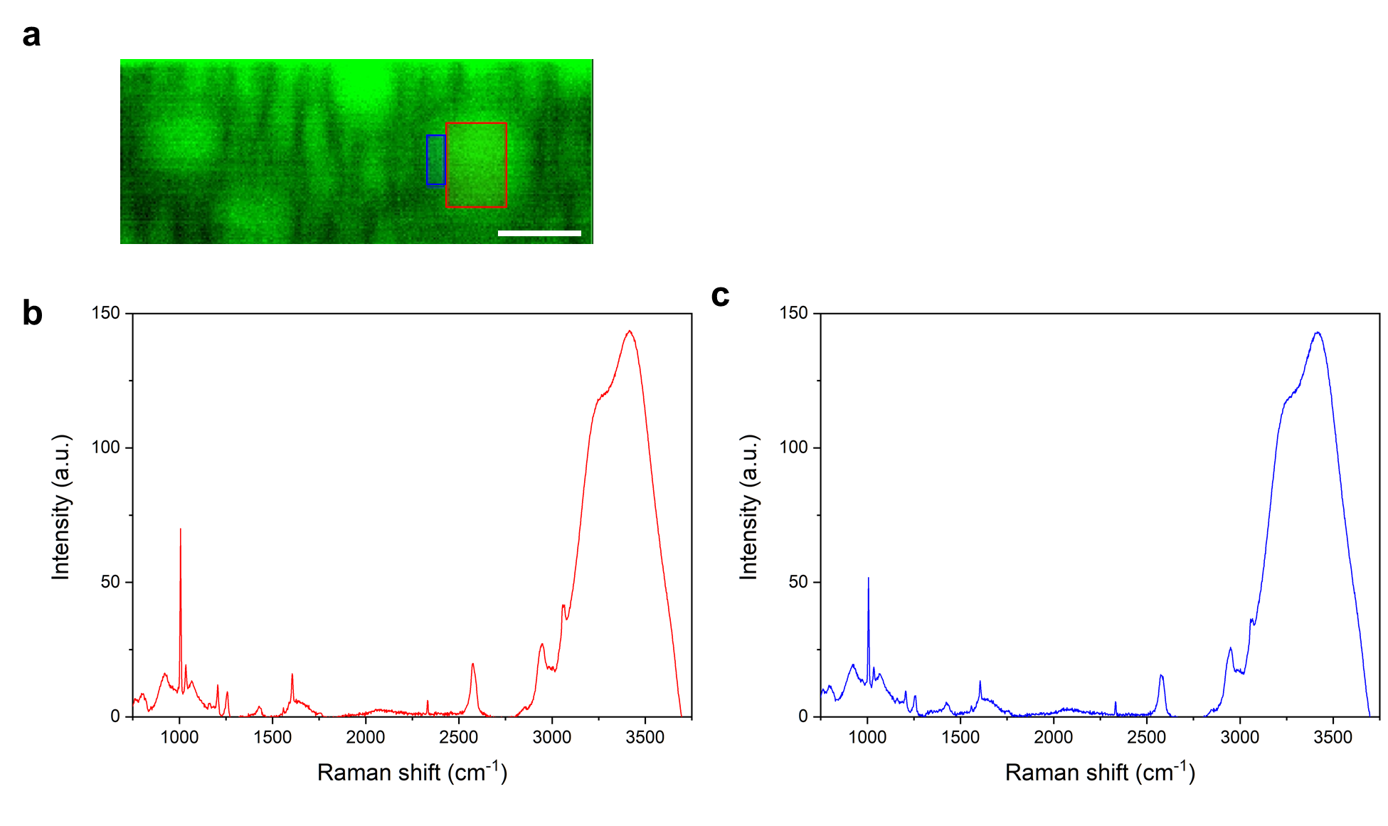
Figure S19 | Raman microspectrometry of a LLPS droplet. a, Raman imaging of a LLPS droplet. The red rectangle represents one typical central part of a measured droplet. The blue rectangle represents one typical peripheral part of a measured droplet. The scale bar represents 20 μm. b, Raman spectra of the central part of the droplet (red rectangle in Fig.S19a). The average value was calculated from the spectrum obtained at the four-regions observation of the four red different rectangles, i.e. the central parts, in the same droplet and the baseline-corrected spectrum were shown. Based on the obtained spectral data, the C(B/W) was calculated to be 0.37±0.016, c, Raman spectra of the peripheral parts of the droplet (blue rectangle in Fig.S19a). The spectrum obtained at the four-regions observation of the four blue different rectangles, i.e. the peripheral parts, in the same droplet was shown. The P(B/W) was calculated to be 0.29±0.038. The p-value between C(B/W) and P(B/W) is 0.031 (p<0.05) calculated by Mann-Whitney U test, which is considered statistically significant. This result indicates that the central part is more hydrophobic than the peripheral part in the droplets.
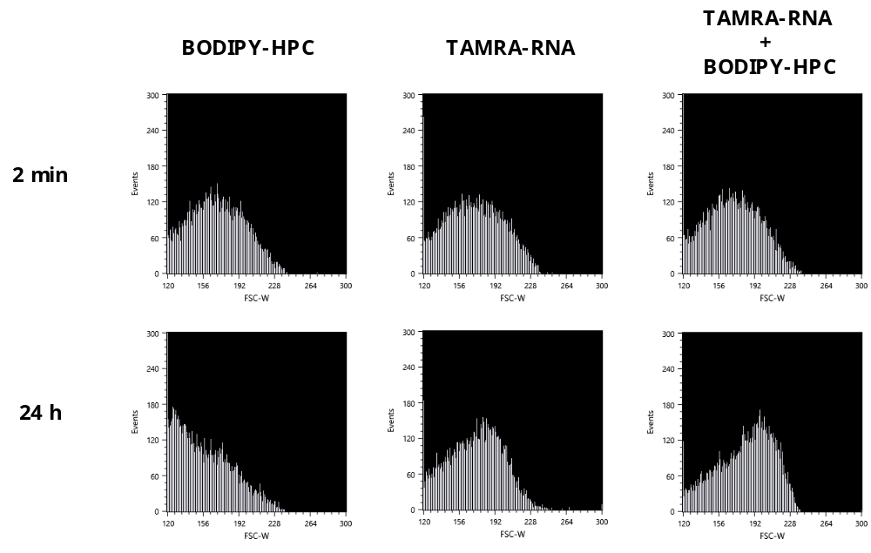
Figure S20 | FACS analysis on particle size distribution of the droplets at 2 min (upper) or 24 h (bottom) after addition of BODIPY-HPC and/or TAMRA-RNA. In these histograms, x-axis represents the forward-scattering light pulse width (FSC-W), which reflects the particle size, and the y-axis represents the number of events. When BODIPY-HPC was added to the LLPS dispersion, the distribution shifted significantly to the left in the histogram after 24 h compared to that after 2 min. This means that the particle size of LLPS droplets decreased. On the other hand, no such decrease in FSC-W values, that is, the decrease in the droplet size, was found when TAMRA-RNA only or both TAMRA-RNA and BODIPY-HPC were added to the droplet. These results mean that TAMRA-RNA suppressed the size reduction effect due to BODIPY-HPC addition.
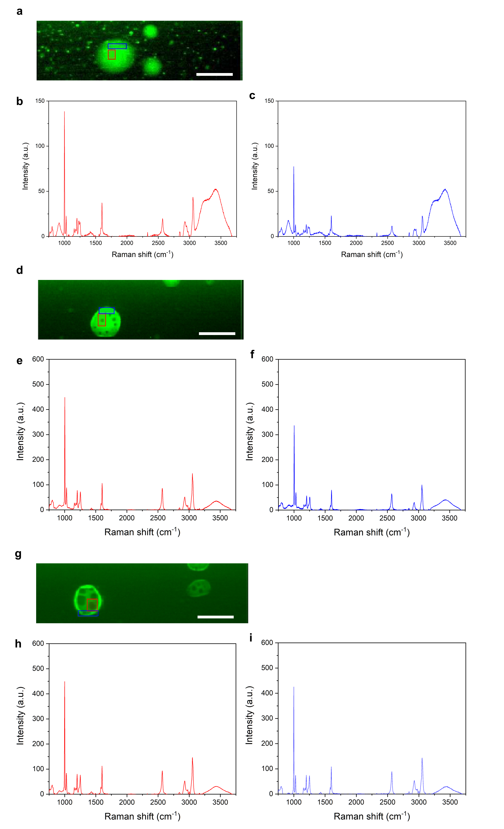
Figure S21 | Raman microspectroscopy of a LLPS droplet incorporation DNA and/or lipids. DNA and lipids were added to the droplets in order to examine the droplets' incorporation ability and retention ability of the nucleic acid/lipid of the droplets. Raman microspectroscopy were conducted using stable DNA as a nucleic acid and DPPC with double-stranded saturated alkyl chains as a lipid. a, Raman imaging of a LLPS droplet containing DNA. The red rectangle represents one typical central part of a measured droplet. The blue rectangle represents one typical peripheral part of a measured droplet. The scale bar represents 20 μm. b, Raman spectra of the central part of the droplet containing DNA (red rectangle in Fig.S21a). The average value was calculated from the spectrum obtained at the four-regions observation of the four red different rectangles in the same droplet and the baseline-corrected spectrum were shown. Based on the obtained spectral data, the C(B/W) was calculated to be 2.4±1.8. c, Raman spectra of the peripheral parts of the droplet containing DNA (blue rectangle in Fig.S21a). The spectrum obtained at the four-regions observation of the four blue different rectangles in the same droplet was shown. The P(B/W) was calculated to be 1.8±2.0. The p-value between C(B/W) and P(B/W) is 0.0012 (p<0.05) calculated by Mann-Whitney U test. These values are summarized in the Table S1. This result indicates that the central part is more hydrophobic than the peripheral part in the droplets. The intensity of the DNA's phosphate peaks (784 cm⁻¹, 830 cm⁻¹, 1090 cm⁻¹)² in the spectra were quite weak. This may be due to the possibility that the amount of DNA intruded into a droplet is quite small compared to that of constituents of the droplet, and also due to the possibility that the DNA was damaged by the laser irradiation at this measurement time. When DNA was added, the central region was also found to be more hydrophobic. d, Raman imaging of a LLPS droplet containing DPPC. The red rectangle represents one typical central part of a measured droplet. The blue rectangle represents one typical peripheral part of a measured droplet. The scale bar represents 20 μm. Raman imaging showed that the internal hydrophobic droplets were clearly visible compared to the sample without lipids (Fig. S18, Fig. S21a). e, Raman spectra of the central part of the droplet containing DPPC (red rectangle in Fig.S21d). The average value was calculated from the spectrum obtained at the four-regions observation of the four red different rectangles in the same droplet and the baseline-corrected spectrum were shown. Peaks were found in the DPPC-derived region (1050-1200 cm⁻¹)². Based on the obtained spectral data, the C(B/W) was calculated to be 9.5±3.4. f, Raman spectra of the peripheral parts of the droplet containing DPPC (blue rectangle in Fig.S21d). The spectrum obtained at the four-regions observation of the four blue different rectangles in the same droplet was shown. The P(B/W) was calculated to be 5.8±10. The p-value between C(B/W) and P(B/W) is 0.13 calculated by Mann-Whitney U test. These values are summarized in the Table S1. g, Raman imaging of a LLPS droplet containing DNA and DPPC. The red rectangle represents one typical central part of a measured droplet. The blue rectangle represents one typical peripheral part of a measured droplet. The scale bar represents 20 μm. h, Raman spectra of the central part of the droplet containing DNA and DPPC (red rectangle in Fig.S21g). The average value was calculated from the spectrum obtained at the four-regions observation of the four red different rectangles in the same droplet and the baseline-corrected spectrum were shown. Based on the obtained spectral data, the C(B/W) was calculated to be 17±3.5. i, Raman spectra of the peripheral parts of the droplet containing DPPC (blue rectangle in Fig.S21g). The spectrum obtained at the four-regions observation of the four blue different rectangles in the same droplet was shown. The P(B/W) was calculated to be 15±7.3. The p-value between C(B/W) and P(B/W) is 0.0040 (p<0.05) calculated by Mann-Whitney U test. These values are summarized in the Table S1. Compared S19 with S21, since the intensity of the peaks derived from the water (3400 cm⁻¹) decreases, B/W values in not only the central but peripheral areas increased relatively. It was suggested that the water inside the droplet might be replaced by hydrophilic DNA and amphiphilic phospholipids.
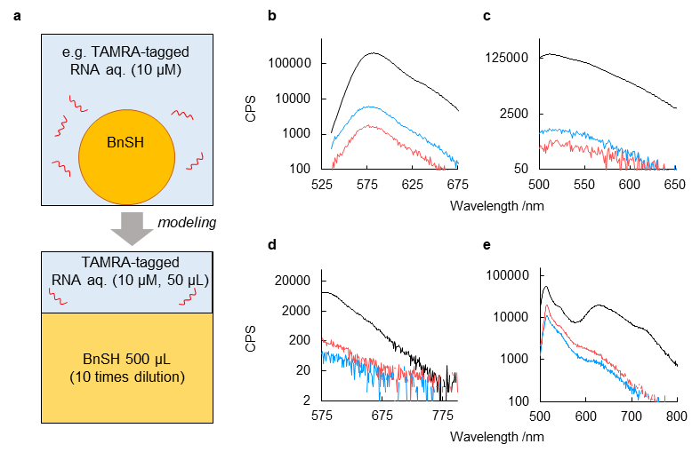
Figure S22 | Fluorescence spectroscopy analysis of the concentration of biopolymers by oligopeptides. a, Scheme of this experiment. In the case of addition of biopolymers to droplet, that is nucleic acids and lipids exist with BnSH, the extent to which those biopolymers are incorporated in BnSH and water is investigated. As a modelled experiment, each solution containing a fluorescent labelled biopolymer (nucleic acid /lipid, 10 µM, 50 µL) was layered on a 10-fold diluted BnSH solution (500 µL). The fluorescence intensity of the biopolymers in the water and BnSH solution was measured by a fluorescence spectrometer. (b-e) Fluorescence spectra of aqueous solutions containing RNA oligomers or phospholipids loaded on the BnSH layer solutions: black, before loading; red, aqueous solution containing oligopeptides 24 h after loading; blue, aqueous solution without oligopeptides 24 h after loading. b, TAMRA-tagged RNA. c, FITC-tagged RNA. d, Texas Red-tagged DHPE. e, BODIPY-tagged HPC. In the presence of RNA, the fluorescence intensity of the aqueous layer containing the oligopeptides was less than one-third of that of the aqueous layer without the oligopeptides, and decreased to 1% or less of that before loading (b, c). However, in the case of phospholipids, no differences in fluorescence intensities associated with the presence of the oligopeptides were observed, although the fluorescence intensity decreased to nearly one-third that of that before layering (d, e).
Supplementary Table
Table S1. Summary of Raman microspectroscopy of a LLPS droplet with/without DNA and/or lipids.
 | DNA | phospholipid | C(B/W) | P(B/W) | p value
S19a | - | - | 0.37±0.016 | 0.29±0.038 | 0.031
S21a | + | - | 2.4±1.8 | 1.8±2.0 | 0.0012
S21d | - | + | 9.5±3.4 | 5.8±10 | 0.13
S21g | + | + | 17±3.5 | 15±7.3 | 0.0040

Supplementary Movie
Movie S1. Droplet formation. Differential interference microscopy video showing the LLPS-droplet formation after the addition of M_{pre} and DTT. The movie was recorded from immediately after addition to 12 hours. The playback speed is 4320 times. The scale bar represents 50 μm.
Movie S2. Droplet fusion. Differential interference microscopy video showing the droplet fusion during formation of droplet (Trimmed movie of Movie S1). The movie was recorded from immediately after addition of M_{pre} and DTT to 12 hours. The playback speed is 4320 times. The size of the field of view is 50 μm×50 μm.

Supplementary References
1. Matsuo, M. et al. DNA length-dependent division of a giant vesicle-based model protocell. Scientific Reports 9, doi:10.1038/s41598-019-43367-4 (2019).
2. Kuhar, N., Sil, S., Verma, T. & Umapathy, S. Challenges in application of Raman spectroscopy to biology and materials. RSC Advances 8, 25888-25908, doi:10.1039/C8RA04491K (2018).

