Supplementary material

Patch-clamp validation of SPRM-detected oscillations in MIN6 beta-cells
To provide evidence that the oscillations observed via Surface Plasmon Resonance Microscopy (SPRM) reflect underlying bioelectrical activity, we performed patch-clamp recordings on MIN6 cells under experimental conditions matching those used during SPRM.
Materials and Methods
The methods were similar to those previously published¹ and are presented here in brief.
Cell Culture
MIN6 pancreatic beta-cells were cultured following previously established protocols. Cells were maintained in RPMI 1640 medium supplemented with 11 mM glucose, 10% fetal bovine serum (FBS), 10 mM HEPES, and 50 µg/mL penicillin-streptomycin. For patch-clamp experiments, cells were seeded onto glass coverslips and incubated for 24 hours prior to measurements under the standard tissue culture conditions described above.
Solutions
Pipettes were filled with a solution containing in mM: 140 KCl, 2.5 CaCl₂, 1.2 MgCl₂, and 10 HEPES (pH 7.4 with NaOH). The external bath solution was Hanks’ Balanced Salt Solution (HBSS). To stimulate electrical activity, 10 mM glucose was added. Nifedipine (10 µM final concentration) was applied from a 20 mM DMSO stock after glucose stimulation. Experiments were performed at 33 °C.
Patch-Clamp Recording Protocol
Recordings were performed using the cell-attached configuration, with pipettes held at 0 mV. Currents were recorded using an Axoclamp 1B amplifier (Molecular Devices), low-pass filtered at 500 Hz (8-pole Bessel), and digitized at 10 kHz using LabChart 8 (ADInstruments).
Data Analysis
Spike detection
Spikes were identified using a dynamic, threshold-based detector in MATLAB. Each recording segment (before/after drug application) was analyzed independently. The baseline was estimated as the median of the signal, and the noise level was estimated using the median absolute deviation (MAD) (robust σ). Spikes were defined as downward deflections exceeding baseline − 3 × noise, with a 50 ms refractory period to reduce false positives. Spike frequency was computed dynamically using non-overlapping 5-second windows, and the mean spike frequency was reported for each condition: HBSS (0 mM glucose, baseline), HBSS containing 10 mM glucose and HBSS containing 10 mM glucose and 10 µM nifedipine.
Statistical comparison of interspike intervals
To test the effect of nifedipine on firing dynamics, interspike interval (ISI) distributions under 10 mM glucose versus 10 mM glucose supplemented with nifedipine were compared using a two-sample Kolmogorov–Smirnov (KS) test for cells where both conditions contained ≥ 2 spikes. For cells where nifedipine completely suppressed spiking activity, this was recorded as complete functional inhibition without statistical comparisons. Significant differences (p < 0.05) were interpreted as evidence of altered calcium channel function.
Results
Three experimental conditions were tested on MIN6 cells: (1) HBSS alone (baseline), (2) HBSS containing 10 mM glucose, and (3) HBSS containing 10 mM glucose and 10 µM nifedipine. Figure S1 shows three representative cell recordings illustrating the effects of glucose and nifedipine on action current activity in MIN6 cells. In the absence of glucose (HBSS), cells displayed spontaneous electrical activity at a lower spike frequency. Glucose stimulation increased spike frequency, consistent with calcium-dependent electrical excitability. Nifedipine application reduced or abolished these oscillations, confirming the involvement of L-type calcium channels. In two cases, nifedipine fully suppressed spiking, precluding statistical comparison but clearly indicating functional inhibition.
Statistical analysis of ISI distributions provided quantitative evidence for nifedipine’s inhibitory effects. For Cell 1 (Fig. S1a), spikes were detected under both glucose and nifedipine. The KS test indicated a significant difference in ISI distributions (p = 1.05 × 10⁻³), suggesting that nifedipine decreases firing dynamics. However, cell 2 (Fig. S1b) showed no detectable spikes under nifedipine treatment, making statistical comparison impossible. This complete suppression is considered a functionally meaningful indicator of calcium channel blockade. Cell 3 (Fig. S1c), under nifedipine treatment, showed significantly altered ISI distributions (p = 1.03 × 10⁻³), indicating a decrease in firing behavior.

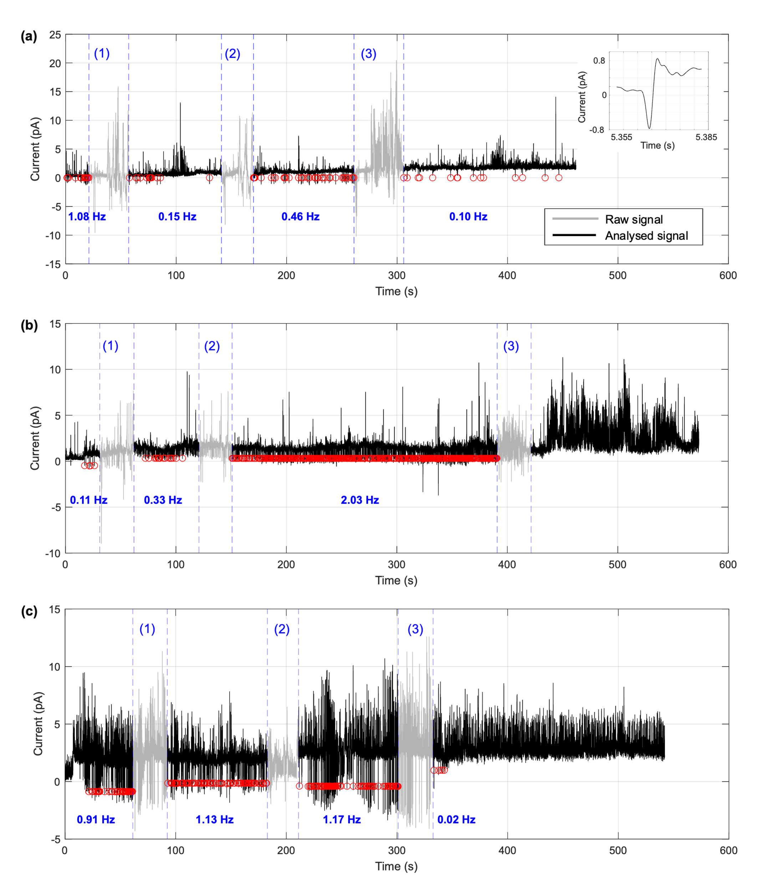
Figure S1. Patch-clamp validation of SPRM observations. Representative cell-attached patch-clamp recordings of MIN6 cells from three experiments (in a, b, and c respectively) under three conditions: (1) HBSS without glucose (baseline), (2) HBSS with 10 mM glucose, and (3) HBSS with 10 mM glucose and 10 µM nifedipine. Two types of currents were recorded: upward positive deflections due to spontaneous activity of KATP potassium channels and downward negative deflection associated with action potential. The decrease in both amplitude and frequency of the KATP channels with glucose is a hallmark of pancreatic beta-cell electrophysiology². Software-identified downward currents representing action currents are flagged with a circle. Glucose induces higher frequency oscillatory inward currents, which are suppressed upon nifedipine treatment, consistent with the activation and subsequent blockade of voltage-gated calcium channels characteristic for this cell type². These findings support the interpretation that SPRM-detected oscillations arise from underlying bioelectrical signaling. Grey shaded regions in the traces represent background perfusion noise. In panels (a–c), Numbers indicate the averaged spike frequency for each condition (1–3), computed using non-overlapping 5-second windows.
Conclusion
Across all cells tested, nifedipine reduces or abolishes glucose-evoked spiking in MIN6 β-cells, consistent with L-type Ca²⁺ channel inhibition and supporting a bioelectrical origin for the SPRM-detected oscillations.
References
1. Smith, P. A., Sellers, L. A. & Humphrey, P. P. Somatostatin activates two types of inwardly rectifying K+ channels in MIN-6 cells. The Journal of physiology 532, 127 (2001).
2. Ashcroft, F. M. & Rorsman, P. Electrophysiology of the pancreatic β-cell. Progress in biophysics and molecular biology 54, 87–143 (1989).

