Supplemental material
Epidemiological and Clinical Characteristics, Transmissibility, and Associated Factors of HAdV in Wuhan, China (2023-2024): Insights from a Multi-Center Public Health Surveillance System

Appendix 1. Integrated Disease Surveillance and Early Warning System (IDSEWS)
The Integrated Disease Surveillance and Early Warning System (IDSEWS) was a multi-center public health surveillance initiative that consolidates data related to acute respiratory infections (ARIs) from electronic medical records (EMR), hospital information management systems (HIS), laboratory information systems (LIS), and picture archiving and communication systems (PACS) across 294 healthcare institutions in Wuhan, utilizing a standardized format established in 2023.

Healthcare institutions were selected proportionally based on the population size of different districts. Institutions with broad community coverage and the capability to conduct standard laboratory testing and public health surveillance were chosen. All participating institutions adhered to a standard surveillance protocol, which included guidelines for patient definition, specimen collection, laboratory testing, data recording, reporting, and management, developed by the Wuhan Center for Disease Control and Prevention (Wuhan CDC). Training on this protocol was provided to all institutions before surveillance commenced.

Patients diagnosed with upper respiratory tract infections (URTI) or community-acquired pneumonia (CAP) in either outpatient or inpatient settings at any participating healthcare institution were included in the surveillance system. URTI and CAP were defined according to the Guidelines for Diagnosis and Treatment of URTI and the Guidelines for Diagnosis and Treatment of CAP in China, respectively ¹⁻³. Case diagnosis and management followed the various respiratory infection prevention and control technical guidelines published by the Chinese Center for Disease Control and Prevention.

Data on individual demographics, clinical manifestations, laboratory test results, and outcomes from participating institutions were gathered through a meticulous review of medical records. All information was subsequently uploaded to the online surveillance system, with daily updates and organization conducted by the Wuhan CDC as an integral component of routine public health surveillance.

Appendix 2. Case definitions and laboratory procedures
In the IDSEWS, the diagnosis and management of human adenovirus (HAdV) were informed by the “Technical Guidelines for Prevention and Control of Human Adenovirus Respiratory Infection” (2019 edition) and the guidelines for the diagnosis and management of severe acute hepatitis in children of unknown origin (2022 edition) ^{4,5}, all under the established standard surveillance protocol, with case definitions as follows:

Suspected case: (1) a history of close contact with a confirmed HAdV case within 8 days before onset; (2) an individual aged 16 years or younger presenting with acute hepatitis (excluding hepatitis A, B, C, D, or E) and serum aminotransferases surpassing 500 IU/L (alanine aminotransferase, ALT, or aspartate aminotransferase, AST); (3) a travel history to HAdV-endemic regions accompanied by symptoms of acute respiratory infection, such as fever and cough.

Clinically diagnosed case: one exhibiting clinical manifestations of respiratory infection or acute hepatitis, along with a history of close contact with a confirmed HAdV case or acute hepatitis case within 8 days before onset.

Laboratory-confirmed cases: These were clinically diagnosed cases that, irrespective of epidemiological history, included any of the following test results: (1) respiratory specimens testing positive for HAdV-specific nucleic acid; (2) respiratory specimens testing positive for HAdV-specific antigen; (3) isolation and culture of HAdV from respiratory specimens; or (4) a transition from negative to positive for HAdV-specific IgG antibody in paired serum samples taken during the acute and recovery stages (with a sampling interval of 2-4 weeks), or a fourfold or greater increase in antibody levels. Laboratory procedures rigorously comply with the established surveillance protocol, as illustrated in Figure. 1.

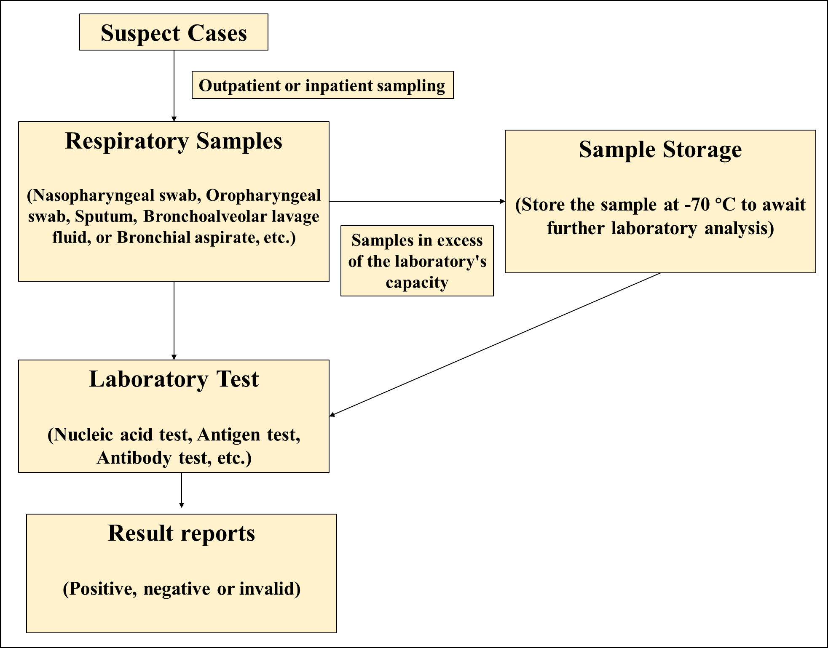

Figure. 1. The flowchart of the laboratory procedures for HAdV.

Appendix 3. Procedures for the data extraction from the IDSEWS
Data from the IDSEWS spanning January 2023 to May 2024 were amassed (n = 522,292,680). This dataset encompasses patient ID, sex, age, incidence date, diagnostic date, clinical diagnosis information (including clinical diagnosis names, chief complaint, and present history), hospitalization details, severe illness, and mortality information, as well as laboratory diagnosis specifics.

From this large dataset, we identified individuals clinically suspected of having HAdV who underwent testing. After data cleaning, we excluded 2,292 cases: 245 with duplicate records, 481 with onset dates outside of 2023 (e.g., 1900-01-01), 616 with illogical values (e.g., age recorded as "-99"), 522 with corrupted data (e.g., 'spanxxxspan'), and 428 with missing information (e.g., "Null"). Among the remaining 683,868 eligible patients, those with positive HAdV laboratory results were classified as confirmed cases, yielding 14,841 confirmed HAdV cases for the study.

To analyze the symptom profile of HAdV, we extracted symptoms from the chief complaint and medical history using regular expressions and mapped them to the Chinese Symptom Knowledge Base (CSKB) ⁶. The CSKB is a publicly available resource with 8,772 symptoms commonly used in Chinese medical natural language processing. After extracting symptom data, we excluded 4,696 HAdV cases with invalid symptom information, including visits for physical exams (n=2,654), preoperative exams (n=1,491), and removal of internal fixation devices (n=551). As a result, 10,145 HAdV cases with valid symptom data were included in the analysis, as illustrated in Figure. 2.
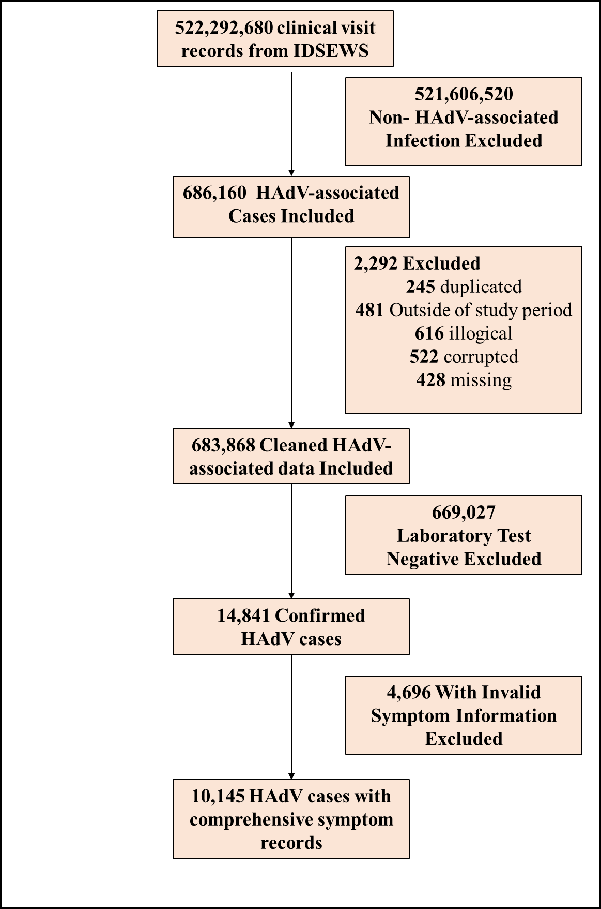

Figure.2. The flowchart of the HAdV-associated data procedure.

Appendix 4. Mathematical model development
Here, We developed a susceptible-exposed-asymptomatic-infectious-removed $(SEAIR)$ model based on the natural history of HAdV, as illustrated in Figure. 3. The total population $(N)$ was divided into five compartments: $S$ (susceptible), $E$ (exposed), $A$ (asymptomatic infected), $I$ (symptomatic infected), and $R$ (recovered). The model was based on the following assumptions:
a. HAdV transmission occurs when susceptible individuals contact symptomatic or asymptomatic infected individuals, with the transmission rate$β$, We assume the proportion of asymptomatic infected individuals was $q$, and their transmissibility was $κ$ times that of symptomatic individuals.
b. Exposed individuals undergo an incubation period$1/{ω_{S}}$ and latent period $1/{ω_{A}}$ before becoming symptomatic or asymptomatic, respectively. Symptomatic and asymptomatic individuals recover after an average period of $1/{γ_{S}}$ and $1/{γ_{A}}$, respectively. A fraction of symptomatic individuals will die, with a case fatality rate$f$.
c. We consider the effects of natural birth and death rates on HAdV transmission dynamics, defined as $b_{r}$ and $d_{r}$. The number of new births was $Λ = N*b_{r}$.
d. We do not consider transmission via contaminated objects due to a lack of data, and zoonotic transmission was omitted due to insufficient evidence.
The equations for the model were as follows:
$$\begin{aligned}\frac{dS}{dt}=Λ-βSI -{ d}_{r}S\#\left(1\right)\end{aligned} \\ \begin{aligned}\frac{dE}{dt}=βSI- (1-q{ )ω}_{s}E - qω_{A}E{- d}_{r}E\#\left(2\right)\end{aligned} \\ \begin{aligned}\frac{dI}{dt}=(1-q{ )ω}_{s}E - γ_{S}I{- (d}_{r}+f) I\#\left(3\right)\end{aligned} \\ \begin{aligned}\frac{dA}{dt}=qω_{A}E - γ_{A}A{- d}_{r}A\#\left(4\right)\end{aligned} \\ \begin{aligned}\frac{dR}{dt}=γ_{A}A+ γ_{s}I{- d}_{r}R\#\left(5\right)\end{aligned} \\ \begin{aligned}N=S+E+I +A +R\#\left(6\right)\end{aligned}$$
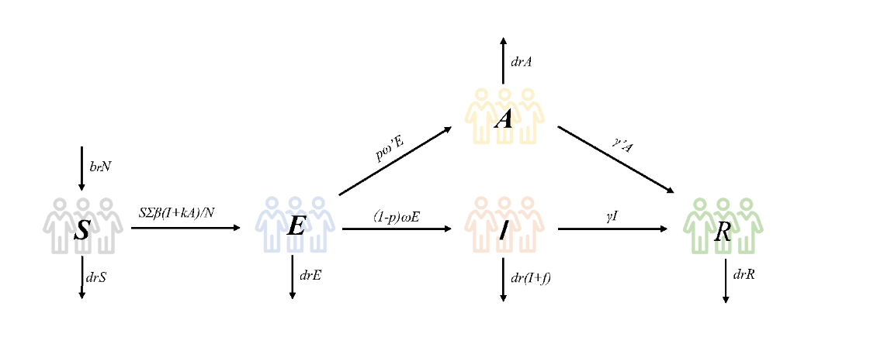

Figure. 3. Flowchart of the Susceptible–Exposed–Asymptomatic–Infectious–Recovered (SEAIR) model.

The parameters are presented in Table 1. We use the basic reproduction number ($R_{0}$) and real-time reproduction number ($R_{t}$) to estimate the transmissibility of HAdV. The equation for $R_{0}$ was derived using the next-generation matrix (NGM) method as follows:
(1) Divide ($S,E, I, A, R$) into two categories: infected ($E, I, A$) and non-infected ($S, R$).
(2) Divide the derivative of ($E, I, A$) into two parts: $F$ represents the rates of new infections, $V$ represents the rates of transition between ($E, I, A$).

$$F - V =\left[\begin{matrix}βS(I + κA) /N \\ 0 \\ 0\end{matrix}\right]- \left[\begin{matrix}pω_{2}E +(1-p)ω_{1}E +drE \\ -(1-p)ω_{1}E + (γ_{1}+f+dr)I \\ - pω_{2}E +(γ_{2}+dr)A\end{matrix}\right]$$

(3) Take derivatives of the vector-valued functions$F$ and $V$ to ($E, I, A$) to obtain the Jacobian matrices $JF$ and $JV$:
$JF =\left(\begin{matrix}0 & \frac{βS}{N} & \frac{kβS}{N} \\ 0 & 0 & 0 \\ 0 & 0 & 0\end{matrix}\right)$

$$JV = \left(\begin{matrix}dr +ω_{1}(1-p)+ω_{2}p & 0 & 0 \\ ω_{1}(p-1) & γ_{1}+f+dr & 0 \\ - ω_{2}p & 0 & dr + γ_{2}\end{matrix}\right)$$

(4) Construct the next generation matrix $G = FV^{-1}$. At the disease-free equilibrium ($S,E, I, A, R) = (N, 0, 0, 0,0)$,$R_{0}$ is the leading eigenvalue of $G:$

$$R_{0}= \frac{β(drω_{2}p - drω_{1}p + drω_{1} + fkω_{2}p +γ_{1}{k ω}_{2}p - γ_{2}ω_{1}p + γ_{2}ω_{1})}{(dr + γ_{2})(γ_{1}+f+dr)(dr + ω_{1} +ω_{2}p-ω_{1}p)}$$
The $R_{t}$ was estimated using the Sequential Bayesian (SB) method ^{7,8} with the ‘R0’ package (version 1.3-1) in R software (version 4.1).

Since five parameters were estimated from references or assumed, some uncertainty may affect the model results. Consequently, a sensitivity analysis was conducted by varying these parameters based on methods from our previous research ^{9,10}. The ranges of these parameters, shown in Table 1, were divided into 1,000 values and simulated separately. The prevalence from each simulation was used to calculate the average prevalence and the average prevalence ± the standard deviation.

Table 1. Definitions and Values of Parameters in the Mathematical Model.
Parameter | Description | Unit | Values | Range | Source
$$β$$ | Transmission relative rate from person to person | - |  | ≥0 | Curve fit
k | Relative transmissibility of asymptomatic to symptomatic individuals | 1 | 0.500 | 0.000 - 1.000 | Assumed
p | proportion of asymptomatic individuals | 1 | 0.092 | 0.000 – 0.195 | Actual data
$$ω_{S}$$ | Incubation relative rate | days-1 | 0.140 | 0.071 – 0.500 | ^{11,12}
$$ω_{A}$$ | Latent relative rate | days-1 | 0.200 | 0.071 – 0.500 | ^{11,12}
$$γ_{s}$$ | The recovery rate of symptomatic individuals | days-1 | 0.125 | 0.071 - 0.500 | ^{11,12}
$$γ_{A}$$ | The recovery rate of asymptomatic individuals | days-1 | 0.200 | 0.071 - 0.500 | ^{11,12}
$$b_{r}$$ | Birth rate of the population | 1 | 4.567e-4 | 0.000 - 1.000 | Wuhan Statistical Yearbook
$$d_{r}$$ | The death rate of the population | 1 | 7.192e-4 | 0.000 - 1.000 | Wuhan Statistical Yearbook
f | Case fatality rate | 1 | 0.000 | 0.000 - 0.498 | Actual data

The mathematical model parameters were fitted using the least squares method. To evaluate the goodness of fit, we use criteria including the coefficient of determination (R²), Mean Squared Error (MSE), Mean Absolute Error (MAE), and Root Mean Squared Error (RMSE). A higher R² and lower error values for the other indices indicate a better fit. Based on the best-fitting results, we forecast the epidemic scale of the 2024-2025 HAdV season.

Appendix 5. Establishment of the Generalized Additive Model (GAM)
Previous studies have demonstrated that the factors influencing the incidence of infectious diseases were complex and diverse ¹³. To address this, we adopted a GAM, using the original incidence rate (per 1,000,000) as the dependent variable. The independent variables include average temperature (T, °C), maximum temperature (Tx, °C), minimum temperature (Tn, °C), average wind speed (WS, m/s), relative humidity (RH, %), 24-hour precipitation (PRCP, mm), average air pressure (P, hPa), AQI and average daily concentrations of PM_{2.5} (μg/m³), PM₁₀ (μg/m³), SO₂ (μg/m³), NO₂ (μg/m³), CO (mg/m³), O₃ (μg/m³). Additionally, we incorporate the CBMI and BSI. The complete formula of the GAM was as follows:

$$Y_{t}=f_{0}+s\left(T\right)+s\left(Tx\right)+s\left(Tn\right)+s\left(WS\right)+s\left(RH\right)+s\left(PRCP\right)+s\left(P\right)+s\left(AQI\right)+ s(PM2.5)+s(PM10)+s(SO2)+s(NO2)+s(CO)+s(O3)+ s(BMI)+s(BSI)$$

Where $Y_{t}$ represents the daily values of dependent variables, and $f_{0}$ was the intercept.

Data was randomly divided into an 80% training set and a 20% validation set. The Distance between Indices of Simulation and Observation (DISO) was used to evaluate the goodness of fit of the GAM ¹⁴. The GAM with the lowest DISO value was considered the optimal model.

Here, we used adjusted McFadden’s pseudo R² (Adj. R²) and GCV (Generalized Cross-Validation) as evaluation metrics for DISO, normalizing all metrics to a 0-1 range based on their maximum and minimum values. The DISO formula was as follows:

$${DISO}_{i}=\sqrt{{({}_{train}^{norm}{ {GCV}_{i}}- 0)}^{2}+ {({{{}_{train}^{norm}{ Adj. R}}^{2}}_{i}- {{{}_{test}^{norm}{ Adj. R}}^{2}}_{i})}^{2} }$$

Where $i$ denotes GAMs with different combinations of independent variables. ${}_{train}^{norm}{ GCV}$ represents the normalized GCV value of the training data, ${{}_{train}^{norm}{ Adj.R}}^{2}$ and ${{}_{test}^{norm}{ Adj.R}}^{2}$ denote the normalized Adj. R² for training and test data, respectively.

We used correlation analysis and covariance diagnostics to select variables. Suitable correlation coefficients (r) were selected based on the data type and normality test results of the included variables. Variables with correlation coefficients greater than 0.70 were considered strongly correlated¹⁵. Strongly correlated variables were analyzed individually in the GAM, with those yielding the lowest DISO values incorporated into the model.

Collinearity was assessed using variance inflation factors (VIF) and tolerance (TOL) for the remaining variables. A VIF greater than 10 or a TOL below 0.10 indicated collinearity ¹⁶⁻¹⁸. Variables exhibiting collinearity were excluded, and the remaining variables were included in the final analysis.

The all possible subsets selection method was used to select the optimal variable combination, and grid search was utilized in GAM to determine the best parameters.

Additionally, many studies suggest a time lag effect between disease incidence and the factors of interest ^{15,19,20}. Therefore, we further constructed a GAM incorporating the optimal time lag, determined by the maximum lead-lag correlation order. To find the optimal time lag for each variable with HAdV incidence, lead-lag correlation analysis was conducted with lags from 0 to 30 days ¹⁵. The lag with the highest correlation coefficient was considered optimal.

The GAM with the lowest DISO value was deemed the optimal model. This model was used to forecast the epidemic scale for the 2024-2025 HAdV season. However, due to the data-driven nature of the GAM, we were only able to acquire complete data for 2024 by the study's deadline, thereby constraining our forecasts to the end of 2024.

Appendix 6. Software and Packages Used in This Study
Data were cleaned, verified, and managed using a database built with Microsoft Excel 2019 and Python (version 3.9) in Jupyter Notebook (version 6.4.12). Trend analysis was performed with the Joinpoint Regression Program (version 5.2.0.0.). The R package 'R0' (version 1.3-1) was used to estimate the $R_{t}$ with R software (version 4.1) in RStudio (version 2013.06.1 + 524). The study design and mathematical model flowchart were created using EDraw Max (version 7.9) and PowerPoint 2019. Other visualizations were done with Python (version 3.9) in Jupyter Notebook (version 6.4.12), and final visualizations were compiled using Adobe Illustrator 2022. Python packages used in this study are listed in Table 2.

Table 2. Python packages employed in this study
Names | Version | Application
pandas | 1.4.4 | Data import, data clean
numpy | 1.26.4. | Data Clean
matplotlib | 3.5.2 | Data visualizations
seaborn | 0.11.2 | Data visualizations
pyecharts | 2.0.6 | Map visualizations
scipy | 1.14.1 | Statistical analysis;  Ordinary differential equation solving
lmfit | 1.3.2 | Curve fitting of mathematical model
pygam | 0.9.1 | generalized additive model (GAM)
scikit-learn | 1.4.2 | Divide training and test data for GAM;  Data normalization;  Model evaluation;  Finds the optimal GAM parameters;
statsmodels | 0.14.2 | Collinearity Diagnostics: Tolerance (TOL) and Variance Inflation Factor (VIF)
sympy | 1.13.1 | The next generation matrix method deduces the basic reproduction number

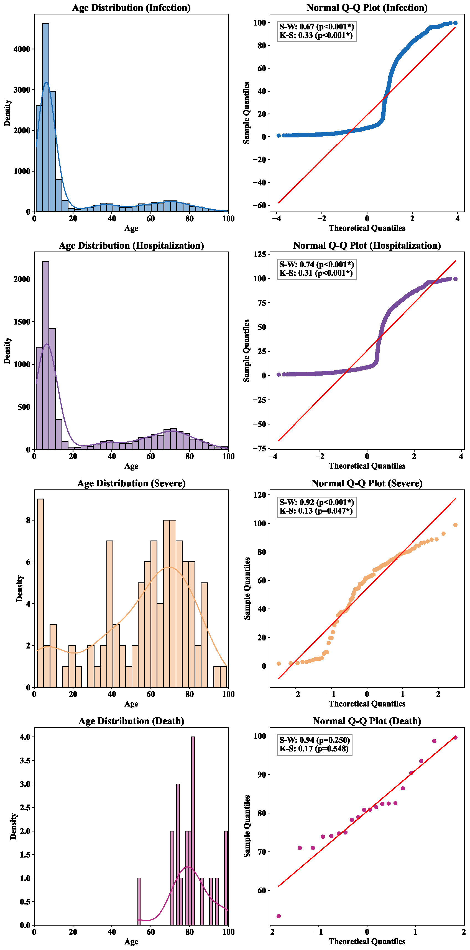

Figure S1. Age Distribution of HAdV Cases by Category. From top to bottom: infected, hospitalized, severe, and death HAdV cases. The left panel displays histograms, while the right panel shows QQ plots. The upper left corner of the right panel includes results from the K-S and S-W normality tests.
*: p < 0.05, HAdV = Human Adenovirus, K-S = Kolmogorov-Smirnov test, S-W = Shapiro-Wilk test.

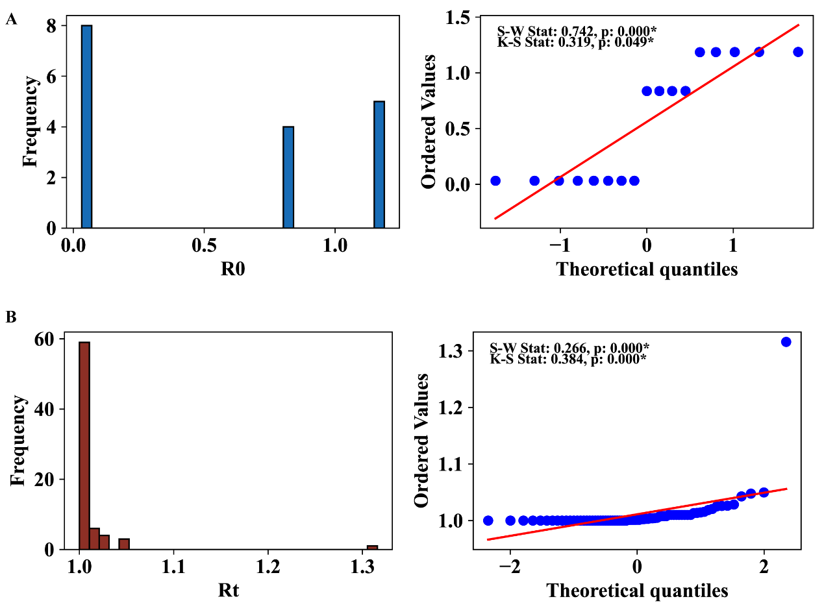

Figure S2. Distribution of $R_{0}$ and $R_{t}$ for HAdV. (A) Distribution of $R_{0}$. (B) Distribution of $R_{t}$. The left panel displays histograms, while the right panel shows QQ plots. The upper left corner of the right panel includes results from the K-S and S-W normality tests.
*: p < 0.05, HAdV = Human Adenovirus, $R_{0}$ = basic reproduction number, $R_{t}$ = real-time reproduction number, K-S = Kolmogorov-Smirnov test, S-W = Shapiro-Wilk test.
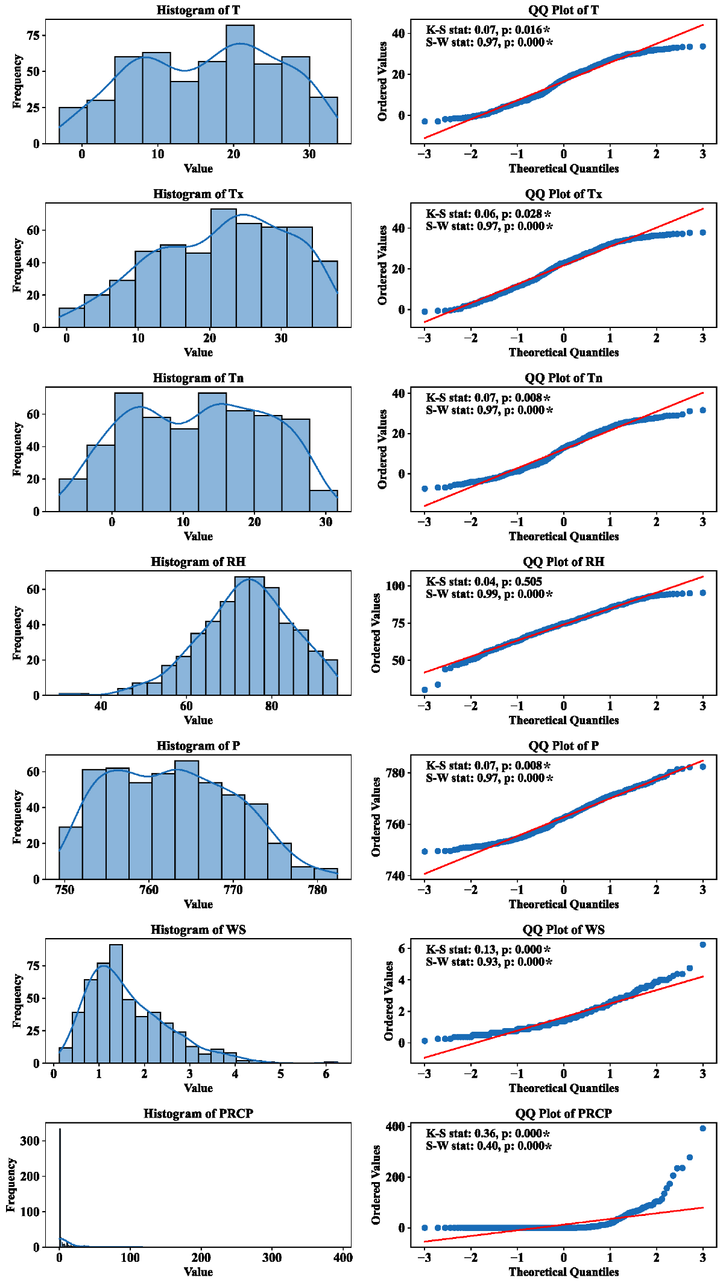

Figure S3. Distribution of Included Meteorological Variables. The left panel displays histograms of the included variables, while the right panel shows QQ plots. The upper left corner of the right panel includes results from the K-S and S-W normality tests.
*: p < 0.05, T = daily average temperature, Tx = daily maximum temperature, Tn = daily minimum temperature, RH = daily relative humidity, P = daily average air pressure, WS = daily average wind speed, PRCP = 24-hour precipitation, K-S = Kolmogorov-Smirnov test, S-W = Shapiro-Wilk test.

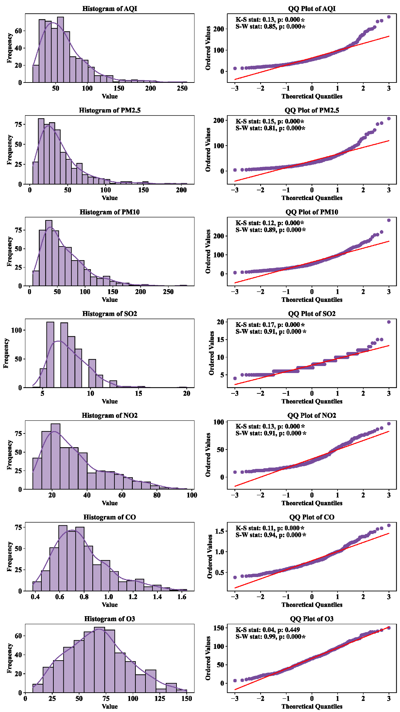

Figure S4. Distribution of Included Air Pollutant Variables. The left panel displays histograms of the included variables, while the right panel shows QQ plots. The upper left corner of the right panel includes results from the K-S and S-W normality tests.
*: p < 0.05, AQI = air quality index, K-S = Kolmogorov-Smirnov test, S-W = Shapiro-Wilk test.

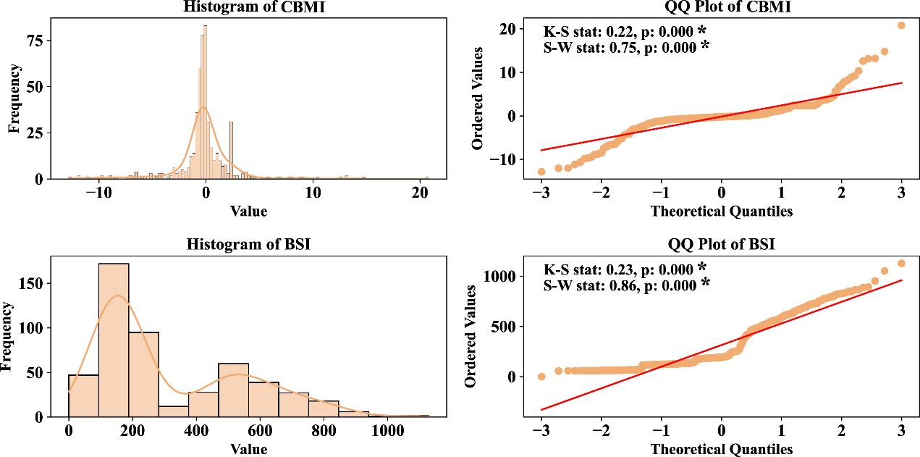

Figure S5. Distribution of Included Human Activities Variables. The left panel displays histograms of the included variables, while the right panel shows QQ plots. The upper left corner of the right panel includes results from the K-S and S-W normality tests.
*: p < 0.05, CBMI = China Baidu Mobility Index, BSI = Baidu Search Index, K-S = Kolmogorov-Smirnov test, S-W = Shapiro-Wilk test.
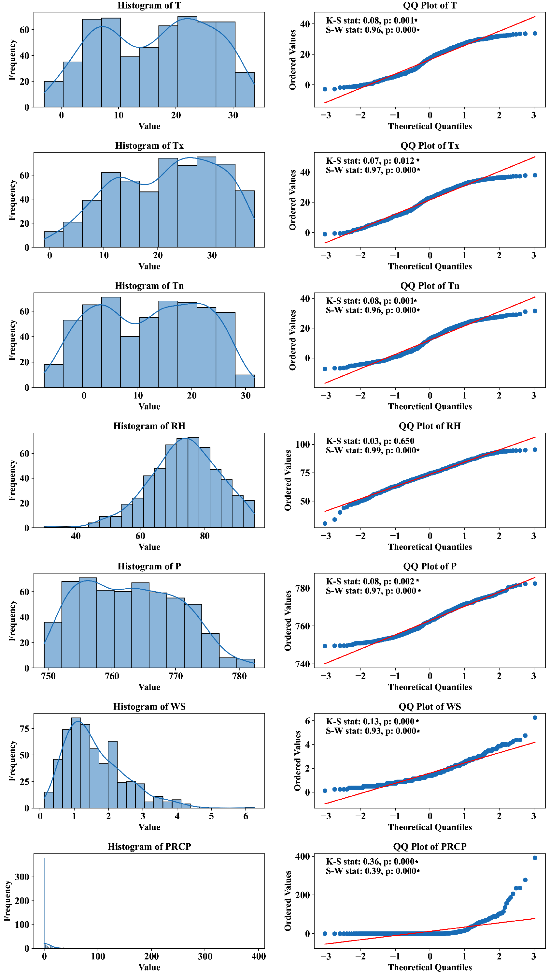

Figure S6. Distribution of Included Meteorological Variables with Optimal Lags. The left panel displays histograms of the included variables, while the right panel shows QQ plots. The upper left corner of the right panel includes results from the K-S and S-W normality tests.
*: p < 0.05, T = daily average temperature, Tx = daily maximum temperature, Tn = daily minimum temperature, RH = daily relative humidity, P = daily average air pressure, WS = daily average wind speed, PRCP = 24-hour precipitation, K-S = Kolmogorov-Smirnov test, S-W = Shapiro-Wilk test.
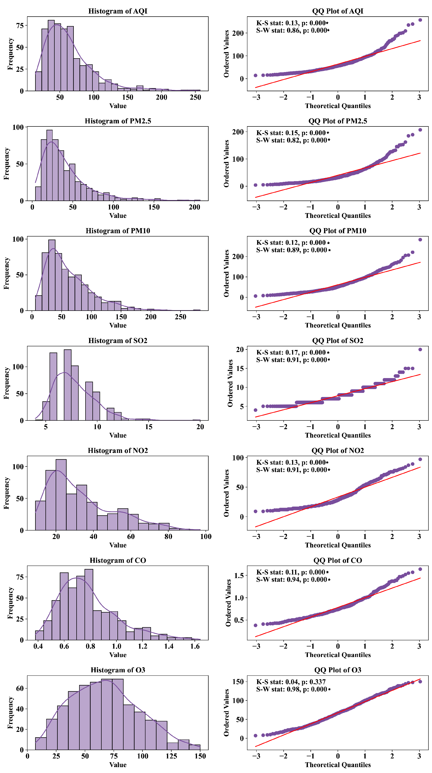

Figure S7. Distribution of Included Air Pollutant Variables with Optimal Lags. The left panel displays histograms of the included variables, while the right panel shows QQ plots. The upper left corner of the right panel includes results from the K-S and S-W normality tests.
*: p < 0.05, AQI = air quality index, K-S = Kolmogorov-Smirnov test, S-W = Shapiro-Wilk test.

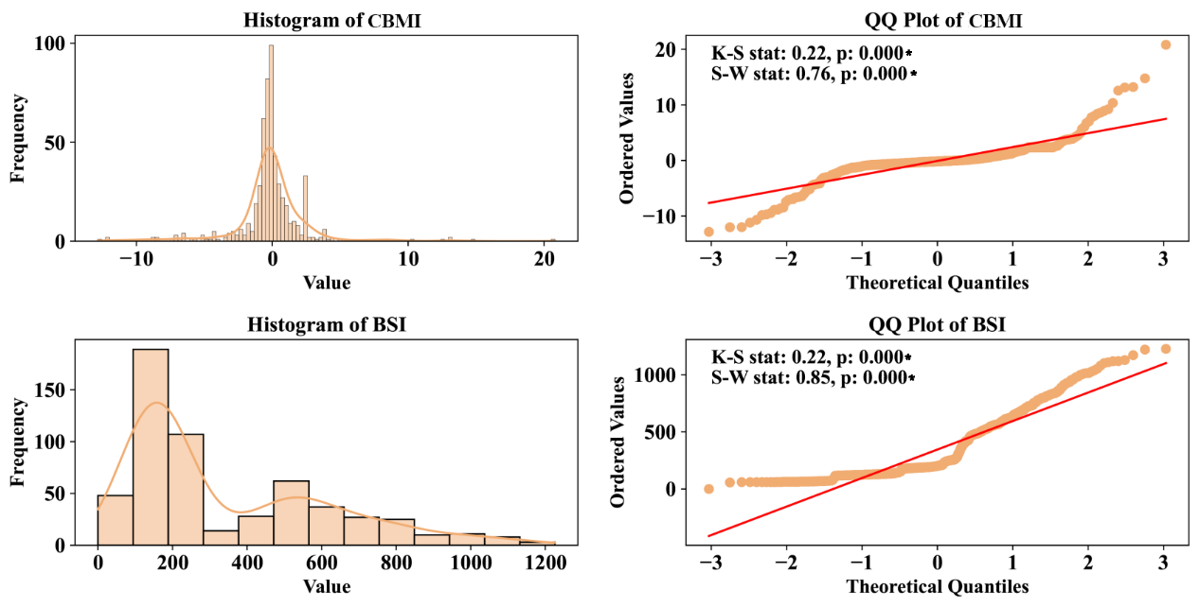

Figure S8. Distribution of Included Human Activities Variables with Optimal Lags. The left panel displays histograms of the included variables, while the right panel shows QQ plots. The upper left corner of the right panel includes results from the K-S and S-W normality tests.
*: p < 0.05, CBMI = China Baidu Mobility Index, BSI = Baidu Search Index, K-S = Kolmogorov-Smirnov test, S-W = Shapiro-Wilk test.
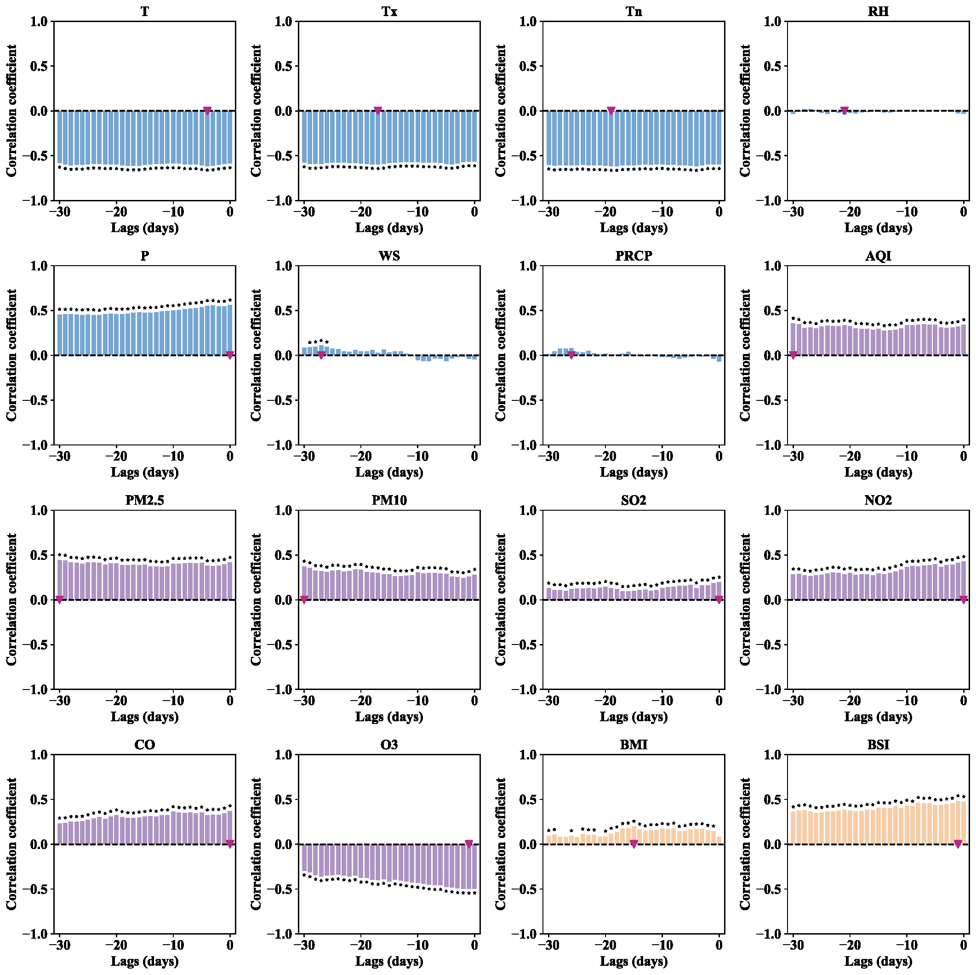

Figure S9. Distribution of Optimal Lags for Included Variables. The blue columns represent the correlation coefficients between meteorological factors and HAdV incidence. The purple columns represent the correlation coefficients between atmospheric pollutants and HAdV incidence. The orange columns represent the correlation coefficients between human behaviors and HAdV incidence. The red triangles indicate the optimal lags.
*: p < 0.05, HAdV = Human Adenovirus, T = daily average temperature, Tx = daily maximum temperature, Tn = daily minimum temperature, RH = daily relative humidity, P = daily average air pressure, WS = daily average wind speed, PRCP = 24-hour precipitation, AQI = air quality index, CBMI = China Baidu Mobility Index, BSI = Baidu Search Index.

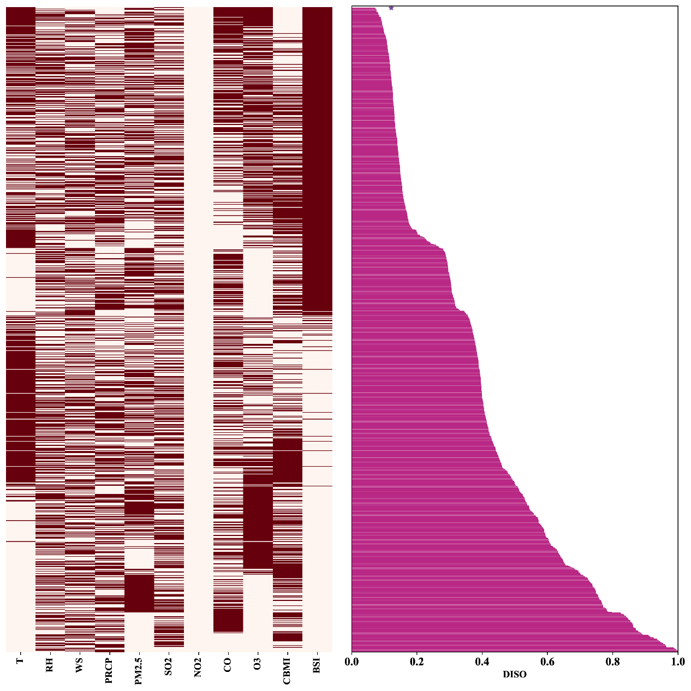

Figure S10. Selection of the Optimal Non-Lagging Model. The left diagram illustrates the included variables, while the right diagram shows the corresponding DISO values. The purple pentagram indicates the combination of variables with the lowest DISO values, representing the optimal lagging model.
T = daily average temperature, RH = daily relative humidity, WS = daily average wind speed, PRCP = 24-hour precipitation, CBMI = China Baidu Mobility Index, BSI = Baidu Search Index, DISO = The Distance between Indices of Simulation and Observation.

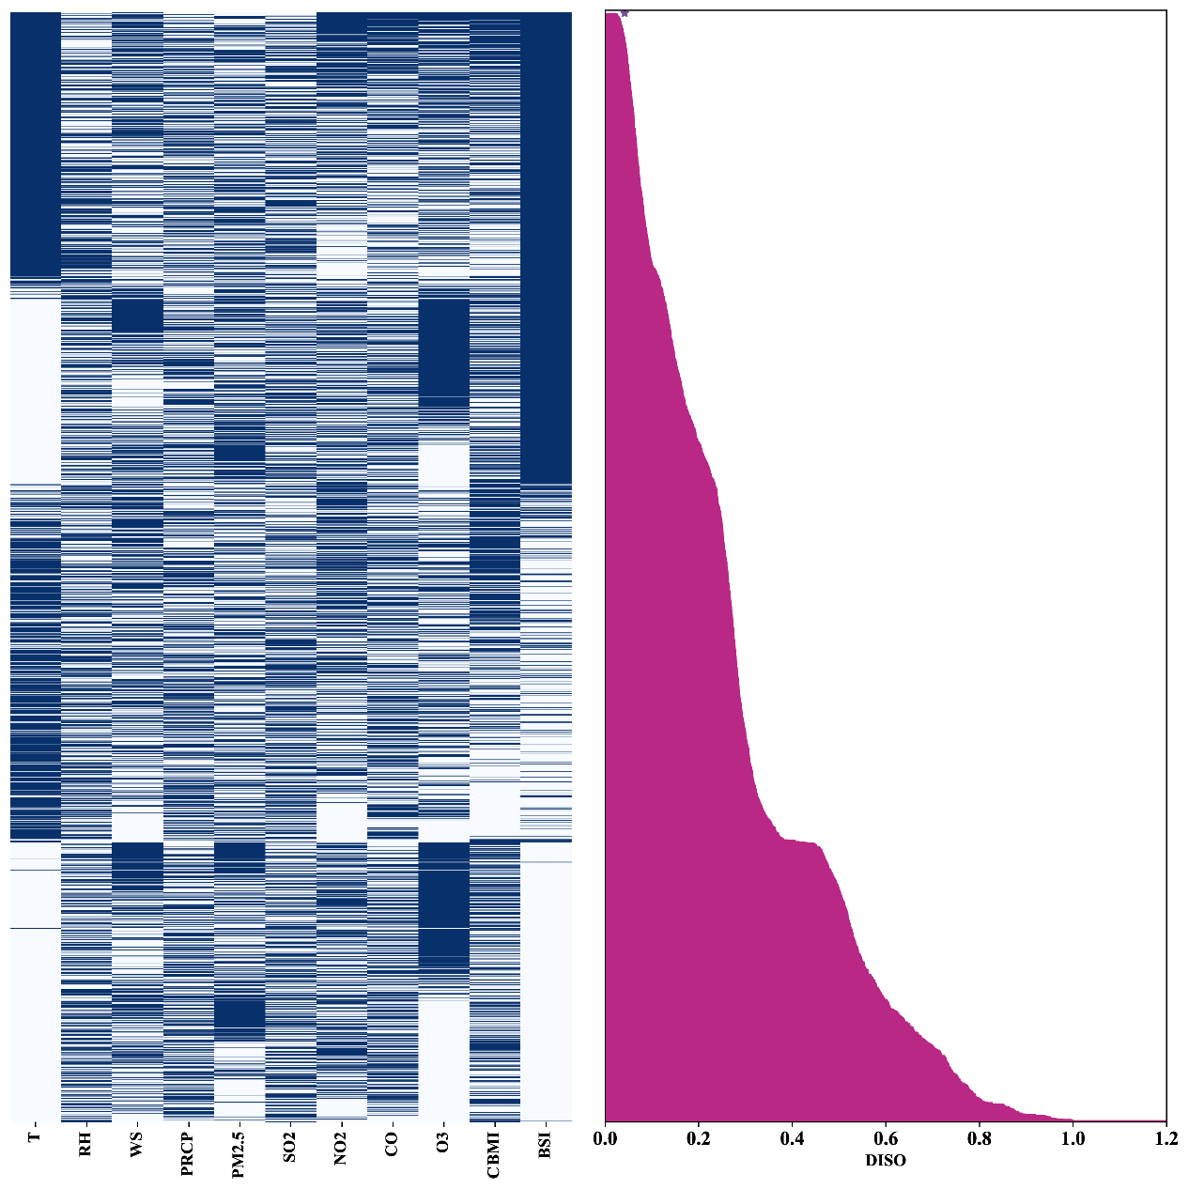

Figure S11. Selection of the Optimal Lagging Model. The left diagram illustrates the included variables, while the right diagram shows the corresponding DISO values. The purple pentagram indicates the combination of variables with the lowest DISO values, representing the optimal lagging model.
T = daily average temperature, RH = daily relative humidity, WS = daily average wind speed, PRCP = 24-hour precipitation, CBMI = China Baidu Mobility Index, BSI = Baidu Search Index, DISO = The Distance between Indices of Simulation and Observation.

Table S1. Optimal Non-Lagging GAM Results.
Variable | EDoF | p
T | 3.80 | <0.001*
SO2 | 1.80 | 0.142
CO | 2.00 | 0.491
O3 | 1.90 | 0.001*
BSI | 1.50 | <0.001*
Intercept | 0.00 | <0.001*
*: p < 0.05, GAM = Generalized Additive Model, EDoF = Effective Degrees of Freedom,T = daily average temperature, BSI = Baidu Search Index.

Table S2. Optimal Lagging GAM Results.
Variable | EDoF | p
T | 3.90 | <0.001*
WS | 2.40 | <0.001*
NO2 | 2.20 | <0.001*
CO | 1.90 | 0.060
O3 | 1.80 | 0.043*
CBMI | 1.30 | <0.001*
BSI | 1.40 | <0.001*
Intercept | 0.00 | <0.001*
*: p < 0.05, GAM = Generalized Additive Model, EDoF = Effective Degrees of Freedom,T = daily average temperature, WS = daily average wind speed, CBMI = China Baidu Mobility Index, BSI = Baidu Search Index.

Reference
1 Qu, J. M. & Cao, B. [Guidelines for the diagnosis and treatment of adult community acquired pneumonia in China (2016 Edition)]. Zhonghua Jie He He Hu Xi Za Zhi 39, 241-242 (2016). https://doi.org:10.3760/cma.j.issn.1001-0939.2016.04.001
2 [Guidelines for management of community acquired pneumonia in children(the revised edition of 2013) (II)]. Zhonghua Er Ke Za Zhi 51, 856-862 (2013).
3 Association, C. M. Guideline for primary care of acute upper respiratory tract infection: practice version (2018). Chinese Journal of General Practitioners (2019). https://doi.org: 10.3760/cma.j.issn.1671-7368.2019.05.006
4 [Technical guidelines for prevention and control of human adenovirus respiratory infection (2019 edition)]. Zhonghua Yu Fang Yi Xue Za Zhi 53, 1088-1093 (2019). https://doi.org:10.3760/cma.j.issn.0253-9624.2019.11.003
5 China, G. O. o. t. N. H. C. o. t. P. s. R. o. Guidelines for the diagnosis and treatment of severe acute hepatitis in children with unknown causes, <https://www.gov.cn/zhengce/zhengceku/2022-06/16/content_5695984.htm> (2022).
6 ZAN Hongying, H. Y., FAN Yaxin, NIU Chengzhi, ZHANG Kunli, SUI Zhifang. Construction and Analysis of Symptom Knowledge Base in Chinese. . Journal of Chinese Information Processing. 34, 30-37 (2020).
7 Lynch, J. P., 3rd & Kajon, A. E. Adenovirus: Epidemiology, Global Spread of Novel Serotypes, and Advances in Treatment and Prevention. Semin Respir Crit Care Med 37, 586-602 (2016). https://doi.org:10.1055/s-0036-1584923
8 Guo, Z. et al. Epidemiological analysis of an outbreak of an adenovirus type 7 infection in a boot camp in China. PLoS One 15, e0232948 (2020). https://doi.org:10.1371/journal.pone.0232948
9 Michaud, C. M. Global Burden of Infectious Diseases. Encyclopedia of Microbiology, 444-454 (2009). https://doi.org:10.1016/b978-012373944-5.00185-1
10 Hu, Z. et al. CCHZ-DISO: A Timely New Assessment System for Data Quality or Model Performance From Da Dao Zhi Jian. Geophysical Research Letters 49, e2022GL100681 (2022). https://doi.org:https://doi.org/10.1029/2022GL100681
11 Deng, B. et al. Meteorological factors and tick density affect the dynamics of SFTS in jiangsu province, China. PLoS Negl Trop Dis 16, e0010432 (2022). https://doi.org:10.1371/journal.pntd.0010432
12 O’brien, R. M. A Caution Regarding Rules of Thumb for Variance Inflation Factors. Quality & Quantity 41, 673-690 (2007). https://doi.org:10.1007/s11135-006-9018-6
13 Abdi, B., Kolo, K. & Shahabi, H. Assessment of land degradation susceptibility within the Shaqlawa subregion of Northern Iraq-Kurdistan Region via synergistic application of remotely acquired datasets and advanced predictive models. Environmental Monitoring and Assessment 196, 1103 (2024). https://doi.org:10.1007/s10661-024-13284-9
14 Chen, W. et al. Spatial prediction of landslide susceptibility using data mining-based kernel logistic regression, naive Bayes and RBFNetwork models for the Long County area (China). Bulletin of Engineering Geology and the Environment 78, 247-266 (2019). https://doi.org:10.1007/s10064-018-1256-z
15 Xi, W. et al. Quantifying the Time-Lag Effects of Human Mobility on the COVID-19 Transmission: A Multi-City Study in China. IEEE Access 8, 216752-216761 (2020). https://doi.org:10.1109/access.2020.3038995
16 Ai, H., Nie, R. & Wang, X. Evaluation of the effects of meteorological factors on COVID-19 prevalence by the distributed lag nonlinear model. J Transl Med 20, 170 (2022). https://doi.org:10.1186/s12967-022-03371-1

