APPENDIX A
Characteristics of study participants at all study-visits, i.e., baseline (wave 1), 3-, 6-, 9-, and 12-year follow-up (waves 2-5).
 | Followed  in W1 W3 W5 |  |  | Followed in  W1 W3 W4 W5 |  |  |  | Followed in  W1 W2 W3 W4 W5
Characteristic | W1  n=1240 | W3  n=1022 | W5  n=835 | W1  n=442 | W3  n=340 | W4  n=275 | W5  n=221 | W1  n=1166 | W2  n=847 | W3  n=602 | W4  n=403 | W5  n=222
Age at wave, (years) | 63.0 (2.9) | 68.7 (2.9) | 74.4 (2.9) | 72.3 (0.2) | 78.1 (0.2) | 81.0 (0.3) | 84.0 (0.2) | 83.6 (5.4) | 86.0 (5.0) | 87.8 (4.4) | 90.0 (3.9) | 92.1 (3.1)
Age group at W1
Sexagenarians | 1,240 (100%) | 1,022 (100%) | 835 (100%) | 0 (0%) | 0 (0%) | 0 (0%) | 0 (0%) | 0 (0%) | 0 (0%) | 0 (0%) | 0 (0%) | 0 (0%)
Septuagenarians | 0 (0%) | 0 (0%) | 0 (0%) | 442 (100%) | 340 (100%) | 275 (100%) | 221 (100%) | 422 (36%) | 333 (39%) | 278 (46%) | 206 (51%) | 131 (59%)
Octagenarians | 0 (0%) | 0 (0%) | 0 (0%) | 0 (0%) | 0 (0%) | 0 (0%) | 0 (0%) | 744 (64%) | 514 (61%) | 324 (54%) | 197 (49%) | 91 (41%)
Sex, female, n(%) | 698 (56%) | 589 (58%) | 495 (59%) | 265 (60%) | 214 (63%) | 171 (62%) | 144 (65%) | 818 (70%) | 602 (71%) | 424 (70%) | 292 (72%) | 167 (75%)
Education, n(%)
Higher | 620 (50%) | 528 (52%) | 448 (54%) | 150 (34%) | 117 (34%) | 100 (36%) | 82 (37%) | 236 (20%) | 184 (22%) | 142 (24%) | 97 (24%) | 54 (24%)
Intermediate | 530 (43%) | 433 (42%) | 342 (41%) | 239 (54%) | 181 (53%) | 143 (52%) | 113 (51%) | 640 (55%) | 472 (56%) | 331 (55%) | 224 (56%) | 126 (57%)
Lower | 90 (7.3%) | 61 (6.0%) | 45 (5.4%) | 53 (12%) | 42 (12%) | 32 (12%) | 26 (12%) | 290 (25%) | 191 (23%) | 129 (21%) | 82 (20%) | 42 (19%)
Cognitive functioning, MMSE score, median (IQR) | 30.0 (1.0) | 29.0 (2.0) | 29.0 (2.0) | 29.0 (1.0) | 28.0 (2.0) | 28.0 (3.0) | 28.0 (3.0) | 29.0 (2.0) | 28.0 (3.0) | 27.0 (4.0) | 27.0 (5.0) | 26.0 (6.0)
Daily functioning, score, median (IQR) | 14.0 (0.0) | 14.0 (0.0) | 14.0 (0.0) | 14.0 (0.0) | 14.0 (1.0) | 14.0 (1.0) | 14.0 (1.0) | 14.0 (1.0) | 13.0 (1.0) | 13.0 (4.0) | 12.0 (6.0) | 11.0 (6.0)
Social participation, index, mean (SD) | 106.6 (11.7) | 108.8 (10.8) | 106.2 (11.8) | 102.8 (12.8) | 101.2 (12.4) | 99.9 (12.1) | 97.3 (13.5) | 92.1 (15.1) | 93.6 (13.0) | 92.4 (12.4) | 90.6 (11.7) | 86.7 (14.4)
Social connections, index, mean (SD) | 102.3 (9.9) | 102.6 (9.8) | 101.9 (9.7) | 101.6 (9.6) | 100.7 (8.9) | 100.4 (8.8) | 98.8 (8.7) | 97.0 (9.5) | 97.2 (9.5) | 97.5 (9.2) | 96.8 (8.9) | 93.2 (10.0)
Social support, index, mean (SD) | 101.9 (7.4) | 103.0 (6.8) | 102.1 (8.0) | 100.8 (8.4) | 100.9 (8.3) | 101.0 (8.2) | 98.8 (10.8) | 97.8 (9.8) | 98.5 (9.4) | 99.3 (9.2) | 99.0 (9.3) | 93.7 (15.0)
Data are presented as mean (SD), n (%), or median (IQR).
Abbreviations: MMSE, Mini-Mental State Examination; IQR, interquartile range; SD, standard deviations; W1-5, examination wave 1 to 5.

Appendix B
Fit statistics for the final Growth Mixture Models.
 | nclass | Parameters | class_counts | class_props | LL | AIC | BIC | Entropy
Cognitive functioning - Quadratic growth, overall random intercept & linear slope, overall adjustment for BL age, free residuals
Final model | 2 | 18 | 2599 247 | 0.91 0.09 | -16,456.58 | 32949.16 | 33056.32 | 0.914
First replication using OPTSEED | 2 | 18 | 2599 247 | 0.91 0.09 | -16,456.58 | 32949.16 | 33056.32 | 0.914
Second replication using OPTSEED | 2 | 18 | 2599 247 | 0.91 0.09 | -16,456.58 | 32949.16 | 33056.32 | 0.914
Daily functioning - Quadratic growth, overall random intercept & linear slope, overall adjustment for BL age, free residuals
Final model | 2 | 18 | 2687 133 | 0.95 0.05 | -12,596.91 | 25229.82 | 25336.82 | 0.994
First replication using OPTSEED | 2 | 18 | 2687 133 | 0.95 0.05 | -12,596.91 | 25229.82 | 25336.82 | 0.994
Second replication using OPTSEED | 2 | 18 | 133 2687 | 0.05 0.95 | -12,596.91 | 25229.82 | 25336.82 | 0.994
Social connections - Quadratic growth, class specific random intercept, overall adjustment for BL age, free residuals
Final model | 2 | 19 | 828 2020 | 0.29 0.71 | -22,117.17 | 44272.34 | 44385.47 | 0.641
First replication using OPTSEED | 2 | 19 | 828 2020 | 0.29 0.71 | -22,117.17 | 44272.34 | 44385.47 | 0.641
Second replication using OPTSEED | 2 | 19 | 2020 828 | 0.71 0.29 | -22,117.17 | 44272.34 | 44385.47 | 0.641
Social support - Quadratic growth, overall random intercept & linear slope, overall adjustment for BL age, free residuals
Final model | 3 | 22 | 2693 58 97 | 0.95 0.02 0.03 | -22,789.90 | 45623.80 | 45754.79 | 0.889
First replication using OPTSEED | 3 | 22 | 2693 58 97 | 0.95 0.02 0.03 | -22,789.90 | 45623.80 | 45754.79 | 0.889
Second replication using OPTSEED | 3 | 22 | 2693 58 97 | 0.95 0.02 0.03 | -22,789.90 | 45623.80 | 45754.79 | 0.889
Social participation - Quadratic growth, no random effects, overall adjustment for BL age, free residuals
Final model | 2 | 15 | 1987 861 | 0.7 0.3 | -25,754.17 | 51538.34 | 51627.65 | 0.658
First replication using OPTSEED | 2 | 15 | 1987 861 | 0.7 0.3 | -25,754.17 | 51538.34 | 51627.65 | 0.658
Second replication using OPTSEED | 2 | 15 | 1987 861 | 0.7 0.3 | -25,754.17 | 51538.34 | 51627.65 | 0.658

Appendix C
We followed Jung and Wickrama’s model-building strategy for latent class growth analysis and growth mixture modeling (Jung & Wickrama. An Introduction to Latent Class Growth Analysis and Growth Mixture Modeling. Social and Personality Psychology Compass 2008;2:302-317). Supplementary Figure 1 shows the Bayesian information criteria (BIC) values plotted against the number of parameters in each model for the three steps of the model building strategy:
- Latent Growth Curve Analysis (LGCA): Blue, squares, identifying growth type (linear or quadratic);
- Latent Class Growth Analysis (LCGA): Green, triangles, identifying the number of growth classes (1 to 4);
- Growth Mixture Modeling (GMM): Red, circles, identifying the random effects needed to further improve fit.
The number indicates the number of classes.
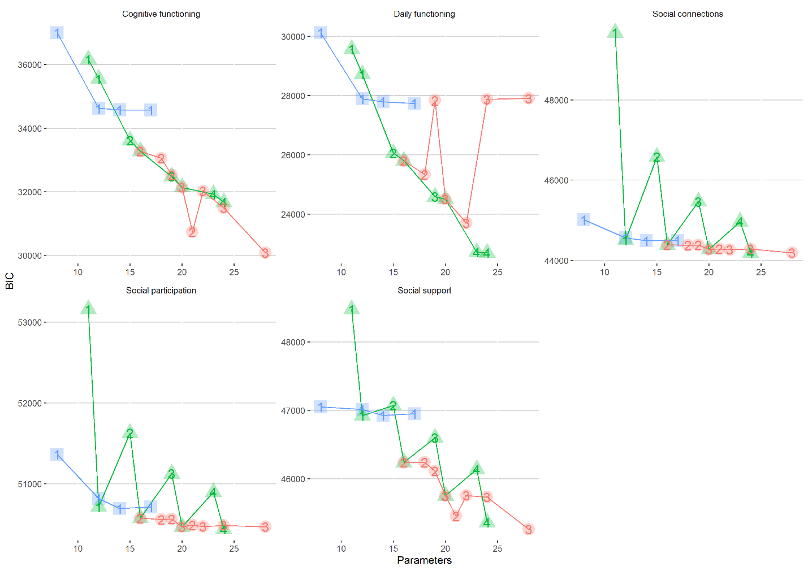
Supplementary Figure 1—BIC values plotted against the number of model parameters for LGCA, LCGA, and GMM.

For LGCA, we fitted models in the following order (blue squares):
  - Means model with fixed and random intercept, adjusted for baseline age, with free residuals for each time point;
  - Linear growth model with fixed and random intercept and linear slope, adjusted for baseline, with free residuals for each time point;
  - Quadratic growth model with fixed intercept, linear and quadratic slope and random intercept and linear slope, adjusted for baseline age, with free residuals for each time point;
  - Quadratic growth model with fixed intercept, linear and quadratic slope and random intercept and linear slope, adjusted for baseline age, with free residuals for each time point;
  - Quadratic growth model with fixed and random intercept, linear and quadratic slope, adjusted for baseline age, with free residuals for each time point.

For LCGA, we fitted models in the following order (green triangles):
- 1 to 4 class model with fixed intercept, linear and quadratic slope without any random effects, adjusted for baseline age, with free residuals for each time point
- 1 to 4 class model with fixed intercept, linear and quadratic slope WITH an overall random intercept, adjusted for baseline age, with free residuals for each time point (essentially this is a GMM and not an LCGA model, as the model includes a random effect. We fitted

For GMM (red circles), we fitted 2 and 3 class models with fixed intercept, linear and quadratic slope and, in order:
- Overall random intercept
- Overall random intercept and linear slope
- Class specific random intercept
- Class specific random intercept and linear slope

Key findings:
- While the addition of (linear) growth factors considerably improved model fit indicated by a decline in BIC in the subsequent LGCA models (blue line) for cognitive and daily functioning, this was less prominent in particularly social connections and social participation
- While an additional class (LCGA and GMM) resulted in a continued decline in BIC for cognitive functioning, this effect was less prominent for the three social outcomes.
- In contrast, while the addition of a random intercept to the model resulted in a huge decline in BIC for particularly social participation and social connections (compare e.g., the BIC for the two 1-class LCGA models (in green)), this effect is much less prominent in cognitive and daily functioning (compare - for cognitive and daily functioning – the difference in BIC for the two 1-class LCGA models (one without random intercept vs one WITH random intercept) against the change in BIC when adding a second class).
- The resulting improvement in model fit with increasing model complexity in the GMM step is shallower in social participation and connections than in cognitive and daily functioning.
- The increases in BIC (i.e. decrease in model fit) for some daily functioning models of the GMM step indicated overfitted models. The most complex GMM model for daily functioning did not converge, which is why no estimate of BIC is provided for this model.

Appendix D
Estimated (top row) and observed (bottom row) trajectories by class for each of the five outcomes among 1000 randomly selected SNAC-K participants.
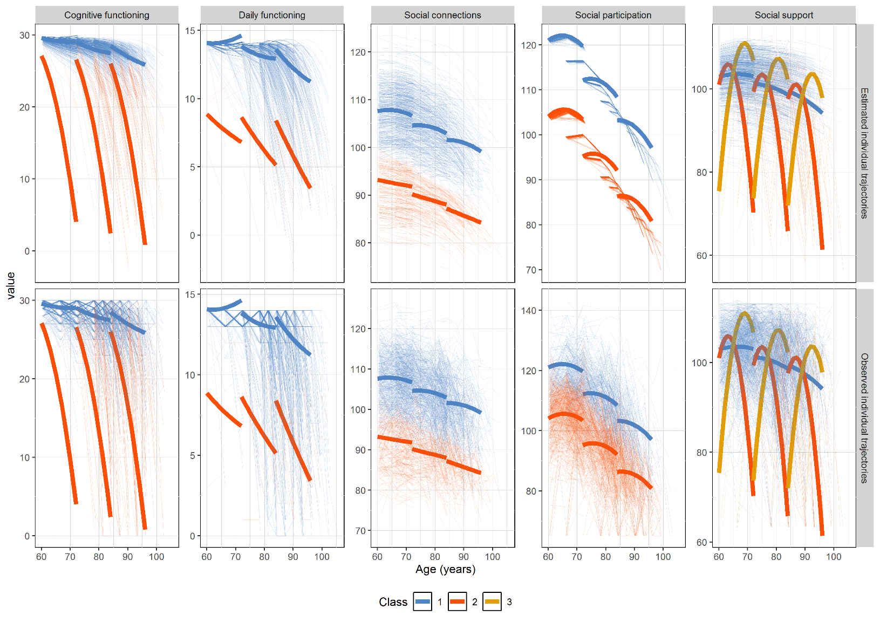
Appendix E
Associations of social health indicators trajectories with cognitive and daily functioning concordance and discordance across four groups.
 | Concordant |  | Discordant
 | High cognitive & daily functioning  N=2491 (88.4%) | Low cognitive & daily functioning  N=47 (1.7%) | High cognitive & Low daily functioning  N=86 (3.0%) | Low cognitive & High daily functioning  N=194 (6.9%)
Social participation
Class 2 (gradual decline) vs. class 1 (stable), OR (95% CI) ª | Reference | 32.9 (0.02–51078.4) | 5.3 (2.1–13.1) | 2.0 (1.3–3.1)
Social connections
Class 2 (initially lower, stable slope) vs. class 1 (stable), OR (95% CI) ª | Reference | 2.0 (1.1–3.9) | 2.2 (1.3–3.8) | 1.9 (1.3–2.7)
Social support
Class 2 (declining) vs. class 1 (stable), OR (95% CI) ª | Reference | 0.3 (0–5081139980899445760) | 1.4 (0.3–6.1) | 2.7 (1.4–5.0)
Class 3 (increasing) vs. class 1 (stable), OR (95% CI) ª | Reference | 6.9 (2.7–17.4) | 4.5 (2.0–10.4) | 4.2 (2.3–7.6)
Abbreviations: CI, confidence intervals; OR, odds ratio.
ª ORs and 95% CI are based on the pseudoclass method with 20 imputations assigning participants to classes based on their individual class probabilities. The ORs were combined using Rubin's Rule.

