Supplementary materials for
14-3-3η Induces a Multidrug-Resistant Phenotype in Rheumatoid Arthritis via p53 Dysregulation: Insights from AIA Models
Li Jun Yang¹*, David Wei Zhang¹*, Yuan Qing Qu¹, Yu Ping Wang¹, Xiong Fei Xu¹, Wei Dan Luo^{1,5}, Betty Yuen Kwan Law^{1,2}, Zhi-Hong Jiang^{1,2}, Rui Hong Chen¹, Cong Ling Qiu¹, Xi Chen¹, Lin Na Wang¹, Jiu Jie Yang¹, Yuan Li^{3,4#} & Vincent Kam Wai Wong^{1,2#}
Correspondence: kawwong@must.edu.mo (V.K.W. Wong); liyuan@njmu.edu.cn (Y. Li)
This file includes:
Supplementary Figures 1 to 4
Supplementary Tables 1 to 3
Western Blots original images
Supplementary Figures
Fig. S1. Gene expression analysis of proinflammatory cytokines in the synovium or PBMCs of AIA rats overexpressing 14-3-3η. (A) The levels of the proinflammatory cytokines TNF-α, IL-1β, IL-6 and MCP-1 were measured by specific ELISA kits using blood serum from AIA rats in different groups. (B) The gene expression of proinflammatory cytokines, including TNF-α, IL-1β, IL-2, IL-6, IL-8 and MCP-1, in synovial tissues from the AIA rats was measured by qPCR. (C) The gene expression of proinflammatory cytokines, including TNF-α, IL-1β, IL-2, IL-6, IL-8 and MCP-1, in PBMCs from AIA rats was measured by qPCR. The data are expressed as the mean values ± SEMs from n=8 rats per group. One-way ANOVA, *P<0.05, significantly different from the MTX + AAV5-null treated AIA group; △P<0.05, significantly different from the AAV5-14-3-3η HD + MTX-treated AIA group; # P < 0.05, significantly different from the healthy control group.

Fig. S2. Gene expression analysis of matrix metalloproteinases in the synovium or PBMCs of AIA-treated rats overexpressing 14-3-3η. (A) The levels of the metalloproteinases MMP1, MMP3, MMP9 and RANKL in synovial tissue from the AIA rats were measured via qPCR. (B) The levels of the metalloproteinases MMP1, MMP3, MMP9 and RANKL in PBMCs from AIA rats were measured by qPCR. The data are expressed as the mean values ± SEMs from n=8 rats per group. One-way ANOVA, *P<0.05, significantly different from the MTX + AAV5-null treated AIA group; △P<0.05, significantly different from the AAV5-14-3-3η HD + MTX-treated AIA group; # P < 0.05, significantly different from the healthy control group.

Fig. S3. Gene expression analysis of proinflammatory cytokines and metalloproteinases in PBMCs harvested from AIA transgenic rats. (A) The levels of the proinflammatory cytokines TNF-α, IL-1β, IL-2, IL-6 and IL-17A and the metalloproteinases MMP1, MMP3 and MMP9 were measured by qPCR in PBMCs derived from AIA transgenic rats. (B) The mRNA expression of 14-3-3η in AIA ^{14-3-3η+/+} transgenic rats with inducible treatment of doxycycline. 14-3-3η mRNA expression in PBMC of AIA ^{14-3-3η+/+} transgenic rats after doxycycline treatment. The data are expressed as the mean ± SEM (n=8 rats per group), statistical significance was calculated by t tests. * P<0.05 indicates a significant difference compared with the MTX + AAV5-null treated AIA group. △P<0.05, significantly different from the AIA 14-3-3η^{+/+} ^{(MTX)}-treated AIA group. #P<0.05, significantly different from the healthy control group.

Fig. S4. Effects of body and organ weight in the AIA ^{14-3-3η+/+} transgenic rat. (A) Line graph depicting the changes in body weight of AIA ^{14-3-3η+/+} transgenic rats over the monitoring period. Rats were subjected to Dox (0.5 mg/ml, administered every other week for 5 consecutive days), MTX (2.5 mg/kg/week, administered via oral gavage), or AAV5-p53 (intravenous injection of 1×10¹¹ PFU). Weight was monitored continuously for 30 days, with measurements taken every three days, and rat organs were collected at the end of the experiment. All samples were biologically independent, and the data are presented as the mean ± SEM (all groups: n = 6). (B) Bar graphs illustrating the organ coefficients of the rats. Organ coefficient = Organ weight/Body weight. The results are presented as a percentage of body weight. (C) Intravenous injections of AAV5-p53 reduced the percentage of CD4⁺ cells among lymphocytes, affecting the CD4⁺/CD8⁺ T-cell ratio. Typical flow cytometry images showing the purification of CD4⁺ and CD8⁺ cells gated on CD3⁺ T lymphocytes. (D) Quantitative bar graphs showing the percentages of CD4⁺ T and CD8⁺ T cells among CD3⁺ T cells. (E) Bar graph showing the ratio of CD4⁺/CD8⁺ cell percentages among CD3⁺ T cells. All samples were biologically independent, and statistical significance was calculated using t tests. *P < 0.05, **P < 0.01, ***P < 0.001, n.s: no significant difference. The data are presented as the means ± SEMs (all groups: n = 6).

Supplementary Tables
Supplementary Table 1. Primer sequences used for real-time PCR
Gene Name | Forward | Reverse
Human-14-3-3η | 5’-ACAAGCCTTCGATGATGCCA-3’ | 5’-TCCAGAGGGTGAGGTTGTCT-3’
Human- p53 | 5’- AGCCGGTGAAGGTTGTGTAC -3’ | 5’- TGACGAAGCAGATGTGGAAG-3’
Human-β-actin | 5’-AGCGAGCATCCCCCAAAGTT-3’ | 5’-GGGCACGAAGGCTCATCATT-3’
Rat-TNF-α | 5’-CAGAGGGAAGAGTTCCCCAG-3’ | 5’-CCTTGGTCTGGTAGGAGACG-3’
Rat-14-3-3η | 5’-TGATCTCTTGGCTCTGCTCG-3’ | 5’-AGCGGTAGTAATCGCCCTTC-3’
Rat- p53 | 5’-GTTCCGAGAGCTGAATGAGG-3’ | 5’-TTTTATGGCGGGACGTAGAC-3’
Rat-IL-1β | 5’-GCACAGTTCCCCAACTGGTA-3’ | 5’-AAGACACGGGTTCCATGGTG-3’
Rat-IL-6 | 5’-CCACCCACAACAGACCAGTA-3’ | 5’-GGAACTCCAGAAGACCAGAGC-3’
Rat-IL-2 | 5’-CTGCAGCGTGTGTTGGATTT-3’ | 5’-GGCTCATCATCGAATTGGCAC-3’
Rat-IL-6 | 5’-CCACCCACAACAGACCAGTA- 3’ | 5’GGAACTCCAGAAGACCAGAGC-3’
Rat-IL-8 | 5’-CTGCGCCAACACAGAAATTA-3’ | 5’-ATTGCATCTGGCAACCCTAC-3’
Rat-IL-17A | 5’-GGGAAGTTGGACCACCACCT-3’ | 5’-TTCTCCACCCGGAAAGTGAA-3’
Rat-MCP-1 | 5’-CAGTTAATGCCCCACTCACCT-3’ | 5’-ACAGCTTCTTTGGGACACCTG-3’
Rat-MMP-1 | 5’-TTTGATGGACCTCAATAT-3’ | 5’-CATTAGTGCTCCTACA-3’
Rat-MMP-3 | 5’-AAAGACAGGCACTTTTGGCG-3’ | 5’-ATCCACCTTTGTGCCAATGC-3’
Rat-MMP-9 | 5’-AGTTTGGTGTCGCGGAGCAC-3’ | 5’-TACATGAGCGCTTCCGGCAC-3’
Rat-RANKL | 5’-CATCCCATCGGGTTCCCATA-3’ | 5’-AGCA AATGTTGGCGTACAGG-3’
Rat-β-actin | 5’-CCCATCTATGAGGGTTACGC-3’ | 5’-TTTAIATGTCACGCACGATTTC-3’

Supplementary Table 2. Gene table of RT2 ProfilerTM PCR Array for human cancer drug-resistance
Gene symbol | Description
ABCB1 | ATP-binding cassette, sub-family B (MDR/TAP), member 1
ABCC1 | ATP-binding cassette, sub-family C (CFTR/MRP), member 1
ABCC2 | ATP-binding cassette, sub-family C (CFTR/MRP), member 2
ABCC3 | ATP-binding cassette, sub-family C (CFTR/MRP), member 3
ABCC5 | ATP-binding cassette, sub-family C (CFTR/MRP), member 5
ABCG2 | ATP-binding cassette, sub-family G (WHITE), member 2
AHR | Aryl hydrocarbon receptor
AP1S1 | Adaptor-related protein complex 1, sigma 1 subunit
APC | Adenomatous polyposis coli
AR | Androgen receptor
ARNT | Aryl hydrocarbon receptor nuclear translocator
ATM | Ataxia telangiectasia mutated
BAX | BCL2-associated X protein
BCL2 | B-cell CLL/lymphoma 2
BCL2L1 | BCL2-like 1
BLMH | Bleomycin hydrolase
BRCA1 | Breast cancer 1, early onset
BRCA2 | Breast cancer 2, early onset
CCND1 | Cyclin D1
CCNE1 | Cyclin E1
CDK2 | Cyclin-dependent kinase 2
CDK4 | Cyclin-dependent kinase 4
CDKN1A | Cyclin-dependent kinase inhibitor 1A (p21, Cip1)
CDKN1B | Cyclin-dependent kinase inhibitor 1B (p27, Kip1)
CDKN2A | Cyclin-dependent kinase inhibitor 2A (melanoma, p16, inhibits CDK4)
CDKN2D | Cyclin-dependent kinase inhibitor 2D (p19, inhibits CDK4)
CLPTM1L | CLPTM1-like
CYP1A1 | Cytochrome P450, family 1, subfamily A, polypeptide 1
CYP1A2 | Cytochrome P450, family 1, subfamily A, polypeptide 2
CYP2B6 | Cytochrome P450, family 2, subfamily B, polypeptide 6
CYP2C19 | Cytochrome P450, family 2, subfamily C, polypeptide 19
CYP2C8 | Cytochrome P450, family 2, subfamily C, polypeptide 8
CYP2C9 | Cytochrome P450, family 2, subfamily C, polypeptide 9
CYP2D6 | Cytochrome P450, family 2, subfamily D, polypeptide 6
CYP2E1 | Cytochrome P450, family 2, subfamily E, polypeptide 1
CYP3A4 | Cytochrome P450, family 3, subfamily A, polypeptide 4
CYP3A5 | Cytochrome P450, family 3, subfamily A, polypeptide 5
DHFR | Dihydrofolate reductase
EGFR | Epidermal growth factor receptor
ELK1 | ELK1, member of ETS oncogene family
EPHX1 | Epoxide hydrolase 1, microsomal (xenobiotic)
ERBB2 | V-erb-b2 erythroblastic leukemia viral oncogene homolog 2, neuro/glioblastoma derived oncogene homolog (avian)
ERBB3 | V-erb-b2 erythroblastic leukemia viral oncogene homolog 3 (avian)
ERBB4 | V-erb-a erythroblastic leukemia viral oncogene homolog 4 (avian)
ERCC3 | Excision repair cross-complementing rodent repair deficiency, complementation group 3 (xeroderma pigmentosum group B complementing)
ESR1 | Estrogen receptor 1
ESR2 | Estrogen receptor 2 (ER beta)
FGF2 | Fibroblast growth factor 2 (basic)
FOS | FBJ murine osteosarcoma viral oncogene homolog
GSK3A | Glycogen synthase kinase 3 alpha
GSTP1 | Glutathione S-transferase pi 1
HIF1A | Hypoxia inducible factor 1, alpha subunit (basic helix-loop-helix transcription factor)
IGF1R | Insulin-like growth factor 1 receptor
IGF2R | Insulin-like growth factor 2 receptor
MET | Met proto-oncogene (hepatocyte growth factor receptor)
MSH2 | MutS homolog 2, colon cancer, nonpolyposis type 1 (E. coli)
MVP | Major vault protein
MYC | V-myc myelocytomatosis viral oncogene homolog (avian)
NAT2 | N-acetyltransferase 2 (arylamine N-acetyltransferase)
NFKB1 | Nuclear factor of kappa light polypeptide gene enhancer in B-cells 1
NFKB2 | Nuclear factor of kappa light polypeptide gene enhancer in B-cells 2 (p49/p100)
NFKBIB | Nuclear factor of kappa light polypeptide gene enhancer in B-cells inhibitor, beta
NFKBIE | Nuclear factor of kappa light polypeptide gene enhancer in B-cells inhibitor, epsilon
PPARA | Peroxisome proliferator-activated receptor alpha
PPARD | Peroxisome proliferator-activated receptor delta
PPARG | Peroxisome proliferator-activated receptor gamma
RARA | Retinoic acid receptor, alpha
RARB | Retinoic acid receptor, beta
RARG | Retinoic acid receptor, gamma
RB1 | Retinoblastoma 1
RELB | V-rel reticuloendotheliosis viral oncogene homolog B
RXRA | Retinoid X receptor, alpha
RXRB | Retinoid X receptor, beta
SOD1 | Superoxide dismutase 1, soluble
SULT1E1 | Sulfotransferase family 1E, estrogen-preferring, member 1
TNFRSF11A | Tumor necrosis factor receptor superfamily, member 11a, NFKB activator
TOP1 | Topoisomerase (DNA) I
TOP2A | Topoisomerase (DNA) II alpha 170kDa
TOP2B | Topoisomerase (DNA) II beta 180kDa
TP53 | Tumor protein p53
TPMT | Thiopurine S-methyltransferase
UGCG | UDP-glucose ceramide glucosyltransferase
XPA | Xeroderma pigmentosum, complementation group A
XPC | Xeroderma pigmentosum, complementation group C
ACTB | Actin, beta
B2M | Beta-2-microglobulin
GAPDH | Glyceraldehyde-3-phosphate dehydrogenase
HPRT1 | Hypoxanthine phosphoribosyltransferase 1
RPLP0 | Ribosomal protein, large, P0
HGDC | Human Genomic DNA Contamination
RTC | Reverse Transcription Control
RTC | Reverse Transcription Control
RTC | Reverse Transcription Control
PRC | Positive PCR Control
PPC | Positive PCR Control
PPC | Positive PCR Control

Supplementary Table 3. RA, OA and healthy donors’ baseline data sheet.
 | RA (n=51) | OA (n=7) | Healthy (n=29)
Age (year (mean (range))) | 53(30~73) | 57(30~72) | 45(24~74)
Sex (N(F/M)) | 24/14 | 14/3 | 22/7
Disease duration (year(mean(range)) | 5(1~20) | 8(1~23) | NA
CRP (mg/L(mean(range))) | 20.2(1.4~93) | 14.5(3.13~39.5) | NA
ESR (mm/h(mean(range))) | 49.5(8~120) | 22.3(8~47) | NA
RF (>20 IU/mL) | 31/38 | NA | NA
CRP, C-reactive protein; ESR, Erythrocyte sedimentation rate; RF, Rheumatoid factors; NA, not assessed.

Western Blots original images
Figure 4
C
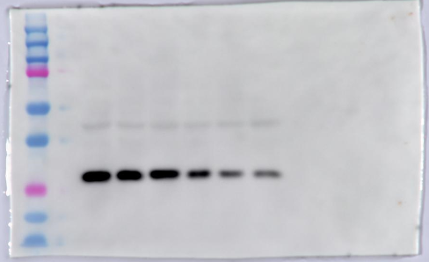
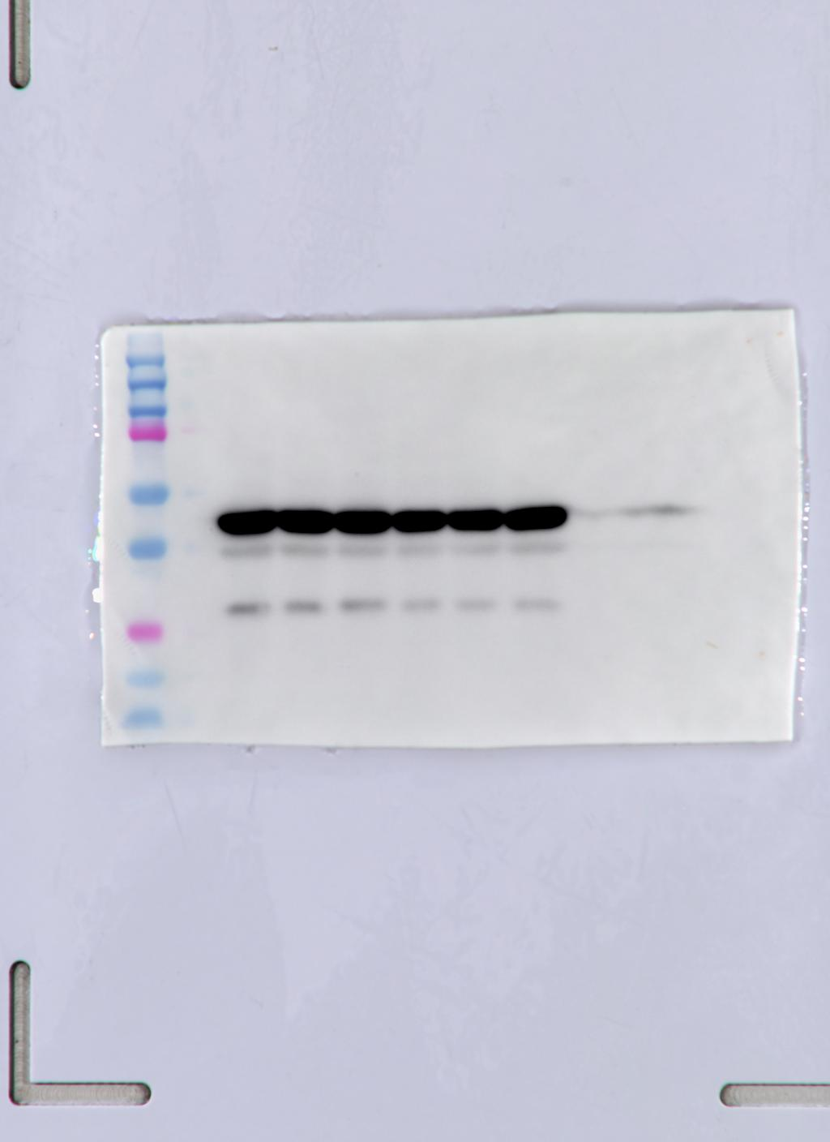
14-3-3η
β-actin
E
14-3-3η
Ubiquitin
β-actin
14-3-3η
Figure 5
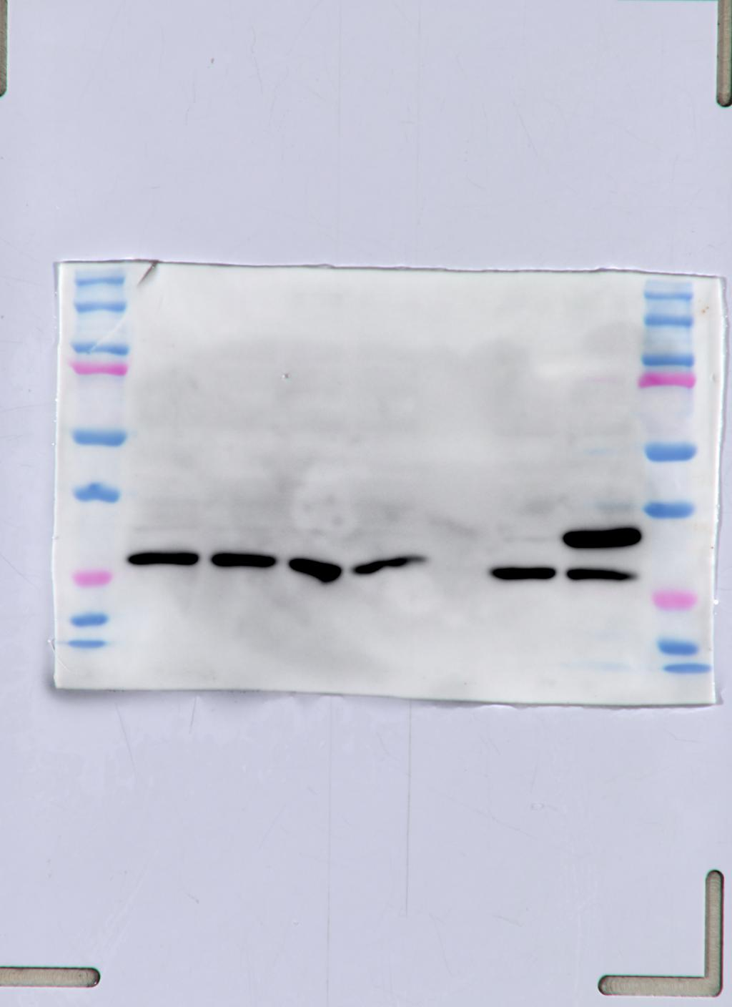
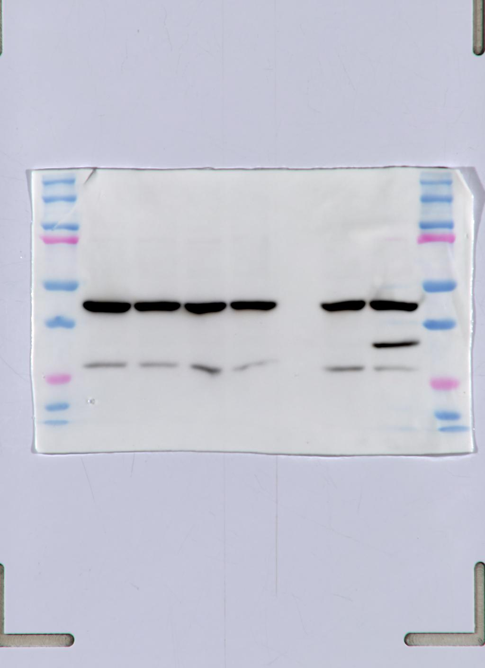
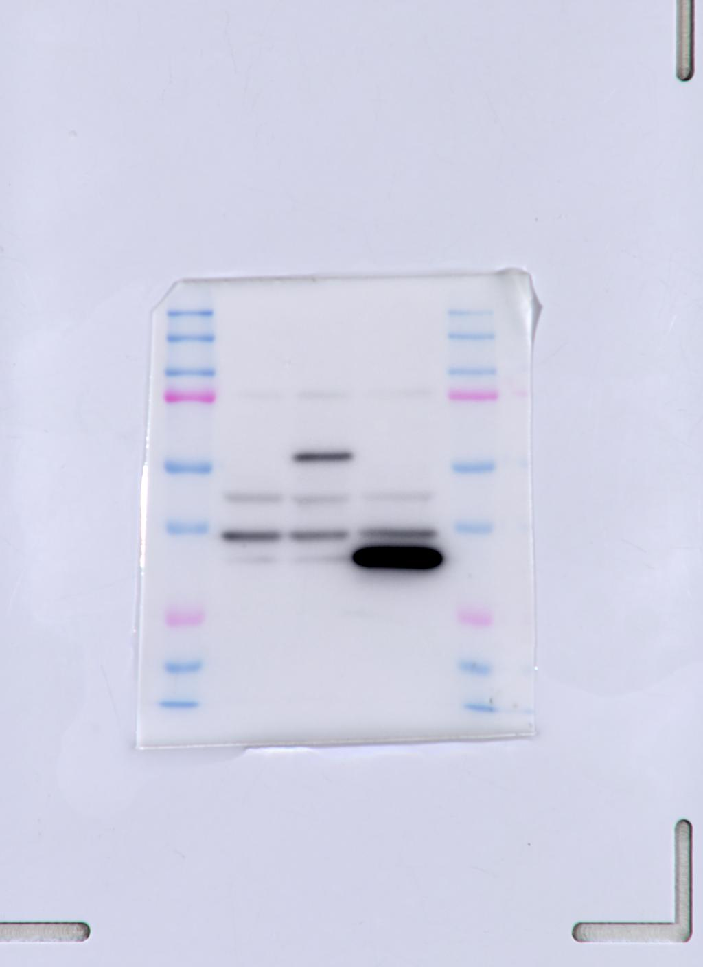
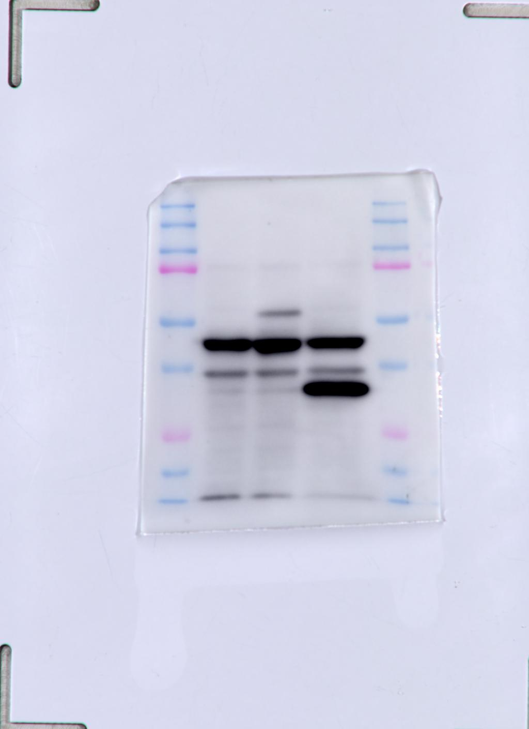
A B
14-3-3η-Flag
β-actin
14-3-3η-flag
actin

C
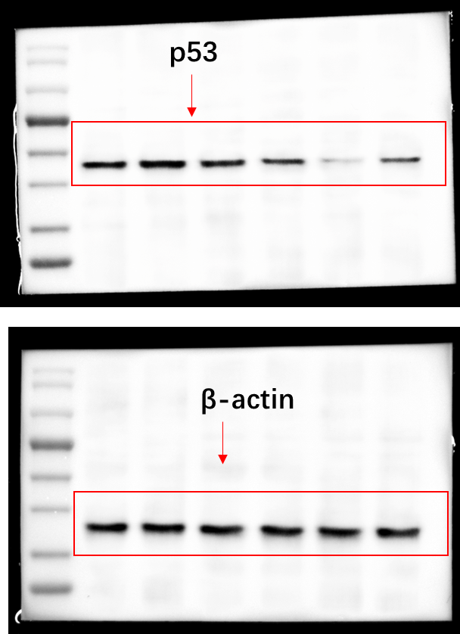

D
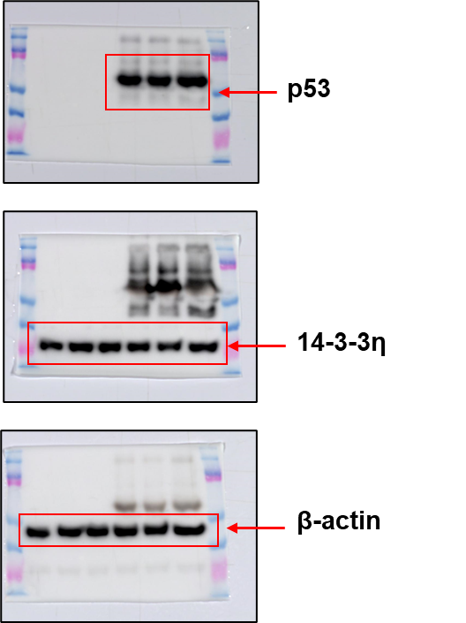

E
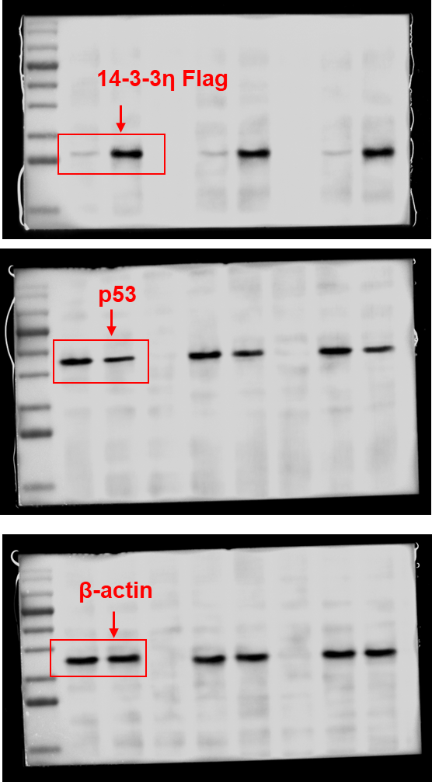
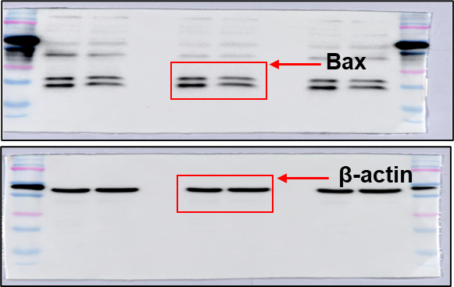

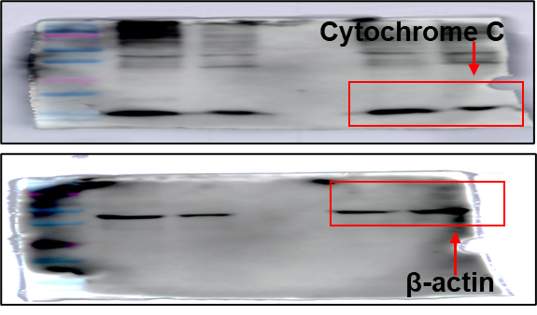

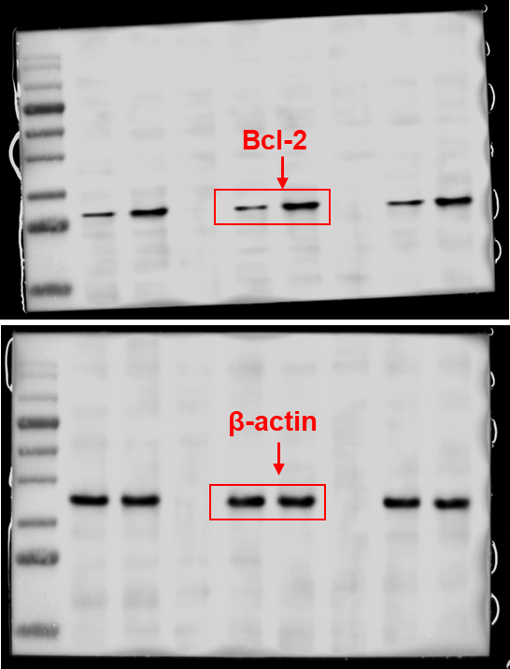
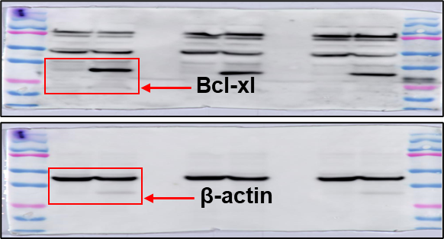

F
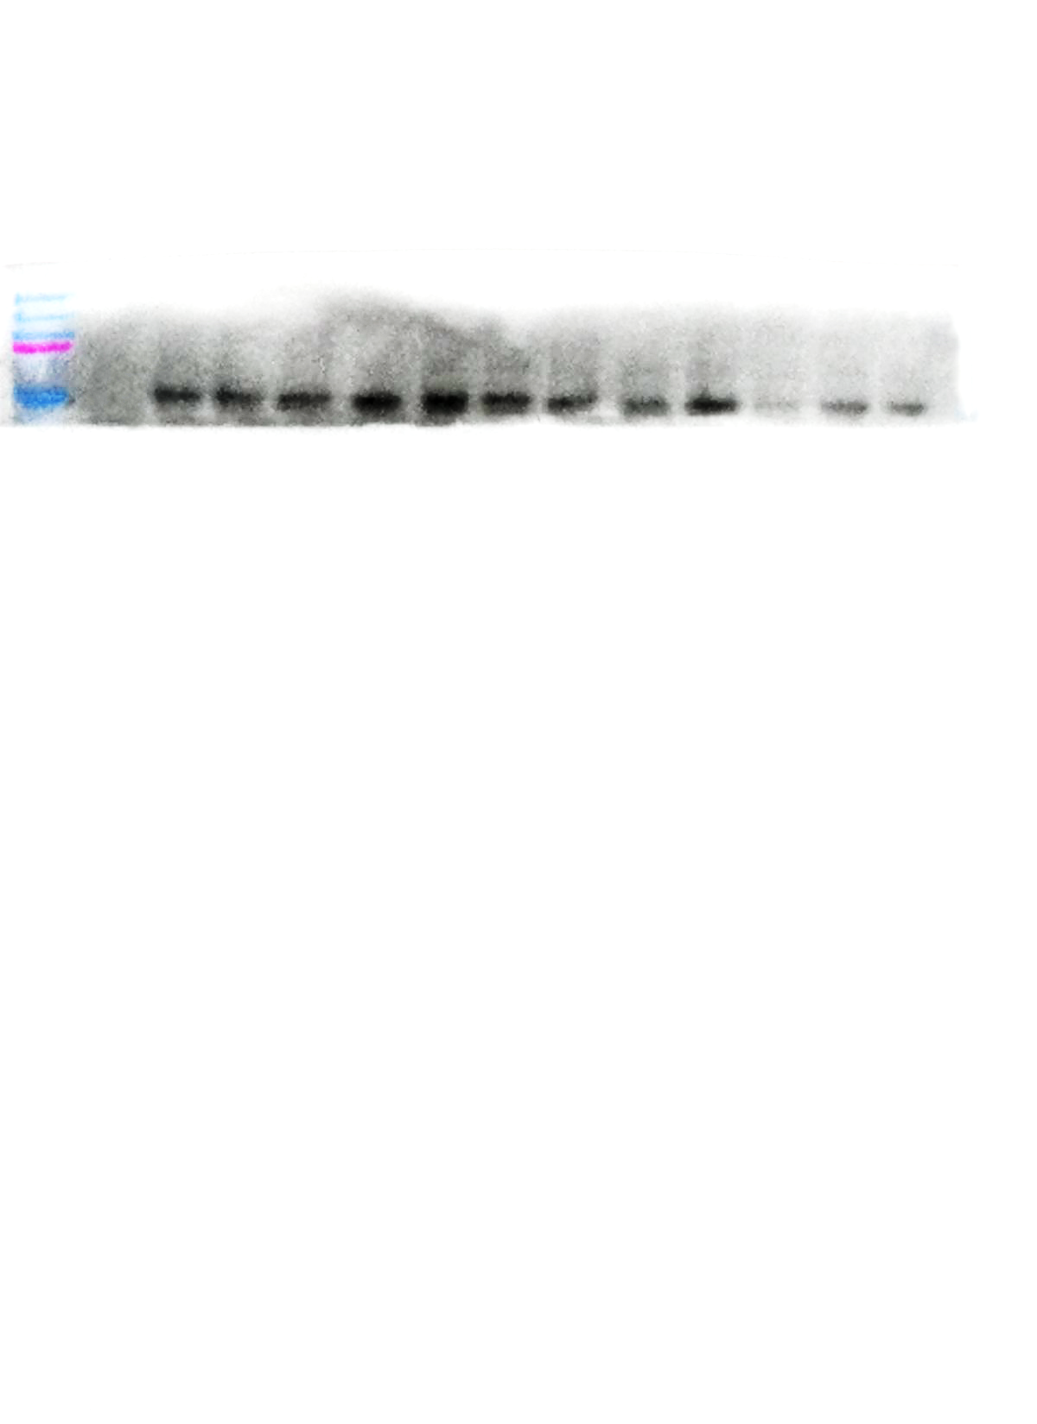
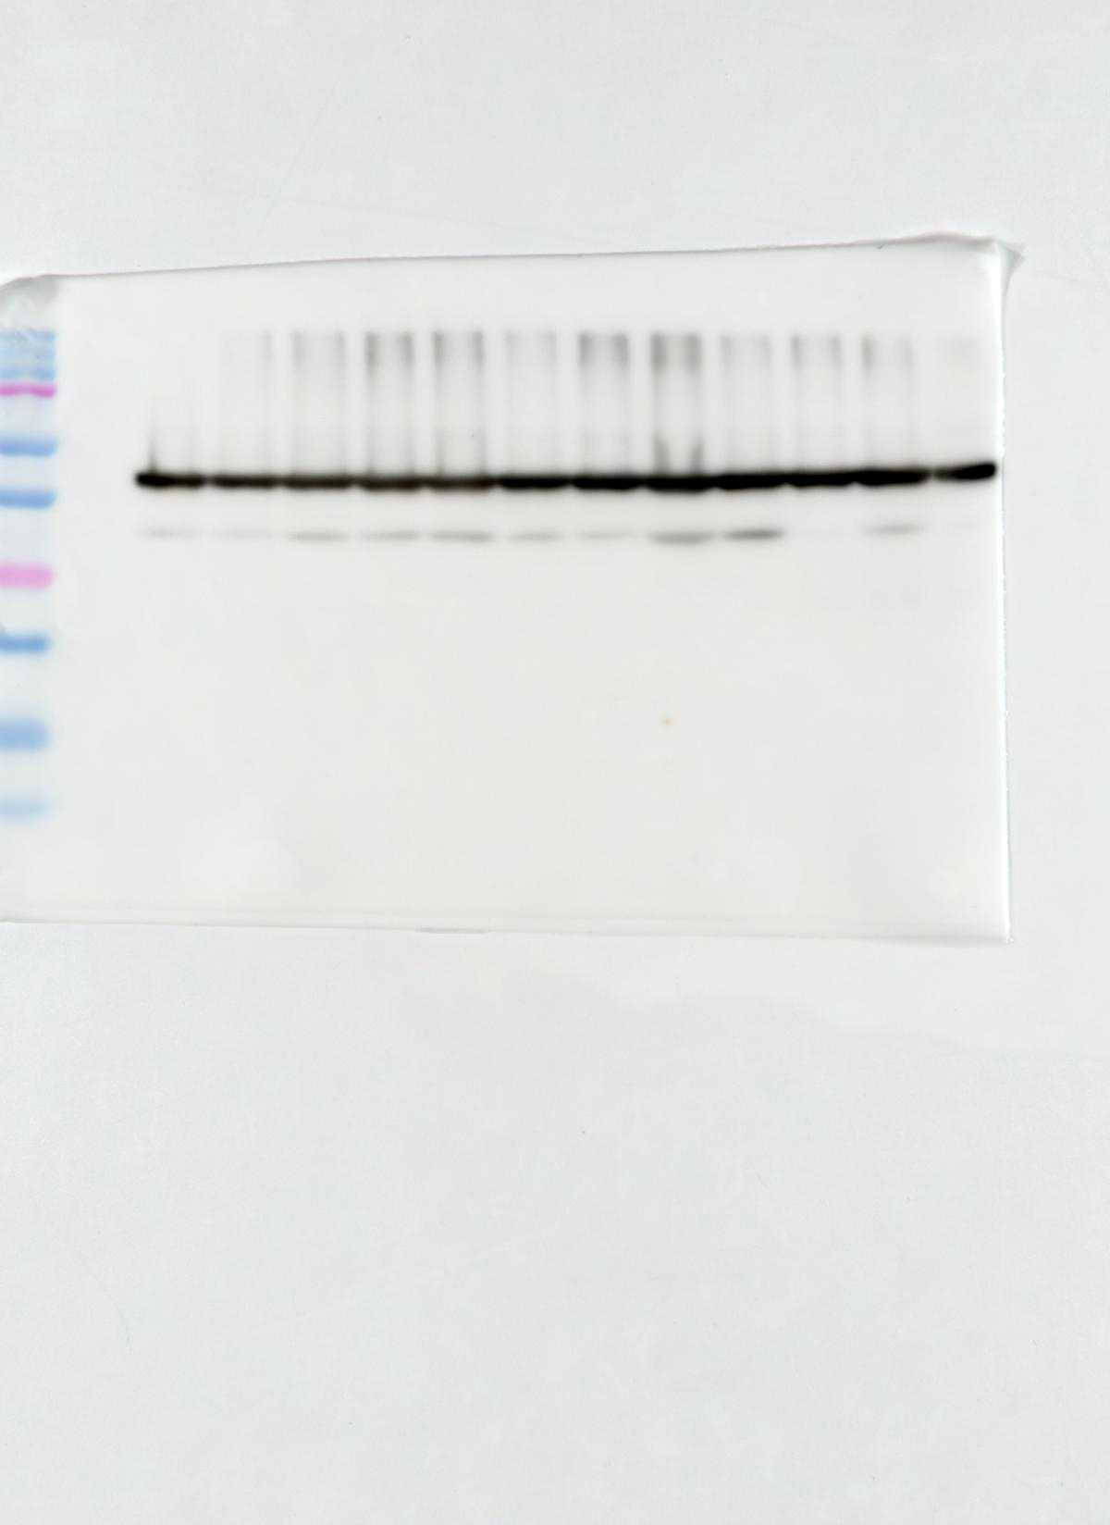
GAPDH

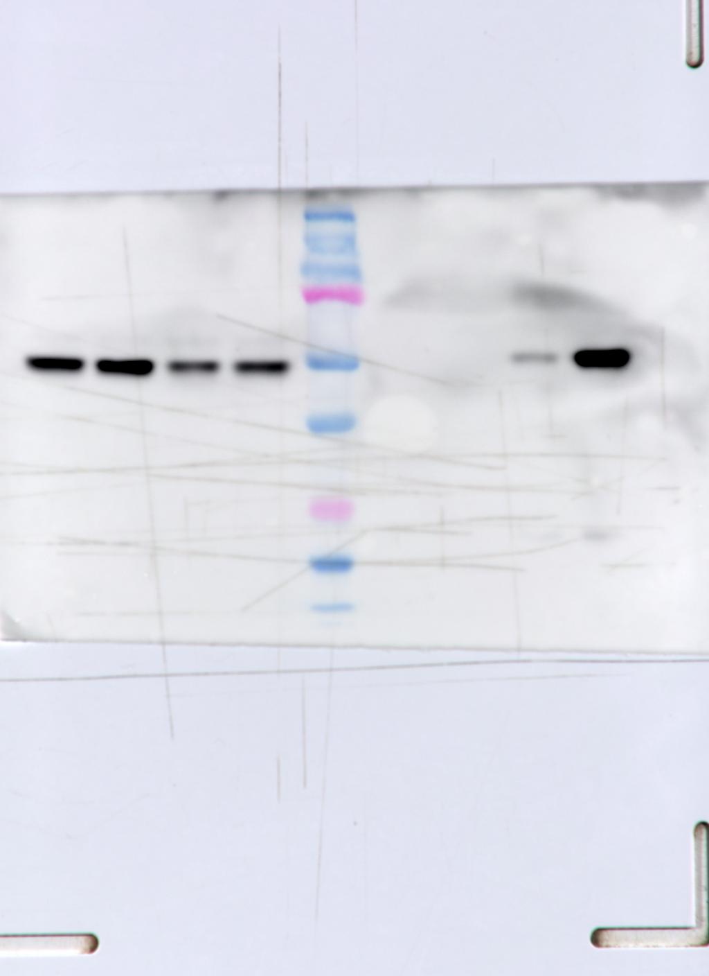
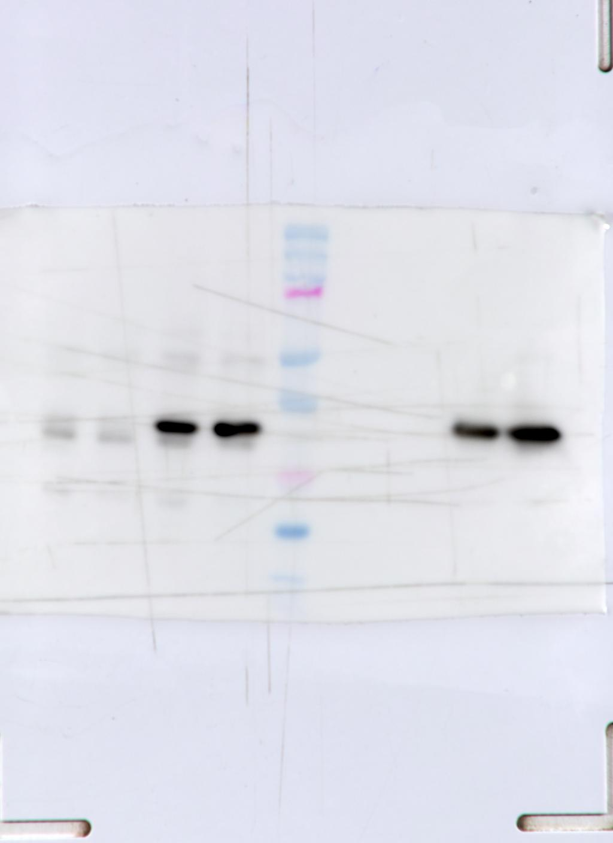
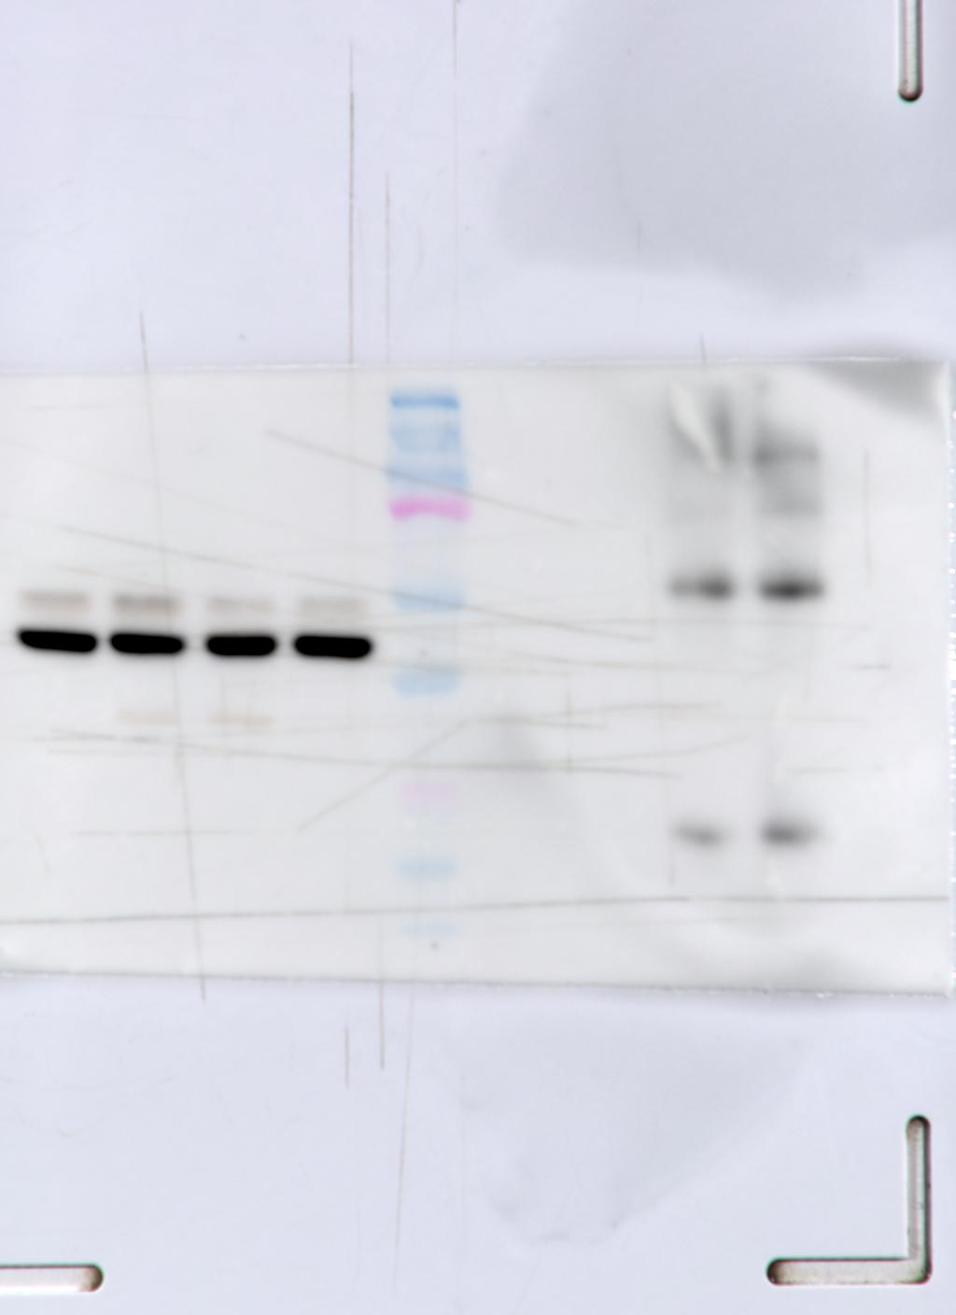
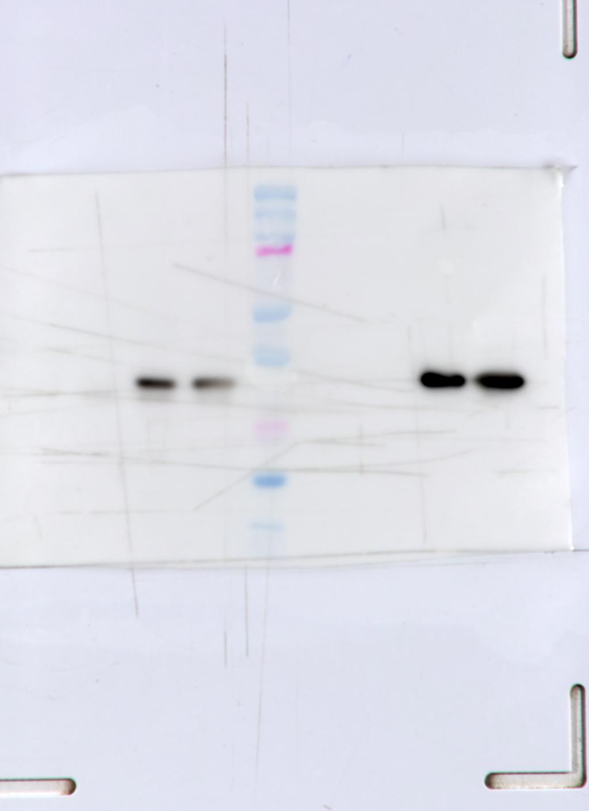
G
p53
14-3-3η
Actin
p53
14-3-3η
Actin

