Appendix A
Table A: Chinese translation of measures / questionnaires used in the study, along with response options.

Social media duration | In the past week, how many hours did you typically spend on social media per day? Please define to one decimal place, e.g. 1 hour and 30 minutes is 1.5 hours; 20 minutes is 0.3 hours) | 一般来说，你每天在各类社交媒体平台上，总共花费多少小时？（注意：请保留一位小数，如1小时30分钟为1.5小时，20分钟为0.3小时）
Bergen Social Media Addiction Scale | How often during the last year have you . . .  From 1=Very rarely to 7=Very often  ---Spent a lot of time thinking about social media or planned use of social media?  ---Felt an urge to use social media more and more?  ---Used social media in order to forget about personal problems?  ---Tried to cut down on the use of social media without success?  ---Become restless or troubled if you have been prohibited from using social media?  ---Used social media so much that it has had a negative impact on your job/studies? | 请根据你最近一年使用社交媒体的情况回答下列问题，选择最符合自己实际的选项。1很少-7很多  花费很多时间思考社交媒体或者计划使用社交媒体  感受到自己越来越高的社交媒体使用冲动  为了忘却个人的问题而去使用社交媒体  尝试着减少使用社交媒体，却没有成功  如果被禁止使用社交媒体，会变得烦躁或困扰  由于使用社交媒体太多，你的工作或学习受到了负面影响
Subjective Happiness  Scale | Instructions to participants: For each of the following statements and/or questions please circle the point on the scale that you feel is most appropriate in describing you.  ---In general, I consider myself:  1 (not a very happy person) – 7 (a very happy  person)  ---Compared to most of my peers, I consider myself  1 (less happy -7 (more happy)  ---Some people are generally very happy. They enjoy life regardless of what is going on, getting the most out of everything. To what extent does this characterization describe you?  1 (not at al1) – 7 (a great deal)  ---Some people are generally not very happy. Although they are not depressed they never seem as happy as they might be. To what extend does this characterization describe you?  1 (not at al1) – 7 (a great deal) | 总的来说，我认为自己  1不是一个很快乐的人 7是一个很快乐的人  与大多数的同龄人相比，我认为自己  - 没那么快乐 7-更加快乐  有这样一类人，他们一般都很快乐，无论发生什么，他们都会享受生活，从每件事中获得最大的收获。你在多大程度上符合这类情况?  1一点也不，7-非常符合  有这样一类人，他们一般都不太快乐，尽管他们并不抑郁，但他们似乎从未像他们应有的那样快乐。A.您认为这个句子是否符合您的特征?  1-一点也不，7-非常符合
Perceived stress 4 | Please answer the following questions according to your feelings in the last month and choose the one that suits your actual situation. 1 never - 5 always  ---were unable to control the important things in your life.  ---felt confident about your ability to handle your personal problems.  ---feel that things were going your way.  --- felt difficulties were pilling up so high that you could not overcome them? | 请根据你最近一个月来的感受回答下列问题，选择符合自己实际情况的选项。（从不-偶尔-有时-常常-总是）  对生活中重要的事情感到无法控制  有信心自己能够处理好自己的问题  感到事情顺心如意  棘手的问题越来越多以致你觉得自己无法解决
The Brief Resilience Scale | Please indicate the extent to which you agree with each of the following statements by using the following scale: 1 = strongly disagree, 2 = disagree, 3 = neutral, 4 =agree, 5 = strongly agree.  ---I tend to bounce back quickly after hard times.  ---I have a hard time making it through stressful events.  ---It does not take me long to recover from a stressful event.  ---It is hard for me to snap back when something bad happens.  ---I usually come through difficult times with little trouble.  ---I tend to take a long time to get over set-backs in my life. | 对于下列陈述，你在多大程度上同意？  经历过挫折之后,我总是能很快恢复  面对压力事件时,我常感到不知所措  不用多久,我就能从压力事件中恢复过来  倒霉事件发生后,我总是很难恢复  我总能轻而易举地渡过困难时期  我总是花很长时间来克服生活中所遇到的挫折
relationship | How close are you to your parents, roommates, and classmates? (1-7, very not close - very close, not applicable)  ---Parents  ---Roommate  ---Classmates | 你和父母、室友、同学的关系怎么样？（1-7，非常不亲近-非常亲近，不适用）  父母  室友  班级同学
Age | Your year of birth is? | 你的出生年份是？
Sex | Your sex is?  1) Male  2) Female | 你的性别是？  男  女
Father’s highest education | Your father's highest education level is:  - junior middle school and below  - Vocational high school/Ordinary high school/Technical secondary school / Technical School  - Associate degree  - Undergraduate  - Graduate and above | 请问你父亲的最高教育程度是？  1）初中及以下  2）职业高中/普通高中/中专/技校  3）大学专科  4）大学本科  5）研究生及以上
Mother’s highest education | As above. | 同上
Family annual income | Which of the following ranges was your family's total income last year?  - <50k  - 50-99.9k  - 100k-199.9k  - 200k-299.9k  - 300k-499.9k  - >500k  - unknown | 请问你的家庭去年全年的总收入在以下哪个区间？  1）5万元以下  2）5-9.99万元  3）10-19.99万元  4）20-29.99万元  5）30-50万元  6）50万元以上  7）不清楚
Residence | Your registered residence before entering school is:  1) in rural areas  2) in cities and towns. | 你入学前的户籍是?  1）农村  2）城镇

Appendix B

Linearity
The Residuals vs Fitted Plot is used to check the assumptions of linearity. Residuals cluster around the horizontal line (red line near zero) with moderate curvature and a few extreme points, but the overall alignment remains acceptable, suggesting the linearity assumption is largely met.

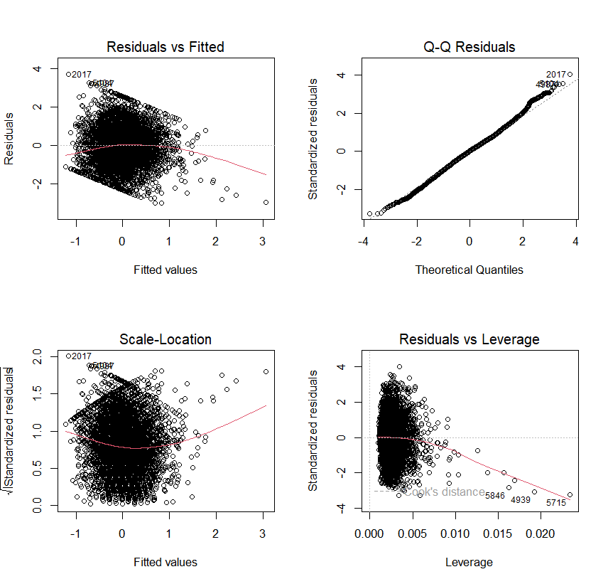

The Predictor-vs-Residual Plots are used to check linearity and homoscedasticity assumptions by plotting raw residuals against each predictor. Residuals exhibit a random scatter around zero with no discernible patterns or unequal spread, supporting the assumptions of linearity and homoscedasticity.
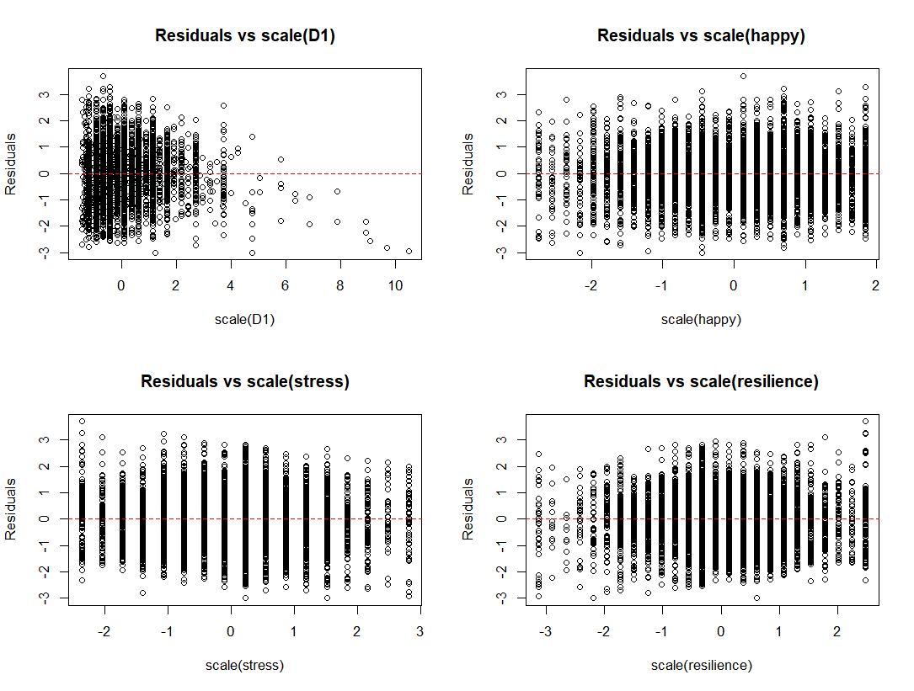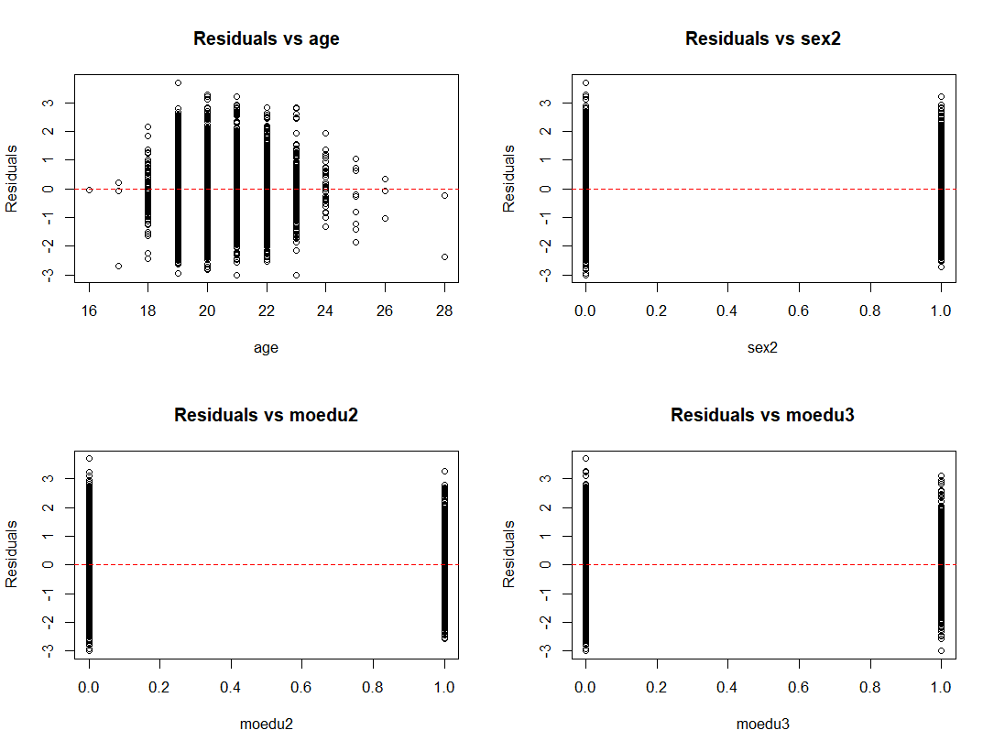
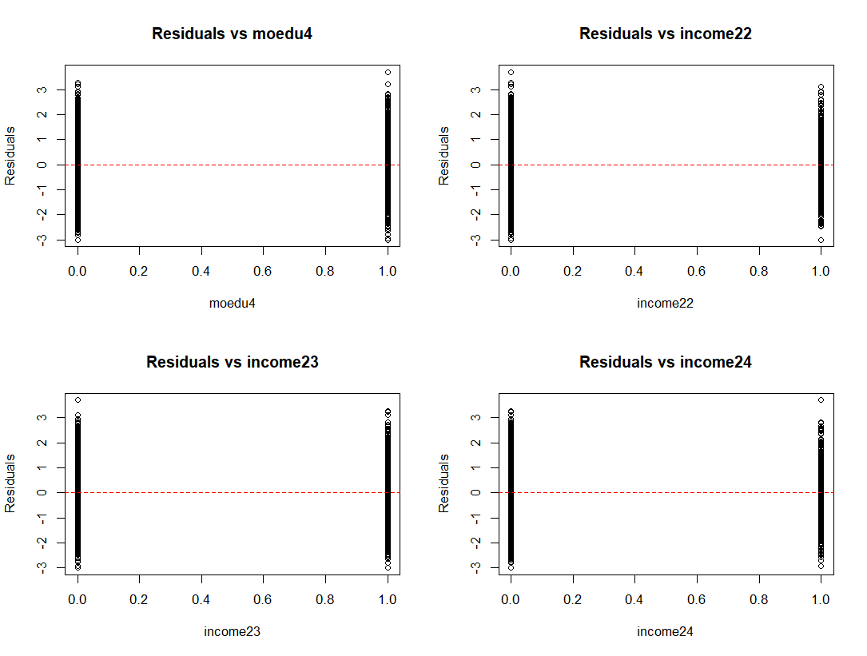
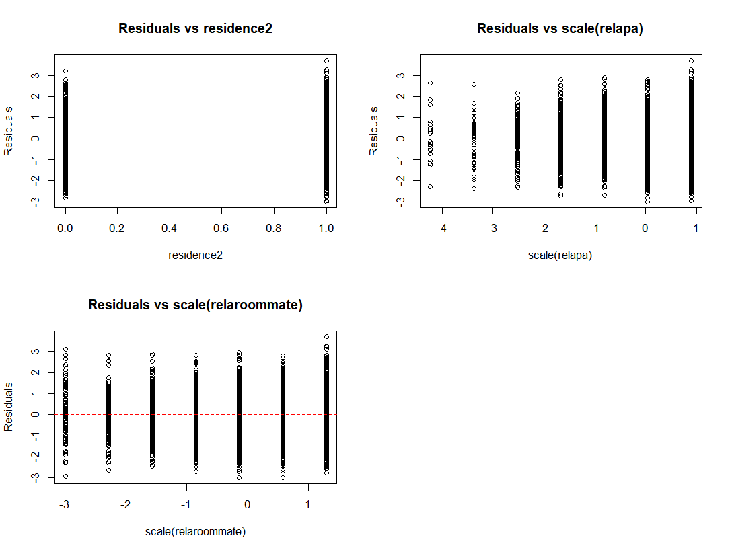

Normality
The Q-Q plot is used to check the normality of residuals assumption. The majority of the residuals follow the straight dashed line, so the assumption was fulfilled.

Homoscedasticity
The Scale-Location Plot is used to check the homoscedasticity of residuals (equal variance of residuals). Although the scale-location plot exhibits mild curvature in the red line, the non-constant variance test (NCV test, χ²=3.365, p=0.067) indicates no statistically significant evidence of heteroscedasticity, suggesting that the homoscedasticity assumption remains plausible despite minor deviations in the visual pattern.

Influential outliers
The Residuals vs Leverage Plot is used to identify any influential value in our dataset. The plot reveals only few isolated points with elevated leverage values, but their overall impact is limited. The majority of data points cluster within acceptable leverage and residual ranges, supporting the validity of the regression assumptions.

Independence
The Durbin Watson examines whether the errors are autocorrelated with themselves. The Durbin-Watson test statistic is 2.014 (p=0.644), suggesting no significant autocorrelation in the residuals, consistent with the null hypothesis of independence.

We also use the variance inflation factor (VIF) to diagnose collinearity. All predictor variables have VIF values below 2, indicating no substantial multicollinearity in the model. This suggests that the predictors are sufficiently independent, and their estimated coefficients are unlikely to be biased by strong intercorrelations.
