Supplementary Information:

The Influence of 3D Printing Parameters on ULTEM 9085 Mechanical Properties: A Combined Experimental and Machine Learning Qualification Approach

Kassandra Hernandez ¹, Seth O’Brien ^{1,2}, Adam Bischoff ¹, John Parmigiani ¹, Devin J. Roach ^{1*}

¹ Department of Mechanical, Industrial, and Manufacturing Engineering, Oregon State University, Corvallis, OR, USA
² Federal Aviation Administration, Washington, DC 20591

* Corresponding author:

Devin J. Roach, 224 Rogers Hall, Corvallis, OR 97331, USA

Email: devin.roach@oregonstate.edu

S1. Tabulated 3D printing parameters
Each of the printing parameters in this study are defined in Table S1 corresponding to all the coupons tested experimentally and within the machine learning model.
Table S1: ULTEM 9085 printing parameters explored in this experiment.
Build orientation |  |  | Number of contours | Raster angle | Air gap (mm)
XZ | XY | ZX | 0 | 45°, -45° | 0
 |  |  |  |  | 0.127
 |  |  |  |  | 0.635
 |  |  |  |  | 1.27
 |  |  |  | 0 | 0
 |  |  |  |  | 0.127
 |  |  |  |  | 0.635
 |  |  |  |  | 1.27
 |  |  |  | 90 | 0
 |  |  |  |  | 0.127
 |  |  |  |  | 0.635
 |  |  |  |  | 1.27
XZ | XY | ZX | 1 | 45°, -45° | 0
 |  |  |  |  | 0.127
 |  |  |  |  | 0.635
 |  |  |  |  | 1.27
 |  |  |  | 0 | 0
 |  |  |  |  | 0.127
 |  |  |  |  | 0.635
 |  |  |  |  | 1.27
 |  |  |  | 90 | 0
 |  |  |  |  | 0.127
 |  |  |  |  | 0.025
 |  |  |  |  | 1.27
XZ | XY | ZX | 3 | 45°, -45° | 0
 |  |  |  |  | 0.127
 |  |  |  |  | 0.635
 |  |  |  |  | 1.27
 |  |  |  | 0 | 0
 |  |  |  |  | 0.127
 |  |  |  |  | 0.635
 |  |  |  |  | 1.27
 |  |  |  | 90 | 0
 |  |  |  |  | 0.127
 |  |  |  |  | 0.635
 |  |  |  |  | 1.27

S1. Multiple Mechanical Properties Results
As noted in the manuscript, the strength, elastic modulus, and yield strength were studied and used in the ANN. Figure S1 depicts the prediction and experimental comparison for both the XY and XZ build orientations using the tensile results gathered using an extensometer. While Figure S2 shows the experimental and prediction results for the XY and XZ build orientations using tensile results gathered without an extensometer.
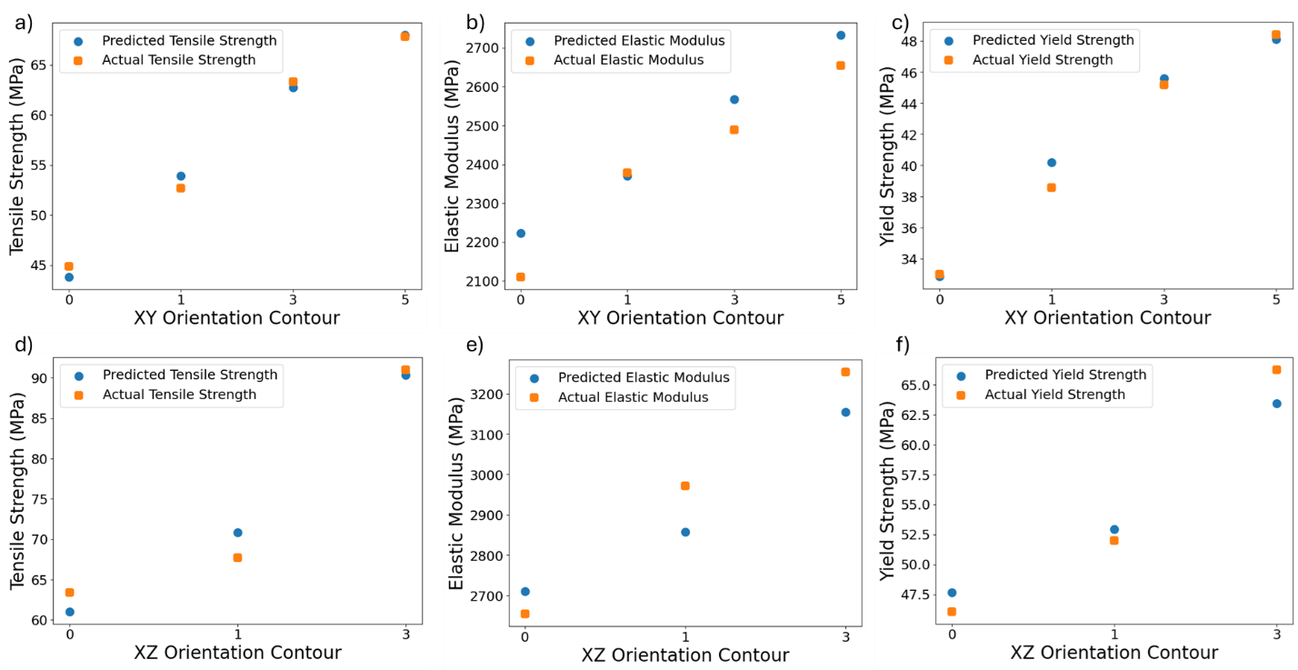
Figure S1: Comparison of predicted and actual mechanical properties of 3D-printed ULTEM 9085 specimens for XY and XZ build orientations. (a-c) Tensile strength, elastic modulus, and yield strength results of XY build orientations at each contour highlighting the agreement between the predicted values using machine learning and actual experimental data gathered from an extensometer. (d-f) Tensile strength, modulus, and yield strength predicted and actual results of XZ build orientation at each contour from experimental data gathered from an extensometer.
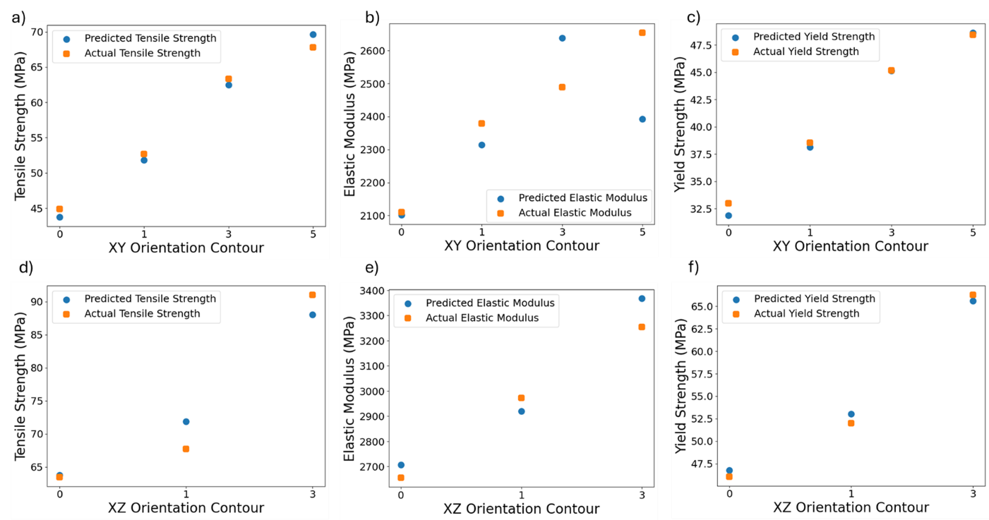
Figure S2: Comparison of predicted and actual mechanical properties of 3D-printed ULTEM 9085 specimens derived from stress-position data for XY and XZ build orientations. (a-c) Tensile strength, modulus, and yield strength results of XY build orientations at each contour highlighting the agreement between the predicted values using machine learning and actual experimental data gathered from stress-position data. (d-f) Tensile strength, elastic modulus, and yield strength predicted and actual results of XZ build orientation at each contour from experimental data gathered from stress-position data.

