Table S1: Expression of mRNA of genes responsible for antiviral immune response, innate and adaptive immune responses, lymphocytes development, coagulation proteins and fibrosis in SARS-CoV-2 (Delta variant)

Gene responsible for antiviral Immune response
Gene | HC (1) | Delta Variant (2) | 1vs2
IFNAR1 | 1.003± 0.098 | 0.077± 0.042 | <0.0001
IFNG | 1.027± 0.271 | 0.068± 0.043 | 0.0019
IFIH1 | 1.007± 0.139 | 0.453± 0.131 | 0.0037
Gene regulating Innate vs Adaptive Immunity
PUM1 | 1.004± 0.11 | 0.248± 0.135 | 0.0008
EGR2 | 1.005± 0.115 | 0.187±0.076 | 0.0003
EGR3 | 1.015± 0.212 | 0.146± 0.035 | 0.0011
Genes responsible for T and B cell development
IL-7 | 1.0011± 0.0582 | 0.463± 0.118 | 0.0011
IL-7R | 1.001± 0.06 | 0.179± 0.068 | <0.0001
CBFB | 1.005± 0.119 | 0.323± 0.079 | 0.0006
FOXO1 | 1.0076± 0.152 | 0.068± 0.025 | 0.0002
Bcl6 | 1.0001± 0.015 | 0.048± 0.021 | <0.0001
CXCR5 | 1.002± 0.076 | 0.56± 0.176 | 0.0081
IL2RG | 1.004± 0.1088 | 0.178± 0.078 | 0.0002
Bcl11b | 1.022± 0.271 | 0.148± 0.063 | 0.0028
Ikzf1 | 1.000± 0.02 | 0.179± 0.068 | <0.0001
Ikzf2 | 1.001± 0.058 | 0.7± 0.492 | Ns
RUNX1 | 1.004± 0.11 | 0.426±  0.106 | 0.0014
cMyb | 1.0031± 0.095 | 1.706± 0.271 | 0.0066
GATA2 | 1.004± 0.106 | 0.262± 0.413 | 0.0197
Genes responsible for Neuropsychiatric manifestations
NOS1 | 1.007± 0.145 | 1.22±  0.047 | 0.0009
NTRK1 | 1.045± 0.396 | 0.046± 0.0176 | 0.006
NTRK2 | 1.036± 0.321 | 0.051± 0.013 | 0.003
Genes responsible for Thrombosis and Coagulation
PLG | 1.005± 0.1225 | 0.924± 0.884 | Ns
ADAMTS13 | 1.0007± 0.045 | 1.015± 0.565 | Ns
NFIC | 1.003± 0.088 | 0.099± 0.093 | 0.00013
POU2f | 1.0029± 0.0929 | 0.131± 0.071 | 0.0001
TPA | 1.006± 0.129 | 1.014± 0.542 | Ns
Genes responsible for hyperinsulinemia and hyperglycemia
IGF1 | 1.0005± 0.039 | 1.398± 0.173 | 0.009
IGF2R | 1.0258± 0.268 | 0.178± 0.153 | 0.0044
Genes responsible for biological clock
Genes responsible for membrane blebbing
TBC1D10C | 1.003± 0.096 | 0.762± 0.117 | 0.0255
TBC1D15 | 1.006± 0.132 | 0.141± 0.059 | 0.0002
Genes responsible for Anti-apoptosis
Bcl2 | 1.002± 0.087 | 0.328± 0.043 | 0.00013

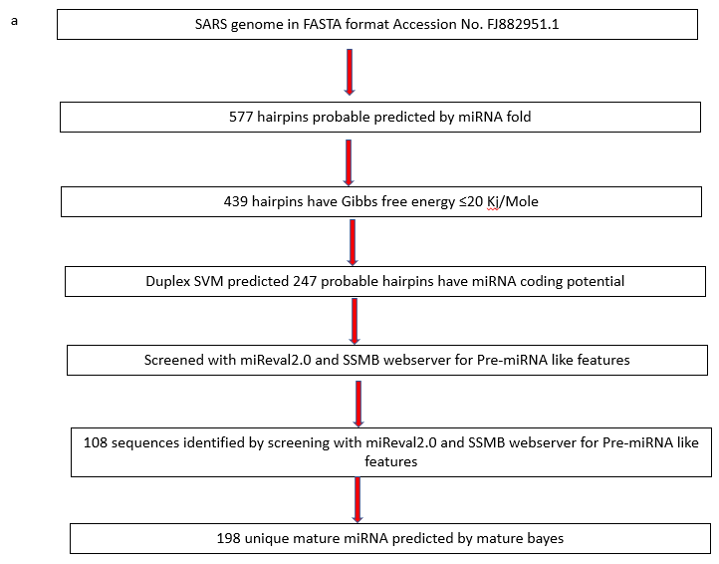
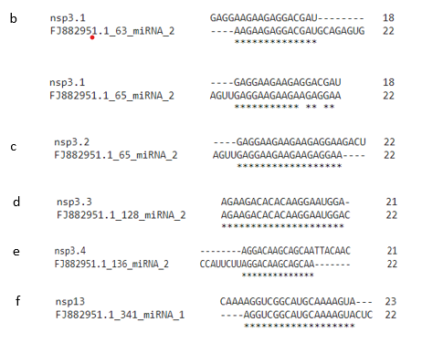
Supplementary Figure S1: Putative miRNA prediction model for SARS-CoV:
(a) Schematic Diagrammatic representation of potential miRNA identification of SARS-CoV Genome. Local Sequence alignment of SARS-CoV encoded miRNA with predicted miRNA (b) nsp3.1, (c) nsp3.2, (d)nsp3.3, (e) nsp3.4 and (f) nsp13.
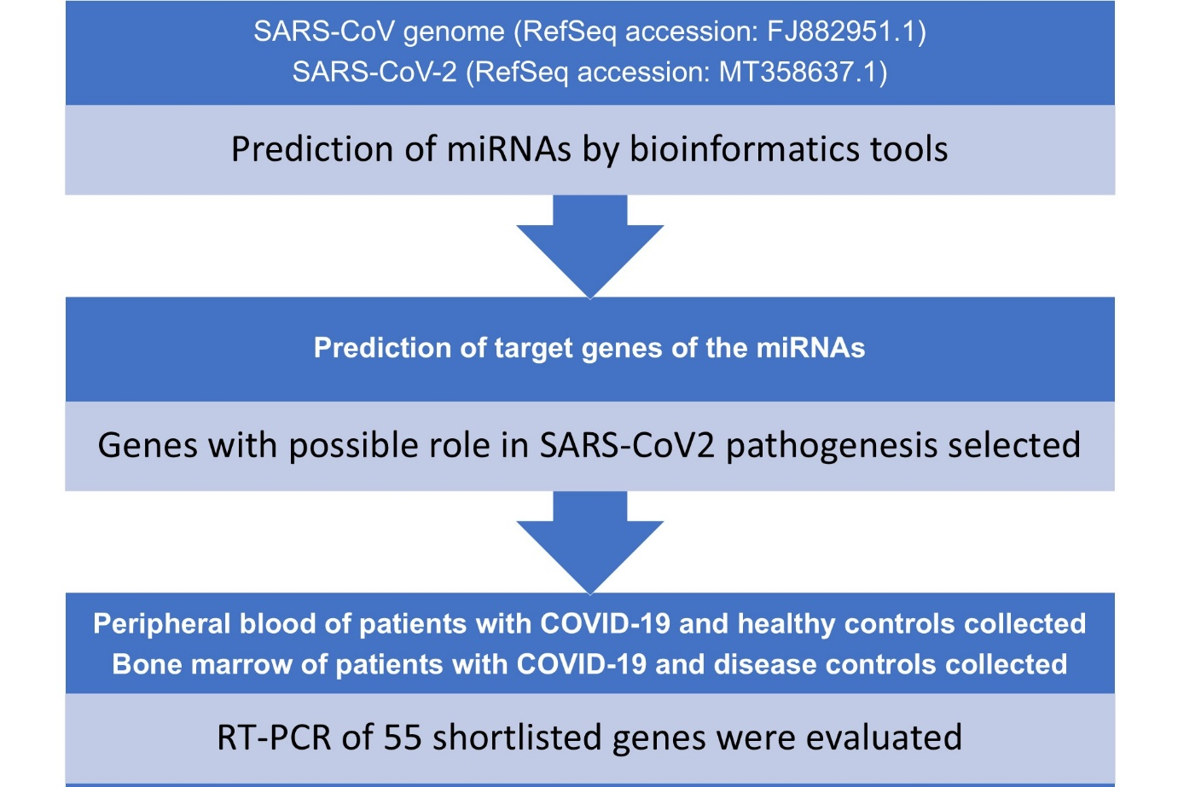

Supplementary figure S2. Study flow chart

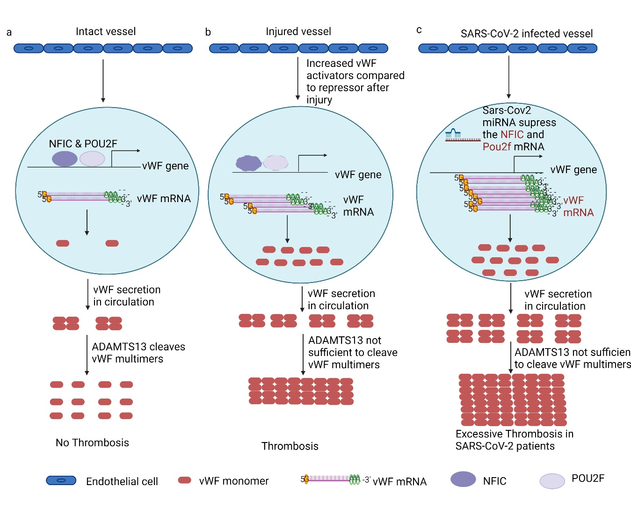
Supplementary Fig. S3: SARS-CoV-2 may mediate thrombosis by increased secretion of vWF multimers: In normal healthy individuals and intact blood vessel, ADAMTS 13 inhibits thrombosis by cleaving large multimers of vWF (procoagulants) to small multimers. NFIC and POU2F1 acts as repressors of vWF. During injury, expression of vWF activators is upregulated whereas those of repressors remain unaffected this leads to excess of large multimers of vWF in circulation leading to thrombosis. In SARS-CoV-2 infected individuals, expression of NFIC and POU2F1 is highly reduced leading to increased expression of large multimers of vWF overwhelming the capacity of ADAMTS13 and leading to thrombosis.

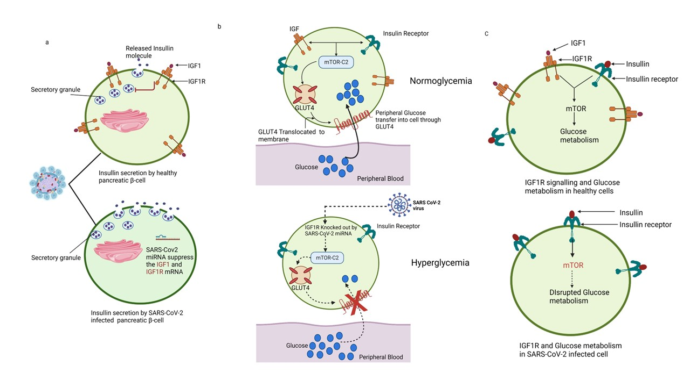
Supplementary Figure S4: Effect of SARS-CoV-2 on hyperinsulinemia and Glucose metabolism: IGF1/IGF1R signaling negatively regulates the release of insulin from pancreatic beta cells. In SARS-CoV-2 infected individuals IGF1R is highly decreased resulting in excessive release of insulin and hyperinsulinemia (a). Similarly reduced IGF1R signaling results in reduced translocation of Glut4 protein and result in reduced uptake of Glucose (b). Reduced mTOR signaling reduced the Glucose metabolism (c).

Expression of genes (downregulated by putative viral miRNAs) that might be playing a role in clinical manifestations of SARS-CoV2 infection:
Loss of smell:
Pax6 gene is responsible for development of olfactory epithelium which governs the smell and taste. Expression of Pax6 mRNA was significantly downregulated in severe SARS-CoV-2 infection which could possibly explain loss of smell (Table 2).
Colitis and hyperplasia of gastric mucosa:
RUNX3 plays crucial role in maintenance of gastric mucosa. However, SARS-CoV-2 encoded putative microRNA may target RUNX3 which could have resulted in Colitis and hyperplasia of gastric mucosa (Table 2). We observed significant downregulation of RUNX3 gene mRNA in patients with severe infection.
Dry eye:
PAX6 expression was downregulated in severe patients and could explain dry eye symptoms (Table 2).
Delayed sleep phase syndrome:
Biological clock and sleep cycle is regulated by CRY1 gene. Its expression was significantly downregulated in severe SARS-CoV-2 patients (Table 2).
High rate of membrane blebbing:
Ras-associated binding protein- guanosine triphosphate (Rab-GTP) causes contraction of actin and myosin leading to formation of membrane bleb. Its activity is negatively regulated by TBC1D family of proteins. TBC1D10B and TBC1D10C expression were reduced in severely infected SARS-CoV-2 patients (Table 2).
Apoptosis:
Anti-apoptotic gene Bcl2 expression was down regulated in severe SARS-CoV-2 patient compared to healthy controls (Table 2).
Discussion:
PAX6 and SOX2 are critical for olfactory epithelium development and repair. Their downregulation may explain anosmia in SARS-CoV-2 [1].
Loss of RUNX3, which maintains gastric mucosal integrity, may contribute to GI complications [2]. Additionally, TBC1D proteins suppress membrane blebbing; their downregulation (especially TBC1D15/10B/10C) during delta variant infections may facilitate viral dissemination via membrane blebs (Fig. S5) [3, 4].
Sleep disturbances in COVID-19 may be linked to downregulation of CRY1, a circadian clock regulator, likely targeted by viral miRNAs (Fig. S6) [5].
References
- Guo Z, Packard A, Krolewski RC, Harris MT, Manglapus GL, Schwob JE. Expression of pax6 and sox2 in adult olfactory epithelium. J Comp Neurol. 2010 Nov 1;518(21):4395-418.
- Brenner O, Levanon D, Negreanu V, Golubkov O, Fainaru O, Woolf E, et al. Loss of Runx3 function in leukocytes is associated with spontaneously developed colitis and gastric mucosal hyperplasia. Proc Natl Acad Sci U S A. 2004 Nov 9;101(45):16016-21.
- Takahara Y, Maeda M, Hasegawa H, Ito S, Hyodo T, Asano E, et al. Silencing of TBC1D15 promotes RhoA activation and membrane blebbing. Mol Cell Biochem. 2014 Apr;389(1-2):9-16.
- Blanc L, Vidal M. New insights into the function of Rab GTPases in the context of exosomal secretion. Small GTPases. 2018 Mar 4;9(1-2):95-106.
- Parico GCG, Perez I, Fribourgh JL, Hernandez BN, Lee HW, Partch CL. The human CRY1 tail controls circadian timing by regulating its association with CLOCK:BMAL1. Proc Natl Acad Sci U S A. 2020 Nov 10;117(45):27971-9.

