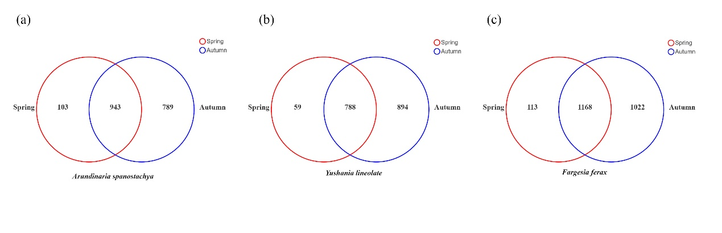
Fig. S1 Venn Diagram showing overlap/non-overlap of phyllosphere bacteria OTUs of A. spanostachya (AS) (a), Y. lineolate (YL) (b) and F. ferax (FF) (c) between spring and autum

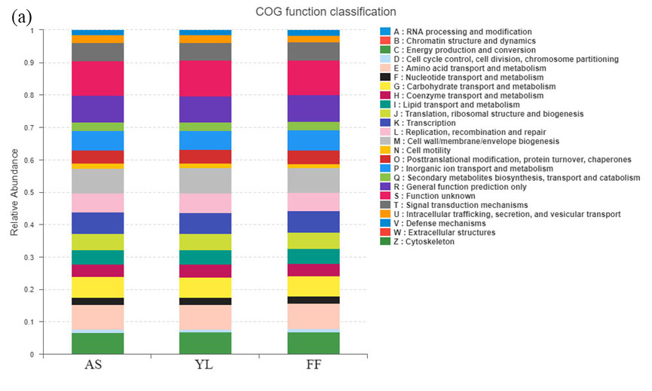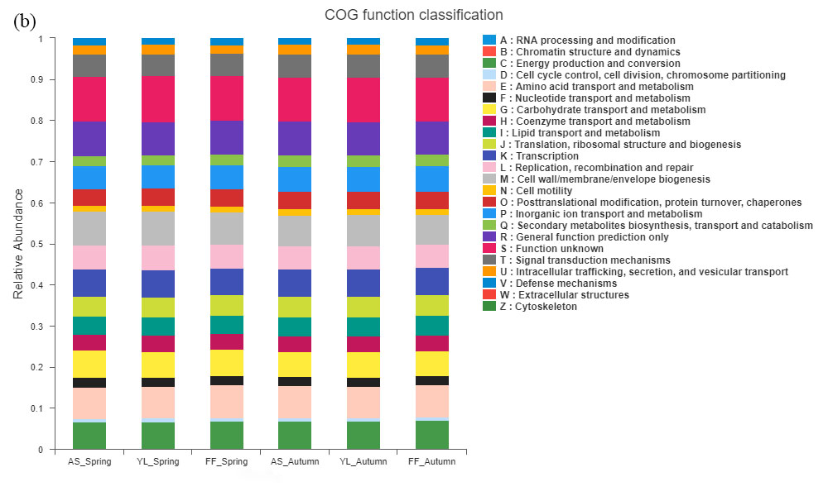 Fig. S2 Histogram of COG functional classification of phyllosphere bacteria among A. spanostachya (AS), Y. lineolate (YL) and F. ferax (FF) (a) in spring and autumn (b).

