Supplementary materials

Table S1. Trait optima (θ) and rate of evolution or ‘drift variance’ (σ²) estimated for both categorizations (nectarivory, 2-regimes: N = nectarivorous, NN = non-nectarivorous; diet, 5-regimes: O = omnivory; F = fruits; P = plants; S = seeds; N = nectar) using the full model (OUMVA) in ‘OUwie’ (Beaulieu & O’Meara, 2015). This model all allows all parameters (θ, σ² and α) to vary by regime. Due to its complexity the likelihood of the OUMVA model for both PCa1 and size did not converge when discerning among the five dietary regimes. It resulted in biologically unfeasible θ values and negative eigenvalues of the Hessian matrix so instead, we reported values obtained using a simpler model (OUMA), which assumes distinct θ and α for each regime while keeping constant σ².

 | PCa1 |  | PCb1 |  | size |  | HWI
 | θ | σ² | θ | σ² | θ | σ² | θ | σ²
nectar
N | -0.22 | 0.03 | -0.62 | 0.43 | 0.48 | 1.68^{e-3} | 1.63 | 0.01
NN | 2.25 | 0.02 | -0.18 | 0.45 | 1.31 | 7.89^{e-4} | 1.58 | 0.01
diet
O | 1.77 | 0.05 | -0.61 | 0.06 | 1.45 | 1.1^{e-3} | -0.34 | 4.8^{e-4}
F | 19.17 | 0.06 | -2.67 | 0.07 | 1.37 | 5.7^{e-3} | 1.60 | 2.8^{e-6}
P | -0.24 | 0.02 | -1.09 | 9.0^{e-3} | -2.99 | 3.3.^{e-5} | 1.37 | 3.5^{e-4}
S | -0.54 | 0.10 | 7.93 | 0.03 | 1.28 | 4.1^{e-3} | 1.64 | 8.7^{e-5}
N | 1.36 | 0.03 | -0.14 | 0.05 | 1.33 | 4.0^{e-3} | 1.63 | 1.0^{e-4}

Figure S1. Posterior probability that a branch has a jump (left) and the posterior mean number of jumps per branch (right) on a color scale from black (no jump) to red (jumps) for each trait (a: body size, b: PCa1; c: PCb1; and d: HWI) following the approach devised by [32].

(a)

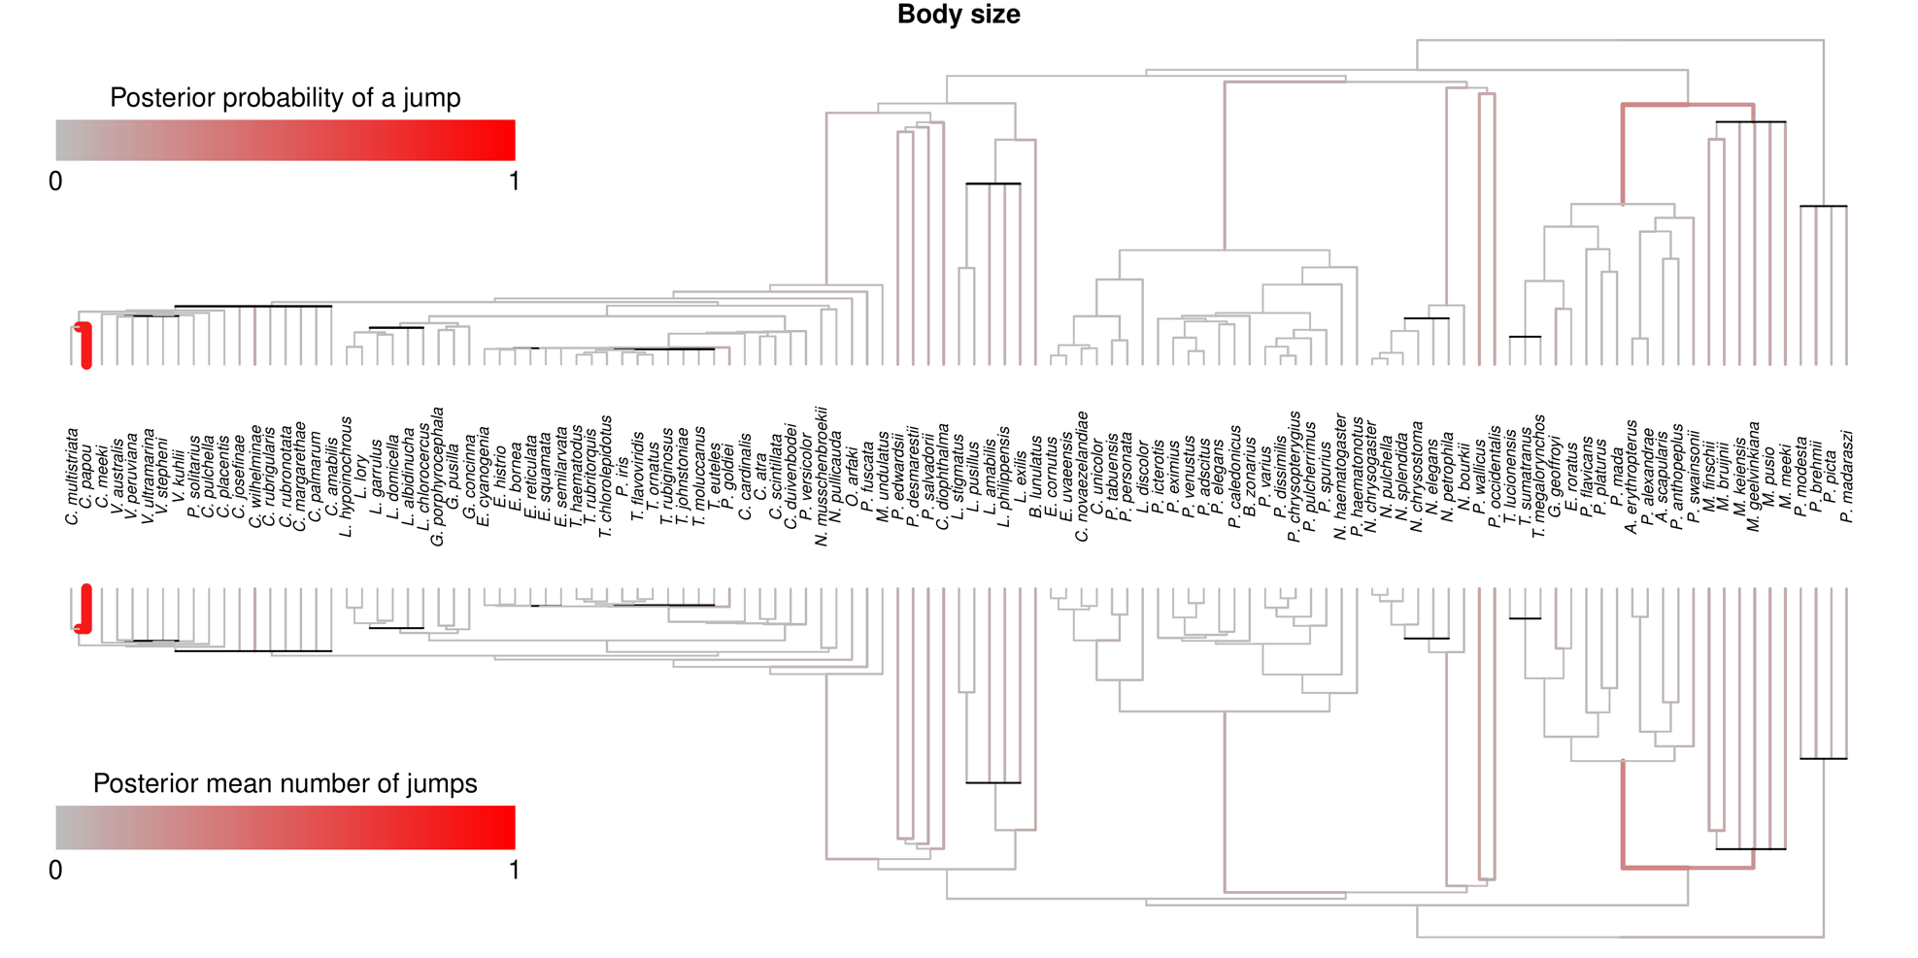
(b)

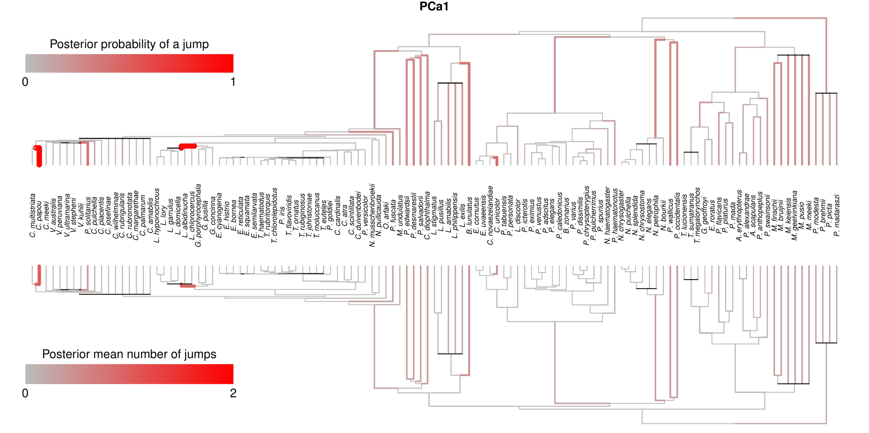

(c)
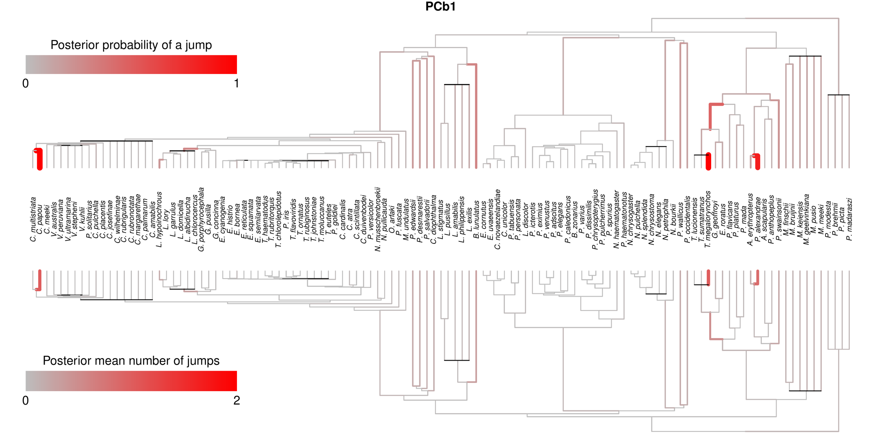

(d)
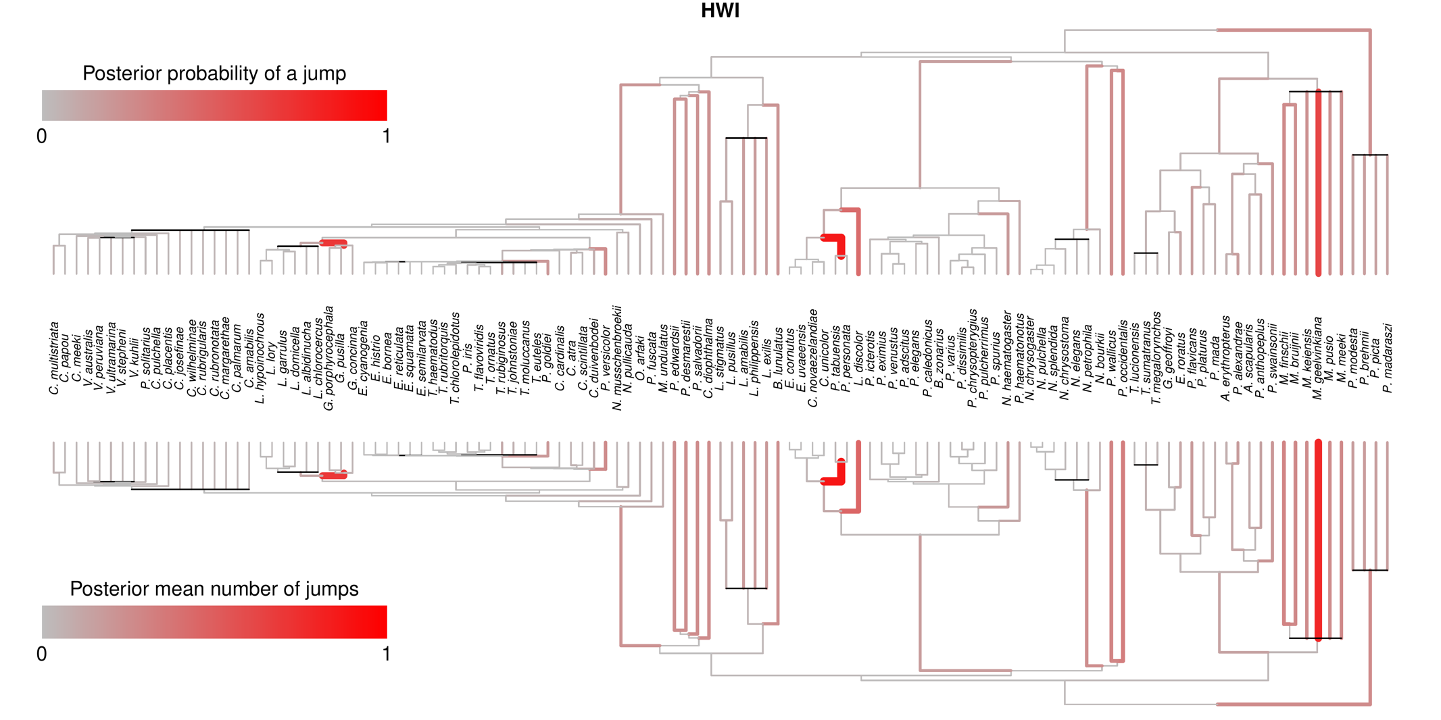

Figure S2. Stochastically mapped discrete character history of diet in psittaculid parrots overlain on a traitgram plot of PCa1, PCb1, body size, and HWI. The posterior probabilities from stochastic mapping are represented at each node.

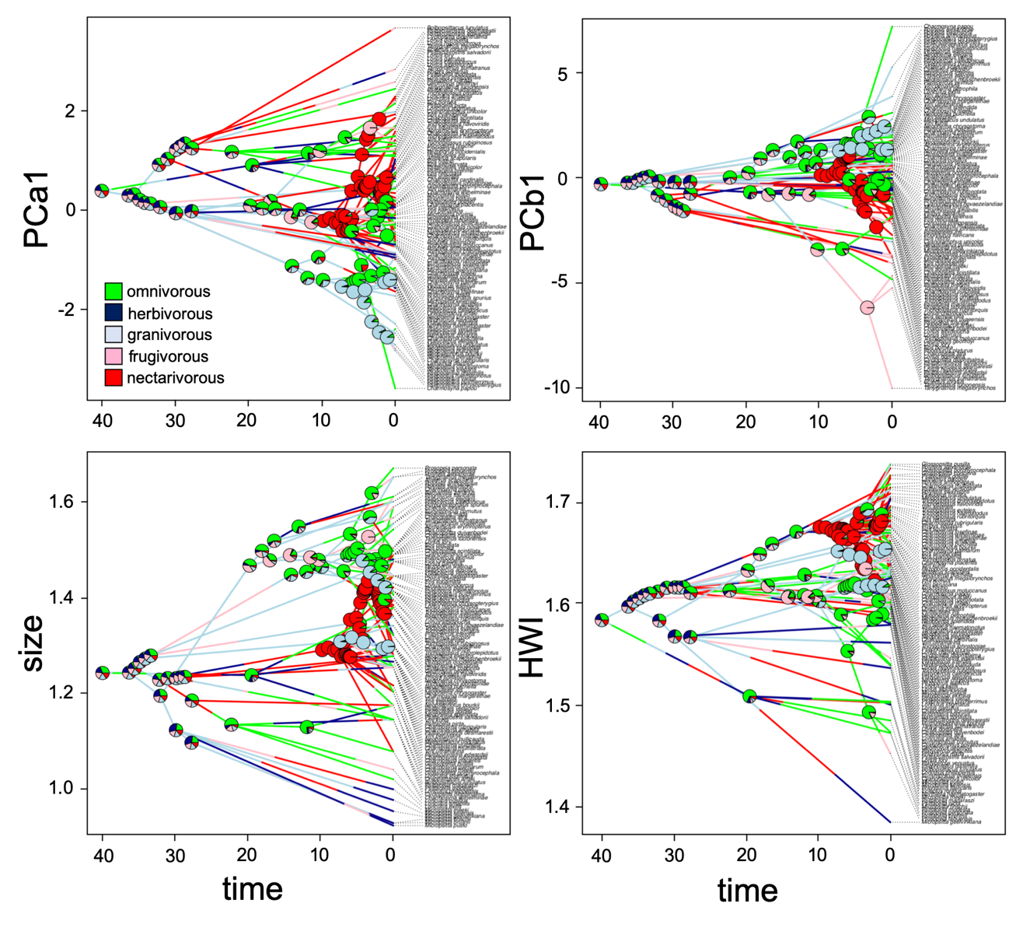
Figure S3. Stochastically mapped discrete character history of nectarivory in psittaculid parrots overlain on a traitgram plot of PCa1, PCb1, body size, and HWI. The posterior probabilities from stochastic mapping are represented at each node.
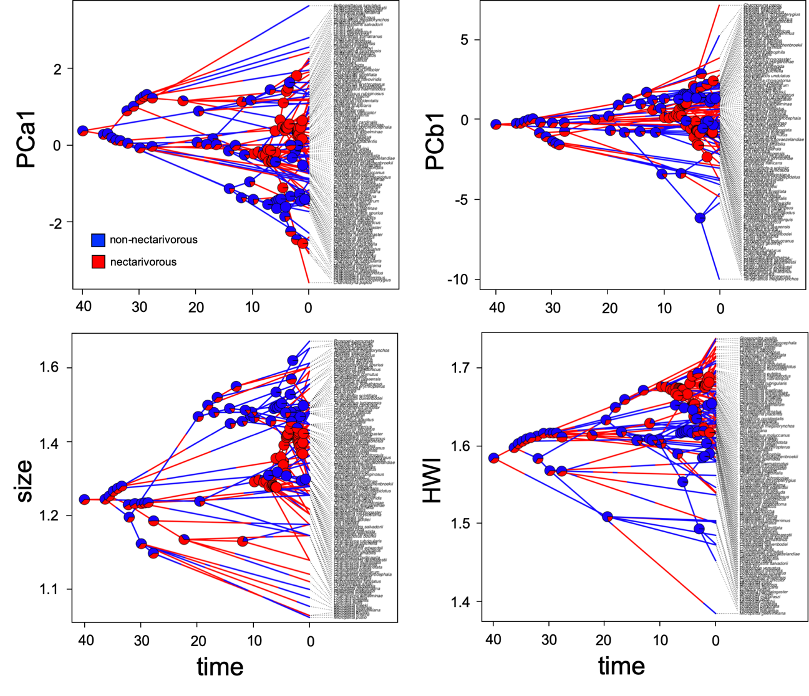
Figure S4. Rate-through-time plots for phenotypic evolution rate (with 95% confidence intervals indicated by shaded areas) in lories (Loriinae) obtained using Bayesian analysis of macroevolutionary mixtures.
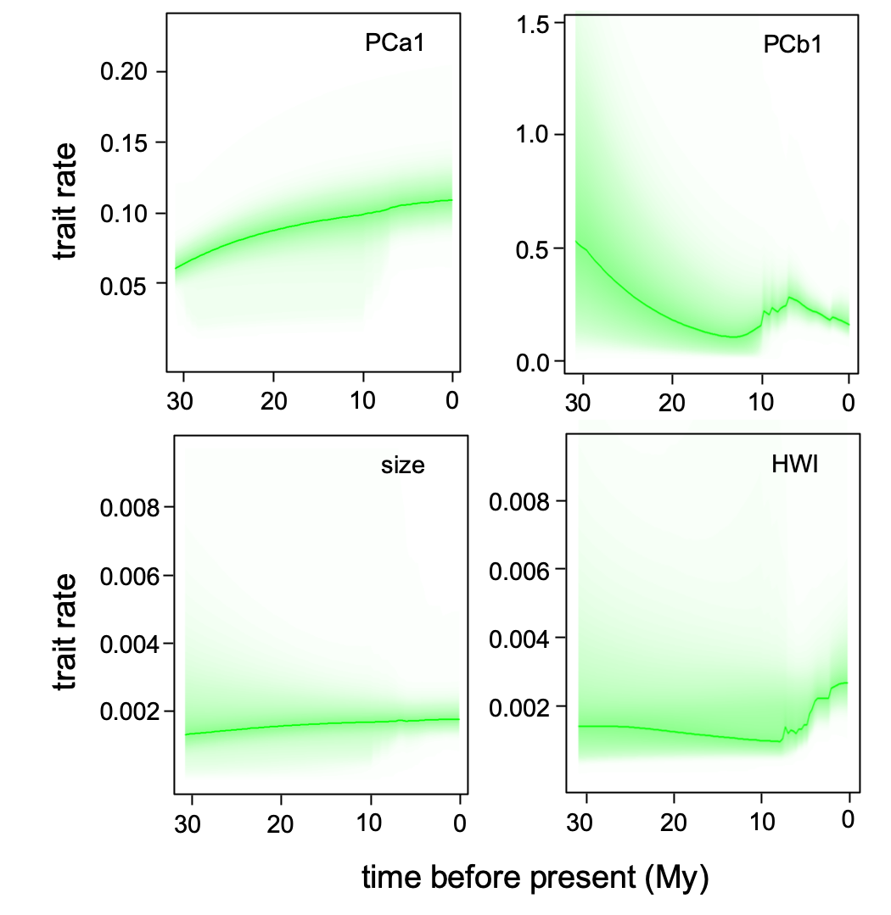

Figure S5. Rates of phenotypic evolution, estimated using BAMM, on different traits (a: PCa1, b: PCb1, c: body size, and d: HWI) during the radiation of Australasian psittaculid parrots. Smaller multipanel phylogenies (a-d) show the distinct rate-shift configurations with the highest posterior probability. For each distinct shift configuration, the locations of rate shifts are shown as circles, with circle size proportional to the marginal probability of the shift. Text labels (e.g., f = 0.25) indicate the posterior probability of each shift configuration.

