Supplemental Table 1. List of primers used.
Gene | Primer | Sequence | Reference Paper
il-1β | Forward | 5’-ATG GCG AAC GTC ATC CAA GA-3’ | Tsarouchas et al., 2018
il-1β | Reverse | 5’-GAG ACC CGC TGA TCT CCT TG-3’ | Tsarouchas et al., 2018
il-8 | Forward | 5’-GTC GCT GCA TTG AAA CAG AA-3’ | Kyritsis et al., 2012
il-8 | Reverse | 5’-AGG GGT CCA GAC AGA TCT CC-3’ | Kyritsis et al., 2012
tgf-β1a | Forward | 5’-GCT GTA TGC GCA AGC TTT ACA-3’ | Tsarouchas et al., 2018
tgf-β1a | Reverse | 5’-GGA CAA TTG CTC CAC CTT GTG-3’ | Tsarouchas et al., 2018
tgf-β3 | Forward | 5’-AAA ACG CCA GCA ACC TGT TC-3’ | Tsarouchas et al., 2018
tgf-β3 | Reverse | 5’-CCT CAA CGT CCA TCC CTC TG-3’ | Tsarouchas et al., 2018
β actin | Forward | 5’-CTC TTC CAG CCT TCC TTC CT-3’ | Sun et al., 2020
β actin | Reverse | 5’-CTT CTG CAT ACG GTC AGC AA-3’ | Sun et al., 2020

Tsarouchas TM, Wehner D, Cavone L, Munir T, Keatinge M, Lambertus M, et al. Dynamic control of proinflammatory cytokines Il-1β and Tnf-α by macrophages in zebrafish spinal cord regeneration. Nat Commun. 2018; 9:4670. https://doi.org/10.1038/s41467-018-07036-w
Kyritsis N, Kizil C, Zocher S, Kroehne V, Kaslin J, Freudenreich D, et al. Acute inflammation initiates the regenerative response in the adult zebrafish brain. Science. 2012; 338:1353–1356. https://doi.org/10.1126/science.1228773
Sun L, Ling Y, Jiang J, Wang D, Wang J, Li J, et al. Differential mechanisms regarding triclosan vs. bisphenol A and fluorene-9-bisphenol induced zebrafish lipid-metabolism disorders by RNA-Seq. Chemosphere. 2020; 251:126318. https://doi.org/10.1016/j.chemosphere.2020.126318

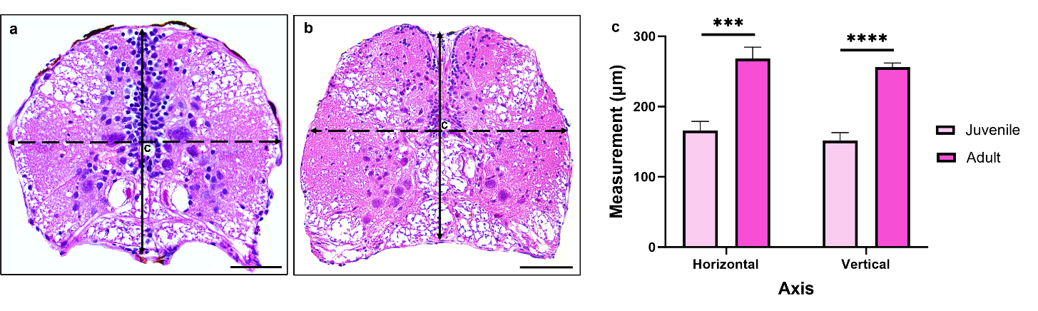

Supplemental Fig. 1 Comparison of horizontal and vertical axes between juvenile and adult spinal cords. a-b Hematoxylin and Eosin (H&E) cross-sections of juvenile (a) and adult (b) uninjured spinal cord showing measurements of the horizontal and vertical axes taken at level of the central canal (c). c Comparison of horizontal and vertical spinal cord axes between juvenile and adult zebrafish. n = 10 animals/group measured. Statistics: Independent samples t-test. ***p <0.001, ****p <0.0001. Scale bars: (a) 50 µm, (b) 75 µm.

