Development and Validation of Survival Scores to Assess Spatial Trends in End-Stage Kidney Disease Outcomes

Nathan Meyer, Hossein Moradi Rekabdarkolaee, Brandon M. Varilek, Surachat Ngorsuraches, Patti Brooks, Jerry Schrier, and Semhar Michael*
*Semhar.Michael@sdstate.edu

Supplemental Materials
Supplemental Table 1 is an extension of Table 1 from the main text such that all variables used in the entire-based mixture cure model (MCM) is shown.
An estimated cumulative distribution function of z-values for each covariate factor may be considered to find a natural cut-off of the top predictor variables considered in the main text. Supplemental Figure 1 displays this along with the top seven predictor variables as a natural cut-off. In particular, these predictor variables are given in the main text but also included here:
- Transplant - At least one transplant
- Liu comorbidity index
- Race - Black
- Hispanic - Yes
- Primary disease - Glomerulonephritis or Cystic kidney disease
- Primary disease - Other
- Race – Asian
However, the sixth and seventh factor level listed each corresponds to a covariate already included within the top five (e.g., both numbers three and seven correspond to the race covariate). Thus, the top five predictor variables considered were transplant, Liu comorbidity index, race, Hispanic, and primary disease.
Supplemental Figure 2 displays the proportion of missing observations of the several clinical variables not used within the MCM. Focusing on the univariate mode at the county level for the various survival scores compared to the median serum creatinine across counties. Supplemental Figure 3 indicates that as serum creatinine increases, the survival scores increase (i.e., survivability increases). Further, the linear correlation of these scatterplots shown have a range around 0.45 to 0.50 - a moderately positive correlation.

Supplemental Table 1. Entire-based MCM coefficient estimates and standard errors (s.e.) of all variables (results reported with an asterisk were significant at a 0.05 level).
Characteristic | Latency  Estimate (s.e.) | Incidence  Estimate (s.e.)
Intercept | N/A | 1.5854 (0.0681)*
Age group (yr)
Younger than 18 | (ref) | (ref)
18-29 | -0.2226 (0.0390)* | 0.0117 (0.0580)
30-39 | -0.2741 (0.0370)* | 0.4088 (0.0553)*
40-49 | -0.2415 (0.0372)* | 1.0181 (0.0594)*
50-59 | -0.0919 (0.0376)* | 1.5998 (0.0576)*
60-69 | 0.0821 (0.0370)* | 2.0480 (0.0571)*
70-79 | 0.3315 (0.0368)* | 2.5912 (0.0603)*
80 and older | 0.6837 (0.0370)* | 3.4683 (0.0721)*
Sex, female | -0.0364 (0.0018)* | -0.0053 (0.0143)
Race
White | (ref) | (ref)
Black | -0.3395 (0.0023)* | 0.3023 (0.0164)*
Asian | -0.3992 (0.0058)* | -0.6768 (0.0301)*
American Indian | -0.2344 (0.0084)* | 0.4665 (0.0611)*
Native Hawaiian /  Pacific Islander | -0.3785 (0.0099)* | -0.3154 (0.0648)*
Other | 0.0812 (0.0169)* | -0.5854 (0.0640)*
Hispanic, yes | -0.3438 (0.0033)* | -0.5295 (0.0179)*
Primary disease
Diabetes | (ref) | (ref)
Hypertension | -0.0221 (0.0021)* | -1.2989 (0.0263)*
Glomerulonephritis /  Cystic kidney disease | -0.2047 (0.0040)* | -1.3087 (0.0231)*
Other | 0.1179 (0.0034)* | -1.7385 (0.0267)*
Liu comorbidity index | 0.0565 (0.0014)* | 0.1231 (0.0039)*
Inability to ambulate, yes | 0.2271 (0.0056)* | 0.0712 (0.0405)
Inability to transfer, yes | 0.2258 (0.0077)* | -0.1823 (0.0548)*
Needs assistance with  daily activities, yes | 0.0314 (0.0038)* | -0.1539 (0.0287)*
Institutionalized
No | (ref) | (ref)
Nursing home | 0.2576 (0.0050)* | -0.5866 (0.0323)*
Assisted living | 0.0882 (0.0117)* | -0.1325 (0.1220)
Other institution | 0.0631 (0.0159)* | -0.5200 (0.0770)*
Alcohol dependence, yes | 0.2101 (0.0098)* | -0.0442 (0.0337)
Tobacco use, yes | 0.0954 (0.0042)* | 0.3240 (0.0209)*
Drug (illicit)  dependence, yes | 0.1756 (0.0094)* | -0.0884 (0.0300)*
Amputation, yes | 0.0337 (0.0055)* | 0.0273 (0.0604)
Toxic nephropathy, yes | -0.0589 (0.0205)* | -0.5349 (0.0625)*
Modality, peritoneal dialysis | -0.0698 (0.0031)* | 0.1485 (0.0228)*
Transplant, at least 1 | -1.5837 (0.0060)* | -1.2711 (0.0215)*
Employment
Unemployed | (ref) | (ref)
Employed | -0.2440 (0.0046)* | -0.0940 (0.0211)*
Retired-Age | -0.0028 (0.0033) | 0.4181 (0.0312)*
Retired-Disabled | 0.0407 (0.0028)* | 0.3781 (0.0197)*
Other | -0.1441 (0.0077)* | -0.0509 (0.0277)
Insurance
Employer only | (ref) | (ref)
Medicaid only | 0.0063 (0.0051) | 0.0227 (0.0230)
Medicare only | 0.0310 (0.0041)* | 0.7411 (0.0291)*
DVA+ | -0.0355 (0.0068)* | 0.4361 (0.0696)*
Medicare and Employer | 0.0485 (0.0047)* | 0.7825 (0.0351)*
Medicare and Medicaid | 0.1143 (0.0044)* | 0.8263 (0.0329)*
Multiple otherwise | 0.0665 (0.0043)* | 1.0009 (0.0388)*
Other | 0.0245 (0.0055)* | -0.0147 (0.0239)
None | -0.1368 (0.0061)* | -0.1300 (0.0221)*
Rurality
Urban | (ref) | (ref)
Large rural | -0.0092 (0.0032)* | 0.1236 (0.0211)*
Small rural | -0.0208 (0.0043)* | 0.1479 (0.0316)*
Isolated small rural | 0.0138 (0.0050)* | 0.1316 (0.0424)*
Region
West | (ref) | (ref)
South | 0.0843 (0.0028)* | 0.1842 (0.0160)*
Midwest | 0.0429 (0.0030)* | 0.0829 (0.0168)*
Northeast | 0.0301 (0.0035)* | 0.1376 (0.0190)*

Supplemental Figure 1. Estimated cumulative distribution function (ECDF) of the z-score magnitudes summed with the proposed natural cut-off as the red, vertical dashed-line.
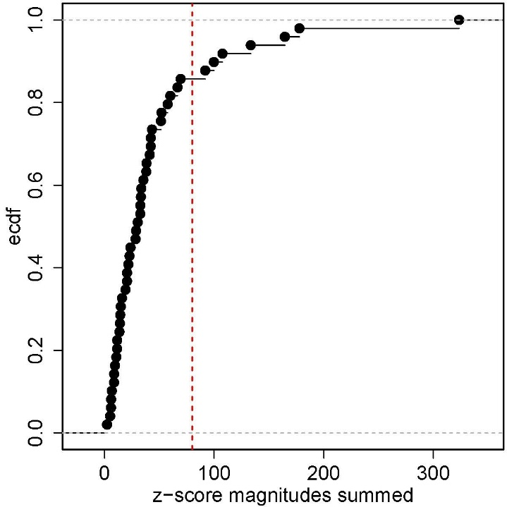

Supplemental Figure 2. Proportion of missing observations of several clinical variables from the United States Renal Data System dataset.
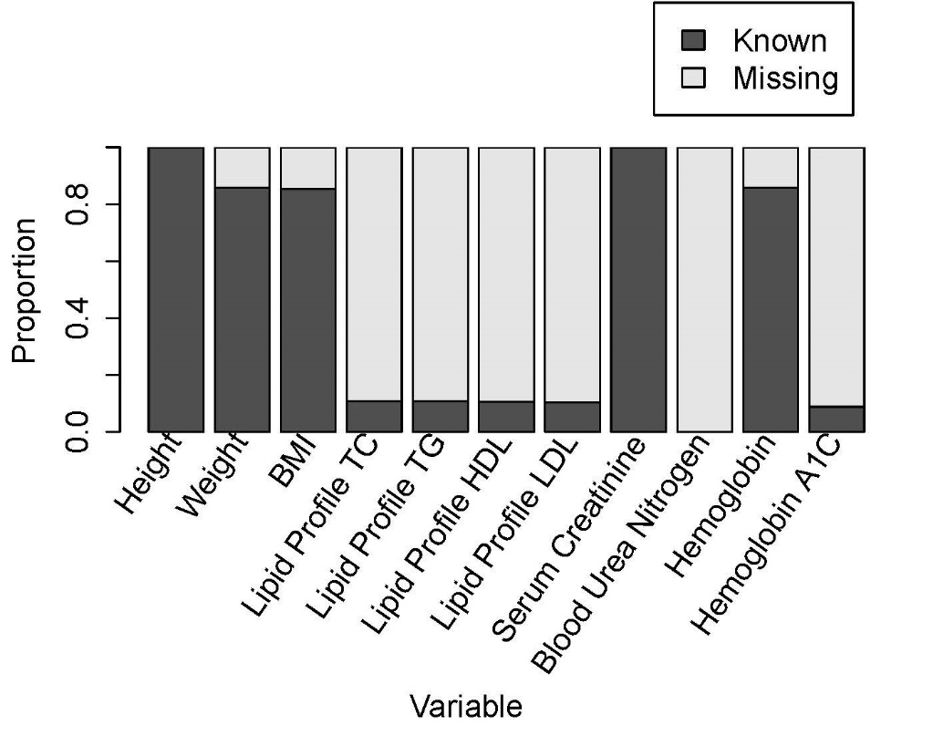
Supplemental Figure 3. County level median serum creatine and survival scores using the univariate mode where the blue line indicates the line of best fit. The blue text indicates the survival score and the correlation.

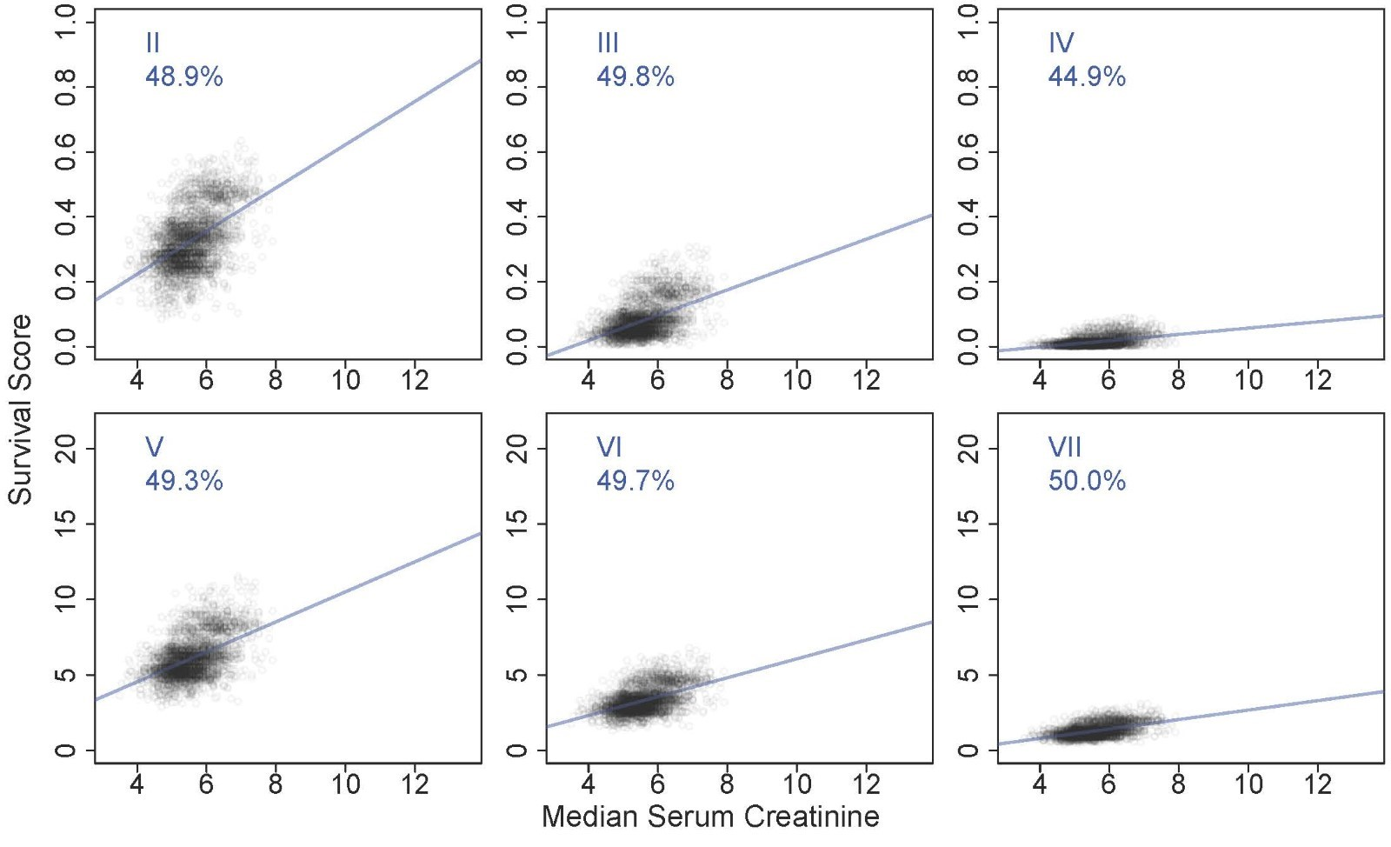
Acknowledgments
The research reported in this work was supported by South Dakota State University, AIM-AHEAD Coordinating Center, award number OTA-21-017, and was, in part, funded by the National Institutes of Health Agreement No. 1OT2OD032581. The work is solely the responsibility of the authors and does not necessarily represent the official view of AIM-AHEAD or the National Institutes of Health. The data reported here have been supplied by the United States Renal Data System (USRDS). The interpretation and reporting of these data are the responsibility of the author(s) and in no way should be seen as an official policy or interpretation of the U.S. government.

