UMIche: A UMI-centric analysis platform for enhancing molecular quantification accuracy in bulk and single-cell sequencing
Jianfeng Sun^{1,2,#} , Shuang Li³, Stefan Canzar⁴ & Adam P. Cribbs^{1,2,#}
¹ Botnar Research Centre, Nuffield Department of Orthopaedics, Rheumatology and Musculoskeletal Sciences, National Institute of Health Research Oxford Biomedical Research Unit (BRU), University of Oxford, Oxford OX3 7LD, UK.
² Oxford Centre for Translational Myeloma Research, University of Oxford, Oxford OX3 7LD, UK
³ Gene Center, Ludwig-Maximilians University of Munich, Munich 81377, Germany
⁴ Faculty of Informatics and Data Science, University of Regensburg, 93053 Regensburg,
Germany

Email: jianfeng.sun@ndorms.ox.ac.uk; adam.cribbs@ndorms.ox.ac.uk

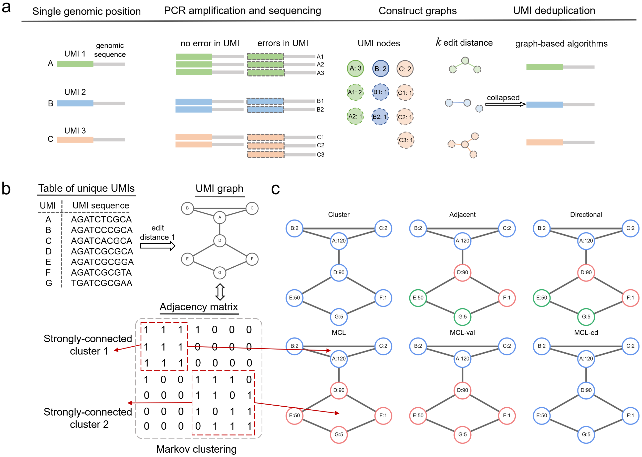
Supplementary Fig. 1 | Overview of using graph-based methods for PCR duplicate removal. a, Subjecting UMI-tagged molecules to PCR amplification and sequencing. The effectiveness of UMI deduplication is evaluated by how the estimated number of molecules is close to the actual number of molecules. b, Building a UMI graph with 7 unique UMI nodes (A-G) connected with an edit-distance threshold of 1. Strongly connected components are visually displayed in the adjacency matrix. c, Graph-based identification of true molecules by collapsing UMIs using the cluster, adjacency, directional, mcl, mcl-ed, and mcl-val algorithms. PCR duplicates are merged into different UMI groups in different edge colours. The identifier of each unique UMI is followed by its count in the single genomic locus.

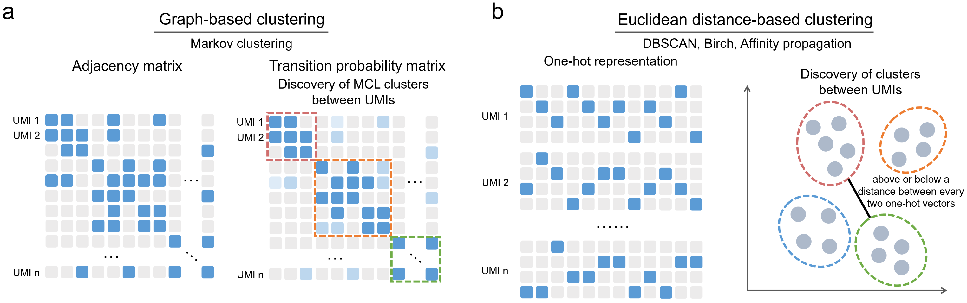
Supplementary Fig. 2 | Schematic of UMI deduplication using the graph-based Markov clustering method and the distance-based clustering methods. a, Schematic of using Markov clustering to discover UMI clusters based on the adjacency matrix and the transition probability matrix. b, Schematic of using Euclidean distance-based clustering to discover UMI clusters with one-hot representations of UMIs. One position in each column is occupied to be indicative of its nucleotide type. The one-hot matrix is flattened as a vector with a dimension of $1×4n$ ($n$ represents the UMI length) prior to taking them as input to the Euclidean distance-based clustering methods.

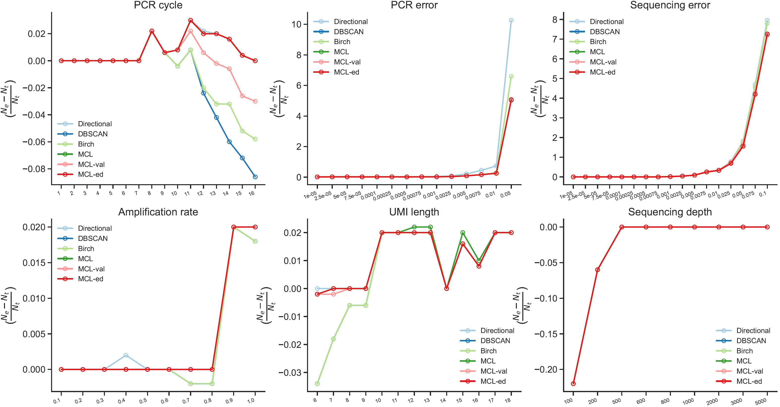
Supplementary Fig. 3 | Fold change between the actual number of UMIs and the number of UMIs deduplicated by UMI-tools Directional, MCL, MCL-ed, MCL-val, DBSCAN, and Birch across multiple PCR cycles, PCR error rates, sequencing error rates, amplification rates, UMI lengths, and sequencing depths, respectively.

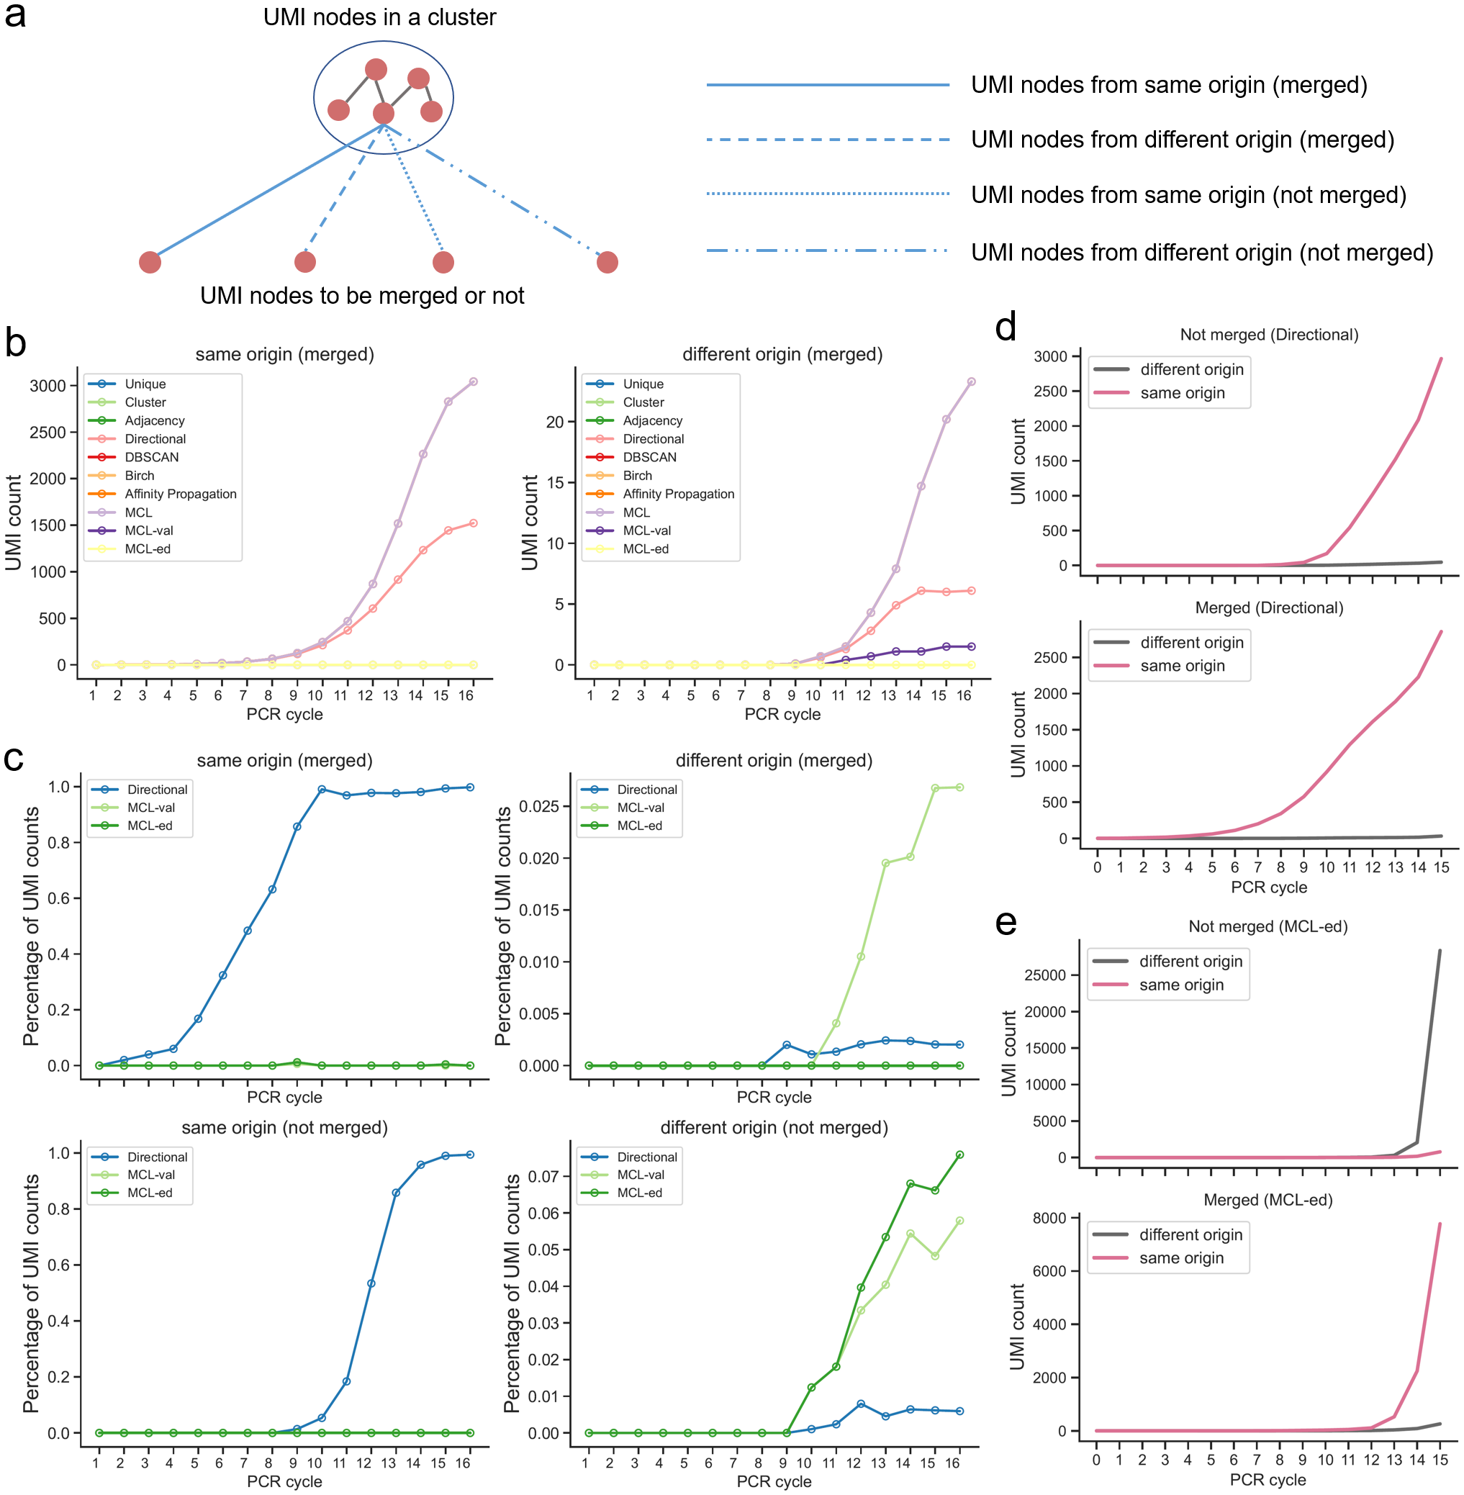
Supplementary Fig. 4 | Investigation of trajectories of UMIs across PCR amplification cycles. a, Schematic of merging UMIs into a cluster. Annotating UMIs with their origin is conducive to study their connectivity in a network in which a merge indicates an estimated association between two UMIs. b, Counts of UMIs derived from the same origin to be merged across multiple PCR cycles with different UMI collapsing methods. c, Comparison of counts of merged or not merged UMIs derived from the same or different origin between the MCL-val/MCL-ed and UMI-tools Directional methods. d and e, Counts of merged or not merged UMIs derived from the same or different origin using the UMI-tools Directional (d) and MCL-ed (e) methods. To compare the effectiveness of UMI collapsing methods in merging UMIs from the same origin, we labelled each amplified read the identifier of its original molecule during the read simulation process. This allows us to track the source of each read under four possible scenarios. The ideal outcome is to merge two UMIs that share the same root. Since only the MCL-val, MCL-ed, and UMI-tools Directional methods merge UMIs with custom-built conditions (e.g., edit distance or UMI counts), we calculated the percentage and count of UMIs that are not merged from the same or different origin. There is a significant increase in the number of UMIs not merged by MCL-ed when they are from different origins, whereas the UMI-tools Directional method exhibits the opposite trend, suggesting that the MCL-based methods facilitate the detection of those UMIs originating from different roots.

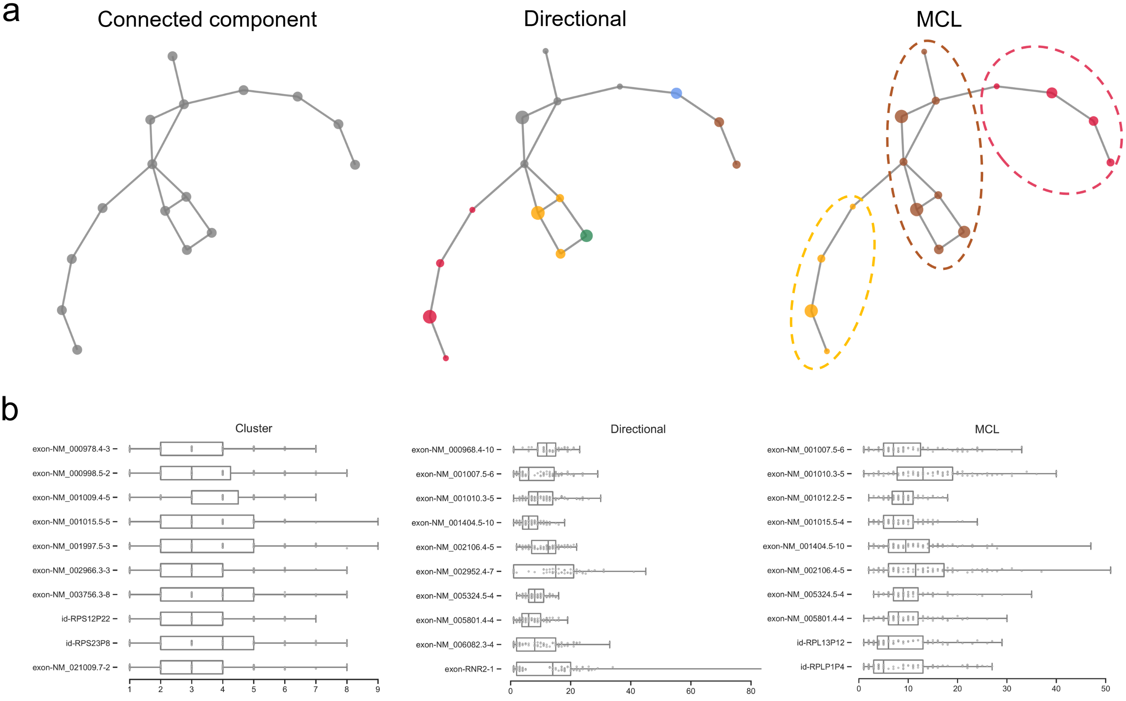
Supplementary Fig. 5 | Connectivity analysis and biological application of deduplicated UMI counts. a, UMI clusters observed at two example genomic loci using iCLIP data¹, respectively, are discovered from connected components by the Directional and MCL methods. Each node in the graphs represents a unique UMI. We projected UMI counts onto UMI nodes to understand whether Markov clusters capture not only strong connectivity but also UMIs which are assumed to be representative of clusters. The node size is enlarged as the count of the unique UMIs increases. Different clusters are shown in different colours. Markov clustering of 16 unique UMIs observed at a genomic position captures stronger connectivity between UMIs nodes than the Directional method, e.g., stray UMIs falling between or within clusters. b, Comparison of top 10 highly expressed genes identified by the Cluster, Directional, and MCL methods using a randomly picked cell from a 10X genomics scRNA-seq dataset with a hybird of human and mouse cells².

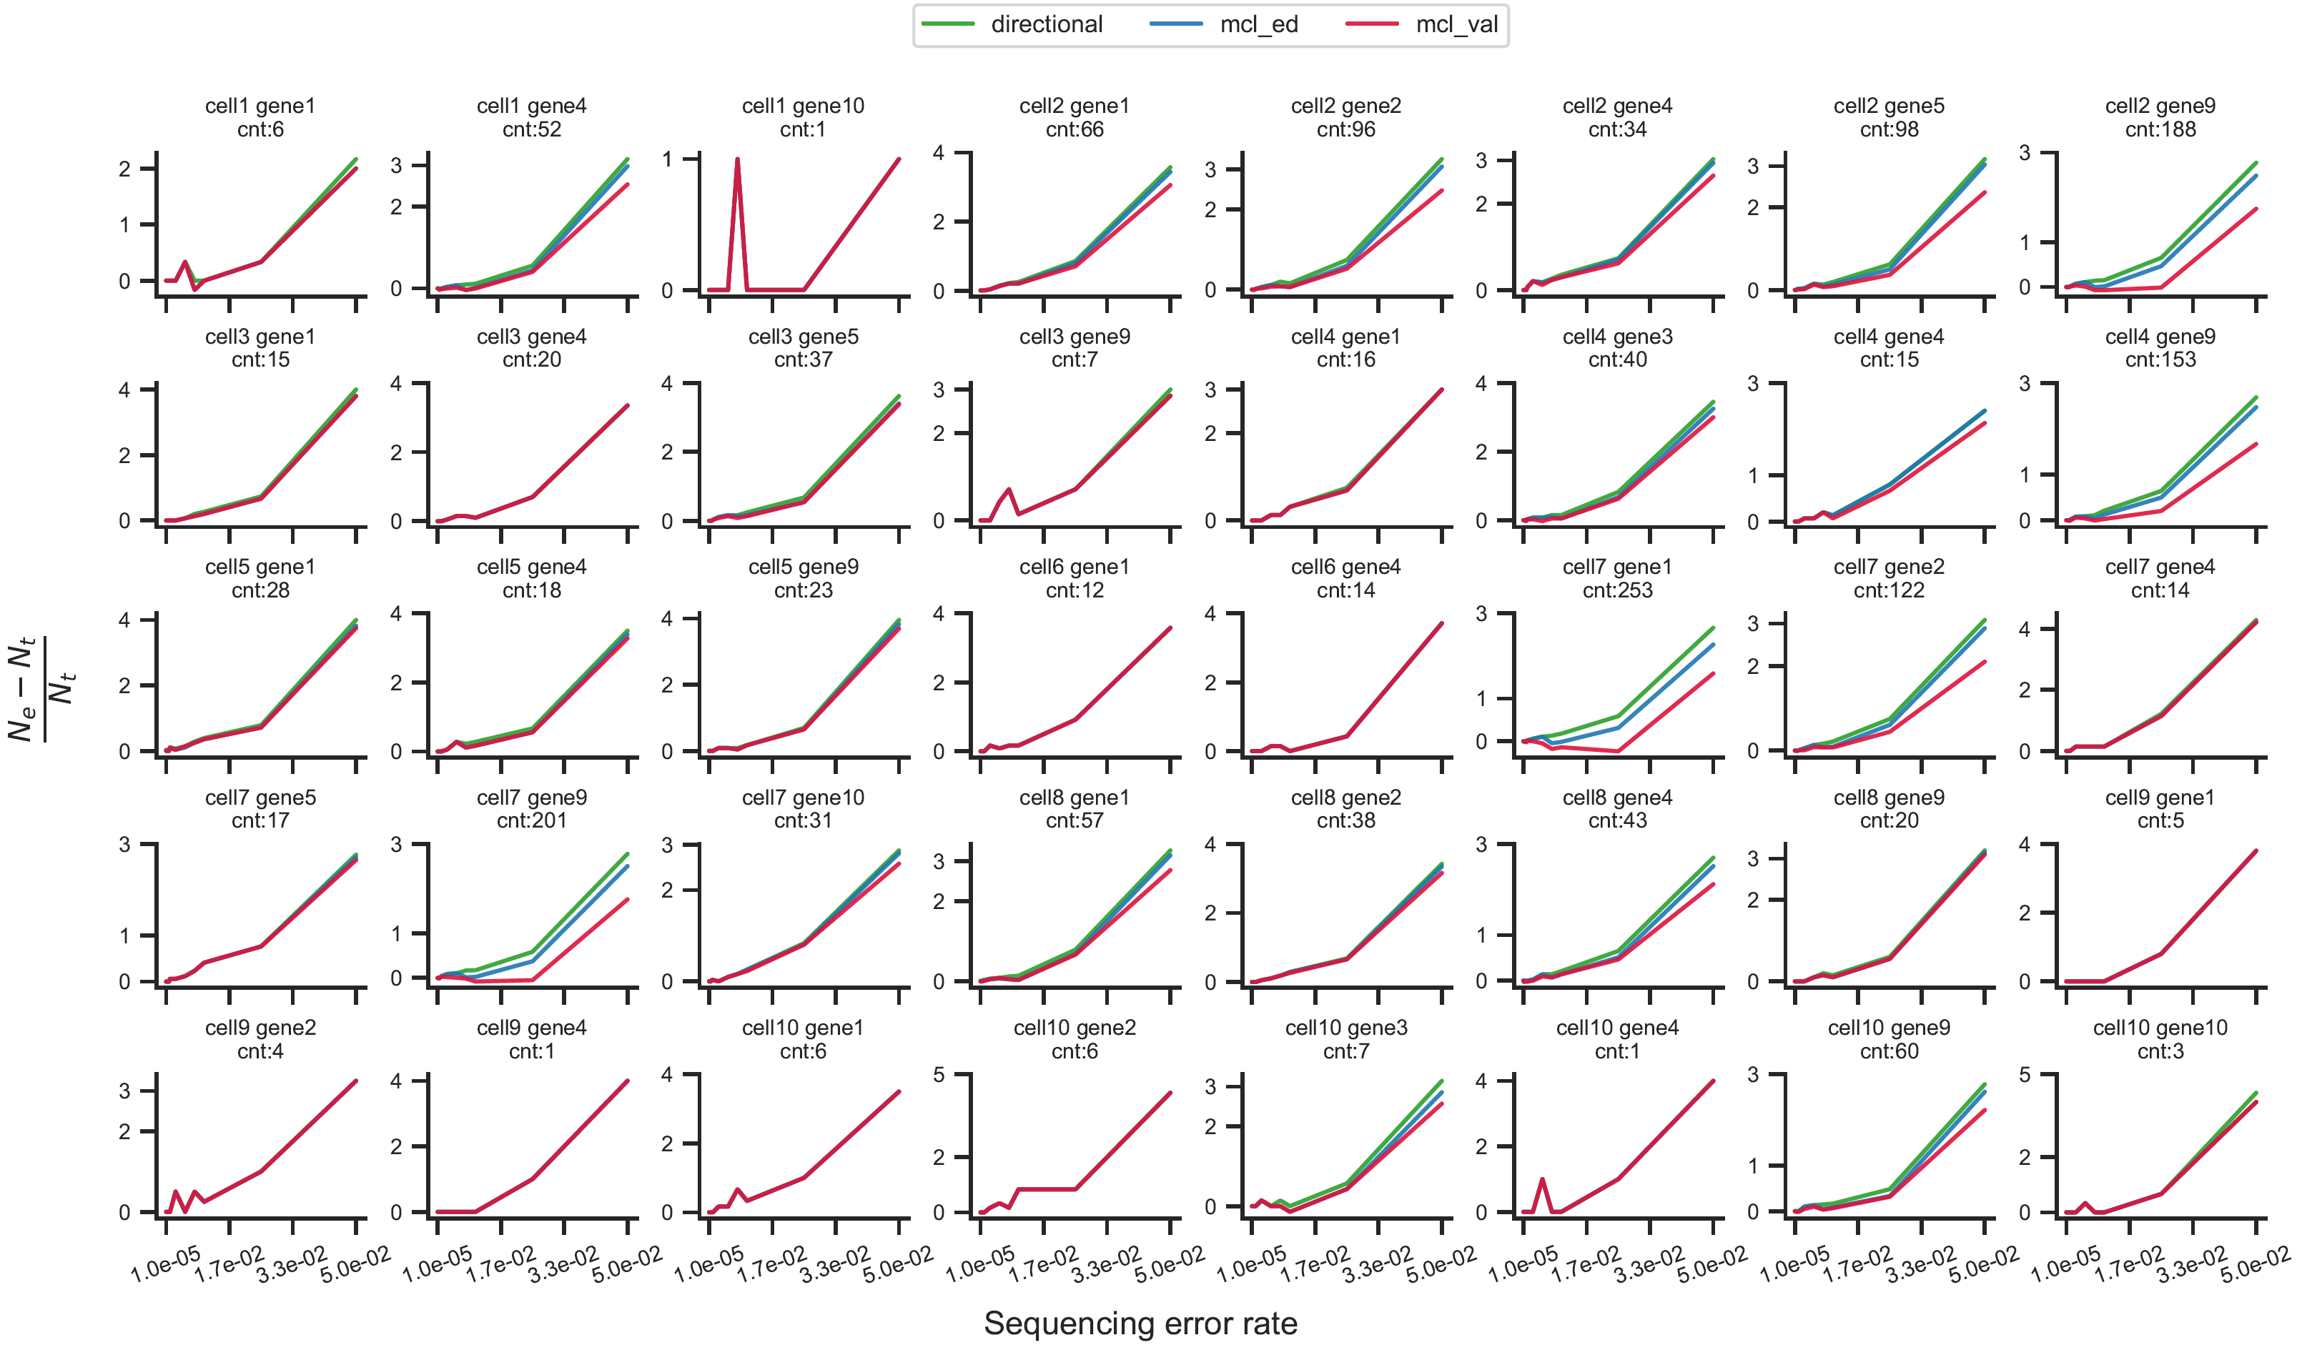
Supplementary Fig. 6 | Comparison of UMI collapsing performance between the Markov clustering method and the UMI-tools Directional method using a single-cell count matrix simulated by SPsimSeq³ and reads simulated by ResimPy⁴ (https://github.com/cribbslab/resimpy) at multiple sequencing error rates. Each subplot shows the UMI collapsing result for a certain cell and a gene. cnt: the count of a gene expressed at a cell.

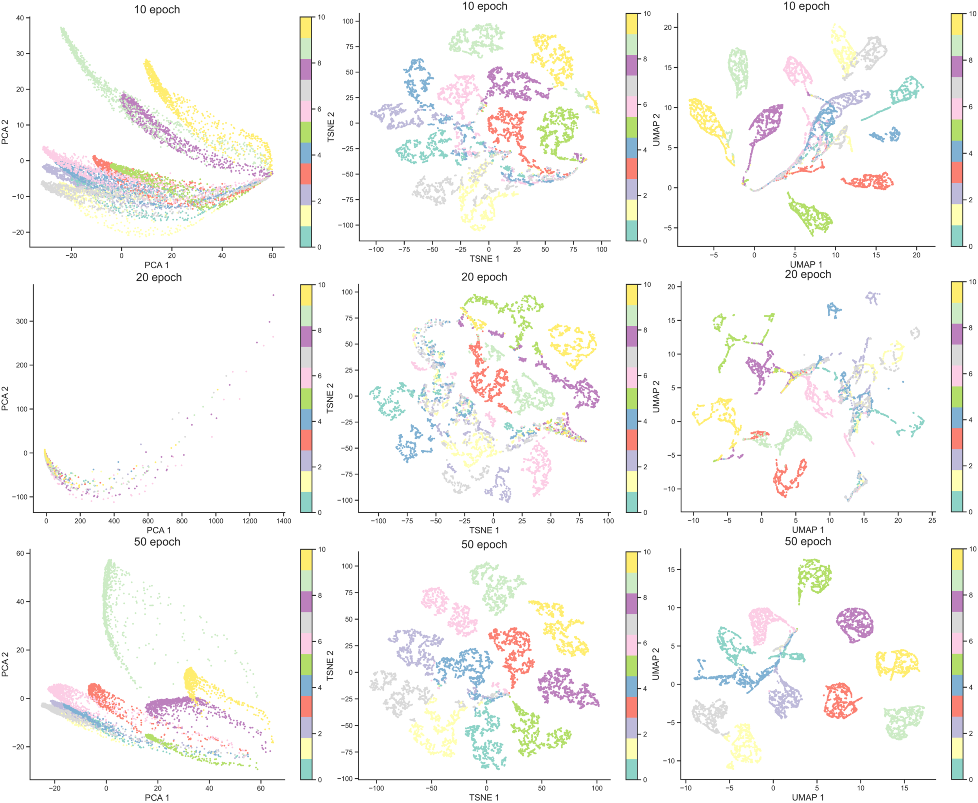
Supplementary Fig. 7 | UMAP plots of UMI counts simulated by trained DeepConvCVAE models at 10, 20, and 50 epochs.

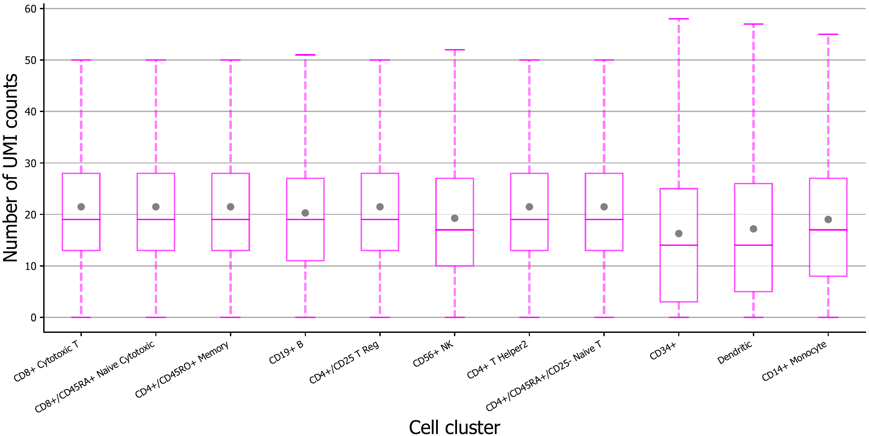
Supplementary Fig. 8 | UMI counts of top 10 highly expressed genes in the 68k PBMCs Donor A dataset at per cell cluster level.

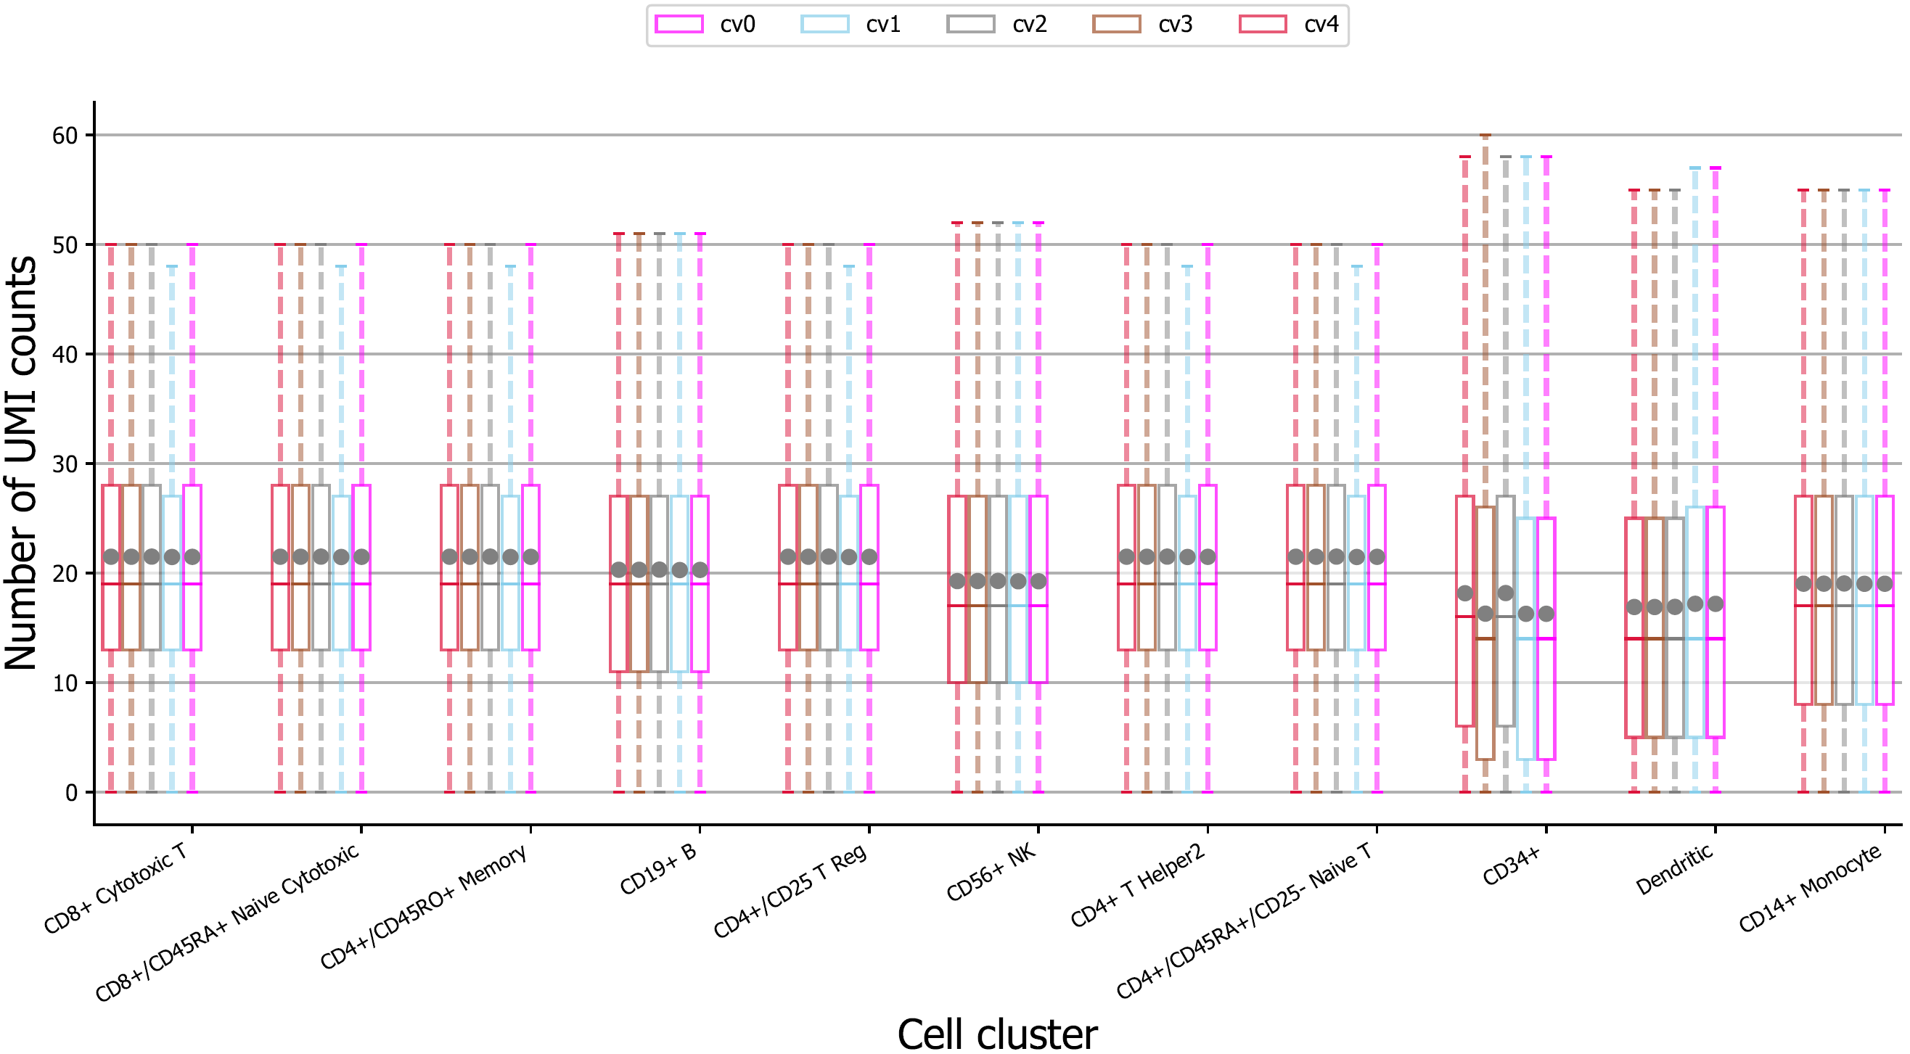
Supplementary Fig. 9 | UMI counts of top 10 highly expressed genes in 5-fold cross validation (cv) sets for training, including cv0, cv1, cv2, cv3, and cv4, spilt by the stratified shuffle split method at per cell cluster level.

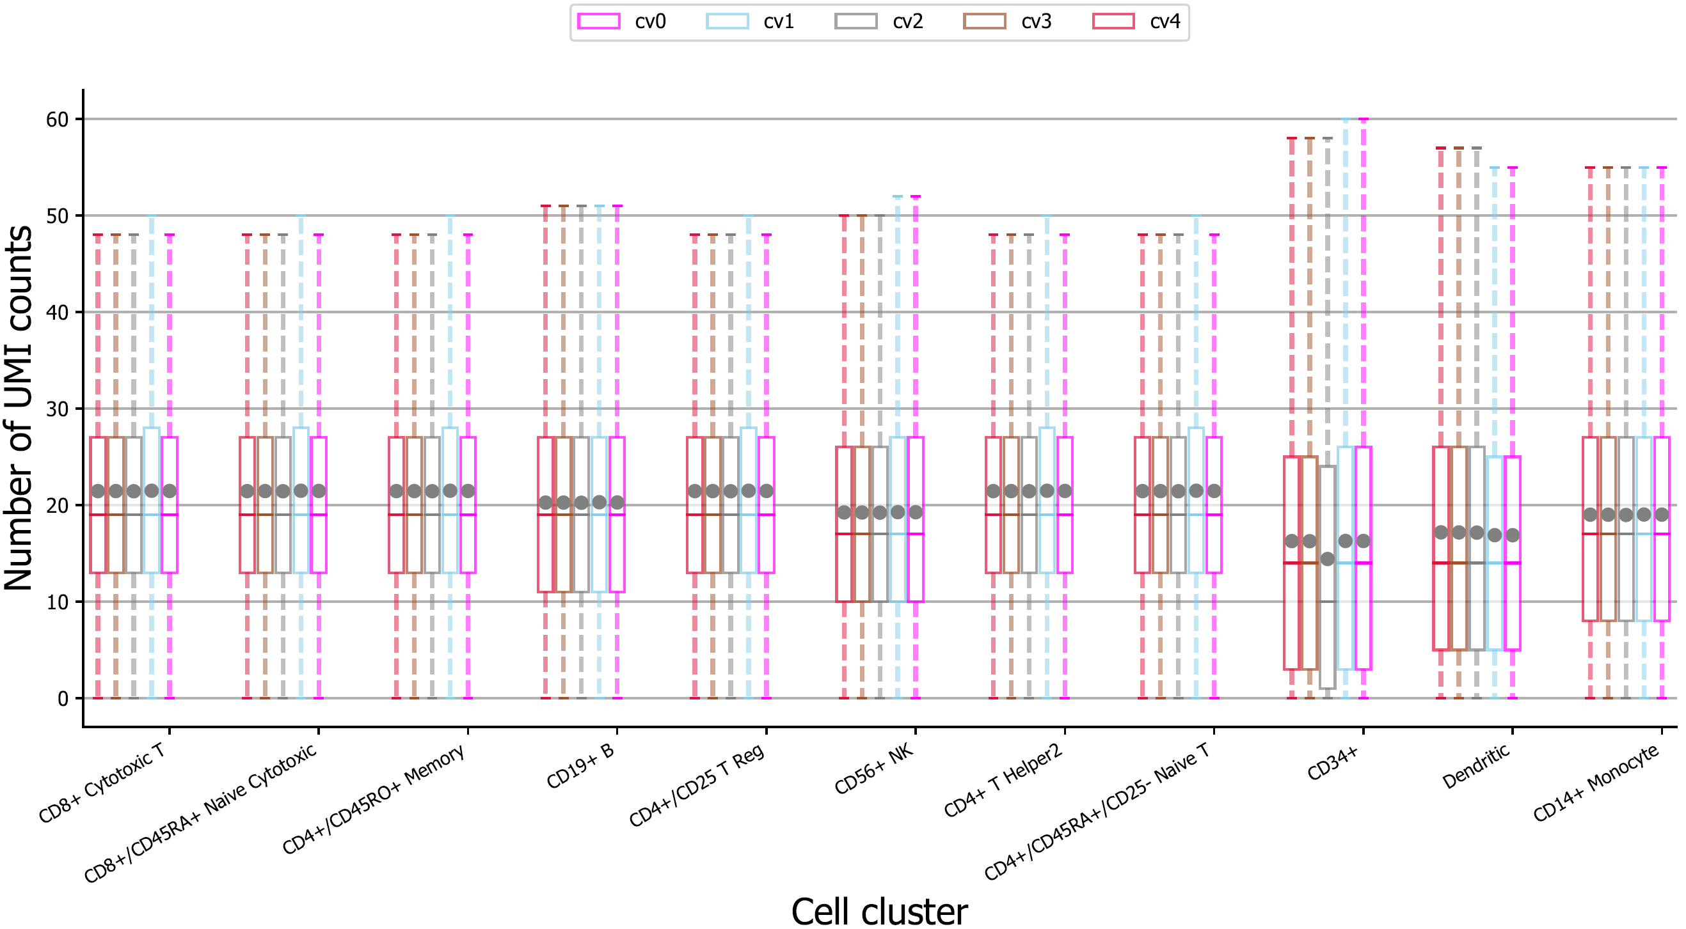
Supplementary Fig. 10 | UMI counts of top 10 highly expressed genes in 5-fold cross validation (cv) sets for validation, including cv0, cv1, cv2, cv3, and cv4, spilt by the stratified shuffle split method at per cell cluster level.

Supplementary References
1. Müller-McNicoll, M. et al. SR proteins are NXF1 adaptors that link alternative RNA processing to mRNA export. Genes Dev 30, 553–566 (2016).
2. Klein, A. M. et al. Droplet Barcoding for Single-Cell Transcriptomics Applied to Embryonic Stem Cells. Cell 161, 1187–1201 (2015).
3. Assefa, A. T., Vandesompele, J. & Thas, O. SPsimSeq: semi-parametric simulation of bulk and single-cell RNA-sequencing data. Bioinformatics 36, 3276–3278 (2020).
4. Sun, J. et al. Correcting PCR amplification errors in unique molecular identifiers to generate accurate numbers of sequencing molecules. Nat Methods 21, 401–405 (2024).

