Supplementary Figures

Figure S1.
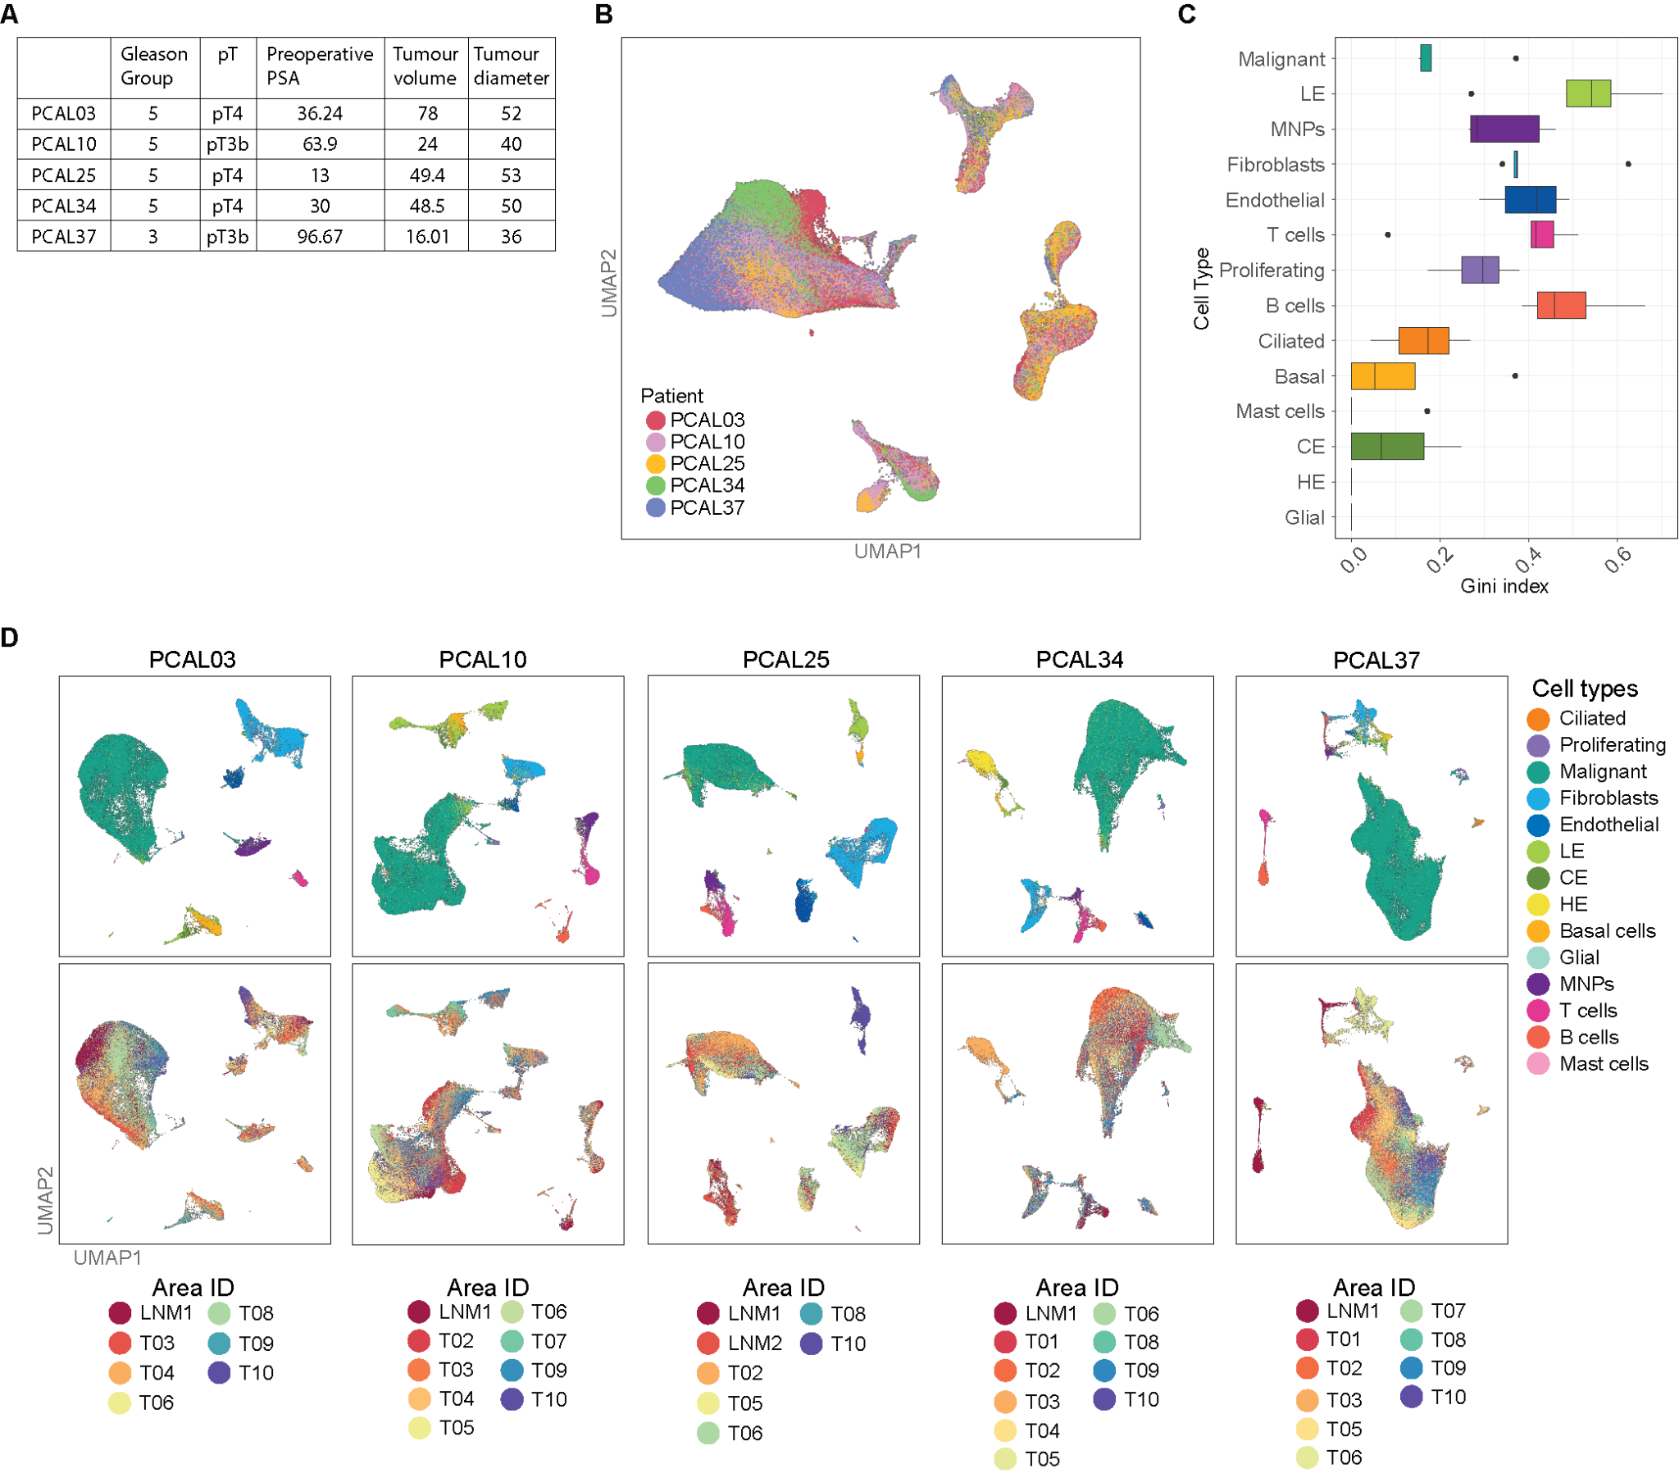
Supplementary Figure 1. A, Clinical and pathology information of each individual including Gleason grade group, pathological tumour stage (pT), preoperative PSA (ng/ml), tumour volume and diameter (mm). B, Integrated UMAP of all patient samples, coloured by patient ID. C, Box plot displaying the distribution of patient-level Gini coefficient by cell type. D, UMAPs of integrated areas per patient: top - coloured by cell type, bottom - by area ID. LE, luminal epithelial; CE, club epithelial; HE, hillock epithelial.

Figure S2.
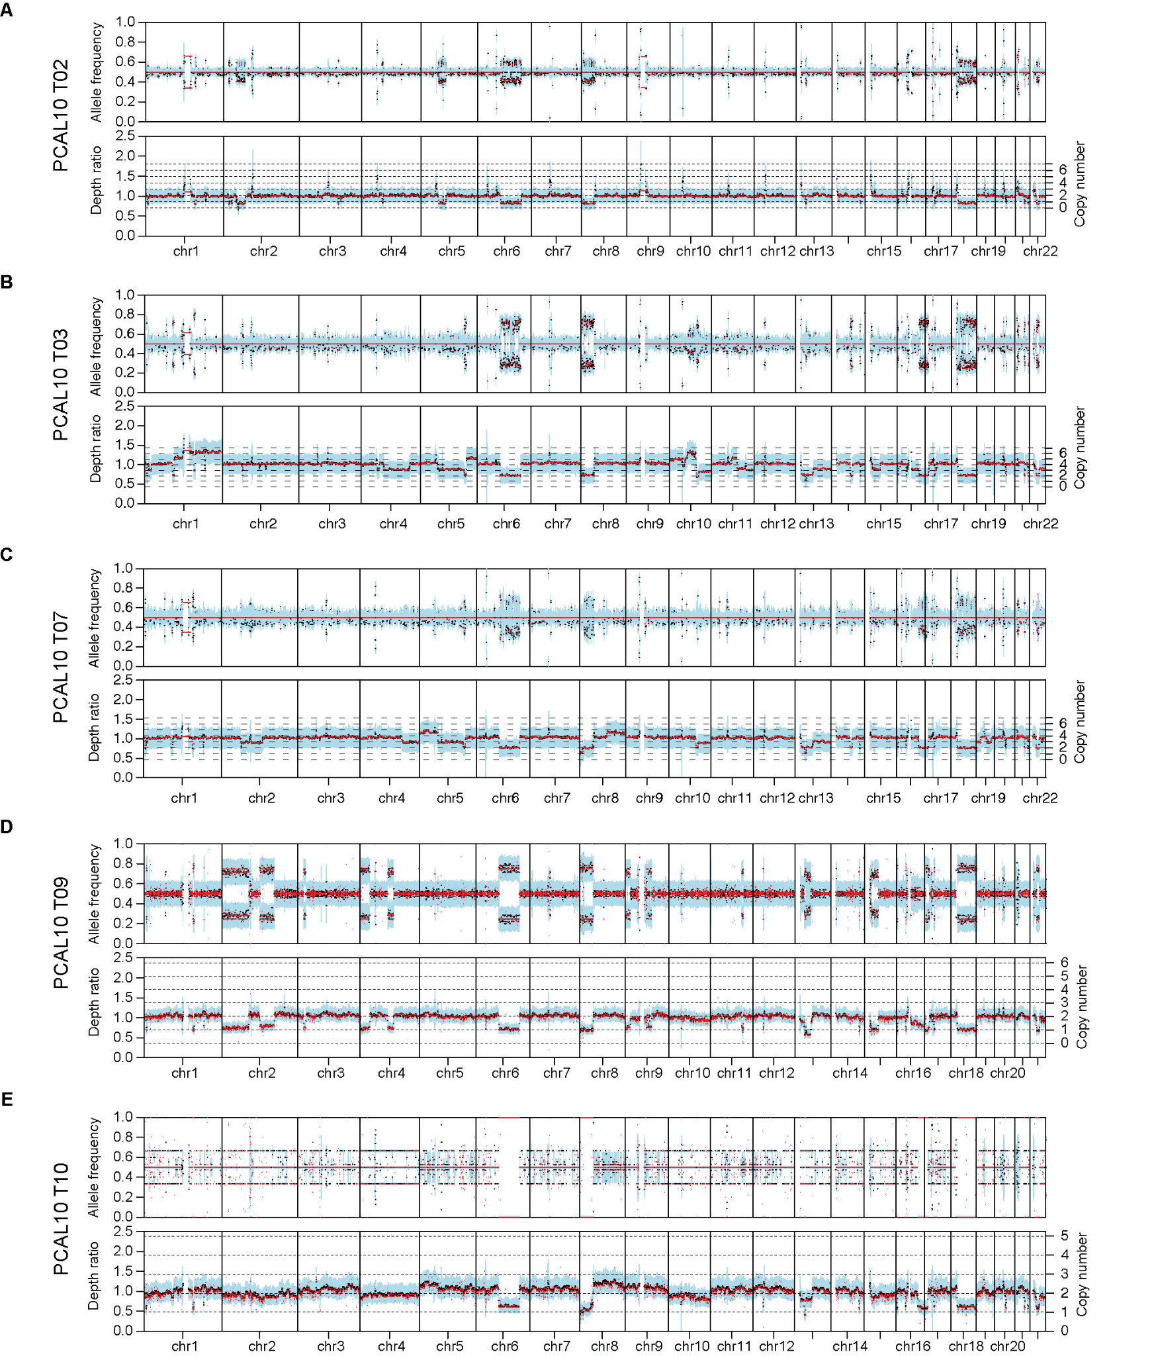
Supplementary Figure 2. Genome-wide copy number levels from whole-genome deep sequenced areas from PCAL10 tumour. A, area T02; B, area T03; C, area T07; D, area T09; E, area T10. Top plot: allele frequency, bottom plot: read depth ratio between tumour and normal. Sex chromosomes were excluded.

Figure S3.
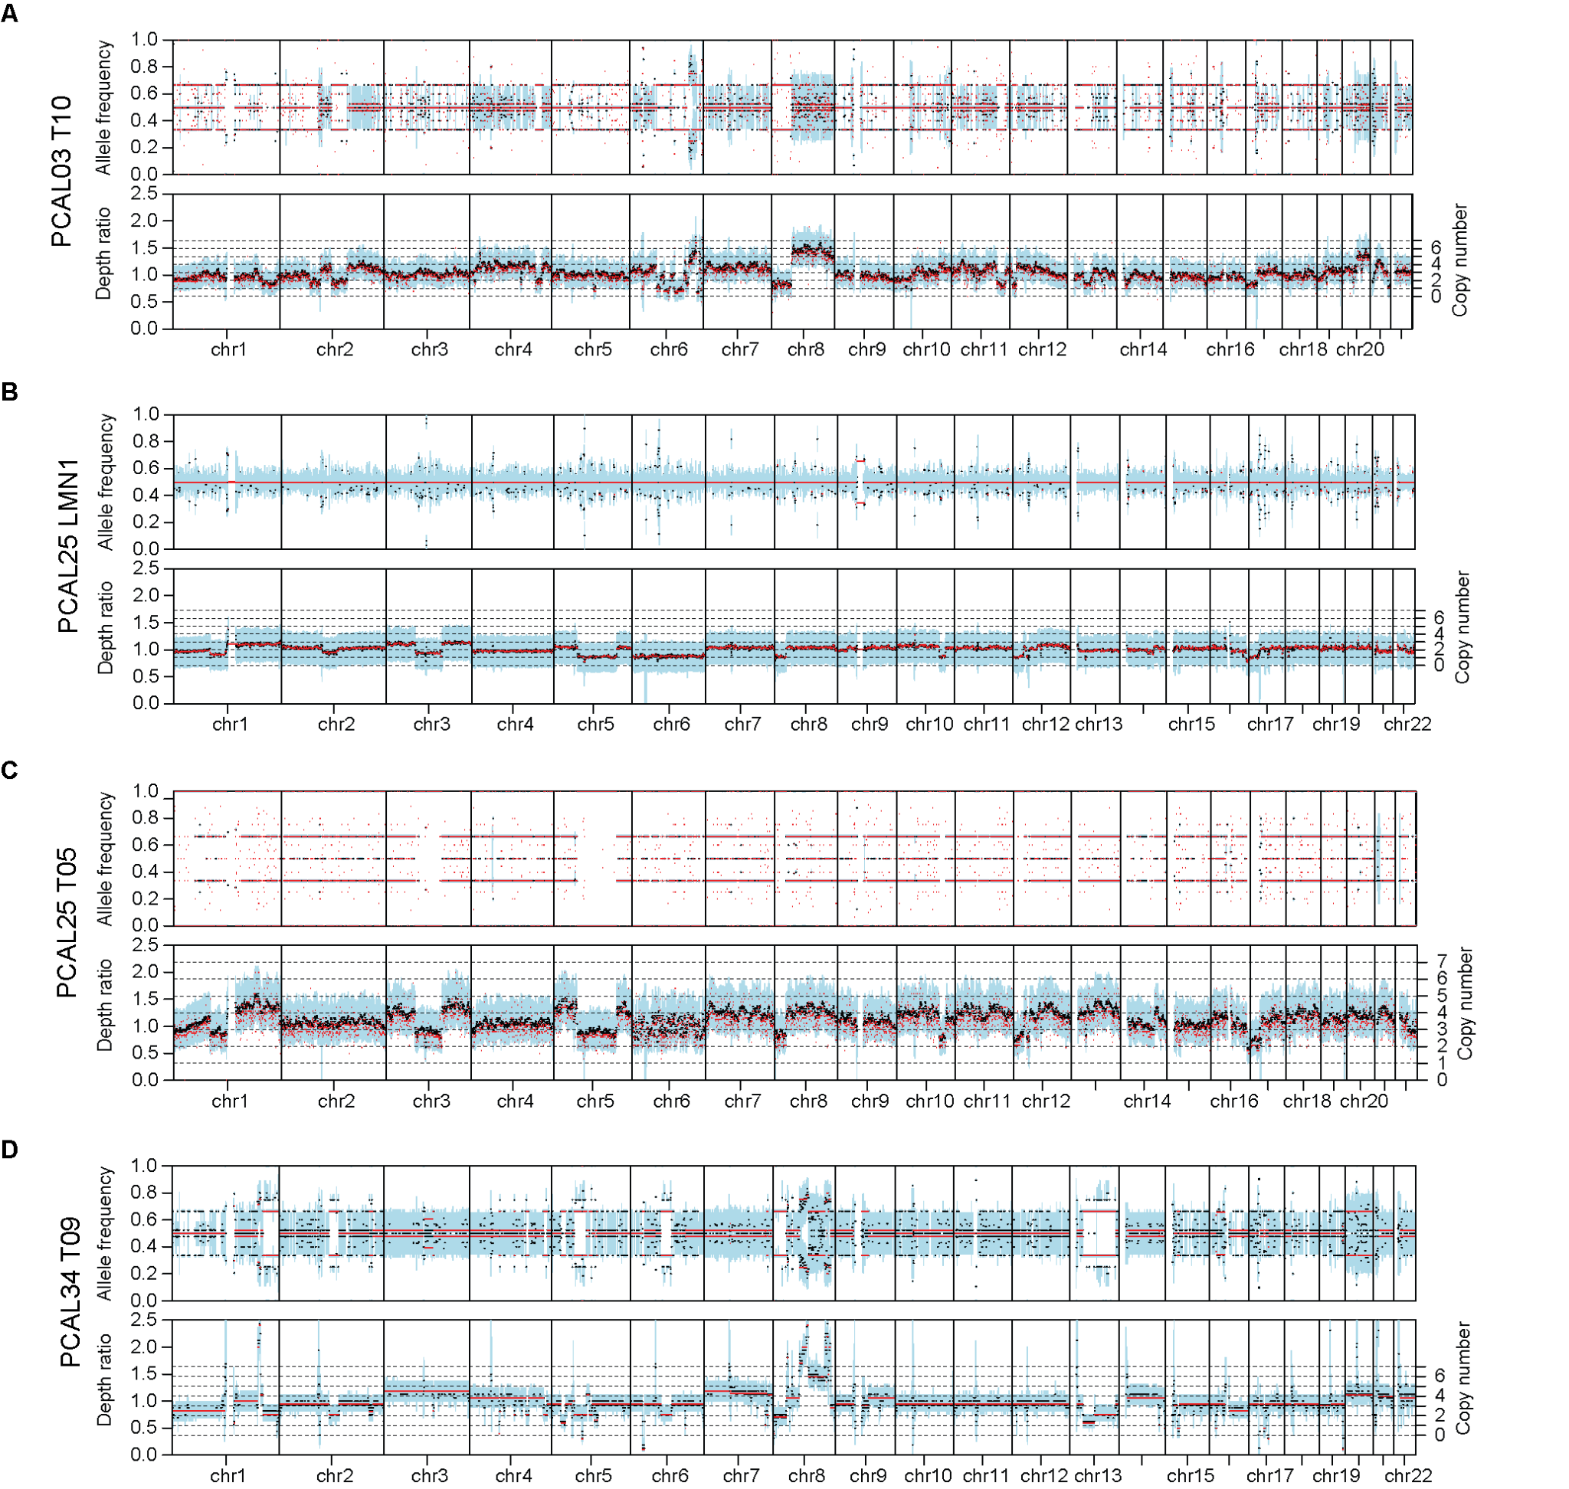
Supplementary Figure 3. Genome-wide copy number levels from whole-genome deep sequenced areas from each patient tumour. A, PCAL03 area T10; B, PCAL25 LNM1; C, PCAL25 area T05; D, PCAL34 area T09. Top plot: allele frequency, bottom plot: read depth ratio between tumour and normal. Sex chromosomes were excluded.

Figure S4.
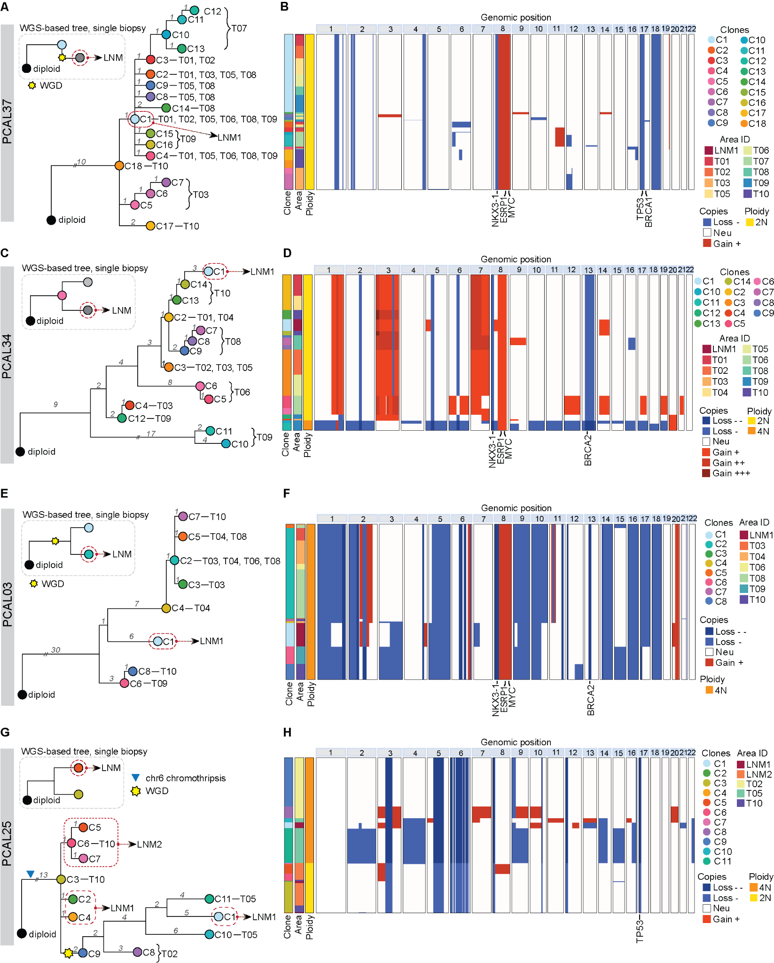
Supplementary Figure 4. Reconstructed phylogenetic trees from individual tumours. A, C, E, G, Reconstructed phylogenetic trees. Top left, WGS-based tree from a bulk DNA single biopsy (dashed rectangle). Colour indicated the closest clone found in a single-cell tree. Right, multi-region scRNA-seq based tree. Branch length and the number on the branch indicate the number of events. Major events are marked, such as WGD. B, D, F, H, Heatmaps showing CNAs, either gains or losses, across the genome. Gains are depicted in red and losses in blue, colour intensity corresponds to more or less copies lost or gained from the baseline. Baseline relative to 2N or 4N, is marked as neutral (Neu, white). The left side bars show cell clustering coloured by clone ID, area ID and ploidy. 2N, diploid; 4N, tetraploid. A, B PCAL37; C, D PCAL34; E, F PCAL03; G, H PCAL25.

Figure S5.
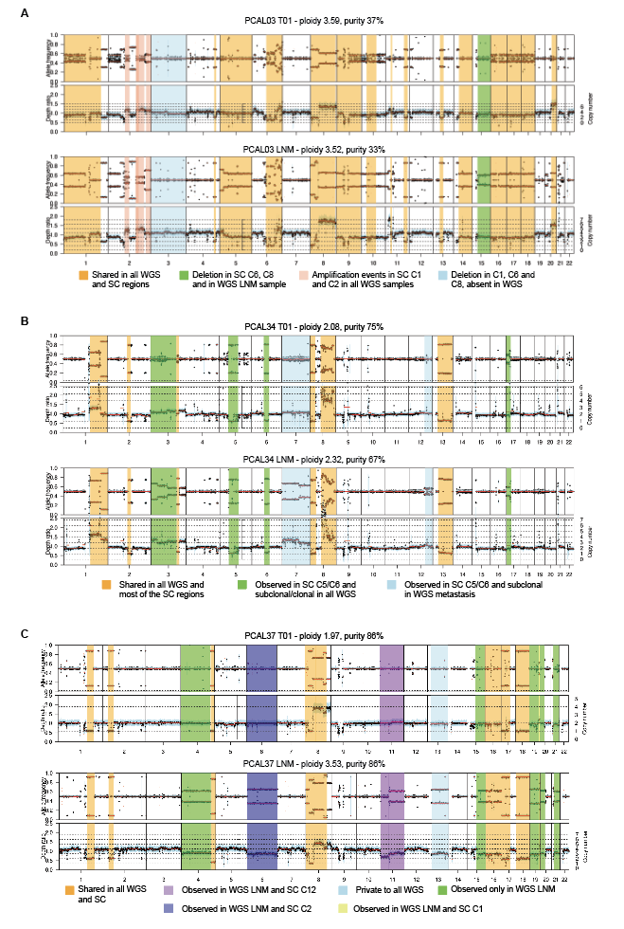
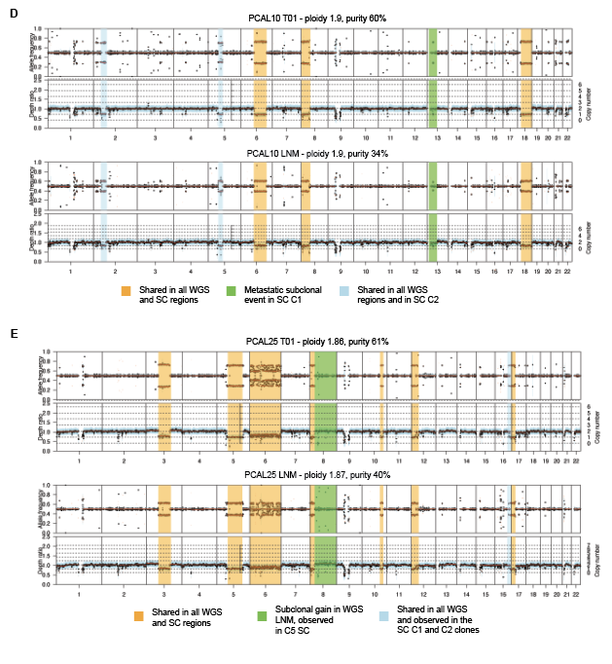
Supplementary Figure 5. Comparative whole genome profiles of primary tumors and corresponding lymph node metastasis (LNM) for five patients (A-E). Each panel shows whole genome profiles obtained from bulk WGS with estimated sample cellularity and ploidy. Top, genomic profile of the primary tumor sample; bottom, the corresponding LNM. Each genomic profile includes two plots: allele-frequency (top), showing allele frequencies across the genome; depth ratio (bottom), comparing the sequencing coverage depth of the tumor sample to a matched normal control. This plot highlights copy number variations, with horizontal dotted lines indicating the estimated copy number value, given cellularity and ploidy. Highlighted regions indicate common or private events in WGS samples, and show corresponding events identified in clones from the single-cell (SC) copy number analysis. A, PCAL03; B, PCAL34; C, PCAL37; D, PCAL10; E, PCAL25.

Figure S6.
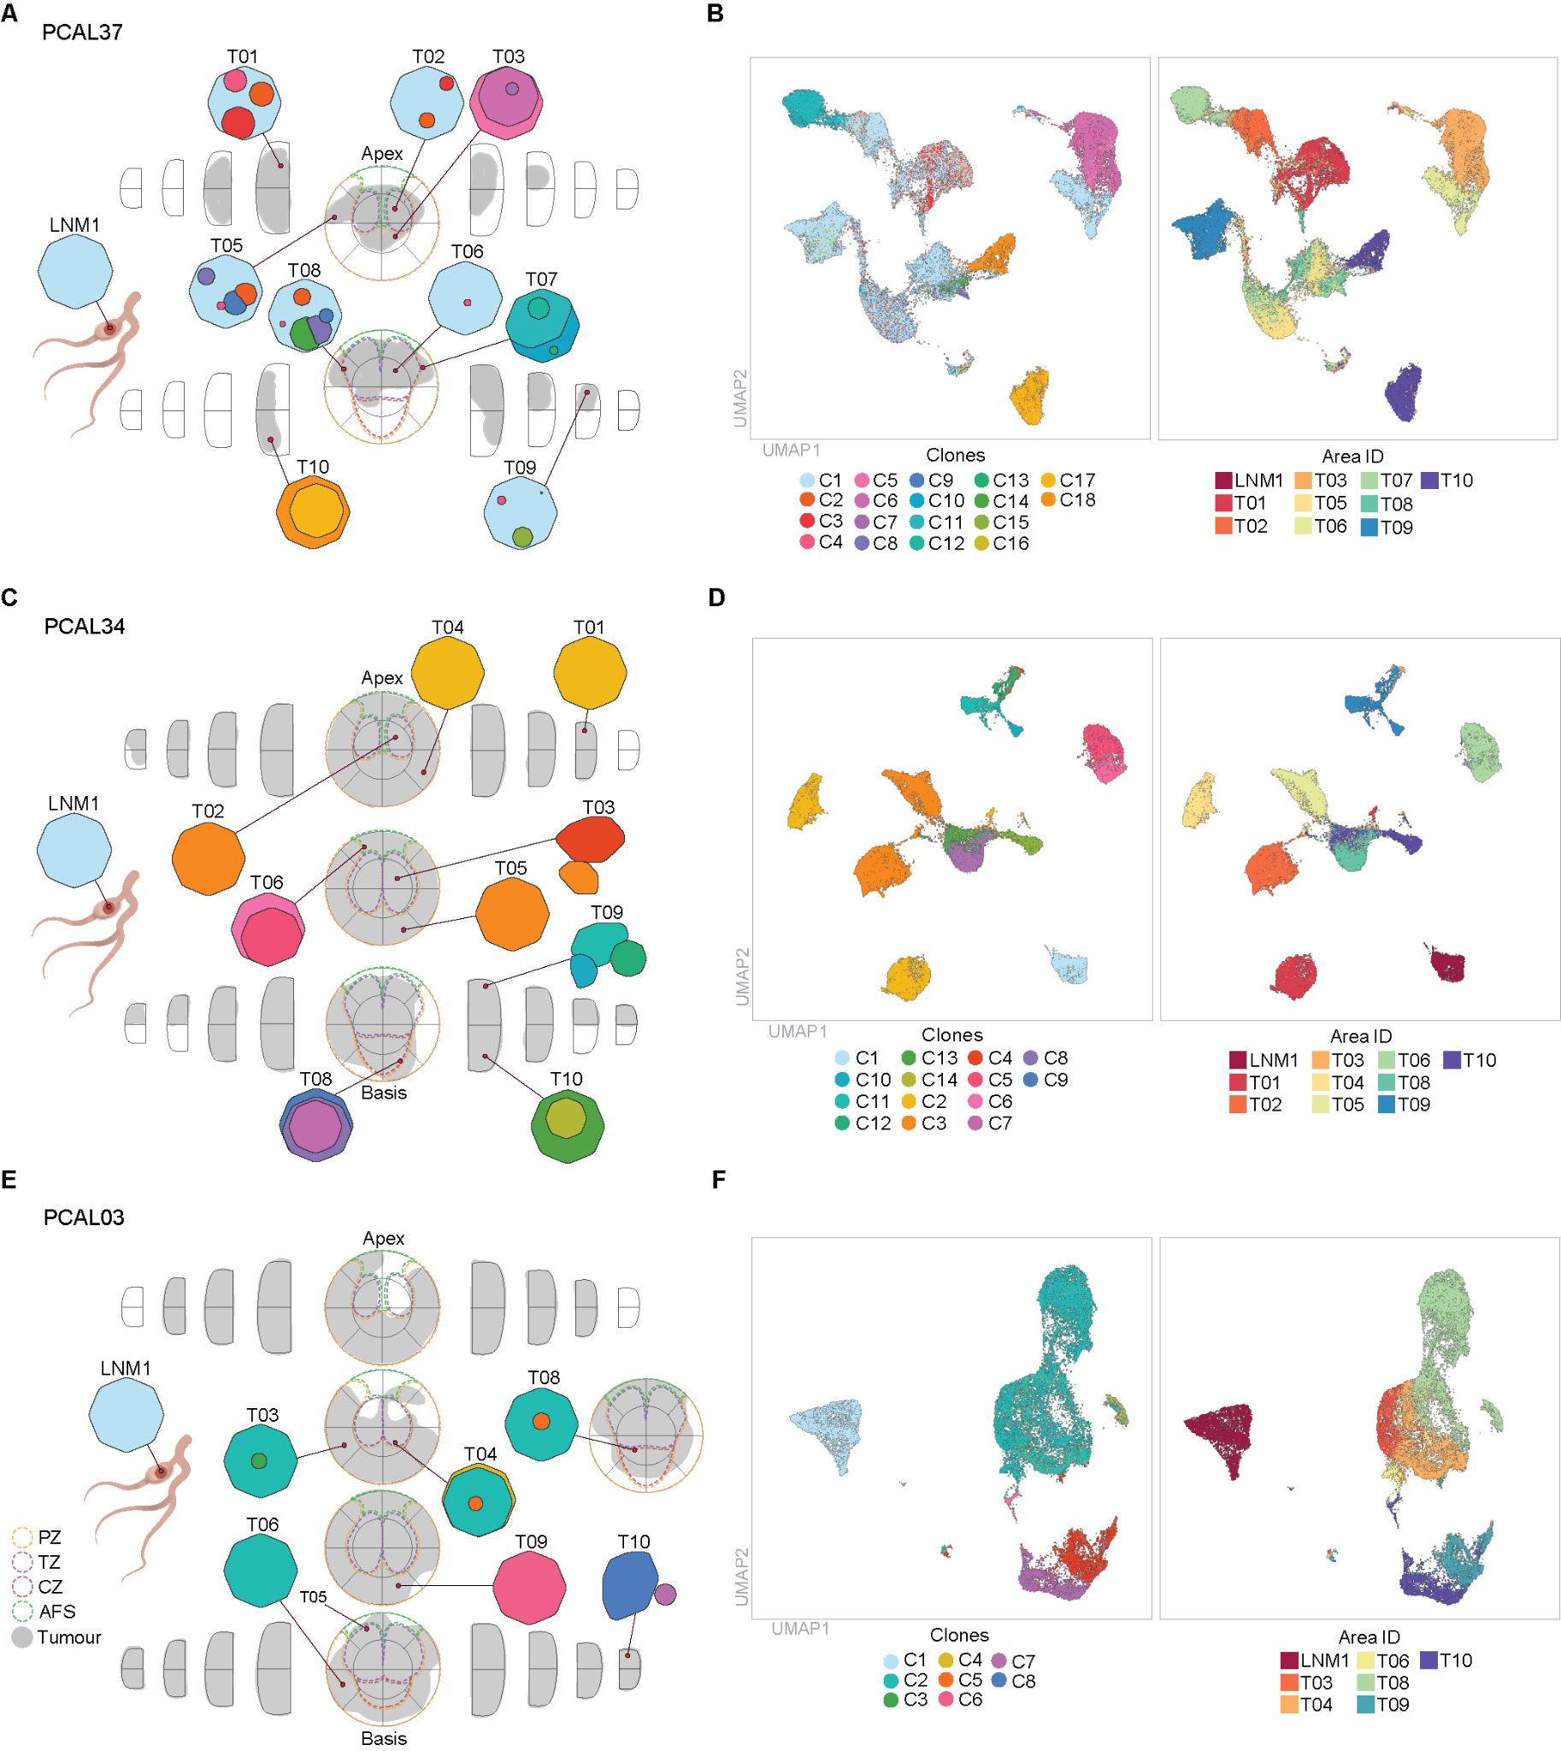
Supplementary Figure 6. A, C, E Pathologist reports showing the clonal composition of cancer cells in each captured area. Subclones deriving from the same lineage are shown within the clone, with the size of the subclone being proportional to the CCF of the clone. Colours represent clones. Prostate zones are marked in dashed lines and tumour spread in grey. PZ., Peripheral Zone; TZ., Transition Zone; CZ., Central Zone; AFS, Anterior Fibromuscular Stroma. B, D, F UMAP plots showing all cancer cells per individual; left, coloured by clone; right, coloured by area. A, B PCAL37; C, D PCAL34; E, F PCAL03.

Figure S7.
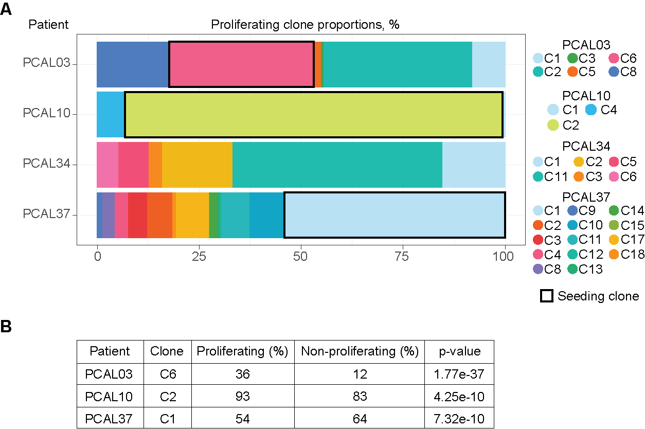
Supplementary Figure 7. A, Proportion of clones identified as proliferating tumour cells for each patient. PCAL25 did not have any proliferating tumour cells. If present, the seeding clone is marked. B, The table shows the percentage of seeding clones in proliferating and non-proliferating malignant cells for three patients (PCAL03, PCAL10, PCAL37), along with the p-values from Chi-squared tests of seeding proliferating clone enrichment versus expected.

Figure S8.
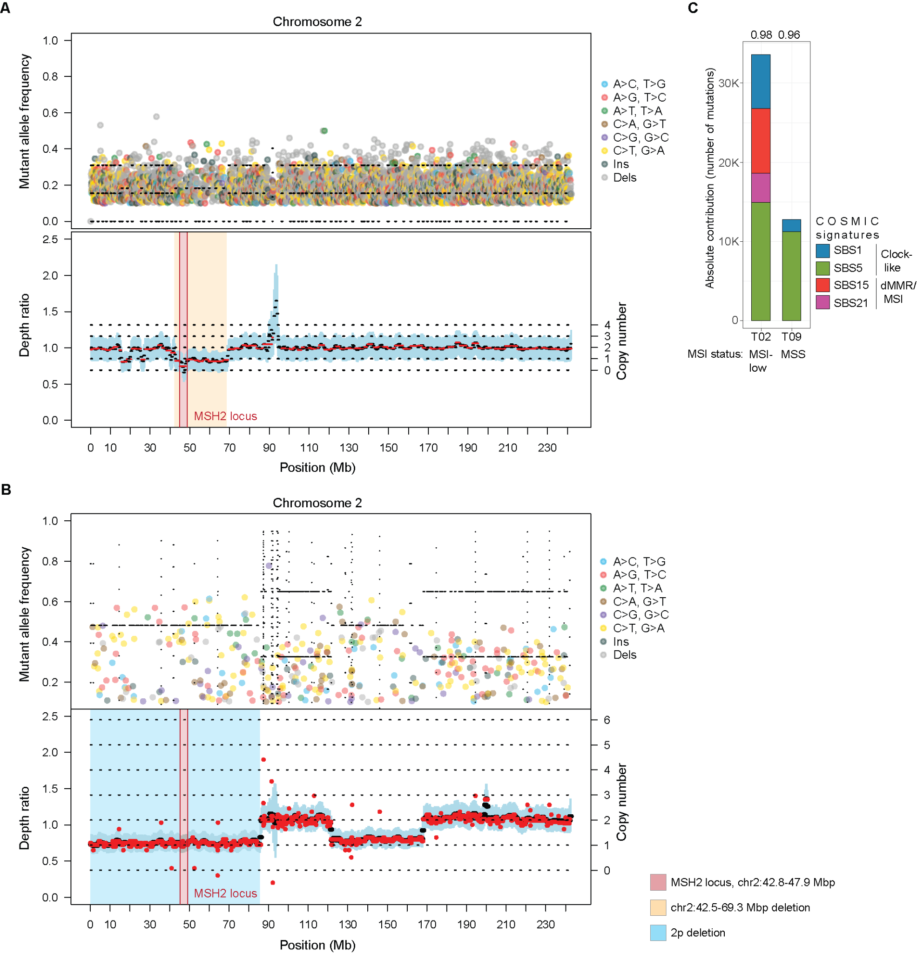
Supplementary Figure 8. A-B, WGS-based mutation frequency and read depth ratio plots of chromosome 2 for PCAL10. MSH2/6 locus is highlighted in red. A, PCAL10 area T02 with homozygous loss of MSH2. B, PCAL10 area T09 with heterozygous loss of MSH2. C, Bar plot showing total number of mutations for areas T02 and T09, colours represent proportions of COSMIC SBS signatures. Numbers on the top indicate signature cosine similarity. Below, MSI status predicted with msisensor2. MSI, Microsatellite Instability; MSS, Microsatellite Stable.

Figure S9.
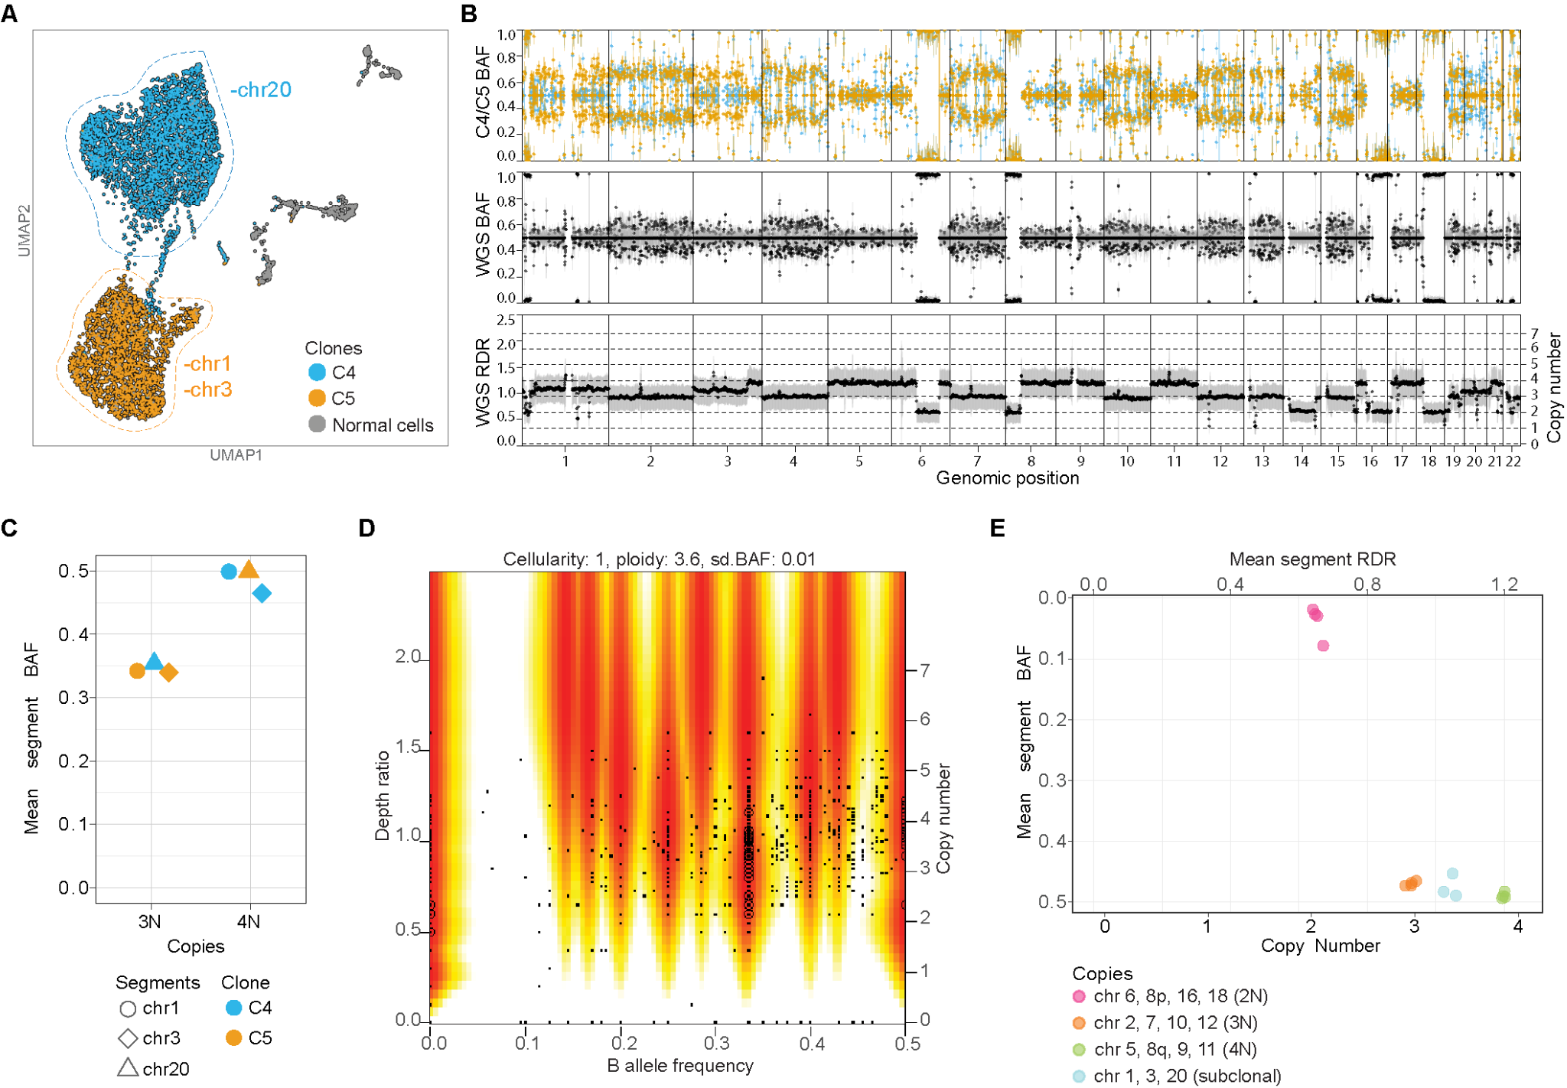
Supplementary Figure 9. A, UMAP of PCAL10 T05 area, malignant cells coloured by clone ID. B, Genome-wide copy number plots. Top - B allele frequency (BAF) across the genome for each clone derived from snRNA-seq; C4, blue; C5, yellow Middle - BAF obtained from T05 derived from bulk WGS. Bottom - read depth ratio (RDR) between tumour and normal C, Mean segment BAF of subclonal segments of chromosomes 1, 3 and 20, coloured by clone ID. D, Depth ratio by BAF and estimated ploidy from WGS. E, Mean segment BAF and RDR from WGS of subclonal segments of chromosomes 1, 3 and 20 and selected regions of 2 copies (2N), 3 copies (3N), and 4 copies (4N).

Figure S10.
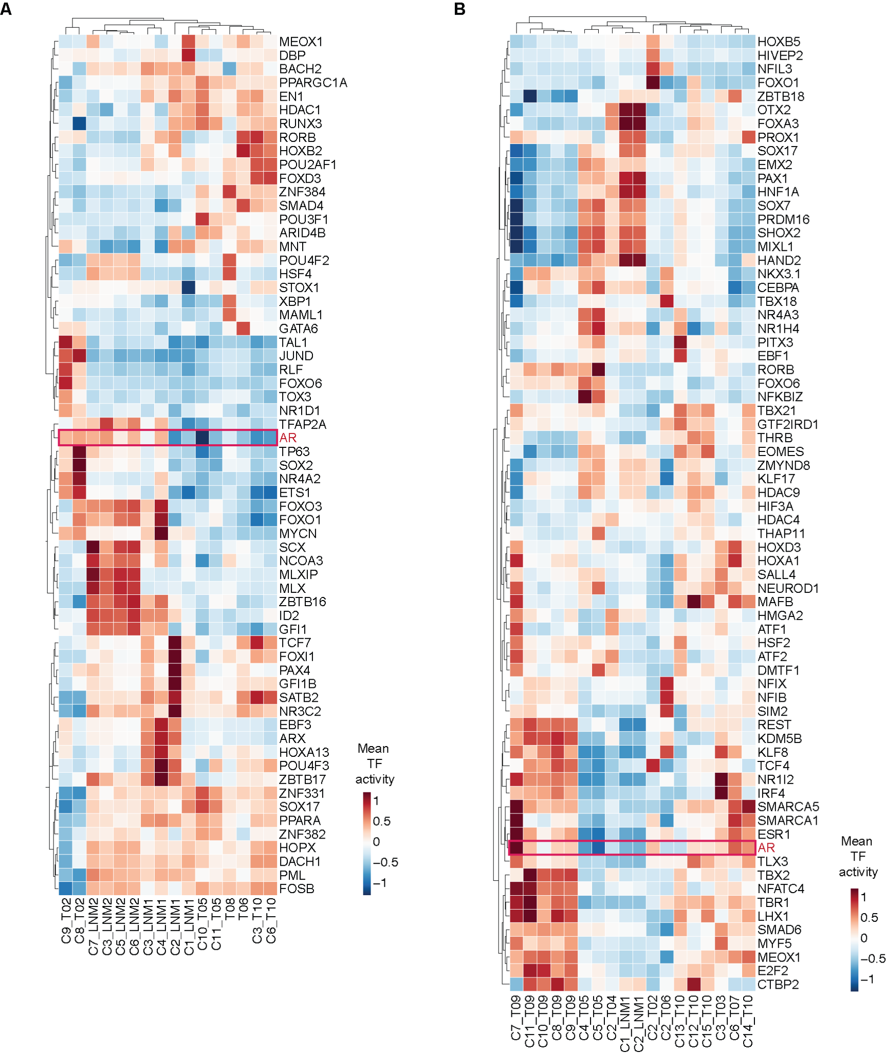
Supplementary Figure 10. Hierarchical clustering of top mean transcription factor (TF) activities per clone and area. A, Patient PCAL25; B, Patient PCAL10. AR activity is highlighted with a horizontal red box.

Figure S11
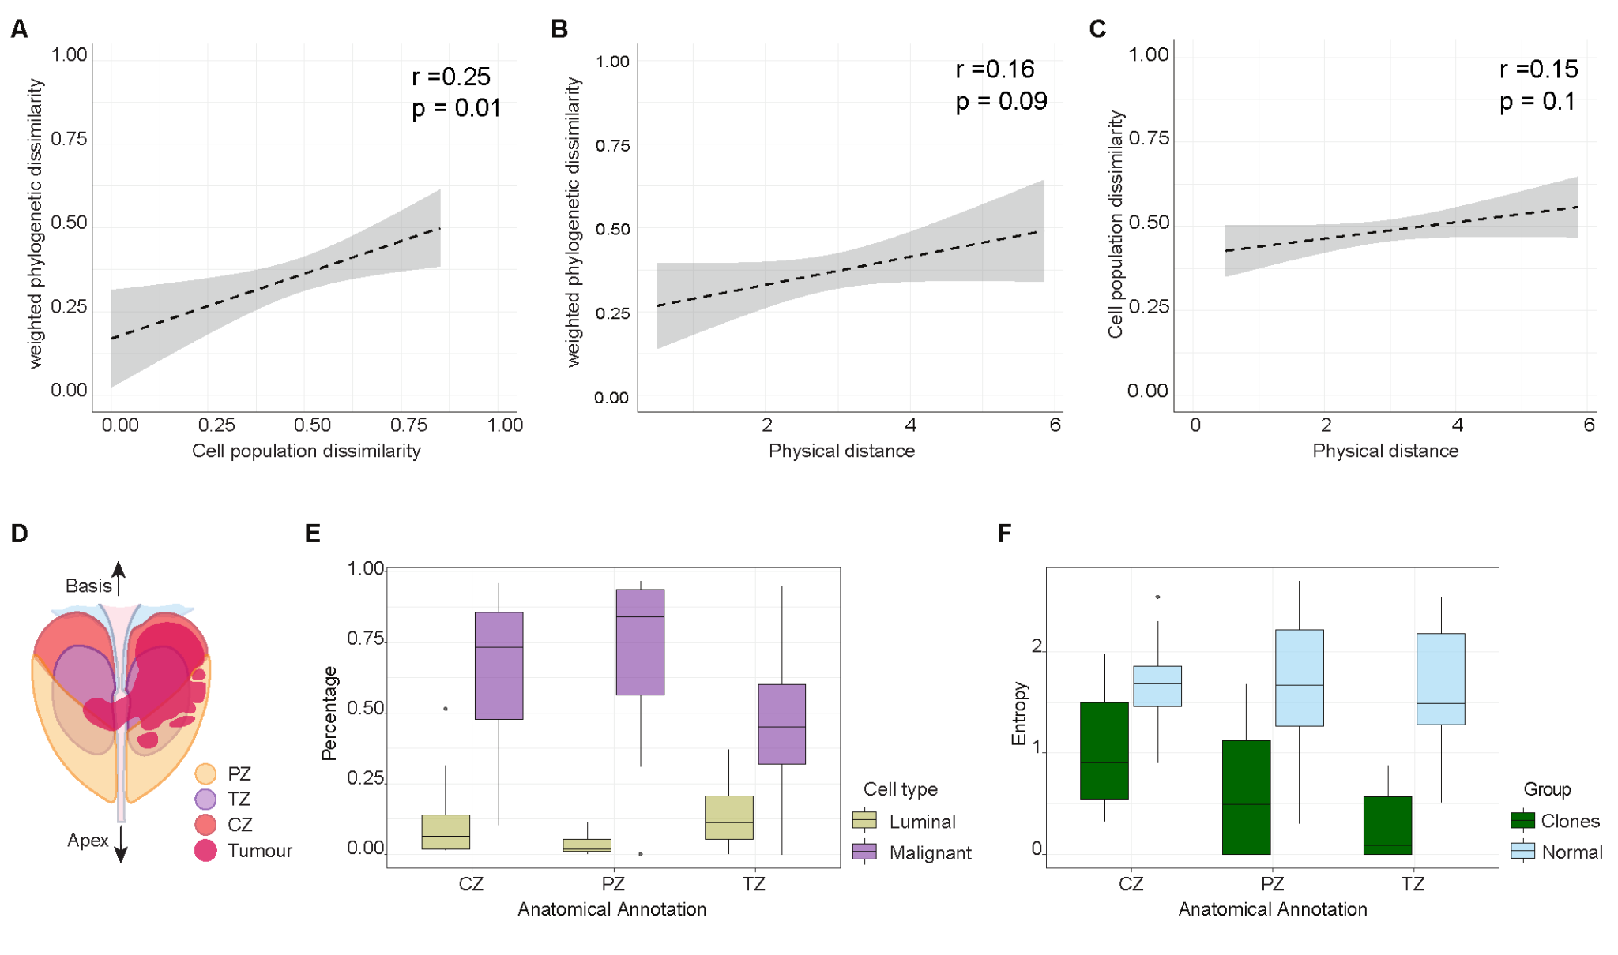
Supplementary Figure 11. A, Scatter plot depicting the relationship between cell type dissimilarity and phylogenetic dissimilarity across tumour areas within each patient. Cell type dissimilarity is measured using the inverse Jaccard index, while phylogenetic dissimilarity is based on the proportional differences in genetic events between clones. Each point represents a pairwise comparison of tumour areas within a patient; only the fitted trend line and confidence intervals are shown. B, Scatter plot of the relationship between physical distance and phylogenetic dissimilarity across tumour areas within each patient, as in (A). C, Scatter plot of the relationship between physical distance and cell type dissimilarity, measured using the inverse Jaccard index, as in (A). D, Schematic representation of the prostate gland with cancer, highlighting the different anatomical zones, as in Figure 1A. E, Box plots showing the percentages of luminal and malignant cell proportions, stratified by the three anatomical zones of the prostate: peripheral, central, and transition. F, Box plots showing the entropy of clones and normal cells, stratified by the three anatomical zones of the prostate: peripheral, central, and transition.

Figure S12
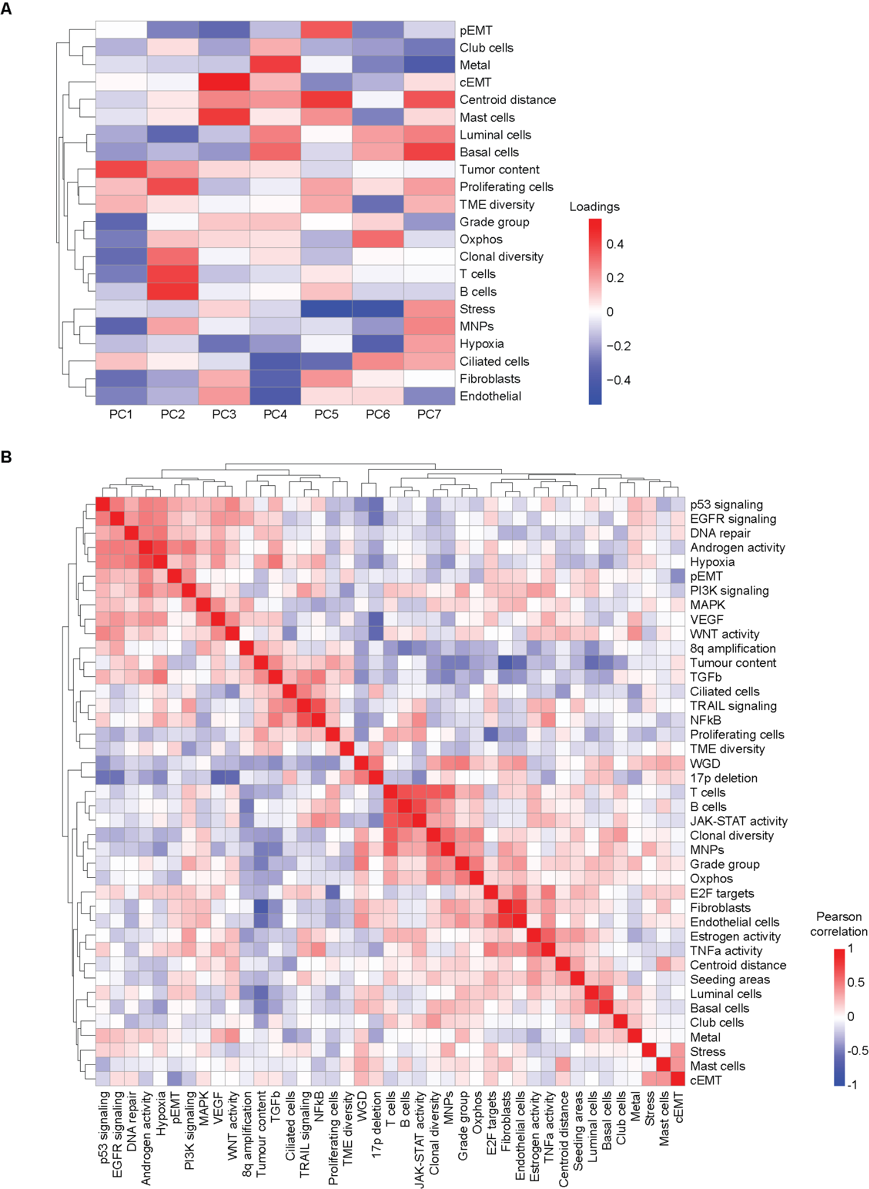
Supplementary Figure 12. A, Heatmap displaying the loadings of the first seven principal components (PCs) from the principal component analysis (PCA), each accounting for more than 5% of the variance. Columns represent PCs, while rows correspond to the features included in the PCA. B, Heatmap showing the Pearson correlation coefficients between features of cells within each tumor area.

