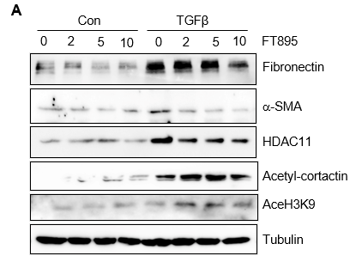
Supplemental Figure 1. FT895 inhibits TGF-β1(TGFβ)-induced expression of fibronectin and a-SMA in a dose dependent manner. Serum-starved RTPCs were treated with 10 mM FT895 for 1 h followed by exposure of cells to TGF-β1 (5 ng/ml) for an additional 24 h. Cell lysates were then prepared and subjected to immunoblot analysis with antibodies against proteins as indicated.

