Visual intelligent loop-mediated isothermal amplification-based magnetic beads for rapid detection of Burkholderia gladioli pv.cocovenenans
Lingyan Zheng^{a,b}, Dongmei Li^{a,b}, Yumin Shen^{a,b}, Jiali Wang^{a,b}，Pengcheng Zhang^{b}, Hong Duan^{a,b}, Ke Xiong^{b*}, Joseph Irudayaraj^{c}
ªKey Laboratory of Geriatric Nutrition and Health, Ministry of Education, Beijing Technology and Business University, Beijing 100048, China

^{b}Beijing Laboratory for Food Quality and Safety, Beijing Technology & Business University (BTBU), Beijing, 100048, China

^{c}Department of Bioengineering, University of Illinois at Urbana-Champaign, Urbana, IL 61801, USA

Corresponding author: Dr. Xiong Ke
Email: xiongke1129@163.com

Supplementary data
Data on primer screening, optimal primer binding sites, optimization of LAMP conditional optimization, and gel electrophoresis of PCR sensitivity to DNA
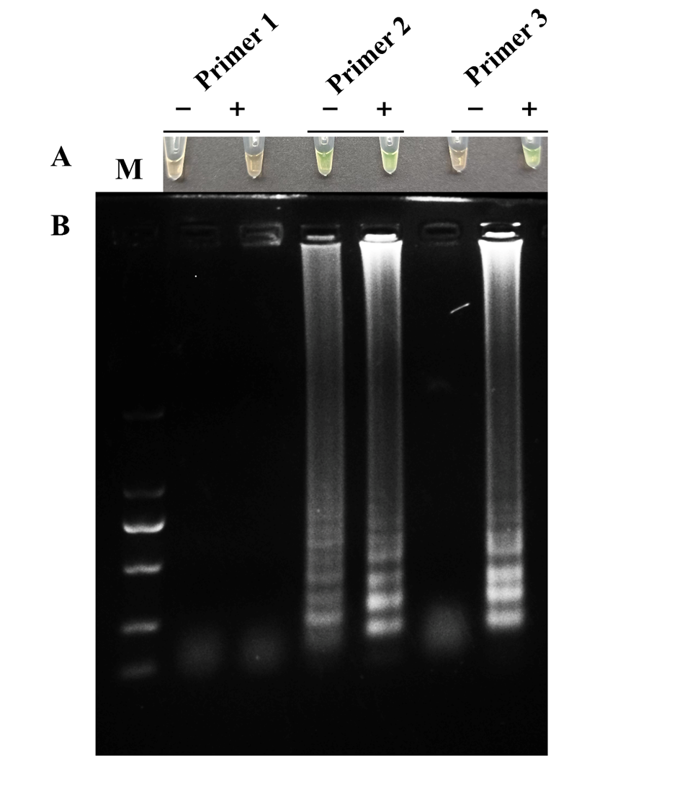

Fig. S1. Screening of three LAMP primers. The outcome of primer screening was confirmed by visualization (A) and gel electrophoresis (B).

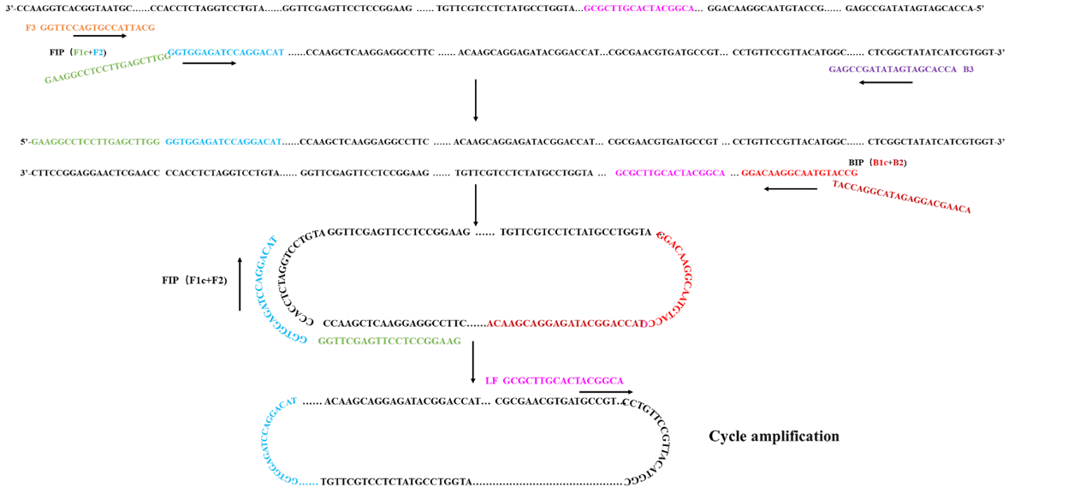

Fig. S2. The primer binding sites. The LAMP 3 primers anneal to six distinct locations in the specific gene Bon M of BGC DSMZ11318 (Gen Bank: JX173632.1).

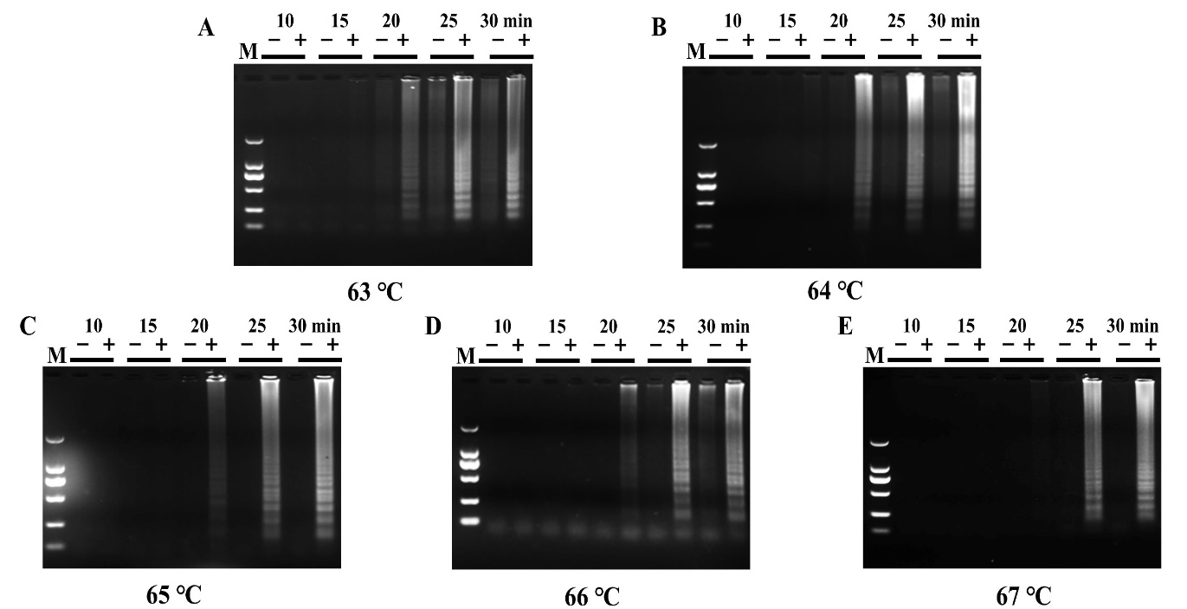

Fig. S3. LAMP reaction temperature and time optimization. (A-E). Gel electropherograms for 63℃, 64℃, 65℃, 66℃, and 67℃ within 30 min.

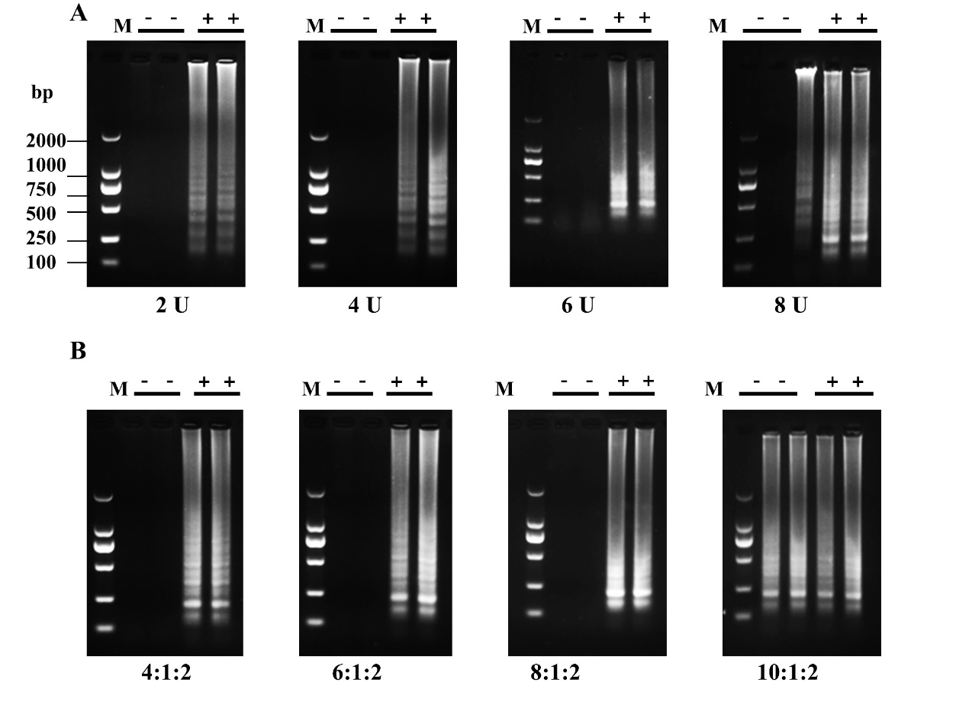
Fig. S4. LAMP reaction enzyme concentration and the ratio of the inner and outer primer concentration optimization. (A). Enzyme concentration optimization. (B). Inner and outer primer concentration optimization.
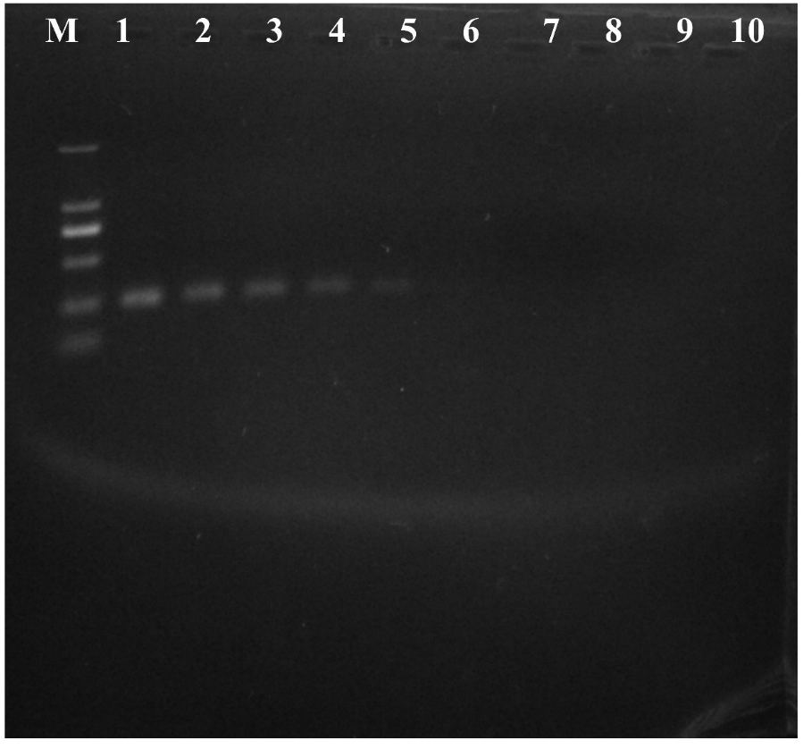
Fig. S5. Gel electrophoresis for PCR product. Lane M: 2000 bp DNA Maker. Lane 1-10: 250 ng/μL,25 ng/μL,2.5 ng/μL,250 pg/μL,25 pg/μL,2.5 pg/μL,250 fg/μL,25 fg/μL,2.5 fg/μL,ddH₂O.

