Visual intelligent loop-mediated isothermal amplification-based magnetic beads for rapid detection of Burkholderia gladioli pv.cocovenenans
Lingyan Zheng^{a,b}, Dongmei Li^{a,b}, Yumin Shen^{a,b}, Jiali Wang^{a,b}，Pengcheng Zhang^{b}, Hong Duan^{a,b}, Ke Xiong^{b*}, Joseph Irudayaraj^{c}
ªKey Laboratory of Geriatric Nutrition and Health, Ministry of Education, Beijing Technology and Business University, Beijing 100048, China

^{b}Beijing Laboratory for Food Quality and Safety, Beijing Technology & Business University (BTBU), Beijing, 100048, China

^{c}Department of Bioengineering, University of Illinois at Urbana-Champaign, Urbana, IL 61801, USA

Corresponding author: Dr. Xiong Ke
Email: xiongke1129@163.com

Supplementary data
Data on primer screening, optimal primer binding sites, optimization of LAMP conditional optimization, and gel electrophoresis of PCR sensitivity to DNA

Fig. S1. Screening of three LAMP primers.

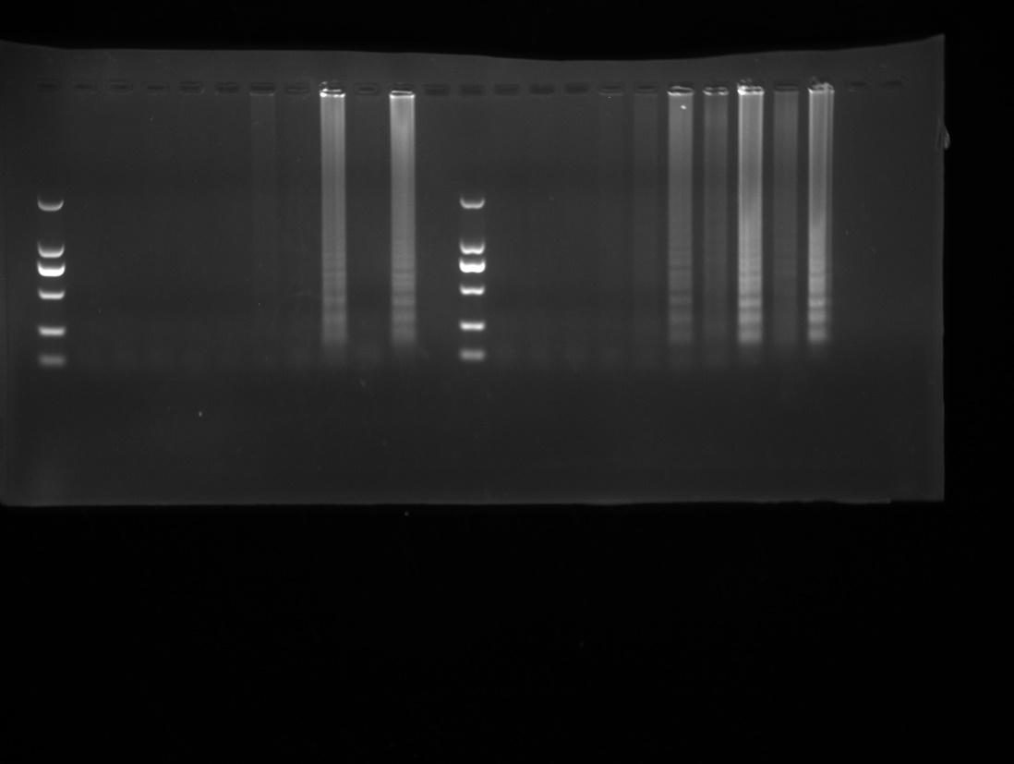
Fig. S3. LAMP reaction temperature and time optimization of gel electropherograms 63℃ and 67℃.
Fig. S3. LAMP reaction temperature and time optimization of gel electropherograms 64℃.
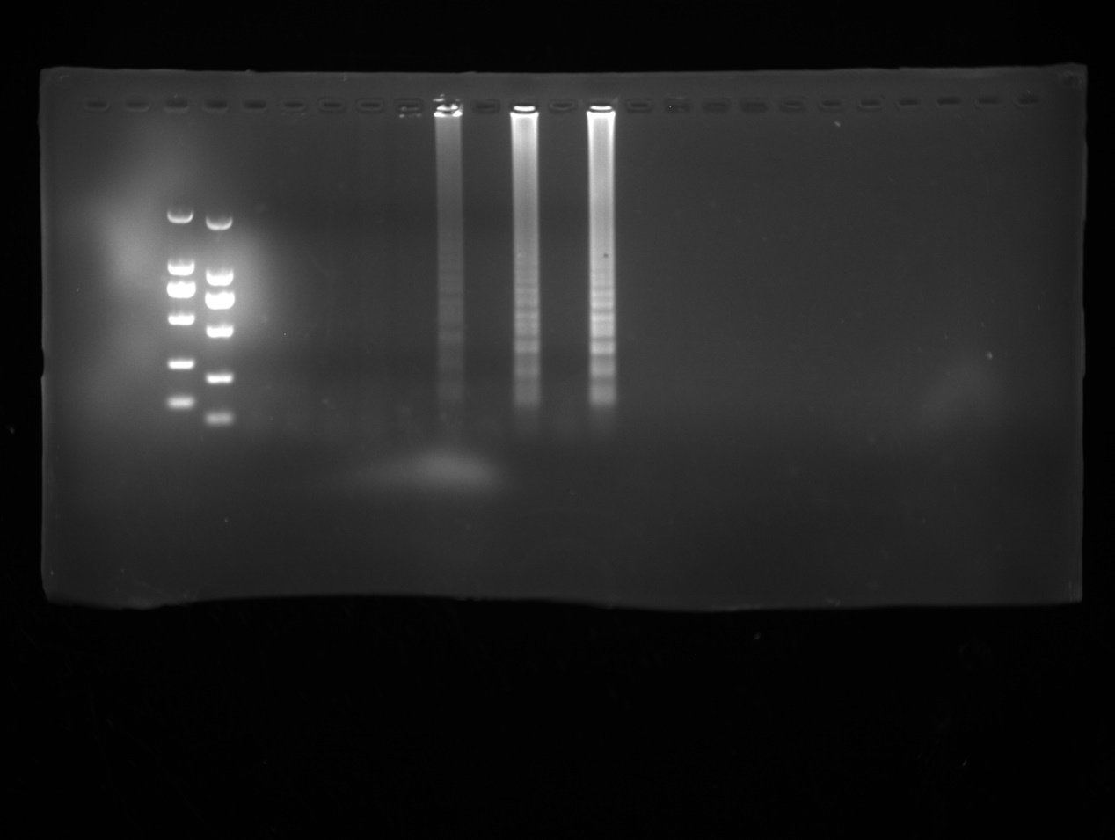
Fig. S3. LAMP reaction temperature and time optimization of gel electropherograms 65℃.
Fig. S3. LAMP reaction temperature and time optimization of gel electropherograms 66℃.
Fig. S4. LAMP reaction enzyme concentration 2U and 4U.
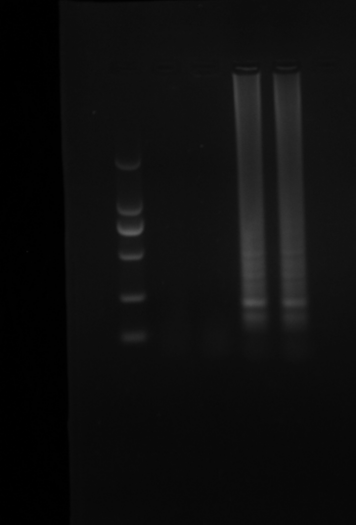
Fig. S4. LAMP reaction enzyme concentration 6U.

Fig. S4. LAMP reaction enzyme concentration 8U.

Fig. S4. LAMP reaction the ratio of the inner and outer primer concentration optimization 10:1:2.
Fig. S4. LAMP reaction the ratio of the inner and outer primer concentration optimization 8:1:2.

Fig. S4. LAMP reaction the ratio of the inner and outer primer concentration optimization 4:1:2 and 6:1:2.

Fig. S5. Gel electrophoresis for PCR product. Lane M: 2000 bp DNA Maker. Lane 1-10: 250 ng/μL,25 ng/μL,2.5 ng/μL,250 pg/μL,25 pg/μL,2.5 pg/μL,250 fg/μL,25 fg/μL,2.5 fg/μL,ddH₂O.

