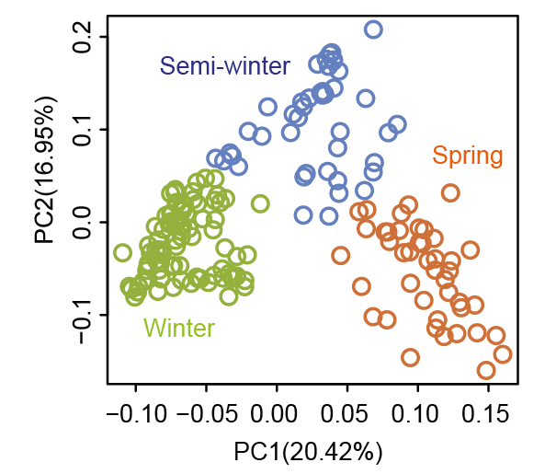
Supplemental Figure 1. Host genetic variation for 300 B. napus ecotypes visualized by a principal component analysis using whole genome resequencing data. The ecotypes are classified as Spring, Winter and Semi-winter. The locations were established in Kaifeng, North China and Yangling, Northwest China. Note that we only harvested in total 175 ecotypes for both locations, and for those specific ecotypes at each location was removed for downstream analyses.

Supplemental Figure 2. Overall transcriptome analysis for B. napus population (n = 175) using all expressed genes. (a) A principal component analysis illustrating the transcriptomic differences across three different ecotypes at two locations. (b) Percentage of variance explained by genotype, location and location: genotype interaction. KF, Kaifeng; YL, Yangling.

Supplemental Figure 3. Large-scale bacterial microbiome profiling in the B. napus rhizosphere. (a) A multidimensional scaling (MDS) plot illustrating the location and compartment effect on bacterial diversity. KF, Kaifeng; YL, Yangling. (b) A principal component analysis demonstrating the bacterial diversity across three different ecotypes at two locations. Both distance matrix plots used the highly abundance ASVs as the input. (c) Percentage of variance explained by genotype, location and location: genotype interaction.

Supplemental Figure 4. Identification of gene co-expressed modules and functional characterization. (a) Weighted gene co-expression network analysis (WGCNA) identified 35 gene co-expressed modules. The number of genes enriched in each module was indicated in the brackets accordingly. The heatmap indicates the Pearson correlation of co-expressed modules with 203 heritable bacterial ASVs. (b) Overlapped unique Gene Ontology (GO) terms of four highly gene-microbial correlated modules. The number of GO terms enriched in each module was indicated in the brackets accordingly. (c) Network visualization of overlapped GO terms identified the major functional pathways enriched among the highly correlated WGCNA modules. The detailed pathways were annotated within the network associations done by REVIGO (http://revigo.irb.hr/).
Supplemental Figure 5. Preparation of multi-omics datasets used for genomic prediction. (a) The overlapped SNPs among whole genome sequencing (WGS) SNPs and RNAseq derived SNPs from KF (Kaifeng) and YL (Yangling) locations respectively. (b) The correlation between different kinship matrix， which was calculated using different datasets, such as WGS SNPs, RNAseq SNPs, Gene expression data or the abundance of ASVs data.

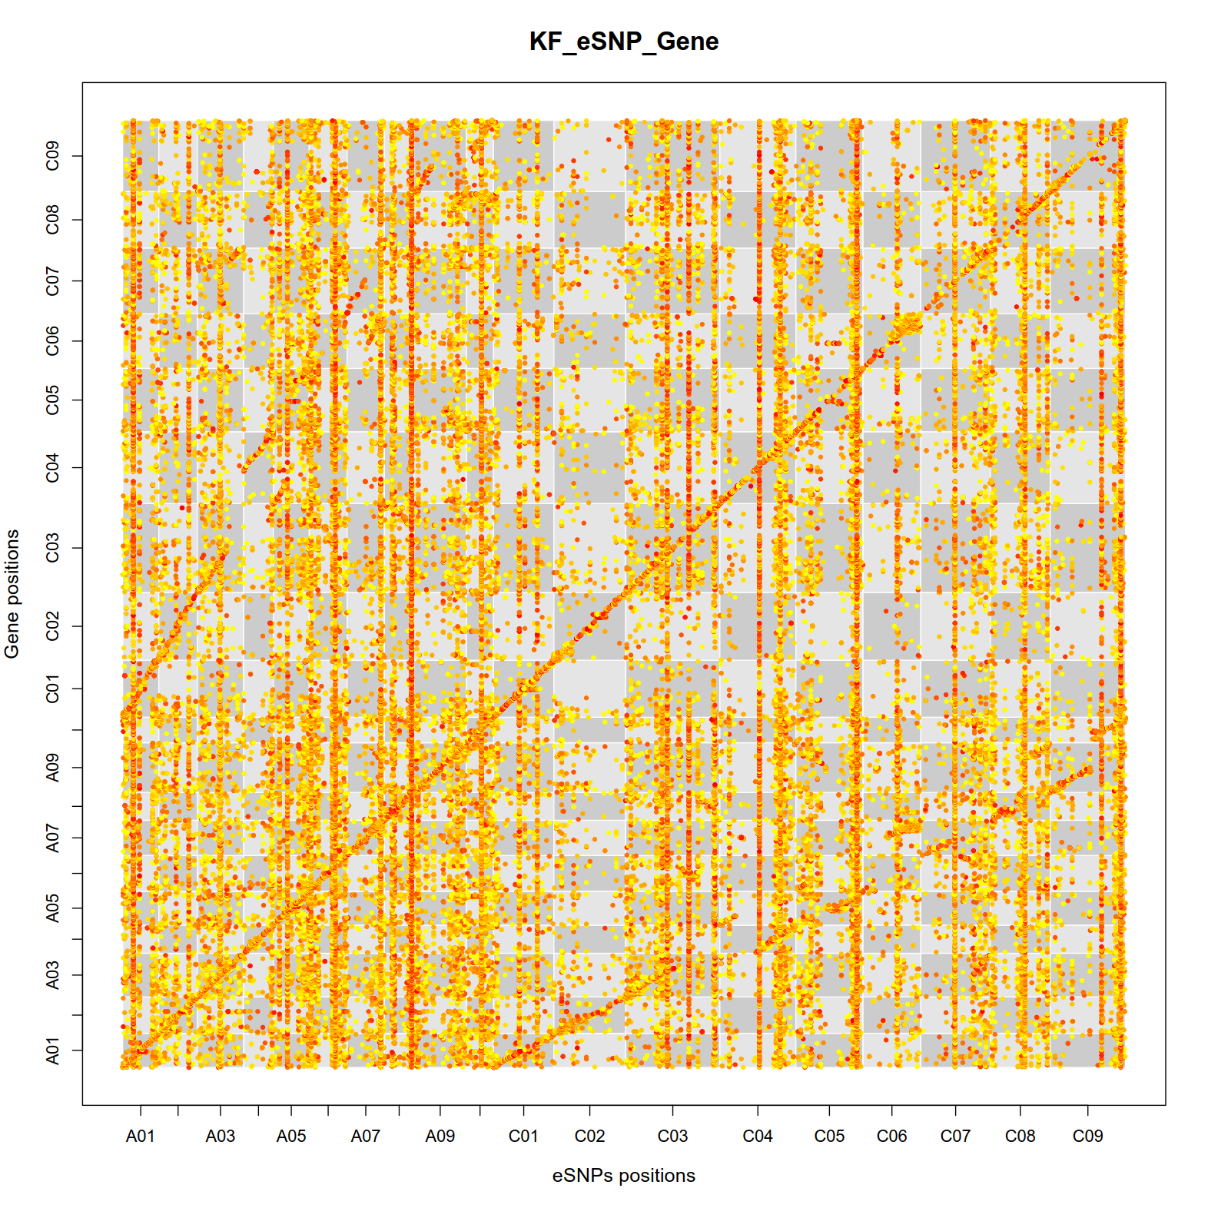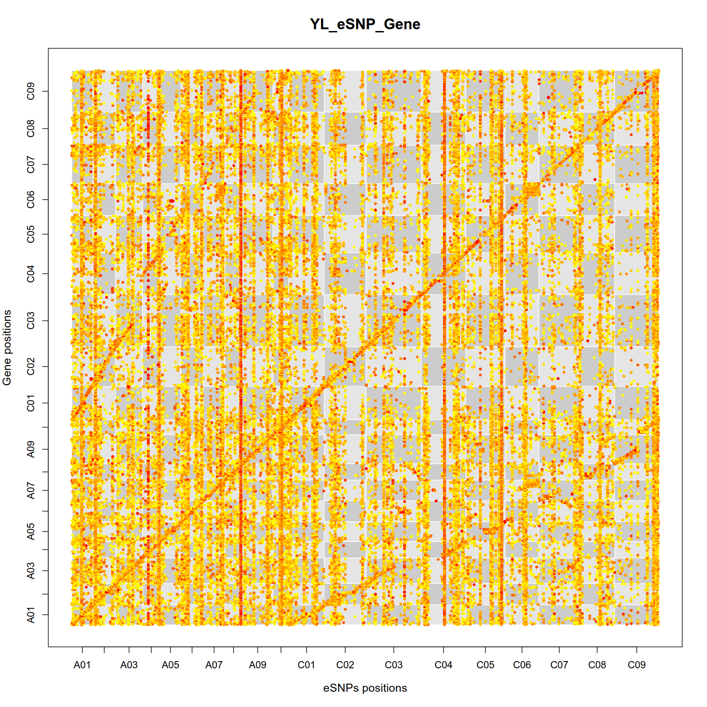
Supplemental Figure 6. Dot plot showing eQTLs and their regulated genes in 19 chromosomes. x-axis shows the single nucleotide polymorphism (SNP) position (bp) in each chromosome and the y-axis shows the gene position (bp) in each chromosome, with a chromosome order of A01 to C09 from left to right (x-axis) or from lower to upper (y-axis). The color of each dot represents the significance (P-value) of each eQTL-gene association, with low significance in yellow and high significance in red. Each chromosome is scaled by the physical chromosome length. Dots in the diagonal line show the intra-chromosomal associations. The lines show the enrichment of inter-subgenomic associations in homoeologous chromosomes and inter-chromosomal associations between the hotspot and other chromosomes. KF, Kaifeng; YL, Yangling.

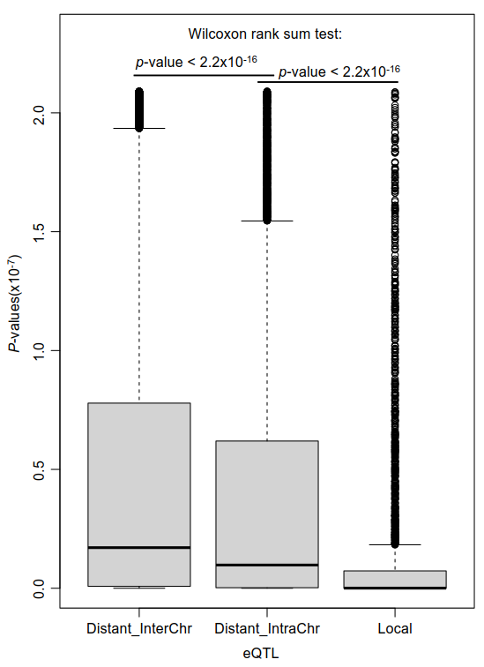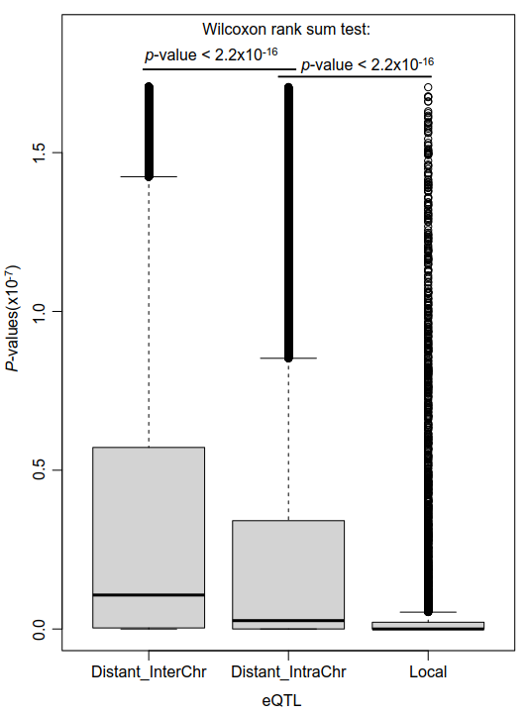
Supplemental Figure 7. The comparison of significance (P values) between inter-chromosomal eQTLs (Distant_InterChr) and intra-chromosomal eQTLs (Distant_IntraChr and Local) in KF (left) and YL (right).

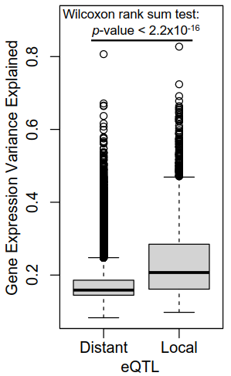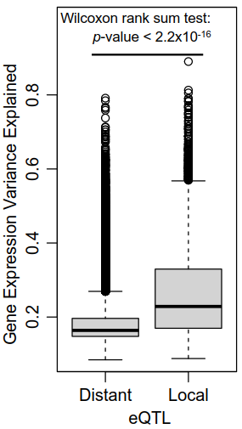
Supplemental Figure 8. Difference of gene explanation variance explained (r2) of SNPs between local eQTL and distant eQTL in Kaifeng (left) and Yangling (right).

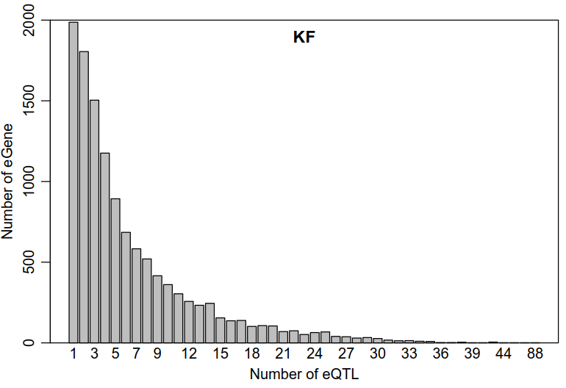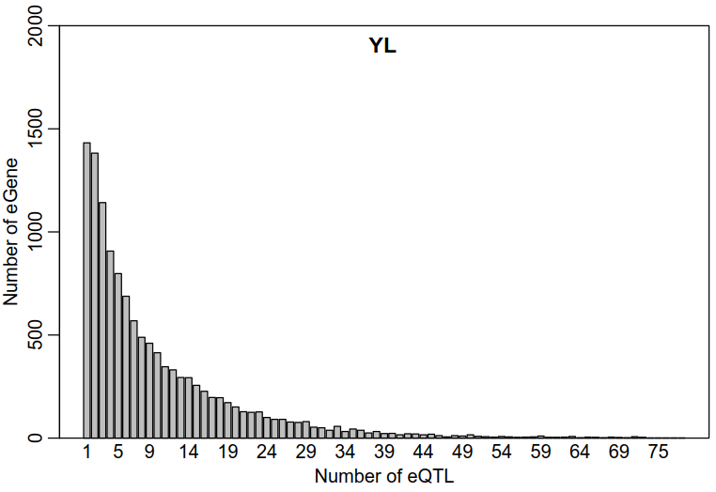
Supplemental Figure 9. Distribution of the number of eQTLs for genes which were regulated by eQTL in Kaifeng (left) and Yangling (right).

Supplemental Figure 10. Phylogenetic tree of 203 highly heritable ASVs. The complete list of 203 ASVs are provided in the Supplemental Dataset 3. Different taxonomic information were color coded at the family level.

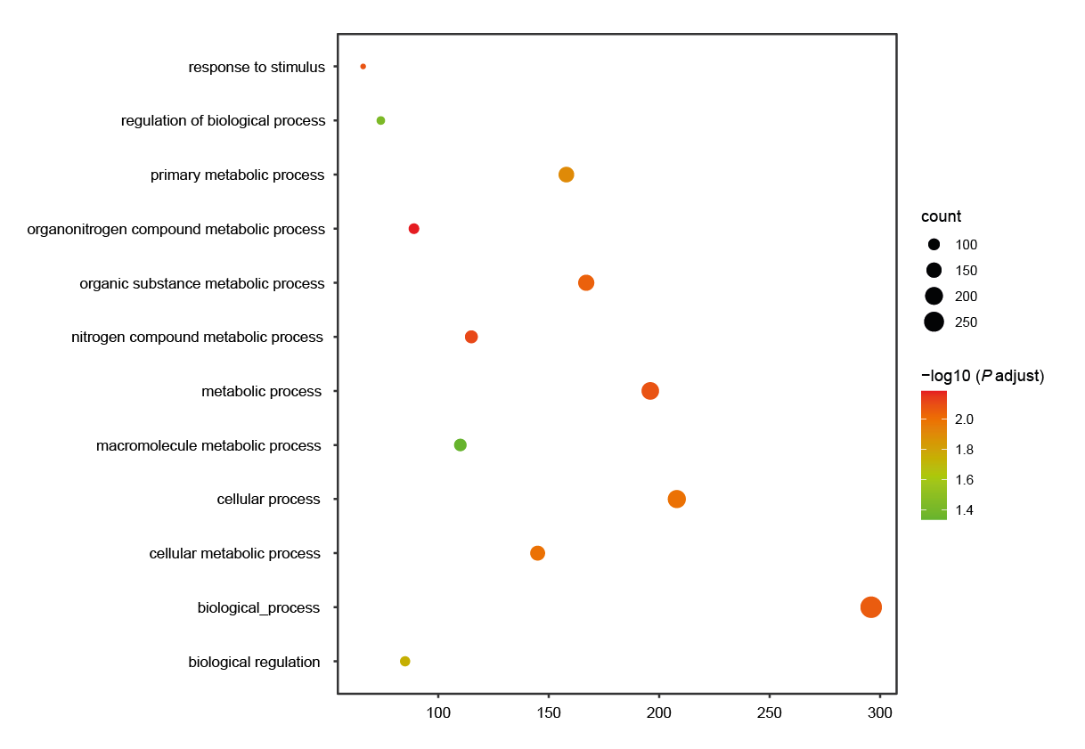
Supplemental Figure 11. Gene ontology (GO) analysis of ASV729 associated genes. The size of dots indicates the number of detected ASVs enriched into each biological process. The color code indicates the significance of enrichment.

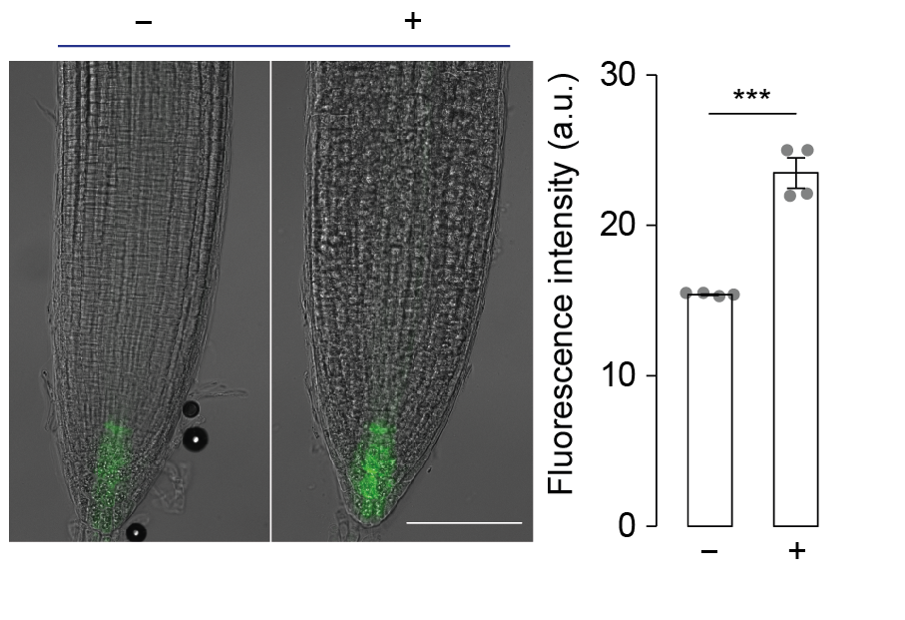Supplemental Figure 12. DR5::GUS tagged root tip imaging with or without inoculation of Sphingopyxis isolate (29-6000-31). The significance was controlled by paired Student’s t test. ***, P <0.001.

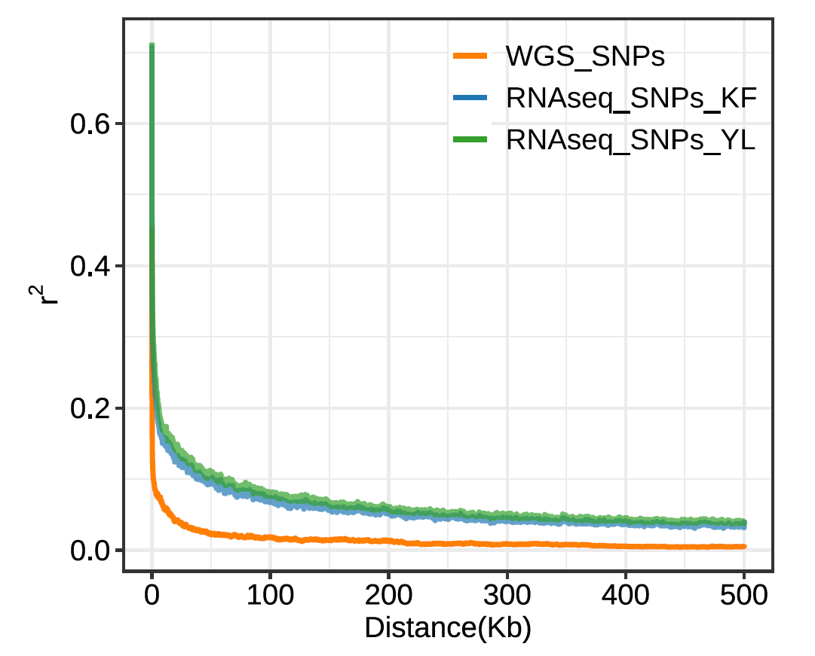

Supplemental Figure 13. Linkage disequilibrium (LD) decay plot referring to the nonrandom associations of alleles at different loci for whole genome sequencing (WGS) and RNAseq derived SNPs data. KF, Kaifeng; YL, Yangling.

Supplemental Figure 14. Nitrogen-fixation capacity test for bacterial isolates Sphingopyxis Isolate 31 and M53. No colonies were detected on nitrogen-free media, indicating the lack of nitrogen-fixing ability in these bacterial isolates.

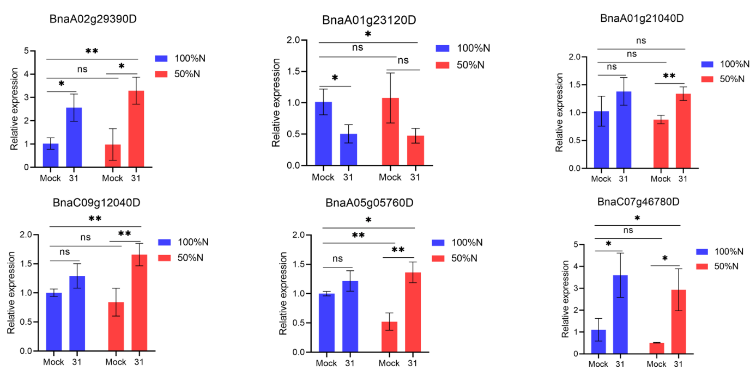
Supplemental Figure 15. Real-time PCR quantification of relative expression of rapeseed genes after inoculation of Sphingopyxis 31. The significances were controlled by paired student t tests. *, P <0.05. ns, not significant.
Supplemental Table 1 Physical and chemical properties of the basic soil at two locations. The values presented are mean ± standard error at Kaifeng (KF) and Yangling (YL) fields in 2019. Means followed by the same letter are not significantly different at p <0.05 according to LSD (ANOVA, turkey HSD, n = 5).

Soil properties | Kaifeng (KF) | Yangling (YL)
Total N (%) | 0.094 ± 0.0027a | 0.076 ± 0.00088b
Conc. P (mg/kg) | 69.23 ± 1.61a | 67.55 ± 1.06a
pH | 6.74 ± 0.08b | 7.23 ± 0.07a
Total organic carbon (%) | 0.60 ± 0.062a | 0.56 ± 0.043a

