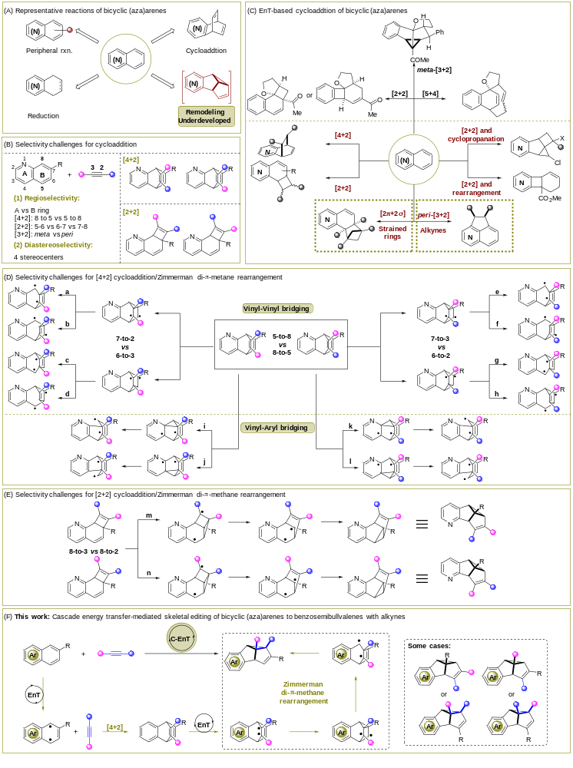
Scheme 1 Photocatalytic skeletal editing of bicyclic (aza)arenes.

