Table 1. Triplet photocatalyst screening and reaction optimizationª
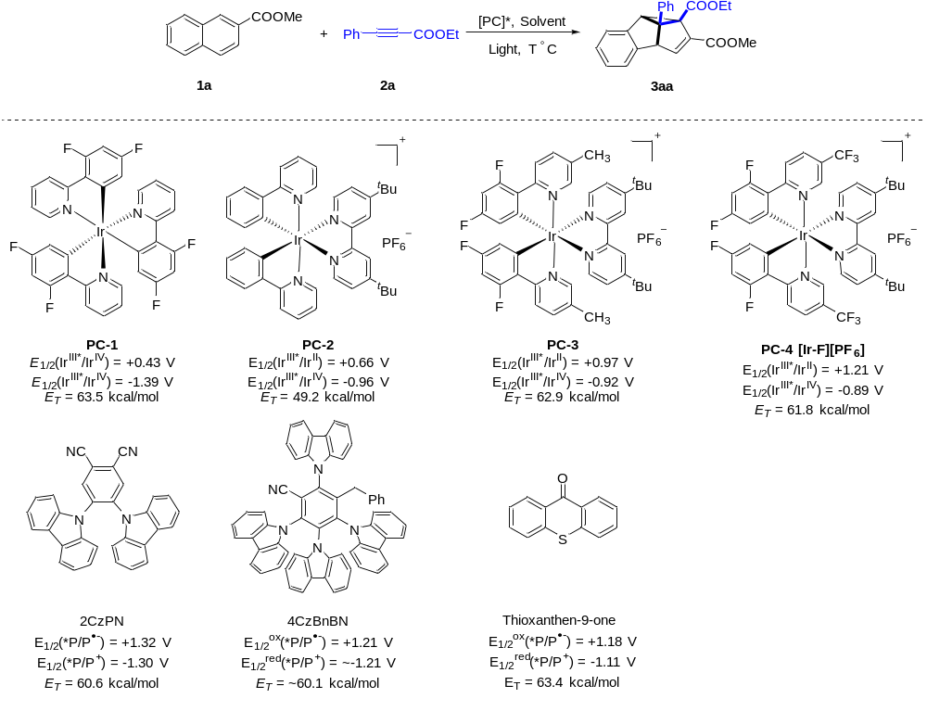
Entry | PC* | Solvent | Yield (%)
1 | PC-1 | MeCN | 19
2 | PC-2 | MeCN | 24
3 | PC-3 | MeCN | 61
4 | PC-4 | MeCN | 64
5 | 2CzPN | MeCN | 15
6 | 4CzBnBN | MeCN | 35
7 | 2,7-Br-4CzIPN | MeCN | 35
8^{b} | Thioxanthone | MeCN | N.D.
9^{c} | PC-4 | MeCN | 60
10^{d} | PC-4 | MeCN | 34
11 | PC-4 | DMSO | 22
12 | PC-4 | DCE | 64
13 | PC-4 | HFIP | N.D.
14 | PC-4 | TFE | 29
15 | PC-4 | 1,4-Dioxane | 30
16 | PC-4 | MeOH | 52
17 | PC-4 | MeCN:MeOH (1:1) | 63
18 | PC-4 | MeCN:1,4-Dioxane (1:1) | 70
19 | PC-4 | MeCN:1,4-Dioxane (1:9) | 74
20e | PC-4 | MeCN:1,4-Dioxane (1:9) | 50
21^{f} | PC-4 | MeCN:1,4-Dioxane (1:9) | N.D.
22^{g} | PC-4 | MeCN:1,4-Dioxane (1:9) | N.D.
23^{h} | ‒ | MeCN:1,4-Dioxane (1:9) | N.D.
ª Reaction conditions: 1a (0.2 mmol), 2a (0.4 mmol), [PC] (2 mol%), solvent (2 mL). The reaction mixture was irradiated with 30 W blue LEDs at < 30 °C under Ar atmosphere for 48 h. The yields were determined by ¹H NMR spectroscopy. [PC] = Photocatalyst. N.D. = Not Detected. ^{b} λ_{max} = 390 nm. ^{c} λ_{max} = 405 nm. ^{d} λ_{max} = 465 nm. ^{e} 10 μL H₂O was added. ^{f} Under air. ^{g} In dark. ^{h} Without [PC].

