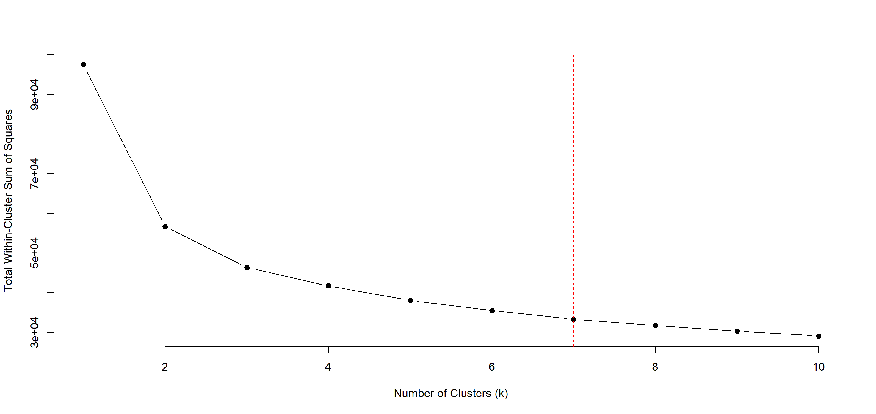
Supplementary Figure 1: The plot displays the Total Within-Cluster Sum of Squares (WSS) (y-axis) against the number of clusters (k), ranging from 1 to 10 (x-axis). The WSS indicates how well-defined the clusters are, with lower values reflecting greater compactness. The elbow method was applied to identify the optimal number of clusters, marked by the red dashed vertical line, which suggests seven clusters as the most appropriate balance between variance reduction and model simplicity.

