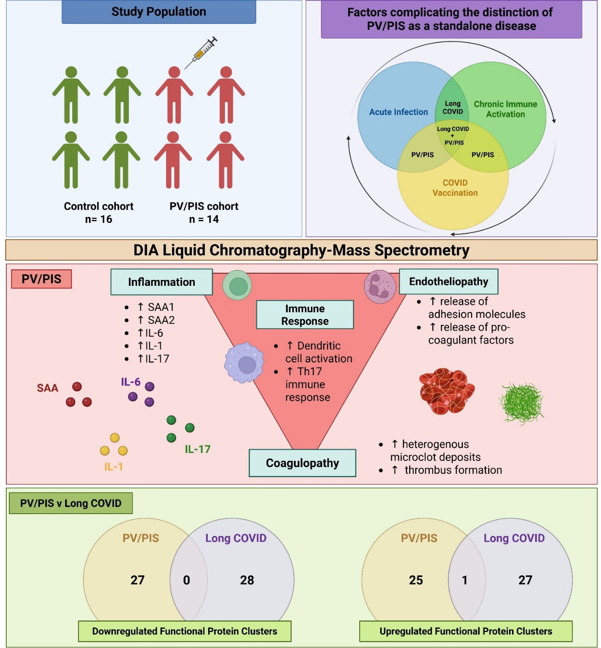
Graphical Abstract
Created in https://BioRender.com

