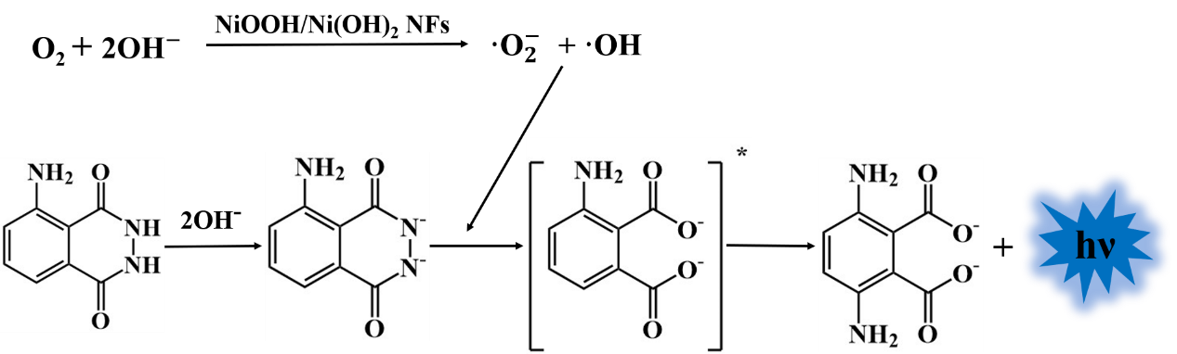

Scheme 1 Mechanism of the luminol-NiOOH/Ni(OH)₂ NFs CL system

