Supplemental Materials
Neuroanatomy Reflects Individual Variability in Impulsivity in Youth

Authors
Elvisha Dhamala^{1-2, *}, Erynn Christensen¹, Jamie L. Hanson³⁻⁴, Jocelyn A. Ricard^{5,6}, Noelle Arcaro¹, Simran Bhola¹, Lisa Wiersch¹, Katharina Brosch¹, B.T. Thomas Yeo⁷⁻¹², Avram J. Holmes¹³, Sarah W. Yip^{14,15}

Affiliations
¹ Institute of Behavioral Sciences, Feinstein Institutes for Medical Research, Manhasset, USA
² Department of Psychiatry, Donald and Barbara Zucker School of Medicine at Hofstra/Northwell, Uniondale, USA
³ Learning Research and Development Center, University of Pittsburgh, Pittsburgh, USA
⁴ Department of Psychology, University of Pittsburgh, Pittsburgh, USA
⁵ Stanford Neurosciences Interdepartmental Program, Stanford University School of Medicine, Stanford, USA
⁶ Department of Psychology, Stanford University, Stanford, USA
⁷ Centre for Sleep & Cognition & Centre for Translational Magnetic Resonance Research, Yong Loo Lin School of Medicine, Singapore, National University of Singapore, Singapore, Singapore
⁸ Department of Electrical and Computer Engineering, National University of Singapore, Singapore, Singapore
⁹ N.1 Institute for Health, National University of Singapore, Singapore, Singapore
¹⁰ Integrative Sciences and Engineering Programme (ISEP), National University of Singapore, Singapore, Singapore
¹¹ Department of Medicine, Healthy Longevity Research Programme, Human Potential Translational Research Programme & Institute for Digital Medicine (WisDM), Yong Loo Lin School of Medicine, National University of Singapore, Singapore, Singapore
¹² Martinos Center for Biomedical Imaging, Massachusetts General Hospital, Charlestown, USA
¹³ Department of Psychiatry, Brain Health Institute, Rutgers University, Piscataway, USA
¹⁴ Department of Psychiatry, Yale School of Medicine, New Haven, USA
¹⁵ Child Study Center, Yale School of Medicine, New Haven, USA

* Corresponding author: Elvisha Dhamala (elvisha@gmail.com)

Introduction
Heightened impulsivity is a core feature of many psychiatric disorders¹. While certain disorders are associated with broad impulsivity, others are linked to specific impairments. Individuals with a history of interpersonal childhood trauma², major depressive disorder^{3,4}, bipolar disorder^{3,4}, anorexia nervosa⁵, or social anxiety disorder⁶ exhibit heightened levels of behavioral inhibition relative to controls. Individuals with bipolar disorder additionally exhibit greater activation relative to controls^{3,7}, while the opposite is observed in those with major depressive disorder⁶, social anxiety disorder⁶, or schizophrenia⁷. Further, individuals with borderline personality disorder⁸ substance use disorder⁹, or attention deficit hyperactivity disorder¹⁰ exhibit higher levels of impulsivity across the UPPS-P measures compared to controls. In contrast, individuals with generalized anxiety disorder specifically exhibit higher levels of negative urgency and lack of premeditation¹¹. Finally, the onset of self-harm behaviors is linked to heightened sensation-seeking, while the maintenance of these behaviors is linked to heightened lack of premeditation¹². Impulsivity also affects physical health, with higher levels associated with various illnesses across multiple biological systems, including endocrine/metabolic, neurological, circulatory, respiratory, and digestive¹³.

Methods
Dataset
We used ABCD Study data from the ABCD 5.1 release. The research protocol for the dataset was reviewed and approved by a central Institutional Review Board (IRB) at the University of California, San Diego, and, in some cases, by individual site IRBs. Parents or guardians provided written informed consent, and children assented before participation. We excluded participants with imaging data that was missing, as well as those not recommended for inclusion or with incidental MRI findings, as recommended in the ABCD Release Notes (https://wiki.abcdstudy.org/release-notes/imaging/quality-control.html). We also excluded participants with incomplete self-report trait data. Finally, we excluded related participants such that a single family member was included in the sample and others were dropped at random. We included 9,099 participants at baseline and 6,432 participants at two-year follow-up with complete and useable imaging and impulsivity data (see Figures S1-S2 for our participant inclusion pipeline and Table S1 for participant demographic data).

Impulsivity
BIS/BAS: We derived participant scores from the Behavioral Inhibition/ Activation System (BIS/BAS) scale. The BIS/BAS scale is a reliable and well-validated 20-item self-report questionnaire used to measure individual differences in the behavioral inhibition and activation systems¹⁴⁻¹⁷. The behavioral inhibition system reflects motivation to avoid aversive outcomes, and the behavioral activation system reflects motivation to approach goal-oriented outcomes. There is one BIS-related scale (inhibition), and three BAS-related scales (reward responsiveness, drive, and fun-seeking). Inhibition reflects sensitivity to punishment and is the sum of seven items. Reward responsiveness reflects reward anticipation, reward response, and reward satiation, and is the sum of four items. Drive reflects persistent pursuit of goals and is the sum of four items. Fun-seeking reflects a desire for new rewards and a willingness to approach a potentially rewarding event and is the sum of five items. Participants respond to each item using a four-point Likert scale (ranging from 0 to 3), where higher values indicate higher levels of a given trait.
UPPS-P: We derived participant scores from the Modified Urgency, (lack of) Planning (or Premeditation), (lack of) Perseverance, Sensation-Seeking, and Positive Urgency (UPPS-P¹⁸) Short Version scale. The UPPS-P scale is a reliable and well-validated 20-item self-report questionnaire used to measure five distinct impulsive personality traits: negative urgency, positive urgency, lack of planning, lack of perseverance, and sensation-seeking¹⁹⁻²¹. Negative urgency is the tendency to act impulsively to negative emotions. Positive urgency is tendency to act impulsively to positive emotions. Lack of perseverance is the tendency to give up or not complete tasks. Lack of planning is the tendency to act without considering the consequences. Sensation-seeking is the tendency to pursue exciting or novel activities. Scores for each of the 5 traits are based on the sum of four items each. Participants respond to each item using a four-point Likert scale (ranging from 1 to 4) where higher values indicate higher levels of a given trait.
We chose to examine these distinct impulsivity-related measures separately rather than deriving a composite impulsivity score for several reasons. First, these scales assess distinct, yet related, facets of impulsivity, providing a more nuanced understanding of the neuroanatomical correlates of impulsivity. Summarizing these measures into a single composite score would obscure potentially important dissociations in brain-behavior relationships across these facets. Second, different aspects of impulsivity may have distinct developmental trajectories and neural underpinnings. Investigating them separately allow us to identify specific neuroanatomical markers associated with each facet, which may be relevant for understanding the heterogeneity of impulsivity-related disorders. Finally, examining the unique contributions of each impulsivity dimension allows for a more comprehensive assessment of their relationship with neuroanatomical variability.

Predictive Modelling
For each set of models, we first randomly shuffled and split the data into 100 distinct training and test sets (at approximately a 4:1 ratio) without replacement. We accounted for potential variability introduced by imaging site by placing all participants from a given site either in the train set or the test set but not split across the two. Within each training set, we optimized the regularization hyperparameter using three-fold cross-validation, again ensuring participants from a given site were not split across folds. Once optimized, we trained the model on the entire training set using the optimized hyperparameter and evaluated model performance on the corresponding test set based on prediction accuracy (i.e., correlation between observed and predicted values), as in prior work²²⁻²⁵. We repeated this process for all training-test splits to obtain a distribution of prediction accuracy for each set of models. We evaluated model significance by comparing these distributions to corresponding null distributions. We generated null models by randomly permuting the output variable within each site and then using those data to train and test a model using a randomly selected regularization hyperparameter from the set of optimized hyperparameters for the original model. This was repeated 1000 times to generate a null distribution. We obtained the p-values for model performance by calculating the proportion of null models with prediction accuracies greater than or equal to the corresponding original distribution. We corrected the p-values for multiple comparisons within the behavioral scales the Benjamini-Hochberg False Discovery Rate (q=0.05) procedure²⁶.
Our approach of ensuring participants from a given site are not split across train-test splits or folds ensures that site-specific effects do not inflate prediction accuracy. If participants from the same site were split across train-test splits or folds, the model could learn site-specific biases, leading to inflated performance estimates. While approaches like ComBat²⁷ can be used to harmonize imaging data across sites, site differences can be overcome with sufficiently large and heterogeneous training sets²⁸. Importantly, using ComBat within a cross-validation framework requires the training set to include participants from every site to avoid test-set leakage. Although applying ComBat parameters estimated from the training set to the test set is technically valid, this approach would not allow us to evaluate inter-site generalization. By keeping sites separate in our leave-some-sites-out approach, we obtain a more reliable assessment of the model's ability to generalize to unseen data from new sites, which is crucial for model validation.
Of note, the inclusion of covariates in brain-based predictive models can mask crucial interactions and non-linear relationships between brain features and the outcome variable^{29,30}. Covariate adjustment generally assumes a linear and independent relationship between the covariate and the outcome, which may not hold true in complex biological systems. By not including covariates, we allow the model to capture the full range of variation in the neuroimaging data, including variance that might be shared with typical covariates, thus potentially revealing more robust and biologically relevant predictive patterns. Therefore, we did not include any covariates in these analyses.

Feature Weights
Cosine similarity is calculated using the dot product of two vectors divided by the product of their magnitudes. Cosine similarity values range from -1 to 1, where 1 indicates complete similarity, 0 indicates orthogonality or no similarity, and -1 indicates complete dissimilarity.
Results
Within the measures derived from the BIS/BAS scale, youths exhibited significantly lower levels of all four behaviors at the two-year follow-up (Mann Whitney U statistic, U_{inhibition}=3.3x10⁷; U_{reward responsiveness}=3.5x10⁷; U_{drive}=3.2x10⁷; U_{fun-seeking}=3.6x10⁷; all p_{FDR}<0.001; Figure S5A). Within the measures derived from the UPPS-P scale, youths exhibited lower levels of negative urgency (U=3.4x10⁷, p_{FDR}<0.001), positive urgency (U=3.2x10⁷, p_{FDR}<0.001), lack of planning (U=2.8x10⁷, p_{FDR}=0.004), and sensation-seeking (U=3.1x10⁷, p_{FDR}<0.001) at the two-year follow-up, but similar levels of lack of perseverance (U=3.0x10⁷, p_{FDR}=0.241; Figure S5B).
Sex differences were present in all behavioral measures (Figure S6; all p_{FDR} <0.001 unless indicated otherwise). Females exhibited significantly higher levels of inhibition (U_{baseline}=1.1x10⁷; U_{2-year}=6.0x10⁶) but lower levels of reward responsiveness (U_{baseline}=9.7x10⁶; U_{2-year}=5.0x10⁶, p_{FDR}=0.03), drive (U_{baseline}=9.2x10⁶; U_{2-year}=4.6x10⁶), and fun-seeking (U_{baseline}=9.6x10⁶; U_{2-year}=4.7x10⁶). Females also exhibited significantly lower levels of negative urgency (U_{baseline}=9.2x10⁶; U_{2-year}=4.6x10⁶), positive urgency (U_{baseline}=9.3x10⁶; U_{2-year}=4.5x10⁶), lack of perseverance (U_{baseline}=9.6x10⁶; U_{2-year}=4.9x10⁶), lack of planning (U_{baseline}=9.0x10⁶; U_{2-year}=4.5x10⁶), and sensation-seeking (U_{baseline}=9.6x10⁶; U_{2-year}=4.9x10⁶).
Across the entire sample, reward responsiveness, drive, and fun-seeking were moderately correlated (0.44≤r_{baseline}≤0.46; 0.44 ≤r_{2-year}≤0.46), negative and positive urgency were moderately correlated (r_{baseline}=0.49; r_{2-year}=0.53), and lack of perseverance and planning were moderately correlated (r_{baseline}=0.45; r_{2-year}=0.47). Across the behavioral scales, fun-seeking and sensation-seeking were moderately correlated (r_{2-year}=0.41) and all other measures were weakly correlated (|r|<0.40), if at all (Figure S5C). Correlation values with an absolute magnitude below 0.02 were not statistically significant after FDR correction, but all others were significant (p_{FDR} <0.050). Similar patterns were also present within each sex (Figure S6).

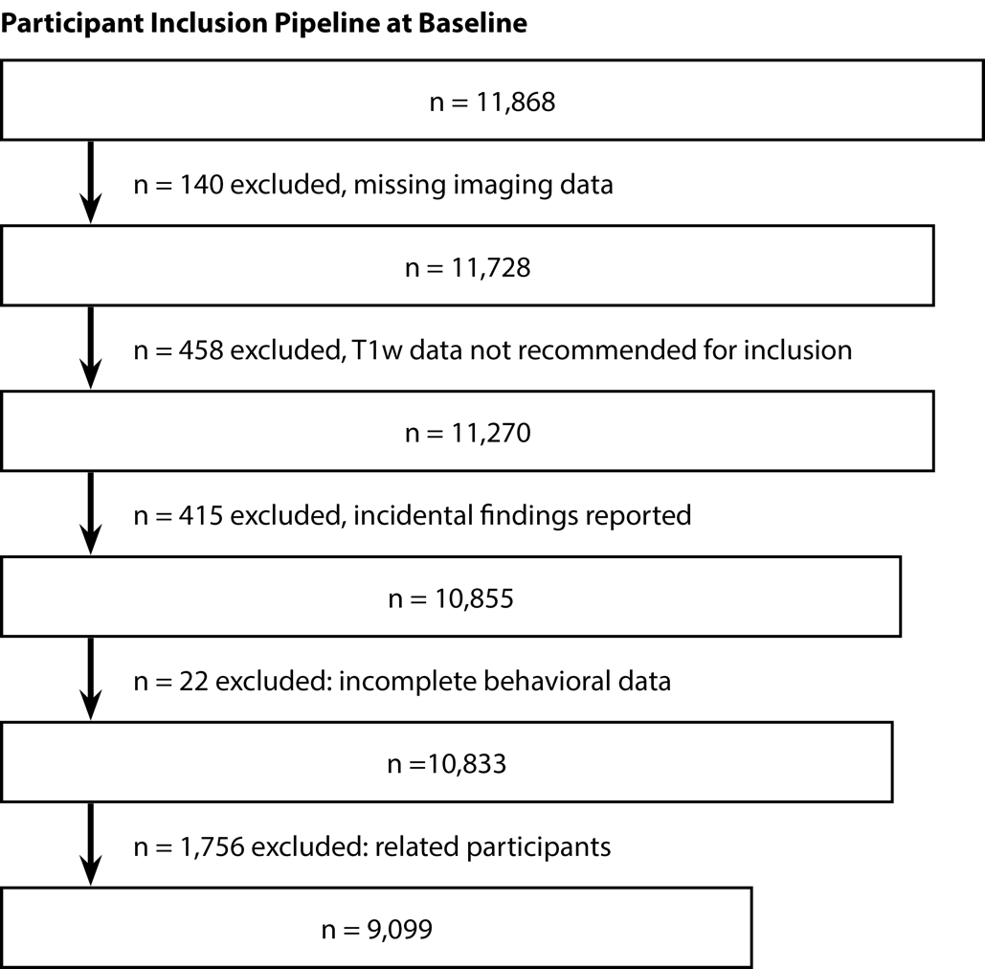
Figure S1: Participant inclusion/exclusion workflow at baseline.
Overview of the process used to include participants in these analyses at baseline.

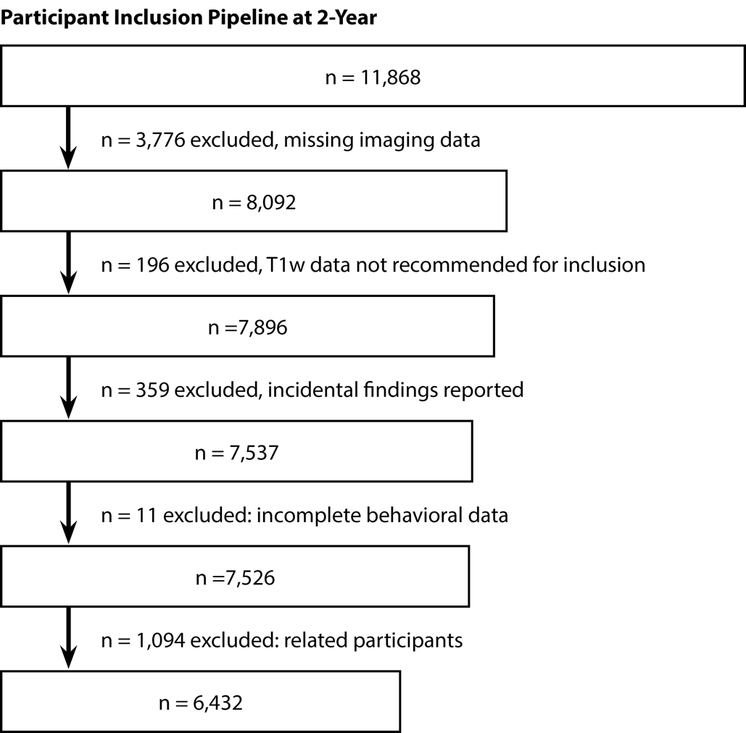
Figure S2: Participant inclusion/exclusion workflow at 2-year follow-up.
Overview of the process used to include participants in these analyses at 2-year follow-up.

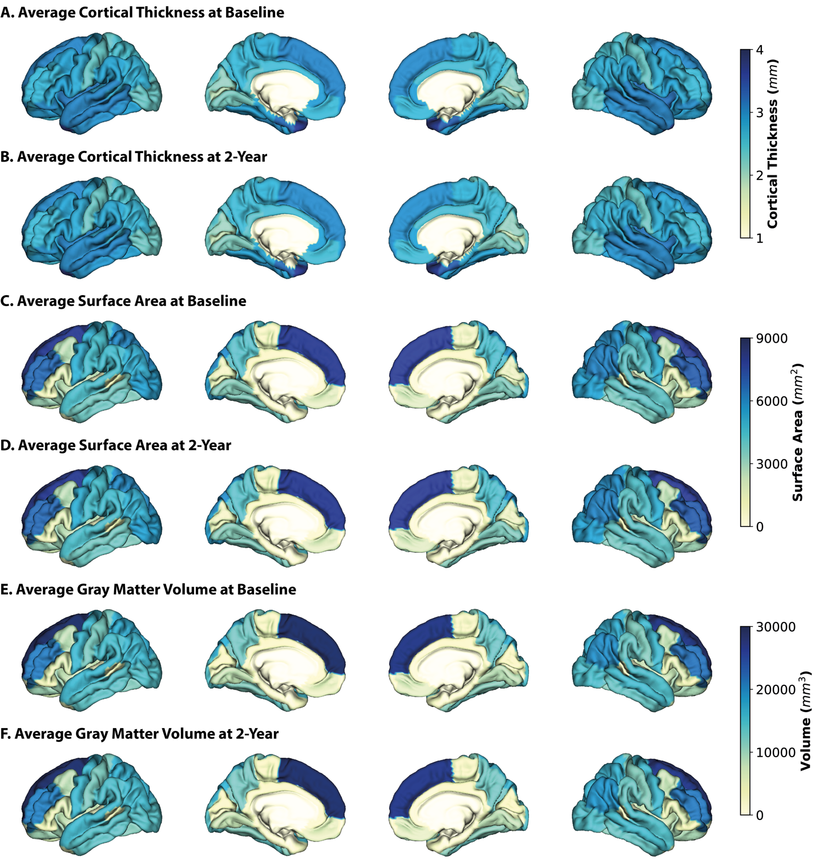
Figure S3: Average neuroanatomical measures at baseline and 2-year follow-up.
Average cortical thickness at baseline (A) and 2-year follow-up (B), average surface area at baseline (C) and 2-year follow-up (D), and average gray matter volume at baseline (E) and 2-year follow-up (F). Lateral and medial surfaces for left and right hemispheres are shown.

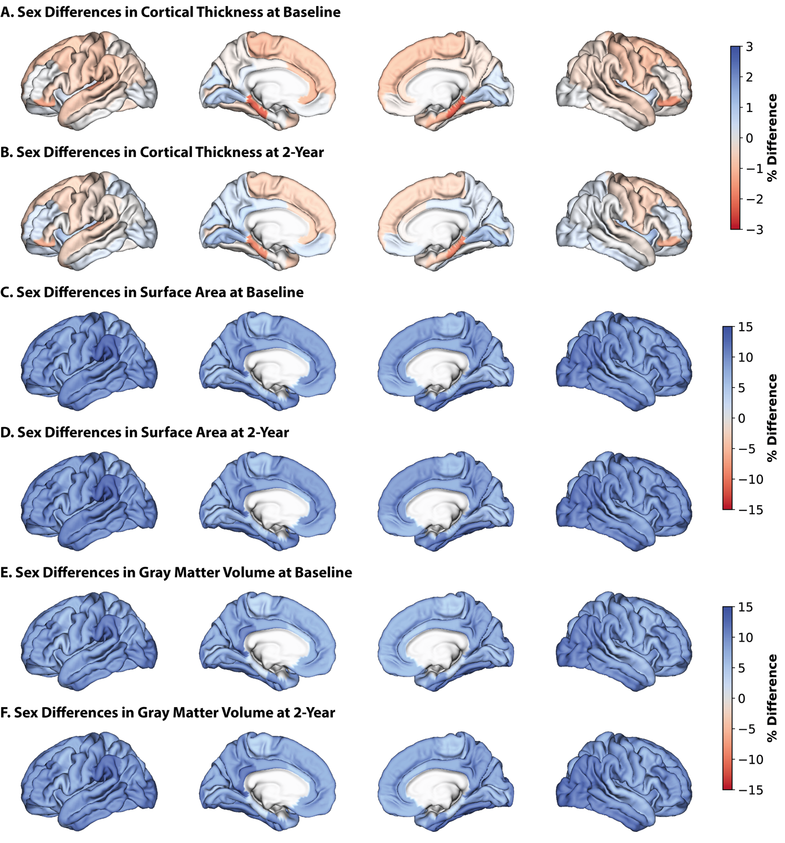
Figure S4: Sex differences in neuroanatomical measures at baseline.
Percent difference between the sexes in cortical thickness at baseline (A) and 2-year follow-up (B), average surface area at baseline (C) and 2-year follow-up (D), and average gray matter volume at baseline (E) and 2-year follow-up (F). Percent differences were calculated by subtracting regional measures in females from regional measures in males and dividing by regional measures in females and then multiplying by 100. Warmer colors indicate a higher thickness/area/volume in females relative to males, cooler colors indicate a higher thickness/area/volume in males. Lateral and medial surfaces for left and right hemispheres are shown.
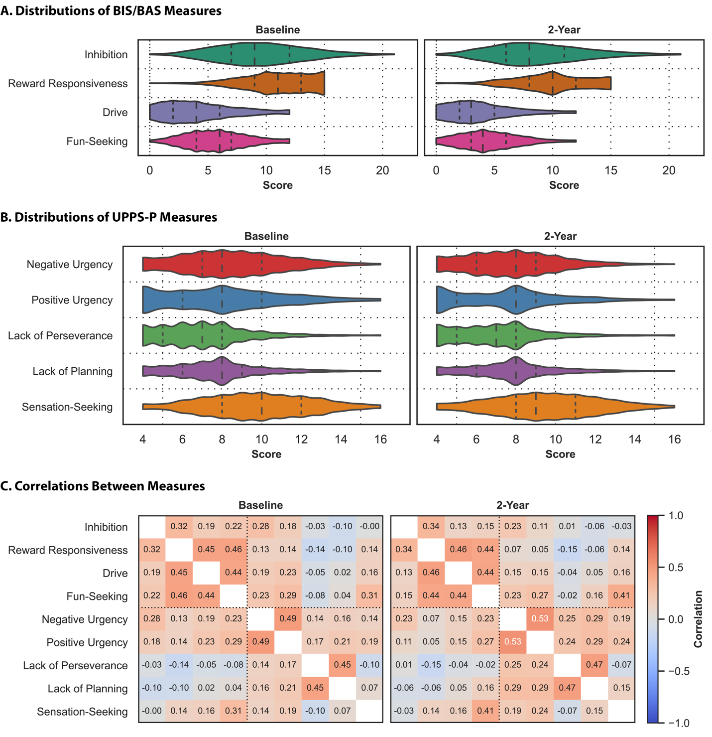
Figure S5: Participants exhibit varying levels of impulsivity, and the measures reflect independent constructs.
Distribution of behavioral measures from the BIS/BAS (A) and UPPS-P (B) scales. The shape of the violins indicates the distribution of values, the dashed lines indicate the median, and the dotted lines indicate the interquartile range. Correlations between behavioral measures (C). Baseline (left) and two-year follow-up (right) data are shown. Warmer colors indicate a stronger positive correlation, cooler colors indicate a stronger negative correlation.

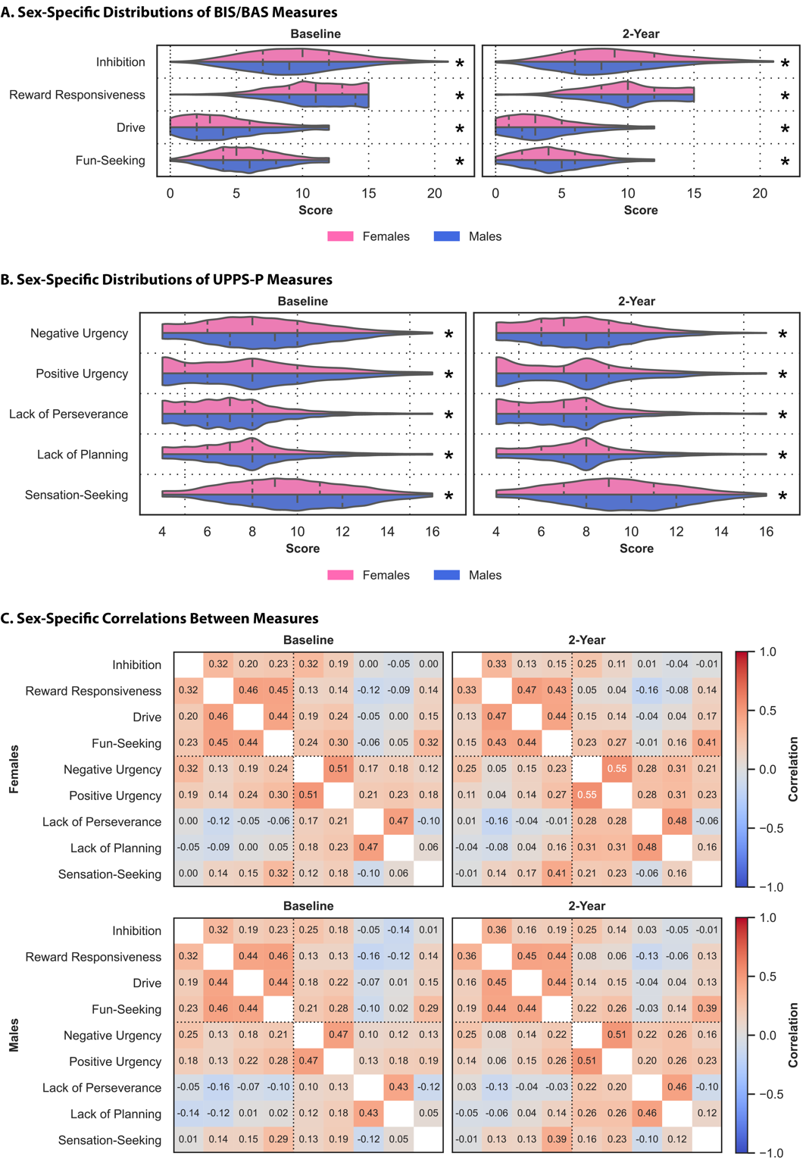
Figure S6: There are sex differences in impulsivity.
Sex-specific distributions of behavioral measures from the BIS/BAS (A) and UPPS-P (B) scales in females (pink) and males (blue). The shape of the violins indicates the distribution of values, the dashed lines indicate the median, and the dotted lines indicate the interquartile range. Asterisks (*) indicate sex differences. Sex-specific correlations between behavioral measures (C) for females (top) and males (bottom). Baseline (left) and two-year follow-up data are shown. Warmer colors indicate a stronger positive correlation, cooler colors indicate a stronger negative correlation.
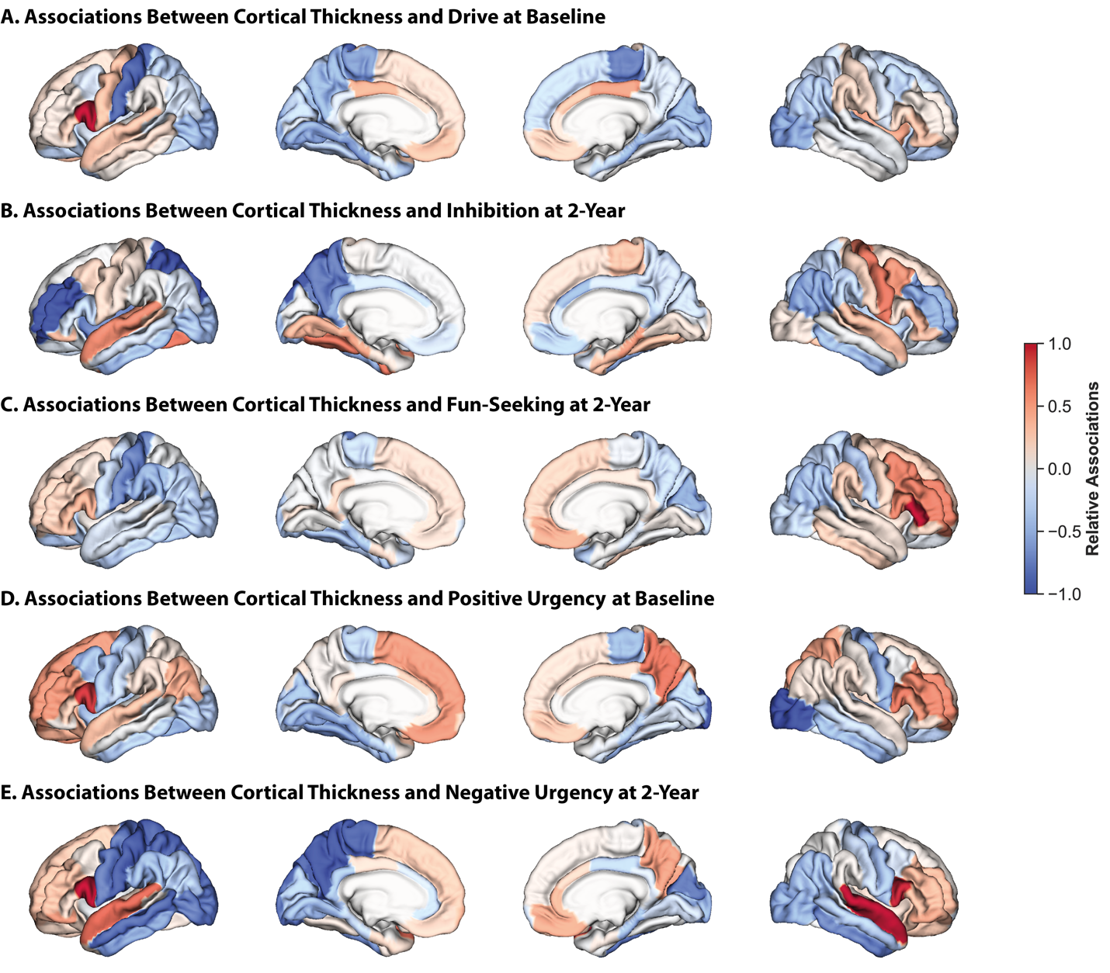
Figure S7: Associations between cortical thickness and reward/punishment sensitivity and impulsivity are dispersed.
Relative regional associations (Haufe-transformed feature weights) from models trained on cortical thickness data to predict drive at baseline (A), inhibition at two-year follow-up (B), fun-seeking at two-year follow-up (C), positive urgency at baseline (D), and negative urgency at two-year follow-up (E). Lateral (outer) and medial (inner) surfaces for left (left) and right (right) hemispheres are shown. Warmer colors indicate a stronger positive association, cooler colors indicate a stronger negative association. To facilitate visualization, association values for each set of models were divided by the maximum value for that model.

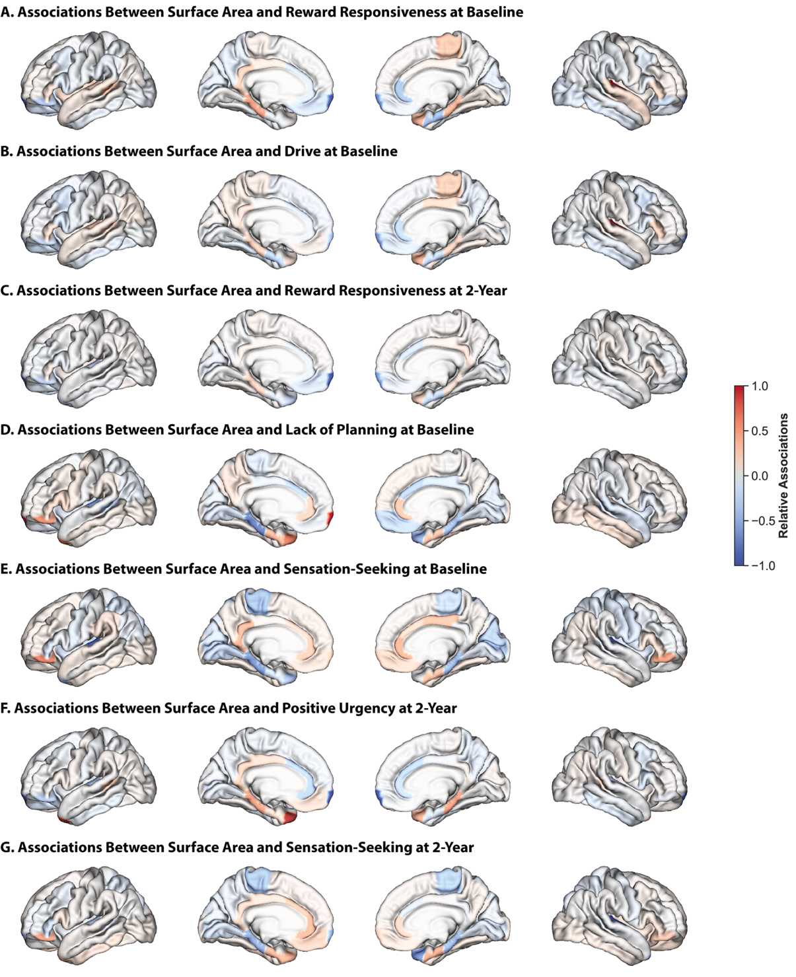
Figure S8: Associations between surface area and reward/punishment sensitivity and impulsivity are localized.
Relative regional associations (Haufe-transformed feature weights) from models trained on surface area data to predict reward responsiveness at baseline (A), drive at baseline (B), reward responsive at two-year follow-up (C), lack of planning at baseline (D), sensation-seeking at baseline (E), positive urgency at two-year follow-up (F), and sensation-seeking at two-year follow-up (G). Lateral (outer) and medial (inner) surfaces for left (left) and right (right) hemispheres are shown. Warmer colors indicate a stronger positive association, cooler colors indicate a stronger negative association. To facilitate visualization, association values for each set of models were divided by the maximum value for that model.
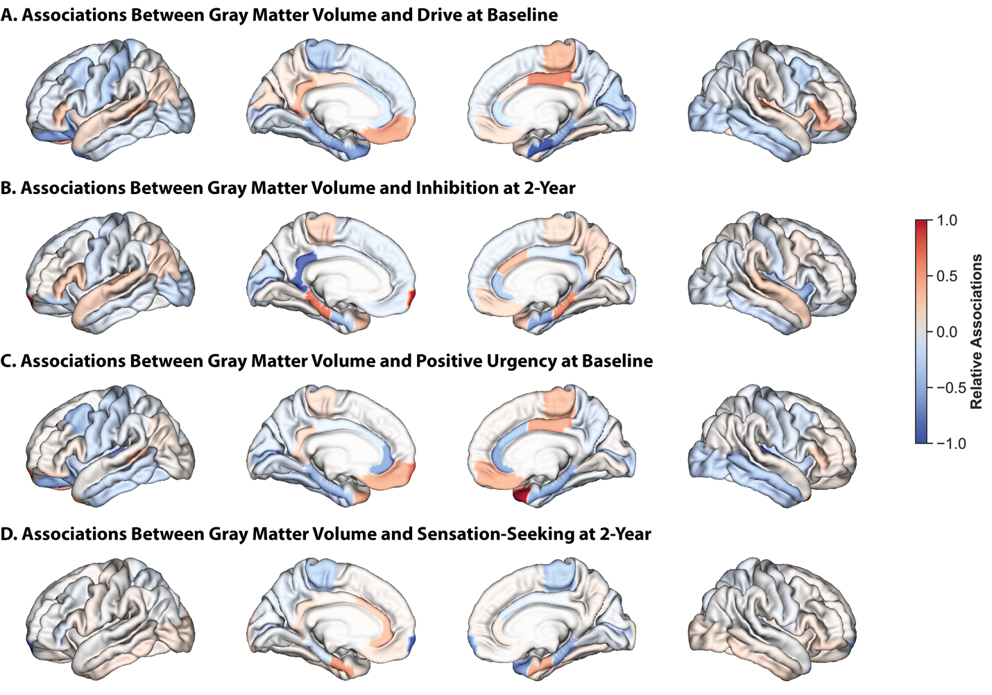
Figure S9. Associations between gray matter volume and impulsivity are localized.
Relative regional associations (Haufe-transformed feature weights) from models trained on gray matter volume data to predict drive at baseline (A), inhibition at two-year follow-up (B), positive urgency at baseline (C), and sensation-seeking at two-year follow-up (D). Lateral (outer) and medial (inner) surfaces for left (left) and right (right) hemispheres are shown. Warmer colors indicate a stronger positive association, cooler colors indicate a stronger negative association. To facilitate visualization, association values for each set of models were divided by the maximum value for that model.

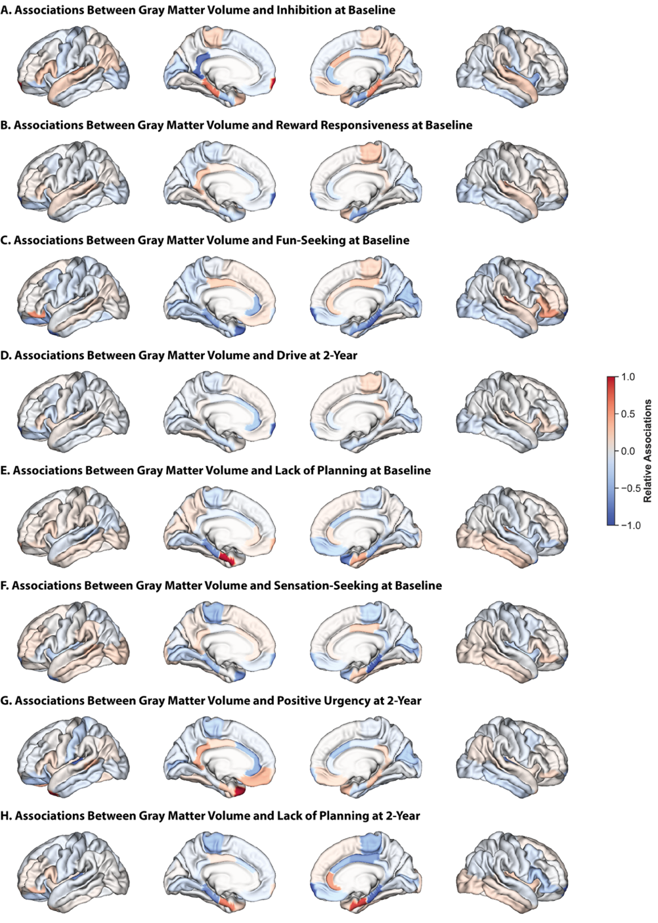
Figure S10: Associations between gray matter volume and reward/punishment sensitivity and impulsivity are localized.
Relative regional associations (Haufe-transformed feature weights) from models trained on gray matter volume data to predict inhibition at baseline (A), reward responsiveness at baseline (B), fun-seeking at baseline (C), drive at two-year follow-up (D), lack of planning at baseline (E), sensation-seeking at baseline (F), positive urgency at two-year follow-up (G), and lack of planning at two-year follow-up (H). Lateral (outer) and medial (inner) surfaces for left (left) and right (right) hemispheres are shown. Warmer colors indicate a stronger positive association, cooler colors indicate a stronger negative association. To facilitate visualization, association values for each set of models were divided by the maximum value for that model.
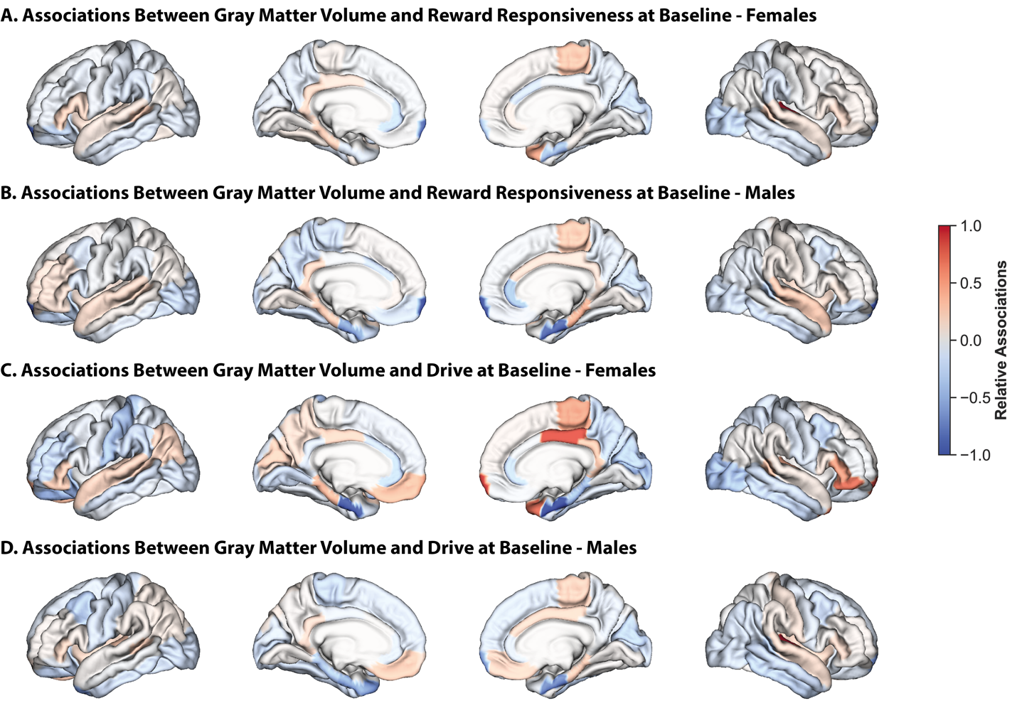
Figure S11: Associations between gray matter volume and reward responsive are largely shared across the sexes, but those between gray matter volume and drive are considerably distinct.
Relative regional associations (Haufe-transformed feature weights) from models trained on gray matter volume data to predict reward responsiveness at baseline in females (A) and males (B), and drive at baseline in females (C) and males (D). Lateral (outer) and medial (inner) surfaces for left (left) and right (right) hemispheres are shown. Warmer colors indicate a stronger positive association, cooler colors indicate a stronger negative association. To facilitate visualization, association values for each set of models were divided by the maximum value for that model.

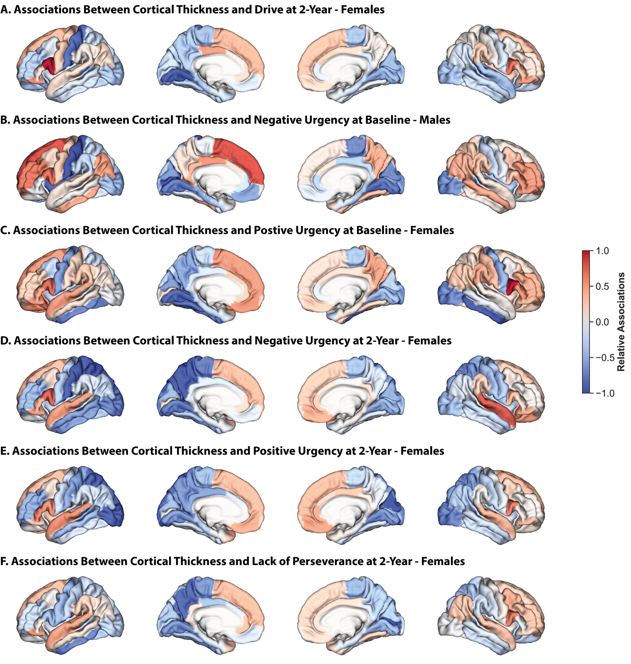
Figure S12: Results from other sex-specific models based on cortical thickness largely overlap with those from sex-independent models.
Relative regional associations (Haufe-transformed feature weights) from models trained on cortical thickness data to predict drive at two-year follow-up in females (A), negative urgency at baseline in males (B), positive urgency at baseline in females (C), negative urgency at two-year follow-up in females (D), positive urgency at two-year follow-up in females (E), lack of perseverance at two-year follow-up in females (F). Lateral (outer) and medial (inner) surfaces for left (left) and right (right) hemispheres are shown. Warmer colors indicate a stronger positive association, cooler colors indicate a stronger negative association. To facilitate visualization, association values for each set of models were divided by the maximum value for that model.
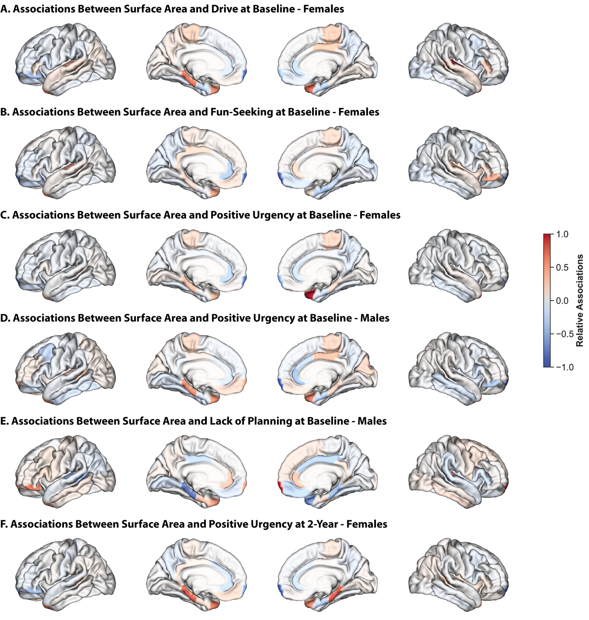
Figure S13: Results from other sex-specific models based on surface area largely overlap with those from sex-independent models.
Relative regional associations (Haufe-transformed feature weights) from models trained on gray matter volume data to predict drive at baseline in females (A), fun-seeking at baseline in females (B), positive urgency at baseline in females (C), positive urgency at baseline in males (D), lack of planning at baseline in males (E), positive urgency at two-year follow-up in females. Lateral (outer) and medial (inner) surfaces for left (left) and right (right) hemispheres are shown. Warmer colors indicate a stronger positive association, cooler colors indicate a stronger negative association. To facilitate visualization, association values for each set of models were divided by the maximum value for that model.
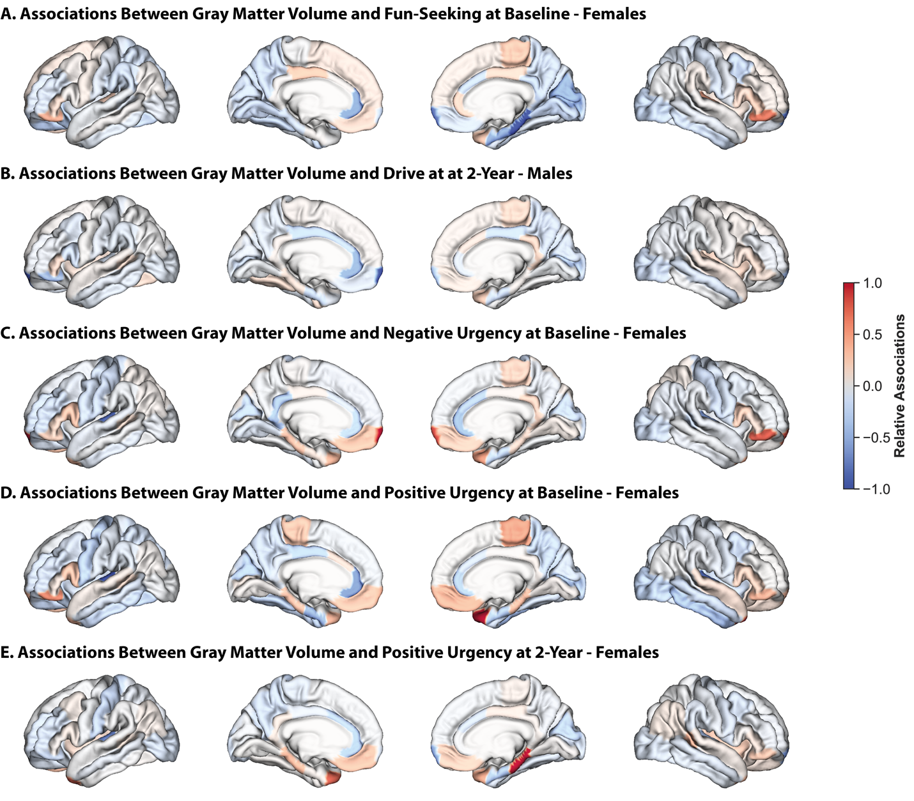
Figure S14: Results from other sex-specific models based on gray matter volume largely overlap with those from sex-independent models.
Relative regional associations (Haufe-transformed feature weights) from models trained on gray matter volume data to predict inhibition at baseline (A), reward responsiveness at baseline (B), fun-seeking at baseline (C), drive at two-year follow-up (D), lack of planning at baseline (E), sensation-seeking at baseline (F), positive urgency at two-year follow-up (G), and lack of planning at two-year follow-up (H). Lateral (outer) and medial (inner) surfaces for left (left) and right (right) hemispheres are shown. Warmer colors indicate a stronger positive association, cooler colors indicate a stronger negative association. To facilitate visualization, association values for each set of models were divided by the maximum value for that model.

 | Baseline  (n = 9,099) | 2-Year Follow-Up  (n=6,432)
Sex (count, proportion)
Male | 4759, 52.3% | 3467, 53.9%
Female | 4337, 47.7% | 2964, 46.1%
Intersex | 3, 0.0% | 1, 0.0%
Race/Ethnicity (count, proportion)
Asian (4) | 207, 2.3% | 131, 2.0%
Black (2) | 1361, 15.0% | 863, 13.4%
Hispanic (3) | 1944, 21.4% | 1294, 20.1%
Other (5) | 950, 10.4% | 674, 10.5%
White (1) | 4636, 51.0% | 3470, 53.9%
No Response | 1, 0.0% | 0, 0.0%
Socioeconomic Status/Income (count, proportion)
< $5,000 | 324, 3.6% | 185, 2.9%
$5,000 – 11,999 | 339, 3.7% | 207, 3.2%
$12,000 – 15,999 | 220, 2.4% | 130, 2.0%
$16,000 – 24,999 | 407, 4.5% | 281, 4.4%
$25,000 – 34,999 | 521, 5.7% | 349, 5.4%
$35,000 – 49,999 | 701, 7.7% | 530, 8.2%
$50,000 – 74,999 | 1140, 12.5% | 860, 13.4%
$75,000 – 99,999 | 1214, 13.3% | 919, 14.3%
$100,000 – 199,999 | 2503, 27.5% | 1806, 28.1%
> $200,000 | 943, 10.4% | 657, 10.2%
Don’t know | 388, 4.3% | 264, 4.1%
Refuse to Answer | 399, 4.4% | 244, 3.8%

Table S1: Demographic Information.
Demographic information (sex, race/ethnicity, socioeconomic status/income) for all participants included at the baseline and 2-year follow-up time points. Reported proportions (%) may not sum to exactly 100% due to rounding.
 | Baseline  (n = 9,099) |  |  | 2-Year Follow-Up  (n=6,432)
 | Cortical Thickness  (r, p_{FDR}) | Surface Area  (r, p_{FDR}) | Gray Matter Volume  (r, p_{FDR}) | Cortical Thickness  (r, p_{FDR}) | Surface Area  (r, p_{FDR}) | Gray Matter Volume  (r, p_{FDR})
Reward/Punishment Sensitivity
Inhibition | 0.014  (0.328) | 0.020  (0.052) | 0.024  (0.023) | 0.059  (0.022) | 0.037  (0.044) | 0.058  (0.010)
Reward Responsiveness | 0.044  (<0.001) | 0.043  (<0.001) | 0.065  (0.002) | 0.005  (0.638) | 0.019  (0.044) | 0.015  (0.129)
Drive | 0.093  (<0.001) | 0.064  (0.004) | 0.088  (0.004) | 0.073  (0.004) | 0.045  (0.051) | 0.077  (<0.001)
Fun-Seeking | 0.022  (0.284) | 0.035  (<0.001) | 0.043  (0.002) | 0.029  (0.028) | 0.002  (0.271) | 0.008  (0.129)
Impulsivity
Negative Urgency | 0.055  (0.020) | 0.021  (0.059) | 0.028  (0.086) | 0.049  (0.008) | -0.014  (0.483) | 0.017  (0.155)
Positive Urgency | 0.078  (0.015) | 0.074  (<0.001) | 0.071  (<0.001) | 0.062  (<0.001) | 0.055  (0.040) | 0.059  (<0.001)
Lack of Perseverance | 0.020  (0.166) | -0.016  (0.720) | -0.004  (0.646) | 0.050  (0.082) | 0.028  (0.483) | 0.043  9).102)
Lack of Planning | 0.022  (0.050) | 0.061  (<0.001) | 0.062  (<0.001) | 0.016  (0.259) | 0.050  (0.040) | 0.056  (0.030)
Sensation-Seeking | 0.026  (0.166) | 0.055  (0.003) | 0.036  (0.033) | 0.032  (0.418) | 0.080  (0.025) | 0.065  (0.005)

Table S2: Model Performance for Sex-Independent Models.
Model performance measures for sex-independent models trained to predict reward/punishment sensitivity and impulsivity based on cortical thickness, surface area, and gray matter volume at baseline and 2-year follow-up. Mean prediction accuracy (r, correlation between observed and predicted values) and FDR-corrected p-values are shown. Models that yielded significant results are denoted by bold text.

 | Baseline  (n = 9,099) |  |  | 2-Year Follow-Up  (n=6,432)
 | Cortical Thickness  (r, p_{FDR}) | Surface Area  (r, p_{FDR}) | Gray Matter Volume  (r, p_{FDR}) | Cortical Thickness  (r, p_{FDR}) | Surface Area  (r, p_{FDR}) | Gray Matter Volume  (r, p_{FDR})
Reward/Punishment Sensitivity
Inhibition | -0.001  (0.716) | 0.001  (0.271) | 0.003  (0.610) | 0.032  (0.119) | 0.011  (0.630) | -0.005  (0.708)
Reward Responsiveness | 0.065  (0.002) | 0.070  (0.051) | 0.052  (0.028) | -0.001  (0.403) | 0.003  (0.630) | 0.008  (0.564)
Drive | 0.133  (<0.001) | 0.106  (<0.001) | 0.105  (<0.001) | 0.104  (0.028) | 0.054  (0.63) | 0.080  (0.132)
Fun-Seeking | 0.03  (0.56) | 0.031  (0.036) | 0.045  (0.006) | 0.040  (0.352) | 0.017  (0.63) | 0.03  (0.132)
Impulsivity
Negative Urgency | 0.071  (0.092) | 0.040  (0.253) | 0.034  (0.040) | 0.065  (0.005) | -0.001  (0.145) | 0.044  (0.195)
Positive Urgency | 0.119  (<0.001) | 0.099  (<0.001) | 0.098  (<0.001) | 0.093  <0.001) | 0.075  (0.005) | 0.094  (0.005)
Lack of Perseverance | -0.005  (0.761) | -0.013  (0.717) | -0.025  (0.744) | 0.051  (0.038) | 0.029  (0.211) | 0.051  (0.225)
Lack of Planning | -0.012  (0.546) | 0.002  (0.391) | 0.004  (0.265) | 0.007  (0.622) | 0.022  (0.211) | 0.034  (0.225)
Sensation-Seeking | 0.017  (0.055) | 0.027  (0.391) | 0.009  (0.454) | 0.005  (0.622) | 0.047  (0.481) | 0.041  (0.388)
Table S3: Model Performance for Female-Specific Models
Model performance measures for female-specific models trained to predict reward/punishment sensitivity and impulsivity based on cortical thickness, surface area, and gray matter volume at baseline and 2-year follow-up. Mean prediction accuracy (r, correlation between observed and predicted values) and FDR-corrected p-values are shown. Models that yielded significant results are denoted by bold text.

 | Baseline  (n = 9,099) |  |  | 2-Year Follow-Up  (n=6,432)
 | Cortical Thickness  (r, p_{FDR}) | Surface Area  (r, p_{FDR}) | Gray Matter Volume  (r, p_{FDR}) | Cortical Thickness  (r, p_{FDR}) | Surface Area  (r, p_{FDR}) | Gray Matter Volume  (r, p_{FDR})
Reward/Punishment Sensitivity
Inhibition | 0.005  (0.119) | 0.034  (0.065) | 0.014  (0.574) | 0.005  (0.509) | 0.009  (0.831) | 0.026  (0.675)
Reward Responsiveness | 0.046  (0.008) | 0.033  (0.065) | 0.059  (0.020) | 0.015  (0.448) | 0.010  (0.644) | 0.015  (0.050)
Drive | 0.060  (0.004) | 0.048  (0.065) | 0.072  (<0.001) | 0.047  (0.448) | 0.020  (0.644) | 0.060  (<0.001)
Fun-Seeking | 0.014  (0.148) | 0.042  (0.065) | 0.030  (0.529) | 0.010  (0.509) | -0.049  (0.885) | -0.046  (0.820)
Impulsivity
Negative Urgency | 0.048  (0.015) | 0.020  (0.193) | 0.018  (0.284) | 0.022  (0.558) | -0.050  (0.787) | -0.030  (0.806)
Positive Urgency | 0.042  (0.055) | 0.046  (0.005) | 0.045  (0.220) | 0.404  (0.558) | 0.041  (0.228) | 0.025  (0.135)
Lack of Perseverance | 0.020  (0.203) | 0.003  (0.426) | 0.013  (0.284) | 0.032  (0.505) | 0.026  (0.110) | 0.033  (0.285)
Lack of Planning | -0.004  (0.719) | 0.031  (0.008) | 0.036  (0.284) | 0.007  (0.558) | 0.039  (0.110) | 0.038  (0.285)
Sensation-Seeking | 0.008  (0.719) | -0.004  (0.729) | -0.038  (0.540) | 0.037  (0.150) | 0.014  (0.787) | 0.027  (0.418)

Table S4: Model Performance for Male-Specific Models
Model performance measures for male-specific models trained to predict reward/punishment sensitivity and impulsivity based on cortical thickness, surface area, and gray matter volume at baseline and 2-year follow-up. Mean prediction accuracy (r, correlation between observed and predicted values) and FDR-corrected p-values are shown. Models that yielded significant results are denoted by bold text.

References

1 Moeller, F. G., Barratt, E. S., Dougherty, D. M., Schmitz, J. M. & Swann, A. C. Psychiatric aspects of impulsivity. American journal of psychiatry 158, 1783-1793 (2001).
2 Miu, A. C., Bîlc, M. I., Bunea, I. & Szentágotai-Tătar, A. Childhood trauma and sensitivity to reward and punishment: Implications for depressive and anxiety symptoms. Personality and Individual Differences 119, 134-140 (2017).
3 Weinstock, L. M., Chou, T., Celis-deHoyos, C., Miller, I. W. & Gruber, J. Reward and punishment sensitivity and emotion regulation processes differentiate bipolar and unipolar depression. Cognitive Therapy and Research 42, 794-802 (2018).
4 Quilty, L. C., Mackew, L. & Bagby, R. M. Distinct profiles of behavioral inhibition and activation system sensitivity in unipolar vs. bipolar mood disorders. Psychiatry Research 219, 228-231 (2014).
5 Jonker, N. C., Glashouwer, K. A., Hoekzema, A., Ostafin, B. D. & de Jong, P. J. Heightened self-reported punishment sensitivity, but no differential attention to cues signaling punishment or reward in anorexia nervosa. PloS one 15, e0229742 (2020).
6 Liu, Q., Davey, D., Jimmy, J., Ajilore, O. & Klumpp, H. Network Analysis of Behavioral Activation/Inhibition Systems and Brain Volume in Individuals With and Without Major Depressive Disorder or Social Anxiety Disorder. Biological Psychiatry: Cognitive Neuroscience and Neuroimaging 9, 551-560 (2024).
7 Afshari, B., Rasouli-Azad, M. & Ghoreishi, F. S. Comparison of original and revised reinforcement sensitivity theory in clinically-stable schizophrenia and bipolar disorder patients. Personality and individual differences 138, 321-327 (2019).
8 Linhartová, P. et al. Impulsivity in patients with borderline personality disorder: a comprehensive profile compared with healthy people and patients with ADHD. Psychological medicine 50, 1829-1838 (2020).
9 Hildebrandt, M. K., Dieterich, R. & Endrass, T. Disentangling substance use and related problems: urgency predicts substance-related problems beyond the degree of use. BMC psychiatry 21, 242 (2021).
10 Haas, S. M., Derefinko, K. J. & Waschbusch, D. A. The use of multimethod impulsivity assessment in the prediction of ADHD, conduct problems, and callous-unemotional symptoms. Personality and Individual Differences 116, 289-295 (2017).
11 Pawluk, E. J. & Koerner, N. A preliminary investigation of impulsivity in generalized anxiety disorder. Personality and Individual Differences 54, 732-737 (2013).
12 Lockwood, J., Townsend, E., Daley, D. & Sayal, K. Impulsivity as a predictor of self-harm onset and maintenance in young adolescents: a longitudinal prospective study. Journal of affective disorders 274, 583-592 (2020).
13 Read, R. W. et al. A study of impulsivity and adverse childhood experiences in a population health setting. Frontiers in Public Health 12, 1447008 (2024).
14 Carver, C. S. & White, T. L. Behavioral inhibition, behavioral activation, and affective responses to impending reward and punishment: the BIS/BAS scales. Journal of personality and social psychology 67, 319 (1994).
15 Demianczyk, A. C., Jenkins, A. L., Henson, J. M. & Conner, B. T. Psychometric evaluation and revision of Carver and White's BIS/BAS scales in a diverse sample of young adults. Journal of Personality Assessment 96, 485-494 (2014).
16 Leone, L., Perugini, M., Bagozzi, R. P., Pierro, A. & Mannetti, L. Construct validity and generalizability of the Carver–White behavioural inhibition system/behavioural activation system scales. European Journal of Personality 15, 373-390 (2001).
17 Jorm, A. F. et al. Using the BIS/BAS scales to measure behavioural inhibition and behavioural activation: Factor structure, validity and norms in a large community sample. Personality and individual Differences 26, 49-58 (1998).
18 Desikan, R. S. et al. An automated labeling system for subdividing the human cerebral cortex on MRI scans into gyral based regions of interest. Neuroimage 31, 968-980 (2006). https://doi.org/10.1016/j.neuroimage.2006.01.021
19 Whiteside, S. P. & Lynam, D. R. The five factor model and impulsivity: Using a structural model of personality to understand impulsivity. Personality and individual differences 30, 669-689 (2001).
20 Whiteside, S. P., Lynam, D. R., Miller, J. D. & Reynolds, S. K. Validation of the UPPS impulsive behaviour scale: a four‐factor model of impulsivity. European Journal of personality 19, 559-574 (2005).
21 McCredie, M. N., Harris, B., Regan, T., Morey, L. C. & Fields, S. A. Development and validation of a validity scale for use with the UPPS-P and Short UPPS-P Impulsive Behavior Scales. Journal of personality assessment 103, 752-761 (2021).
22 Chen, J. et al. Relationship between prediction accuracy and feature importance reliability: An empirical and theoretical study. NeuroImage 274, 120115 (2023).
23 Chen, J. et al. Shared and unique brain network features predict cognitive, personality, and mental health scores in the ABCD study. Nature communications 13, 2217 (2022). https://doi.org/10.1038/s41467-022-29766-8
24 Dhamala, E. et al. Brain-based predictions of psychiatric illness-linked behaviors across the sexes. Biol Psychiat (2023).
25 Li, J. et al. Global signal regression strengthens association between resting-state functional connectivity and behavior. Neuroimage 196, 126-141 (2019). https://doi.org/10.1016/j.neuroimage.2019.04.016
26 Benjamini, Y. & Hochberg, Y. Controlling the False Discovery Rate - a Practical and Powerful Approach to Multiple Testing. J R Stat Soc B 57, 289-300 (1995).
27 Fortin, J.-P. et al. Harmonization of cortical thickness measurements across scanners and sites. Neuroimage 167, 104-120 (2018).
28 Abraham, A. et al. Deriving reproducible biomarkers from multi-site resting-state data: An Autism-based example. Neuroimage 147, 736-745 (2017). https://doi.org/10.1016/j.neuroimage.2016.10.045
29 Dhamala, E. et al. Considering the interconnected nature of social identities in neuroimaging research. Nature Neuroscience, 1-12 (2024).
30 Dhamala, E., Yeo, B. T. & Holmes, A. J. Methodological Considerations for Brain-Based Predictive Modelling in Psychiatry. Biol Psychiat (2022).

