Extended Data
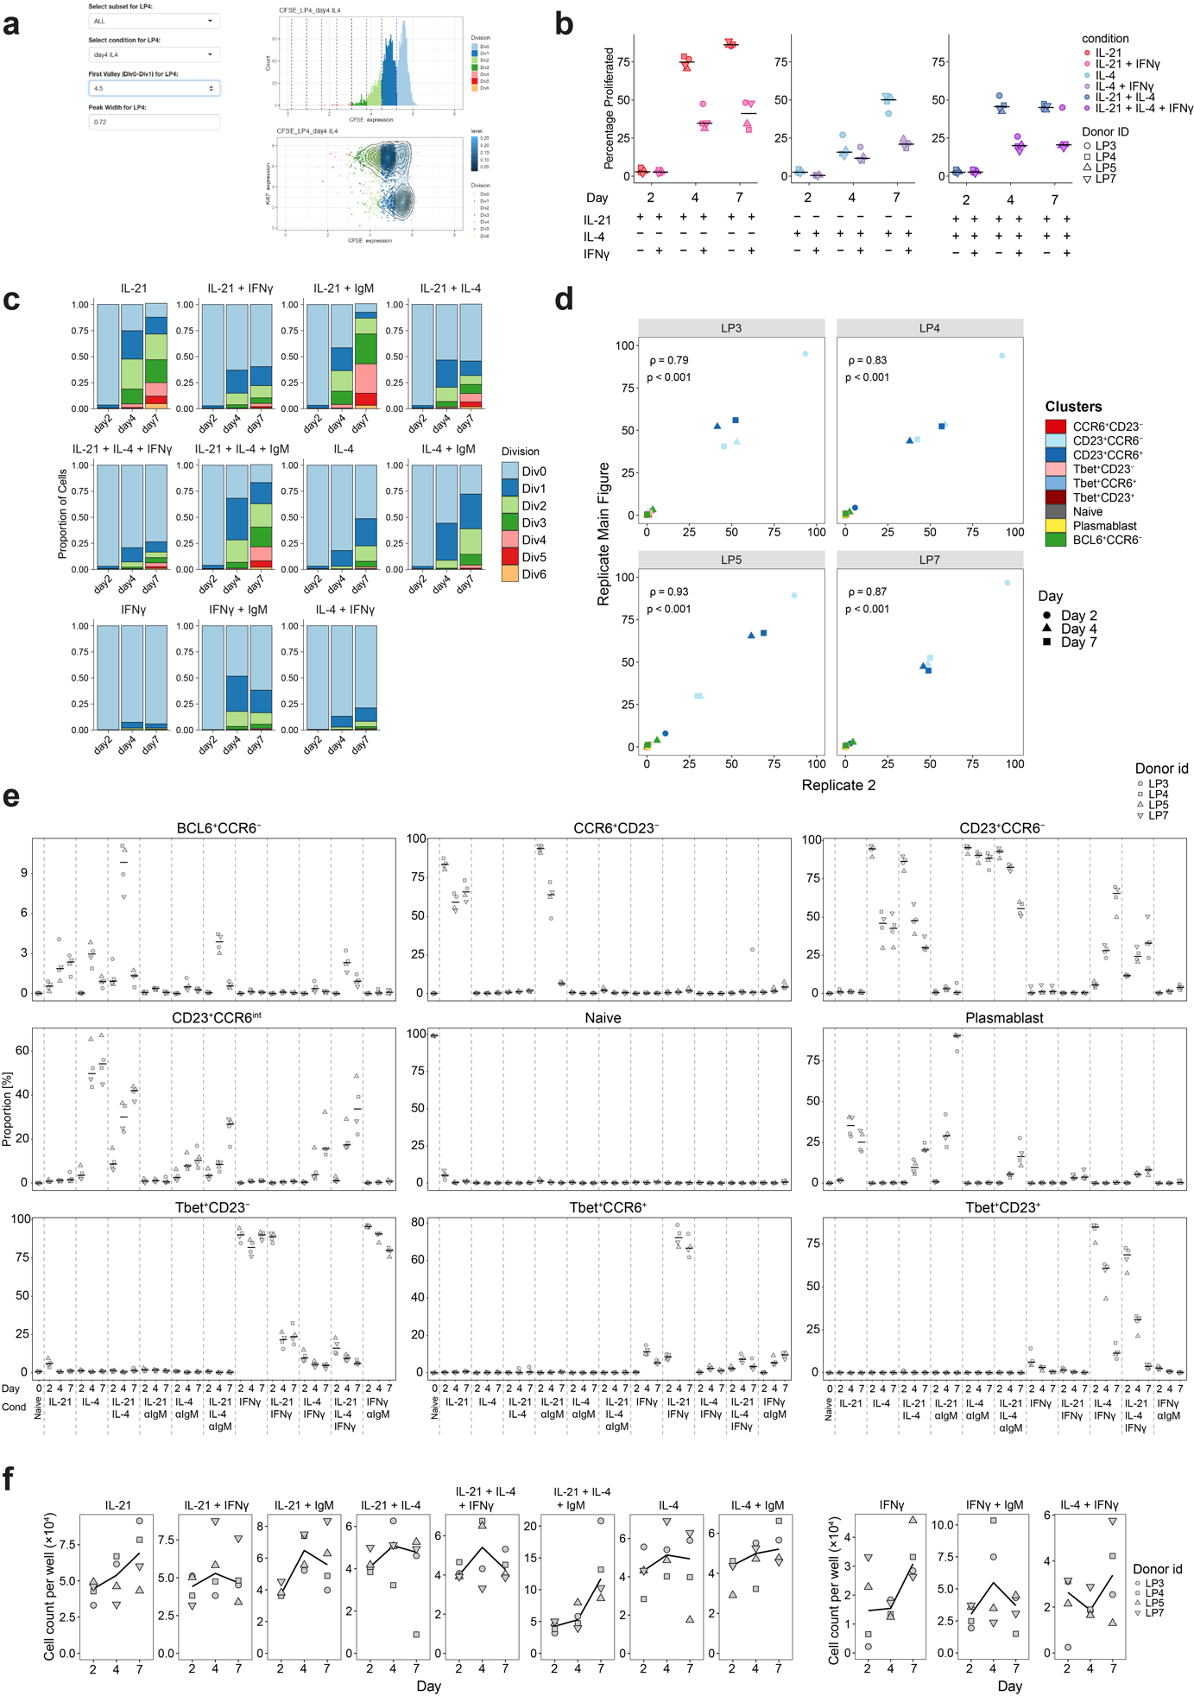
Extended Data Fig. 1 (related to Fig. 1). (a) Graphical user interface for assigning division peaks. (b) Percentage proliferated in the presence and absence of IFNγ. n = 4. (c) Stacked bars showing proportion of division by day for each first stimulation condition. Mean. n = 4. (d) Proportions of clusters in the IL-4 condition between two replicate experiments. One scatterplot for each donor is shown. (e) Proportions of clusters for first stimulation conditions. See also Fig. 1g for averaged data. (f) Cell counts per well for first stimulation experiments measured just prior to CyTOF staining of samples (cell input at day 0 was 50,000 per well). Left 8 conditions (Experiment 3B, Extended Data table 3). Right 3 conditions (Experiment 3A).
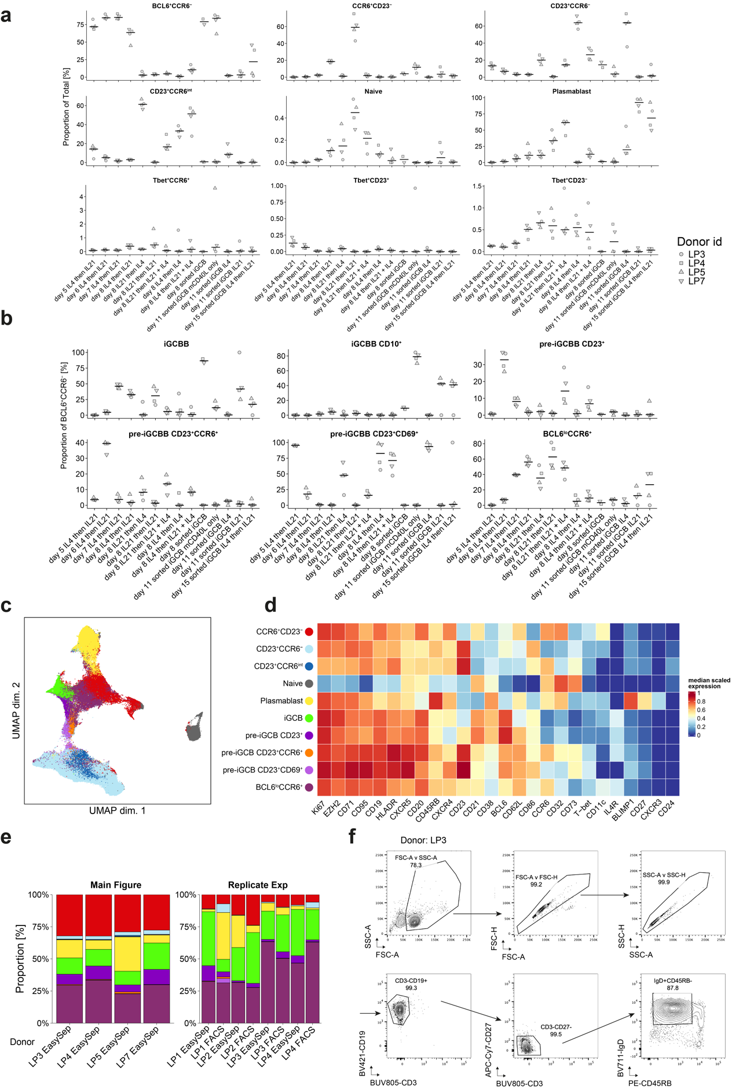
Extended Data Fig. 2 (related to Fig. 2) (a) Proportions of clusters for second, third and fourth stimulation conditions. See also Fig. 2e and Fig. 3a for averaged data (smaller donuts). (b) Proportions among BCL6⁺CCR6⁻ subclusters. See also Fig. 2e and 3a for averaged data (larger donuts). (c) UMAP of all conditions containing only IL-4 and/or IL-21 along with Fresh Naive, sorted iGCB, and sorted iGCB mCD40L only, including data from replicate iGCB experiment. Donors LP3 and LP4 from the main Fig. are replicated. (d) Data was clustered using the indicated markers and displayed in a heatmap. (e). Frequencies across these clusters for main Figure data (Fig. 2e) and replicate experiment. (f). Sorting strategy for Naive B cells (CD3⁻CD19⁺CD27⁻IgD⁺CD45RB⁻) in this experiment.
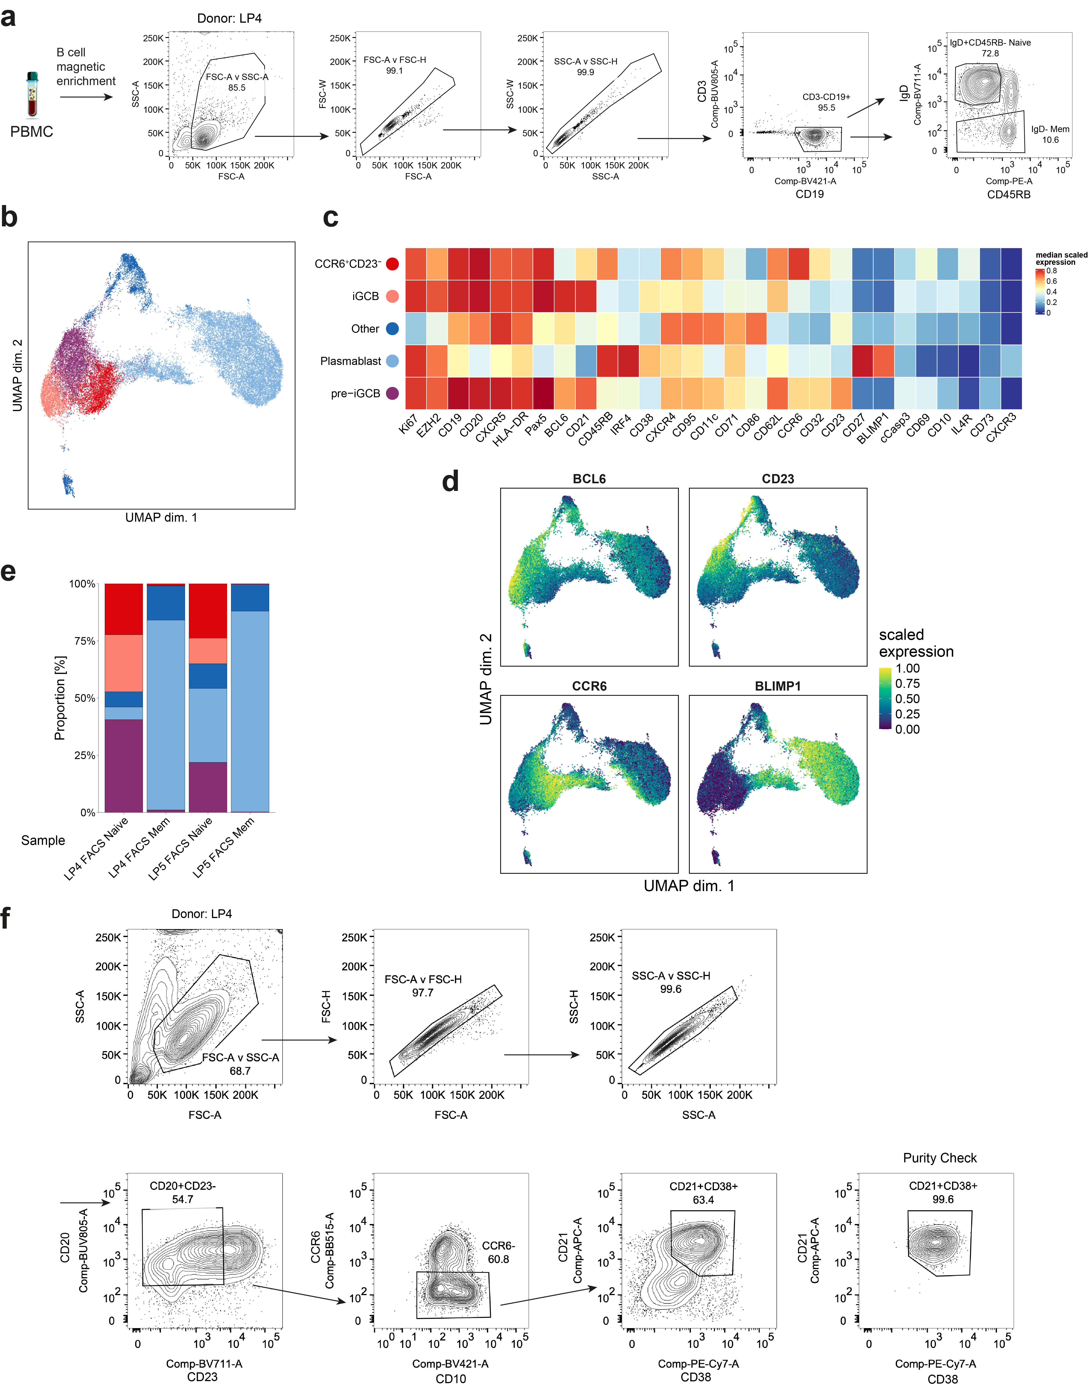
Extended Data Fig. 3. (Related to Fig. 3) (a) Sorting strategy to sort memory (CD3⁻CD19⁺IgD⁻CD45RB^{+/−}) and naive B cells (CD3⁻CD19⁺IgD⁺CD45RB⁻) from magnetically enriched total B cells. (b) UMAP of cells from Memory vs Naive 8 day iGCB generation experiment. (c) Heatmap of cell clusters from this experiment. (d) Expression of markers on UMAP. (e) Proportions across clusters for two donors LP4 and LP5. (f) Sorting strategy to enrich iGCB cells (CD20⁺CD23^{low}CCR6⁻ CD21⁺CD38⁺).

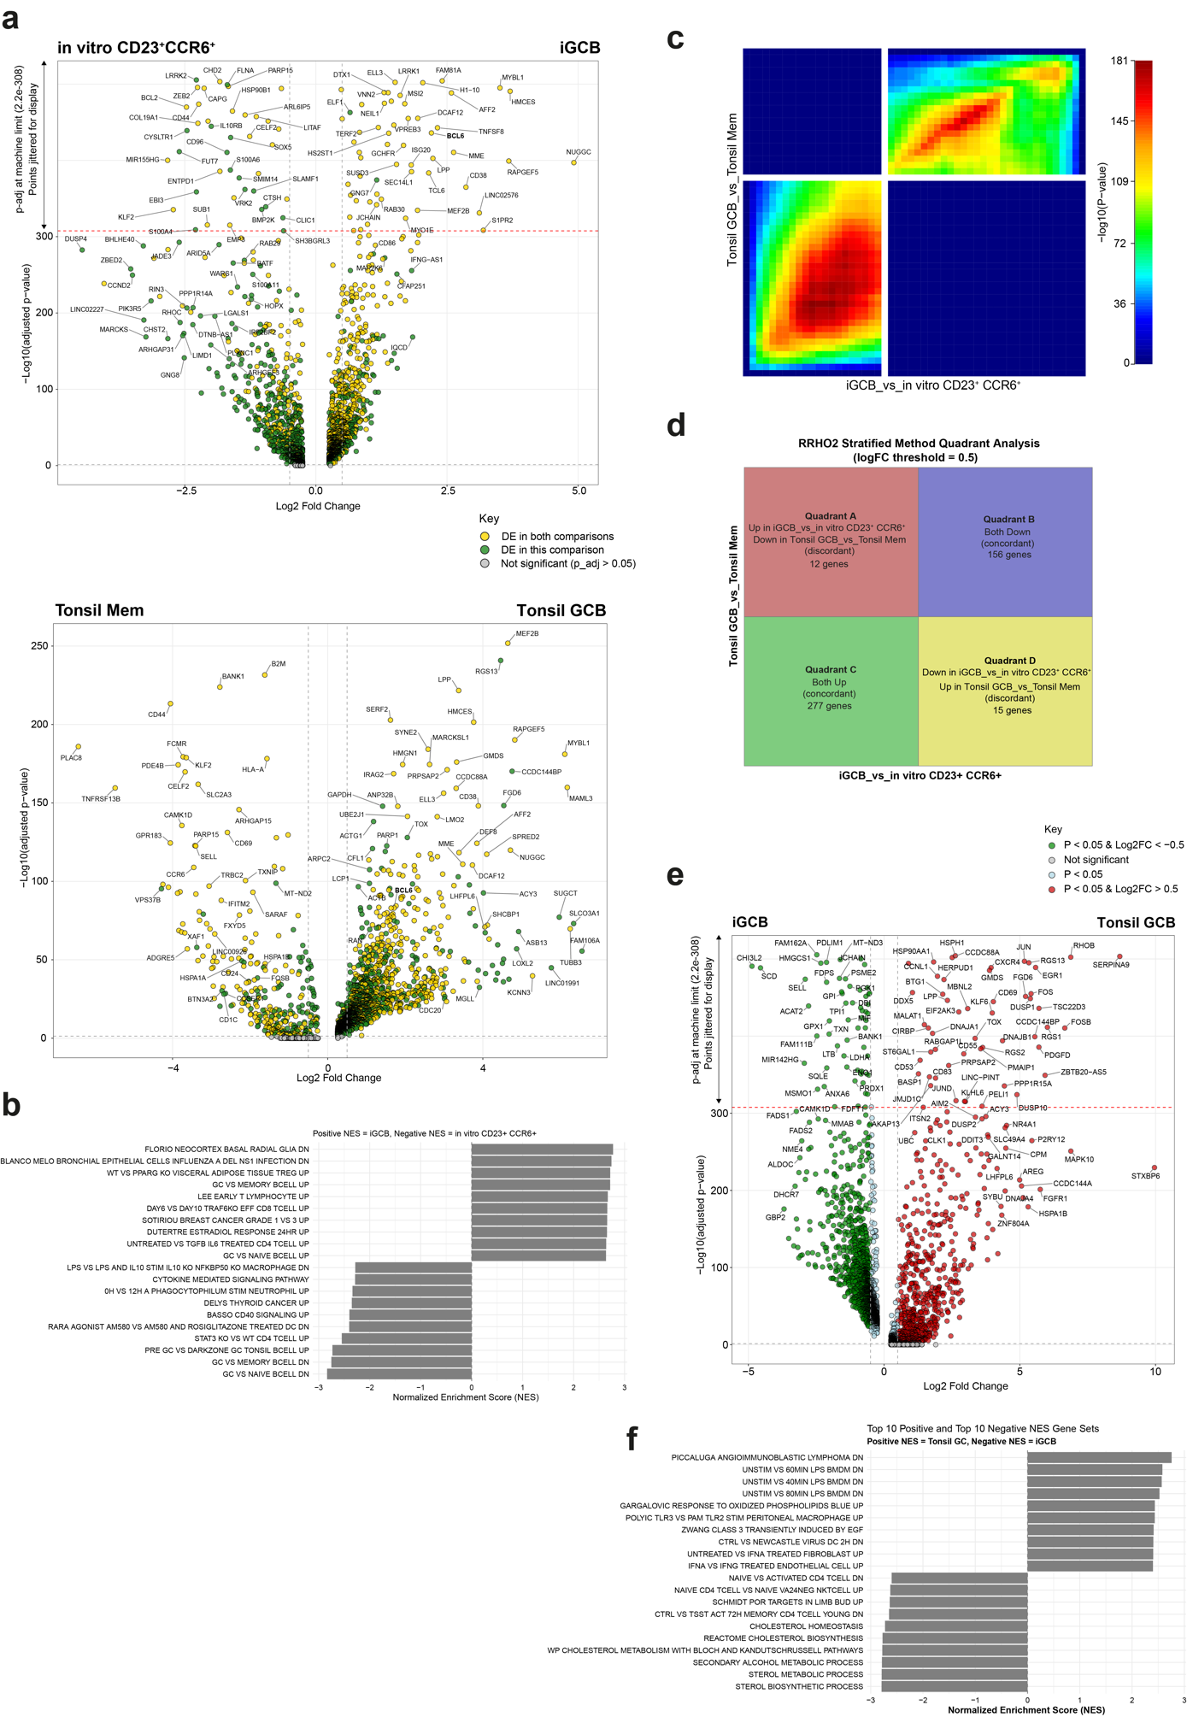
Extended Data Fig. 4 (Related to Fig. 4). (a) Volcano plot showing DEGs between the indicated CITE-seq clusters. (b) Top 10 positive (iGCB) and negative (in vitro CD23⁺CCR6⁺) by NES gene sets from a query of C7 gene sets using unfiltered DEGs sorted by Log2FC. (c) RRHO2 heatmap for the indicated cluster comparisons. (d) Details of RRHO2 heatmap quadrants. (e) Volcano plot showing DEGs between indicated clusters. (f) As for b but with the indicated DEGs.
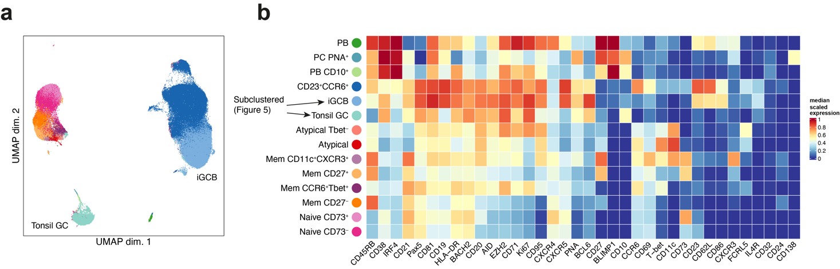
Extended Data Fig. 5 (Related to Fig. 5) (a) UMAP and (b) Heatmap showing Tonsil vs iGCB cultures clusters. Data in the iGCB and Tonsil GC clusters is sub-clustered and shown in Fig. 5.

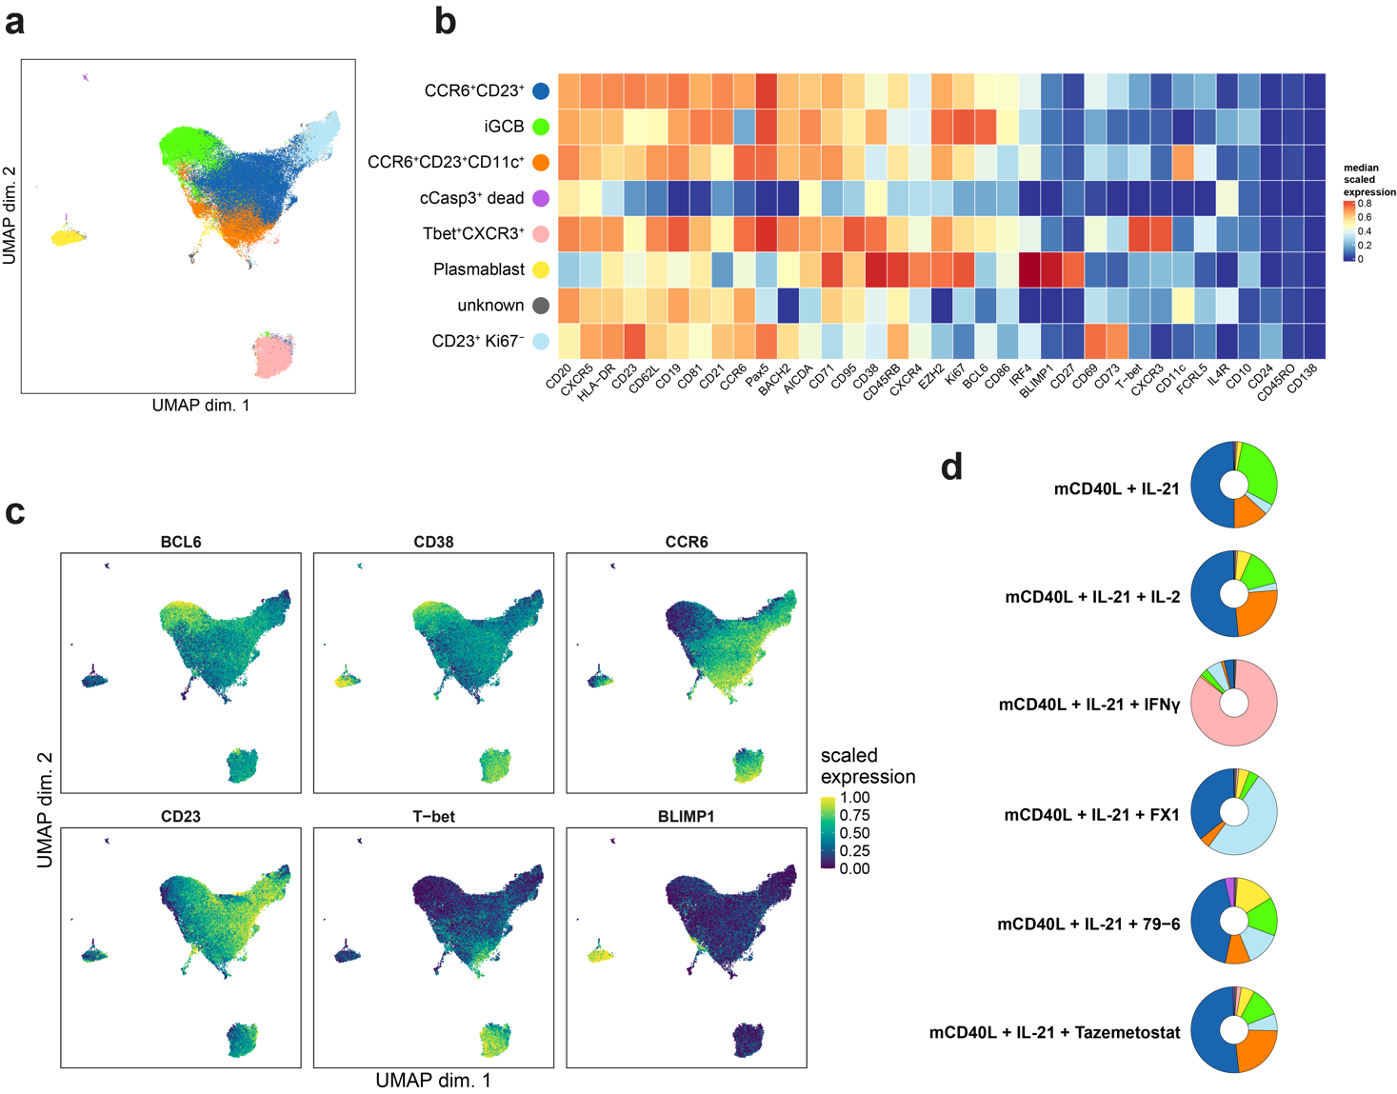
Extended Data Fig. 6 (Related to Fig. 6) (a) UMAP and (b) Heatmap for inhibitor experiment data clustering. (c) Expression of indicated markers on UMAP. (d) Donut plots showing expression of clusters in each condition. Mean, n = 4.
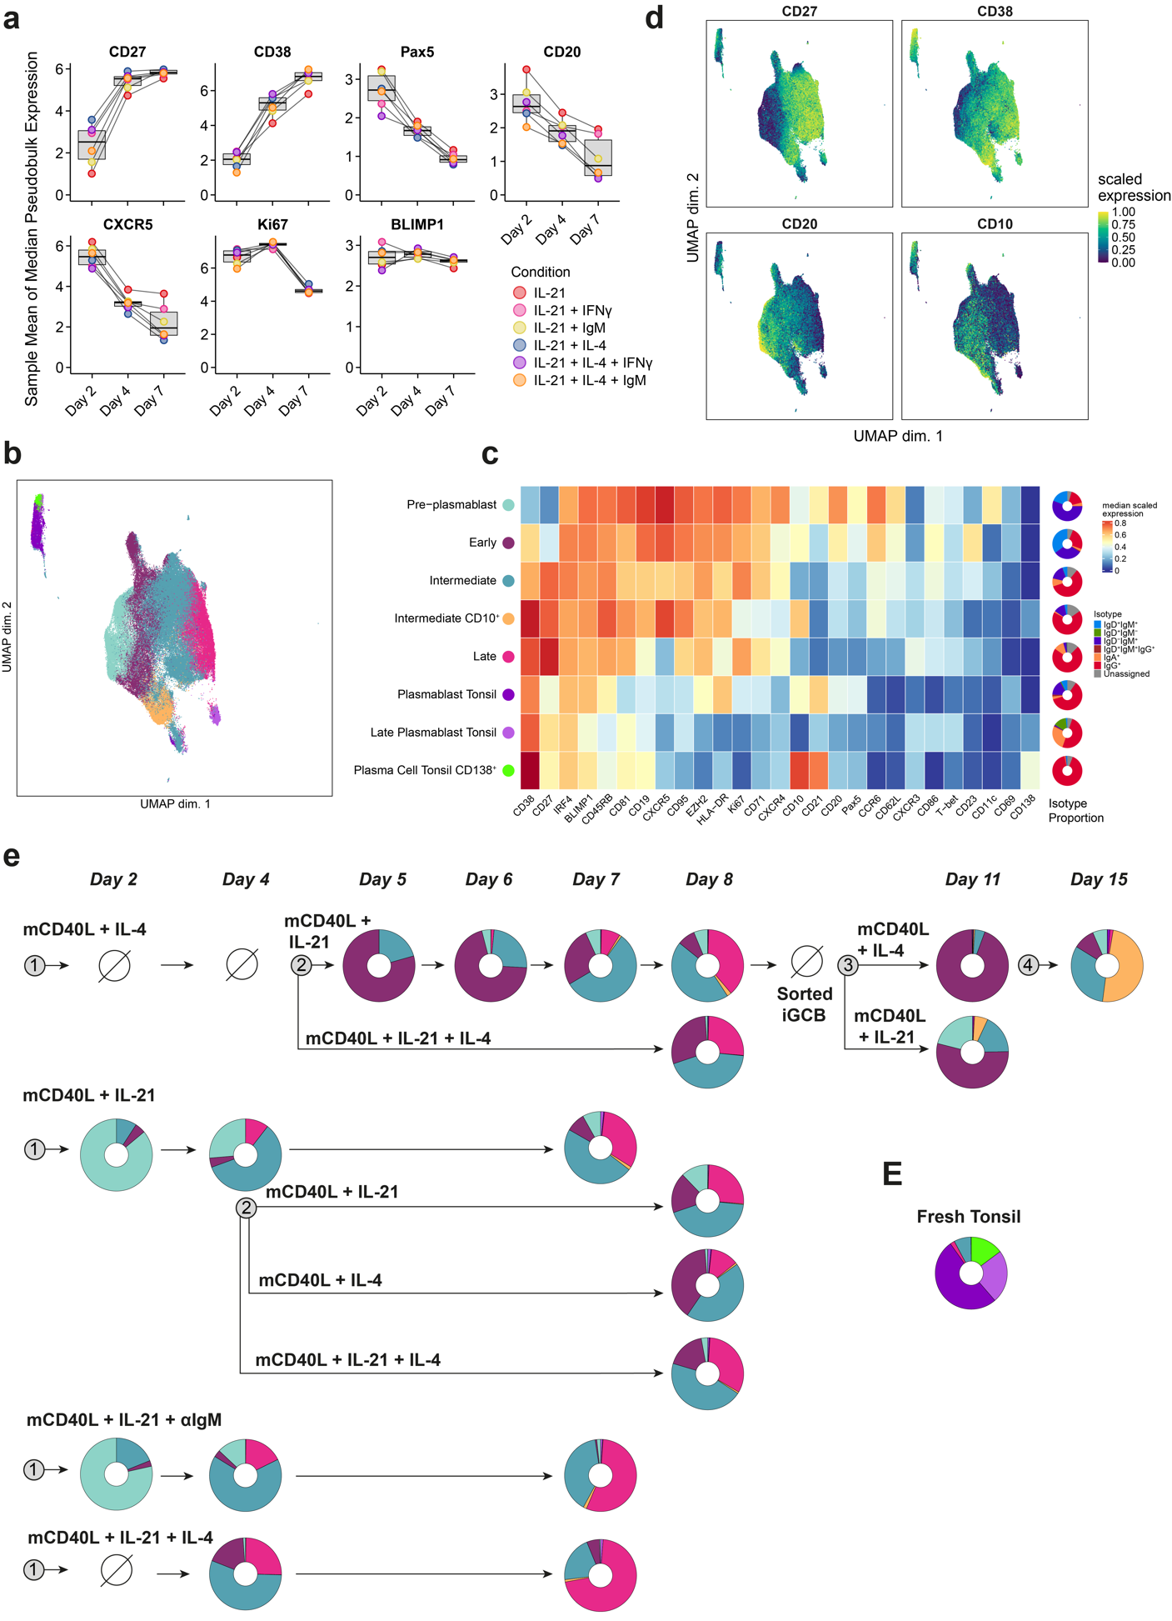
Extended Data Fig. 7. A continuum of plasmablast states highlights CD10 as a germinal-centre derived plasmablast marker. (a) Median expression of markers in BLIMP1⁺ cells. Mean, n = 4. Boxplots show the median and interquartile range of conditions. (b) UMAP and (c) Heatmap of showing BLIMP1⁺ cell subclusters. (d) Marker expressions on UMAP. (e) Donut plots showing proportions of clusters. Mean, n = 4. Prohibition sign (⌀) indicates none or insufficient BLIMP1⁺ cells for that condition.
Extended Data Table 1 - Reagents and resources
Reagent or Resource | Source | Identifier
Antibodies (non-Cytometry)
Goat F(ab')2 Anti-Human IgM-LE/AF | Southern Biotech | Cat # 2022-14
Biological Samples
Leukopak PBMC | STEMCELL Technologies | Leukopak IDs: LP1 (CE0007925 (F, 41, African American), LP2 (CE0009357, F, 22, Caucasian), LP3 (CE0007408, M, 47, African American), LP4 (CE0009454, M, 39, Asian), LP5 (CE0010220, F, 22, Caucasian), LP7 (CE0010632, M, 22, Pacific Islander).
Human Tonsil MNC | STEMCELL Technologies | Tonsil 1 (BRH1589802, F, 28), Tonsil 2 (BRH1515664, M, 25)
Chemicals, peptides, and recombinant proteins
Pierce™ 16% Formaldehyde (w/v), Methanol-free | Thermo | Cat# 28906
Permeabilization Buffer (10X) | Thermo | Cat# 00-8333-56
BD Horizon™ Brilliant Stain Buffer | BD | Cat# 563794, RRID: AB_2869750
CellTrace™ CFSE Cell Proliferation Kit, for flow cytometry | Invitrogen (Thermo Fisher) | C34554
CyFACS (PBS with 0.1% BSA and 2 mM EDTA)
EDTA | Nacalai Tesque | Cat# 06894-14
Maxpar Water | Standard Biotools | Cat# 201069
Maxpar® Cell Acquisition Solution Plus for CyTOF® XT | Standard Biotools | Cat# 201244
EQ Six Element Calibration Beads (CyTOF XT) | Standard Biotools | Cat # 201245
Maxpar® Washing Solution for CyTOF® XT | Standard Biotools | Cat # 201243
PBS-based antibody stabilizer | Candor Biosciences | Cat # 130 050
HRP-protector stabilizer for cadmium labeling | Candor Biosciences | Cat # 222 050
RPMI 1640 with L-Gln and HEPES | Nacalai | Cat # 30263-95
IMDM with L-Gln and HEPES | Nacalai | Cat # 11506-05
Penicillin-Streptomycin (10,000 U/mL) | Gibco | Cat # 15-140-122
Fetal Bovine Serum, qualified, USDA-approved regions | Gibco | Cat # 10437028
Cell-ID™ Intercalator-Rh | Standard Biotools | Cat # 201103A
Cell-ID™ Cisplatin-194Pt | Standard Biotools | Cat # 201194
Cell-ID™ Cisplatin-195Pt | Standard Biotools | Cat # 201195
Cell-ID™ Cisplatin-196Pt | Standard Biotools | Cat # 201196
Cell-ID™ Cisplatin-198Pt | Standard Biotools | Cat # 201198
Cerium(III) chloride heptahydrate | Sigma | Cat # 202983-10G
Gadolinium(III) chloride, 157Gd Isotope | Trace Sciences International | Custom order
Indium(III) chloride,113In Isotope | Trace Sciences International | Custom order
Indium(III) chloride, 115In Isotope | Trace Sciences International | Custom order
Recombinant Human IL-4 | Peprotech | Cat # 200-04
Recombinant Human IL-21 | Peprotech | Cat # 200-21
IL2 (Immunace35) | Shinogi | Immunace35
Recombinant Human IFNγ | Peprotech | Cat # 300-02
Mega CD40L | Enzo | Cat# ALX-522-110-C010
79-6 | Selleck Chemicals | Cat# S8250
FX1 | Selleck Chemicals | Cat# S8591
Tazemetostat | Selleck Chemicals | Cat# S7128
Critical commercial assays
EasySep Human Naive B Cell Isolation Kit | STEMCELL technologies | Cat # ST-17254
EasySep Human Pan B Cell Enrichment Kit | STEMCELL technologies | Cat # ST-19554
Foxp3 / Transcription Factor Staining Buffer Set | Thermo | Cat# 00-5523-00
Maxpar X8 and MCP9 antibody metal labelling kits | Standard Biotools | -
Plasticware
U bottom plates treated | Corning | Cat# 163320

Extended Data Table 2. Antibody Panels
Label | Target | Manufacturer | Cat Number | Clone | Titration
In vitro B cell assay Panel 1 (Fig. 1, 2 and 3)
Barcode
 | Fc block | Biolegend | 422302 | - | 50
89Y | CD45 | Standard Biotools | 3089003B | HI30 | 75
113In | CD45 | Biolegend | 304002 | HI30 | 100
115In | CD45 | Biolegend | 304002 | HI30 | 100
194Pt | CD45 | Biolegend | 304002 | HI30 | 100
195Pt | CD45 | Biolegend | 304002 | HI30 | 100
196Pt | CD45 | Biolegend | 304002 | HI30 | 100
Surface Stain
106Cd | CD32 | Biolegend | 303202 | FUN-2 | 100
111Cd | CD21 | Biolegend | 354902 | Bu32 | 200
112Cd | CD20 | Biolegend | 302302 | 2H7 | 100
114Cd | CD69 | Biolegend | 310939 | FN50 | 100
116Cd | CD19 | Biolegend | 302202 | HIB19 | 100
141Pr | CCR6 | Biolegend | 353427 | G034E3 | 100
145Nd | IL4R | R&D | RSD-MAB230-100 | 25463 | 50
146Nd | CD62L | Biolegend | 304835 | DREG56 | 50
147Sm | CD86 | Biolegend | 305402 | IT2.2 | 50
151Eu | IgD | Biolegend | 348202 | IA6-2 | 200
154Sm | CD73 | Biolegend | 344002 | AD2 | 200
155Gd | CD71 | eBioscience | 14-0719-82 | OKT9 | 100
156Gd | CXCR4 | Biolegend | 306523 | 12G5 | 50
158Gd | CD27 | Biolegend | 302839 | O323 | 200
159Tb | CD10 | Biolegend | 312223 | HI10a | 100
161Dy | CD11c | Biolegend | 371502 | S-HCL-3 | 200
162Dy | CD23 | Biolegend | 338502 | EBVCS-5 | 100
164Dy | CD95 | Standard Biotools | 3164008B | DX2 | 200
165Ho | CXCR5 | BD | 552032 | RF8B2 | 50
166Er | CD24 | Standard Biotools | 3166007B | ML5 | 50
169Tm | CD81 | BioLegend | 349502 | 5A6 | 100
170Er | CD138 | BioLegend | 356502 | MI-15 | 50
172Yb | CD38 | Biolegend | 303535 | HIT2 | 100
173Yb | FCRL5 | Biolegend | 340302 | 509f6 | 50
174Yb | HLA-DR | Biolegend | 307602 | L243 | 400
175Lu | CXCR3 | Biolegend | 353733 | G025H7 | 100
176Yb | CD45RB | Biolegend | 310202 | MEM-55 | 200
198Pt | Cell-ID™ Cisplatin-198Pt (Live Dead stain) | Standard Biotools | 201198 | - | -
Intracellular Stain
103Rh | Cell-ID Intercalator-Rh (DNA stain) | Standard Biotools | 201103A | -
110Cd | Pax5 | BioLegend | 649702 | 1H9 | 100
140Ce | H3K27me3 | Active motive | 61017 | 323 | 400
142Nd | Cleaved caspase 3 | Standard Biotools | 3142004A | D3E9 | 100
143Nd | IgM | Biolegend | 314502 | MHM-88 | 400
144Nd | FITC (for CFSE) | SouthernBiotech | 6400-01 | polyclonal | 100
148Nd | IgA | Standard Biotools | 3148007B | Polyclonal | 400
149Sm | BLIMP1 | R&D Systems | 646702 | MAB36081 | 100
150Nd | BCL6 | Abcam | ab307682 | K112-91 | 50
152Sm | IRF4 | BioLegend | 646402 | IRF4.3E4 | 100
153Eu | IgG | Biolegend | 410701 | M1310G05 | 200
157Gd | Tbet | Biolegend | 644802 | 4B10 | 100
160Gd | EZH2 | GENETEX | GNT-GTX82503-400 | Polyclonal | 200
163Dy | AICDA | Abcam | ab255769 | 5G9 | 100
168Er | Ki67 | Standard Biotools | 3168001B | Ki67 | 100
171Yb | BACH2 | Biolegend | 695602 | 16B10B53 | 100
In vitro B cell assay Panel 2 (Fig. 4, 5 and 6)
Barcode
 | Fc block | Biolegend | 422302 | - | 50
89Y | CD45 | Standard Biotools | 3089003B | HI30 | 75
113In | CD45 | Biolegend | 304002 | HI30 | 100
115In | CD45 | Biolegend | 304002 | HI30 | 100
194Pt | CD45 | Biolegend | 304002 | HI30 | 100
195Pt | CD45 | Biolegend | 304002 | HI30 | 100
196Pt | CD45 | Biolegend | 304002 | HI30 | 100
FITC | PNA lectin | Sigma Aldrich | L7381-1MG | - | 100
Surface Stain
106Cd | CD45RO | Biolegend | 304239 | UCHL1 | 100
111Cd | CD21 | Biolegend | 354902 | Bu32 | 200
112Cd | CD20 | Biolegend | 302302 | 2H7 | 100
114Cd | CD69 | Biolegend | 310939 | FN50 | 100
116Cd | CD19 | Biolegend | 302202 | HIB19 | 100
141Pr | CCR6 | Biolegend | 353427 | G034E3 | 100
144Nd | FITC (for PNA) | SouthernBiotech | 6400-01 | polyclonal | 100
145Nd | IL4R | R&D | RSD-MAB230-100 | 25463 | 50
146Nd | CD62L | Biolegend | 304835 | DREG56 | 50
147Sm | CD86 | Biolegend | 305402 | IT2.2 | 50
151Eu | IgD | Bi+C50:C90olegend | 348202 | IA6-2 | 200
154Sm | CD73 | Biolegend | 344002 | AD2 | 200
155Gd | CD71 | eBioscience | 14-0719-82 | OKT9 | 100
156Gd | CXCR4 | Biolegend | 306523 | 12G5 | 50
158Gd | CD27 | Biolegend | 302839 | O323 | 200
159Tb | CD10 | Biolegend | 312223 | HI10a | 100
161Dy | CD11c | Biolegend | 371502 | S-HCL-3 | 200
162Dy | CD23 | Biolegend | 338502 | EBVCS-5 | 100
164Dy | CD95 | Standard Biotools | 3164008B | DX2 | 200
165Ho | CXCR5 | BD | 552032 | RF8B2 | 50
166Er | CD24 | Standard Biotools | 3166007B | ML5 | 50
169Tm | CD81 | BioLegend | 349502 | 5A6 | 100
170Er | CD138 | BioLegend | 356502 | MI-15 | 50
172Yb | CD38 | Biolegend | 303535 | HIT2 | 100
173Yb | FCRL5 | Biolegend | 340302 | 509f6 | 50
174Yb | HLA-DR | Biolegend | 307602 | L243 | 400
175Lu | CXCR3 | Biolegend | 353733 | G025H7 | 100
176Yb | CD45RB | Biolegend | 310202 | MEM-55 | 200
198Pt | Cell-ID™ Cisplatin-198Pt (Live Dead stain) | Standard Biotools | 201198 | - | -
Intracellular Stain
103Rh | Cell-ID Intercalator-Rh (DNA stain) | Standard Biotools | 201103A | -
110Cd | Pax5 | BioLegend | 649702 | 1H9 | 100
140Ce | H3K27me3 | Active motive | 61017 | 323 | 400
142Nd | Cleaved caspase 3 | Standard Biotools | 3142004A | D3E9 | 100
143Nd | IgM | Biolegend | 314502 | MHM-88 | 400
148Nd | IgA | Standard Biotools | 3148007B | Polyclonal | 400
149Sm | BLIMP1 | R&D Systems | 646702 | MAB36081 | 100
150Nd | BCL6 | Abcam | ab307682 | K112-91 | 50
152Sm | IRF4 | BioLegend | 646402 | IRF4.3E4 | 100
153Eu | IgG | Biolegend | 410701 | M1310G05 | 200
157Gd | Tbet | Biolegend | 644802 | 4B10 | 100
160Gd | EZH2 | GENETEX | GNT-GTX82503-400 | Polyclonal | 200
163Dy | AICDA | Abcam | ab255769 | 5G9 | 100
168Er | Ki67 | Standard Biotools | 3168001B | Ki67 | 100
171Yb | BACH2 | Biolegend | 695602 | 16B10B53 | 100
In vitro B cell assay Panel 3 (Extended Data Fig. 2)
Barcode
 | Fc block | Biolegend | 422302 | - | 50
89Y | CD45 | Standard Biotools | 3089003B | HI30 | 75
113In | CD45 | Biolegend | 304002 | HI30 | 100
115In | CD45 | Biolegend | 304002 | HI30 | 100
194Pt | CD45 | Biolegend | 304002 | HI30 | 100
195Pt | CD45 | Biolegend | 304002 | HI30 | 100
196Pt | CD45 | Biolegend | 304002 | HI30 | 100
Surface Stain
106Cd | CD32 | Biolegend | 303202 | FUN-2 | 100
111Cd | CD21 | Biolegend | 354902 | Bu32 | 200
112Cd | CD20 | Biolegend | 302302 | 2H7 | 100
116Cd | CD19 | Biolegend | 302202 | HIB19 | 100
141Pr | CCR6 | Biolegend | 353427 | G034E3 | 100
142Nd | CD69 | Biolegend | 310939 | FN50 | 100
145Nd | IL4R | R&D | RSD-MAB230-100 | 25463 | 50
146Nd | CD62L | Biolegend | 304835 | DREG56 | 50
147Sm | CD86 | Biolegend | 305402 | IT2.2 | 50
151Eu | IgD | Biolegend | 348202 | IA6-2 | 200
152Sm | CD11a | BioLegend | 301223 | HI111 | 100
154Sm | CD73 | Biolegend | 344002 | AD2 | 200
155Gd | CD71 | eBioscience | 14-0719-82 | OKT9 | 100
156Gd | CXCR4 | Biolegend | 306523 | 12G5 | 50
158Gd | CD27 | Biolegend | 302839 | O323 | 200
159Tb | CD1c | Biolegend | 331502 | L161 | 200
161Dy | CD11c | Biolegend | 371502 | S-HCL-3 | 200
162Dy | CD23 | Biolegend | 338502 | EBVCS-5 | 100
164Dy | CD95 | Standard Biotools | 3164008B | DX2 | 200
165Ho | CXCR5 | BD | 552032 | RF8B2 | 50
166Er | CD24 | Standard Biotools | 3166007B | ML5 | 50
167Er | CD10 | Biolegend | 312223 | HI10a | 100
170Er | CD138 | BioLegend | 352311 | DL-101 | 50
172Yb | CD38 | Biolegend | 303535 | HIT2 | 100
174Yb | HLA-DR | Biolegend | 307602 | L243 | 400
175Lu | CXCR3 | Biolegend | 353733 | G025H7 | 100
176Yb | CD45RB | Biolegend | 310202 | MEM-55 | 200
198Pt | CD3 | Biolegend | 300443 | UCHT1 | 100
198Pt | CD66b | Biolegend | 392902 | 6/40c | 100
198Pt | CD14 | Biolegend | 301843 | M5E2 | 100
209Bi | CD11b | Standard Biotools | 3209003B | ICRF44 | 100
198Pt | Cell-ID™ Cisplatin-198Pt (Live Dead stain) | Standard Biotools | 201198 | - | -
Intracellular Stain
103Rh | Cell-ID Intercalator-Rh (DNA stain) | Standard Biotools | 201103A | -
140Ce | H3K27me3 | Active motive | 61017 | 323 | 400
143Nd | IgM | Biolegend | 314502 | MHM-88 | 400
148Nd | IgA | Standard Biotools | 3148007B | Polyclonal | 400
149Sm | BLIMP1 | R&D Systems | 646702 | MAB36081 | 100
150Nd | BCL6 | Abcam | ab307682 | K112-91 | 50
153Eu | IgG | Biolegend | 410701 | M1310G05 | 200
157Gd | Tbet | Biolegend | 644802 | 4B10 | 100
160Gd | EZH2 | GENETEX | GNT-GTX82503-400 | Polyclonal | 200
168Er | Ki67 | Standard Biotools | 3168001B | Ki67 | 100
169Tm | Zeb2 | R&D Systems | MAB73782 | 923328 | 100
173Yb | FCRL5 | Biolegend | 340302 | 509f6 | 50
In vitro B cell assay Panel 4 (Extended Data Fig. 3)
Barcode
 | Fc block | Biolegend | 422302 | - | 50
89Y | CD45 | Standard Biotools | 3089003B | HI30 | 75
113In | CD45 | Biolegend | 304002 | HI30 | 100
115In | CD45 | Biolegend | 304002 | HI30 | 100
194Pt | CD45 | Biolegend | 304002 | HI30 | 100
195Pt | CD45 | Biolegend | 304002 | HI30 | 100
196Pt | CD45 | Biolegend | 304002 | HI30 | 100
Surface Stain
106Cd | CD32 | Biolegend | 303202 | FUN-2 | 100
111Cd | CD21 | Biolegend | 354902 | Bu32 | 200
112Cd | CD20 | Biolegend | 302302 | 2H7 | 100
114Cd | CD69 | Biolegend | 310939 | FN50 | 100
116Cd | CD19 | Biolegend | 302202 | HIB19 | 100
146Nd | CD62L | Biolegend | 304835 | DREG56 | 50
147Sm | CD86 | Biolegend | 305402 | IT2.2 | 50
151Eu | IgD | Biolegend | 348202 | IA6-2 | 200
154Sm | CD73 | Biolegend | 344002 | AD2 | 200
155Gd | CD71 | eBioscience | 14-0719-82 | OKT9 | 100
158Gd | CD27 | Biolegend | 302839 | O323 | 200
159Tb | CD1c | Biolegend | 331502 | L161 | 200
161Dy | CD11c | Biolegend | 371502 | S-HCL-3 | 200
162Dy | CD23 | Biolegend | 338502 | EBVCS-5 | 100
163Dy | CD45RA | Biolegend | 304102 | HI100 | 100
164Dy | CD95 | Standard Biotools | 3164008B | DX2 | 200
165Ho | CXCR5 | BD | 552032 | RF8B2 | 50
166Er | CCR6 | Biolegend | 353427 | G034E3 | 100
167Er | CD10 | Biolegend | 312223 | HI10a | 100
170Er | CD138 | BioLegend | 356502 | MI-15 | 50
172Yb | CD38 | Biolegend | 303535 | HIT2 | 100
173Yb | CXCR4 | Biolegend | 306523 | 12G5 | 50
174Yb | HLA-DR | Biolegend | 307602 | L243 | 200
175Lu | CXCR3 | Biolegend | 353733 | G025H7 | 100
176Yb | CD45RB | Biolegend | 310202 | MEM-55 | 200
209Bi | CD11b | Standard Biotools | 3209003B | ICRF44 | 100
Intracellular Stain
110Cd | Pax5 | BioLegend | 649702 | 1H9 | 100
140Ce | H3K27me3 | Active motif | 61017 | MABI 0323 | 400
141Pr | Puromycin | Merck | MABE343 | 12D10 | 200
142Nd | cCaspase3 | Standard Biotools | 3142004A | D3E9 | 100
143Nd | IgM | Biolegend | 314502 | MHM-88 | 400
148Nd | IgA | Standard Biotools | 3148007B | Polyclonal | 400
149Sm | BLIMP1 | R&D Systems | 646702 | MAB36081 | 100
150Nd | BCL6 | Abcam | ab307682 | K112-91 | 50
152Sm | IRF4 | Biolegend | 646402 | IRF4.3E4 | 100
153Eu | IgG | Biolegend | 410701 | M1310G05 | 200
156Gd | BrdU (for BrU) | BD | 555627 | 3D4 | 50
157Gd | T-bet | Biolegend | 644802 | 4B10 | 100
160Gd | EZH2 | GENETEX | GNT-GTX82503-400 | Polyclonal | 100
168Er | Ki67 | Biolegend | 350523 | Ki-67 | 100
169Tm | HIF1α | AbCam | ab210073 | EP1215Y | 100
FACS Panel for sorting Naive B cells
BV421 | CD19 | Biolegend | 3022234 | HIB19 | 100
BUV805 | CD3 | BD | 612895 | UCHT1 | 100
BV711 | IgD | BD | 740794 | IA6-2 | 100
PE | CD45RB | Biolegend | 310204 | MEM-55 | 100
APCF750 | CD27 | Biolegend | 302846 | O323 | 100
FACS Panel for sorting iGCB cells
BV421 | CD10 | BioLegend | 312218 | HI10a | 50
FITC | CCR6 | BioLegend | 353412 | G034E3 | 100
BV711 | CD23 | BD | 743430 | EBVCS-5 | 100
BUV805 | CD20 | BD | 612906 | 2H7 | 100
PE-Cy7 | CD38 | BioLegend | 303516 | HIT2 | 100
APC | CD21 | BioLegend | 354906 | Bu32 | 100
CITE-seq Hashtags
TotalSeq-C0251 | anti-human Hashtag 1 | Biolegend | 394661 | LNH-94 and 2M2 | 200
TotalSeq-C0252 | anti-human Hashtag 2 | Biolegend | 394663 | LNH-94 and 2M2 | 200
TotalSeq-C0253 | anti-human Hashtag 3 | Biolegend | 394665 | LNH-94 and 2M2 | 200
TotalSeq-C0254 | anti-human Hashtag 4 | Biolegend | 394667 | LNH-94 and 2M2 | 200
TotalSeq-C0255 | anti-human Hashtag 5 | Biolegend | 394669 | LNH-94 and 2M2 | 200
TotalSeq-C0256 | anti-human Hashtag 6 | Biolegend | 394671 | LNH-94 and 2M2 | 200
TotalSeq-C0257 | anti-human Hashtag 7 | Biolegend | 394673 | LNH-94 and 2M2 | 200
TotalSeq-C0258 | anti-human Hashtag 8 | Biolegend | 394675 | LNH-94 and 2M2 | 200
TotalSeq-C0259 | anti-human Hashtag 9 | Biolegend | 394677 | LNH-94 and 2M2 | 200
TotalSeq-C0260 | anti-human Hashtag 10 | Biolegend | 394679 | LNH-94 and 2M2 | 200
TotalSeq-C0263 | anti-human Hashtag 13 | Biolegend | 394685 | LNH-94 and 2M2 | 200
TotalSeq-C0264 | anti-human Hashtag 14 | Biolegend | 394687 | LNH-94 and 2M2 | 200
TotalSeq-C0265 | anti-human Hashtag 15 | Biolegend | 394689 | LNH-94 and 2M2 | 200
TotalSeq-C0276 | anti-human Hashtag 16 | Biolegend | 394691 | LNH-94 and 2M2 | 200
CITE-seq Surface Stain
 | TotalSeq™-C Human Universal Cocktail, V1.0 | Biolegend | 399905 | - | -
TotalSeq-C0844 | anti-human CD45RB | Biolegend | 310211 | MEM-55 | 100
TotalSeq-C0366 | anti-human CD184 (CXCR4) | Biolegend | 306533 | 12G5 | 50
TotalSeq-C0826 | anti-human CD307c/FcRL3 | Biolegend | 374413 | H5/FcRL3 | 100
TotalSeq-C0828 | anti-human CD307d (FcRL4) | Biolegend | 340213 | 413D12 | 100
TotalSeq-C0829 | anti-human CD307e (FcRL5) | Biolegend | 340309 | 509f6 | 100
TotalSeq-C0055 | anti-human CD138 (Syndecan-1) | Biolegend | 356539 | MI15 | 50
TotalSeq-C0447 | anti-human CD200 (OX2) | Biolegend | 329229 | OX-104 | 100

Extended Data Table 3 - Experiments
ID | Start | Description | Fig. | CyTOF clustering | Conditions (all contain mCD40L) | CyTOF panel | CITE−seq | Donor IDs
1 | 240509 | FACS vs Sort iGCB | Extended Data Fig. 2 | Separately | FACS sorted Naive and Magnetically enriched Naive.  First stimulation with IL−4 then 2nd stimulation on day 4 with IL−21, measurement on day 8. | 3 | no | LP1, LP2, LP3, LP4
2 | 240624 | iGCB Day 8 CITE−seq | Fig. 4, Extended Data Fig. 4 | - | First stimulation with IL-4 then second stimulation day 4 with IL−21, measurement on day 8. | - | yes (analysed together with assay 4) | LP2, LP3, LP4, LP5
6 | 240718 | iGCB culture from sorted Naive vs Memory | Extended Data Fig. 3 | Separately | First stimulation with IL-4 then second stimulation day 4 with IL−21, measurement on day 8. | 4 | no | LP4, LP5
3A | 240902 | 1st stim big expt 1 | Fig. 1, Extended Data Fig. 1 | Assay 3 Together | First stimulation with IL-4 (replicate), IFNγ, IL−4 + IFNγ, IFNγ + αIgM | 1 | no | LP3, LP4, LP5, LP7
3B | 240923 | 1st stim big expt 2 | Fig. 1, Extended Data Fig. 1 | Assay 3 Together | First stimulation with IL−21, IL−4, IL−21 + IL-4, IL−21 + IL−4 + IFNγ, IL−21 + IFNγ, IL−21 + αIgM, IL−4 + αIgM, IL−21 + IL−4 + αIgM | 1 | no | LP3, LP4, LP5, LP7
3C | 240923 | 2−3−4th stim expt | Fig. 2, Extended Data Fig. 2, Fig. 3, Extended Data Fig. 3 | Assay 3 Together | First stimulation with IL−4 then second stimulation on day 4 with either IL−4, IL−21 or IL−21 + IL−4, measurement on day 8.  First stimulation with IL−21 then second stimulation with either IL−4, IL−21 or IL−21 then IL−4, measurement on day 8.  Sorted day 8 iGCB third stimulation with IL−21 or IL−4, measurement on day 11.  Sorted iGCB third stimulation with IL−4 and fourth stimulation on day 11 with IL−21, measurement on day 15. | 1 | no | LP3, LP4, LP5, LP7
3D | 241018 | iGCB day 5 and 6 | Fig. 2, Extended Data Fig. 2 | Assay 3 Together | First stimulation IL−4 then second stimulation on day 4 with IL−21, measurement on day 5 and 6. | 1 | no | LP3, LP4, LP5, LP7
3E | 241111 | iGCB day 7 | Fig. 2, Extended Data Fig. 2 | Assay 3 Together | First stimulation IL−4 then second stimulation on day 4 with IL−21, measurement on day 7. | 1 | no | LP3, LP4, LP5, LP7
4 | 241206 | iGCB vs Tonsil CyTOF and CITE-seq | Fig. 4, Extended Data Fig. 4 (CITE-seq). Fig. 5, Extended Data Fig. 5 (CyTOF) | Separately | First stimulation with IL−4 then second stimulation on day 4 with IL−21, measurement on day 7.  Sorted day 7 iGCB stimulated with mCD40L only, measurement on day 10.  Two freshly thawed tonsil samples | 2 | yes (analysed together with assay 2) | LP3, LP4, LP5, LP7
5 | 250110 | Inhibitor expt | Fig. 6, Extended Data Fig. 6 | Separately | First stimulation with IL−4 then second stimulation on day 4 with IL−21 + inhibitors, measurement on day 8 | 2 | no | LP3, LP4, LP5, LP7

