Figure S1: Phylum-level taxonomic profiles for obese (above) and lean (below) subjects, separated by early pregnancy (left) and late pregnancy (right).
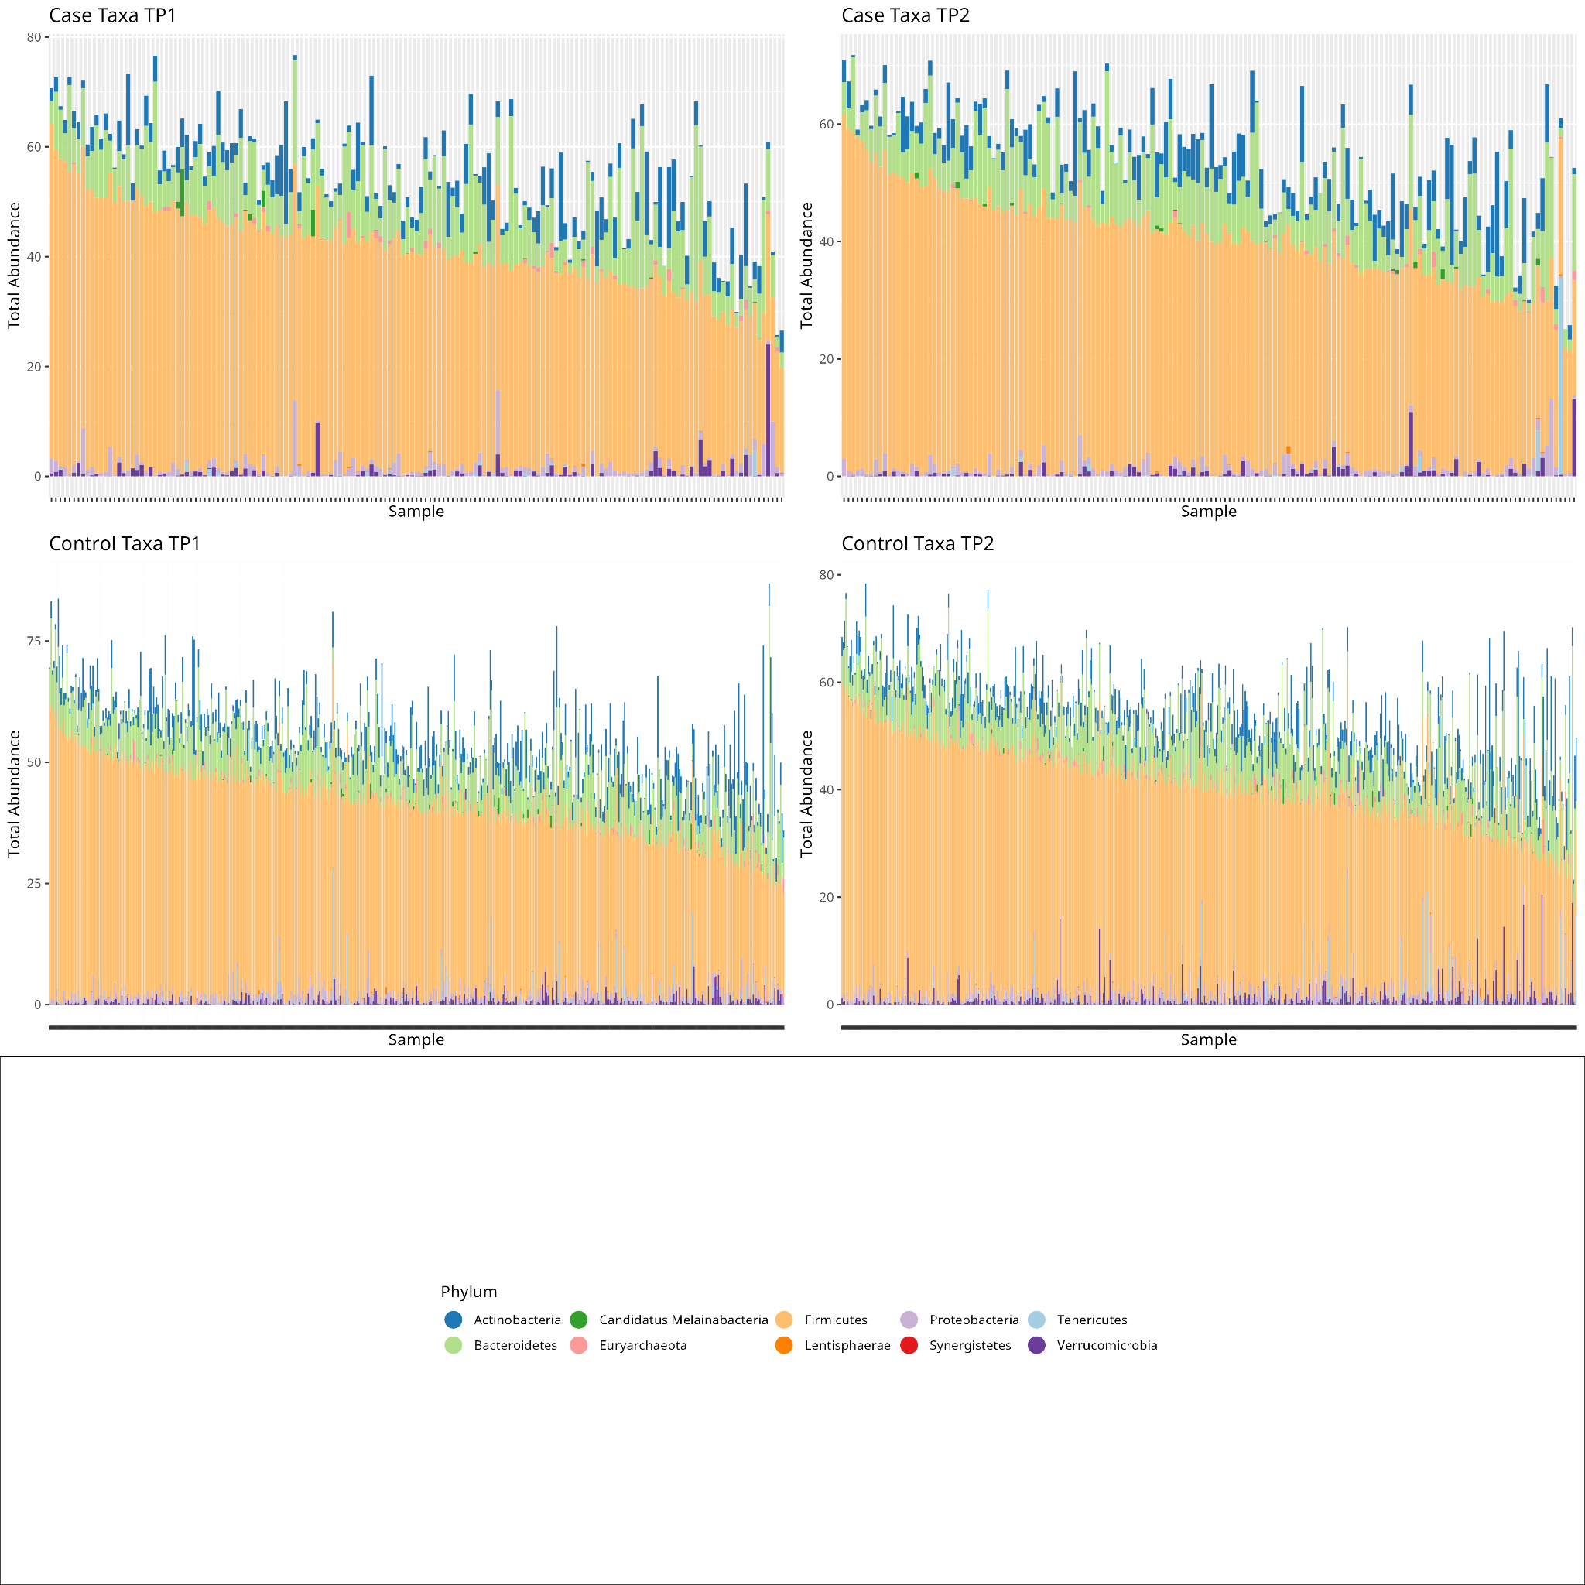

Figure S2: Species richness is significantly higher at time-point 2 for lean subjects. While the same trend is observed for the obese, it is not significant.

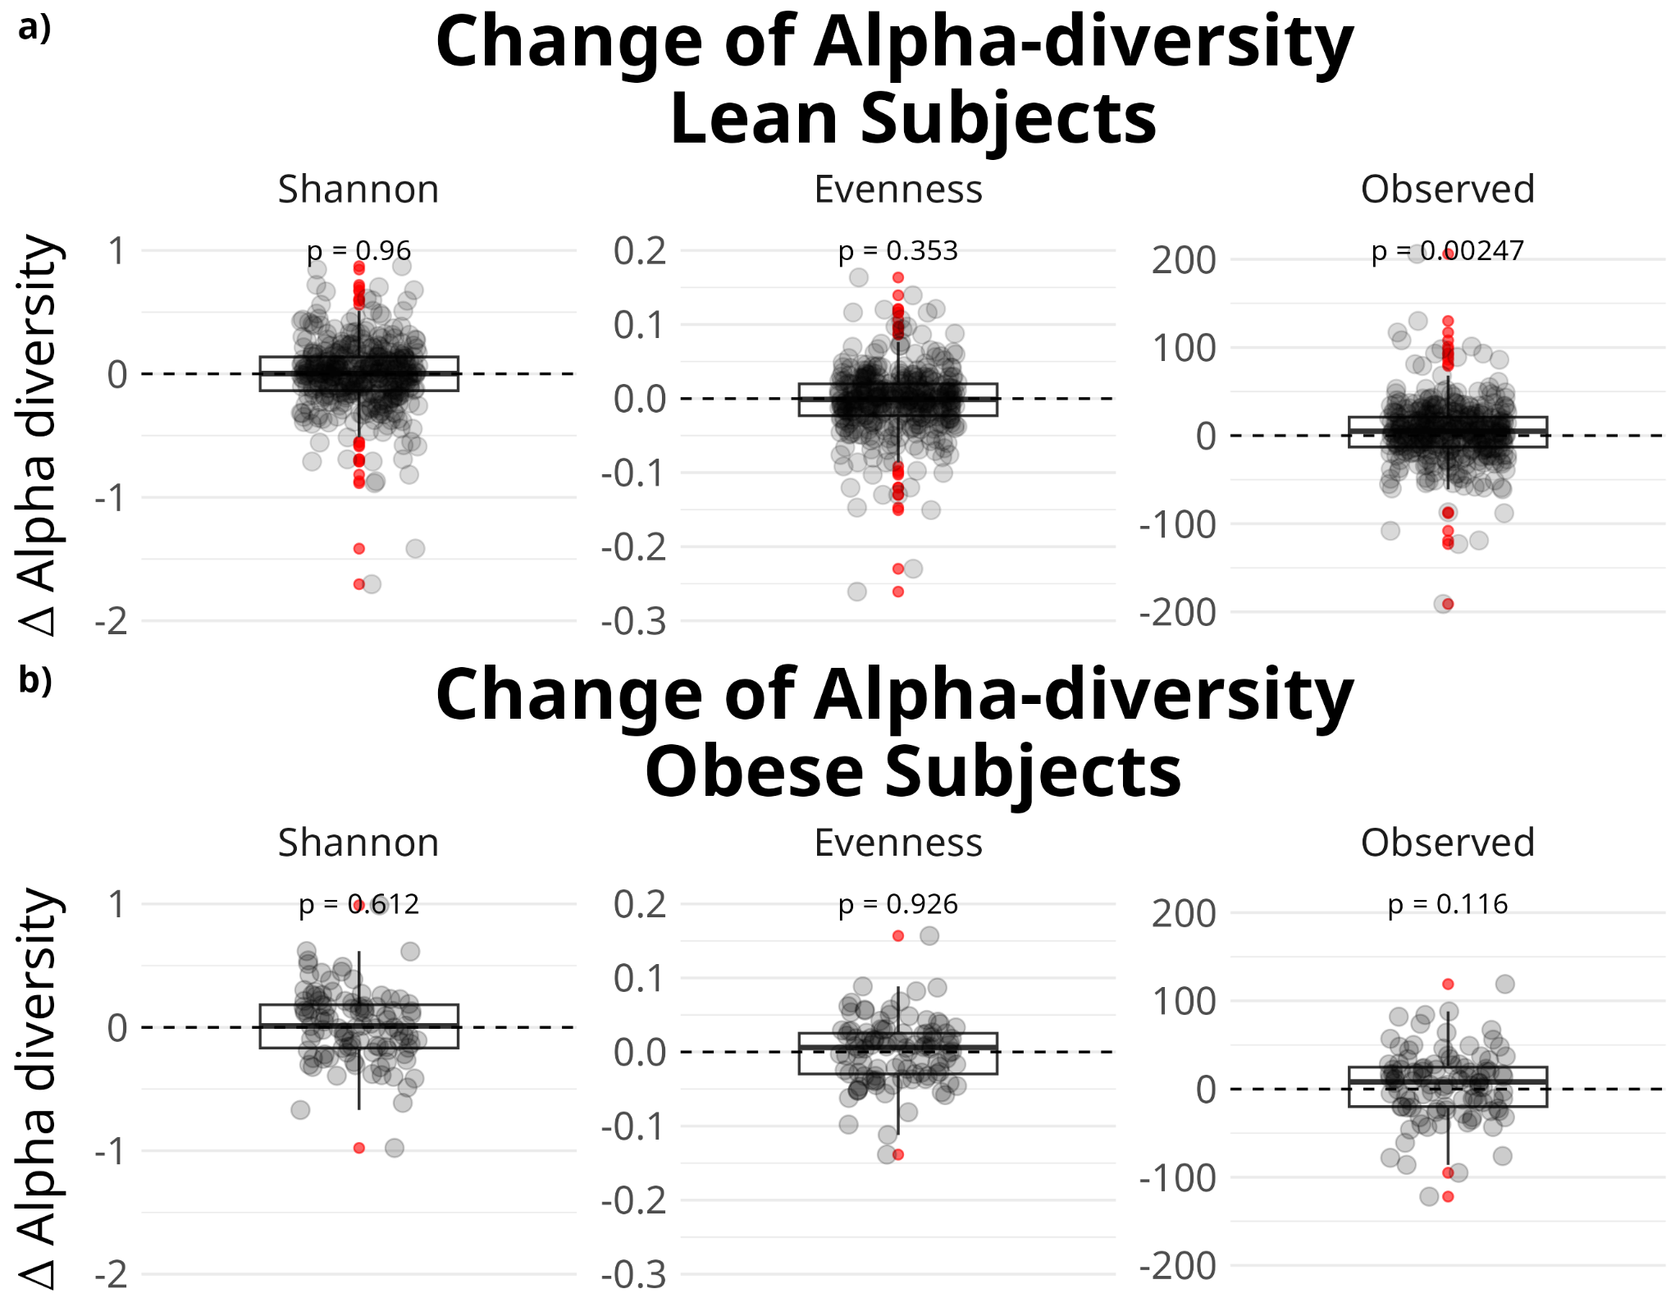

Figure S3: Bristol stool form scale, BMI, and diet are major contributors to differences between samples at both time points
Permanova R² (length of bar) and p-value (color scale) based on Jaccard distance at early and mid-pregnancy

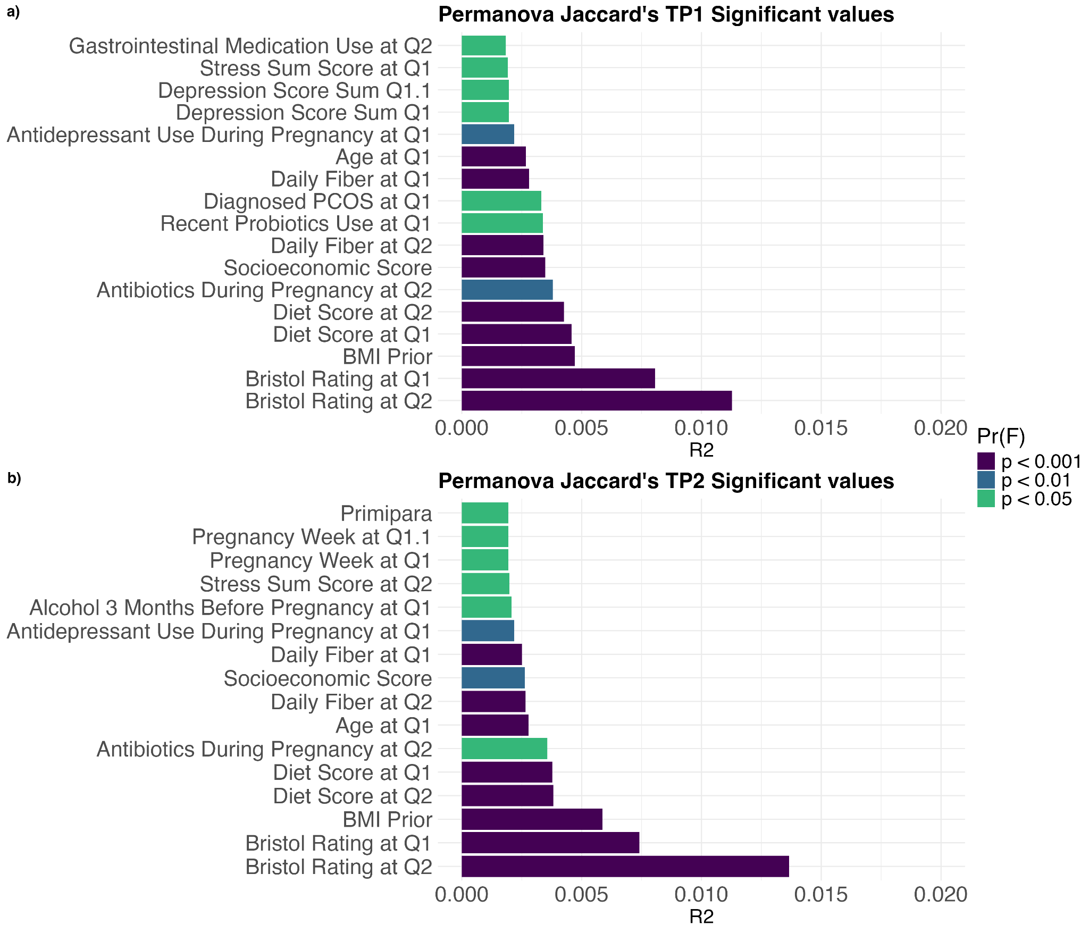

Fig S4. Significantly lower beta diversity among samples at time-point 2 compared with those at time-point 1 in both the lean and the obese groups. a) Lean: Boxplot of Aitchinson distances among samples at both time-points within the lean (control) group; a) Obese: Boxplot of Aitchinson distances among samples at both time-points within the obese (case) group. b) Lean: Boxplot of Jaccard’s distances among samples at both time-points within the lean (control) group; b) Obeset: Boxplot of Jaccard’s distances among samples at both time-points within the obese (case) group.

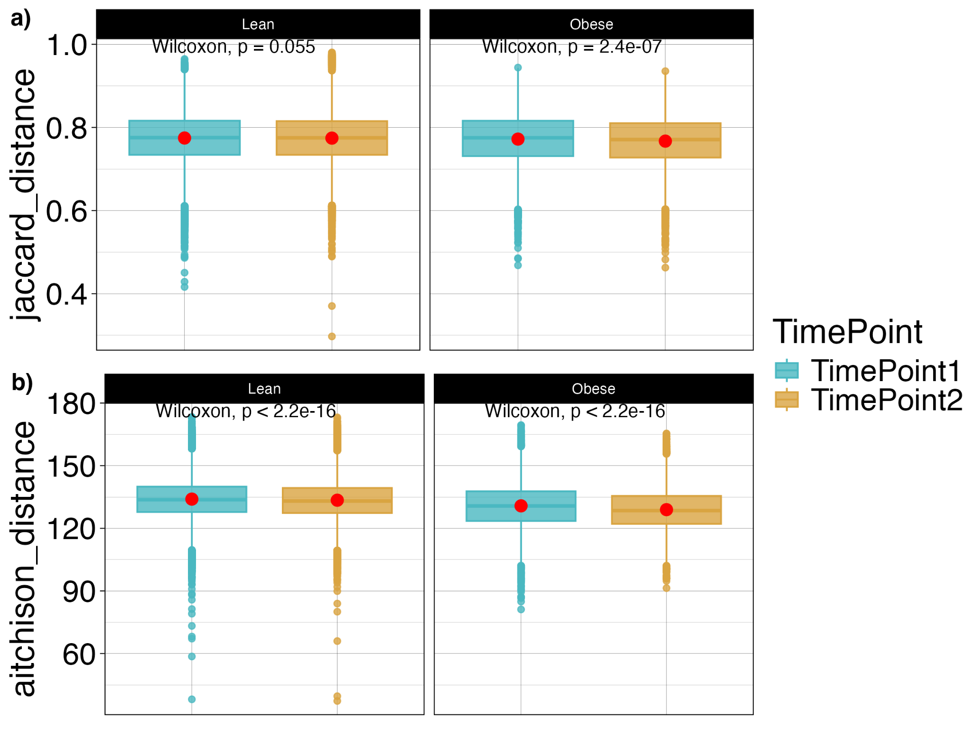

Figure S5: Differentially abundant species in lean and obese pregnant women in the univariable model. Bubble plot displays the differentially abundant species found with the use of the univariable ANCOM-BC2 model. The x-axis shows the log2-fold change of the species in the groups while the y-axis shows the differentially abundant species names. Species in the blue shadow of each bubble plot are enriched in the obese women while species in the red shadow are enriched in the control women with lower abundance in obese women are positioned on the left of each bubble plot. The colour of each dot indicates its phylum. a) time-point 1, b) time-point 2.

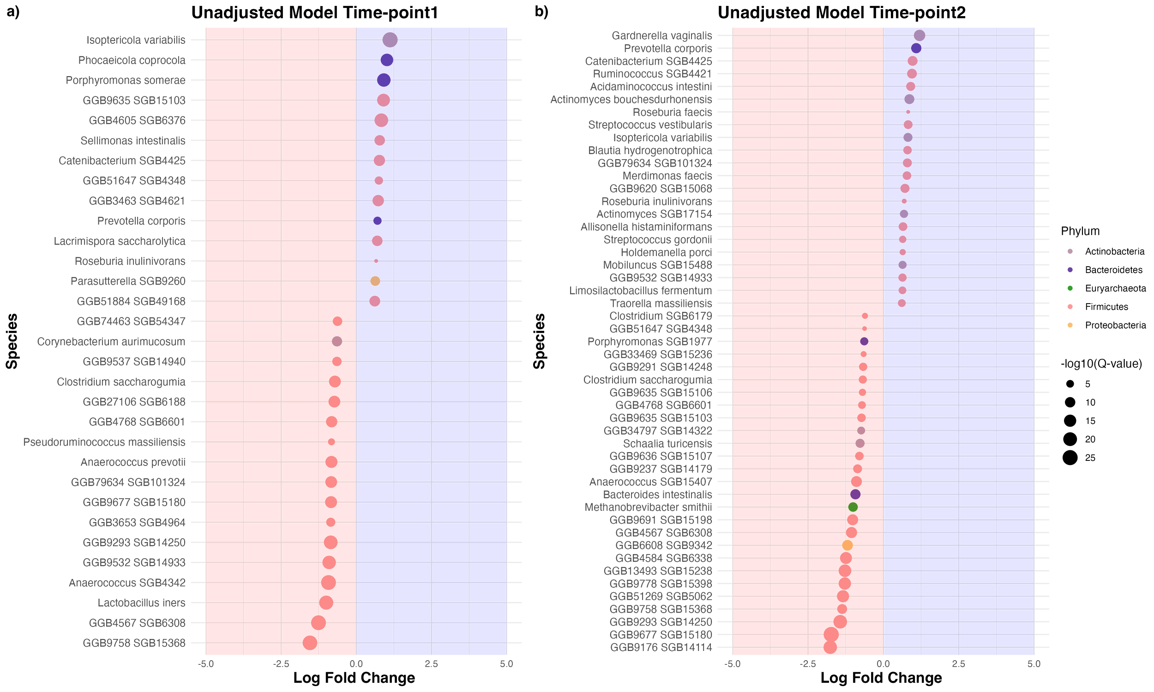

Figure S6: Differentially abundant species in lean and obese pregnant women in the multivariable model adjusted with primiparity, age, diet score. Bubble plot displays the differentially abundant species found with the use of ANCOM-BC2 with primiparity, age, diet score adjusted. The x-axis shows the log2-fold change of the species in the groups while the y-axis shows the differentially abundant species names. Species in the blue shadow of each bubble plot are enriched in the obese women while species in the red shadow are enriched in the control women with lower abundance in obese women are positioned on the left of each bubble plot. The colour of each dot indicates its phylum. a) time-point 1, b) time-point 2.

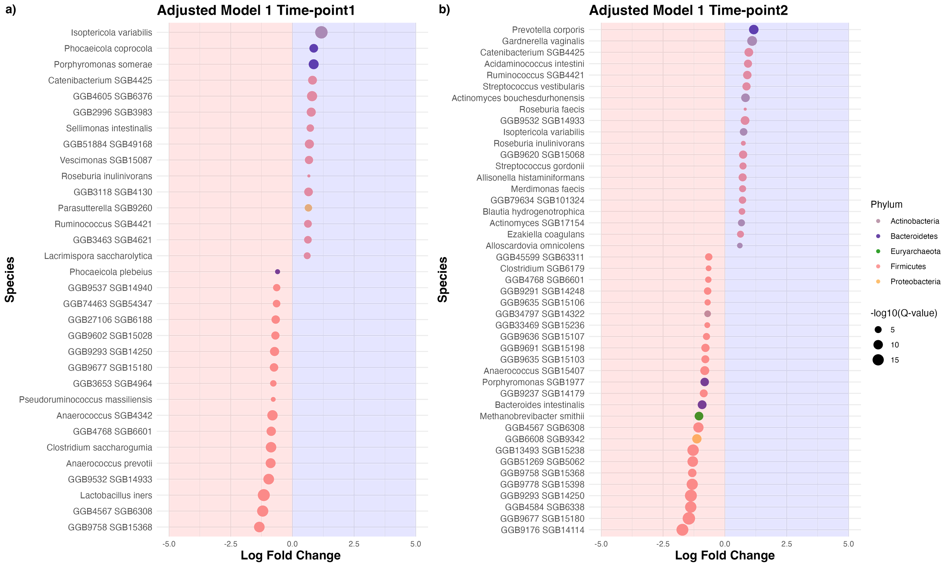
Figure S7. Comparison of ANCOMBC2 results in different models at both time points. Scatter plots showing the intersection of significantly different GMMs between the unadjusted model and each of the two adjusted models at separate time points. (a) Comparison between unadjusted model and adjusted model 1 at time point 1; (b) Comparison between unadjusted model and adjusted model 2 at time point 1; (c) Comparison between unadjusted model and adjusted model 1 at time point 2; (d) Comparison between unadjusted model and adjusted model 2 at time point 2. In the scatter plot, the x-axis shows the log fold change (LFC) of GMMs in multivariable models. The y-axis shows the log fold change of the GMMs in the univariate model. GMMs were represented in dots, coloured in blue (significant in both unadjusted and adjusted models), orange (significant in only unadjusted models) and grey (Not significant in any model). GMMs with lfc > 0.5 or < -0.5 in any model were labelled.

