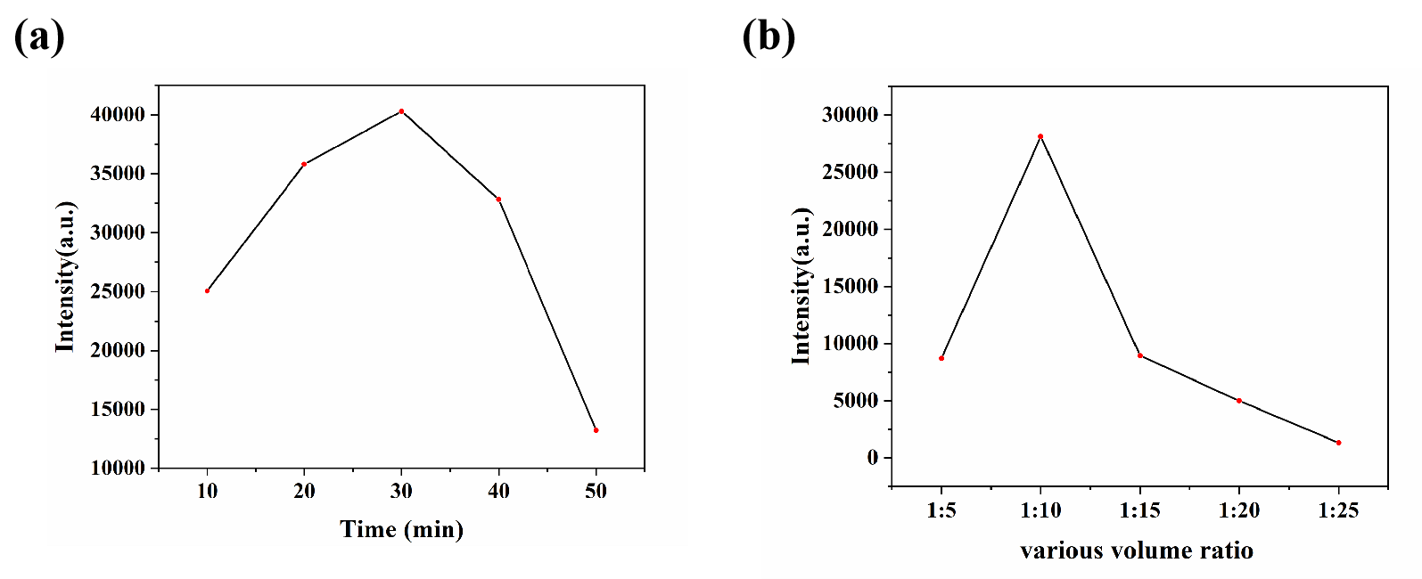
Fig. S1. (a) Optimization of UV irradiation time; (b) Optimization of MMT and Au@Ag core-shell nanoparticles volume ratio

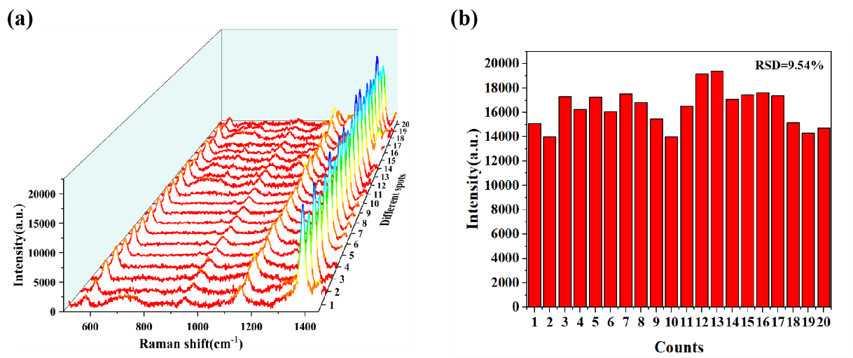
Fig. S2. (a) SERS spectra of TRM from 20 random locations on MMT/Au@Ag core-shell nanoparticles substrates. (b) distribution of the SERS intensity at 1380 cm -1.

Fig. S3. (a) e-a The Raman spectra of TRM stored for 0-4 weeks; (b) The
bar graph of the change in TRM signal intensity at 1380cm⁻¹.

Fig. S4. (a) SERS spectra of CV (10⁻⁴ M-10⁻⁵ M) (b) SERS spectra of NBA (10⁻⁴ M-10⁻⁵ M)

