SUPPLIMENTARY/RAW DATA

Experimental setup:
Fig.1. Experimental test setup using impact vibration test
To measure the natural frequency of a structure, an experimental setup became prepared as shown in fig.1 based at the principle of impact testing under free-free boundary conditions. The test specimen was suspended using thin threads at both ends.
- Following Figures illustrate the different 3D-printed lattice structure specimens discussed in the research article.
- Gyroid Re-entrant honeycomb structure:
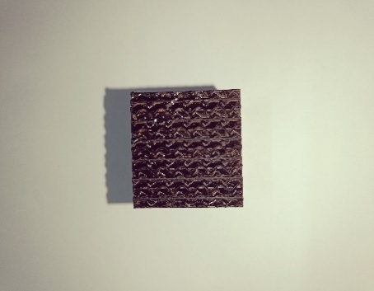
Fig.2. Combination of Gyroid + Re-entrant lattice structure (GR1A)

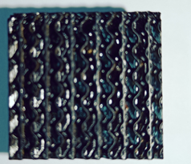
Fig.3. Combination of Gyroid + Re-entrant lattice structure (GR1B)
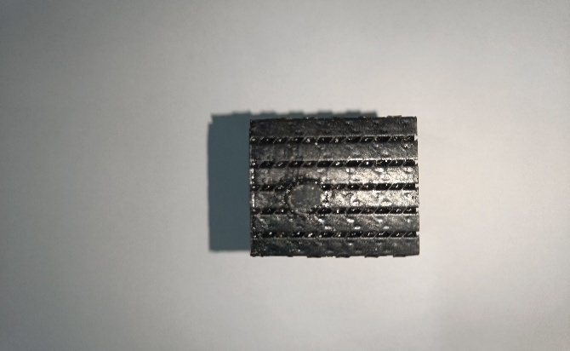
Fig.4. Combination of Gyroid + Re-entrant lattice structure (GR1C)
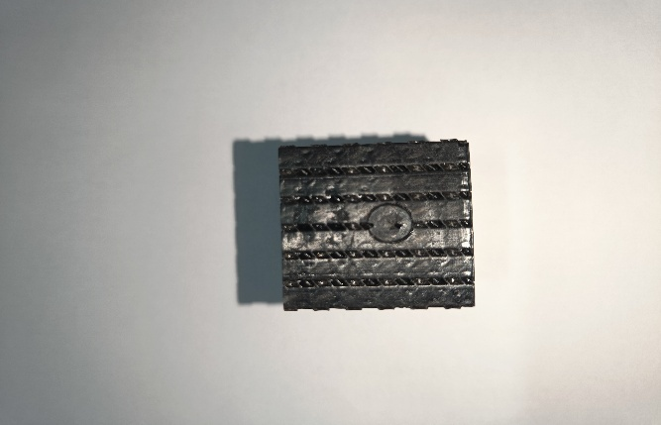
Fig.5. Combination of Gyroid + Re-entrant lattice structure (GR2A)

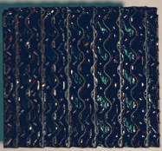
Fig.6. Combination of Gyroid + Re-entrant lattice structure (GR2B)

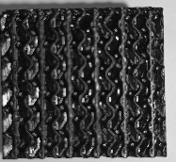
Fig.7. Combination of Gyroid + Re-entrant lattice structure (GR2C)

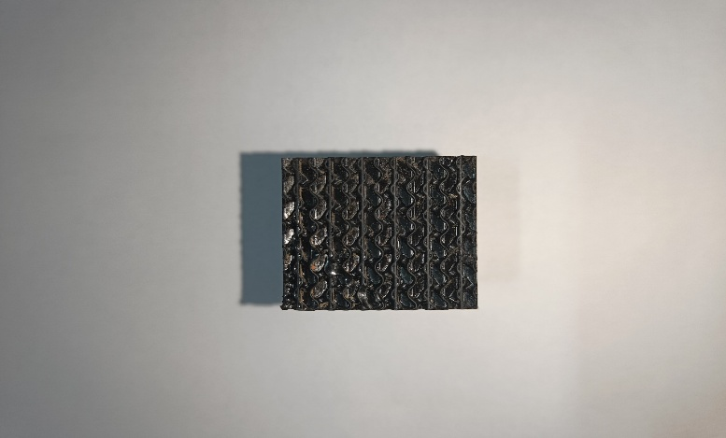
Fig.8. Combination of Gyroid + Re-entrant lattice structure (GR3A)
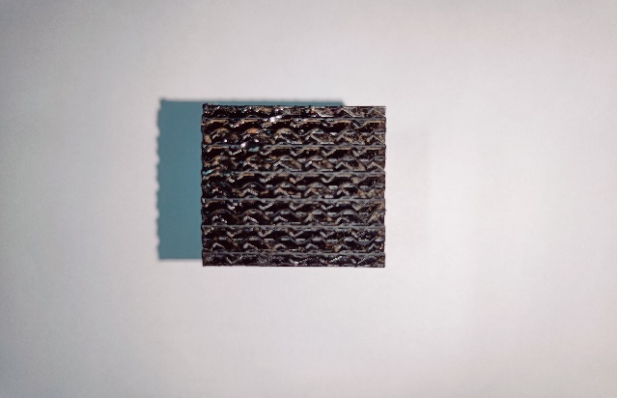
Fig.9. Combination of Gyroid + Re-entrant lattice structure (GR3B)

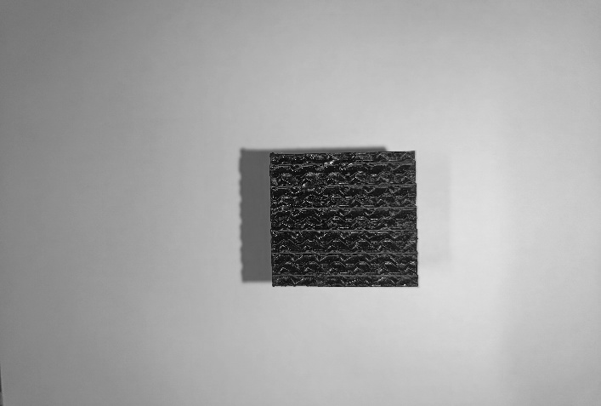
Fig.10. Combination of Gyroid + Re-entrant lattice structure (GR3C)
- Gyroid structure:

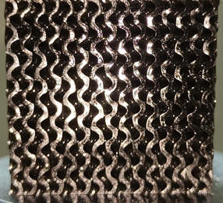
Fig.11. Gyroid lattice structure (G1A)

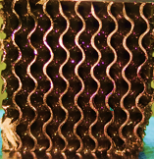
Fig.12. Gyroid lattice structure (G1B)

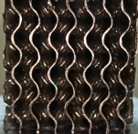
Fig.13. Gyroid lattice structure (G1C)

Fig.14. Gyroid lattice structure (G2A)

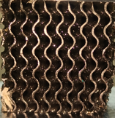
Fig.15. Gyroid lattice structure (G2B)

Fig.16. Gyroid lattice structure (G2C)

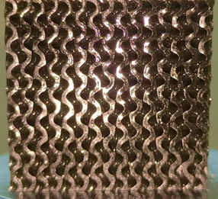
Fig.17. Gyroid lattice structure (G3A)

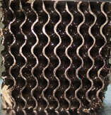
Fig.18. Gyroid lattice structure (G3B)

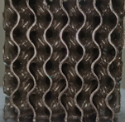
Fig.19. Gyroid lattice structure (G3C)
- Hexagonal honeycomb:

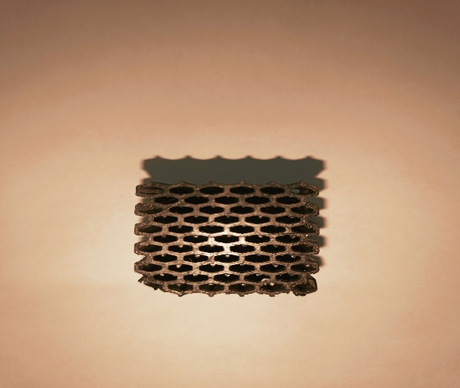
Fig. 20. Hexagonal honeycomb structure(H1A)
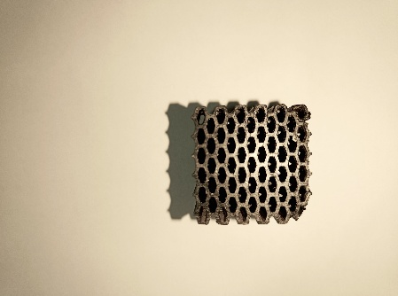
Fig. 21. Hexagonal honeycomb structure(H1B)

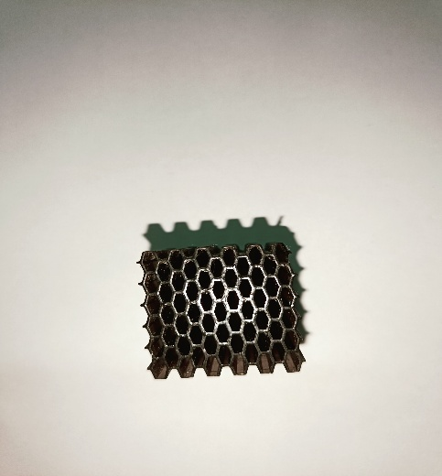
Fig. 22. Hexagonal honeycomb structure(H1C)

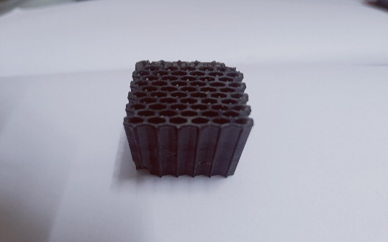
Fig. 23. Hexagonal honeycomb structure(H2A)

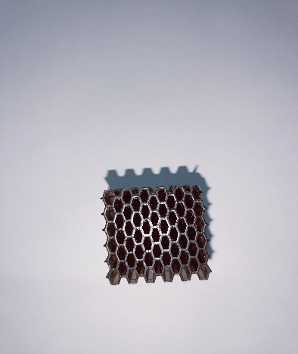
Fig. 24. Hexagonal honeycomb structure(H2B)

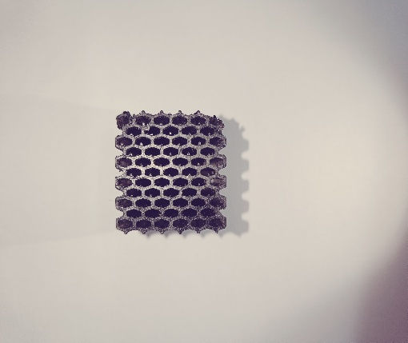
Fig. 25. Hexagonal honeycomb structure(H2C)

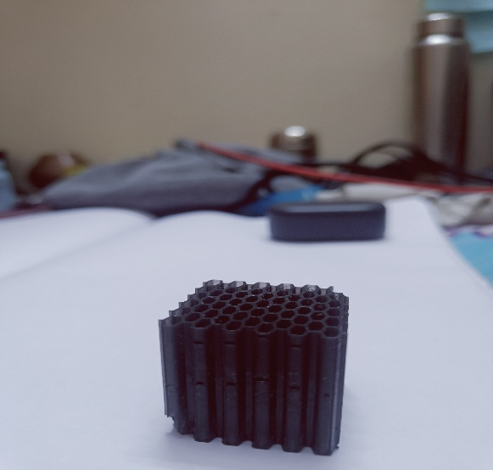
Fig. 26. Hexagonal honeycomb structure(H3A)

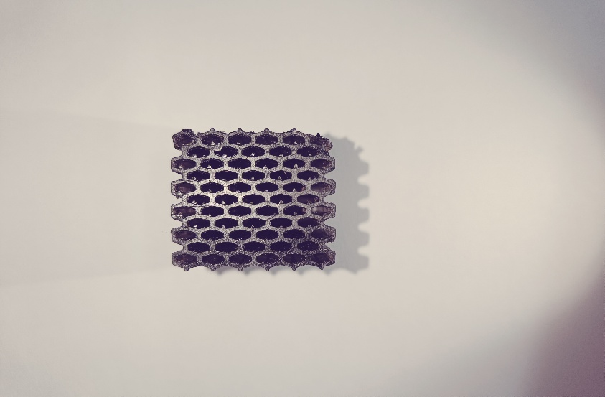
Fig. 27. Hexagonal honeycomb structure(H3B)

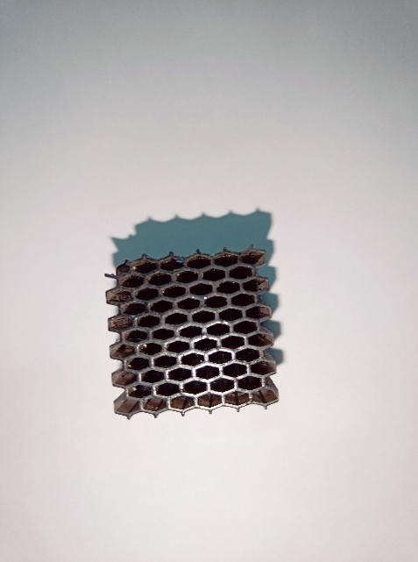
Fig. 28. Hexagonal honeycomb structure(H3C)

- Graphs of results: The following outputs (magnitude vs. frequency), represents the transfer function in terms of acceleration per unit force
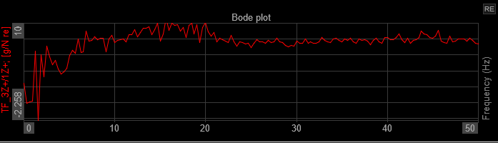
Fig. 29. Frequency of Gyroid Re-entrant honeycomb structure (GR1A)
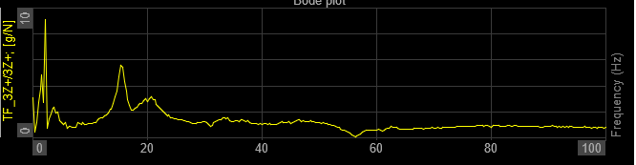
Fig. 30 Frequency of Gyroid Re-entrant honeycomb structure (GR1B)

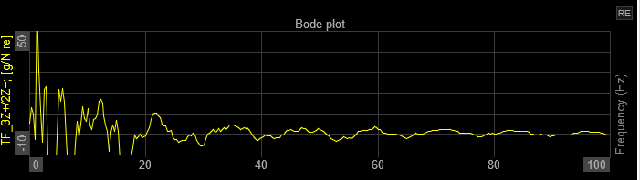
Fig. 31. Frequency of Gyroid Re-entrant honeycomb structure (GR1C)

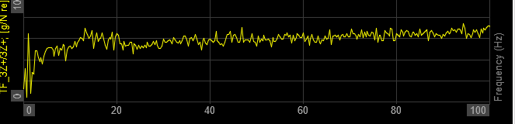
Fig. 32. Frequency of Gyroid Re-entrant honeycomb structure (GR2A)

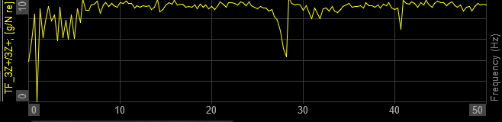
Fig. 33. Frequency of Gyroid Re-entrant honeycomb structure (GR2B)

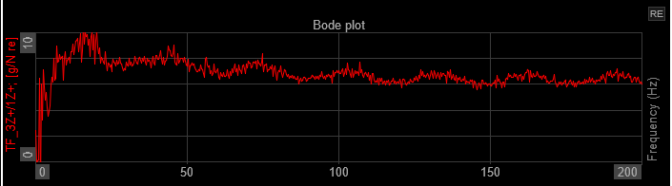
Fig. 34. Frequency of Gyroid Re-entrant honeycomb structure (GR2C)
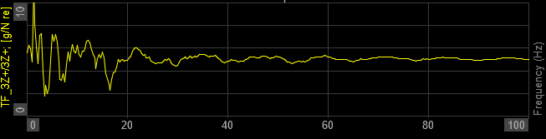
Fig. 35. Frequency of Gyroid Re-entrant honeycomb structure (GR3A)

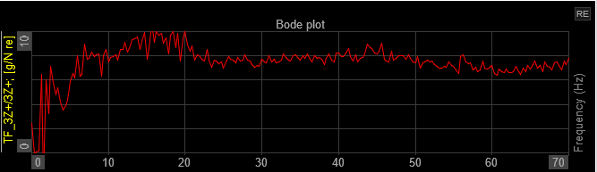
Fig. 35. Frequency of Gyroid Re-entrant honeycomb structure (GR3B)

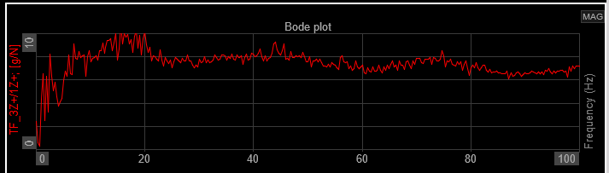
Fig. 37. Frequency of Gyroid Re-entrant honeycomb structure (GR3C)

Gyroid structure:
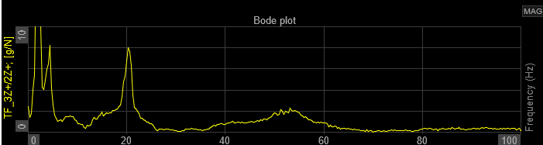
Fig.38. Frequency of Gyroid structure (G1A)

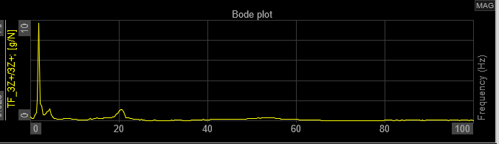
Fig.39. Frequency of Gyroid structure (G1B)
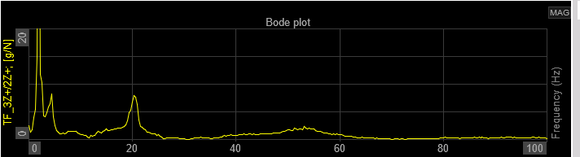
Fig.40. Frequency of Gyroid structure (G1C)

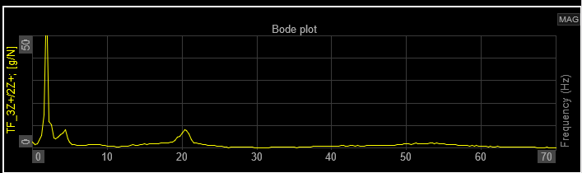
Fig.41. Frequency of Gyroid structure (G2A)

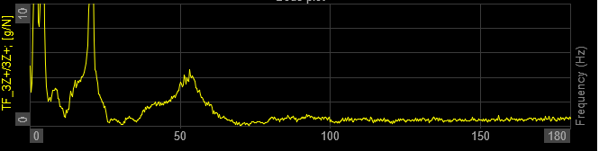
Fig. 42. Frequency of Gyroid structure (G2B)

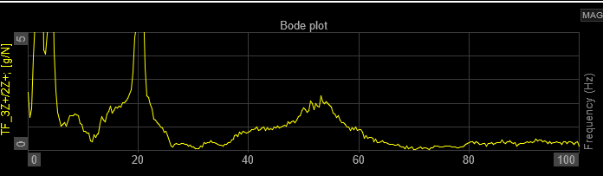
Fig. 43. Frequency of Gyroid structure (G2B)
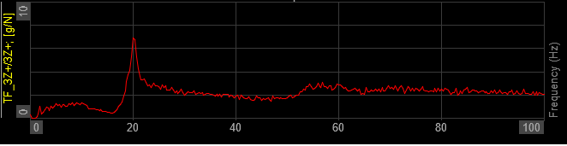
Fig. 44. Frequency of Gyroid structure (G3A)
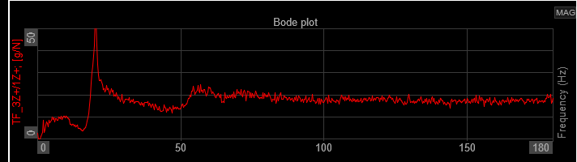
Fig. 45 Frequency of Gyroid structure (G3B)

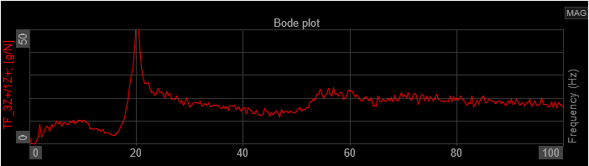
Fig. 46 Frequency of Gyroid structure (G3C)

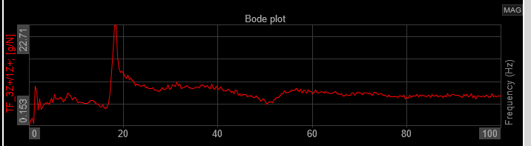
Fig. 47. Frequency Hexagonal honeycomb structure (H1A)

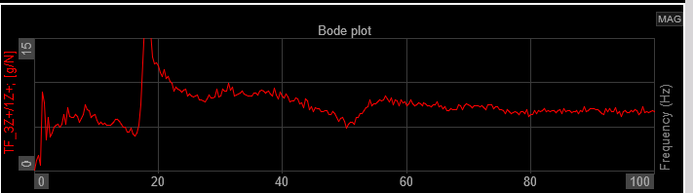
Fig. 48. Frequency Hexagonal honeycomb structure (H1B)

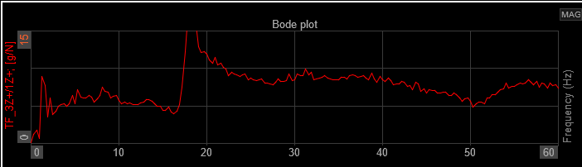
Fig. 49. Frequency Hexagonal honeycomb structure (H1C)

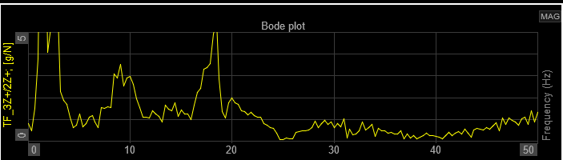
Fig. 50. Frequency Hexagonal honeycomb structure (H2A)
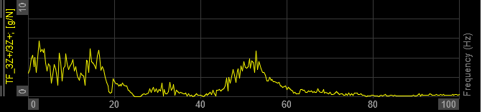
Fig. 51. Frequency Hexagonal honeycomb structure (H2B)

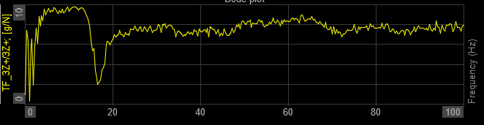
Fig. 52. Frequency Hexagonal honeycomb structure (H2C)

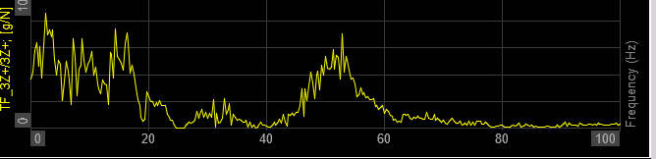
Fig. 53. Frequency Hexagonal honeycomb structure (H3A)

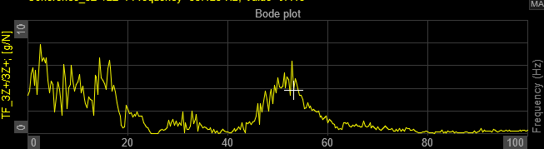
Fig. 54. Frequency Hexagonal honeycomb structure (H3B)

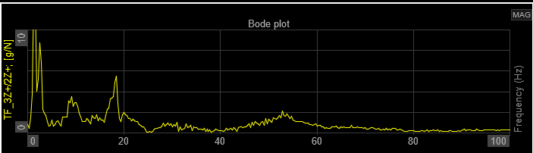
Fig. 55. Frequency Hexagonal honeycomb structure (H3C)

Table 1: Results of all 27 specimens
Natural frequency and damping ratio of all 27 specimens with the help of experimental setup.
Structure | Component Code | Natural Frequency (Hz) | Damping ratio (ζ)
Gyroid Re-entrant honeycomb | GR1A | 1.0349 | 0.1950
Gyroid Re-entrant honeycomb | GR1B | 1.0478 | 0.1969
Gyroid Re-entrant honeycomb | GR1C | 1.0620 | 0.1998
Gyroid Re-entrant honeycomb | GR2A | 1.0735 | 0.2010
Gyroid Re-entrant honeycomb | GR2B | 1.0900 | 0.2044
Gyroid Re-entrant honeycomb | GR2C | 1.1010 | 0.2071
Gyroid Re-entrant honeycomb | GR3A | 1.1050 | 0.2101
Gyroid Re-entrant honeycomb | GR3B | 1.1067 | 0.2113
Gyroid Re-entrant honeycomb | GR3C | 1.1093 | 0.2121
Gyroid | G1A | 1.9119 | 0.037841
Gyroid | G1B | 1.9189 | 0.037879
Gyroid | G1C | 1.9210 | 0.038010
Gyroid | G2A | 1.9247 | 0.038963
Gyroid | G2B | 1.9268 | 0.038989
Gyroid | G2C | 1.9310 | 0.039401
Gyroid | G3A | 1.9368 | 0.039451
Gyroid | G3B | 1.9397 | 0.039478
Gyroid | G3C | 1.9483 | 0.039499
Hexagonal honeycomb | H1A | 1.2681 | 0.069802
Hexagonal honeycomb | H1B | 1.2796 | 0.069982
Hexagonal honeycomb | H1C | 1.2987 | 0.072334
Hexagonal honeycomb | H2A | 1.3209 | 0.072609
Hexagonal honeycomb | H2B | 1.3311 | 0.074601
Hexagonal honeycomb | H2C | 1.3452 | 0.078466
Hexagonal honeycomb | H3A | 1.3681 | 0.079393
Hexagonal honeycomb | H3B | 1.3700 | 0.079578
Hexagonal honeycomb | H3C | 1.3778 | 0.079642

