Supplementary Information for:
Synthesis, characterization and application of ether and alcohol based solid phase extraction resins for purification of antimony-119 compatible with radiochemical applications in nuclear medicine

Aivija Grundmane^{a,b}, Illarion Dovhyi^{c}, Lauren Aburto-Kungª, Steffen Happel^{c}, Caterina Ramogida^{a,b} and Valery Radchenko^{b,d}

ª Simon Fraser University, Department of Chemistry, 8888 University Dr W, Burnaby, BC, V5A 1S6, Canada, aivija_grundmane@sfu.ca, caterina_ramogida@sfu.ca.
^{b} TRIUMF, Life Sciences Division, 4004 Wesbrook Mall, Vancouver, BC, V6T 2A3, Canada. vradchenko@triumf.ca
^{b} TrisKem International, 3 Rue des Champs Géons ZAC de, L'Éperon, 35170, Bruz, France.
^{d} University of British Columbia, Department of Chemistry, Vancouver, BC, V6T 1Z4, Canada.

Table S1. Radionuclides produced from proton bombardment of ^{nat}Sn and their predicted and measured activities decay corrected for the end of bombardment time.
Radionuclide^{[a]} | Half-life (h) | Decay^{[b]} | Predicted Activity (Electroplated) (MBq)^{[c]} | Measured Activity (Electroplated)  (n = 3, MBq)^{[d]}
¹¹⁵Sb | 0.535 | 100% ε | 161 | ^{[e]}
¹¹⁶Sb | 0.263 | 100% ε | 9250 | ^{[e]}
^{116m}Sb | 1.01 | 100% ε | 208 | ^{[e]}
¹¹⁷Sb | 2.80 | 100% β⁺ | 1470 | 700 ± 200
^{117m}Sn | 336 | 100% IT | 0.177 | ^{[e]}
¹¹⁸Sb | 0.0600 | 100% ε | 17900 | ^{[e]}
^{118m}Sb | 5.00 | 100% ε | 87.6 | 70 ± 20
¹¹⁹Sb | 38.2 | 100% EC | 281 | 280 ± 60
¹²⁰Sb | 0.265 | 100% β⁺ | 12300 | ^{[e]}
^{120m}Sb | 138 | 100% ε | 7.42 | 3 ± 1
¹²²Sb | 65.4 | 97.6% β⁻  2.41% ε | 8.74 | 6 ± 2
¹²⁴Sb | 1440 | 100% β⁻ | 0.142 | 0.18 ± 0.04
^{124m}Sb | 0.337 | 100% IT | 136 | ^{[e]}
[a] Only radioantimony and radiotin nuclides with a half-life longer than 10 min (or those generated from a meta-stable state with a half-life longer than 10 min) resulting in a predicted activity of at least 0.1 MBq at the highest irradiation conditions are reported here.
[b] β⁻ – beta decay, EC – electron capture, β⁺ – positron, ε – EC and β⁺, IT – isomeric transition.
[c] Calculated using IAEA Medical Isotope Browser, IAEA and TENDL cross sections. Irradiation of a 100 mg/cm² ^{nat}Sn electroplated on Ag backing using 13 MeV protons, 30 µA beam current for 1 hour.
[d] Irradiation of 100 ± 1 mg/cm² (n = 3) ^{nat}Sn electroplated on Ag backing using 13 MeV protons, 30 µA beam current for 1 hour.
[e] Radionuclide not measured experimentally.

Table S2. Mass of the resin used depending on the volume of the chromatography reservoir.
Resin Name | Mass of resin in 1 mL reservoir (mg ± 5 mg) | Mass of resin in 2 mL reservoir (mg ± 5 mg)
DBE-71 | 300 | 500
DPE-71 | 300 | 600
DOE-71 | 300 | 600
TK401-71 | 350 | 700
CG71 support only | 300 | 650
DBE-300 | 200 | 400
DPE-300 | 250 | 500
DOE-300 | 250 | 550
TK401-300 | 300 | 550

Table S3. Layering of aqueous phase and resin in a range of concentrations/densities of hydrochloric acid. ↑ – resin floated, ↓ – resin sank, ↕ – no clear layering.
Resin name | Resin layering in different concentrations/densities of hydrochloric acid
Resin name | 0.01 M  (1.00 g/cm³) | 0.1 M  (1.00 g/cm³) | 0.5 M  (1.01 g/cm³) | 1 M  (1.02 g/cm³) | 2 M  (1.03 g/cm³) | 3 M  (1.07 g/cm³) | 6 M  (1.10 g/cm³) | 8 M  (1.13 g/cm³) | 10 M  (1.16 g/cm³) | 12 M  (1.18 g/cm³)
DBE-71 | ↑ | ↑ | ↕ | ↕ | ↕ | ↕ | ↓ | ↓ | ↓ | ↓
DPE-71 | ↑ | ↑ | ↑ | ↑ | ↑ | ↑ | ↑ | ↑ | ↑ | ↑
DOE-71 | ↑ | ↑ | ↑ | ↑ | ↑ | ↑ | ↑ | ↑ | ↑ | ↑
TK401-71 | ↑ | ↑ | ↑ | ↑ | ↑ | ↑ | ↕ | ↓ | ↓ | ↓
CG71 support only | ↓ | ↓ | ↓ | ↓ | ↓ | ↓ | ↓ | ↓ | ↓ | ↓
DBE-300 | ↑ | ↑ | ↑ | ↑ | ↑ | ↑ | ↑ | ↑ | ↑ | ↑
DPE-300 | ↑ | ↑ | ↑ | ↑ | ↑ | ↑ | ↑ | ↑ | ↑ | ↑
DOE-300 | ↑ | ↑ | ↑ | ↑ | ↑ | ↑ | ↑ | ↑ | ↑ | ↑
TK401-300 | ↑ | ↑ | ↑ | ↑ | ↑ | ↑ | ↑ | ↑ | ↑ | ↑
CG300 support only | ↑ | ↑ | ↑ | ↑ | ↑ | ↑ | ↑ | ↑ | ↑

Table S4. Distribution coefficient (K_{D}) values for DBE-71 resin.
Element^{[a]} | Distribution coefficients (K_{D}) in hydrochloric acid (K_{D} ± SD, n = 3)
Element^{[a]} | 0.01 M | 0.1 M | 0.5 M | 1 M | 2 M | 3 M | 6 M | 8 M | 10 M | 12 M
Aluminium (Al) | 21 ± 6 | 12 ± 3 | 12 ± 4 | 31 ± 16 | 30 ± 30 | 18 ± 4 | 17 ± 13 | 22 ± 13 | 50 ± 40
Antimony (Sb) | 5.3 ± 1.6 | 10 ± 2 | 9 ± 3 | 13 ± 3 | 15 ± 6 | 15 ± 4 | 540 ± 20 | 7700 ± 700 | 82000 ± 11000
Antimony (Sb, single-element standard) |  |  |  |  |  |  | 440 ± 130 | 1700 ± 200 | 2950 ± 170 | 3600 ± 900
Antimony (^{120m}Sb) |  | 35 ± 4 | 54 ± 2 | 54 ± 7 | 62 ± 4 | 64 ± 4 | 840 ± 20 | 20000 ± 30000 | 1300 ± 200 | 2200 ± 1300
Barium (Ba) | 5.1 ± 1.5 | 10 ± 2 | 10 ± 3 | 13 ± 3 | 14 ± 7 | 15 ± 4 | 18.8 ± 1.9 | 13 ± 2 | 37 ± 14
Bismuth (Bi) | 1.9 ± 0.3 | 10 ± 3 | 11 ± 5 | 14.4 ± 0.3 | 15 ± 6 | 15.2 ± 1.7 | 19 ± 4 | 14 ± 3 | 37 ± 12
Cerium (Ce) | 4 ± 3 | 14 ± 3 | 9.3 ± 1.3 | 9 ± 8 | 13 ± 7 | 13 ± 6 | 16 ± 4 | 15 ± 4 | 31 ± 11
Cesium (Cs) | 6.3 ± 1.4 | 11 ± 2 | 11 ± 3 | 14 ± 2 | 15 ± 8 | 15 ± 4 | 19.1 ± 1.7 | 14 ± 3 | 38 ± 14
Cobalt (Co) | 7.5 ± 1.9 | 11 ± 3 | 11 ± 3 | 17 ± 3 | 16 ± 8 | 15 ± 4 | 20.9 ± 1.8 | 18 ± 3 | 45 ± 17
Copper (Cu) | 7 ± 2 | 11 ± 2 | 12 ± 3 | 16 ± 3 | 17 ± 7 | 15 ± 5 | 21 ± 3 | 16 ± 2 | 44 ± 18
Erbium (Er) | 6.0 ± 1.4 | 9 ± 2 | 9 ± 3 | 13 ± 3 | 15 ± 7 | 16 ± 4 | 19 ± 2 | 14 ± 3 | 37 ± 14
Europium (Eu) | 5.6 ± 1.4 | 8 ± 2 | 8.0 ± 0.8 | 13 ± 3 | 15 ± 7 | 16.7 ± 0.3 | 17.9 ± 1.9 | 13 ± 2 | 35 ± 13
Gallium (Ga) | 7.3 ± 1.7 | 11 ± 2 | 10.3 ± 1.0 | 16 ± 4 | 17 ± 7 | 22 ± 6 | 1430 ± 110 | 1290 ± 120 | 2600 ± 800
Hafnium (Hf) | 4.4 ± 1.6 | 9 ± 2 | 9.9 ± 1.9 | 14 ± 3 | 14 ± 6 | 14 ± 4 | 16 ± 2 | 12 ± 2 | 33 ± 12
Lanthanum (La) | 6.0 ± 1.8 | 9 ± 2 | 10 ± 3 | 13 ± 3 | 14 ± 6 | 14 ± 4 | 15.8 ± 1.7 | 13 ± 2 | 33 ± 13
Lead (Pb) | 2.6 ± 1.9 | 8 ± 3 | 9 ± 5 | 14.6 ± 1.6 | 14 ± 4 | 14.7 ± 1.7 | 20 ± 6 | 14 ± 8 | 43 ± 11
Lutetium (Lu) | 5.1 ± 1.7 | 10 ± 2 | 10 ± 3 | 14 ± 3 | 14 ± 7 | 14 ± 4 | 16.9 ± 1.7 | 13 ± 2 | 34 ± 14
Molybdenum (Mo) | 5.6 ± 1.7 | 10.9 ± 1.7 | 10 ± 3 | 16 ± 4 | 20 ± 9 | 27 ± 5 | 90 ± 6 | 91 ± 14 | 180 ± 50
Neodymium (Nd) | 4 ± 3 | 10 ± 2 | 10 ± 3 | 14 ± 3 | 13 ± 7 | 13 ± 5 | 15 ± 7 | 12 ± 2 | 32 ± 11
Nickel (Ni) | 8 ± 2 | 12 ± 3 | 13 ± 4 | 17 ± 3 | 18 ± 7 | 20 ± 6 | 22 ± 2 | 19 ± 3 | 46 ± 19
Niobium (Nb) | 7.6 ± 1.5 | 13 ± 2 | 10 ± 3 | 17 ± 4 | 18 ± 8 | 15 ± 4 | 26 ± 3 | 69 ± 11 | 390 ± 110
Rhenium (Re) | 13 ± 2 | 19 ± 3 | 22 ± 3 | 28 ± 5 | 30 ± 9 | 31 ± 5 | 26 ± 3 | 21 ± 3 | 41 ± 15
Rubidium (Rb) | 6 ± 2 | 11 ± 2 | 13 ± 3 | 15 ± 3 | 16 ± 7 | 15 ± 4 | 21 ± 2 | 15 ± 3 | 42 ± 16
Scandium (Sc) | 6.7 ± 1.8 | 10.6 ± 1.9 | 11 ± 3 | 17 ± 2 | 16 ± 7 | 16 ± 4 | 21 ± 3 | 16 ± 2 | 42 ± 17
Silver (Ag) | 4 ± 3 | 21.0 ± 1.6 | 13 ± 4 | 17 ± 3 | 18 ± 8 | 17 ± 4 | 20.7 ± 1.3 | 15 ± 3 | 40 ± 15
Strontium (Sr) | 6 ± 2 | 10 ± 3 | 12 ± 3 | 16 ± 3 | 17 ± 8 | 15 ± 5 | 20 ± 2 | 14 ± 3 | 41 ± 16
Thallium (Tl) | 5.3 ± 1.8 | 13.7 ± 1.5 | 90 ± 10 | 7100 ± 500 | 10000 ± 2000 | 6600 ± 400 | 3000 ± 1000 | 2200 ± 600 | 2500 ± 500
Thorium (Th) | 4.1 ± 1.7 | 7.6 ± 1.4 | 9 ± 2 | 12.8 ± 1.9 | 13 ± 5 | 12 ± 3 | 15 ± 3 | 12 ± 3 | 32 ± 10
Tin (Sn) | 5.8 ± 1.8 | 10.5 ± 1.5 | 13 ± 3 | 19 ± 4 | 31 ± 10 | 42 ± 6 | 47 ± 5 | 38 ± 4 | 70 ± 20
Tin (^{117m}Sn) |  | 5 ± 5 | 10 ± 2 | 6 ± 7 | 21 ± 6 | 17 ± 5 | 15 ± 4 | 25 ± 3 | 28 ± 8 | 26 ± 10
Uranium (U) | 4.8 ± 1.9 | 8 ± 2 | 10 ± 3 | 14 ± 3 | 14 ± 7 | 14 ± 4 | 17 ± 2 | 14.9 ± 1.6 | 42 ± 15
Ytterbium (Yb) | 6.0 ± 1.8 | 9 ± 3 | 10 ± 3 | 14 ± 3 | 15 ± 7 | 15 ± 5 | 18 ± 2 | 14 ± 2 | 37 ± 14
Yttrium (Y) | 6.7 ± 1.3 | 11 ± 2 | 11 ± 3 | 16 ± 3 | 17 ± 7 | 16 ± 5 | 20.7 ± 1.9 | 14 ± 3 | 40 ± 15
Zinc (Zn) | 4.9 ± 1.9 | 9.1 ± 1.8 | 9.7 ± 1.9 | 15 ± 3 | 15 ± 7 | 15 ± 4 | 20.1 ± 1.9 | 15 ± 2 | 38 ± 14
Zirconium (Zr) | 5.9 ± 1.5 | 10.0 ± 1.8 | 11 ± 3 | 14 ± 3 | 16 ± 7 | 13 ± 4 | 18.8 ± 1.8 | 13 ± 3 | 38 ± 13
^{[a]}Unless noted otherwise, all K_{D} values were acquired using stable elements from a multi-element standard.

Table S5. Distribution coefficient (K_{D}) values for DPE-71 resin.
Element^{[a]} | Distribution coefficients (K_{D}) in hydrochloric acid (K_{D} ± SD, n = 3)
Element^{[a]} | 0.01 M | 0.1 M | 0.5 M | 1 M | 2 M | 3 M | 6 M | 8 M | 10 M | 12 M
Aluminium (Al) | 2.7 ± 1.4 | 1.2 ± 0.4 | 1.8 ± 1.3 | 7.2 ± 0.7 | 12 ± 4 | 8 ± 6 | 4 ± 4 | 17.5 ± 1.2 | 13 ± 2
Antimony (Sb) | 2.74×10⁻³ ± 9×10⁻⁵ | 0.7 ± 1.1 | 0.8 ± 1.3 | 4.0 ± 1.5 | 6.7 ± 1.8 | 6.1 ± 0.9 | 57 ± 3 | 2040 ± 150 | 26000 ± 2000
Antimony (Sb, single-element standard) |  |  |  |  |  |  | 174 ± 14 | 1600 ± 500 | 5000 ± 5000 | 8600 ± 300
Antimony (^{120m}Sb) |  | 24.2 ± 1.5 | 36 ± 3 | 47 ± 5 | 50 ± 2 | 41 ± 5 | 200 ± 20 | 1500 ± 500 | 700 ± 400 | 1500 ± 500
Barium (Ba) | 6.4×10⁻³ ± 2×10⁻⁴ | 0.4 ± 0.8 | 1.3 ± 1.2 | 3.6 ± 1.1 | 5.3 ± 1.3 | 6.9 ± 1.0 | 3.5 ± 0.5 | 8.2 ± 1.0 | 8 ± 2
Bismuth (Bi) | 2.0 ± 0.6 | 0.50 ± 0.09 | 0.4 ± 0.4 | 1.3 ± 0.9 | 4 ± 4 | 3 ± 2 | 4.5 ± 1.3 | 6.9 ± 1.7 | 8.0 ± 1.6
Cerium (Ce) | 1.05×10⁻² ± 5×10⁻⁴ | 4 ± 2 | 1.4 ± 1.3 | 3.7 ± 1.4 | 5.6 ± 1.7 | 6.4 ± 0.5 | 4.5 ± 0.2 | 7.5 ± 1.7 | 7.7 ± 0.6
Cesium (Cs) | 4.8×10⁻³ ± 2×10⁻⁴ | 0.5 ± 0.9 | 1.9 ± 1.4 | 4.2 ± 1.2 | 6.0 ± 1.3 | 6.4 ± 1.0 | 4.8 ± 1.3 | 8.3 ± 1.4 | 7.8 ± 1.0
Cobalt (Co) | 4.86×10⁻³ ± 8×10⁻⁵ | 0.5 ± 0.9 | 2.0 ± 1.1 | 3.2 ± 1.8 | 8.5 ± 1.8 | 7.4 ± 0.9 | 5.8 ± 1.0 | 8.3 ± 0.8 | 9.2 ± 0.9
Copper (Cu) | 4.9×10⁻² ± 3×10⁻³ | 1.1 ± 1.7 | 2.0 ± 1.5 | 5.6 ± 1.4 | 8 ± 2 | 7 ± 3 | 5.2 ± 1.0 | 8.2 ± 1.3 | 8.5 ± 0.4
Erbium (Er) | 3.8×10⁻⁴ ± 2×10⁻⁵ | 0.6 ± 1.1 | 1.5 ± 1.5 | 3.6 ± 1.4 | 6.5 ± 1.8 | 6.2 ± 0.2 | 4.2 ± 0.4 | 7.0 ± 1.8 | 7.9 ± 1.0
Europium (Eu) | 1.45×10⁻³ ± 5×10⁻⁵ | 0.5 ± 0.9 | 2.4 ± 1.0 | 3.5 ± 1.0 | 5.6 ± 1.4 | 5.5 ± 0.9 | 4.3 ± 0.9 | 7.9 ± 1.4 | 7.2 ± 1.8
Gallium (Ga) | 2.40×10⁻³ ± 1.1×10⁻⁴ | 0.6 ± 1.1 | 1.7 ± 1.4 | 4.2 ± 1.9 | 6 ± 2 | 8.0 ± 0.8 | 420 ± 20 | 1330 ± 30 | 1600 ± 90
Hafnium (Hf) | 2.27×10⁻² ± 1.1×10⁻³ | 0.9 ± 1.5 | 1.9 ± 1.2 | 2.6 ± 1.1 | 5 ± 2 | 6.9 ± 1.2 | 4.3 ± 1.2 | 6.6 ± 1.3 | 7.1 ± 1.0
Lanthanum (La) | 4.2×10⁻³ ± 3×10⁻⁴ | 0.8 ± 1.4 | 1.4 ± 1.2 | 4.9 ± 1.4 | 5.6 ± 1.0 | 6.4 ± 0.8 | 4.7 ± 1.1 | 6.9 ± 1.8 | 7.2 ± 1.7
Lead (Pb) | 0.31 ± 0.03 | 0.34 ± 0.05 | 1.1 ± 1.2 | 1.4 ± 1.8 | 4 ± 4 | 4 ± 4 | 3 ± 3 | 5 ± 3 | 7 ± 3
Lutetium (Lu) | 1.15×10⁻² ± 3×10⁻⁴ | 0.4 ± 0.8 | 1.4 ± 0.8 | 4.5 ± 1.1 | 5.8 ± 1.6 | 6.0 ± 0.6 | 4.6 ± 1.5 | 6.7 ± 1.8 | 6.8 ± 1.1
Molybdenum (Mo) | 0.106 ± 0.005 | 0.7 ± 1.1 | 1.0 ± 1.4 | 3.6 ± 1.9 | 6 ± 2 | 7.0 ± 0.8 | 14.8 ± 1.9 | 36 ± 4 | 45.8 ± 1.1
Neodymium (Nd) | 9.0×10⁻³ ± 4×10⁻⁴ | 1.3 ± 1.3 | 1.2 ± 1.0 | 3.4 ± 1.3 | 5.3 ± 1.5 | 5.3 ± 0.7 | 4.9 ± 0.9 | 7.2 ± 1.1 | 7.5 ± 0.6
Nickel (Ni) | 3.88×10⁻² ± 1.7×10⁻³ | 1.7 ± 1.8 | 2.3 ± 1.6 | 5.4 ± 1.8 | 9.9 ± 1.8 | 9.2 ± 1.5 | 7.0 ± 0.6 | 10.1 ± 1.4 | 9.9 ± 1.0
Niobium (Nb) | 4.42×10⁻² ± 1.5×10⁻³ | 1.0 ± 1.7 | 0.5 ± 0.8 | 3.7 ± 1.4 | 5.9 ± 1.7 | 4.8 ± 0.9 | 3.4 ± 0.5 | 20.4 ± 1.5 | 91.1 ± 1.4
Rhenium (Re) | 3.38×10⁻⁴ ± 1.2×10⁻⁵ | 0.4 ± 0.7 | 2.5 ± 1.4 | 3.7 ± 1.2 | 6.6 ± 1.8 | 5.3 ± 0.5 | 5.6 ± 0.9 | 9.0 ± 1.3 | 8.5 ± 0.5
Rubidium (Rb) | 2.01×10⁻³ ± 5×10⁻⁵ | 0.6 ± 1.1 | 1.5 ± 1.2 | 4 ± 2 | 7.2 ± 1.5 | 6.8 ± 1.3 | 4.8 ± 1.1 | 7.7 ± 1.2 | 9.4 ± 1.2
Scandium (Sc) | 2.18×10⁻² ± 8×10⁻⁴ | 0.6 ± 1.0 | 0.9 ± 1.0 | 4.0 ± 1.3 | 8 ± 2 | 6.1 ± 0.8 | 4.3 ± 0.6 | 7.6 ± 1.2 | 8.7 ± 0.6
Silver (Ag) | 0.14 ± 0.03 | 5.6 ± 1.4 | 1.4 ± 1.6 | 3.9 ± 1.5 | 8 ± 2 | 6.9 ± 1.1 | 6.1 ± 0.2 | 9.2 ± 1.7 | 9.5 ± 1.3
Strontium (Sr) | 1.54×10⁻² ± 1.0×10⁻³ | 0.2 ± 0.3 | 2.7 ± 1.1 | 4.4 ± 1.2 | 8 ± 2 | 6.9 ± 0.8 | 4.4 ± 0.9 | 8.7 ± 1.4 | 9.6 ± 0.6
Thallium (Tl) | 4.20×10⁻² ± 1.3×10⁻³ | 2.5 ± 1.7 | 107 ± 13 | 148 ± 13 | 230 ± 60 | 219 ± 19 | 94 ± 4 | 287 ± 5 | 552 ± 12
Thorium (Th) | 3.14×10⁻² ± 1.3×10⁻³ | 0.4 ± 0.7 | 0.4 ± 0.7 | 3.3 ± 1.8 | 5 ± 2 | 4.3 ± 1.5 | 2.9 ± 1.0 | 4.8 ± 0.8 | 5.6 ± 0.7
Tin (Sn) | 9.9×10⁻² ± 3×10⁻³ | 0.4 ± 0.6 | 0.7 ± 1.0 | 4.4 ± 1.9 | 7.1 ± 1.9 | 7.0 ± 1.7 | 4.6 ± 0.6 | 11.1 ± 1.3 | 14 ± 2
Tin (^{117m}Sn) |  | 4 ± 3 | 14 ± 15 | 23 ± 2 | 27 ± 15 | 10 ± 4 | 30 ± 20 | 21 ± 4 | 18 ± 2 | 28 ± 8
Uranium (U) | 1.260×10⁻³ ± 9×10⁻⁶ | 0.4 ± 0.8 | 0.9 ± 1.1 | 3.8 ± 1.8 | 6.1 ± 1.6 | 4.8 ± 0.7 | 2.9 ± 1.1 | 6.2 ± 1.0 | 7.7 ± 0.8
Ytterbium (Yb) | 0.149 ± 0.006 | 0.9 ± 1.3 | 1.5 ± 1.0 | 4.1 ± 1.4 | 7.4 ± 1.9 | 6.9 ± 0.7 | 4.5 ± 0.7 | 6.1 ± 1.2 | 7.5 ± 1.1
Yttrium (Y) | 1.37×10⁻³ ± 3×10⁻⁵ | 0.4 ± 0.8 | 1.3 ± 1.7 | 4.0 ± 1.6 | 6.2 ± 1.4 | 6.9 ± 0.9 | 6.1 ± 0.8 | 9.1 ± 0.8 | 9.1 ± 1.8
Zinc (Zn) | 5.0×10⁻² ± 3×10⁻³ | 1.1 ± 1.4 | 2.0 ± 1.1 | 3.5 ± 1.9 | 9 ± 2 | 7.7 ± 0.9 | 5.3 ± 1.1 | 8.7 ± 1.3 | 10.0 ± 0.5
Zirconium (Zr) | 3.77×10⁻² ± 1.1×10⁻³ | 0.5 ± 0.7 | 0.9 ± 1.4 | 3.4 ± 1.2 | 6 ± 2 | 5.3 ± 1.9 | 4.9 ± 1.0 | 6.5 ± 1.1 | 8 ± 2
^{[a]}Unless noted otherwise, all K_{D} values were acquired using stable elements from a multi-element standard.

Table S6. Distribution coefficient (K_{D}) values for DOE-71 resin.
Element^{[a]} | Distribution coefficients (K_{D}) in hydrochloric acid (K_{D} ± SD, n = 3)
Element^{[a]} | 0.01 M | 0.1 M | 0.5 M | 1 M | 2 M | 3 M | 6 M | 8 M | 10 M | 12 M
Aluminium (Al) | 6 ± 3 | 0.7 ± 0.6 | 4.4 ± 0.5 | 1.0 ± 0.5 | 3 ± 2 | 3.9 ± 0.7 | 2.5 ± 0.8 | 1.7 ± 0.4 | 0.4 ± 0.3
Antimony (Sb) | 0.5 ± 0.8 | 2.59×10⁻³ ± 2×10⁻⁵ | 2.76×10⁻³ ± 2×10⁻⁵ | 2.81×10⁻³ ± 1.5×10⁻⁴ | 0.6 ± 1.1 | 0.5 ± 0.3 | 17.4 ± 1.0 | 640 ± 30 | 14600 ± 200
Antimony (Sb, single-element standard) |  |  |  |  |  |  | 179 ± 15 | 1600 ± 500 | 5000 ± 5000 | 8570 ± 170
Antimony (^{120m}Sb) |  | 20 ± 5 | 48 ± 3 | 57 ± 7 | 60 ± 10 | 53 ± 2 | 90 ± 30 | 400 ± 300 | 180 ± 30 | 1700 ± 1100
Barium (Ba) | 0.4 ± 0.7 | 3.20×10⁻³ ± 4×10⁻⁵ | 4.4×10⁻³ ± 1.4×10⁻³ | 3.05×10⁻³ ± 1.7×10⁻⁴ | 0.5 ± 0.9 | 0.2 ± 0.2 | 0.3 ± 0.3 | 3.70×10⁻³ ± 1.4×10⁻⁴ | 0.09 ± 0.12
Bismuth (Bi) | 1.95 ± 0.07 | 0.38 ± 0.03 | 0.47 ± 0.04 | 0.46 ± 0.03 | 0.46 ± 0.02 | 0.34 ± 0.12 | 0.307 ± 0.003 | 0.230 ± 0.005 | 0.211 ± 0.008
Cerium (Ce) | 0.9 ± 1.2 | 2.9 ± 0.4 | 3.42×10⁻² ± 7×10⁻⁴ | 6.7×10⁻³ ± 3×10⁻⁴ | 0.6 ± 1.0 | 0.7 ± 0.3 | 0.8 ± 0.3 | 0.08 ± 0.12 | 0.2 ± 0.4
Cesium (Cs) | 9×10⁻² ± 4×10⁻² | 1.9×10⁻³ ± 2×10⁻⁴ | 4×10⁻² ± 3×10⁻² | 2.24×10⁻³ ± 1.2×10⁻⁴ | 0.4 ± 0.7 | 0.6 ± 0.4 | 0.06 ± 0.11 | 2.57×10⁻³ ± 6×10⁻⁵ | 0.1 ± 0.2
Cobalt (Co) | 0.8 ± 1.3 | 5.04×10⁻³ ± 8×10⁻⁵ | 0.15 ± 0.15 | 5.8×10⁻³ ± 3×10⁻⁴ | 0.5 ± 0.9 | 0.4 ± 0.4 | 5.70×10⁻³ ± 3×10⁻⁵ | 5.49×10⁻³ ± 1.2×10⁻⁴ | 6.3×10⁻³ ± 4×10⁻⁴
Copper (Cu) | 0.8 ± 1.4 | 6×10⁻² ± 3×10⁻² | 0.7 ± 0.5 | 4.2×10⁻² ± 2×10⁻³ | 1.0 ± 1.6 | 0.5 ± 0.6 | 0.16 ± 0.14 | 0.22637 ± 0.00010 | 0.3 ± 0.3
Erbium (Er) | 0.5 ± 0.8 | 2.389×10⁻⁴ ± 1.9×10⁻⁶ | 5×10⁻³ ± 8×10⁻³ | 2.22×10⁻⁴ ± 1.2×10⁻⁵ | 1.1 ± 1.7 | 0.4 ± 0.5 | 0.2 ± 0.3 | 2.01×10⁻⁴ ± 3×10⁻⁶ | 2.28×10⁻⁴ ± 7×10⁻⁶
Europium (Eu) | 0.3 ± 0.5 | 4.72×10⁻⁴ ± 8×10⁻⁶ | 0.10 ± 0.15 | 5.7×10⁻⁴ ± 2×10⁻⁵ | 0.7 ± 1.3 | 0.2 ± 0.2 | 0.3 ± 0.2 | 3.88×10⁻⁴ ± 9×10⁻⁶ | 7.3×10⁻⁴ ± 3×10⁻⁵
Gallium (Ga) | 0.7 ± 1.1 | 1.064×10⁻³ ± 1.0×10⁻⁵ | 1.56×10⁻³ ± 5×10⁻⁵ | 2.08×10⁻³ ± 9×10⁻⁵ | 0.5 ± 0.9 | 0.2 ± 0.3 | 91 ± 3 | 453 ± 18 | 793 ± 17
Hafnium (Hf) | 0.4 ± 0.6 | 0.11 ± 0.16 | 1.53×10⁻² ± 3×10⁻⁴ | 1.56×10⁻² ± 7×10⁻⁴ | 0.6 ± 1.0 | 0.4 ± 0.4 | 1.461×10⁻² ± 1.1×10⁻⁴ | 1.36×10⁻² ± 2×10⁻⁴ | 1.34×10⁻² ± 4×10⁻⁴
Lanthanum (La) | 0.6 ± 1.0 | 1.123×10⁻³ ± 6×10⁻⁶ | 1.276×10⁻³ ± 1.5×10⁻⁵ | 1.38×10⁻³ ± 5×10⁻⁵ | 0.8 ± 1.3 | 0.68 ± 0.16 | 1.71×10⁻³ ± 2×10⁻⁵ | 1.40×10⁻³ ± 3×10⁻⁵ | 1.69×10⁻³ ± 8×10⁻⁵
Lead (Pb) | 0.122 ± 0.010 | 0.103 ± 0.003 | 0.118 ± 0.007 | 0.119 ± 0.008 | 0.124 ± 0.007 | 0.11 ± 0.04 | 0.128 ± 0.003 | 0.1068 ± 0.0014 | 0.111 ± 0.004
Lutetium (Lu) | 0.5 ± 0.9 | 2.24×10⁻⁴ ± 3×10⁻⁶ | 0.2 ± 0.3 | 1.98×10⁻⁴ ± 8×10⁻⁶ | 0.8 ± 1.4 | 1.0 ± 0.7 | 0.2 ± 0.3 | 2.052×10⁻⁴ ± 1.4×10⁻⁶ | 0.04 ± 0.07
Molybdenum (Mo) | 0.12 ± 0.07 | 0.767 ± 0.0005 | 0.3 ± 0.3 | 8.3×10⁻² ± 5×10⁻³ | 0.7 ± 1.0 | 0.8 ± 0.7 | 2.0 ± 0.7 | 7.1 ± 0.5 | 24.6 ± 1.3
Neodymium (Nd) | 0.2 ± 0.3 | 0.60 ± 0.02 | 8.58×10⁻³ ± 7×10⁻⁵ | 2.63×10⁻³ ± 1.2×10⁻⁴ | 0.8 ± 1.3 | 0.8 ± 0.3 | 0.4 ± 0.4 | 2.44×10⁻³ ± 8×10⁻⁵ | 0.09 ± 0.15
Nickel (Ni) | 1.0 ± 1.6 | 0.2 ± 0.2 | 0.7 ± 0.5 | 0.3 ± 0.5 | 1.3 ± 1.6 | 1.06 ± 0.19 | 1.0 ± 0.8 | 0.186 ± 0.006 | 0.2 ± 0.2
Niobium (Nb) | 0.9 ± 1.4 | 7.50×10⁻² ± 7×10⁻⁴ | 0.5 ± 0.5 | 7.0×10⁻² ± 4×10⁻³ | 1.1 ± 1.7 | 7.99×10⁻² ± 8×10⁻⁴ | 0.3 ± 0.3 | 0.8 ± 0.5 | 47.3 ± 1.4
Rhenium (Re) | 0.8 ± 1.3 | 6.795×10⁻⁵ ± 1.8×10⁻⁷ | 2.14×10⁻⁵ ± 6×10⁻⁷ | 3.04×10⁻⁵ ± 1.5×10⁻⁶ | 0.5 ± 0.9 | 0.10 ± 0.17 | 7.03×10⁻⁵ ± 5×10⁻⁷ | 7.55×10⁻⁵ ± 1.5×10⁻⁶ | 0.7 ± 0.9
Rubidium (Rb) | 7.7×10⁻³ ± 4×10⁻⁴ | 1.44×10⁻³ ± 3×10⁻⁵ | 0.2 ± 0.4 | 1.44×10⁻³ ± 9×10⁻⁵ | 0.9 ± 1.3 | 0.2 ± 0.4 | 0.4 ± 0.6 | 1.725×10⁻³ ± 1.7×10⁻⁵ | 0.2 ± 0.4
Scandium (Sc) | 0.2 ± 0.4 | 1.808×10⁻² ± 9×10⁻⁵ | 0.15 ± 0.19 | 1.94×10⁻² ± 1.2×10⁻³ | 0.6 ± 0.9 | 0.3 ± 0.5 | 1.791×10⁻² ± 1.9×10⁻⁴ | 1.72×10⁻² ± 3×10⁻⁴ | 1.77×10⁻² ± 9×10⁻⁴
Silver (Ag) | 8×10⁻² ± 4×10⁻² | 2.3 ± 0.6 | 0.2 ± 0.2 | 1.22×10⁻² ± 5×10⁻⁴ | 0.5 ± 0.8 | 0.9 ± 0.4 | 0.2 ± 0.4 | 4.76×10⁻³ ± 9×10⁻⁵ | 0.07 ± 0.10
Strontium (Sr) | 1.9×10⁻² ± 4×10⁻³ | 1.17×10⁻² ± 7×10⁻⁴ | 0.11 ± 0.17 | 1.7×10⁻² ± 1.0×10⁻² | 0.9 ± 1.6 | 1.2 ± 0.5 | 1.145×10⁻² ± 1.9×10⁻⁴ | 1.20×10⁻² ± 4×10⁻⁴ | 1.26×10⁻² ± 5×10⁻⁴
Thallium (Tl) | 0.4 ± 0.6 | 1.5 ± 0.3 | 18.7 ± 1.2 | 44 ± 7 | 49 ± 4 | 53.8 ± 1.1 | 15.7 ± 0.9 | 27 ± 2 | 258 ± 18
Thorium (Th) | 0.2 ± 0.3 | 2.266×10⁻² ± 1.6×10⁻⁴ | 6×10⁻² ± 7×10⁻² | 2.31×10⁻² ± 1.3×10⁻³ | 0.3 ± 0.4 | 6×10⁻² ± 6×10⁻² | 2.401×10⁻² ± 1.9×10⁻⁴ | 1.70×10⁻² ± 7×10⁻⁴ | 1.87×10⁻² ± 1.0×10⁻³
Tin (Sn) | 0.4 ± 0.6 | 6.60×10⁻² ± 6×10⁻⁴ | 7.42×10⁻² ± 9×10⁻⁴ | 6.5×10⁻² ± 3×10⁻³ | 0.4 ± 0.6 | 0.6 ± 0.3 | 0.5 ± 0.8 | 5.02×10⁻² ± 7×10⁻⁴ | 2.5 ± 0.4
Tin (^{117m}Sn) |  | 1.3 ± 1.7 | 1.0 ± 1.4 | 9 ± 6 | 7 ± 2 | 3.0 ± 0.9 | 9 ± 6 | 2.4 ± 1.8 | 5 ± 7 | 8.4 ± 0.7
Uranium (U) | 0.4 ± 0.7 | 9.4×10⁻⁴ ± 3×10⁻⁵ | 0.08 ± 0.14 | 3.47×10⁻⁴ ± 1.8×10⁻⁵ | 0.4 ± 0.7 | 0.2 ± 0.3 | 5.58×10⁻⁴ ± 5×10⁻⁶ | 5.12×10⁻⁴ ± 1.7×10⁻⁵ | 5.1×10⁻⁴ ± 2×10⁻⁵
Ytterbium (Yb) | 0.17 ± 0.03 | 2.8×10⁻² ± 3×10⁻³ | 3.54×10⁻² ± 4×10⁻⁴ | 5.8×10⁻² ± 3×10⁻³ | 0.6 ± 1.0 | 0.8 ± 0.8 | 0.3 ± 0.4 | 1.238×10⁻² ± 1.2×10⁻⁴ | 8.4×10⁻² ± 1.1×10⁻²
Yttrium (Y) | 0.3 ± 0.5 | 4.12×10⁻⁴ ± 7×10⁻⁶ | 2.77×10⁻⁴ ± 7×10⁻⁶ | 2.75×10⁻⁴ ± 1.1×10⁻⁵ | 0.8 ± 1.3 | 0.4 ± 0.6 | 0.06 ± 0.10 | 5.33×10⁻⁴ ± 1.2×10⁻⁵ | 7.19×10⁻⁴ ± 1.0×10⁻⁵
Zinc (Zn) | 0.7 ± 1.0 | 0.31 ± 0.10 | 0.2 ± 0.3 | 0.2 ± 0.4 | 1.3 ± 1.8 | 1.0 ± 0.7 | 0.21 ± 0.19 | 1.648 ± 0.006 | 0.3 ± 0.3
Zirconium (Zr) | 0.4 ± 0.7 | 2.66×10⁻² ± 4×10⁻⁴ | 2.93×10⁻² ± 4×10⁻⁴ | 3.11×10⁻² ± 1.7×10⁻³ | 0.6 ± 0.9 | 7×10⁻² ± 4×10⁻² | 9×10⁻² ± 7×10⁻² | 3.66×10⁻² ± 3×10⁻⁴ | 3.91×10⁻² ± 7×10⁻⁴
^{[a]}Unless noted otherwise, all K_{D} values were acquired using stable elements from a multi-element standard.

Table S7. Distribution coefficient (K_{D}) values for TK401-71 resin.
Element^{[a]} | Distribution coefficients (K_{D}) in hydrochloric acid (K_{D} ± SD, n = 3)
Element^{[a]} | 0.01 M | 0.1 M | 0.5 M | 1 M | 2 M | 3 M | 6 M | 8 M | 10 M | 12 M
Aluminium (Al) | 13 ± 3 | 1.85 ± 0.17 | 4.1 ± 1.7 | 3 ± 2 | 0.962 ± 0.016 | 1.7 ± 1.3 | 1.81 ± 0.02 | 2.2 ± 0.3 | 1.1 ± 0.9
Antimony (Sb) | 0.3 ± 0.4 | 0.5 ± 0.4 | 0.9 ± 0.8 | 1 ± 1 | 0.3 ± 0.2 | 1 ± 1 | 15 ± 2 | 132 ± 4 | 6200 ± 700
Antimony (Sb, single-element standard) |  |  |  |  |  |  | 23.7 ± 1.4 | 105 ± 5 | 650 ± 20 | 700 ± 100
Antimony (^{120m}Sb) |  | 16.9 ± 1.2 | 24.5 ± 0.8 | 27.4 ± 0.4 | 29.1 ± 1.4 | 34 ± 2 | 55.9 ± 1.7 | 305 ± 12 | 870 ± 30 | 2200 ± 130
Barium (Ba) | 0.3 ± 0.2 | 0.4 ± 0.4 | 1.0 ± 0.9 | 1.9 ± 0.9 | 0.3 ± 0.3 | 1.2 ± 1.0 | 1.8 ± 1.0 | 5.05×10⁻³ ± 1.2×10⁻⁴ | 3.7 ± 1.0
Bismuth (Bi) | 27.7 ± 1.9 | 0.71 ± 0.08 | 0.84 ± 0.05 | 1.1 ± 0.3 | 0.86 ± 0.06 | 1.0 ± 0.6 | 2.3 ± 1.1 | 0.49 ± 0.12 | 3.2 ± 1.1
Cerium (Ce) | 0.4 ± 0.6 | 4 ± 3 | 0.8 ± 0.9 | 1.1 ± 0.9 | 4×10⁻² ± 3×10⁻² | 1.3 ± 1.5 | 2.1 ± 1.3 | 3.26×10⁻² ± 5×10⁻⁴ | 2.1 ± 0.9
Cesium (Cs) | 0.6 ± 0.5 | 0.4 ± 0.5 | 1.2 ± 1.1 | 1.4 ± 1.3 | 0.2 ± 0.3 | 0.8 ± 1.3 | 1.7 ± 1.1 | 3.23×10⁻³ ± 6×10⁻⁵ | 2.9 ± 0.9
Cobalt (Co) | 8.8×10⁻² ± 4×10⁻³ | 0.7 ± 0.6 | 1.5 ± 0.4 | 2.1 ± 0.8 | 0.4 ± 0.7 | 2.3 ± 1.1 | 1.4 ± 1.3 | 2.71×10⁻² ± 5×10⁻⁴ | 3.4 ± 1.1
Copper (Cu) | 0.279 ± 0.017 | 1.1 ± 0.8 | 1.4 ± 0.8 | 1.9 ± 1.1 | 0.4 ± 0.3 | 1.4 ± 1.3 | 1.2 ± 0.8 | 0.23 ± 0.02 | 3.9 ± 1.1
Erbium (Er) | 3.6×10⁻² ± 2×10⁻³ | 0.8 ± 0.7 | 1.2 ± 1.0 | 1.6 ± 1.1 | 0.4 ± 0.4 | 0.7 ± 0.9 | 2.0 ± 0.8 | 7×10⁻³ ± 1.1×10⁻² | 2.9 ± 0.4
Europium (Eu) | 4.0×10⁻² ± 3×10⁻³ | 0.8 ± 0.5 | 1.3 ± 1.1 | 2.0 ± 1.2 | 0.3 ± 0.3 | 1.3 ± 1.8 | 1.2 ± 1.1 | 1.13×10⁻³ ± 4×10⁻⁵ | 2.5 ± 1.4
Gallium (Ga) | 0.4 ± 0.4 | 0.5 ± 0.4 | 0.9 ± 0.8 | 1.2 ± 1.0 | 2.03×10⁻³ ± 6×10⁻⁵ | 1.6 ± 1.1 | 202 ± 12 | 495 ± 19 | 766 ± 17
Hafnium (Hf) | 5.3×10⁻² ± 3×10⁻³ | 0.3 ± 0.6 | 0.5 ± 0.6 | 1.8 ± 1.4 | 0.7 ± 0.6 | 2.0 ± 1.4 | 1.5 ± 1.1 | 1.64×10⁻² ± 5×10⁻⁴ | 3.4 ± 0.9
Lanthanum (La) | 6×10⁻² ± 3×10⁻² | 0.7 ± 0.6 | 1.0 ± 1.1 | 1.6 ± 1.1 | 0.6 ± 0.6 | 1.3 ± 1.4 | 1.4 ± 1.0 | 2.93×10⁻³ ± 1.1×10⁻⁴ | 2.6 ± 0.8
Lead (Pb) | 0.379 ± 0.006 | 0.8 ± 0.9 | 1.2 ± 0.9 | 1.2 ± 1.6 | 0.7 ± 0.6 | 1.3 ± 0.9 | 2 ± 2 | 0.293 ± 0.016 | 3.6 ± 0.4
Lutetium (Lu) | 5.9×10⁻² ± 1.9×10⁻² | 0.4 ± 0.4 | 1.0 ± 1.0 | 1.5 ± 1.5 | 0.6 ± 0.7 | 2.1 ± 1.6 | 1.4 ± 0.7 | 0.2 ± 0.4 | 3.8 ± 1.0
Molybdenum (Mo) | 0.142 ± 0.008 | 0.8 ± 0.7 | 0.9 ± 0.8 | 2.1 ± 0.9 | 7×10⁻² ± 6×10⁻² | 2.2 ± 1.3 | 6.6 ± 1.3 | 5.4 ± 0.9 | 13.6 ± 0.9
Neodymium (Nd) | 0.6 ± 0.5 | 1.2 ± 1.1 | 1.3 ± 0.9 | 1.6 ± 1.5 | 6×10⁻² ± 6×10⁻² | 1.4 ± 1.4 | 1.7 ± 0.8 | 0.136 ± 0.005 | 2.0 ± 0.5
Nickel (Ni) | 0.6 ± 0.3 | 0.7 ± 0.5 | 1.9 ± 1.1 | 1.4 ± 0.2 | 0.37 ± 0.09 | 1.4 ± 1.3 | 1.3 ± 1.0 | 0.33 ± 0.09 | 2.4 ± 1.4
Niobium (Nb) | 0.19 ± 0.13 | 0.4 ± 0.5 | 1.6 ± 1.2 | 1.4 ± 1.2 | 6.83×10⁻² ± 3×10⁻⁴ | 1.3 ± 0.7 | 1.0 ± 1.0 | 2.5 ± 0.5 | 14.4 ± 0.9
Rhenium (Re) | 0.5 ± 0.4 | 1.6 ± 0.6 | 1.7 ± 1.0 | 2.8 ± 1.0 | 1.1 ± 0.9 | 2.6 ± 1.2 | 1.9 ± 1.0 | 0.9 ± 0.4 | 4.5 ± 1.2
Rubidium (Rb) | 0.2 ± 0.2 | 0.4 ± 0.3 | 1.9 ± 1.4 | 2.1 ± 1.4 | 0.2 ± 0.2 | 2.0 ± 0.7 | 1.5 ± 0.8 | 0.3 ± 0.5 | 3.6 ± 0.7
Scandium (Sc) | 6.2×10⁻² ± 5×10⁻³ | 0.4 ± 0.3 | 2.0 ± 0.9 | 1.5 ± 1.0 | 0.2 ± 0.3 | 1.3 ± 1.0 | 1.5 ± 1.2 | 2.50×10⁻² ± 1.5×10⁻³ | 3.0 ± 1.3
Silver (Ag) | 0.5 ± 0.3 | 0.8 ± 0.7 | 2.2 ± 0.7 | 2.7 ± 0.9 | 0.8 ± 0.4 | 1.3 ± 1.3 | 0.8 ± 0.7 | 7.08×10⁻³ ± 1.3×10⁻⁴ | 3.8 ± 0.2
Strontium (Sr) | 0.112 ± 0.006 | 0.6 ± 0.8 | 1.5 ± 1.3 | 0.8 ± 0.8 | 0.4 ± 0.2 | 1.1 ± 1.1 | 1.2 ± 0.7 | 4.7×10⁻² ± 2×10⁻³ | 2.6 ± 1.4
Thallium (Tl) | 7.2×10⁻² ± 3×10⁻³ | 2.7 ± 0.7 | 26.2 ± 1.4 | 58 ± 4 | 54 ± 4 | 58 ± 9 | 45 ± 2 | 34.4 ± 0.3 | 52 ± 6
Thorium (Th) | 7.1×10⁻² ± 3×10⁻³ | 0.3 ± 0.3 | 1.2 ± 0.9 | 1.6 ± 1.1 | 0.7 ± 0.3 | 2.3 ± 1.0 | 1.7 ± 1.0 | 3.21×10⁻² ± 1.1×10⁻³ | 3.4 ± 1.3
Tin (Sn) | 9.3×10⁻² ± 6×10⁻³ | 0.7 ± 0.8 | 0.8 ± 0.6 | 1.9 ± 0.9 | 0.7 ± 0.6 | 1.6 ± 1.1 | 1.7 ± 0.9 | 0.3 ± 0.4 | 5.1 ± 1.5
Tin (^{117m}Sn) |  | 2.4 ± 1.7 | 2.8 ± 0.4 | 2.8 ± 1.6 | 1.3 ± 1.1 | 2.0 ± 0.4 | 2 ± 3 | 10 ± 8 | 2.7 ± 1.9 | 6.3 ± 1.7
Uranium (U) | 3.1×10⁻² ± 1.1×10⁻² | 0.8 ± 0.3 | 1.0 ± 0.8 | 1.3 ± 1.2 | 0.5 ± 0.6 | 1.6 ± 1.6 | 1.0 ± 0.7 | 0.07 ± 0.11 | 3.8 ± 1.1
Ytterbium (Yb) | 1.3 ± 0.9 | 0.9 ± 1.0 | 0.9 ± 0.8 | 1.1 ± 1.1 | 0.2 ± 0.2 | 1.0 ± 1.6 | 1.2 ± 1.2 | 0.07 ± 0.06 | 3.16 ± 0.08
Yttrium (Y) | 0.2 ± 0.3 | 1.1 ± 0.8 | 2.5 ± 0.8 | 0.7 ± 0.5 | 1×10⁻² ± 2×10⁻² | 0.9 ± 0.9 | 1.1 ± 0.8 | 1.25×10⁻³ ± 5×10⁻⁵ | 2.7 ± 0.7
Zinc (Zn) | 0.23 ± 0.10 | 0.6 ± 0.4 | 0.7 ± 0.7 | 1.2 ± 1.2 | 6.94×10⁻² ± 1.1×10⁻³ | 1.6 ± 1.4 | 0.9 ± 1.0 | 7.0×10⁻² ± 2×10⁻³ | 3.4 ± 1.0
Zirconium (Zr) | 6.7×10⁻² ± 4×10⁻³ | 1.0 ± 0.9 | 1.8 ± 1.1 | 1.0 ± 0.9 | 4.10×10⁻² ± 2×10⁻⁴ | 1.6 ± 0.6 | 0.6 ± 0.8 | 4.5×10⁻² ± 1.0×10⁻² | 2.7 ± 0.6
^{[a]}Unless noted otherwise, all K_{D} values were acquired using stable elements from a multi-element standard.

Table S8. Distribution coefficient (K_{D}) values for CG71 resin support.
Element^{[a]} | Distribution coefficients (K_{D}) in hydrochloric acid (K_{D} ± SD, n = 3)
Element^{[a]} | 0.01 M | 0.1 M | 0.5 M | 1 M | 2 M | 3 M | 6 M | 8 M | 10 M | 12 M
Aluminium (Al) | 0.4 ± 0.5 | 1.14 ± 0.06 | 0.11 ± 0.05 | 0.70 ± 0.09 | 1.00 ± 0.03 | 1.06 ± 0.03 | 0.9 ± 0.4 | 19.0 ± 0.9 | 1.09 ± 0.07
Antimony (Sb) | 6.6×10⁻² ± 3×10⁻³ | 5.03×10⁻³ ± 1.1×10⁻⁴ | 0.04 ± 0.03 | 4.75×10⁻³ ± 4×10⁻⁵ | 7.6×10⁻³ ± 3×10⁻⁴ | 0.8 ± 0.3 | 1580 ± 60 | 8000 ± 6000 | 24000 ± 4000
Antimony (Sb, single-element standard) |  |  |  |  |  |  | 4100 ± 600 | 2300 ± 300 | 4000 ± 800 | 107 ± 4
Barium (Ba) | 0.84 ± 0.06 | 0.2 ± 0.4 | 0.7 ± 0.6 | 2.67×10⁻³ ± 2×10⁻⁵ | 0.3 ± 0.6 | 4.73×10⁻³ ± 4×10⁻⁵ | 3.92×10⁻³ ± 1.4×10⁻⁴ | 4.76×10⁻³ ± 1.6×10⁻⁴ | 0.8 ± 0.7
Bismuth (Bi) | 2.56 ± 0.08 | 2.9 ± 1.5 | 4 ± 2 | 2.1 ± 1.2 | 0.63 ± 0.07 | 0.9 ± 0.3 | 0.435 ± 0.011 | 0.34 ± 0.07 | 1.2 ± 0.5
Cerium (Ce) | 0.3 ± 0.3 | 5.82×10⁻³ ± 1.7×10⁻⁴ | 0.15 ± 0.17 | 6.56×10⁻³ ± 4×10⁻⁵ | 6.2×10⁻³ ± 2×10⁻⁴ | 2.23×10⁻² ± 3×10⁻⁴ | 6.2×10⁻³ ± 2×10⁻⁴ | 4.78×10⁻³ ± 1.1×10⁻⁴ | 0.5 ± 0.6
Cesium (Cs) | 0.65 ± 0.19 | 0.4 ± 0.3 | 0.2 ± 0.3 | 0.07 ± 0.11 | 0.3 ± 0.4 | 1.05×10⁻² ± 3×10⁻⁴ | 2.93×10⁻³ ± 1.0×10⁻⁴ | 3.70×10⁻³ ± 1.0×10⁻⁴ | 1.1 ± 0.5
Cobalt (Co) | 0.6 ± 0.3 | 0.11 ± 0.19 | 0.2 ± 0.3 | 3.14×10⁻³ ± 9×10⁻⁵ | 0.6 ± 0.6 | 3.94×10⁻³ ± 5×10⁻⁵ | 2.91×10⁻³ ± 1.0×10⁻⁴ | 0.3 ± 0.3 | 1.0 ± 1.0
Copper (Cu) | 0.7 ± 0.6 | 5.73×10⁻² ± 1.0×10⁻³ | 0.17 ± 0.07 | 3.34×10⁻² ± 1.0×10⁻³ | 0.4 ± 0.3 | 6.1×10⁻² ± 2×10⁻³ | 0.203 ± 0.005 | 0.6 ± 0.4 | 0.8 ± 0.2
Erbium (Er) | 4×10⁻² ± 4×10⁻² | 3.79×10⁻⁴ ± 9×10⁻⁶ | 0.1 ± 0.2 | 4.76×10⁻⁴ ± 6×10⁻⁶ | 1.14×10⁻³ ± 3×10⁻⁵ | 5.91×10⁻⁴ ± 1.5×10⁻⁵ | 5.8×10⁻⁴ ± 2×10⁻⁵ | 4.06×10⁻⁴ ± 1.4×10⁻⁵ | 0.9 ± 0.9
Europium (Eu) | 2.44×10⁻³ ± 9×10⁻⁵ | 5.48×10⁻⁴ ± 9×10⁻⁶ | 7.37×10⁻⁴ ± 9×10⁻⁶ | 6.79×10⁻⁴ ± 4×10⁻⁶ | 1.32×10⁻³ ± 6×10⁻⁵ | 6.81×10⁻⁴ ± 3×10⁻⁶ | 9.6×10⁻⁴ ± 3×10⁻⁵ | 7.8×10⁻⁴ ± 3×10⁻⁵ | 0.5 ± 0.5
Gallium (Ga) | 1.63×10⁻³ ± 2×10⁻⁵ | 1.59×10⁻³ ± 4×10⁻⁵ | 6×10⁻² ± 7×10⁻² | 1.95×10⁻³ ± 4×10⁻⁵ | 2.7 ± 0.5 | 20.1 ± 0.8 | 580 ± 30 | 640 ± 40 | 700 ± 30
Hafnium (Hf) | 6×10⁻² ± 4×10⁻² | 1.80×10⁻² ± 4×10⁻⁴ | 0.1 ± 0.2 | 1.74×10⁻² ± 2×10⁻⁴ | 3×10⁻² ± 3×10⁻² | 1.597×10⁻² ± 1.3×10⁻⁴ | 1.52×10⁻² ± 5×10⁻⁴ | 1.55×10⁻² ± 5×10⁻⁴ | 0.5 ± 0.5
Lanthanum (La) | 0.63 ± 0.08 | 0.2 ± 0.3 | 0.3 ± 0.5 | 2.310×10⁻³ ± 7×10⁻⁶ | 2×10⁻² ± 2×10⁻² | 2.29×10⁻³ ± 3×10⁻⁵ | 4×10⁻² ± 6×10⁻² | 2.27×10⁻³ ± 6×10⁻⁵ | 0.4 ± 0.4
Lead (Pb) | 0.41 ± 0.02 | 0.40 ± 0.02 | 0.391 ± 0.018 | 0.36 ± 0.03 | 0.314 ± 0.012 | 0.33 ± 0.06 | 0.278 ± 0.019 | 0.25 ± 0.08 | 0.5 ± 0.2
Lutetium (Lu) | 0.10 ± 0.16 | 4.62×10⁻⁴ ± 1.1×10⁻⁵ | 0.1 ± 0.3 | 2.91×10⁻⁴ ± 3×10⁻⁶ | 0.2 ± 0.3 | 5.15 ×10⁻⁴ ± 1.3×10⁻⁵ | 1.37×10⁻³ ± 4×10⁻⁵ | 1.01×10⁻³ ± 3×10⁻⁵ | 0.9 ± 0.7
Molybdenum (Mo) | 7.07×10⁻² ± 1.7×10⁻³ | 7.59×10⁻² ± 1.9×10⁻³ | 8.13×10⁻² ± 1.8×10⁻³ | 7.16×10⁻² ± 1.1×10⁻³ | 6.7 ± 0.3 | 34.4 ± 1.3 | 140 ± 7 | 144 ± 8 | 99 ± 2
Neodymium (Nd) | 2.28×10⁻² ± 3×10⁻⁴ | 3.02×10⁻³ ± 9×10⁻⁵ | 1.16×10⁻² ± 5×10⁻⁴ | 3.24×10⁻³ ± 7×10⁻⁵ | 3.01×10⁻³ ± 1.3×10⁻⁴ | 8.0×10⁻³ ± 2×10⁻⁴ | 3.66×10⁻³ ± 9×10⁻⁵ | 2.15×10⁻³ ± 3×10⁻⁵ | 0.5 ± 0.6
Nickel (Ni) | 0.17 ± 0.14 | 0.7 ± 0.5 | 0.20 ± 0.17 | 5.23×10⁻³ ± 8×10⁻⁵ | 0.4 ± 0.5 | 0.614 ± 0.009 | 7.1×10⁻³ ± 2×10⁻⁴ | 8.89×10⁻³ ± 1.6×10⁻⁴ | 1.2 ± 0.7
Niobium (Nb) | 7.7×10⁻² ± 3×10⁻³ | 9.5×10⁻² ± 3×10⁻³ | 7.18×10⁻² ± 9×10⁻⁴ | 6.30×10⁻² ± 3×10⁻⁴ | 0.11 ± 0.07 | 7.04×10⁻² ± 1.2×10⁻³ | 10.8 ± 1.0 | 150 ± 4 | 263 ± 11
Rhenium (Re) | 54 ± 2 | 65.5 ± 0.3 | 88 ± 2 | 95.9 ± 1.6 | 99 ± 2 | 82 ± 3 | 33.7 ± 1.4 | 21.9 ± 0.7 | 10.8 ± 1.1
Rubidium (Rb) | 2.80×10⁻³ ± 6×10⁻⁵ | 2.11×10⁻³ ± 3×10⁻⁵ | 1.79×10⁻² ± 7×10⁻⁴ | 0.11 ± 0.19 | 0.13 ± 0.17 | 2.16×10⁻³ ± 3×10⁻⁵ | 2.82×10⁻³ ± 9×10⁻⁵ | 0.08 ± 0.14 | 1.2 ± 0.4
Scandium (Sc) | 0.2 ± 0.3 | 0.4 ± 0.4 | 0.2 ± 0.2 | 2.2×10⁻² ± 9×10⁻³ | 0.4 ± 0.5 | 1.577×10⁻² ± 1.1×10⁻⁴ | 1.52×10⁻² ± 3×10⁻⁴ | 1.73×10⁻² ± 7×10⁻⁴ | 0.5 ± 0.5
Silver (Ag) | 8 ± 6 | 5.0 ± 1.1 | 7.6 ± 1.1 | 5.2 ± 0.4 | 1.9 ± 0.5 | 1.023×10⁻² ± 8×10⁻⁵ | 8.3×10⁻³ ± 5×10⁻⁴ | 8.5×10⁻³ ± 3×10⁻⁴ | 0.9 ± 0.5
Strontium (Sr) | 1.26×10⁻² ± 4×10⁻⁴ | 2.44×10⁻² ± 6×10⁻⁴ | 2.8 ± 0.3 | 1.052×10⁻² ± 9×10⁻⁵ | 0.21 ± 0.18 | 1.46×10⁻² ± 5×10⁻⁴ | 1.24×10⁻² ± 4×10⁻⁴ | 0.9 ± 0.5 | 3.6 ± 0.5
Thallium (Tl) | 2 ± 3 | 2.4 ± 0.4 | 46 ± 3 | 2980 ± 190 | 19000 ± 14000 | 2430 ± 50 | 8400 ± 1300 | 5300 ± 400 | 1680 ± 160
Thorium (Th) | 3.14×10⁻² ± 6×10⁻⁴ | 3.22×10⁻² ± 5×10⁻⁴ | 3.56×10⁻² ± 8×10⁻⁴ | 2.98×10⁻² ± 4×10⁻⁴ | 2.65×10⁻² ± 7×10⁻⁴ | 2.49×10⁻² ± 4×10⁻⁴ | 2.50×10⁻² ± 4×10⁻⁴ | 2.73×10⁻² ± 1.0×10⁻³ | 0.7 ± 0.4
Tin (Sn) | 0.10 ± 0.02 | 9.75×10⁻² ± 1.1×10⁻³ | 6.3 ± 0.4 | 24.0 ± 0.7 | 78.6 ± 1.7 | 102 ± 3 | 78 ± 4 | 45.9 ± 1.6 | 25.0 ± 0.7
Uranium (U) | 3×10⁻² ± 6×10⁻² | 7.6×10⁻⁴ ± 2×10⁻⁵ | 2.14×10⁻³ ± 7×10⁻⁵ | 4.86×10⁻⁴ ± 4×10⁻⁶ | 0.2 ± 0.4 | 7.77×10⁻⁴ ± 1.4×10⁻⁶ | 0.7 ± 0.4 | 4.0 ± 0.6 | 6.9 ± 0.7
Ytterbium (Yb) | 0.146 ± 0.004 | 1.11×10⁻² ± 2×10⁻⁴ | 3.75×10⁻³ ± 1.7×10⁻⁴ | 1.276×10⁻² ± 1.5×10⁻⁴ | 0.2 ± 0.2 | 1.074×10⁻² ± 1.5×10⁻⁴ | 1.19×10⁻² ± 5×10⁻⁴ | 5.5×10⁻² ± 1.4×10⁻² | 1.1 ± 0.9
Yttrium (Y) | 8.8×10⁻⁴ ± 4×10⁻⁵ | 7.60×10⁻⁴ ± 6×10⁻⁶ | 7.3×10⁻³ ± 5×10⁻⁴ | 2.17×10⁻⁴ ± 6×10⁻⁶ | 0.16 ± 0.10 | 9.66×10⁻⁴ ± 6×10⁻⁶ | 1.21×10⁻³ ± 4×10⁻⁵ | 6.6×10⁻⁴ ± 4×10⁻⁵ | 0.4 ± 0.5
Zinc (Zn) | 0.86 ± 0.05 | 0.95 ± 0.04 | 1.41 ± 0.06 | 0.91 ± 0.02 | 0.8 ± 0.4 | 0.97 ± 0.03 | 0.99 ± 0.04 | 1.20 ± 0.03 | 0.94 ± 0.15
Zirconium (Zr) | 2.85×10⁻² ± 1.3×10⁻³ | 3.03×10⁻² ± 1.7×10⁻³ | 3.12×10⁻² ± 8×10⁻⁴ | 2.936×10⁻² ± 1.0×10⁻⁴ | 0.29 ± 0.03 | 3.25×10⁻² ± 6×10⁻⁴ | 3.8×10⁻² ± 2×10⁻³ | 4.00×10⁻² ± 1.6×10⁻³ | 0.3 ± 0.5
^{[a]}Unless noted otherwise, all K_{D} values were acquired using stable elements from a multi-element standard.

Table S9. Distribution coefficient (K_{D}) values for DBE-300 resin.
Element^{[a]} | Distribution coefficients (K_{D}) in hydrochloric acid (K_{D} ± SD, n = 3)
Element^{[a]} | 0.01 M | 0.1 M^{[b]} | 0.5 M | 1 M | 2 M | 3 M | 6 M | 8 M | 10 M | 12 M
Aluminium (Al) | 3 ± 2 | < 2 | 1.7 ± 1.4 | 0.6 ± 0.7 | 1.1 ± 0.9 | 1.08 ± 0.04 | 5 ± 7 | 1.56 ± 0.05 | 1.32 ± 0.17
Antimony (Sb) | 0.6 ± 1.1 | < 2 | 0.8 ± 0.2 | 1.3 ± 0.6 | 2.7 ± 0.9 | 0.6 ± 0.4 | 1.1 ± 0.6 | 31 ± 2 | 1730 ± 110
Antimony (Sb, single-element standard) |  |  |  |  |  |  | 52 ± 8 | 102 ± 12 | 510 ± 120 | 87 ± 14
Antimony (^{120m}Sb) |  | 13.0 ± 1.1 | 25.6 ± 1.4 | 26.0 ± 1.1 | 27 ± 4 | 31.0 ± 1.5 | 28 ± 2 | 61 ± 2 | 260 ± 20 | 760 ± 90
Barium (Ba) | 0.8 ± 1.2 | < 2 | 1.90 ± 0.07 | 1.7 ± 0.9 | 2.9 ± 1.0 | 1.0 ± 0.2 | 4.72×10⁻³ ± 1.9×10⁻⁴ | 0.1 ± 0.2 | 0.3 ± 0.3
Bismuth (Bi) | 1.42 ± 0.04 | < 2 | 0.65 ± 0.04 | 0.68 ± 0.02 | 2 ± 2 | 1.1 ± 0.4 | 0.53 ± 0.15 | 0.7 ± 0.6 | 1.7 ± 0.6
Cerium (Ce) | 1.1 ± 1.5 | < 2 | 1.70 ± 0.15 | 2.3 ± 0.6 | 2.9 ± 1.1 | 1.1 ± 0.5 | 6.3×10⁻³ ± 2×10⁻⁴ | 0.4 ± 0.7 | 0.9 ± 0.5
Cesium (Cs) | 0.8 ± 1.3 | < 2 | 1.7 ± 0.4 | 1.5 ± 0.8 | 6 ± 6 | 1.3 ± 0.5 | 0.4 ± 0.4 | 0.6 ± 1.1 | 0.6 ± 0.5
Cobalt (Co) | 1.6 ± 1.5 | < 2 | 1.6 ± 0.2 | 1.6 ± 0.4 | 4.3 ± 1.3 | 2.0 ± 0.9 | 6×10⁻² ± 9×10⁻² | 0.9 ± 1.1 | 1.4 ± 0.9
Copper (Cu) | 1.5 ± 1.2 | < 2 | 2.14 ± 0.19 | 1.3 ± 0.7 | 4 ± 3 | 1.4 ± 0.6 | 3.94×10⁻² ± 6×10⁻⁴ | 0.5 ± 0.9 | 0.3 ± 0.4
Erbium (Er) | 0.6 ± 1.0 | < 2 | 1.31 ± 0.04 | 1.5 ± 0.5 | 2.9 ± 1.4 | 1.2 ± 0.5 | 3.08×10⁻² ± 1.2×10⁻³ | 0.6 ± 0.9 | 0.9 ± 0.2
Europium (Eu) | 0.5 ± 0.9 | < 2 | 1.3 ± 0.5 | 1.3 ± 0.8 | 3.4 ± 1.0 | 1.1 ± 0.6 | 2×10⁻² ± 3×10⁻² | 0.3 ± 0.5 | 0.7 ± 0.4
Gallium (Ga) | 1.3 ± 1.4 | < 2 | 0.7 ± 0.4 | 2.5 ± 0.4 | 2.3 ± 0.8 | 0.7 ± 1.0 | 8.9 ± 1.1 | 31 ± 4 | 54 ± 6
Hafnium (Hf) | 0.7 ± 1.1 | < 2 | 1.04 ± 0.12 | 1.4 ± 0.7 | 2.9 ± 1.2 | 1.05 ± 0.13 | 4×10⁻² ± 4×10⁻² | 0.5 ± 0.8 | 0.9 ± 0.3
Lanthanum (La) | 1.5 ± 1.5 | < 2 | 1.89 ± 0.04 | 1.9 ± 0.7 | 3.3 ± 0.9 | 1.3 ± 0.5 | 2×10⁻² ± 3×10⁻² | 0.2 ± 0.4 | 1.5 ± 0.4
Lead (Pb) | 0.52 ± 0.05 | < 2 | 0.53 ± 0.04 | 0.48 ± 0.03 | 2 ± 2 | 0.49 ± 0.05 | 0.521 ± 0.009 | 0.45 ± 0.08 | 1.0 ± 1.2
Lutetium (Lu) | 0.9 ± 1.3 | < 2 | 1.5 ± 0.4 | 1.9 ± 0.7 | 2.7 ± 1.3 | 1.3 ± 0.3 | 0.07 ± 0.12 | 0.2 ± 0.4 | 0.9 ± 0.7
Molybdenum (Mo) | 9.7×10⁻² ± 4×10⁻³ | < 2 | 0.53 ± 0.06 | 0.5 ± 0.6 | 2.4 ± 1.4 | 0.94 ± 0.11 | 0.103 ± 0.003 | 0.3 ± 0.4 | 0.9 ± 0.7
Neodymium (Nd) | 0.8 ± 1.2 | < 2 | 1.2344 ± 0.0017 | 1.9 ± 0.7 | 3.0 ± 1.3 | 0.5 ± 0.4 | 3.96×10⁻³ ± 1.5×10⁻⁴ | 0.3 ± 0.6 | 0.6 ± 0.6
Nickel (Ni) | 1 ± 2 | < 2 | 1.7 ± 0.6 | 2.2 ± 0.4 | 3.0 ± 0.2 | 1.3 ± 1.0 | 8.41×10⁻³ ± 1.2×10⁻⁴ | 0.5 ± 0.8 | 0.11 ± 0.17
Niobium (Nb) | 0.4 ± 0.5 | < 2 | 0.17 ± 0.10 | 9.2×10⁻² ± 1.1×10⁻² | 1.4 ± 1.6 | 7×10⁻² ± 4×10⁻² | 0.102 ± 0.002 | 0.9 ± 0.7 | 0.16 ± 0.08
Rhenium (Re) | 1.1 ± 1.3 | < 2 | 1.1 ± 0.2 | 0.8 ± 0.7 | 2.8 ± 0.8 | 1.03 ± 0.15 | 0.2 ± 0.3 | 0.4 ± 0.7 | 1.6 ± 0.3
Rubidium (Rb) | 0.4 ± 0.7 | < 2 | 1.1 ± 0.6 | 1.4 ± 1.1 | 3 ± 3 | 1.0 ± 0.9 | 1.92×10⁻³ ± 6×10⁻⁵ | 0.7 ± 1.1 | 0.3 ± 0.4
Scandium (Sc) | 1.5 ± 1.2 | < 2 | 0.8 ± 0.7 | 2.2 ± 0.8 | 4.3 ± 1.0 | 1.2 ± 0.4 | 1.85×10⁻² ± 7×10⁻⁴ | 0.7 ± 1.2 | 1.6 ± 0.6
Silver (Ag) | 4 ± 5 | < 2 | 3.978×10⁻² ± 1.2×10⁻⁴ | 1.5 ± 1.1 | 1.9 ± 1.1 | 0.17 ± 0.14 | 1.37×10⁻² ± 3×10⁻⁴ | 0.3 ± 0.6 | 0.3 ± 0.5
Strontium (Sr) | 0.5 ± 0.8 | < 2 | 1.4 ± 0.7 | 0.7 ± 0.6 | 2.1 ± 1.2 | 1.1 ± 0.7 | 1.9×10⁻² ± 4×10⁻³ | 0.8 ± 1.3 | 0.5 ± 0.5
Thallium (Tl) | 0.9 ± 1.0 | < 2 | 5.9 ± 0.9 | 9.5 ± 0.8 | 13.1 ± 1.3 | 9.6 ± 1.7 | 1.0 ± 0.6 | 1.1 ± 0.8 | 2.6 ± 0.8
Thorium (Th) | 0.5 ± 0.9 | < 2 | 0.2 ± 0.3 | 0.5 ± 0.5 | 2.7 ± 1.3 | 1.1 ± 0.4 | 4.42×10⁻² ± 1.1×10⁻³ | 0.2 ± 0.2 | 1.3 ± 0.6
Tin (Sn) | 0.3 ± 0.4 | < 2 | 1.08 ± 0.14 | 1.6 ± 0.6 | 2.3 ± 1.2 | 0.85 ± 0.12 | 7.6×10⁻² ± 3×10⁻³ | 0.3 ± 0.5 | 0.7 ± 0.5
Tin (^{117m}Sn) |  | 1.6 ± 1.2 | 3 ± 2 | 4.0 ± 0.7 | 3 ± 2 | 4 ± 3 | 2 ± 3 | 5 ± 4 | 10 ± 4 | 1.2 ± 1.3
Uranium (U) | 0.7 ± 1.0 | < 2 | 0.71 ± 0.19 | 1.3 ± 0.5 | 2.9 ± 1.1 | 1.0 ± 0.7 | 2×10⁻² ± 4×10⁻² | 0.2 ± 0.2 | 1.2 ± 0.3
Ytterbium (Yb) | 0.8 ± 1.2 | < 2 | 0.82 ± 0.10 | 2.0 ± 0.9 | 2.9 ± 1.4 | 1.4 ± 0.3 | 1.21×10⁻² ± 4×10⁻⁴ | 0.7 ± 1.0 | 0.8 ± 0.3
Yttrium (Y) | 0.3 ± 0.5 | < 2 | 0.23 ± 0.09 | 1.3 ± 0.6 | 2.1 ± 1.5 | 1.6 ± 1.0 | 1.4×10⁻³ ± 1.7×10⁻³ | 0.6 ± 0.8 | 0.4 ± 0.4
Zinc (Zn) | 0.76 ± 0.06 | < 2 | 0.8705 ± 0.0005 | 0.82 ± 0.04 | 1.4 ± 0.7 | 0.88 ± 0.03 | 0.96 ± 0.05 | 0.95 ± 0.02 | 1.129 ± 0.018
Zirconium (Zr) | 0.3 ± 0.4 | < 2 | 0.9 ± 0.5 | 1.0 ± 0.8 | 0.9 ± 1.1 | 1.2 ± 0.5 | 5.58×10⁻² ± 1.3×10⁻³ | 0.8 ± 1.1 | 0.2 ± 0.3
^{[a]}Unless noted otherwise, all K_{D} values were acquired using stable elements from a multi-element standard. ^{[b]}For K_{D} determined using the multi-element standard the total procedural blank gave higher readings than the samples themselves. Hence a maximum K_{D} value was established based on the highest readings and is denoted as “< n”.

Table S10. Distribution coefficient (K_{D}) values for DPE-300 resin.
Element^{[a]} | Distribution coefficients (K_{D}) in hydrochloric acid (K_{D} ± SD, n = 3)
Element^{[a]} | 0.01 M | 0.1 M | 0.5 M | 1 M | 2 M | 3 M | 6 M | 8 M | 10 M | 12 M
Aluminium (Al) | 0.4 ± 0.2 | 0.6 ± 0.2 | 9 ± 14 | 1.081 ± 0.010 | 0.11 ± 0.04 | 0.99 ± 0.04 | 0.85 ± 0.04 | 1.067 ± 0.019 | 1.32 ± 0.04
Antimony (Sb) | 4.24×10⁻³ ± 1.1×10⁻⁴ | 3.82×10⁻³ ± 1.3×10⁻⁴ | 4.41×10⁻³ ± 1.6×10⁻⁴ | 4.92×10⁻³ ± 1.7×10⁻⁴ | 1.52×10⁻² ± 6×10⁻⁴ | 2.1×10⁻² ± 6×10⁻³ | 2.9 ± 0.3 | 42 ± 2 | 1800 ± 300
Antimony (Sb, single-element standard) |  |  |  |  |  |  | 32 ± 3 | 108 ± 19 | 1430 ± 150 | 290 ± 80
Antimony (^{120m}Sb) |  | 10.1 ± 1.5 | 25 ± 4 | 33 ± 6 | 33.5 ± 0.6 | 33 ± 2 | 31 ± 3 | 63 ± 2 | 290 ± 20 | 800 ± 20
Barium (Ba) | 5.29×10⁻³ ± 1.9×10⁻⁴ | 3.41×10⁻³ ± 9×10⁻⁵ | 3.64×10⁻³ ± 8×10⁻⁵ | 4.71×10⁻³ ± 1.1×10⁻⁴ | 1 ± 2 | 0.4 ± 0.3 | 0.4 ± 0.2 | 4.81×10⁻³ ± 1.4×10⁻⁴ | 0.2 ± 0.2
Bismuth (Bi) | 1.43 ± 0.16 | 0.50 ± 0.06 | 0.65 ± 0.06 | 0.72 ± 0.07 | 1.6 ± 1.4 | 0.6 ± 0.2 | 1.4 ± 0.7 | 1.2 ± 0.3 | 0.7 ± 0.8
Cerium (Ce) | 7.07×10⁻³ ± 1.5×10⁻⁴ | 5.48×10⁻³ ± 1.3×10⁻⁴ | 5.31×10⁻³ ± 1.2×10⁻⁴ | 6.37×10⁻³ ± 1.6×10⁻⁴ | 1.1 ± 1.9 | 6.9×10⁻³ ± 3×10⁻⁴ | 0.5 ± 0.3 | 0.4 ± 0.3 | 0.2 ± 0.3
Cesium (Cs) | 4.76×10⁻³ ± 1.7×10⁻⁴ | 0.08 ± 0.14 | 4.79×10⁻³ ± 1.8×10⁻⁴ | 5.07×10⁻³ ± 1.9×10⁻⁴ | 1.38×10⁻² ± 4×10⁻⁴ | 7×10⁻² ± 6×10⁻² | 0.4 ± 0.4 | 0.4 ± 0.3 | 0.1 ± 0.2
Cobalt (Co) | 4.90×10⁻³ ± 1.9×10⁻⁴ | 3.78×10⁻³ ± 8×10⁻⁵ | 0.3 ± 0.3 | 4.38×10⁻³ ± 1.6×10⁻⁴ | 1.1 ± 1.5 | 4.60×10⁻³ ± 1.8×10⁻⁴ | 0.7 ± 0.4 | 0.5 ± 0.3 | 0.07 ± 0.12
Copper (Cu) | 4.34×10⁻² ± 3×10⁻⁴ | 0.7 ± 0.3 | 3.9×10⁻² ± 6×10⁻³ | 3.20×10⁻² ± 5×10⁻⁴ | 2 ± 2 | 0.10 ± 0.04 | 3.6×10⁻² ± 1.3×10⁻² | 0.6 ± 0.6 | 5.23×10⁻² ± 3×10⁻⁴
Erbium (Er) | 1.38×10⁻³ ± 5×10⁻⁵ | 1.65×10⁻³ ± 3×10⁻⁵ | 1.47×10⁻³ ± 4×10⁻⁵ | 1.33×10⁻³ ± 3×10⁻⁵ | 0.8 ± 1.4 | 2.07×10⁻³ ± 9×10⁻⁵ | 0.80 ± 0.06 | 0.27 ± 0.06 | 0.4 ± 0.3
Europium (Eu) | 1.01×10⁻³ ± 3×10⁻⁵ | 6.7×10⁻⁴ ± 2×10⁻⁵ | 8.3×10⁻⁴ ± 4×10⁻⁵ | 1.01×10⁻³ ± 3×10⁻⁵ | 0.9 ± 1.6 | 8.4×10⁻⁴ ± 2×10⁻⁵ | 0.6 ± 0.5 | 0.7 ± 0.5 | 0.7 ± 0.5
Gallium (Ga) | 0.2 ± 0.4 | 0.2 ± 0.3 | 0.08 ± 0.11 | 3.53×10⁻³ ± 1.9×10⁻⁴ | 1.5 ± 1.8 | 0.3 ± 0.4 | 22.9 ± 1.2 | 51.4 ± 1.8 | 41.2 ± 1.4
Hafnium (Hf) | 2.43×10⁻² ± 1.1×10⁻³ | 2.18×10⁻² ± 9×10⁻⁴ | 2.12×10⁻² ± 3×10⁻⁴ | 2.09×10⁻² ± 7×10⁻⁴ | 0.7 ± 1.2 | 2.44×10⁻² ± 9×10⁻⁴ | 1.1 ± 0.3 | 0.13 ± 0.19 | 0.4 ± 0.4
Lanthanum (La) | 3.35×10⁻³ ± 8×10⁻⁵ | 2.71×10⁻³ ± 6×10⁻⁵ | 5×10⁻² ± 8×10⁻² | 3.28×10⁻³ ± 4×10⁻⁵ | 1 ± 2 | 2.76×10⁻³ ± 8×10⁻⁵ | 0.5 ± 0.3 | 0.5 ± 0.5 | 0.6 ± 0.3
Lead (Pb) | 0.55 ± 0.06 | 0.50 ± 0.05 | 0.53 ± 0.05 | 0.50 ± 0.04 | 1.4 ± 1.6 | 0.54 ± 0.03 | 1.2 ± 1.2 | 0.56 ± 0.12 | 0.67 ± 0.19
Lutetium (Lu) | 1.73×10⁻⁴ ± 6×10⁻⁶ | 3.97×10⁻⁴ ± 1.8×10⁻⁵ | 2.93×10⁻⁴ ± 3×10⁻⁶ | 4.88×10⁻⁴ ± 1.8×10⁻⁵ | 0.9 ± 1.6 | 6.59×10⁻⁴ ± 1.8×10⁻⁵ | 0.88 ± 0.18 | 0.2 ± 0.2 | 0.8 ± 0.5
Molybdenum (Mo) | 0.126 ± 0.003 | 8×10⁻² ± 6×10⁻² | 0.3 ± 0.3 | 0.115 ± 0.005 | 0.7 ± 1.0 | 0.17 ± 0.09 | 0.4 ± 0.4 | 0.8 ± 0.9 | 0.5 ± 0.7
Neodymium (Nd) | 3.32×10⁻³ ± 1.1×10⁻⁴ | 2.59×10⁻³ ± 8×10⁻⁵ | 3.19×10⁻³ ± 6×10⁻⁵ | 3.06×10⁻³ ± 1.0×10⁻⁴ | 1 ± 2 | 2.57×10⁻³ ± 9×10⁻⁵ | 0.3 ± 0.3 | 0.2 ± 0.3 | 0.2 ± 0.3
Nickel (Ni) | 0.09 ± 0.15 | 4.18×10⁻³ ± 1.1×10⁻⁴ | 0.2 ± 0.3 | 5.89×10⁻³ ± 1.3×10⁻⁴ | 1.1 ± 0.8 | 0.72 ± 0.02 | 0.5 ± 0.7 | 0.15 ± 0.15 | 1.43×10⁻² ± 2×10⁻⁴
Niobium (Nb) | 4.5×10⁻² ± 2×10⁻³ | 4.10×10⁻² ± 1.6×10⁻³ | 2.84×10⁻² ± 9×10⁻⁴ | 1.63×10⁻² ± 3×10⁻⁴ | 1.63×10⁻² ± 1.0×10⁻³ | 1.59×10⁻² ± 9×10⁻⁴ | 1.27×10⁻² ± 5×10⁻⁴ | 8×10⁻² ± 4×10⁻² | 0.4 ± 0.5
Rhenium (Re) | 1.28×10⁻⁴ ± 3×10⁻⁶ | 4.45×10⁻⁵ ± 1.4×10⁻⁶ | 6.30×10⁻⁵ ± 5×10⁻⁷ | 1.76×10⁻⁴ ± 6×10⁻⁶ | 0.7 ± 1.2 | 0.11 ± 0.19 | 1.0 ± 0.6 | 0.6 ± 0.5 | 0.7 ± 0.3
Rubidium (Rb) | 0.3 ± 0.3 | 0.1 ± 0.2 | 2.96×10⁻³ ± 1.2×10⁻⁴ | 3.07×10⁻³ ± 1.0×10⁻⁴ | 0.7 ± 1.1 | 0.4 ± 0.6 | 0.2 ± 0.3 | 3.08×10⁻³ ± 1.0×10⁻⁴ | 4.18×10⁻³ ± 1.0×10⁻⁴
Scandium (Sc) | 7.85×10⁻² ± 1.1×10⁻³ | 6.9×10⁻² ± 2×10⁻³ | 7.0×10⁻² ± 2×10⁻³ | 6.31×10⁻² ± 5×10⁻⁴ | 1.0 ± 1.7 | 6.6×10⁻² ± 2×10⁻³ | 0.2 ± 0.3 | 0.3 ± 0.3 | 6.23×10⁻² ± 8×10⁻⁴
Silver (Ag) | 1.7 ± 1.6 | 8.8×10⁻² ± 4×10⁻³ | 0.2 ± 0.2 | 2.56×10⁻² ± 1.1×10⁻³ | 0.6 ± 1.0 | 1.70×10⁻² ± 7×10⁻⁴ | 0.1 ± 0.2 | 0.1 ± 0.2 | 0.07 ± 0.11
Strontium (Sr) | 1.78×10⁻² ± 5×10⁻⁴ | 9.6×10⁻³ ± 3×10⁻⁴ | 1.206×10⁻² ± 1.0×10⁻⁴ | 1.69×10⁻² ± 6×10⁻⁴ | 1.7 ± 0.8 | 1.0 ± 0.8 | 0.9 ± 0.5 | 1.68×10⁻² ± 6×10⁻⁴ | 4×10⁻² ± 4×10⁻²
Thallium (Tl) | 3.30×10⁻² ± 3×10⁻⁴ | 0.8 ± 0.4 | 7.7 ± 0.6 | 8.8 ± 1.0 | 13 ± 3 | 10.9 ± 1.2 | 4.3 ± 0.4 | 2.5 ± 0.3 | 1.4 ± 0.5
Thorium (Th) | 3.97×10⁻² ± 1.0×10⁻³ | 3.65×10⁻² ± 1.4×10⁻³ | 4.01×10⁻² ± 1.5×10⁻³ | 3.96×10⁻² ± 1.6×10⁻³ | 1.1 ± 1.9 | 0.2 ± 0.3 | 0.7 ± 0.5 | 0.16 ± 0.13 | 4.71×10⁻² ± 8×10⁻⁴
Tin (Sn) | 0.125 ± 0.002 | 0.116 ± 0.005 | 0.123 ± 0.005 | 0.1098 ± 0.0017 | 0.8 ± 1.2 | 0.106 ± 0.004 | 0.2 ± 0.2 | 0.14 ± 0.11 | 0.15 ± 0.12
Tin (^{117m}Sn) |  | 0.8 ± 1.2 | 1.0 ± 1.5 | 1.2 ± 1.0 | 0.9 ± 1.3 | 3.7 ± 0.6 | 5.1 ± 1.7 | 4.7 ± 1.3 | 2 ± 2 | 10 ± 10
Uranium (U) | 9.0×10⁻⁴ ± 4×10⁻⁵ | 3×10⁻² ± 5×10⁻² | 4×10⁻² ± 7×10⁻² | 7.26×10⁻⁴ ± 1.9×10⁻⁵ | 0.9 ± 1.5 | 7.5×10⁻⁴ ± 2×10⁻⁵ | 0.07 ± 0.13 | 0.2 ± 0.2 | 0.15 ± 0.14
Ytterbium (Yb) | 1.83×10⁻³ ± 5×10⁻⁵ | 1.14×10⁻³ ± 4×10⁻⁵ | 3.56×10⁻³ ± 5×10⁻⁵ | 1.742×10⁻³ ± 8×10⁻⁶ | 0.7 ± 1.3 | 3.39×10⁻³ ± 1.7×10⁻⁴ | 1.1 ± 0.3 | 0.6 ± 0.6 | 0.7 ± 0.3
Yttrium (Y) | 9.8×10⁻⁴ ± 2×10⁻⁵ | 0.3 ± 0.6 | 0.1 ± 0.2 | 6.6×10⁻⁴ ± 3×10⁻⁵ | 1.2 ± 1.7 | 0.5 ± 0.5 | 4×10⁻² ± 7×10⁻² | 0.07 ± 0.12 | 0.5 ± 0.7
Zinc (Zn) | 0.80 ± 0.04 | 0.87 ± 0.03 | 0.962 ± 0.017 | 0.97 ± 0.04 | 1.14 ± 0.11 | 0.90 ± 0.05 | 1.087 ± 0.016 | 1.04 ± 0.05 | 1.06 ± 0.06
Zirconium (Zr) | 3.56×10⁻² ± 1.2×10⁻³ | 0.2 ± 0.3 | 3.48×10⁻² ± 1.3×10⁻³ | 3.24×10⁻² ± 1.8×10⁻³ | 1.0 ± 1.4 | 0.8 ± 0.8 | 0.14 ± 0.14 | 5.88×10⁻² ± 1.5×10⁻³ | 0.3 ± 0.5
^{[a]}Unless noted otherwise, all K_{D} values were acquired using stable elements from a multi-element standard.

Table S11. Distribution coefficient (K_{D}) values for DOE-300 resin.
Element^{[a]} | Distribution coefficients (K_{D}) in hydrochloric acid (K_{D} ± SD, n = 3)
Element^{[a]} | 0.01 M | 0.1 M | 0.5 M | 1 M | 2 M | 3 M | 6 M | 8 M | 10 M | 12 M
Aluminium (Al) | 1.0 ± 0.8 | 0.9 ± 0.3 | 2.7 ± 1.7 | 1.1 ± 0.6 | 1.28 ± 0.02 | 0.9 ± 0.4 | 0.7 ± 0.6 | 1.29 ± 0.06 | 1.07 ± 0.07
Antimony (Sb) | 6.54×10⁻² ± 1.3×10⁻³ | 6.04×10⁻³ ± 1.5×10⁻⁴ | 0.3 ± 0.3 | 0.5 ± 0.9 | 8.07×10⁻³ ± 1.4×10⁻⁴ | 0.27 ± 0.18 | 1.1 ± 0.9 | 27.6 ± 0.5 | 970 ± 20
Antimony (Sb, single-element standard) |  |  |  |  |  |  | 13 ± 11 | 50 ± 4 | 230 ± 160 | 290 ± 60
Antimony (^{120m}Sb) |  | 14 ± 4 | 22 ± 2 | 50 ± 16 | 32 ± 12 | 26.8 ± 1.0 | 100 ± 30 | 73 ± 10 | 1500 ± 200 | 1030 ± 50
Barium (Ba) | 3.92×10⁻³ ± 6×10⁻⁵ | 4.96×10⁻³ ± 7×10⁻⁵ | 0.5 ± 0.5 | 1.0 ± 1.7 | 0.7 ± 0.5 | 0.2 ± 0.3 | 0.3 ± 0.3 | 5×10⁻² ± 4×10⁻² | 0.3 ± 0.2
Bismuth (Bi) | 2.56 ± 0.09 | 1.08 ± 0.13 | 1.26 ± 0.04 | 2.2 ± 1.8 | 0.4 ± 0.6 | 0.7 ± 0.6 | 0.6 ± 0.3 | 1.2 ± 0.3 | 0.6 ± 0.2
Cerium (Ce) | 8.2×10⁻³ ± 3×10⁻⁴ | 8.28×10⁻³ ± 6×10⁻⁵ | 0.21 ± 0.18 | 1 ± 2 | 0.07 ± 0.10 | 0.2 ± 0.4 | 0.2 ± 0.3 | 0.11 ± 0.18 | 0.4 ± 0.2
Cesium (Cs) | 4.56×10⁻³ ± 1.2×10⁻⁴ | 5.77×10⁻³ ± 1.8×10⁻⁴ | 0.4 ± 0.3 | 1 ± 2 | 0.1 ± 0.2 | 0.5 ± 0.6 | 0.4 ± 0.4 | 5.26×10⁻³ ± 1.8×10⁻⁴ | 0.2 ± 0.4
Cobalt (Co) | 4.09×10⁻³ ± 1.5×10⁻⁴ | 5.25×10⁻³ ± 1.1×10⁻⁴ | 1.3 ± 0.8 | 1.0 ± 1.8 | 0.5 ± 0.7 | 0.5 ± 0.9 | 0.5 ± 0.5 | 3.86×10⁻³ ± 1.1×10⁻⁴ | 1.1 ± 0.6
Copper (Cu) | 3.10×10⁻² ± 3×10⁻⁴ | 3.34×10⁻² ± 6×10⁻⁴ | 0.6 ± 0.5 | 1 ± 2 | 2.74×10⁻² ± 5×10⁻⁴ | 0.2 ± 0.3 | 1.0 ± 1.0 | 3.34×10⁻² ± 1.2×10⁻³ | 0.5 ± 0.5
Erbium (Er) | 9.38×10⁻³ ± 1.0×10⁻⁴ | 3.55×10⁻³ ± 1.0×10⁻⁴ | 0.2 ± 0.3 | 2 ± 3 | 0.2 ± 0.4 | 0.9 ± 0.4 | 0.6 ± 0.4 | 0.3 ± 0.4 | 0.6 ± 0.7
Europium (Eu) | 1.55×10⁻³ ± 4×10⁻⁵ | 1.74×10⁻³ ± 4×10⁻⁵ | 5×10⁻² ± 6×10⁻² | 0.7 ± 1.2 | 2.10×10⁻³ ± 3×10⁻⁵ | 0.4 ± 0.6 | 0.5 ± 0.5 | 1.33×10⁻³ ± 4×10⁻⁵ | 0.2 ± 0.2
Gallium (Ga) | 4.31×10⁻³ ± 1.4×10⁻⁴ | 0.2 ± 0.3 | 4.74×10⁻³ ± 3×10⁻⁵ | 1.0 ± 1.7 | 4.93×10⁻³ ± 1.6×10⁻⁴ | 5.08×10⁻³ ± 1.7×10⁻⁴ | 11.6 ± 1.2 | 27.7 ± 1.0 | 26.6 ± 0.7
Hafnium (Hf) | 4.82×10⁻² ± 4×10⁻⁴ | 5.30×10⁻² ± 1.4×10⁻³ | 0.3 ± 0.2 | 1 ± 2 | 4.2×10⁻² ± 9×10⁻³ | 0.5 ± 0.5 | 0.7 ± 0.5 | 4.68×10⁻² ± 1.5×10⁻³ | 0.5 ± 0.5
Lanthanum (La) | 3.91×10⁻³ ± 5×10⁻⁵ | 4.095×10⁻³ ± 1.9×10⁻⁵ | 0.8 ± 0.8 | 0.8 ± 1.5 | 4×10⁻² ± 6×10⁻² | 0.5 ± 0.4 | 0.3 ± 0.5 | 4×10⁻² ± 7×10⁻² | 0.2 ± 0.2
Lead (Pb) | 0.99 ± 0.07 | 0.97 ± 0.08 | 0.82 ± 0.15 | 1.8 ± 1.6 | 0.91 ± 0.06 | 1.1 ± 0.4 | 0.5 ± 0.4 | 1.1 ± 0.7 | 1.3 ± 1.2
Lutetium (Lu) | 5.09×10⁻⁴ ± 6×10⁻⁶ | 1.134×10⁻³ ± 1.7×10⁻⁵ | 0.9 ± 0.3 | 0.9 ± 1.6 | 4×10⁻² ± 6×10⁻² | 0.5 ± 0.5 | 0.4 ± 0.7 | 0.08 ± 0.13 | 2.0 ± 0.3
Molybdenum (Mo) | 0.115 ± 0.005 | 0.147 ± 0.009 | 0.8 ± 0.7 | 0.8 ± 1.2 | 0.15 ± 0.04 | 0.7 ± 0.9 | 0.13 ± 0.04 | 0.104 ± 0.004 | 1.8 ± 0.6
Neodymium (Nd) | 3.85×10⁻³ ± 3×10⁻⁵ | 3.63×10⁻³ ± 7×10⁻⁵ | 0.7 ± 0.4 | 0.8 ± 1.4 | 3.301×10⁻³ ± 1.6×10⁻⁵ | 0.5 ± 0.3 | 0.2 ± 0.3 | 5×10⁻² ± 8×10⁻² | 0.2 ± 0.3
Nickel (Ni) | 6.8×10⁻³ ± 3×10⁻⁴ | 8.71×10⁻³ ± 5×10⁻⁵ | 1.1 ± 1.0 | 1 ± 3 | 8.5×10⁻³ ± 3×10⁻⁴ | 0.61 ± 0.13 | 0.9 ± 0.7 | 1.245×10⁻² ± 1.6×10⁻⁴ | 0.3 ± 0.5
Niobium (Nb) | 8.93×10⁻² ± 1.3×10⁻³ | 0.115 ± 0.004 | 0.16 ± 0.13 | 0.8 ± 1.2 | 9.1×10⁻² ± 3×10⁻³ | 0.4 ± 0.3 | 9.9×10⁻² ± 2×10⁻³ | 9.5×10⁻² ± 3×10⁻³ | 1.1 ± 0.7
Rhenium (Re) | 1.36×10⁻⁴ ± 3×10⁻⁶ | 4.80×10⁻⁴ ± 5×10⁻⁶ | 0.9 ± 0.6 | 1 ± 2 | 0.16 ± 0.14 | 0.6 ± 0.6 | 0.2 ± 0.3 | 0.1 ± 0.2 | 1.0 ± 0.3
Rubidium (Rb) | 6.39×10⁻² ± 7×10⁻⁴ | 7.2×10⁻² ± 4×10⁻³ | 0.8 ± 0.4 | 0.9 ± 1.5 | 7.24×10⁻² ± 1.6×10⁻³ | 0.3 ± 0.4 | 0.8 ± 0.3 | 0.15 ± 0.14 | 7.4×10⁻² ± 3×10⁻³
Scandium (Sc) | 0.3 ± 0.3 | 0.22 ± 0.13 | 0.5 ± 0.3 | 1.1 ± 1.6 | 0.4 ± 0.3 | 0.6 ± 0.8 | 0.12 ± 0.03 | 0.23 ± 0.18 | 0.17 ± 0.07
Silver (Ag) | 5.8 ± 0.3 | 0.127 ± 0.009 | 0.5 ± 0.6 | 1.0 ± 1.6 | 2.54×10⁻² ± 5×10⁻⁴ | 0.8 ± 0.8 | 0.5 ± 0.8 | 1.42×10⁻² ± 5×10⁻⁴ | 0.3 ± 0.5
Strontium (Sr) | 2.302×10⁻² ± 1.1×10⁻⁴ | 1.92×10⁻² ± 7×10⁻⁴ | 1.4 ± 1.1 | 1.0 ± 1.7 | 0.2 ± 0.2 | 0.2 ± 0.2 | 5×10⁻² ± 4×10⁻² | 1.28×10⁻² ± 6×10⁻⁴ | 0.3 ± 0.3
Thallium (Tl) | 7.00×10⁻² ± 1.2×10⁻³ | 0.2 ± 0.2 | 4.3 ± 1.1 | 6 ± 4 | 4.45 ± 0.18 | 7.0 ± 0.7 | 2.3 ± 0.5 | 0.7 ± 0.9 | 0.5 ± 0.7
Thorium (Th) | 0.149 ± 0.002 | 0.154 ± 0.003 | 0.6 ± 0.5 | 1.1 ± 1.7 | 0.1431 ± 0.0017 | 0.5 ± 0.4 | 0.144 ± 0.015 | 0.125 ± 0.006 | 0.134 ± 0.003
Tin (Sn) | 0.1199 ± 0.0011 | 0.133 ± 0.004 | 0.9 ± 0.5 | 0.6 ± 0.8 | 0.16 ± 0.09 | 0.6 ± 0.7 | 0.3 ± 0.4 | 7.5×10⁻² ± 4×10⁻³ | 9.5×10⁻² ± 4×10⁻³
Tin (^{117m}Sn) |  | 10 ± 20 | 17 ± 2 | 9 ± 5 | 16 ± 8 | 20.4 ± 1.0 | 20.5 ± 1.4 | 13 ± 6 | 17 ± 4 | 21 ± 8
Uranium (U) | 1.67×10⁻³ ± 5×10⁻⁵ | 1.74×10⁻³ ± 2×10⁻⁵ | 0.15 ± 0.15 | 0.6 ± 1.0 | 9.40×10⁻⁴ ± 1.3×10⁻⁵ | 0.3 ± 0.4 | 8.0×10⁻⁴ ± 3×10⁻⁵ | 1.01×10⁻³ ± 4×10⁻⁵ | 0.3 ± 0.3
Ytterbium (Yb) | 0.31 ± 0.13 | 0.108 ± 0.003 | 0.6 ± 0.5 | 1.2 ± 1.7 | 0.1138 ± 0.0009 | 0.3 ± 0.3 | 0.38 ± 0.16 | 6.3×10⁻² ± 2×10⁻³ | 1.1 ± 0.2
Yttrium (Y) | 9.8×10⁻⁴ ± 3×10⁻⁵ | 1.41×10⁻³ ± 6×10⁻⁵ | 1.2 ± 1.1 | 0.9 ± 1.5 | 2.30×10⁻³ ± 3×10⁻⁵ | 0.3 ± 0.5 | 1.463×10⁻³ ± 1.2×10⁻⁵ | 1.01×10⁻³ ± 3×10⁻⁵ | 0.10 ± 0.13
Zinc (Zn) | 0.794 ± 0.003 | 0.87 ± 0.05 | 0.94 ± 0.06 | 0.79 ± 0.08 | 0.93 ± 0.04 | 0.91 ± 0.04 | 0.990 ± 0.019 | 0.96 ± 0.04 | 0.97 ± 0.04
Zirconium (Zr) | 6.10×10⁻² ± 1.2×10⁻³ | 5.81×10⁻² ± 7×10⁻⁴ | 0.9 ± 0.8 | 1.2 ± 1.9 | 7.12×10⁻² ± 1.1×10⁻³ | 1.0 ± 0.3 | 0.6 ± 0.4 | 9.3×10⁻² ± 2×10⁻³ | 0.105 ± 0.005
^{[a]}Unless noted otherwise, all K_{D} values were acquired using stable elements from a multi-element standard.

Table S12. Distribution coefficient (K_{D}) values for TK401-300 resin.
Element^{[a]} | Distribution coefficients (K_{D}) in hydrochloric acid (K_{D} ± SD, n = 3)
Element^{[a]} | 0.01 M | 0.1 M | 0.5 M | 1 M | 2 M | 3 M | 6 M | 8 M | 10 M | 12 M
Aluminium (Al) | 1.2 ± 0.7 | 0.9 ± 0.2 | 0.78 ± 0.03 | 106 ± 3 | 1.9 ± 0.3 | 3.33 ± 0.04 | 0.176 ± 0.014 | 1.42 ± 0.08 | 1.14 ± 0.12
Antimony (Sb) | 3.4 ± 0.2 | 5.7×10⁻² ± 2×10⁻³ | 5.43×10⁻² ± 1.1×10⁻³ | 1.4 ± 1.0 | 0.740 ± 0.012 | 1.063×10⁻² ± 1.9×10⁻⁴ | 1.40×10⁻² ± 3×10⁻⁴ | 3.6 ± 0.6 | 10 ± 9
Antimony (Sb, single-element standard) |  |  |  |  |  |  | 1.99 ± 0.04 | 10 ± 2 | 5 ± 9 | 1.99 ± 0.02
Antimony (^{120m}Sb) |  | 0.4 ± 0.3 | 7 ± 3 | 5.7 ± 0.2 | 8 ± 2 | 10 ± 4 | 13.4 ± 1.9 | 13.4 ± 0.2 | 21 ± 5 | 36 ± 5
Barium (Ba) | 7.39×10⁻² ± 1.5×10⁻³ | 3.57×10⁻³ ± 7×10⁻⁵ | 7.3 ± 0.9 | 0.166 ± 0.003 | 0.12 ± 0.08 | 4.35×10⁻³ ± 6×10⁻⁵ | 0.5 ± 0.4 | 1.1 ± 1.1 | 0.4 ± 0.4
Bismuth (Bi) | 7.1 ± 1.2 | 0.22 ± 0.02 | 0.27 ± 0.02 | 0.7 ± 0.7 | 0.4 ± 0.2 | 0.397 ± 0.018 | 0.6 ± 0.4 | 0.9 ± 0.6 | 0.9 ± 0.6
Cerium (Ce) | 2.91×10⁻² ± 3×10⁻⁴ | 5.20×10⁻³ ± 7×10⁻⁵ | 0.2 ± 0.3 | 0.8 ± 1.0 | 0.08 ± 0.11 | 1.159×10⁻² ± 1.7×10⁻⁴ | 0.3 ± 0.4 | 1.2 ± 0.7 | 0.7 ± 0.6
Cesium (Cs) | 1.97 ± 0.11 | 4.56×10⁻³ ± 1.4×10⁻⁴ | 0.2 ± 0.3 | 0.9 ± 0.5 | 0.7 ± 0.6 | 1.115×10⁻² ± 1.1×10⁻⁴ | 6.32×10⁻³ ± 1.1×10⁻⁴ | 0.7 ± 0.8 | 0.2 ± 0.4
Cobalt (Co) | 2.35×10⁻² ± 5×10⁻⁴ | 2.88×10⁻³ ± 8×10⁻⁵ | 2.67×10⁻³ ± 9×10⁻⁵ | 7.0 ± 1.7 | 0.3 ± 0.3 | 4.53×10⁻³ ± 7×10⁻⁵ | 0.08 ± 0.14 | 0.7 ± 0.8 | 0.7 ± 0.8
Copper (Cu) | 4.99×10⁻² ± 6×10⁻⁴ | 2.05×10⁻² ± 9×10⁻⁴ | 4.1 ± 1.8 | 0.108 ± 0.006 | 0.2 ± 0.3 | 6.04×10⁻² ± 6×10⁻⁴ | 0.33 ± 0.23 | 1.0 ± 1.1 | 0.2 ± 0.4
Erbium (Er) | 3.04×10⁻² ± 7×10⁻⁴ | 2.45×10⁻³ ± 6×10⁻⁵ | 2.407×10⁻³ ± 1.5×10⁻⁵ | 0.7 ± 1.0 | 2.55×10⁻² ± 3×10⁻⁴ | 2.34×10⁻³ ± 3×10⁻⁵ | 0.11 ± 0.18 | 0.6 ± 0.7 | 0.4 ± 0.3
Europium (Eu) | 2.64×10⁻² ± 6×10⁻⁴ | 8.51×10⁻⁴ ± 1.7×10⁻⁵ | 9.6×10⁻⁴ ± 3×10⁻⁵ | 0.3 ± 0.5 | 1.54×10⁻² ± 3×10⁻⁴ | 1.104×10⁻³ ± 1.7×10⁻⁵ | 0.1 ± 0.3 | 0.6 ± 0.6 | 0.2 ± 0.2
Gallium (Ga) | 2.37×10⁻² ± 6×10⁻⁴ | 1.97×10⁻³ ± 5×10⁻⁵ | 0.5 ± 0.7 | 0.5 ± 0.8 | 0.13 ± 0.16 | 2.42×10⁻³ ± 5×10⁻⁵ | 1.294×10⁻² ± 1.5×10⁻⁴ | 1.6 ± 1.2 | 0.5 ± 0.5
Hafnium (Hf) | 1.96×10⁻² ± 4×10⁻⁴ | 1.14×10⁻² ± 4×10⁻⁴ | 1.166×10⁻² ± 1.8×10⁻⁴ | 0.8 ± 1.1 | 6×10⁻² ± 6×10⁻² | 1.241×10⁻² ± 1.9×10⁻⁴ | 0.12 ± 0.18 | 1.0 ± 0.6 | 0.4 ± 0.3
Lanthanum (La) | 1.97×10⁻² ± 4×10⁻⁴ | 2.43×10⁻³ ± 6×10⁻⁵ | 0.2 ± 0.3 | 1.0 ± 1.0 | 0.19 ± 0.19 | 0.11 ± 0.19 | 0.7 ± 0.3 | 1.4 ± 1.0 | 0.5 ± 0.4
Lead (Pb) | 0.34 ± 0.03 | 0.32 ± 0.04 | 0.33 ± 0.04 | 0.457 ± 0.019 | 0.3 ± 0.3 | 0.34 ± 0.03 | 0.501 ± 0.010 | 0.44 ± 0.10 | 0.380 ± 0.017
Lutetium (Lu) | 2.76×10⁻² ± 6×10⁻⁴ | 3.06×10⁻⁴ ± 8×10⁻⁶ | 7.79×10⁻⁴ ± 9×10⁻⁶ | 0.6 ± 0.9 | 4.44×10⁻² ± 7×10⁻⁴ | 6.146×10⁻⁴ ± 1.7×10⁻⁶ | 0.2 ± 0.4 | 0.8 ± 0.5 | 0.2 ± 0.3
Molybdenum (Mo) | 4.58×10⁻² ± 5×10⁻⁴ | 2.82×10⁻² ± 1.0×10⁻³ | 5×10⁻² ± 5×10⁻² | 0.6 ± 0.9 | 8×10⁻² ± 8×10⁻² | 2.73×10⁻² ± 5×10⁻⁴ | 2.85×10⁻² ± 7×10⁻⁴ | 0.5 ± 0.5 | 2.71×10⁻² ± 1.6×10⁻³
Neodymium (Nd) | 3.788×10⁻² ± 1.8×10⁻⁴ | 3.08×10⁻³ ± 1.0×10⁻⁴ | 2.92×10⁻³ ± 8×10⁻⁵ | 9.79×10⁻² ± 1.0×10⁻³ | 0.14 ± 0.19 | 3.74×10⁻³ ± 7×10⁻⁵ | 5.84×10⁻³ ± 6×10⁻⁵ | 0.9 ± 0.7 | 0.2 ± 0.4
Nickel (Ni) | 3.24×10⁻² ± 8×10⁻⁴ | 5.42×10⁻³ ± 1.2×10⁻⁴ | 5.18×10⁻³ ± 1.7×10⁻⁴ | 0.8 ± 1.2 | 0.7 ± 0.3 | 0.4 ± 0.3 | 0.2 ± 0.3 | 0.6 ± 0.7 | 0.3 ± 0.3
Niobium (Nb) | 5.49×10⁻² ± 4×10⁻⁴ | 1.2 ± 0.7 | 6.5 ± 1.2 | 7.9×10⁻² ± 1.3×10⁻² | 0.11 ± 0.13 | 3.73×10⁻² ± 4×10⁻⁴ | 4.33×10⁻² ± 1.4×10⁻³ | 0.3 ± 0.4 | 0.5 ± 0.7
Rhenium (Re) | 2.81×10⁻² ± 8×10⁻⁴ | 1.77×10⁻⁴ ± 6×10⁻⁶ | 0.1 ± 0.2 | 0.5 ± 0.8 | 0.14 ± 0.13 | 9×10⁻³ ± 1.6×10⁻² | 0.2 ± 0.3 | 0.8 ± 0.8 | 0.6 ± 0.6
Rubidium (Rb) | 5.33×10⁻² ± 1.6×10⁻³ | 6.6×10⁻³ ± 2×10⁻⁴ | 8.1×10⁻³ ± 2×10⁻⁴ | 0.6 ± 0.8 | 0.12 ± 0.16 | 8.14×10⁻³ ± 7×10⁻⁵ | 0.3 ± 0.6 | 0.8 ± 1.3 | 0.12 ± 0.19
Scandium (Sc) | 9.1×10⁻² ± 3×10⁻³ | 8.1×10⁻² ± 3×10⁻³ | 7.9×10⁻² ± 3×10⁻³ | 1.2 ± 0.9 | 0.14 ± 0.10 | 7.84×10⁻² ± 1.1×10⁻³ | 0.2 ± 0.2 | 1.1 ± 1.1 | 1.1 ± 1.0
Silver (Ag) | 2 ± 2 | 7.0 ± 0.9 | 0.5 ± 0.8 | 0.135 ± 0.014 | 3.37×10⁻² ± 3×10⁻⁴ | 7.19×10⁻³ ± 9×10⁻⁵ | 3.5×10⁻³ ± 3×10⁻⁴ | 0.5 ± 0.8 | 1.1×10⁻² ± 1.0×10⁻²
Strontium (Sr) | 0.319 ± 0.011 | 1.00×10⁻² ± 5×10⁻⁴ | 1.35×10⁻² ± 4×10⁻⁴ | 0.44 ± 0.10 | 0.145 ± 0.002 | 1.38×10⁻² ± 2×10⁻⁴ | 6.53×10⁻² ± 8×10⁻⁴ | 0.5 ± 0.4 | 0.2 ± 0.3
Thallium (Tl) | 4.96×10⁻² ± 4×10⁻⁴ | 2.18×10⁻² ± 5×10⁻⁴ | 1.4×10⁻² ± 8×10⁻³ | 0.7 ± 1.1 | 5×10⁻² ± 6×10⁻² | 2.00×10⁻² ± 5×10⁻⁴ | 6.44×10⁻³ ± 8×10⁻⁵ | 0.6 ± 0.4 | 0.3 ± 0.2
Thorium (Th) | 2.97×10⁻² ± 9×10⁻⁴ | 1.95×10⁻² ± 8×10⁻⁴ | 2.06×10⁻² ± 4×10⁻⁴ | 0.6 ± 0.9 | 3.03×10⁻² ± 5×10⁻⁴ | 2.31×10⁻² ± 5×10⁻⁴ | 0.17 ± 0.13 | 1.0 ± 0.8 | 0.3 ± 0.3
Tin (Sn) | 0.1052 ± 0.0016 | 8.5×10⁻² ± 4×10⁻³ | 8.7×10⁻² ± 5×10⁻³ | 0.132 ± 0.005 | 8.9×10⁻² ± 3×10⁻³ | 7.22×10⁻² ± 3×10⁻⁴ | 6.64×10⁻² ± 7×10⁻⁴ | 0.3 ± 0.3 | 6.2×10⁻² ± 5×10⁻³
Tin (^{117m}Sn) |  | 0 | 0.8 ± 1.1 | 2.0 ± 1.8 | 0 | 0.4 ± 0.6 | 0 | 1 ± 2 | 0.8 ± 0.9 | 0.6 ± 0.9
Uranium (U) | 1.62×10⁻² ± 4×10⁻⁴ | 5.31×10⁻⁴ ± 1.2×10⁻⁵ | 7.32×10⁻⁴ ± 1.3×10⁻⁵ | 0.5 ± 0.7 | 9.2×10⁻³ ± 2×10⁻⁴ | 4.23×10⁻⁴ ± 9×10⁻⁶ | 0.1 ± 0.2 | 0.4 ± 0.4 | 0.2 ± 0.3
Ytterbium (Yb) | 0.173 ± 0.003 | 1.41×10⁻² ± 2×10⁻⁴ | 9.2×10⁻³ ± 2×10⁻⁴ | 0.148 ± 0.010 | 0.175 ± 0.002 | 1.78×10⁻² ± 4×10⁻⁴ | 8.8×10⁻² ± 4×10⁻³ | 1.0 ± 0.6 | 0.3 ± 0.4
Yttrium (Y) | 3.23×10⁻² ± 9×10⁻⁴ | 6.5×10⁻⁴ ± 3×10⁻⁵ | 0.2 ± 0.3 | 0.2 ± 0.3 | 1.74×10⁻² ± 5×10⁻⁴ | 9.74×10⁻⁴ ± 7×10⁻⁶ | 3.33×10⁻³ ± 4×10⁻⁵ | 0.7 ± 0.5 | 1.31×10⁻³ ± 8×10⁻⁵
Zinc (Zn) | 0.89 ± 0.03 | 1.00 ± 0.02 | 0.96 ± 0.02 | 1.25 ± 0.08 | 2.18 ± 0.06 | 0.92 ± 0.03 | 4.34 ± 0.08 | 1.11 ± 0.12 | 0.93 ± 0.17
Zirconium (Zr) | 2.18×10⁻² ± 4×10⁻⁴ | 1.39×10⁻² ± 3×10⁻⁴ | 1.44×10⁻² ± 5×10⁻⁴ | 1.0 ± 1.5 | 7×10⁻² ± 7×10⁻² | 1.90×10⁻² ± 2×10⁻⁴ | 0.2 ± 0.4 | 1.0 ± 0.7 | 0.5 ± 0.4
^{[a]}Unless noted otherwise, all K_{D} values were acquired using stable elements from a multi-element standard.

Table S13. Distribution coefficient (K_{D}) values for CG300 resin support.
Element^{[a]} | Distribution coefficients (K_{D}) in hydrochloric acid (K_{D} ± SD, n = 3)
Element^{[a]} | 0.01 M | 0.1 M | 0.5 M | 1 M | 2 M | 3 M | 6 M^{[b]} | 8 M | 10 M
Aluminium (Al) | 0.4 ± 0.3 | 0.67 ± 0.05 | 6 ± 2 | 0.96 ± 0.18 | 0.752 ± 0.016 | 1.22 ± 0.08 | < 2 | 1.30 ± 0.03 | 2.08 ± 0.17
Antimony (Sb) | 9.69×10⁻³ ± 7×10⁻⁵ | 0.2 ± 0.4 | 2.3×10⁻² ± 1.7×10⁻² | 0.09 ± 0.13 | 1.101×10⁻² ± 1.5×10⁻⁴ | 9×10⁻³ ± 2×10⁻³ | 1.2 ± 0.8 | 14.1 ± 0.7 | 2.02 ± 0.02
Barium (Ba) | 4.068×10⁻³ ± 1.7×10⁻⁵ | 0.2 ± 0.4 | 6.16×10⁻³ ± 1.3×10⁻⁴ | 0.08 ± 0.13 | 0.06 ± 0.10 | 4.30×10⁻³ ± 6×10⁻⁵ | <2 | 4.59×10⁻³ ± 1.0×10⁻⁴ | 0.4 ± 0.7
Bismuth (Bi) | 1.9 ± 0.3 | 0.70 ± 0.08 | 0.67 ± 0.08 | 0.86 ± 0.06 | 0.6 ± 0.3 | 0.78 ± 0.04 | < 2 | 1.4 ± 0.7 | 0.9 ± 1.0
Cerium (Ce) | 7.29×10⁻³ ± 4×10⁻⁵ | 1.2×10⁻² ± 7×10⁻³ | 1.07×10⁻² ± 2×10⁻⁴ | 7.16×10⁻³ ± 1.9×10⁻⁴ | 9.27×10⁻³ ± 1.2×10⁻⁴ | 6×10⁻² ± 9×10⁻² | < 2 | 6.15×10⁻³ ± 1.5×10⁻⁴ | 0.6 ± 1.0
Cesium (Cs) | 3.10×10⁻³ ± 3×10⁻⁵ | 0.1 ± 0.2 | 4.5×10⁻³ ± 1.8×10⁻³ | 8×10⁻³ ± 8×10⁻³ | 1.5×10⁻² ± 1.8×10⁻² | 9.6×10⁻³ ± 1.5×10⁻³ | < 2 | 0.1 ± 0.2 | 2.02 ± 0.02
Cobalt (Co) | 3.59×10⁻³ ± 3×10⁻⁵ | 3×10⁻² ± 5×10⁻² | 4.67×10⁻³ ± 5×10⁻⁵ | 3.64×10⁻³ ± 9×10⁻⁵ | 4×10⁻² ± 7×10⁻² | 4.14×10⁻³ ± 5×10⁻⁵ | < 2 | 4.48×10⁻³ ± 1.5×10⁻⁴ | 0.5 ± 0.8
Copper (Cu) | 3.27×10⁻² ± 9×10⁻⁴ | 0.2 ± 0.3 | 4.55×10⁻² ± 1.0×10⁻³ | 5.10×10⁻² ± 1.1×10⁻³ | 4.51×10⁻² ± 1.1×10⁻³ | 5.5×10⁻² ± 5×10⁻³ | < 2 | 0.214 ± 0.009 | 5.4×10⁻² ± 2×10⁻³
Erbium (Er) | 1.003×10⁻² ± 1.7×10⁻⁴ | 0.2 ± 0.4 | 3.83×10⁻² ± 5×10⁻⁴ | 1.19×10⁻² ± 2×10⁻⁴ | 4.019×10⁻³ ± 1.6×10⁻⁵ | 7.48×10⁻³ ± 9×10⁻⁵ | < 2 | 2.00×10⁻³ ± 7×10⁻⁵ | 0.5 ± 0.9
Europium (Eu) | 7.75×10⁻⁴ ± 1.3×10⁻⁵ | 0.07 ± 0.11 | 9.8×10⁻⁴ ± 2×10⁻⁵ | 1.37×10⁻³ ± 4×10⁻⁵ | 1.263×10⁻³ ± 1.1×10⁻⁵ | 6.14×10⁻⁴ ± 2×10⁻⁶ | < 2 | 6.0×10⁻⁴ ± 3×10⁻⁵ | 0.4 ± 0.7
Gallium (Ga) | 0.2 ± 0.3 | 0.4 ± 0.6 | 2.077×10⁻³ ± 3×10⁻⁶ | 2.11×10⁻³ ± 8×10⁻⁵ | 2.619×10⁻³ ± 1.5×10⁻⁵ | 0.09 ± 0.15 | < 2 | 3.34 ± 0.11 | 2.8 ± 1.4
Hafnium (Hf) | 3.23×10⁻² ± 2×10⁻⁴ | 0.2 ± 0.2 | 3.24×10⁻² ± 6×10⁻⁴ | 3.44×10⁻² ± 4×10⁻⁴ | 3.17×10⁻² ± 2×10⁻⁴ | 3.45×10⁻² ± 4×10⁻⁴ | < 2 | 2.90×10⁻² ± 9×10⁻⁴ | 0.4 ± 0.6
Lanthanum (La) | 2.243×10⁻³ ± 1.9×10⁻⁵ | 0.3 ± 0.5 | 2.33×10⁻³ ± 3×10⁻⁵ | 4×10⁻² ± 3×10⁻² | 2.40×10⁻³ ± 4×10⁻⁵ | 2.60×10⁻³ ± 4×10⁻⁵ | < 2 | 2.53×10⁻³ ± 7×10⁻⁵ | 0.6 ± 1.0
Lead (Pb) | 0.35 ± 0.02 | 0.359 ± 0.019 | 0.33 ± 0.04 | 0.334 ± 0.017 | 0.39 ± 0.10 | 0.36 ± 0.02 | < 2 | 0.29 ± 0.09 | 0.8 ± 0.8
Lutetium (Lu) | 2×10⁻² ± 3×10⁻² | 0.2 ± 0.3 | 4.28×10⁻⁴ ± 8×10⁻⁶ | 3.57×10⁻⁴ ± 8×10⁻⁶ | 5.91×10⁻⁴ ± 4×10⁻⁴ | 5.89×10⁻⁴ ± 9×10⁻⁶ | < 2 | 0.07 ± 0.10 | 0.4 ± 0.7
Molybdenum (Mo) | 0.195 ± 0.005 | 0.198 ± 0.007 | 0.188 ± 0.005 | 0.184 ± 0.003 | 0.181 ± 0.005 | 0.171 ± 0.004 | < 2 | 0.160 ± 0.004 | 0.155 ± 0.013
Neodymium (Nd) | 4.46×10⁻³ ± 5×10⁻⁵ | 0.09 ± 0.15 | 4.85×10⁻³ ± 1.9×10⁻⁴ | 3.01×10⁻³ ± 3×10⁻⁵ | 2.94×10⁻³ ± 8×10⁻⁵ | 4.26×10⁻³ ± 8×10⁻⁵ | < 2 | 2.49×10⁻³ ± 1.1×10⁻⁴ | 0.7 ± 1.1
Nickel (Ni) | 0.10 ± 0.17 | 1.296×10⁻² ± 9×10⁻⁵ | 7.16×10⁻³ ± 1.1×10⁻⁴ | 6.75×10⁻³ ± 1.8×10⁻⁴ | 9.37×10⁻³ ± 6×10⁻⁵ | 0.64 ± 0.02 | < 2 | 2.14×10⁻² ± 1.1×10⁻³ | 0.3 ± 0.5
Niobium (Nb) | 0.1078 ± 0.0014 | 0.146 ± 0.004 | 0.108 ± 0.003 | 0.102 ± 0.003 | 0.1127 ± 0.0018 | 0.1044 ± 0.0008 | < 2 | 0.116 ± 0.003 | 0.128 ± 0.010
Rhenium (Re) | 3×10⁻² ± 5×10⁻² | 0.3 ± 0.5 | 1.07×10⁻⁴ ± 2×10⁻⁶ | 0.07 ± 0.12 | 8.36×10⁻³ ± 8×10⁻⁵ | 3×10⁻² ± 6×10⁻² | < 2 | 0.12 ± 0.17 | 0.6 ± 1.0
Rubidium (Rb) | 2.66×10⁻³ ± 7×10⁻⁵ | 2.0×10⁻³ ± 6×10⁻⁴ | 3.10×10⁻³ ± 1.0×10⁻⁴ | 2.85×10⁻³ ± 1.3×10⁻⁴ | 2.47×10⁻³ ± 6×10⁻⁵ | 2.75×10⁻³ ± 1.1×10⁻⁴ | < 2 | 3.1×10⁻³ ± 2×10⁻⁴ | 0.2 ± 0.2
Scandium (Sc) | 2.49×10⁻² ± 4×10⁻⁴ | 0.2 ± 0.3 | 2.42×10⁻² ± 4×10⁻⁴ | 6×10⁻² ± 7×10⁻² | 0.2 ± 0.3 | 2.31×10⁻² ± 8×10⁻⁴ | < 2 | 0.3 ± 0.4 | 0.2 ± 0.4
Silver (Ag) | 6 ± 2 | 0.4 ± 0.5 | 2.19×10⁻² ± 1.7×10⁻³ | 2.553×10⁻² ± 7×10⁻⁵ | 1.95×10⁻² ± 3×10⁻⁴ | 1.79×10⁻² ± 6×10⁻⁴ | < 2 | 1.36×10⁻² ± 7×10⁻⁴ | 0.21 ± 0.14
Strontium (Sr) | 1.34×10⁻² ± 5×10⁻⁴ | 0.8 ± 0.7 | 5.8×10⁻² ± 7×10⁻³ | 4.54×10⁻² ± 1.4×10⁻³ | 0.11 ± 0.16 | 1.63×10⁻² ± 5×10⁻⁴ | < 2 | 1.66×10⁻² ± 1.0×10⁻³ | 0.74 ± 0.04
Thallium (Tl) | 3.98×10⁻² ± 4×10⁻⁴ | 0.6 ± 0.6 | 6.0 ± 1.2 | 13.6 ± 0.2 | 12.3 ± 1.4 | 11.0 ± 0.6 | < 2 | 5.1×10⁻² ± 9×10⁻³ | 0.8 ± 1.2
Thorium (Th) | 6.26×10⁻² ± 1.1×10⁻³ | 6.55×10⁻² ± 1.3×10⁻³ | 6.25×10⁻² ± 1.6×10⁻³ | 8×10⁻² ± 3×10⁻² | 6.26×10⁻² ± 1.8×10⁻³ | 6.45×10⁻² ± 1.4×10⁻³ | < 2 | 0.3 ± 0.3 | 0.4 ± 0.6
Tin (Sn) | 0.127 ± 0.002 | 0.142 ± 0.006 | 0.134 ± 0.003 | 0.132 ± 0.004 | 0.1122 ± 0.0019 | 0.115 ± 0.003 | < 2 | 8.5×10⁻² ± 4×10⁻³ | 9.2×10⁻² ± 6×10⁻³
Uranium (U) | 2×10⁻² ± 3×10⁻² | 5×10⁻² ± 8×10⁻² | 6.86×10⁻⁴ ± 1.1×10⁻⁵ | 9.59×10⁻⁴ ± 1.8×10⁻⁵ | 6.15×10⁻⁴ ± 4×10⁻⁶ | 6.49×10⁻⁴ ± 1.0×10⁻⁵ | < 2 | 5.65×10⁻⁴ ± 1.9×10⁻⁵ | 0.2 ± 0.3
Ytterbium (Yb) | 5.43×10⁻³ ± 5×10⁻⁵ | 0.3 ± 0.6 | 4.5×10⁻³ ± 2×10⁻⁴ | 9.15×10⁻² ± 1.4×10⁻³ | 4.29×10⁻³ ± 4×10⁻⁵ | 6.99×10⁻³ ± 1.1×10⁻⁴ | < 2 | 6.41×10⁻³ ± 9×10⁻⁵ | 0.7 ± 1.0
Yttrium (Y) | 4.58×10⁻⁴ ± 6×10⁻⁶ | 0.5 ± 0.7 | 8.8×10⁻⁴ ± 3×10⁻⁵ | 1.33×10⁻³ ± 4×10⁻⁵ | 8.75×10⁻⁴ ± 6×10⁻⁶ | 1.34×10⁻³ ± 3×10⁻⁵ | < 2 | 1.1798×10⁻³ ± 1.3×10⁻⁶ | 0.3 ± 0.4
Zinc (Zn) | 0.71 ± 0.02 | 0.69 ± 0.03 | 0.7446 ± 0.0019 | 0.86 ± 0.06 | 0.77 ± 0.03 | 0.849 ± 0.006 | < 2 | 1.08 ± 0.07 | 1.08 ± 0.09
Zirconium (Zr) | 4.47×10⁻² ± 1.5×10⁻³ | 0.3 ± 0.4 | 4.73×10⁻² ± 1.4×10⁻³ | 4.79×10⁻² ± 1.9×10⁻³ | 5.06×10⁻² ± 1.4×10⁻³ | 6.03×10⁻² ± 1.7×10⁻³ | < 2 | 7.3×10⁻² ± 2×10⁻³ | 0.4 ± 0.5
^{[a]}All K_{D} values were acquired using stable elements from a multi-element standard. ^{[b]} The total procedural blank gave higher readings than the samples themselves. Hence a maximum K_{D} value was established based on the highest readings and is denoted as “< n”.

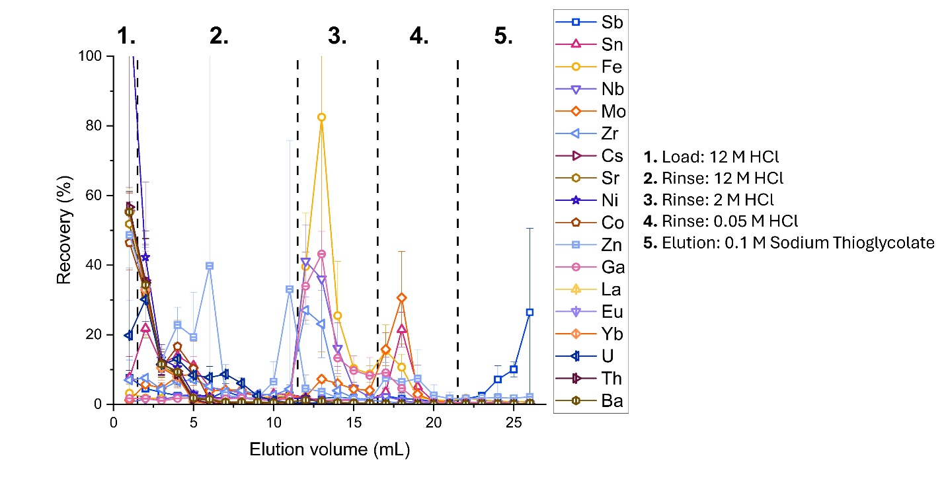
Figure S1. Elution profile for a range of stable elements on the CG71 resin support (~1 μg of each element, 1 mL column volume, 300 mg resin support, ICP-MS. n = 3).

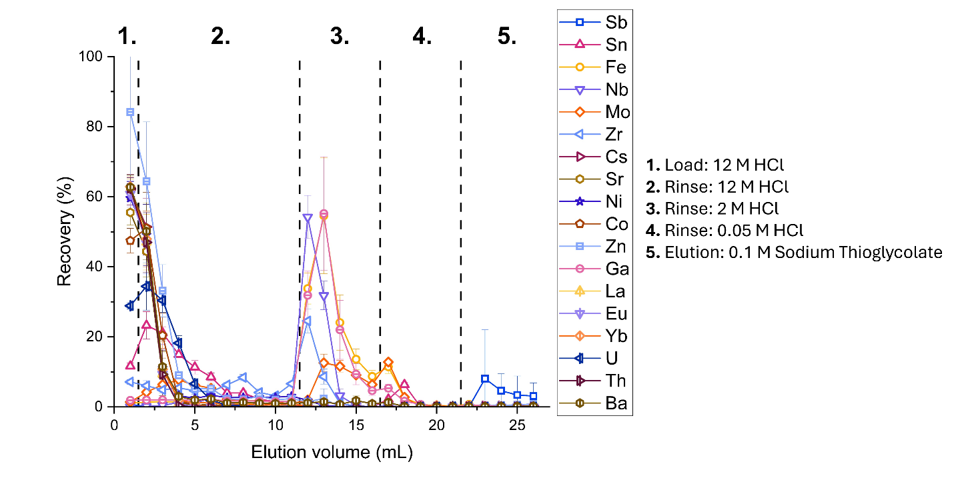
Figure S2. Elution profile for a range of stable elements on the DBE-71 resin (~1 μg of each element, 1 mL column volume, 300 mg resin, ICP-MS. n = 3).

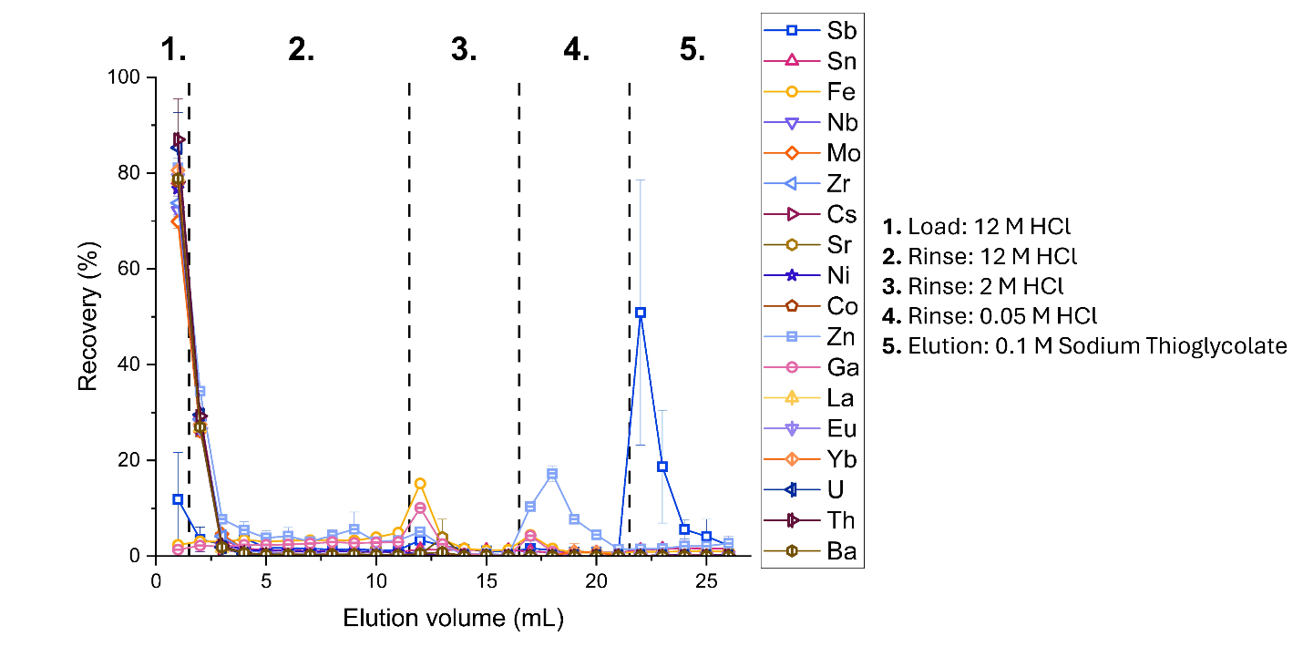
Figure S3. Elution profile for a range of stable elements on the DBE-300 resin (~1 μg of each element, 1 mL column volume, 200 mg resin, ICP-MS. n = 3).

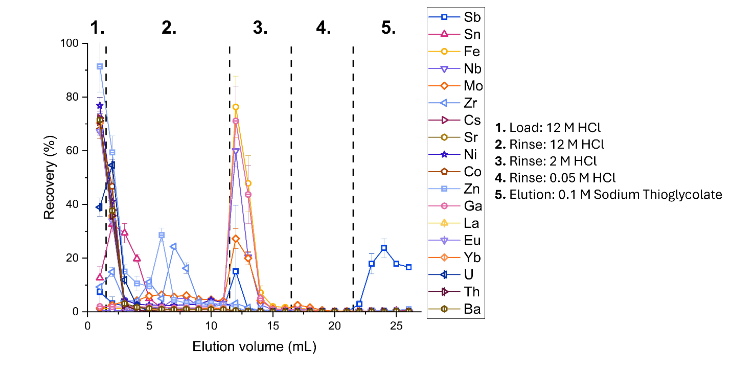
Figure S4. Elution profile for a range of stable elements on the DPE-71 resin (~1 μg of each element, 1 mL column volume, 300 mg resin, ICP-MS. n = 3).

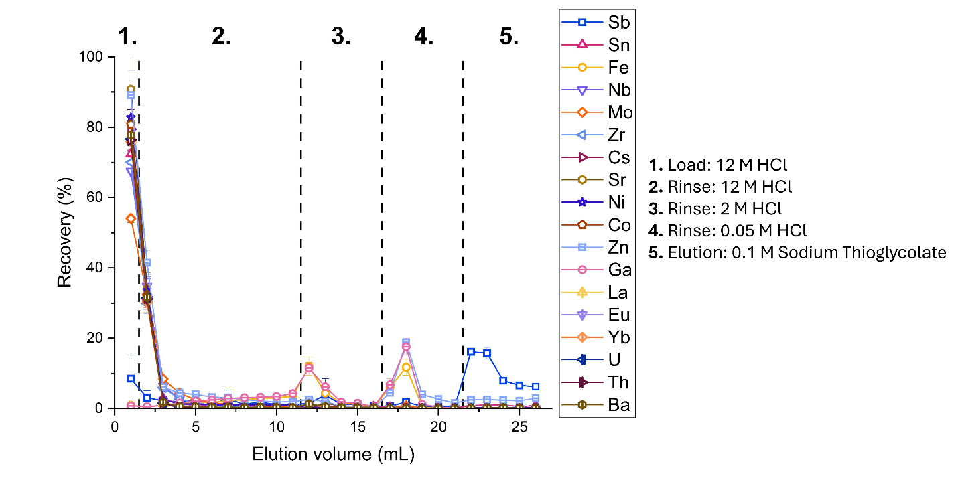
Figure S5. Elution profile for a range of stable elements on the DPE-300 resin (~1 μg of each element, 1 mL column volume, 250 mg resin, ICP-MS. n = 3).

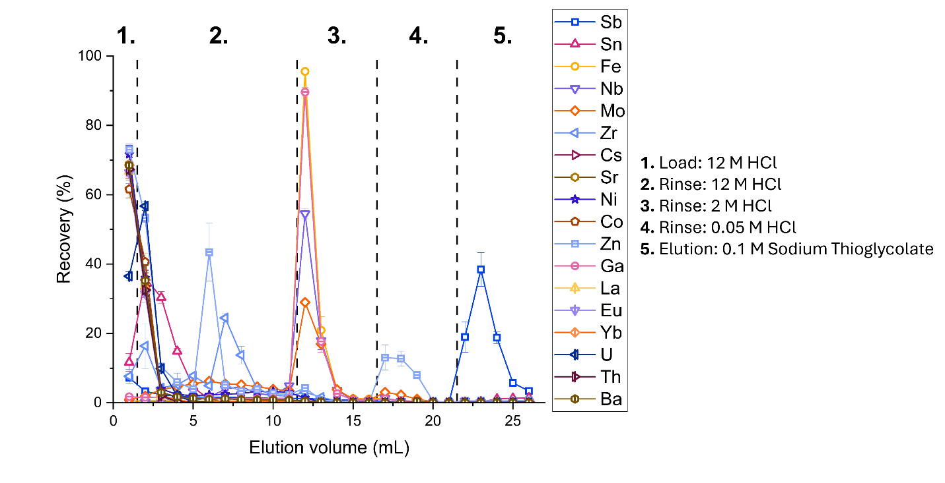
Figure S6. Elution profile for a range of stable elements on the DOE-71 resin (~1 μg of each element, 1 mL column volume, 300 mg resin, ICP-MS. n = 3).

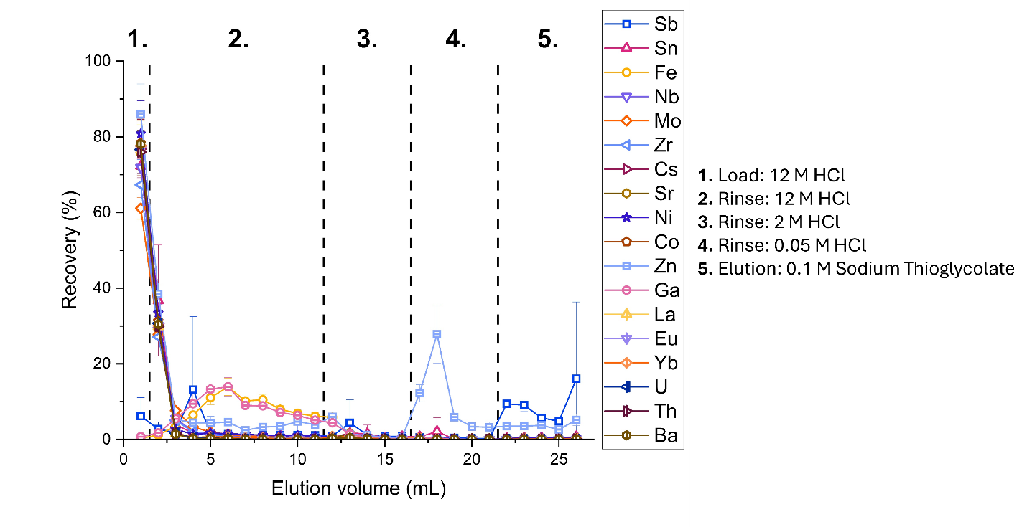
Figure S7. Elution profile for a range of stable elements on the DOE-300 resin (~1 μg of each element, 1 mL column volume, 250 mg resin, ICP-MS. n = 3).

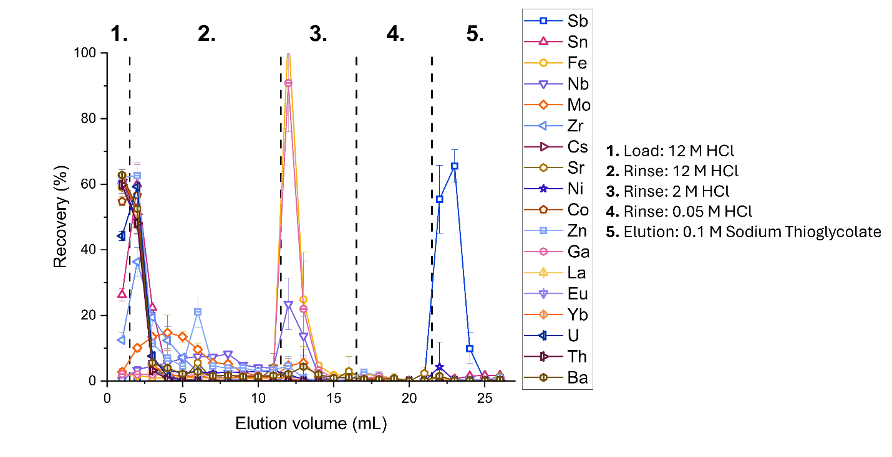
Figure S8. Elution profile for a range of stable elements on the TK401-71 resin (~1 μg of each element, 1 mL column volume, 350 mg resin, ICP-MS. n = 3).

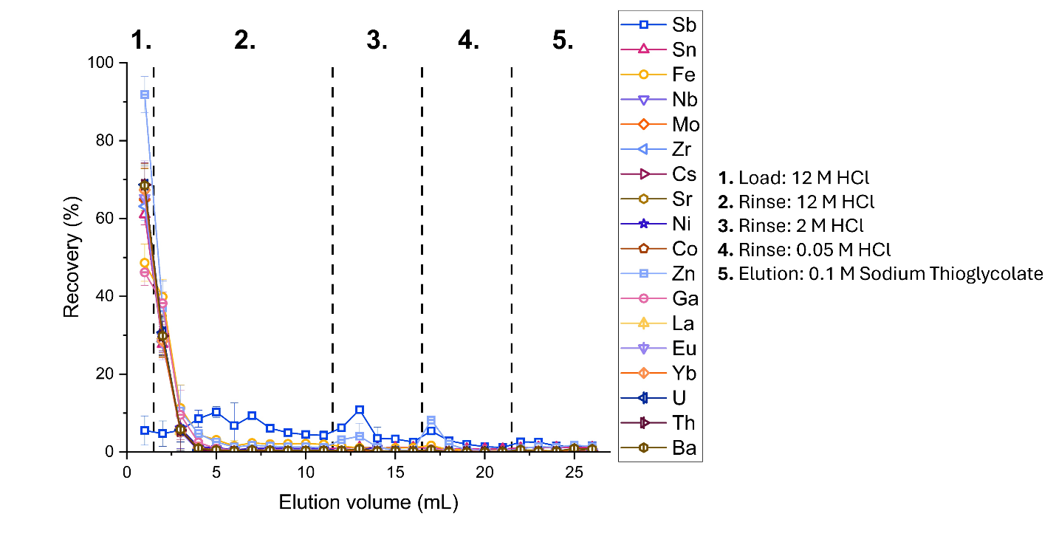
Figure S9. Elution profile for a range of stable elements on the TK401-300 resin (~1 μg of each element, 1 mL column volume, 300 mg resin, ICP-MS. n = 3).

