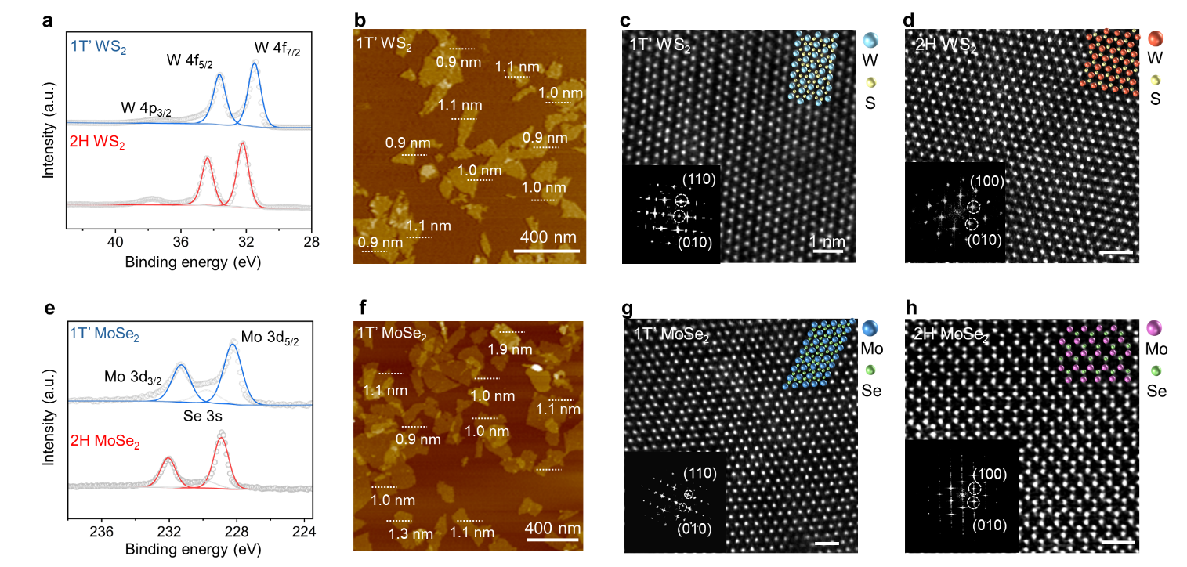
Extended Data Fig. 1 | Generic fabrication of high-phase-purity TMDs. a,e XPS spectra of exfoliated WS₂ NSs (a) and MoSe₂ NSs (e). b,f AFM images and measured thicknesses of exfoliated 1T’-WS₂ NSs (b) and 1T’-MoSe₂ NSs (f). c,d,g,h Atomic-resolution HAADF-STEM image of 1T’-WS₂ NSs (c), 2H-WS₂ NSs (d), 1T’-MoSe₂ NSs (g) and 2H-MoSe₂ NSs (h) (inset: the corresponding fast Fourier transform pattern) and panels share the same scale bar.

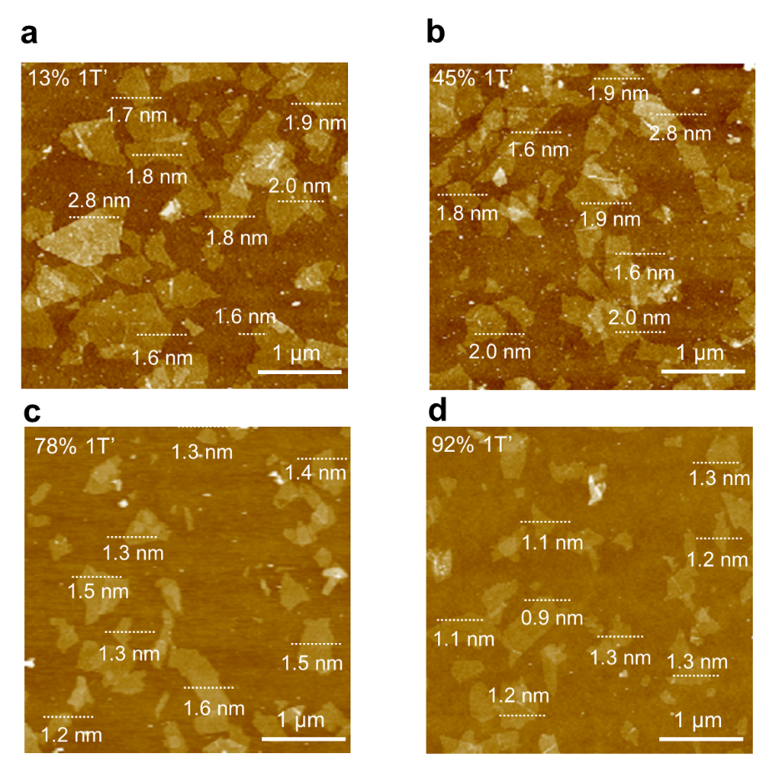
Extended Data Fig. 2 | AFM images of exfoliated 1T’/2H-MoS₂ heterophase NSs. Heterophase MoS₂ with 1T’ ratio of 13% (a), 45% (b), 78% (c) and 92% (d).

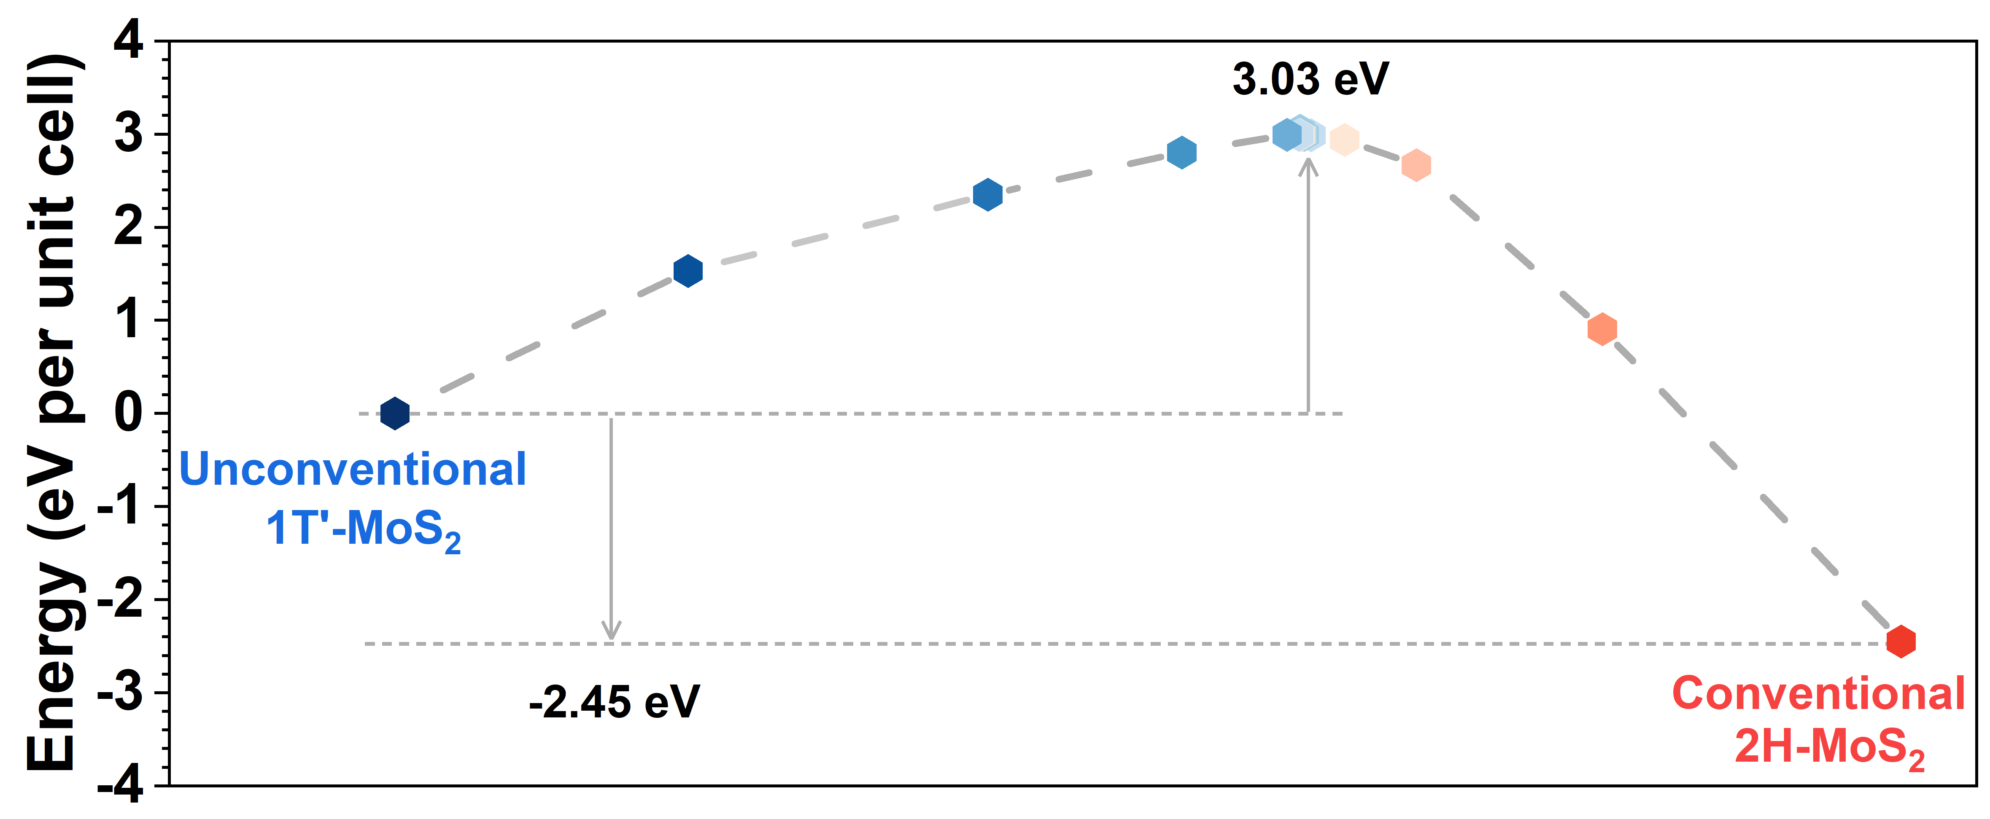
Extended Data Fig. 3 | The energy difference between 1T’-MoS₂ and 2H-MoS₂.

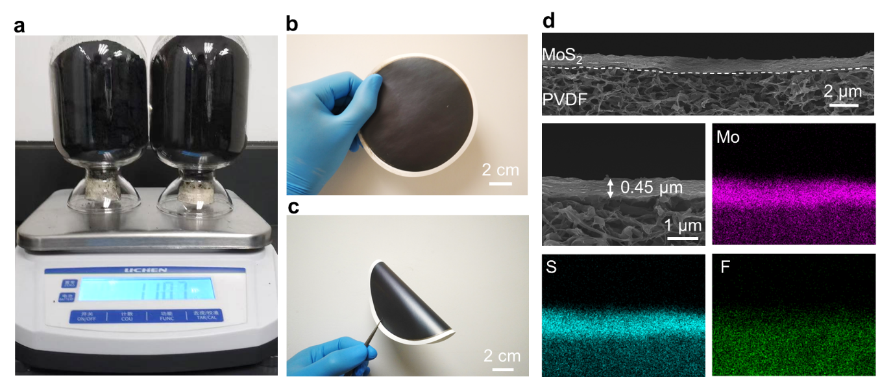
Extended Data Fig. 4 | Post-process and characterization of exfoliated 1T’ MoS₂. a, Photographs of 1T’-MoS₂ NSs after drying from ink solutions. b,c Photo of a 1T’-MoS₂ membrane (diameter=11 cm) fabricated onto a polyvinylidene difluoride (PVDF) substrate by vacuum filtration (b) and good flexibility of the membrane (c). d, Cross-section SEM view and corresponding EDS elemental mappings of 1T’-MoS₂ membrane.

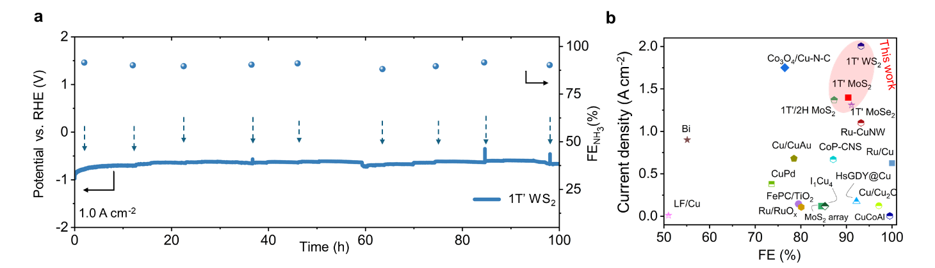
Extended Data Fig. 5 | Electrochemical NO₃⁻RR stability test and performance comparison of 1T’-TMDs flakes. a, Long-term electrocatalytic stability test of the NO₃⁻RR over 1T’-WS₂ at 1.0 A cm⁻² in a H-cell. Arrows indicate the renewal of fresh electrolytes (the measured potentials were not iR-compensated). b, NO₃⁻ RR performance of 1T’-MoS₂, 1T’-WS₂, 1T’-MoSe₂ and 2H/1T mixed MoS₂ comparison with reported electrocatalyst.

