Supporting Information
Electrochemical engineering for phase-controlled exfoliation of transition metal dichalcogenides
Honglu Hu¹, Mingzi Sun², Qiang Zhang², Zheng Zhang¹, Xinru Yang¹, Ruixin Yan¹, Liang Mei ¹, Ting Ying¹, Yue Zhang¹, Weikang Zheng¹, Damien Voiry³, Yang Chai⁴, Ruquan Ye², Bolong Huang², Xiao Zhang⁵, Bilu Liu⁶, Bin Liu¹, Kian Ping Loh⁷, Ju Li⁸*, Zhiyuan Zeng^{1,9}*
¹ Department of Materials Science and Engineering and State Key Laboratory of Marine Pollution, City University of Hong Kong, Hong Kong, People’s Republic of China
² Department of Chemistry, City University of Hong Kong, Hong Kong, People’s Republic of China
³ Institut Européen des Membranes, UMR 5635, ENSCM, CNRS, Université Montpellier, Montpellier, France
⁴ Department of Applied Physics, The Hong Kong Polytechnic University, Hong Kong, People’s Republic of China
⁵ Department of Mechanical Engineering, The Hong Kong Polytechnic University, Kowloon, Hong Kong SAR
⁶ Shenzhen Geim Graphene Center, Shenzhen Key Laboratory for Value-added Applications, Institute of Materials Research, Tsinghua Shenzhen International Graduate School, Tsinghua University, Shenzhen, P.R. China
⁷ Department of Chemistry, National University of Singapore, Singapore, Singapore
⁸ Department of Nuclear Science and Engineering and Department of Materials Science and Engineering, Massachusetts Institute of Technology, Cambridge, MA, USA.
⁹ Shenzhen Research Institute, City University of Hong Kong, Shenzhen, People’s Republic of China
* Corresponding authors: Ju Li (liju@mit.edu) and Zhiyuan Zeng (zhiyzeng@cityu.edu.hk)

Contents
- Supplementary Figures 1-40
Supplementary Fig. 1. | The atomic models of different phases of MoS_{2.}
Supplementary Fig. 2. | Characterizations of MoS₂ bulk powder.
Supplementary Fig. 3. | Characterizations of WS₂ bulk powder.
Supplementary Fig. 4. | Characterizations of MoSe₂ bulk powder.
Supplementary Fig. 5. | XRD spectra of bulk MoS₂, bulk WS₂ and bulk MoSe₂.
Supplementary Fig. 6. | XPS spectra of bulk MoS₂, bulk WS₂ and bulk MoSe₂.
Supplementary Fig. 7. | Photograph of exfoliated MoS₂ NSs dispersed in water.
Supplementary Fig. 8. | Phase analysis of exfoliated MoS₂ NSs by traditional electrochemical Li-ion intercalation.
Supplementary Fig. 9. | XAFS results of 1T’- and 2H-MoS₂ NSs.
Supplementary Fig. 10. | The structural model of 1T’- and 2H-MoS₂ NSs.
Supplementary Fig. 11. | TEM analysis of 1T’- and 2H-MoS₂ NSs.
Supplementary Fig. 12. | Electrochemical discharge profiles of WS_{2.}
Supplementary Fig. 13. | XPS spectra of exfoliated WS₂ NSs by traditional electrochemical Li-ion intercalation.
Supplementary Fig. 14. | Electrochemical discharge profiles of MoSe₂.
Supplementary Fig. 15. | XPS spectra of exfoliated MoSe₂ NSs by traditional electrochemical Li-ion intercalation.
Supplementary Fig. 16. | AFM measurement of 1T’-WS₂ NSs.
Supplementary Fig. 17. | AFM measurement of 1T’-MoSe₂ NSs.
Supplementary Fig. 18. | AFM images of exfoliated 2H-WS₂ NSs.
Supplementary Fig. 19. | AFM images of exfoliated 2H-MoS₂ NSs.
Supplementary Fig. 20. | TEM analysis of 1T’- and 2H-WS₂ NSs.
Supplementary Fig. 21. | TEM analysis of 1T’- and 2H-MoSe₂ NSs.
Supplementary Fig. 22. | XPS spectra corresponding to 1T’ phase and MoO_{x} ratios of MoS₂ by regulation of cut-off voltage and temperature.
Supplementary Fig. 23. | The discharge curves for the Li-ion intercalation capacity.
Supplementary Fig. 24. | Structural diagram of In-situ XRD.
Supplementary Fig. 25. | In-situ Raman patterns of electrochemical lithiation of MoS₂ in PC-based electrolyte.
Supplementary Fig. 26. | The binding and desolvation energies of DEGDME, DEC, PC, and EC with Li⁺ in different coordination numbers.
Supplementary Fig. 27. | The MSD of Li⁺ in DEGDME, DEC, PC, and EC electrolytes.
Supplementary Fig. 28. | The interaction energies between Li⁺ and MoS₂ as well as the distortion ratios of MoS₂ in different electrolytes.
Supplementary Fig. 29. | 2H-MoS₂||LiFePO₄ pouch-type battery before charging.
Supplementary Fig. 30. | Charge profiles of battery in DEGDME-based and PC-based electrolytes.
Supplementary Fig. 31. | Characterizations of the as-fabricated 2D 1T’-MoS₂ NSs and their aqueous suspensions.
Supplementary Fig. 32. | Schematic representation of monolayer MoS₂ nanosheets with different particle sizes obtained using differential centrifugation.
Supplementary Fig. 33. | AFM images of exfoliated 1T’-MoS₂ NSs with measured thicknesses in different sizes.
Supplementary Fig. 34. | Standard curves of NH₄⁺-N quantification by the colorimetric method.
Supplementary Fig. 35. | Chronoamperometric curves of TMDs nanosheets in at different potentials.
Supplementary Fig. 36. | The PDOS of 1T’-WS₂, 1T’-MoS_{2,} and 1T’-MoSe₂.
Supplementary Fig. 37. | The d-band center and p-band center evolutions for 1T’-WS₂, 1T’-MoS₂ and 1T’-MoSe₂.
Supplementary Fig. 38. | The PDOS comparisons between 1T’ and 2H phases of MoS₂ and WS₂.
Supplementary Fig. 39. | The energy evolutions for nitrate reduction in 1T’-WS₂ and 2H-WS₂.
2. Supplementary Tables 1-2
Supplementary Table S1. | Comparison of other exfoliation methods with phase-selective exfoliation for producing high-phase purity TMDs nanosheets.
Supplementary Table S2. | Detailed information for previously published NO₃⁻ reduction reaction catalyst.
3. Supplementary References

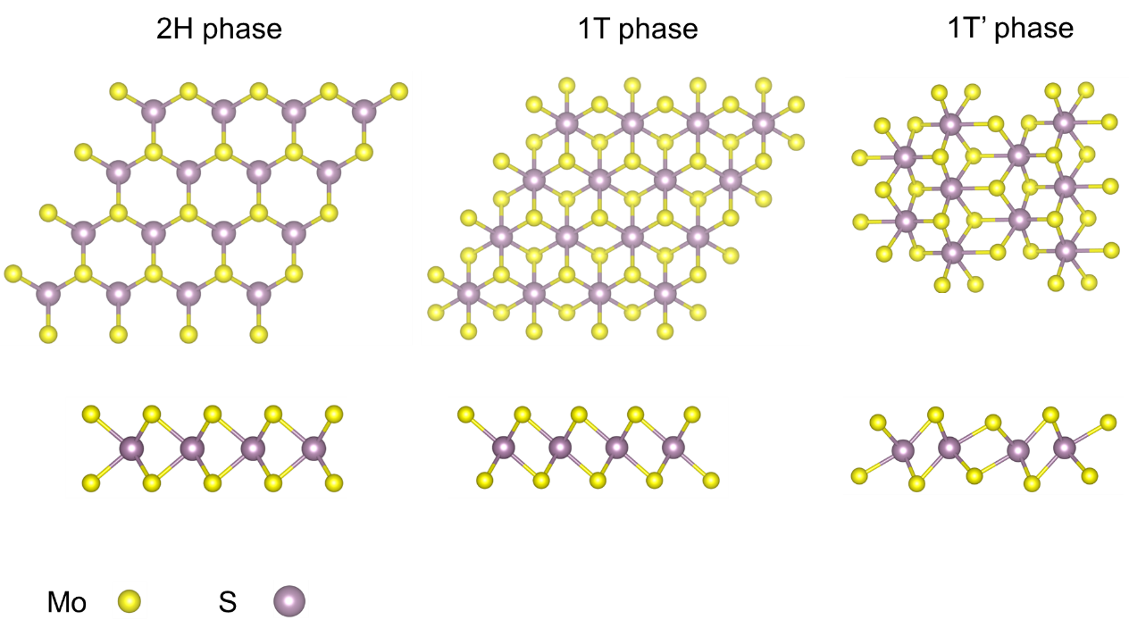
Supplementary Fig. 1. | The atomic models of different phases of MoS₂. Schematic illustration of 2H, 1T and 1T’ phase MoS₂ structure. Upside: top view of the structure; downside: side view of the structures.

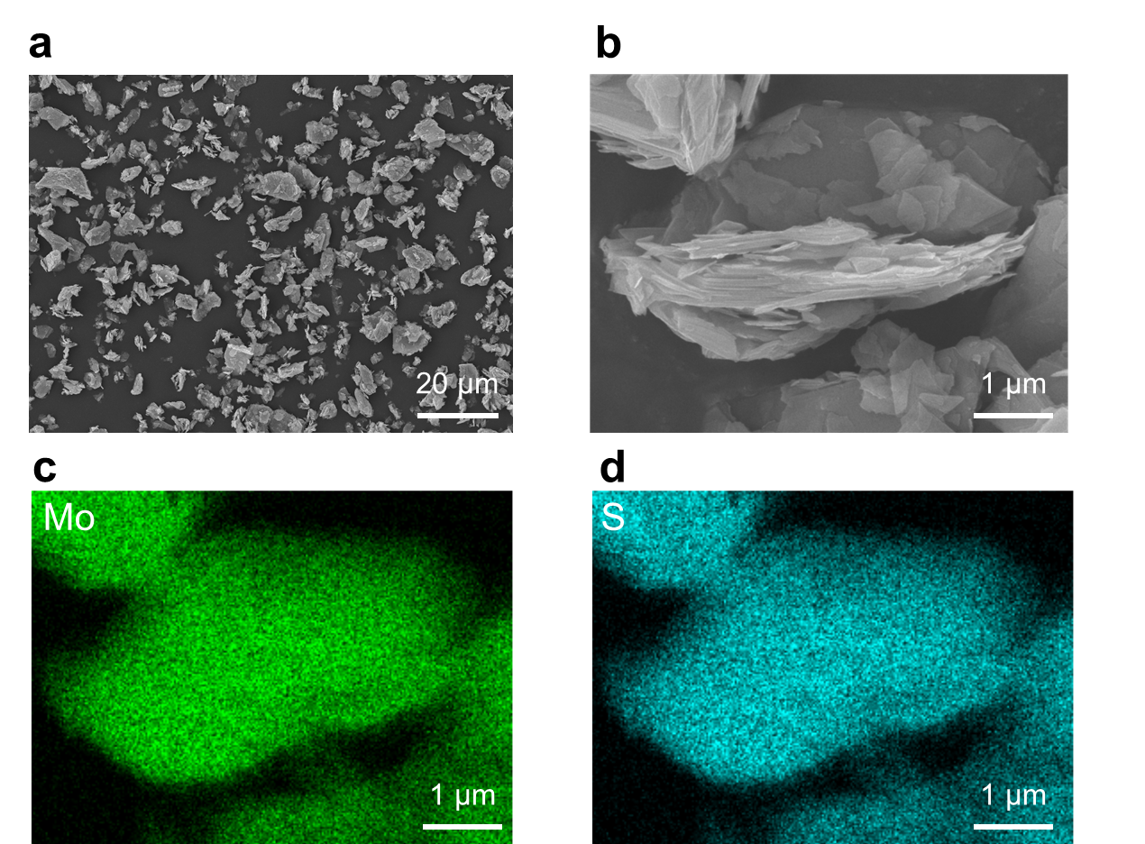
Supplementary Fig. 2. | Characterizations of MoS₂ bulk powder. (a) SEM images of MoS₂ powder on a large scale. (b) SEM images of selected MoS₂ particles. c,d EDS elemental mappings of Mo (c) and S (d) corresponding to (b).

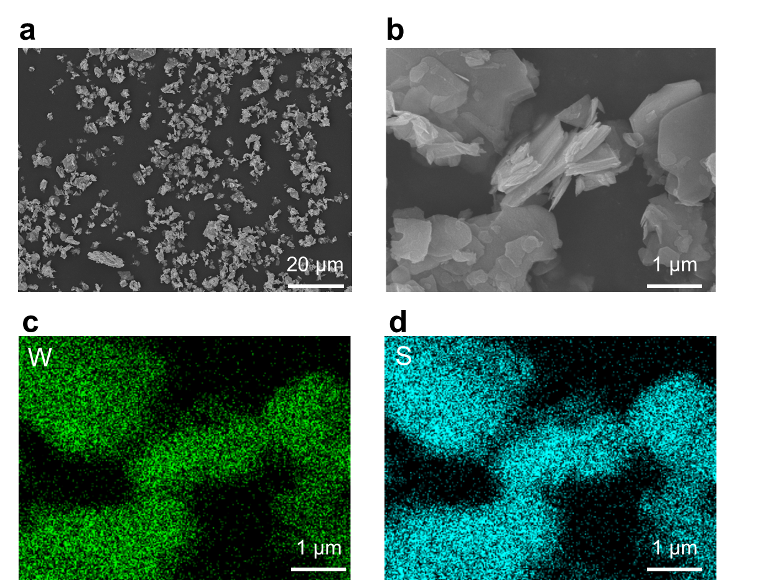
Supplementary Fig. 3. | Characterizations of WS₂ bulk powder. (a) SEM images of WS₂ powder on a large scale. (b) SEM images of selected WS₂ particles. c,d EDS elemental mappings of W (c) and S (d) corresponding to (b).

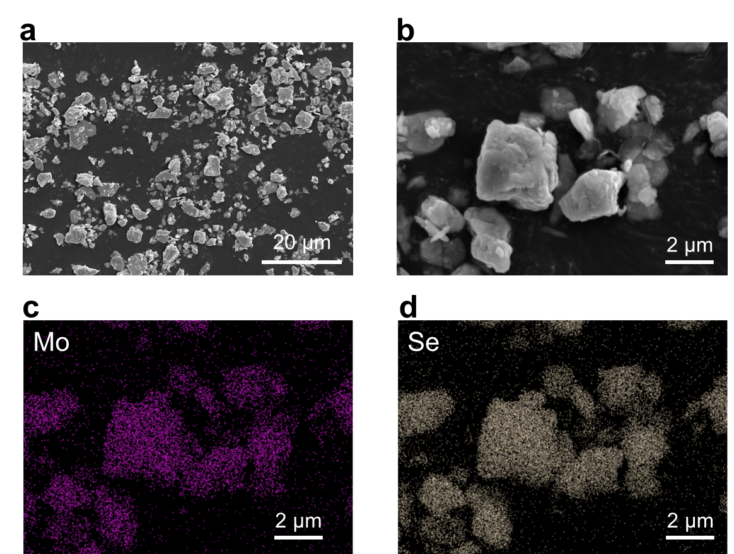
Supplementary Fig. 4. | Characterizations of MoSe₂ bulk powder. (a) SEM images of MoSe₂ powder on a large scale. (b) SEM images of selected MoSe₂ particles. c,d EDS elemental mappings of Mo (c) and Se (d) corresponding to (b).

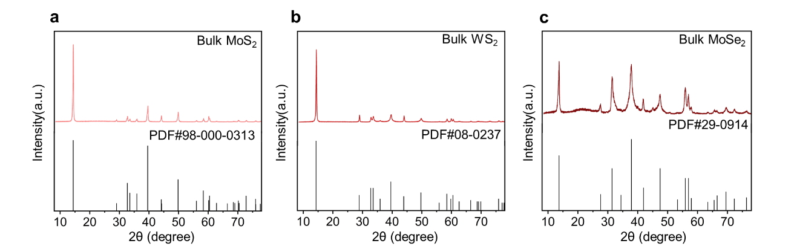
Supplementary Fig. 5. | XRD spectra of (a) bulk MoS₂, (b) bulk WS₂ and (c) bulk MoSe₂. XRD results show the high purity of bulk TMDs source, no peaks for impurities are detected.

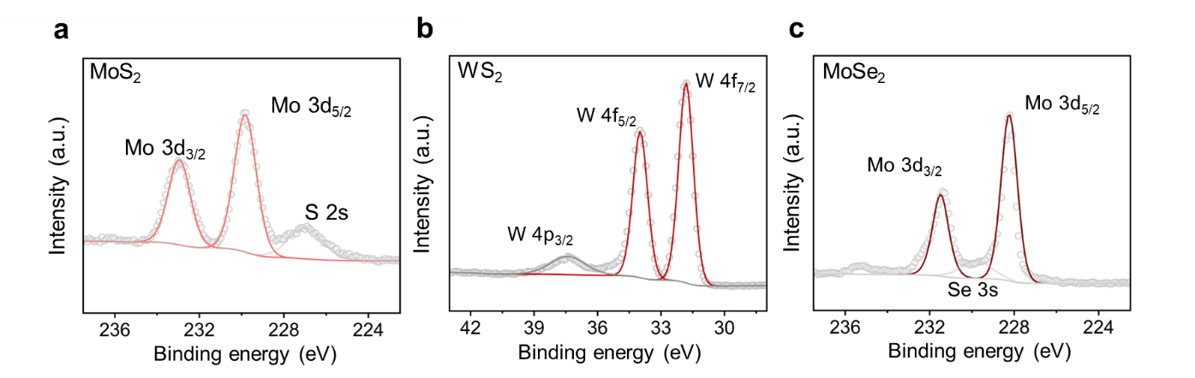
Supplementary Fig. 6. | XPS spectra of (a) bulk MoS₂, (b) bulk WS₂ and (c) bulk MoSe₂. XPS results show the bulk TMDs source are all pure 2H phase.

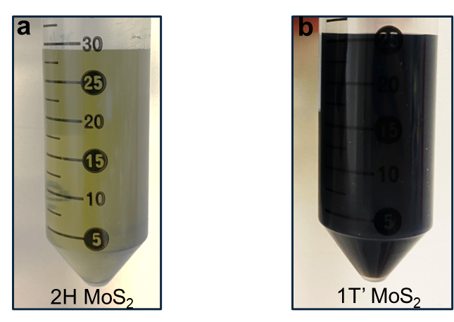
Supplementary Fig. 7. | Photograph of exfoliated MoS₂ NSs dispersed in water. (a) 2H-MoS₂. (b) 1T’-MoS₂. After 5 minutes of sonication, MoS₂ was completely dispersed in the DI water, presenting two suspensions that would appear dark green and dark black, respectively.
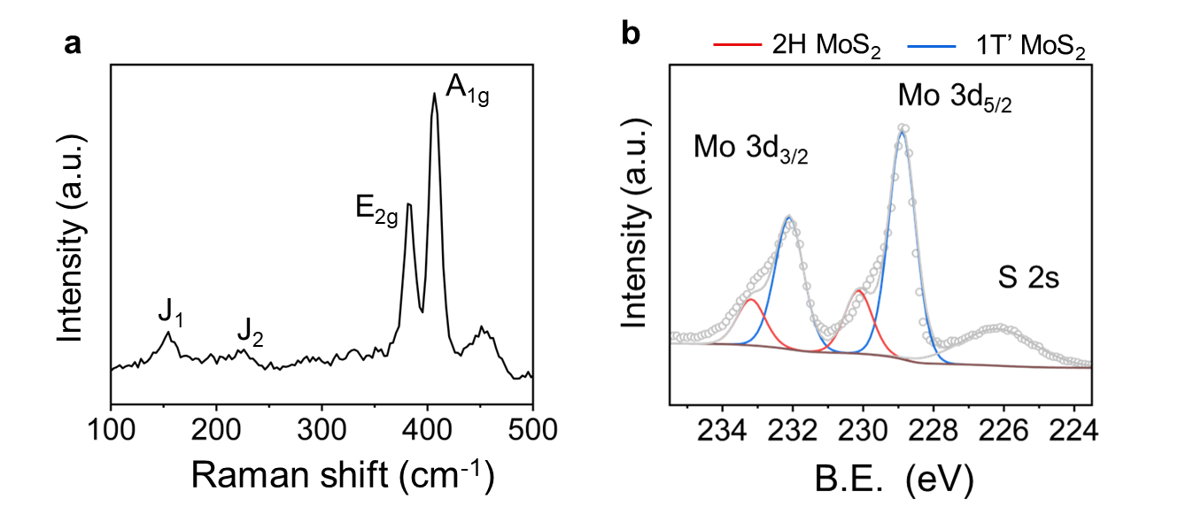
Supplementary Fig. 8. | Phase analysis of exfoliated MoS₂ NSs by traditional electrochemical Li-ion intercalation. (a) Raman spectra of the exfoliated MoS₂. (b) XPS spectra of the exfoliated MoS₂. (a.u., arbitrary unit).

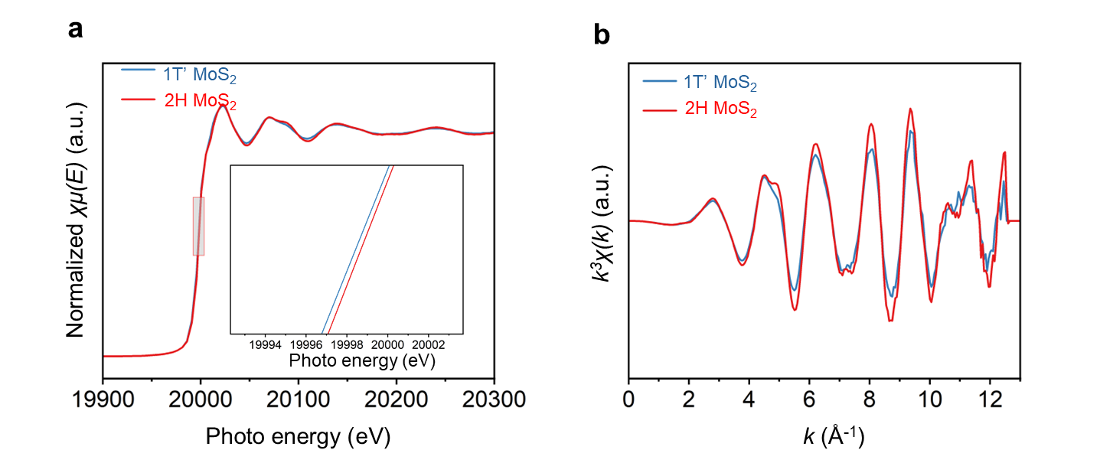
Supplementary Fig. 9. | XAFS results of 1T’- and 2H-MoS₂ NSs. (a) Normalized XAFS spectra of 1T’- and 2H-MoS₂ NSs. (b) The EXAFS oscillation curves of the Mo K-edge of 1T’-MoS₂ and 2H-MoS₂. The Mo K-edge absorption spectra were recorded at room temperature in the transmission mode. The 1T’-MoS₂ and 2H-MoS₂ NSs aqueous solution (5 wt.% MoS₂ in DI water) were used for the XAFS measurements. The chemical state of Mo in 1T’-MoS₂ was a little lower than that of 2H-MoS₂ according to the Mo K-edge XAFS spectra (Supplementary Fig. 9a), because the surface of 1T’-MoS₂ is rich in electron¹.

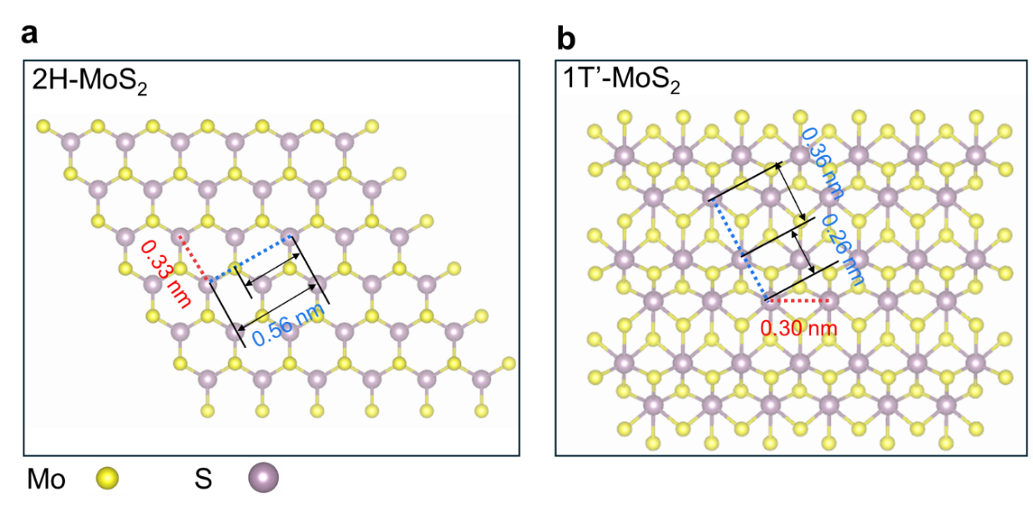
Supplementary Fig. 10. | The structural model of 1T’- and 2H-MoS₂ NSs. Schematic illustrations of the atomic structures of (a) 2H-MoS₂ and (b) 1T’-MoS₂, respectively.

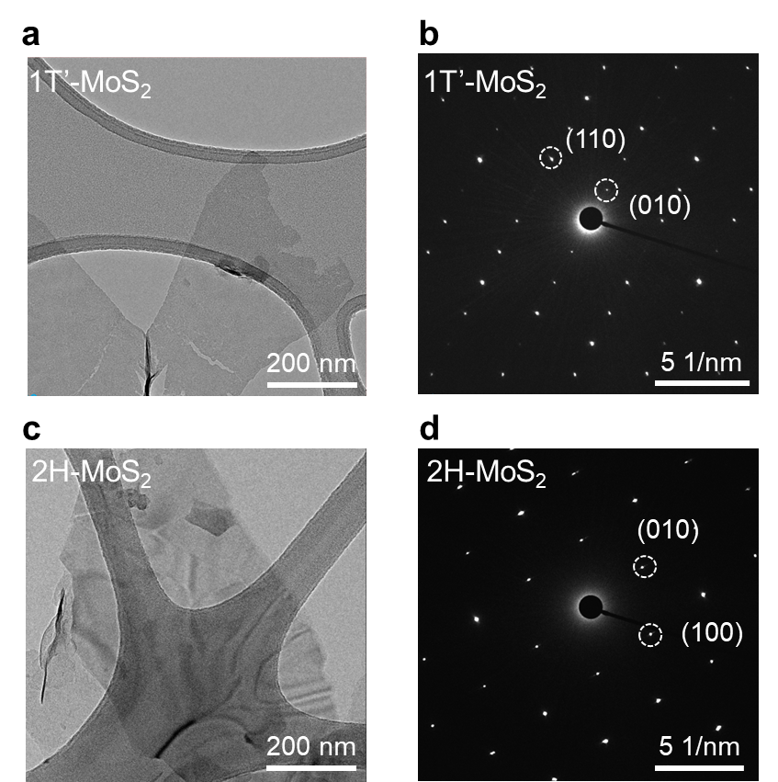
Supplementary Fig. 11. | TEM analysis of 1T’- and 2H-MoS₂ NSs. TEM images of 1T’-MoS₂ NSs (a) and 2H-MoS₂ NSs (c). The corresponding selected area electron diffraction (SAED) pattern obtained from the 1T’-MoS₂ NSs (b) and 2H-MoS₂ NSs (d).

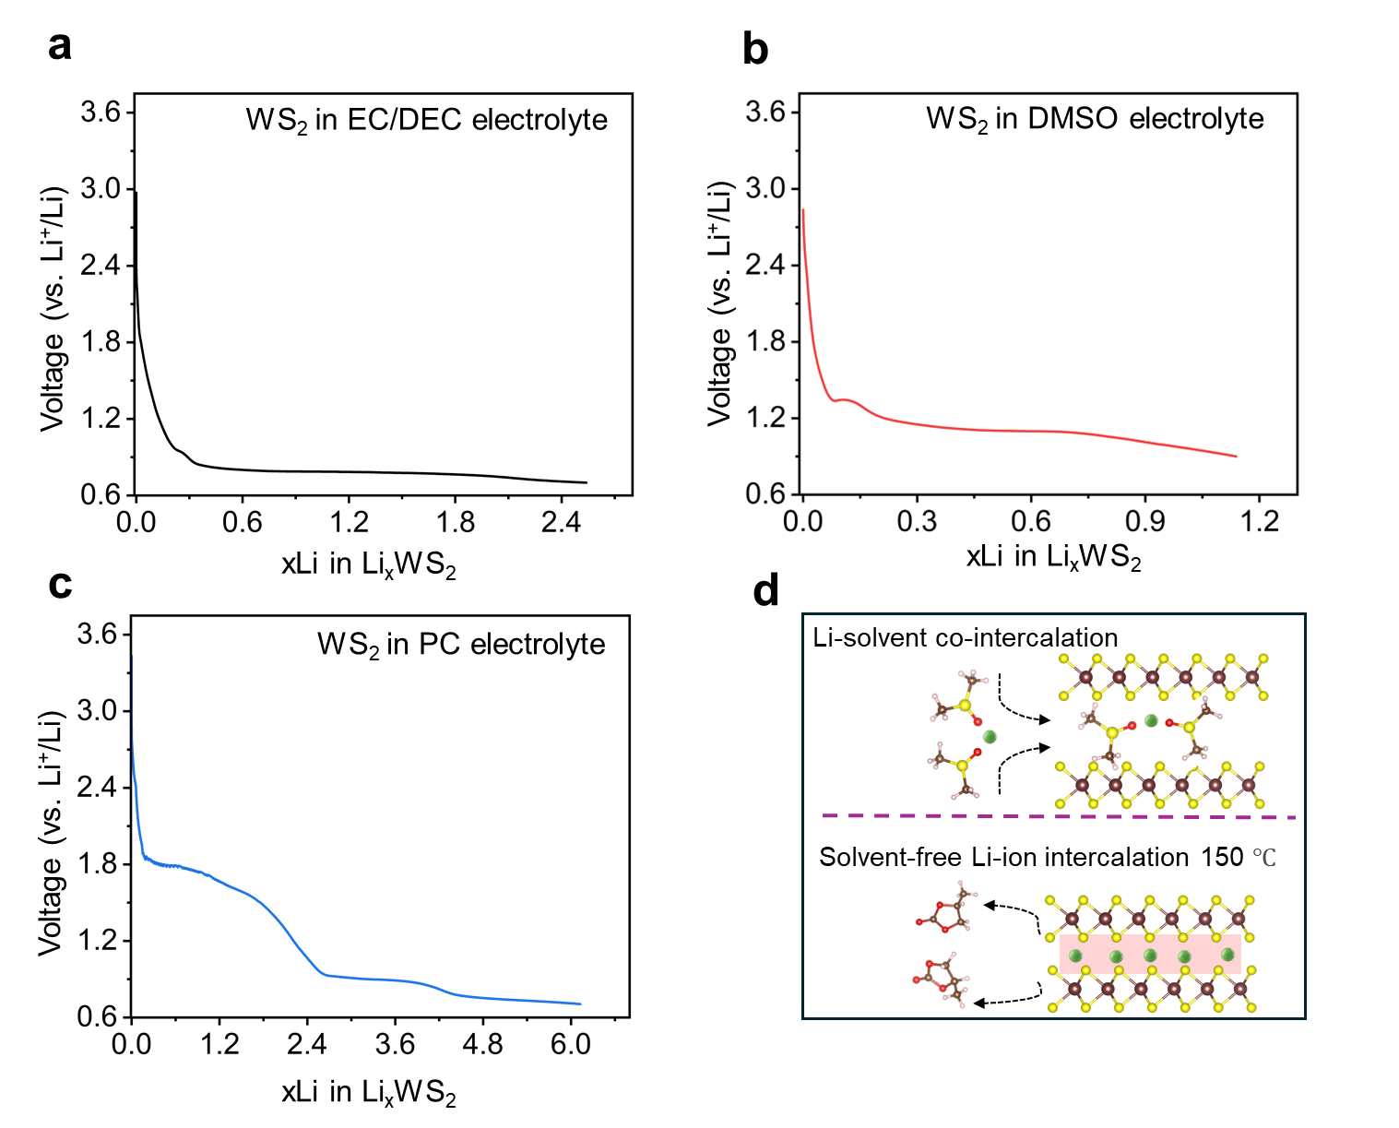
Supplementary Fig. 12. | Electrochemical discharge voltage profiles of WS₂ with traditional electrolyte (cut-off at 0.7 V) (a), DMSO-electrolyte (as a co-intercalation electrolyte for 2H-WS₂ NSs, cut-off at 1.1 V) (b) and PC-electrolyte (as a solvent-free intercalation electrolyte for 1T’-WS₂ NSs, cut-off at 0.7 V, 150 °C) (c). (d) Schematics for the phase-selective synthesis for WS₂.

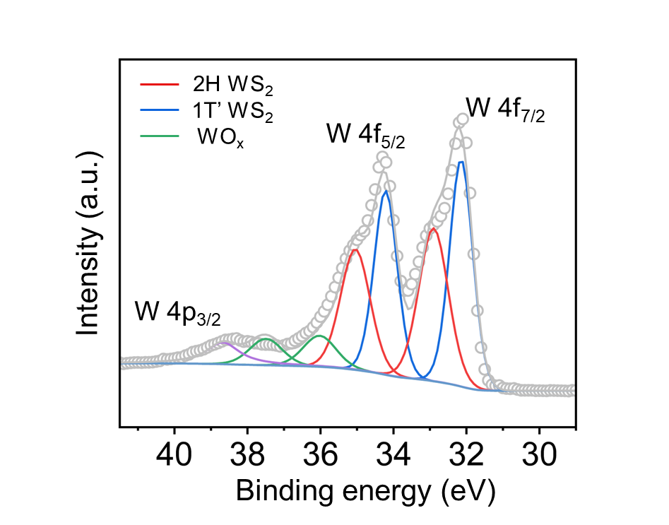
Supplementary Fig. 13. | XPS spectra of exfoliated WS₂ NSs by traditional electrochemical Li-ion intercalation. The mixed phase of 2H and 1T’ WS₂ is consistent with previously reported results².

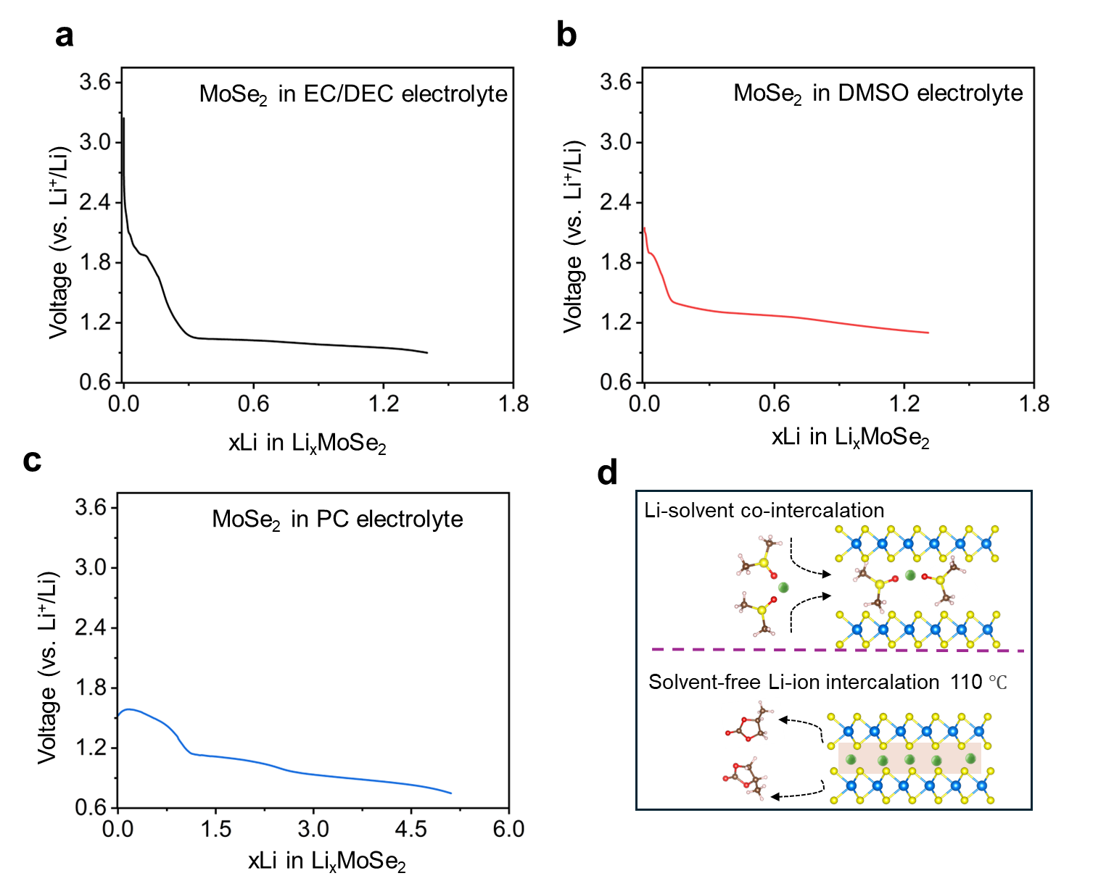
Supplementary Fig. 14. | Electrochemical discharge voltage profiles of MoSe₂ with traditional electrolyte (cut-off at 0.7 V) (a), DMSO-electrolyte (as a co-intercalation electrolyte for 2H-MoSe₂ NSs, cut-off at 1.1 V) (b) and PC-electrolyte (as a solvent-free intercalation electrolyte for 1T’-MoSe₂ NSs, cut-off at 0.7 V, 110 °C) (c). (d) Schematics for the phase-selective synthesis for WS₂.

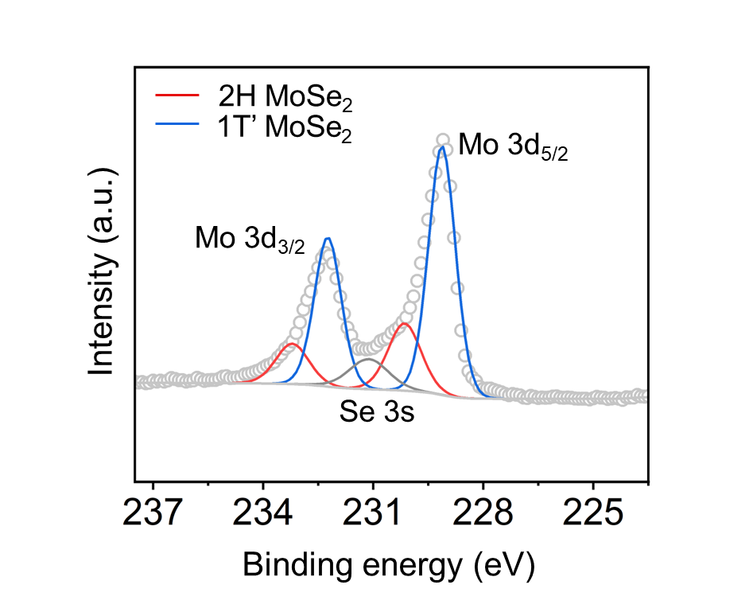
Supplementary Fig. 15. | XPS spectra of exfoliated MoSe₂ NSs by traditional electrochemical Li-ion intercalation. The mixed phase of 2H and 1T’ MoSe₂ is consistent with previously reported results^{3,4}.

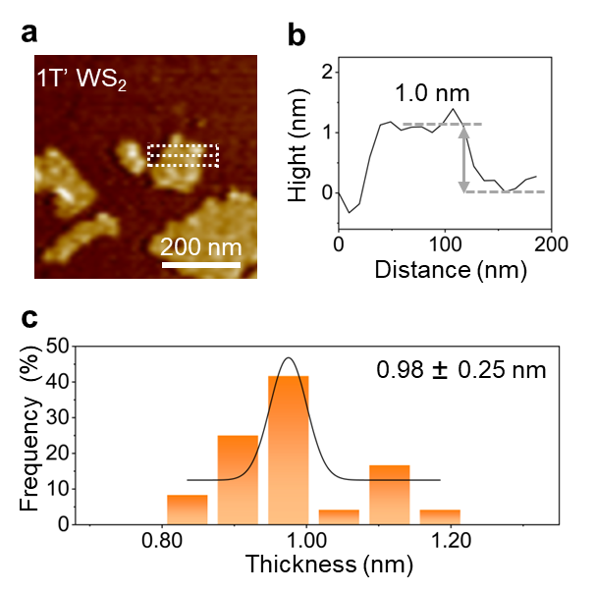
Supplementary Fig. 16. | AFM measurement of 1T’-WS₂ NSs. (a) The measured thicknesses (WS₂ NSs selected from Extended Data Fig. 1b), (b) height profiles of 1T’-WS₂ NSs and (c) thickness distribution histogram of 1T’-WS₂ NSs measured by AFM (0.98 nm is the mean thickness, and 0.25 nm is the s.d.) with a single-layer yield of 91%.

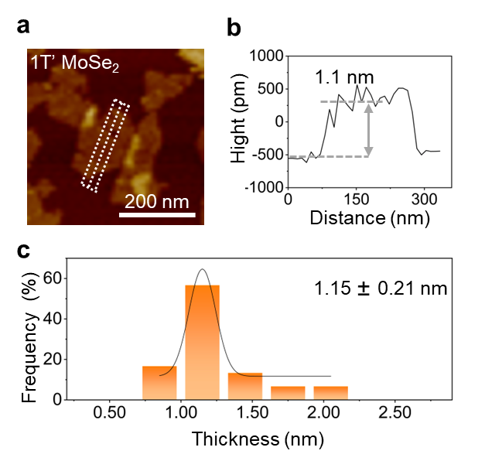
Supplementary Fig. 17. | AFM measurement of 1T’-MoSe₂ NSs. (a) The measured thicknesses (MoSe₂ NSs selected from Extended Data Fig. 1f), (b) height profiles of 1T’-MoSe₂ NSs and (c) thickness distribution histogram of 1T’-MoS₂ NSs measured by AFM with a single-layer yield of 90% (1.15 nm is the mean thickness, and 0.27 nm is the s.d.).

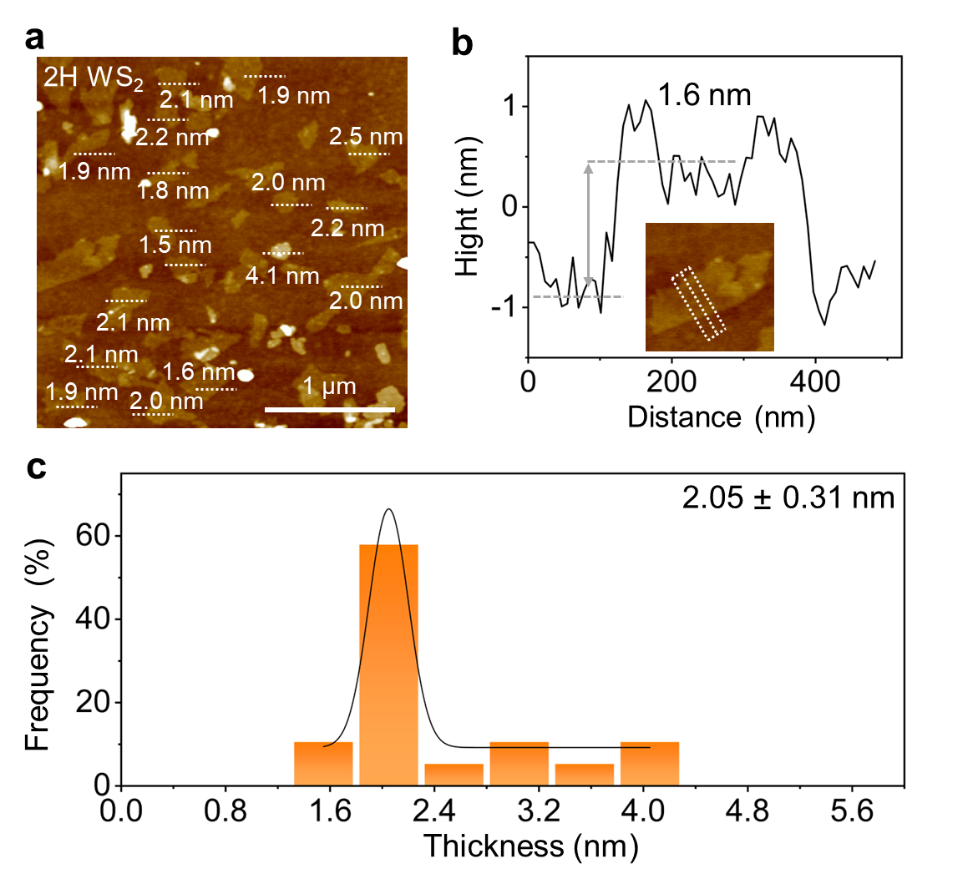
Supplementary Fig. 18. | AFM images of exfoliated 2H-WS₂ NSs. (a) The measured thicknesses, (b) height profiles of 2H-WS₂ NSs and (c) thickness distribution histogram of 2H-WS₂ NSs measured by AFM with a bi-layer yield of 75% (2.05 nm is the mean thickness, and 0.31 nm is the s.d.).

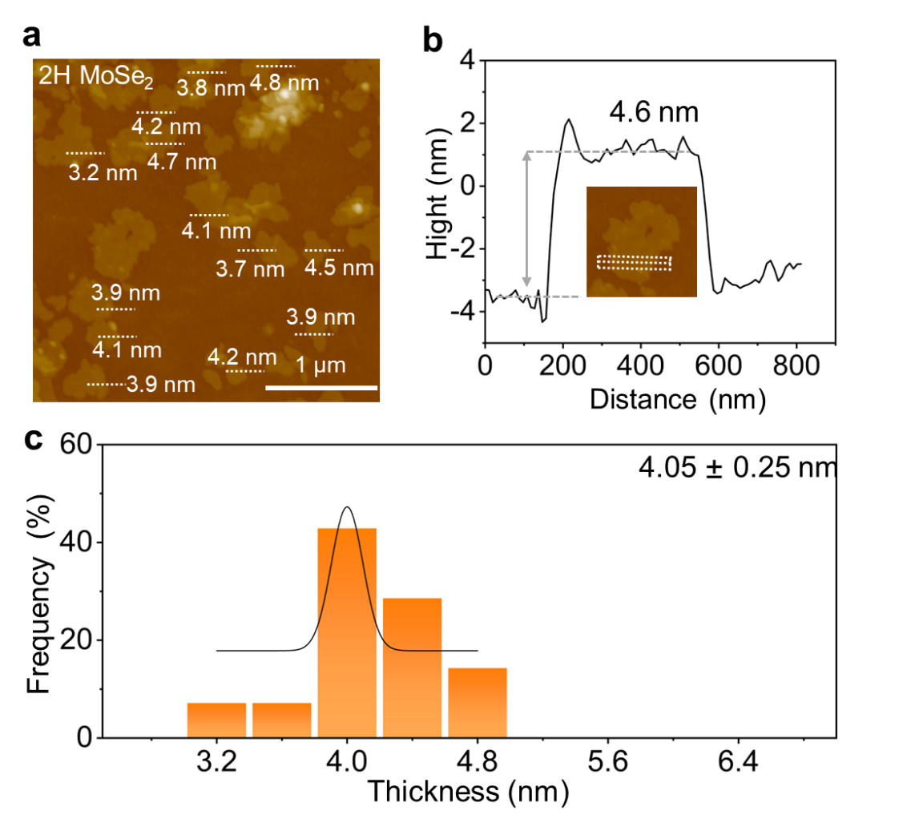
Supplementary Fig. 19. | AFM images of exfoliated 2H-MoSe₂ NSs. (a) The measured thicknesses, (b) height profiles of 2H-MoSe₂ NSs and (c) thickness distribution histogram of 2H-MoSe₂ NSs measured by AFM with a tri-layer yield of 87% (4.05 nm is the mean thickness, and 0.25 nm is the s.d.).

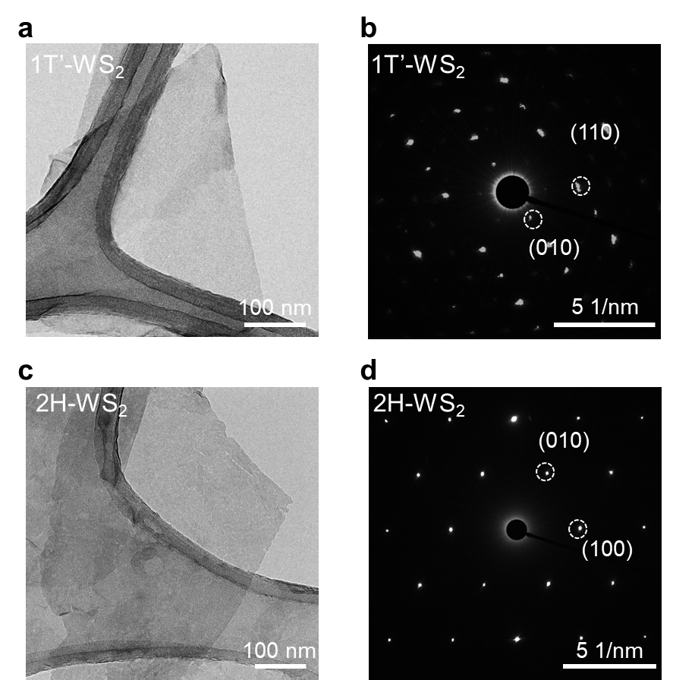
Supplementary Fig. 20. | TEM analysis of 1T’- and 2H-WS₂ NSs. TEM images of 1T’-WS₂ NSs (a) and 2H-WS₂ NSs (c). The corresponding SAED pattern obtained from the 1T’-WS₂ NSs (b) and 2H-WS₂ NSs (d).

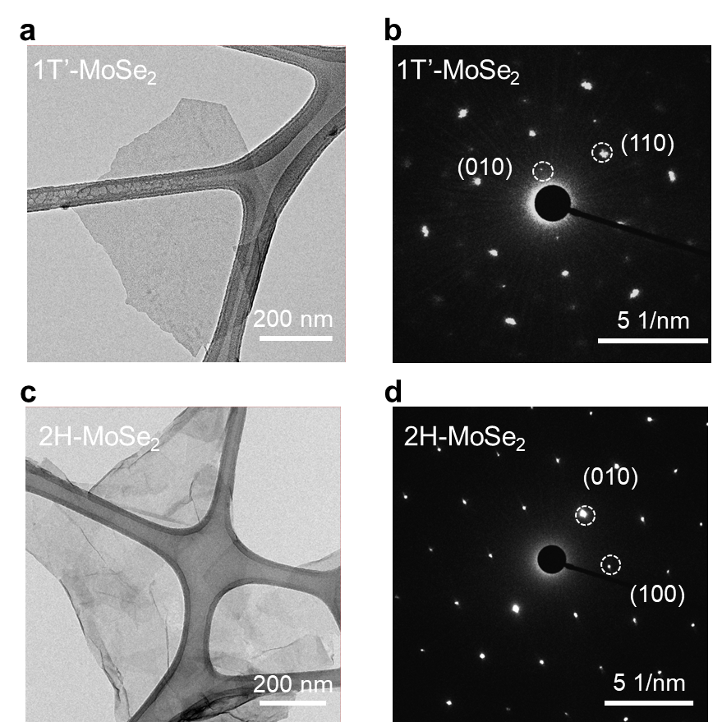
Supplementary Fig. 21. | TEM analysis of 1T’- and 2H-MoSe₂ NSs. TEM images of 1T’-MoSe₂ NSs (a) and 2H-MoSe₂ NSs (c). The corresponding SAED pattern obtained from the 1T’-MoSe₂ NSs (b) and 2H-MoSe₂ NSs (d).

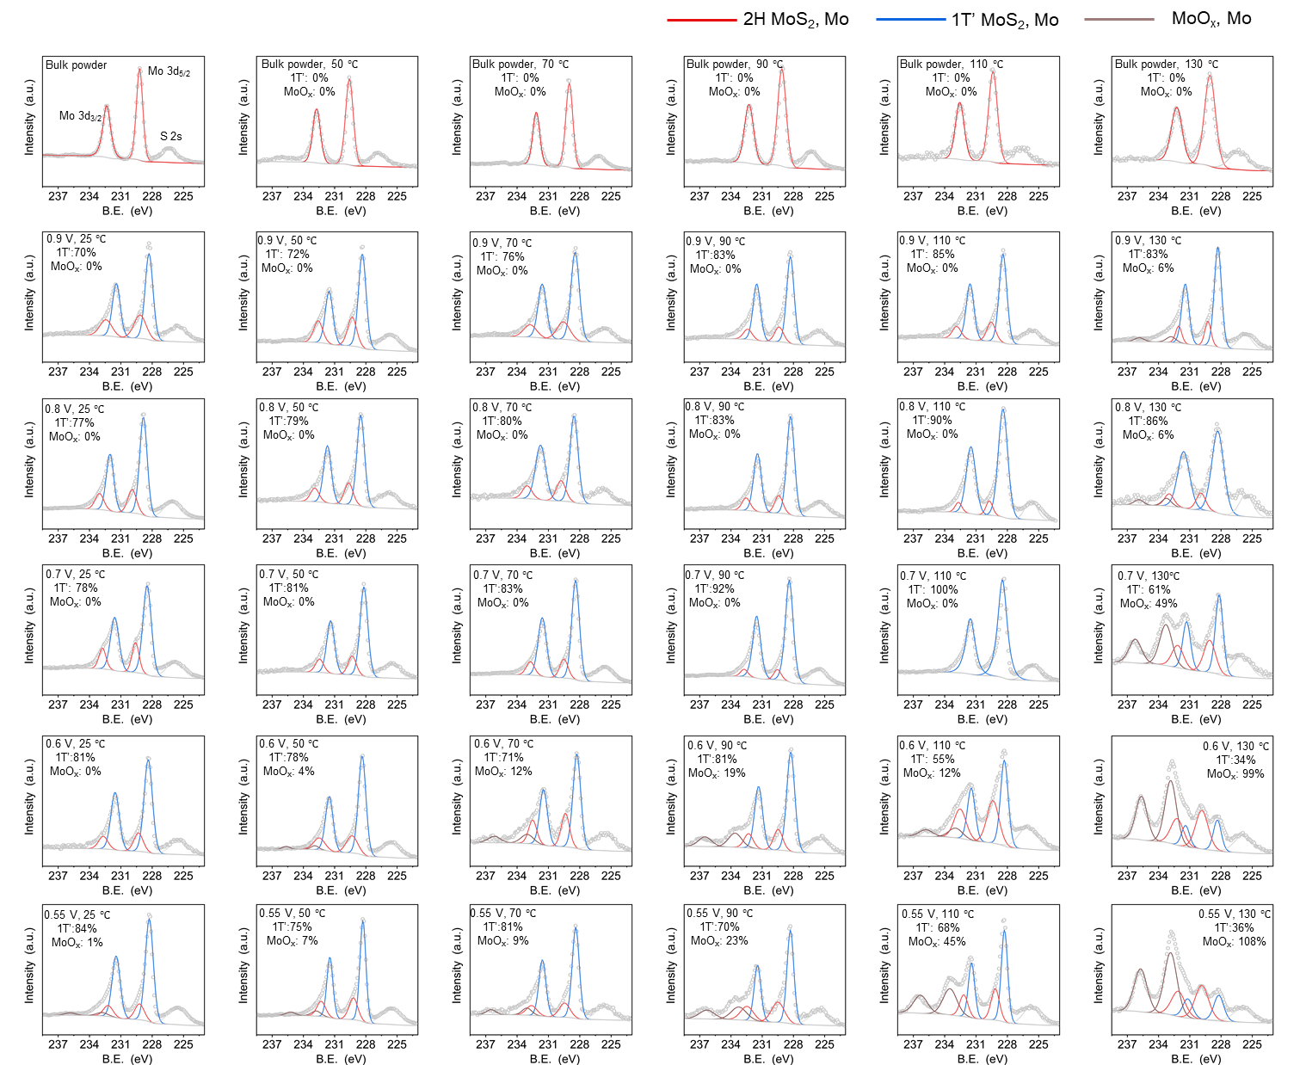
Supplementary Fig. 22. | XPS spectra corresponding to 1T’ phase and MoO_{x} ratios of MoS₂ by regulation of cut-off voltage and temperature during electrosynthesis. In our study, we analysed the phase composition of MoS₂ using XPS. After performing peak deconvolution, the areas under the peaks corresponding to the 1T’ and 2H phases were determined, allowing us to calculate the total area as the sum of both phases and 1T’ phase relative ratio. To calculate the relative content of MoO_{x} in relation to the MoS₂, we first determine the area under the peak corresponding to MoO_{x} from the XPS spectrum. Next, we calculate the total area of the MoS₂ phases by summing the corrected areas of the 1T’ and 2H phases. Finally, the relative content of MoO_{x} is found by dividing the area of MoO_{x} by the total area of the MoS₂ phases and multiplying by 100 to express it as a percentage. This approach provides the relative content of MoO_{x} as a percentage of the total area of the MoS₂.
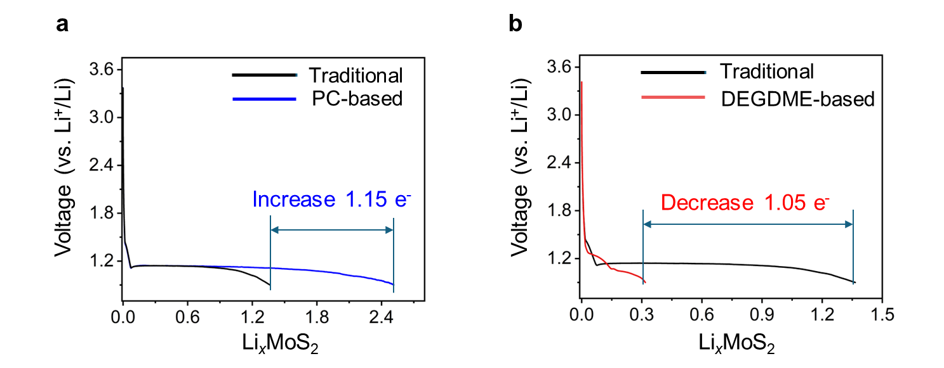
Supplementary Fig. 23. | The discharge curves for the Li-ion intercalation capacity in DEGDME-based (a) and PC-based electrolytes (b) compared to traditional electrolytes (discharged to 0.9 V).

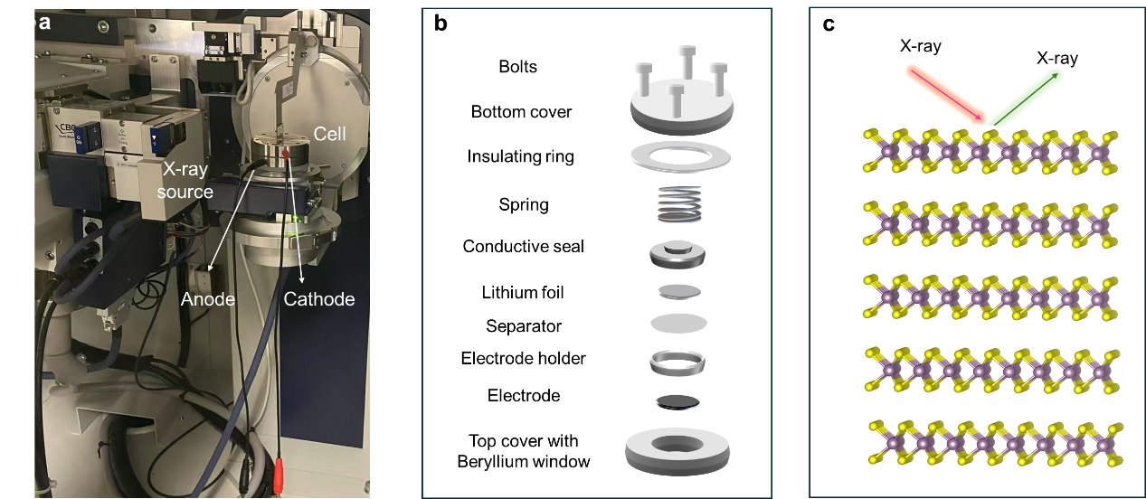
Supplementary Fig. 24. | Structural diagram of In-situ XRD. (a) Optical photograph of the test setup for electrochemical in-situ XRD. (b) Schematic of In-situ XRD cell. (c) Schematic for diffraction of X-rays in MoS₂.

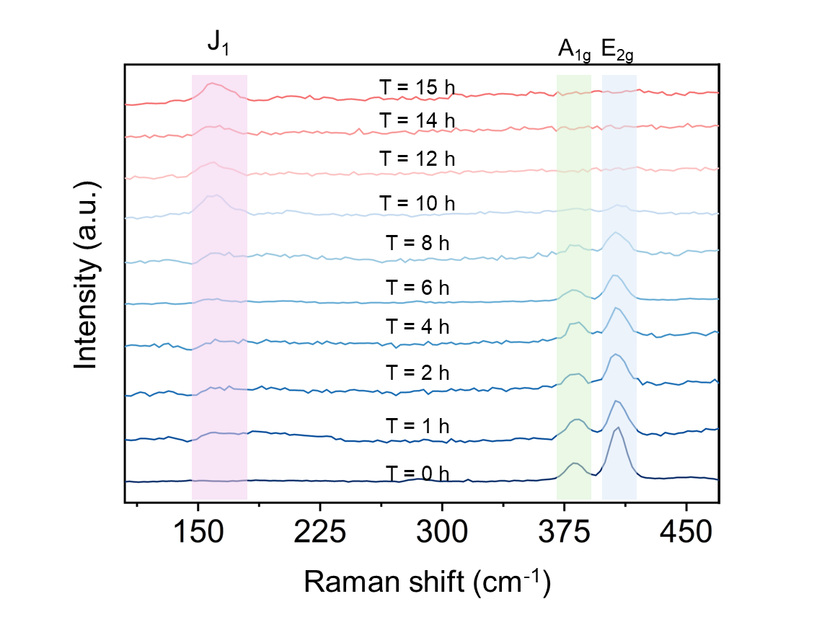
Supplementary Fig. 25. | In-situ Raman patterns of electrochemical lithiation of MoS₂ in PC-based electrolyte. Stacked The peaks attributed to 1T(1T’) Li_{x}MoS₂ (J₁) and 2H MoS₂ (E_{2g}) are increasing and decreasing with Li-ion intercalation time, implying a 2H to 1T(1T’) transition.

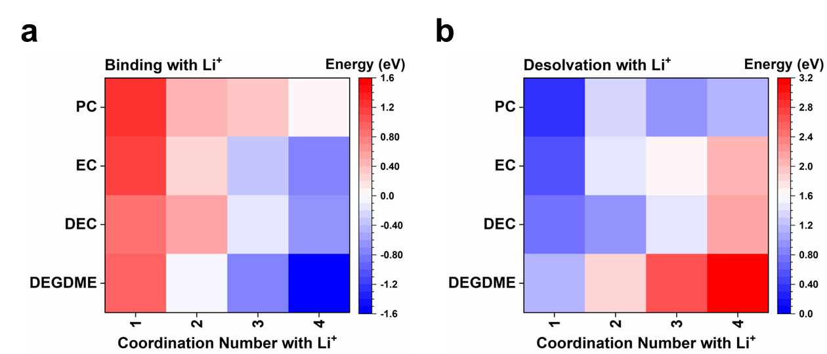
Supplementary Fig. 26. | The (a) binding and (b) desolvation energies of DEGDME, DEC, PC, and EC with Li⁺ in different coordination numbers.

Supplementary Fig. 27. | The MSD of Li⁺ in DEGDME, DEC, PC, and EC electrolytes.

Supplementary Fig. 28. | The interaction energies between Li⁺ and MoS₂ as well as the distortion ratios of MoS₂ in different electrolytes.

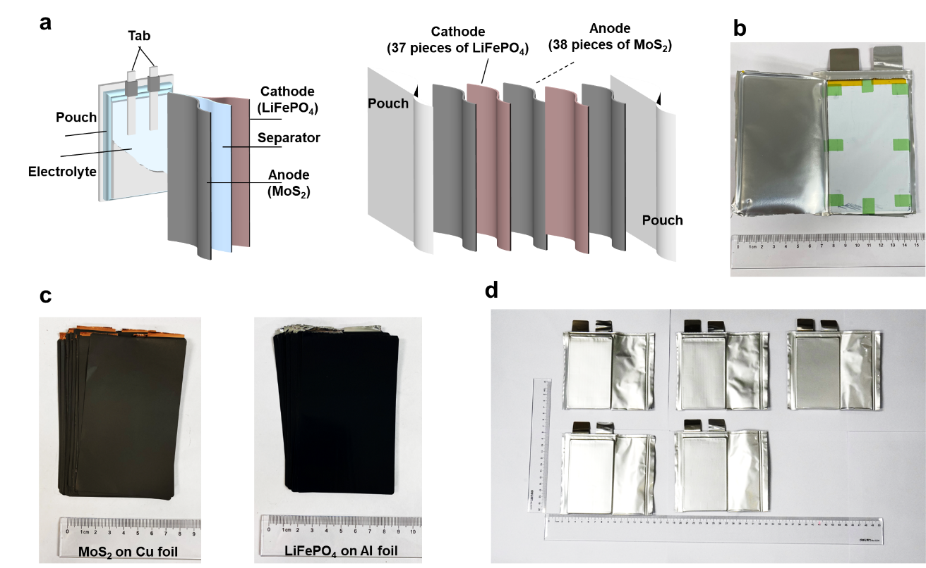
Supplementary Fig. 29. | 2H-MoS₂||LiFePO₄ pouch-type battery before charging. (a) Schematic diagram of internal structure of 2H-MoS₂||LiFePO₄ pouch-type battery. b,c Photograph of pouch-type battery (b) consisting of 38 pieces of MoS₂ anodes (left) and 37 pieces of LiFePO₄ cathode sheets (right) (c). (d) Photograph of five pouch-type batteries for scale-up preparation of high-phase-purity MoS₂ NSs.

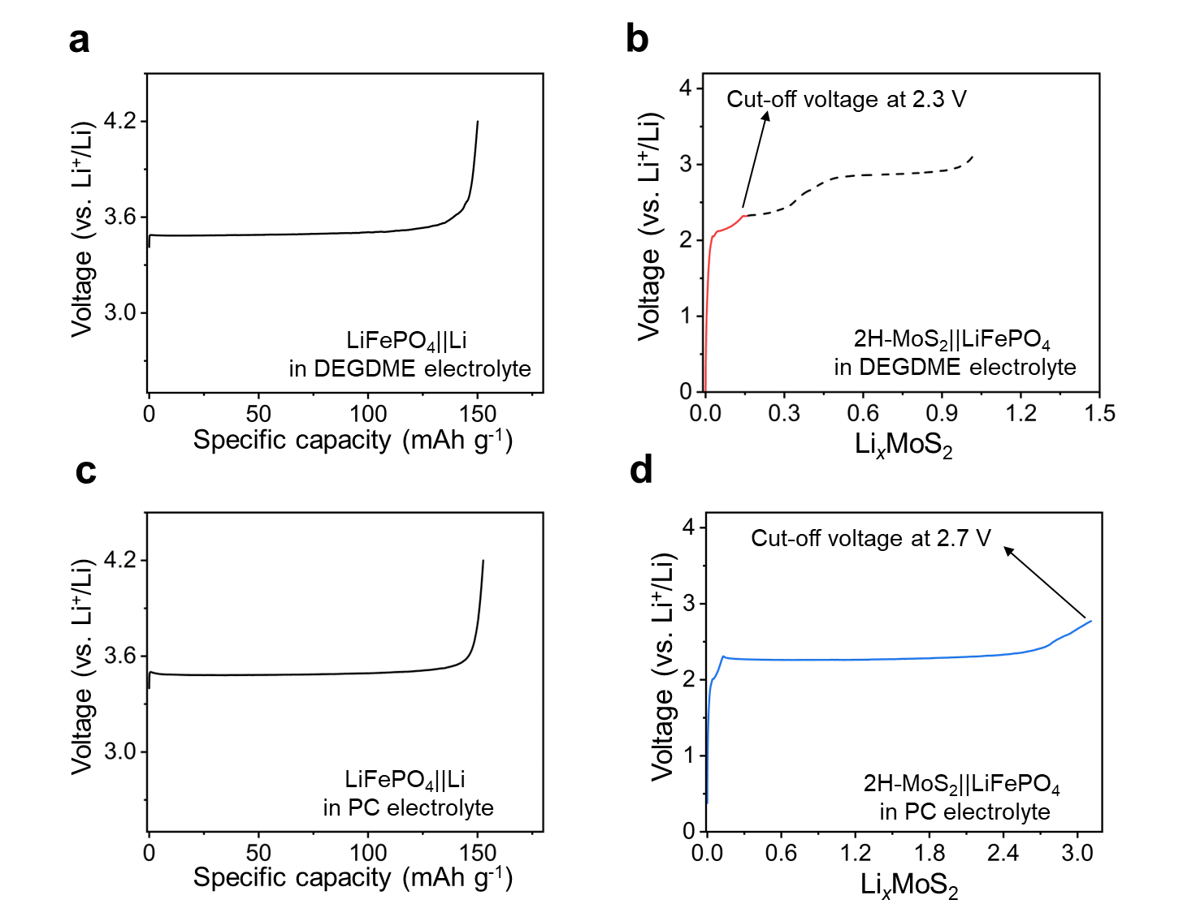
Supplementary Fig. 30. | Charge profiles of battery in DEGDME-based and PC-based electrolytes. a,c Charge profiles of the LiFePO₄||Li battery in DEGDME-based electrolyte (a) and PC-based electrolyte (c). b,d Charge profiles of the LiFePO₄||MoS₂ battery in DEGDME-based electrolyte (b) and PC-based electrolyte (d) at room temperature. The LiFePO₄||MoS₂ pouch-type batteries were charged at current density of 0.1 C (1 C = 167.4 mA g⁻¹).

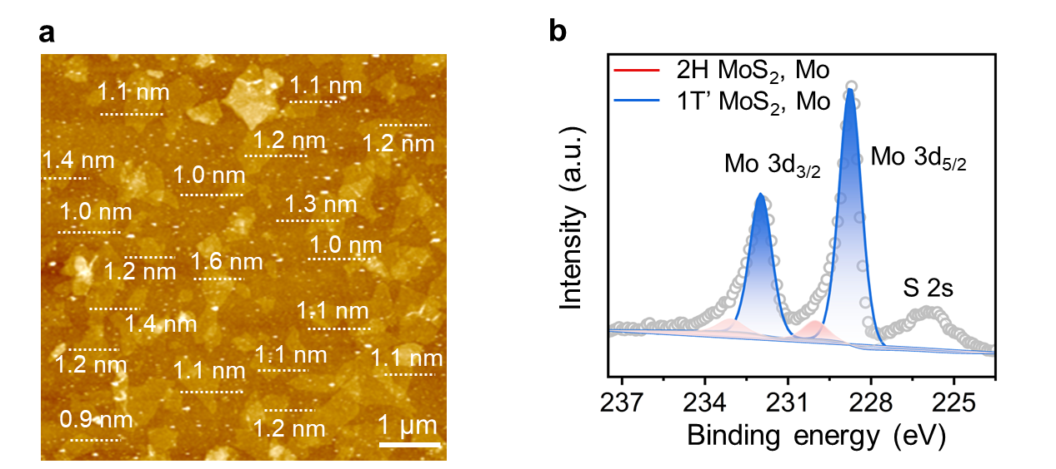
Supplementary Fig. 31. | Characterizations of the as-fabricated 2D 1T’-MoS₂ NSs. (a) AFM characterizations of 1T’-MoS₂. (b) High resolution XPS spectra of Mo 3d peaks. The 1T phase proportion in the resultant MoS₂ NSs was calculated to be ~98 wt.% based on the deconvolution results of Mo 3d peaks.

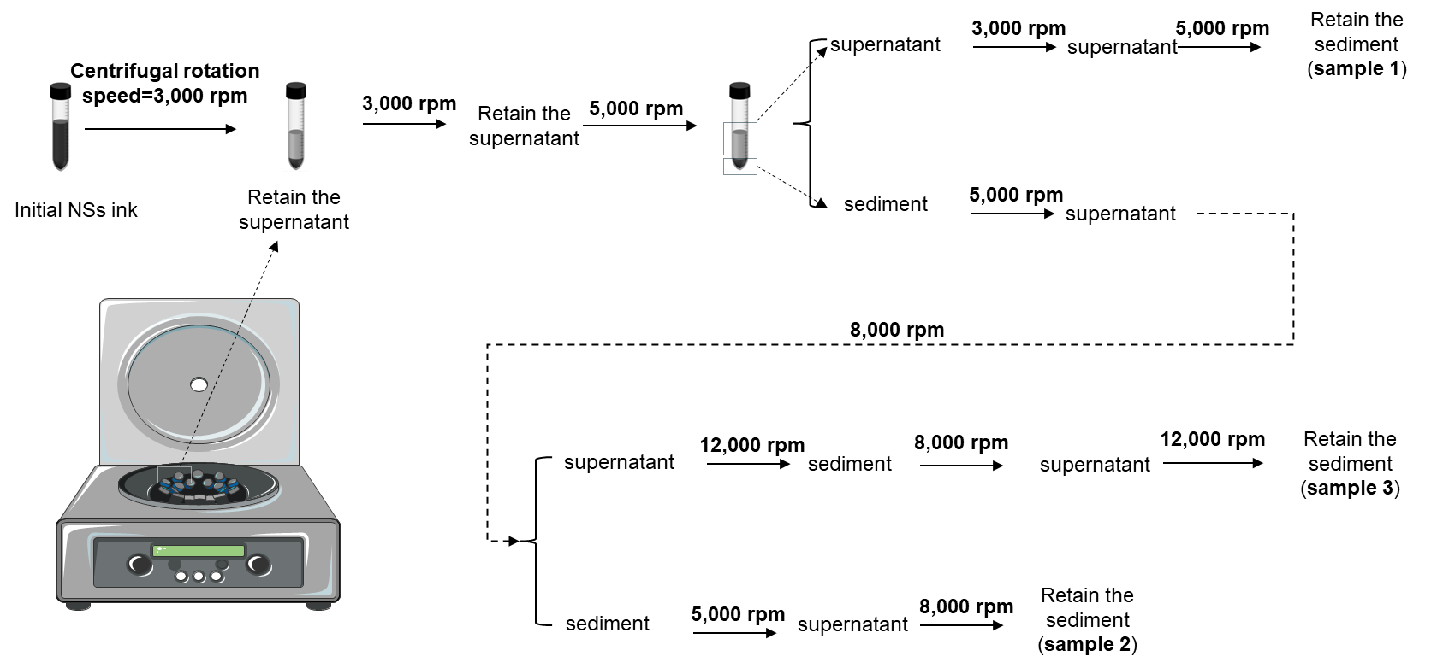
Supplementary Fig. 32. | Schematic representation of monolayer MoS₂ nanosheets with different particle sizes obtained using differential centrifugation. The nanosheet sediments were collected by alternating high and low rotational speeds between 3000 and 5000 rpm, between 5000 and 8000 rpm, and between 8000 and 12000 rpm, and were recorded as sample 1, sample 2, and sample 3, respectively.

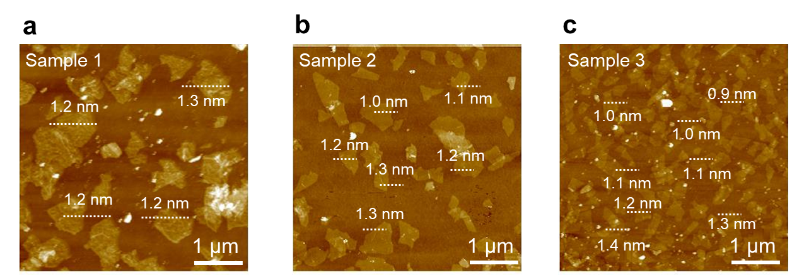
Supplementary Fig. 33. | AFM images of exfoliated 1T’-MoS₂ NSs with measured thicknesses in different sizes. (a) 1T’-MoS₂ monolayer with dimensions greater than 1 µm, screened by centrifugation at 3000-5000 rpm. (b) 1T’-MoS₂ monolayer with dimensions between 500 nm and 1 µm, screened by centrifugation at 5000-8000 rpm. (c) 1T’-MoS₂ monolayer with dimensions smaller than 500 nm, screened by centrifugation at 8000-12000 rpm. TMDs of the smallest size (like sample 3) screened using differential centrifugation were used for subsequent NO₃⁻ reduction reaction.

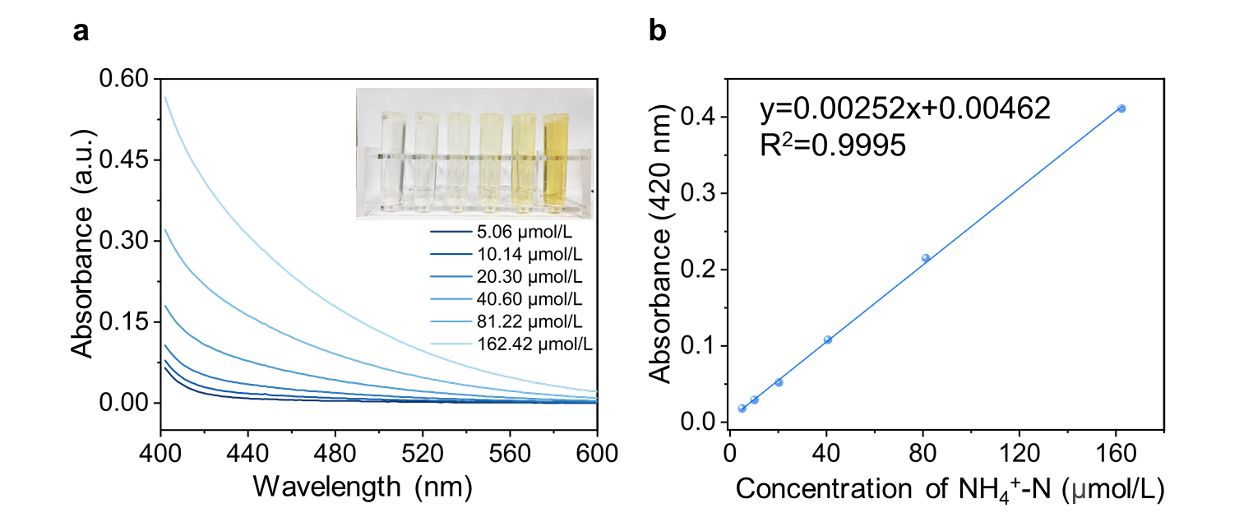
Supplementary Fig. 34. | Standard curves of NH₄⁺-N quantification by the colorimetric method. (a) UV-vis absorption spectroscopy of Nessler Reagent method with different concentrations of NH₄⁺-N, (b) the corresponding standard curve. The calibration curve shows good linearity.

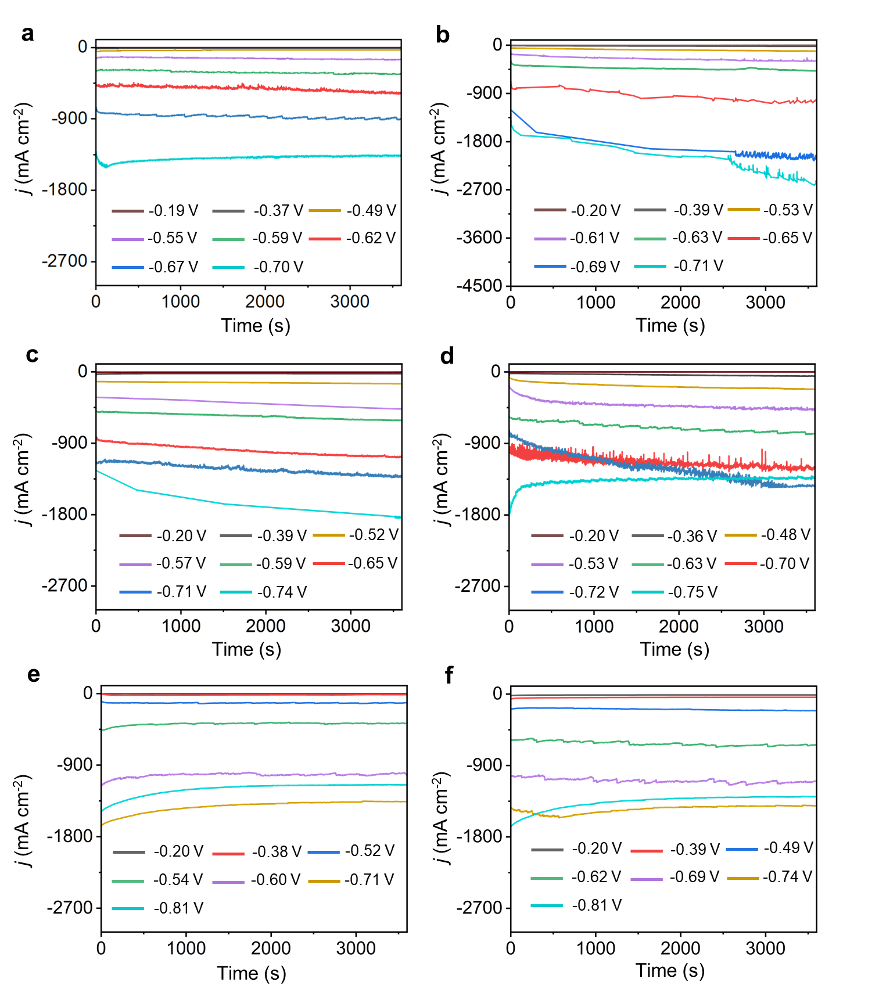
Supplementary Fig. 35. | Chronoamperometric curves of (a) 1T’ MoS₂, (b) 1T’ WS₂, (c) 2H MoS₂, (d) 2H WS₂, (e) 1T’-MoSe₂, and (f) 1T’/2H mixed MoS₂ nanosheets in at different potentials.

Supplementary Fig. 36. | The PDOS of 1T’-WS₂, 1T’-MoS_{2,} and 1T’-MoSe₂.

Supplementary Fig. 37. | The d-band center and p-band center evolutions for 1T’-WS₂, 1T’-MoS₂ and 1T’-MoSe₂.

Supplementary Fig. 38. | The PDOS comparisons between 1T’ and 2H phases of MoS₂ and WS₂.

Supplementary Fig. 39. | The energy evolutions for nitrate reduction in 1T’-WS₂ and 2H-WS₂.
Supplementary Table S1. | Comparison of other exfoliation methods with phase-selective exfoliation for producing high-phase purity TMDs nanosheets.
Method | Phase purity | Thickness (nm) | Scale (g) | Reference
Phase-selective exfoliation for 1T’ TMDs | 98% | 0.8-1.6 | ~100 | This work
Phase-selective exfoliation for 2H TMDs | 100% | 1.3-4.2 | ~100 | This work
Li-ion electrochemical exfoliation for 1T’ TMDs | ~72% | 1-2 | <1 | Ref ⁵
n-BuLi chemical exfoliation for 1T’ TMDs | ~70% | 1-2 | <5 | Ref ⁶
nap-Li chemical exfoliation for 1T’ TMDs | ~72% | 0.9-1.2 | ~3 | Ref ⁷
Solid lithiation for exfoliation for 1T’ TMDs | ~80% | 2-14 | ~100 | Ref ⁸
Solution-processable exfoliation for 2H TMDs | 100% | 0.9-8 | <2.5 | Ref ⁹
Mild electrochemical exfoliation for 2H TMDs | 100% | 0.8-8 | <5 | Ref ¹⁰
Solvent lithium intercalation for exfoliation for 1T’ TMDs | 98% | 0.8-10 | <1 | Ref ¹¹
Solvent lithium intercalation for exfoliation for 2H TMDs | 100% | 0.8-10 | <1 | Ref ¹¹
Solvent-assisted mechanical exfoliation for 2H TMDs | 100% | 2.5-37.5 | <10 | Ref ¹²
Solid-state ball milling exfoliation for 1T’ TMDs | ~70% | 1-6 | <1 | Ref ¹³
Redox liquid phase exfoliation for 2H TMDs | 95% | 2-16 | <1 | Ref ¹⁴
Intermediate assisted grinding exfoliation for 2H TMDs | 100% | 1-5 | 15 | Ref ¹⁵

Supplementary Table S2. | Detailed information for previously published NO₃⁻ reduction reaction catalyst.
Material | Current density (A cm⁻²) | NH₃ Faraday efficiency | Reference
1T’ WS₂ | 2.00 | 93.2% | This work
1T’ MoS₂ | 1.40 | 90.4% | This work
1T’ MoSe₂ | 1.31 | 91.1% | This work
1T’/2H MoS₂ | 1.37 | 87.3% | This work
Co₃O₄/Cu-N-C | 1.75 | 76.5% | Ref ¹⁶
Ru-CuNW | 1.12 | 93.2% | Ref ¹⁷
Bi | 0.95 | 55.1% | Ref ¹⁸
Cu/CuAu | 0.68 | 78.5% | Ref ¹⁹
CoP-CNS | 0.67 | 87.1% | Ref ²⁰
Ru/Cu | 0.63 | 100% | Ref ²¹
CuPd | 0.8 | 73.6% | Ref ²²
HsGDY@Cu | 0.18 | 92.2% | Ref ²³
Cu/Cu₂O | 0.13 | 97.1% | Ref ²⁴
I₁Cu₄ | 0.12 | 85.3% | Ref ²⁵
Ru/RuO_{x} | 0.11 | 80.1% | Ref ²⁶
LF/Cu | 0.011 | 51.2% | Ref ²⁷
CuCoAl | 0.005 | 99.5% | Ref ²⁸
NO₃⁻ concentration: 0.1 mol L⁻¹ in Ref 23, 0.05 M mol L⁻¹ in Ref 28, 2000 ppm in Ref 17, 200 ppm in Ref 24, 100 ppm in Ref 26, 50 ppm in Ref 27. All other remaining references use 1.0 mol L⁻¹ NO₃⁻.
Supplementary References
1 Lin, Y.-C., Dumcenco, D. O., Huang, Y.-S. & Suenaga, K. Atomic mechanism of the semiconducting-to-metallic phase transition in single-layered MoS₂. Nat. Nanotechnol. 9, 391-396, (2014).
2 Mei, L. et al. Phase-switchable preparation of solution-processable WS₂ mono- or bilayers. Nat. Synth. 4, 303-313 (2025).
3 Tan, C. et al. Preparation of high-percentage 1T-phase transition metal dichalcogenide nanodots for electrochemical hydrogen evolution. Adv. Mater. 30, 1705509, (2018).
4 Zeng, Z. et al. Single-layer semiconducting nanosheets: high-yield preparation and device fabrication. Angew. Chem. Int. Ed. 50, 11093-11097, (2011).
5 Yang, R. et al. High-yield production of mono- or few-layer transition metal dichalcogenide nanosheets by an electrochemical lithium ion intercalation-based exfoliation method. Nat. Protoc. 17, 358-377, (2022).
6 Joensen, P., Frindt, R. F. & Morrison, S. R. Single-layer MoS₂. Mater. Res. Bull. 21, 457-461, (1986).
7 Zheng, J. et al. High yield exfoliation of two-dimensional chalcogenides using sodium naphthalenide. Nat. Commun. 5, 2995, (2014).
8 Zhang, L. et al. Metal telluride nanosheets by scalable solid lithiation and exfoliation. Nature 628, 313-319, (2024).
9 Lin, Z. et al. Solution-processable 2D semiconductors for high-performance large-area electronics. Nature 562, 254-258, (2018).
10 Li, J. et al. Printable two-dimensional superconducting monolayers. Nat. Mater. 20, 181-187, (2021).
11 Peng, J. et al. High phase purity of large-sized 1T’-MoS₂ monolayers with 2D superconductivity. Adv. Mater. 31, 1900568, (2019).
12 Coleman, J. N. et al. Two-dimensional nanosheets produced by liquid exfoliation of layered materials. Science 331, 568-571, (2011).
13 Zhang, L. et al. Solid phase exfoliation for producing dispersible transition metal dichalcogenides nanosheets. Adv. Funct. Mater. 30, 2004139, (2020).
14 Jawaid, A. et al. Redox exfoliation of layered transition metal dichalcogenides. ACS Nano 11, 635-646, (2017).
15 Zhang, C. et al. Mass production of 2D materials by intermediate-assisted grinding exfoliation. Natl. Sci. Rev. 7, 324-332, (2020).
16 Liu, Y. et al. Efficient tandem electroreduction of nitrate into ammonia through coupling Cu single atoms with adjacent Co₃O₄. Nat. Commun. 15, 3619, (2024).
17 Chen, F.-Y. et al. Efficient conversion of low-concentration nitrate sources into ammonia on a Ru-dispersed Cu nanowire electrocatalyst. Nat. Nanotechnol. 17, 759-767, (2022).
18 Zhang, N. et al. Governing interlayer strain in bismuth nanocrystals for efficient Ammonia electrosynthesis from nitrate reduction. ACS Nano 16, 4795-4804, (2022).
19 Gao, Q. et al. Synthesis of core/shell nanocrystals with ordered intermetallic single-atom alloy layers for nitrate electroreduction to ammonia. Nat. Synth. 2, 624-634, (2023).
20 Fan, K. et al. Active hydrogen boosts electrochemical nitrate reduction to ammonia. Nat. Commun. 13, 7958, (2022).
21 Hu, Q. et al. Ammonia electrosynthesis from nitrate using a ruthenium–copper cocatalyst system: A full concentration range study. J. Am. Chem. Soc. 146, 668-676, (2024).
22 Gao, Q. et al. Breaking adsorption-energy scaling limitations of electrocatalytic nitrate reduction on intermetallic CuPd nanocubes by machine-learned insights. Nat. Commun. 13, 2338, (2022).
23 Wang, B. et al. Bridging nickel-MOF and copper single atoms/clusters with H-substituted graphdiyne for the tandem catalysis of nitrate to ammonia. Angew. Chem. Int. Ed. 63, e202404819, (2024).
24 Wang, Y., Zhou, W., Jia, R., Yu, Y. & Zhang, B. Unveiling the activity origin of a copper-based electrocatalyst for aelective nitrate reduction to ammonia. Angew. Chem. Int. Ed. 59, 5350-5354, (2020).
25 Zhou, B. et al. Reversed I₁Cu₄ single-atom sites for superior neutral ammonia electrosynthesis with nitrate. Proc. Nat. Acad. Sci. 121, e2405236121, (2024).
26 Li, J. et al. Efficient ammonia electrosynthesis from nitrate on strained ruthenium nanoclusters. J. Am. Chem. Soc. 142, 7036-7046, (2020).
27 Chu, K. et al. Cation substitution strategy for developing perovskite oxide with rich oxygen vacancy-mediated charge redistribution enables highly efficient nitrate electroreduction to ammonia. J. Am. Chem. Soc. 145, 21387-21396, (2023).
28 Wang, W., Chen, J. & Tse, E. C. M. Synergy between Cu and Co in a layered double hydroxide enables close to 100% nitrate-to-ammonia selectivity. J. Am. Chem. Soc. 145, 26678-26687, (2023).

