Study of Structural Stability, Mechanical and Optoelectronic Properties of New Earth-Abundant Cu₂Ni(Sn,Ge,Si)Se₄ Kesterites for Photovoltaic Applications
Iskandar Raufov ª, Dilshod Nematov ^{a,b *}, Saidjafar Murodzodaª, Anushervon Ashurovª, Sakhidod Sattorzoda ª Kodir Boturovª
ª S.U. Umarov Physical-Technical Institute of NAST, Dushanbe 734063, Tajikistan
^{b} School of Optoelectronic Engineering & CQUPT-BUL Innovation Institute, Chongqing University of Posts and Telecommunications, Chongqing 400065, China
* Corresponding author: dilnem@mail.ru (D.N)

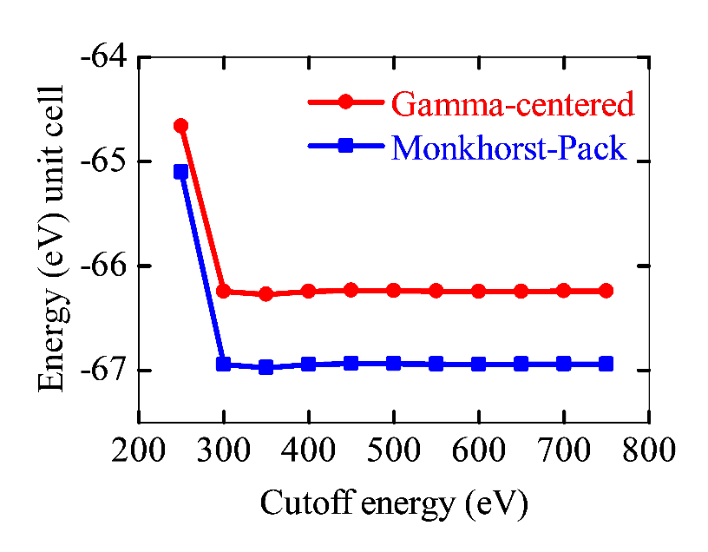
Figure S1. Convergence of the total energy of the Cu₂NiGeSe₄ crystal structure as a function of the plane-wave cutoff energy (ENCUT), calculated using Monkhorst-Pack (blue) and Γ-centered (red) k-point sampling schemes.

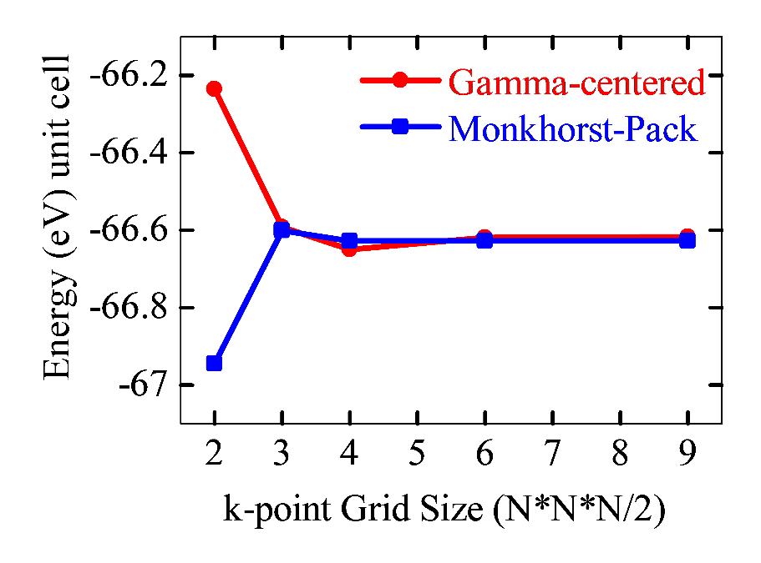
Figure S2. Convergence of the total energy of the Cu₂NiGeSe₄ crystal structure as a function of k-point mesh density, constructed using the Monkhorst-Pack scheme (blue) and Gamma-centered scheme (red).

Figure S3. Calculated pressure-dependent values ​​of the band gap width of kesterites of the Cu₂Ni(Sn, Ge, Si)Se₄ system
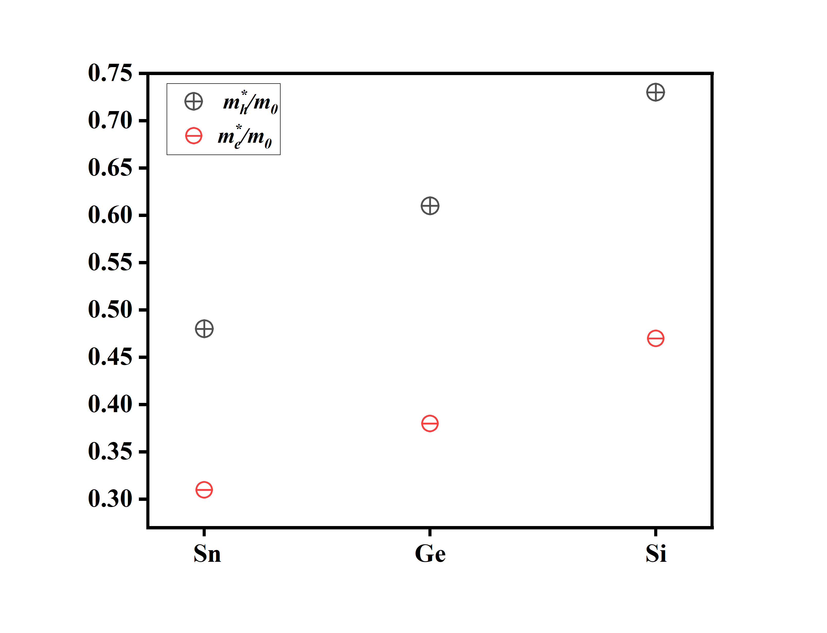
Figure S4. Calculated values ​​of the effective masses of electrons$(m_{h}^{*}/m_{0})$and holes ($m_{e}^{*}/m_{0}$) of semiconductors of the Cu₂Ni(Sn, Ge, Si)Se₄ system

Figure S5. Calculation of the total electronic density of states for: (a) Cu₂NiSnSe₄, (b) Cu₂NiGeSe₄, and (c) Cu₂NiSiSe₄, considering spin polarization (spin-up and spin-down).
Table S1. Pressure dependence of the elastic constants Cij (in GPa) and bulk moduli 𝐵 for the Cu₂NiXSe₄ (X = Sn, Ge , Si)
System | Pressure | C11 | C12 | C13 | C33 | C44 | C66 | B
Cu₂NiSnSe₄ | 0 | 62.70 | 47.32 | 43.37 | 64.59 | 19.68 | 22.82 | 50.41
Cu₂NiSnSe₄ | 5 | 63.42 | 48.33 | 44.27 | 64.77 | 19.34 | 22.50 | 50.94
Cu₂NiSnSe₄ | 10 | 64.97 | 49.55 | 43.13 | 60.14 | 18.52 | 21.73 | 49.79
Cu₂NiSnSe₄ | 15 | 66.71 | 52.92 | 48.53 | 68.15 | 18.38 | 21.86 | 54.79
Cu₂NiSnSe₄ | 20 | 69.28 | 55.77 | 51.50 | 70.60 | 17.86 | 21.46 | 57.31
Cu₂NiSnSe₄ | 25 | 72.07 | 59.23 | 52.09 | 68.15 | 16.88 | 20.41 | 58.37
Cu₂NiSnSe₄ | 30 | 70.64 | 59.41 | 51.87 | 68.654 | 16.51 | 19.65 | 58.30
Cu₂NiGeSe₄ | 0 | 62.72 | 46.54 | 42.37 | 70.51 | 25.16 | 23.34 | 51.87
Cu₂NiGeSe₄ | 5 | 61.32 | 45.07 | 41.84 | 70.39 | 24.82 | 23.29 | 50.43
Cu₂NiGeSe₄ | 10 | 63.11 | 47.12 | 43.87 | 71.92 | 24.60 | 23.25 | 52.20
Cu₂NiGeSe₄ | 15 | 72.76 | 52.20 | 55.31 | 84.74 | 24.62 | 23.21 | 59.44
Cu₂NiGeSe₄ | 20 | 67.86 | 54.03 | 50.55 | 79.34 | 24.54 | 23.26 | 59.21
Cu₂NiGeSe₄ | 25 | 69.75 | 56.96 | 53.11 | 82.04 | 24.30 | 23.01 | 61.88
Cu₂NiGeSe₄ | 30 | 72.73 | 60.54 | 57.00 | 86.25 | 24.02 | 22.73 | 65.46
Cu₂NiSiSe₄ | 0 | 80.63 | 56.30 | 54.13 | 89.54 | 29.21 | 30.14 | 63.59
Cu₂NiSiSe₄ | 5 | 82.01 | 58.07 | 55.95 | 91.31 | 28.99 | 30.12 | 65.23
Cu₂NiSiSe₄ | 10 | 82.91 | 59.46 | 57.29 | 92.61 | 28.76 | 30.07 | 66.11
Cu₂NiSiSe₄ | 15 | 86.29 | 63.07 | 60.93 | 96.00 | 28.45 | 29.98 | 69.55
Cu₂NiSiSe₄ | 20 | 85.56 | 62.82 | 60.53 | 95.39 | 28.14 | 29.88 | 69.20
Cu₂NiSiSe₄ | 25 | 86.54 | 66.23 | 64.34 | 101.28 | 27.89 | 30.12 | 72.94
Cu₂NiSiSe₄ | 30 | 88.22 | 68.07 | 66.21 | 102.77 | 27.52 | 30.04 | 74.38

Table S2. Calculated shear moduli, sound velocities and Debye temperatures for Cu₂NiXSe₄ (X = Sn, Ge , Si)
System | P, GPa | G, GPa | V_{t}, m/s | V_{l}, m/s | V_{m}, m/s | Θ_{D}, K
Cu₂NiSnSe₄ | 0 | 14.756 | 1610.980 | 3510.786 | 1815.338 | 191.0
Cu₂NiSnSe₄ | 5 | 14.407 | 1585.856 | 3499.360 | 1788.035 | 188.6
Cu₂NiSnSe₄ | 10 | 13.832 | 1548.214 | 3438.614 | 1746.094 | 184.7
Cu₂NiSnSe₄ | 15 | 13.585 | 1528.647 | 3541.176 | 1727.013 | 183.1
Cu₂NiSnSe₄ | 20 | 13.150 | 1498.723 | 3575.392 | 1695.052 | 180.1
Cu₂NiSnSe₄ | 25 | 12.457 | 1453.742 | 3566.477 | 1645.748 | 175.3
Cu₂NiSnSe₄ | 30 | 11.945 | 1418.676 | 3536.532 | 1606.873 | 171.5
Cu₂NiGeSe₄ | 0 | 17.732 | 1784.391 | 3682.314 | 2005.286 | 215.0
Cu₂NiGeSe₄ | 5 | 17.510 | 1766.663 | 3626.297 | 1984.788 | 213.3
Cu₂NiGeSe₄ | 10 | 17.285 | 1748.820 | 3648.912 | 1966.461 | 211.9
Cu₂NiGeSe₄ | 15 | 17.126 | 1734.793 | 3802.258 | 1955.368 | 211.2
Cu₂NiGeSe₄ | 20 | 16.946 | 1719.689 | 3778.308 | 1938.555 | 209.9
Cu₂NiGeSe₄ | 25 | 16.683 | 1700.719 | 3818.939 | 1918.995 | 208.2
Cu₂NiGeSe₄ | 30 | 16.403 | 1681.034 | 3878.900 | 1898.885 | 206.4
Cu₂NiSiSe₄ | 0 | 21.697 | 2021.043 | 4173.287 | 2271.311 | 246.3
Cu₂NiSiSe₄ | 5 | 21.502 | 2004.880 | 4189.662 | 2254.569 | 245.0
Cu₂NiSiSe₄ | 10 | 21.272 | 1987.516 | 4188.605 | 2236.012 | 243.6
Cu₂NiSiSe₄ | 15 | 21.037 | 1969.951 | 4243.182 | 2218.629 | 242.2
Cu₂NiSiSe₄ | 20 | 20.814 | 1953.202 | 4215.460 | 2199.974 | 240.7
Cu₂NiSiSe₄ | 25 | 20.582 | 1936.279 | 4276.144 | 2183.214 | 239.3
Cu₂NiSiSe₄ | 30 | 20.302 | 1917.281 | 4285.767 | 2162.934 | 237.6

Table S3. Band gap Cu₂NiXSe₄ (X = Sn, Ge , Si)
System
Cu₂NiSnSe₄ |  | 0 | 0.583
 |  | 5 | 0.605
 |  | 10 | 0.616
 |  | 15 | 0.616
 |  | 20 | 0.638
 |  | 25 | 0.649
 |  | 30 | 0.693
Cu₂NiGeSe₄ |  | 0 | 0.99
 |  | 5 | 1.012
 |  | 10 | 1.034
 |  | 15 | 1.045
 |  | 20 | 1.067
 |  | 25 | 1.089
 |  | 30 | 1.1
Cu₂NiSiSe₄ |  | 0 | 2.123
 |  | 5 | 2.145
 |  | 10 | 2.156
 |  | 15 | 2.178
 |  | 20 | 2.2
 |  | 25 | 2.211
 |  | 30 | 2.233

Table S4. Calculated values of lattice constants a Cu₂NiXSe₄ (X = Sn, Ge , Si) within the GGA framework.
System | Cu₂NiSnSe₄ |  | Cu₂NiGeSe₄ |  | Cu₂NiSiSe₄
Pressure (GPa) | 𝑎, b (Å) | c (Å) | 𝑎, b (Å) | c (Å) | 𝑎, b (Å) | c (Å)
0 | 5.667 | 11.283 | 5.523 | 11.228 | 5.466 | 11.084
5 | 5.653 | 11.256 | 5.508 | 11.208 | 5.452 | 11.065
10 | 5.637 | 11.234 | 5.493 | 11.184 | 5.438 | 11.049
15 | 5.626 | 11.195 | 5.478 | 11.168 | 5.424 | 11.032
20 | 5.612 | 11.172 | 5.464 | 11.149 | 5.412 | 11.011
25 | 5.599 | 11.151 | 5.450 | 11.134 | 5.398 | 10.997
30 | 5.576 | 11.166 | 5.437 | 11.117 | 5.387 | 10.978

Table S5. Calculated and experimental band gap of Cu₂NiXSe₄ (X = Sn, Ge , Si) in eV.

System | ε | n | R
Cu₂NiSnSe₄ | 8.88 | 3.24 | 0.34
Cu₂NiGeSe₄ | 13.41 | 3.83 | 0.38
Cu₂NiSiSe₄ | 7.05 | 2.73 | 0.24

