Supporting Information

Ion Flux Optimization via Hollow Carbon Nanoreactors for High-Power and Energy-Dense Li-Cl₂ Batteries

Yan Xu^{1,*}, Jiejun Ye¹, Zhipeng Wang¹, Peichao Zou¹, Lidong Sun², Liyao Wang¹, Qi Liu¹, Mark H. Rummeli^{1,3}, Shenxiang Zhang^{1,*}, Wei Chen^{2,*}

¹College of Energy, College of Chemistry, Chemical Engineering and Materials Science, Soochow University, Suzhou, Jiangsu 215006, China
²Department of Chemistry, School of Chemistry and Materials Science, Hefei National Research Center for Physical Sciences at the Microscale, University of Science and Technology of China, Hefei, Anhui 230026, China
³Institute for Materials Chemistry, IFW Dresden, 20 Helmholtz Strasse, Dresden 01069, Germany
Corresponding authors: yanxu2022@suda.edu.cn; sxzhang@suda.edu.cn; weichen1@ustc.edu.cn

Methods
HCNRs synthesis
High-purity MgO powders (AR, 99.9%, Aladdin) with particle sizes of approximately 20 nm and 50 nm were utilized as templates for the growth of hollow carbon nanocages (HCNs) through the chemical vapor deposition (CVD) method. The process involved placing 3 g of MgO powder in a quartz boat and sealing it in the CVD system. Pure acetonitrile (AR, 99.7%, Sinopharm Chemical Reagent Co., Ltd.) was employed as the carbon source and introduced into the CVD system via argon gas flow at a rate of 200 mL/min. Subsequently, calcination was carried out in a tube furnace at 900 °C for 1 h with a heating rate of 20 °C/min under vacuum. The resulting product was then washed three times with 100 mL 1 mol/L HCl and collected through centrifugation, followed by freeze-drying for 2 days.
Electrochemical measurements of coin cell and pouch cell
The electrolyte recipe was 1.5 M AlCl₃ + 1.5 M LiCl in SOCl₂ solution. The HCNRs and AB electrodes were prepared by mixing the active material (HCNR-50 nm or HCNR-20 nm), ketjenblack, CNT, and polytetrafluoroethylene (PTFE) in a specific mass ratio of 8:0.5:0.7:0.8 in water. The resulting paste was drop-casted onto carbon paper collectors with a diameter of 12 mm and dried at 60 °C in a vacuum oven overnight. The mass loading of active materials in the cathode was maintained at approximately 1 mg/cm² and 2-3 mg/cm². Li-Cl₂ coin cells were assembled with Li foil as the anode, glass fiber as the separator, and 120 μL of electrolyte in each coin cell. The cathode for pouch cells was prepared by drop casting the same slurry onto Ni foam (33*62 mm²) with a mass loading of ~120 mg. Then the cathode, separator, Li foil were stacked sequentially with 5 layers. Finally, 18-20 g electrolyte was injected into the pouch cell and sealed. The entire assembly process took place in an Ar-filled glove box for coin cells and a dry room for pouch cells. The electrochemical performance of the coin cell and pouch cell was evaluated using a LAND battery tester, and impedance testing was performed on a CHI 660E electrochemical workstation. The impedance test and current rate tests were conducted at room temperature, and other electrochemical measurements were conducted at a low temperature of -5±5 ℃ in a refrigerator (CHIGO).
Cl₂ adsorption experiment
Cl₂ gas was generated in the laboratory by using manganese dioxide (MnO₂) to oxidize hydrochloric acid (HCl), as shown in the below equation:
MnO₂ + 4HCl Cl₂ + MnCl₂ + 2H₂O
In detail, 20 g MnO₂ was added into 30 mL concentrated HCl and heated at 80 °C. The generated gas was bubbled through a saturated sodium chloride solution and concentrated sulfuric acid to remove residual HCl gas and water vapor, respectively. Afterwards, the purified Cl₂ gas was injected into the sealed bottle with pre-placed 10 mg of HCN-20 nm, HCNs-50 nm and AB. After 30 min static adsorption, the residual chlorine gas on the samples’ surface was purged by nitrogen gas. Afterwards, the samples were dispersed in 10 mL Na₂CO₃ solution with pH of 10. The concentration of Cl⁻ was measured by a silver nitrate titration method. The adsorption amount of Cl₂ by HCN-50 nm, HCN-20 nm and AB can be calculated based on the Cl⁻ in solution.
Materials characterizations
For morphology analysis, scanning electron microscopy (SEM) images were acquired using a scanning electron microscope (SU8230, Japan) and transmission electron microscopy (TEM) was performed with FEI Tecnai G2F20 s-twin 200 kV, America. Raman measurements were conducted using a spectrometer (Horiba LabRam Soleil, France) with a laser having an excitation wavelength of 532 nm. Powder X-ray diffraction data were obtained using a Bruker D8 Advance, Germany) with Cu K_{α} at room temperature. Nitrogen sorption isotherms were recorded at 77 K (Quantachrome Autosorb-iQ2, America). X-ray photoelectron spectroscopy (XPS) data were collected with a monochromatic Al source (KRATOS, Axis Ultra). Electron paramagnetic resonance (EPR) measurements were carried out using a Thermo Escalab 250Xi with a monochromatic Al K_{α} source.

Supporting Figures
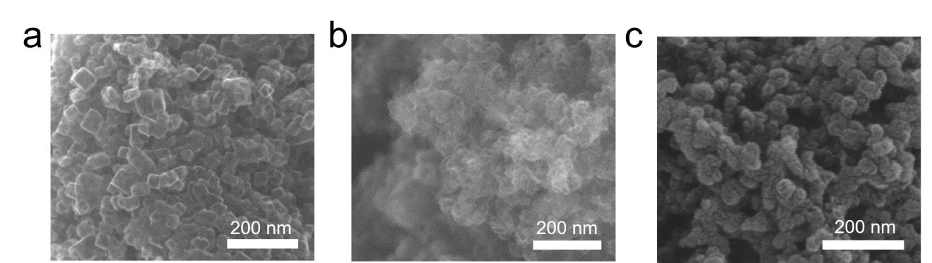
Figure S1. SEM images of (a) HCNR-50 nm, (b) HCNR-20 nm and (c) KJ Black.

Figure S2. Diameter distribution of HCNR-20 nm and HCNR-50 nm.

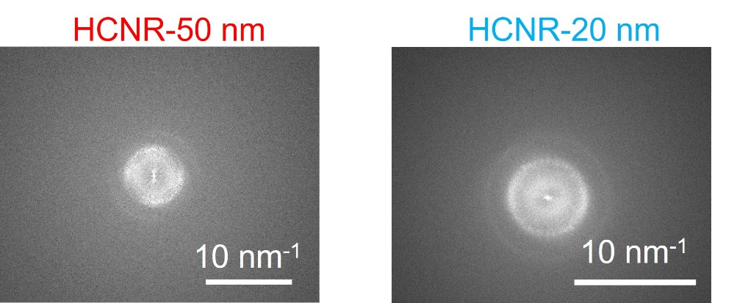
Figure S3. TEM diffraction pattern of HCNR-50 nm and HCNR-20 nm.

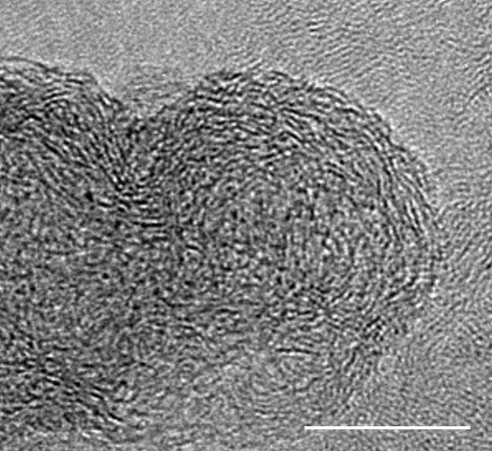
Figure S4. HRTEM of KJ Black. Scale bar is 10 nm.

Figure S5. Pore size distribution curves of HCNR-50 nm, HCNR-20 nm and KJ Black.

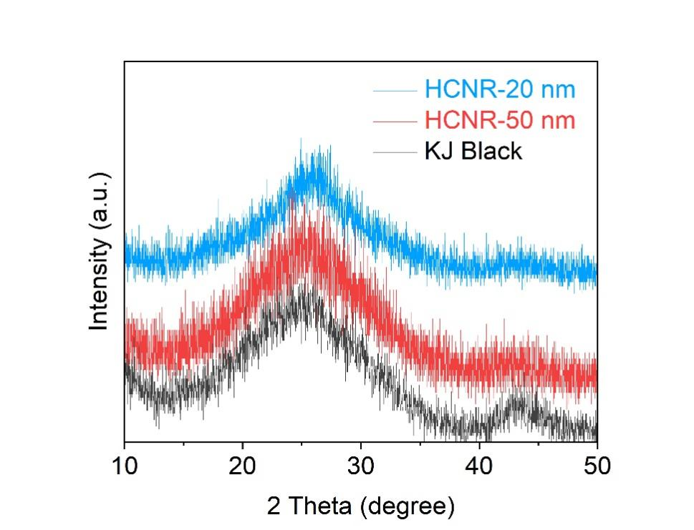
Figure S6. XRD patterns of HCNR-50 nm, HCNR-20 nm and KJ Black.

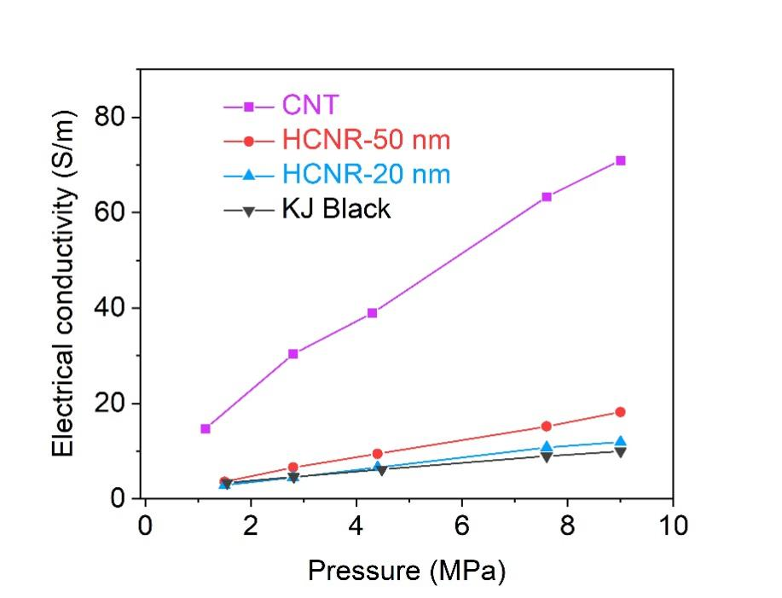
Figure S7. The electron conductivity of CNT, HCNR-50 nm, HCNR-20 nm and KJ Black.

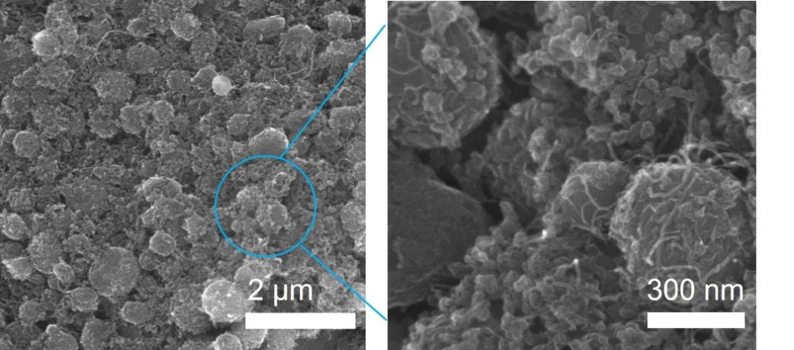
Figure S8. The SEM image of HCNR-50 nm electrode.

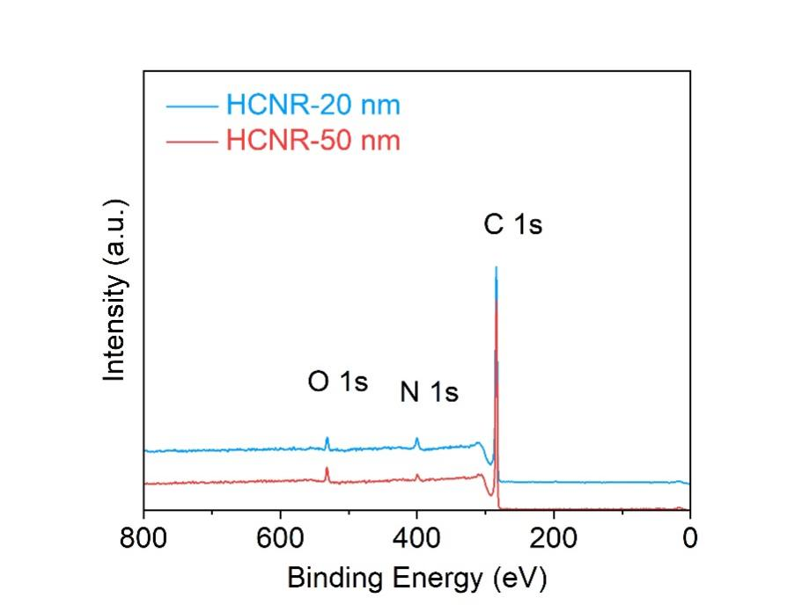
Figure S9. The XPS survey curves of pristine HCNR-20 nm and pristine HCNR-50 nm.
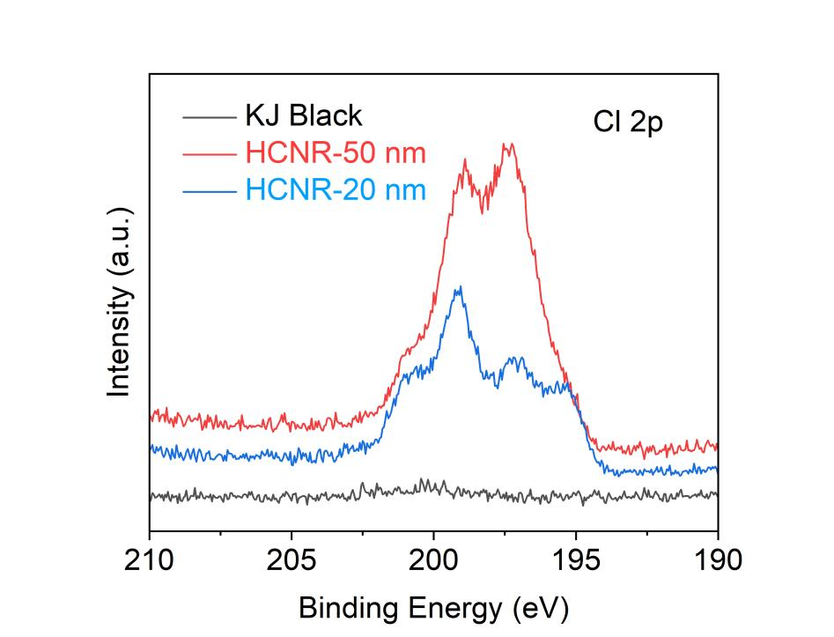
Figure S10. The Cl 2p XPS of KJ Black, HCNR-50 nm and HCNR-20 nm after the adsorption of Cl₂.

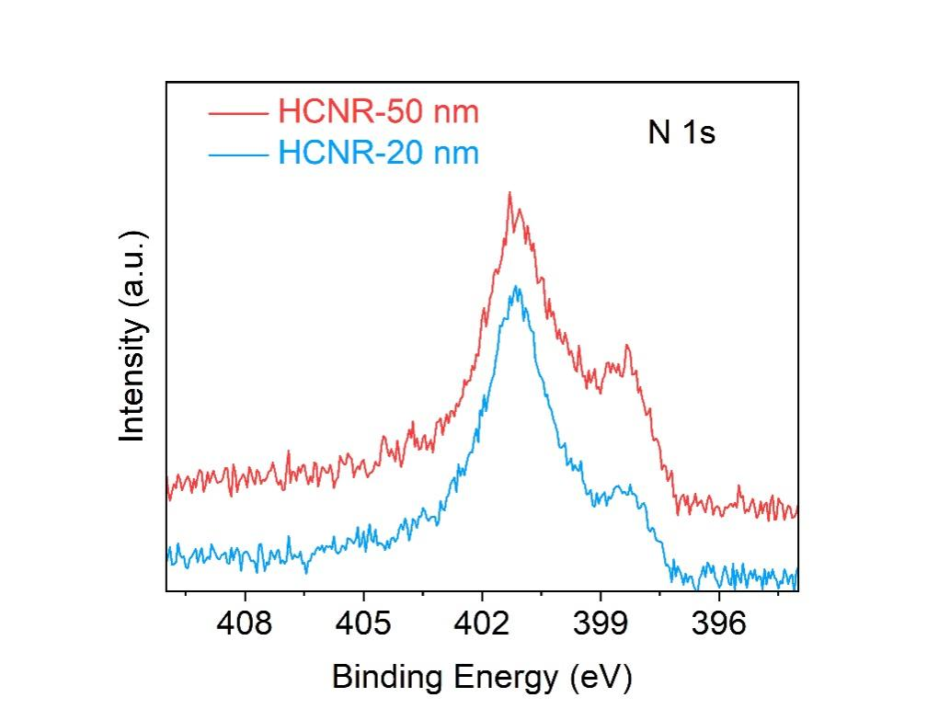
Figure S11. The N 1s XPS of HCN-50 nm and HCN-20 nm after the adsorption of Cl₂.

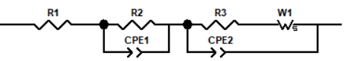
 | Li-Cl₂@KJ Black | Li-Cl₂@HCNR-50 nm | Li-Cl₂@HCNR-20 nm
Warburg  resistance (Ω) | 187 | 94 | 81
Figure S12. The corresponding equivalent circuit used for EIS fitting and the warburg resistance.

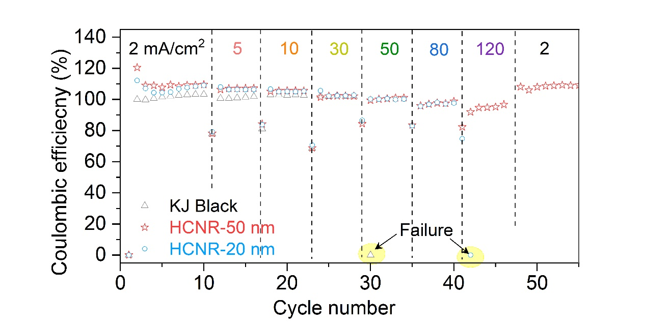
Figure S13. CE of Li-Cl₂@HCNR-50 nm battery, Li-Cl₂@HCNR-20 nm battery and Li-Cl₂@KJ Black battery under the current densities from 2 mA/cm² to 120 mA/cm².

Figure S14. Voltage profiles of Li-Cl₂@HCNR-50 nm battery at a current density of 120 mA/cm².

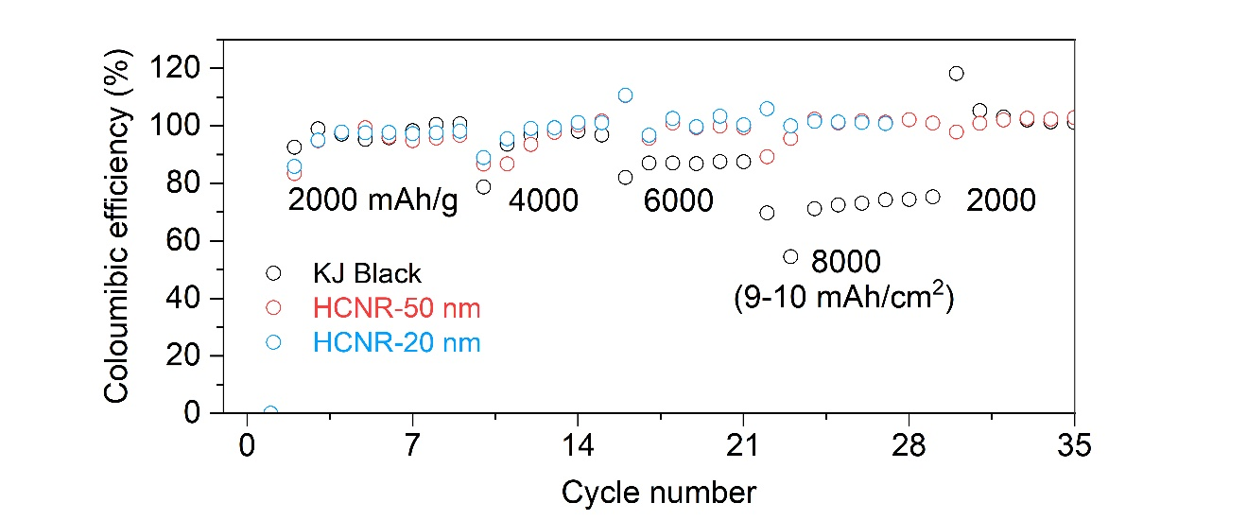
Figure S15. The CEs of Li-Cl₂@KJ Black, Li-Cl₂@HCNR-20 nm and Li-Cl₂@HCNR-50 nm batteries under the specific capacities from 2000 mAh/g to 8000 mAh/g.
Figure S16. The voltage profile of Li-Cl₂@HCNR-20 nm battery at the last cycle.

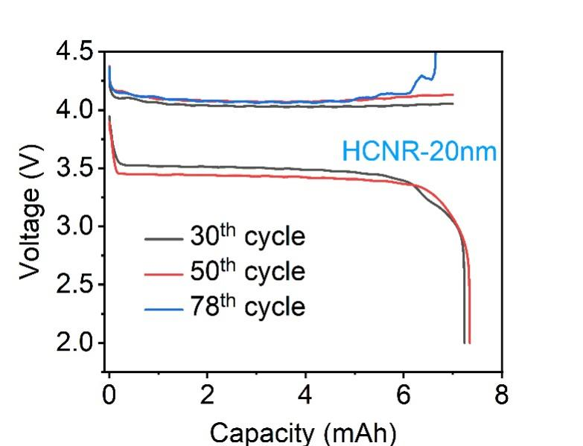
Figure S17. The voltage profiles of Li-Cl₂@HCNR-20 nm battery at the 30th, 50th and 78th cycles.

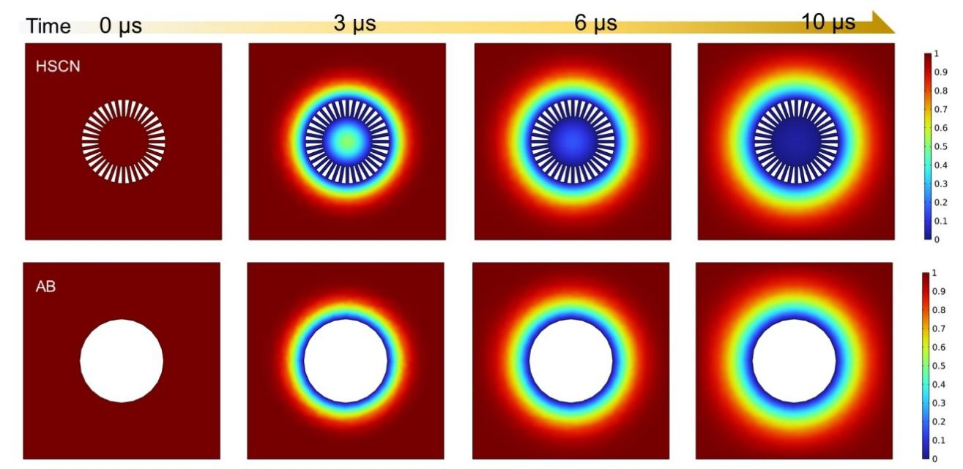
Figure S18. The simulated Cl₂ species distribution on (a) HCNRs and (b) KJ Black. Scale bar is the relative concentration of Cl₂.
Figure S19. The first discharge voltage profile of Li-Cl₂ pouch cell.

Table S1. The C, N, O contents calculated from survey spectra.
HCNs | Atomic C (%) | Atomic N (%) | Atomic O (%)
 | 90.6 | 6.3 | 3.1

Table S2. The energy density of Li-Cl₂@HCNR-50 nm pouch cell.
Capacity of the 1st cycle (mAh) | Average voltage (V) | Mass of pouch cell (g) | Energy density  (Wh/kg)
1000 | 3.45 | 32.4 | 106.5

