Supplementary Figure
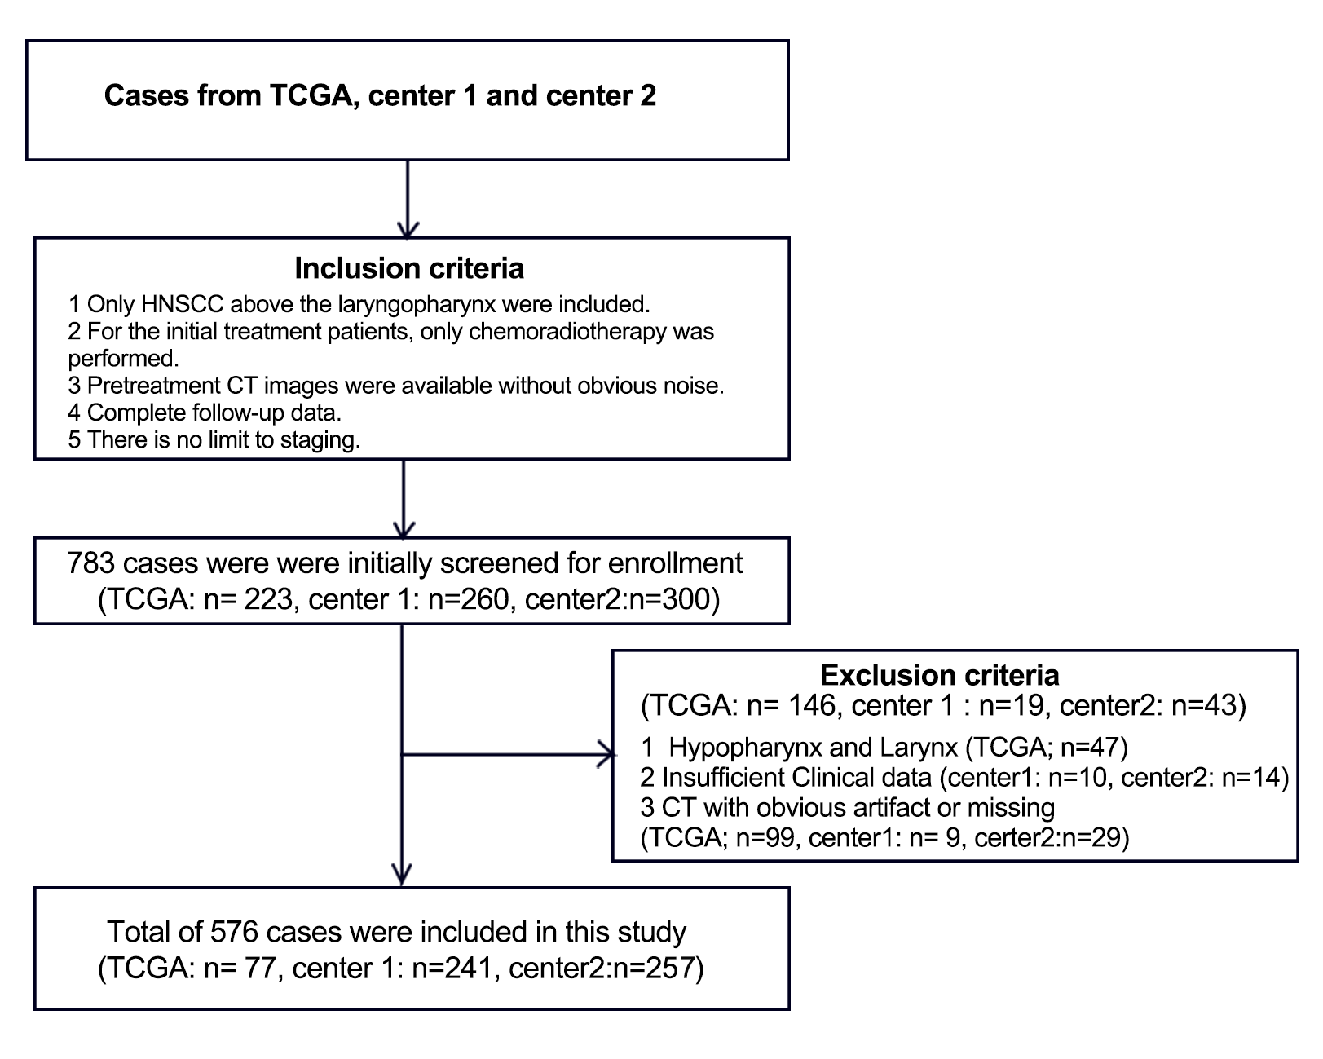
Figure 1 Flowchart of included and excluded patients in this study

Noted: TCGA=The Cancer Genome Atlas; NPC=Nasopharyngeal carcinoma, OPC=Oropharyngeal cancer;

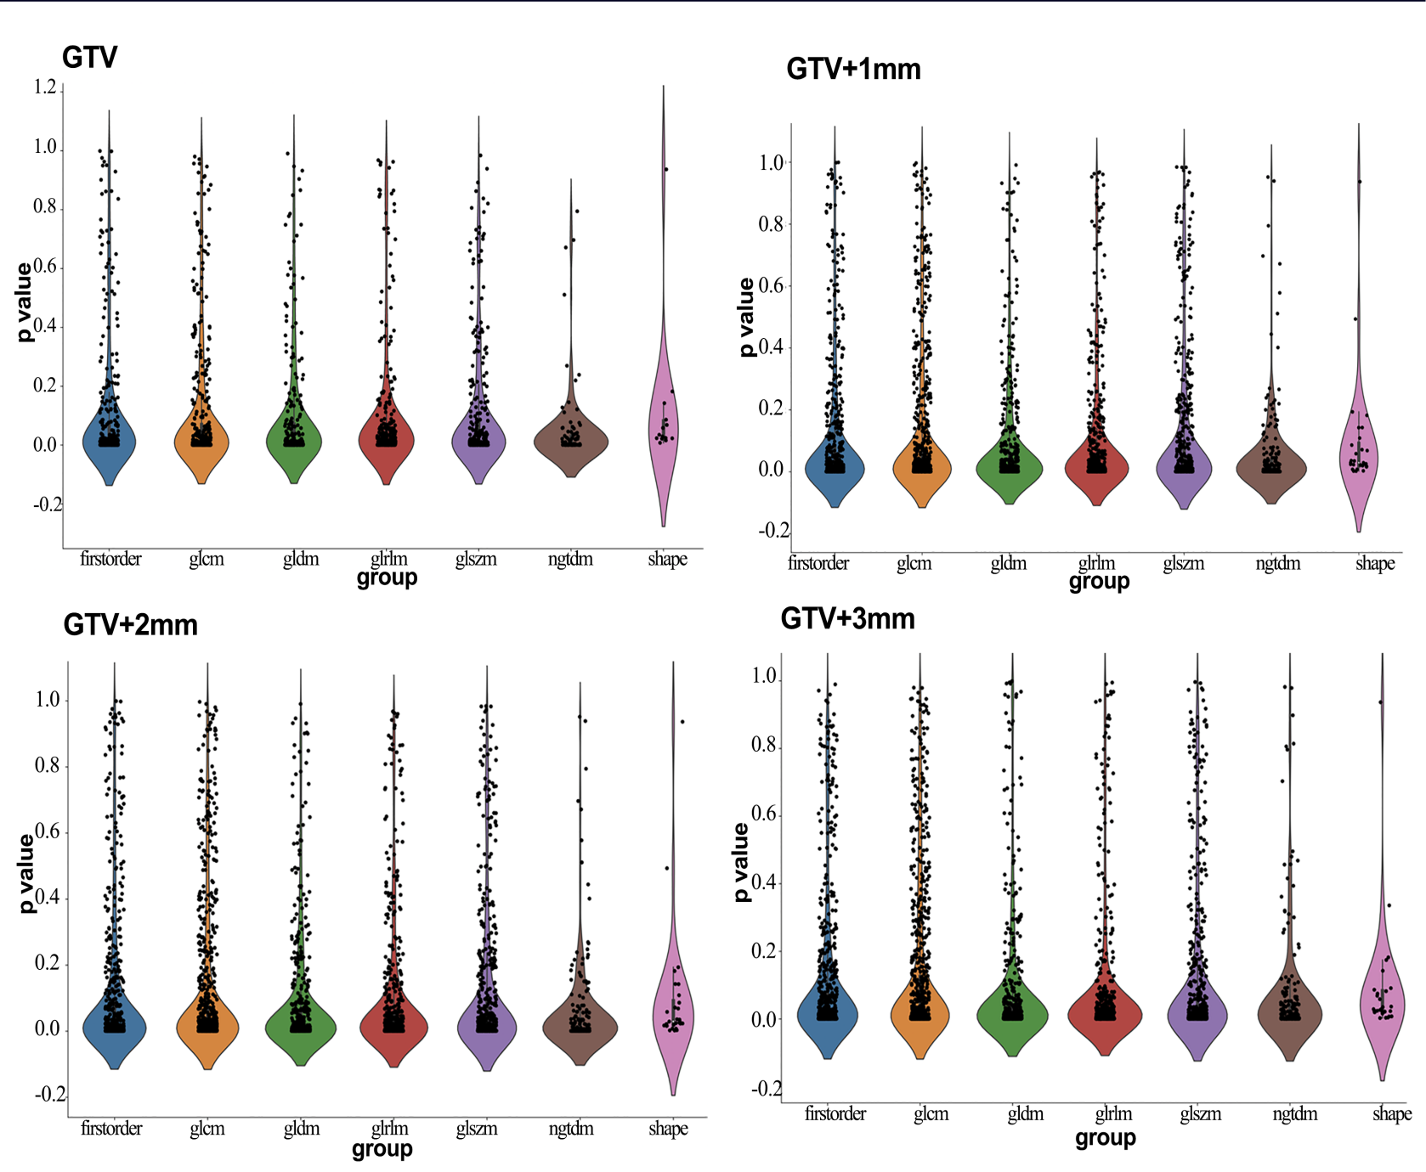
Figure2 The Rad feature stats extracted from VIOs : GTV, GTV+1mm, GTV+2mm and GTV+3mm

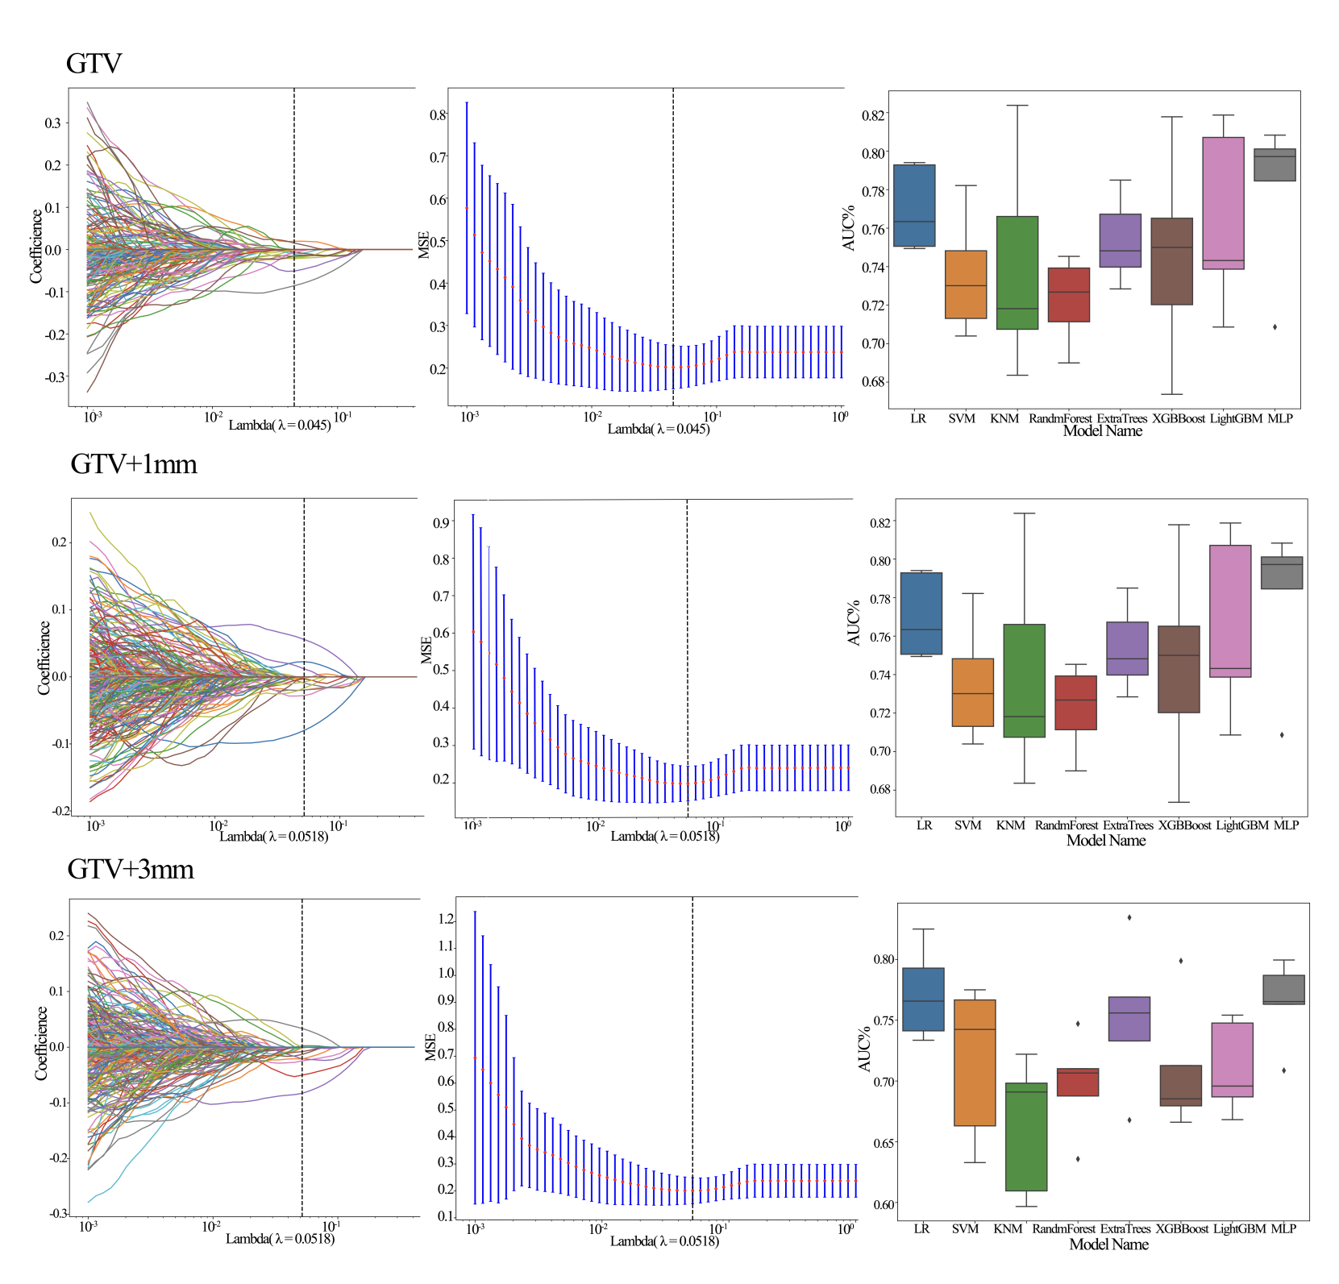
Figure3 Lasso Rad feature selection from VOIs

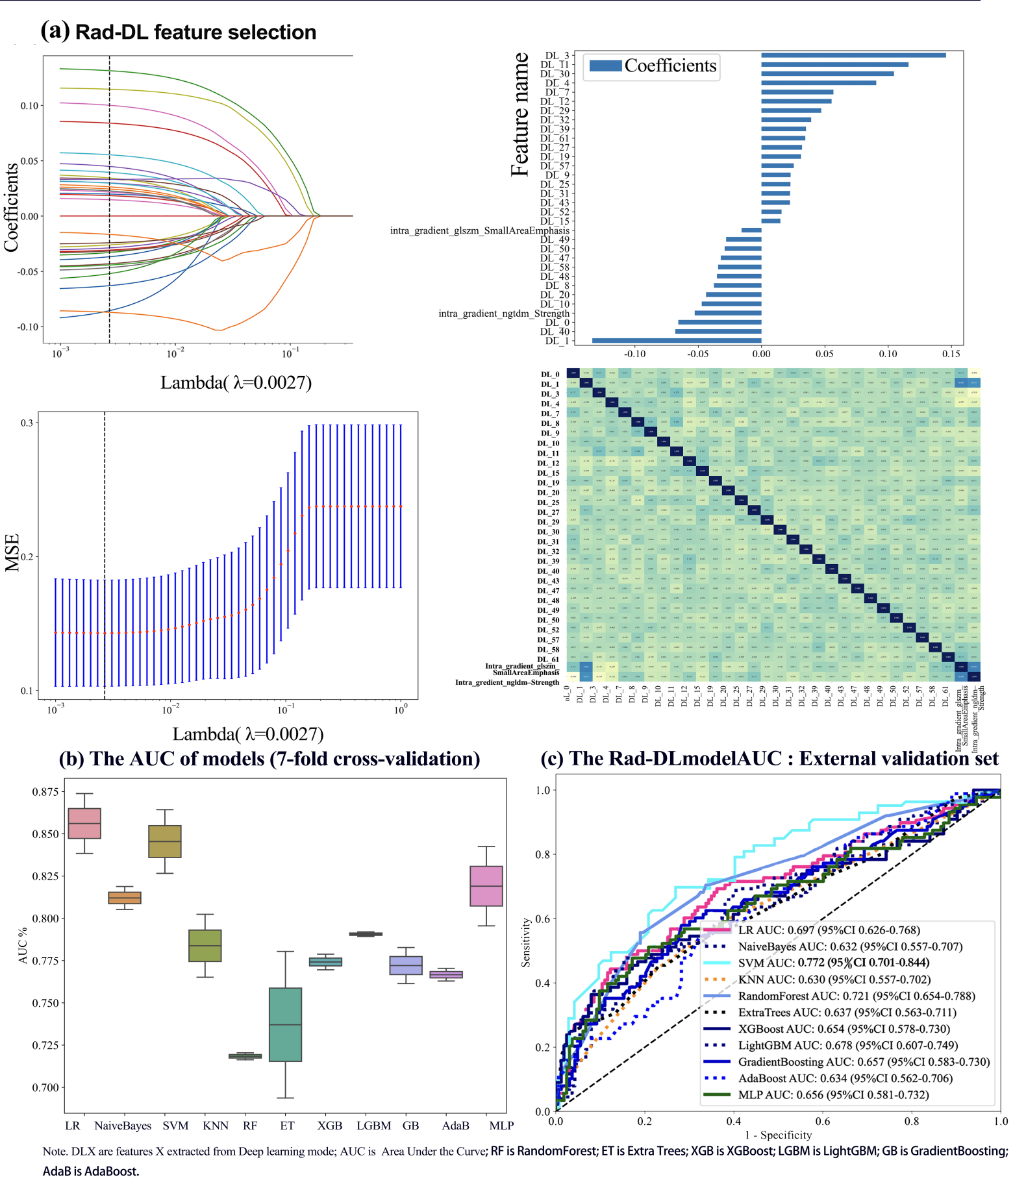
Figure4 The Rad-DL features selection and model building

Suppl

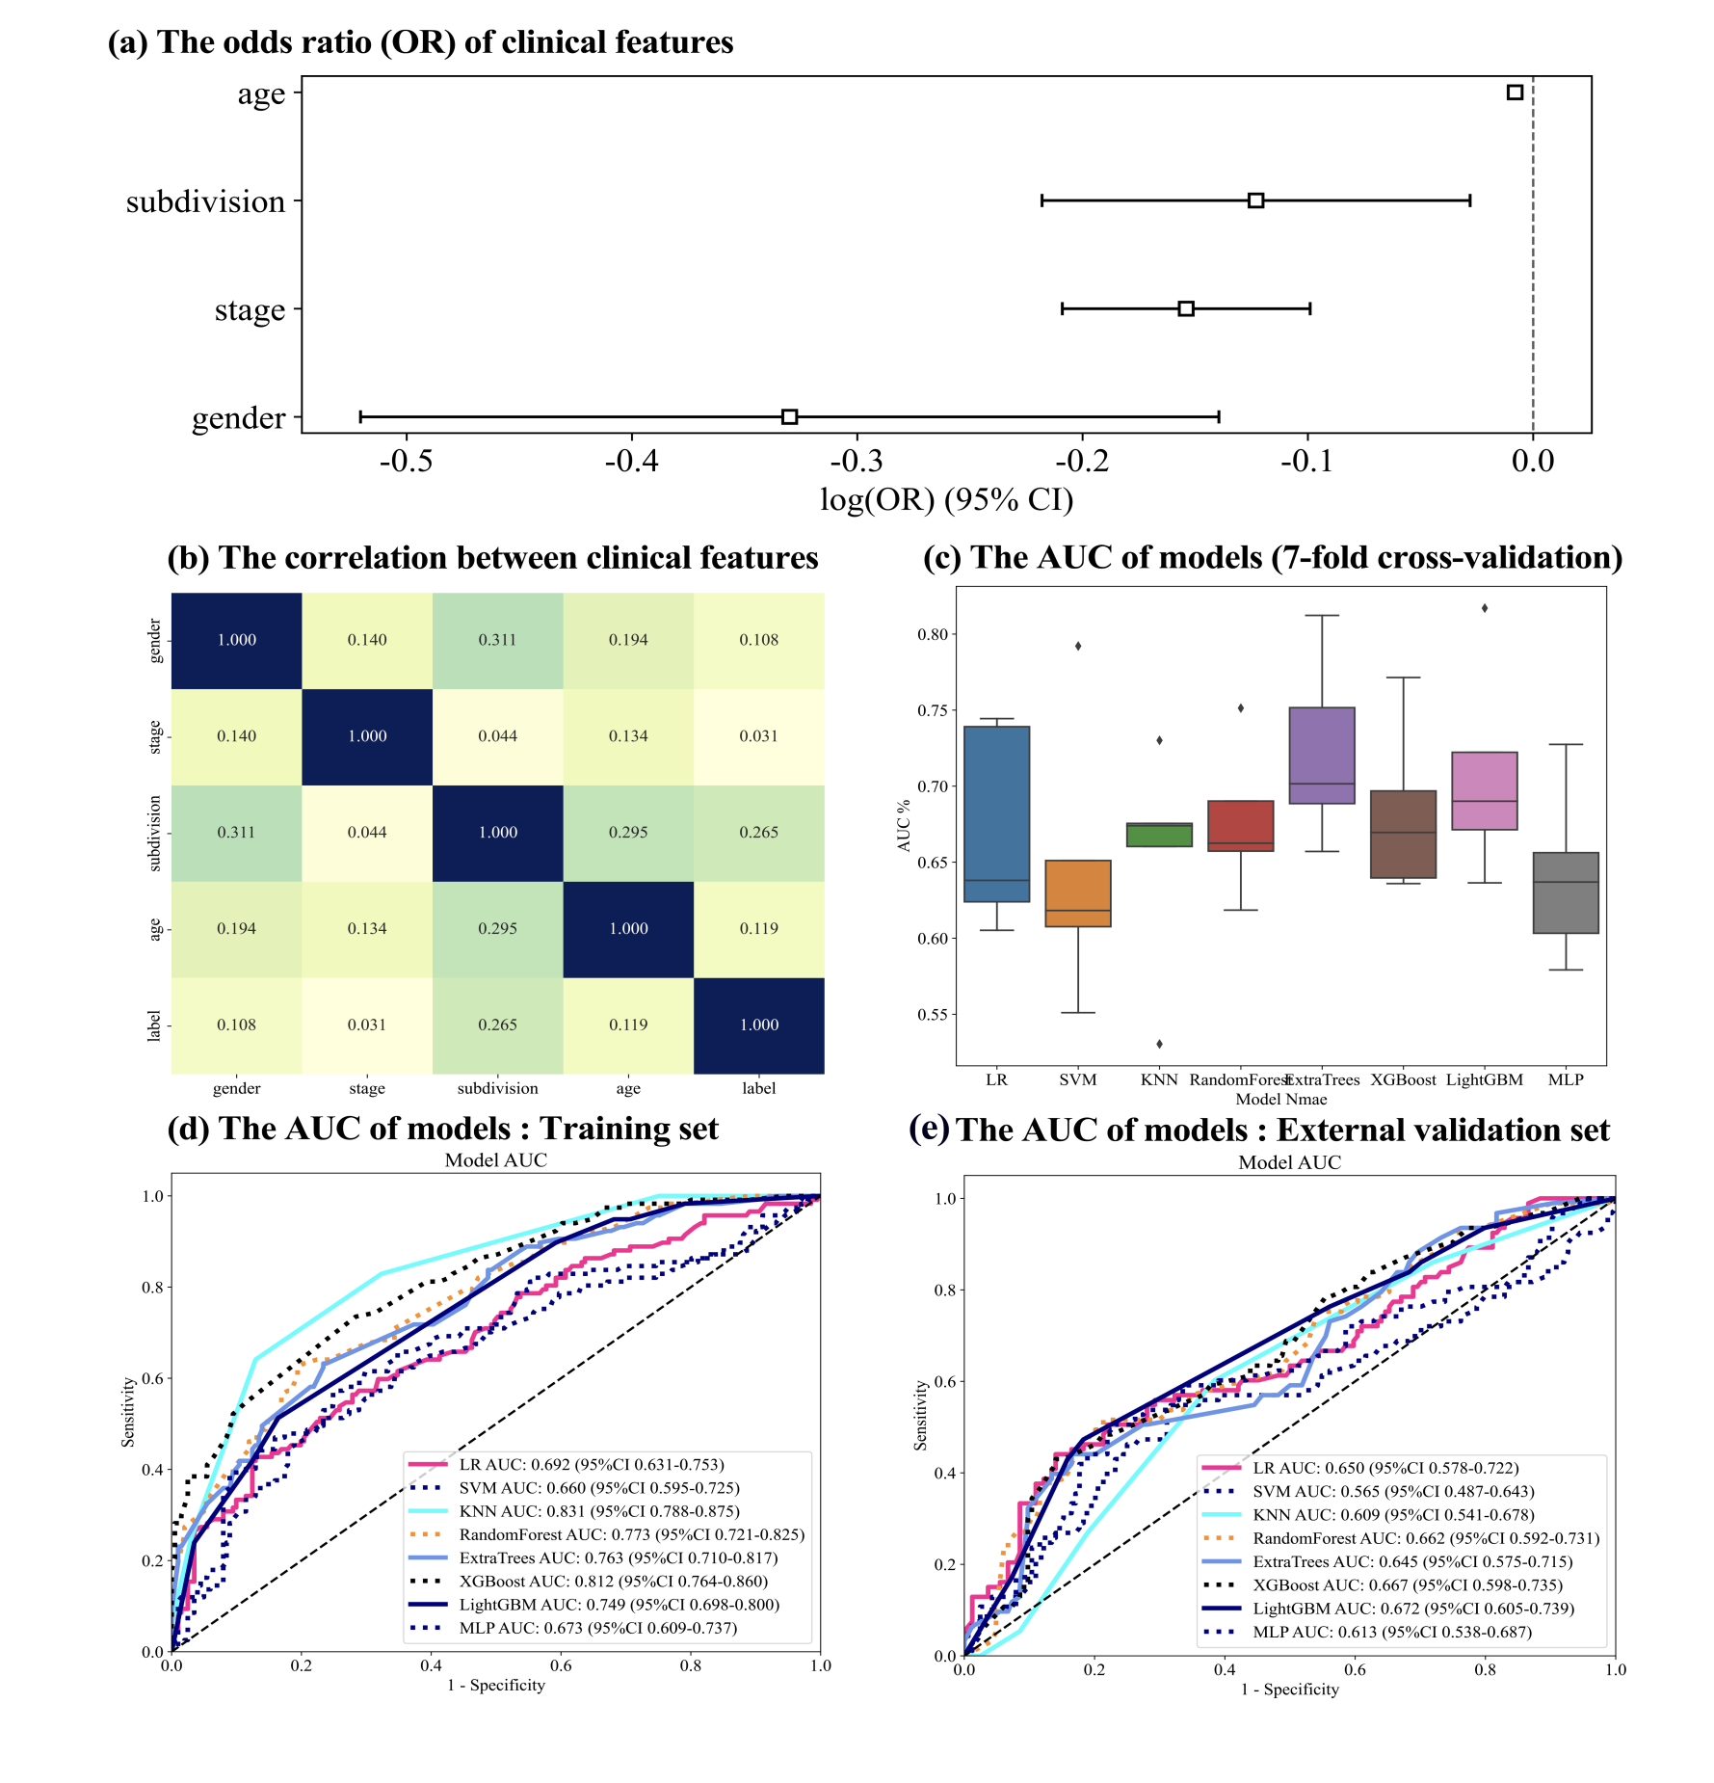
Figure5 Clinical features analysis and model buiding
(Univariate analysis)

supplementary Table

Supplementary Tables
Table1 The performance of Rad models based on all VOIs
Model_name | GTV |  |  | GTV+1mm |  |  | GTV+2mm |  |  | GTV+3mm |  |  | Cohort
Model_name | Accuracy | AUC | 95% CI | Accuracy | AUC | 95% CI | Accuracy | AUC | 95% CI | Accuracy | AUC | 95% CI | Cohort
LR | 0.755 | 0.799 | 0.746- 0.852 | 0.791 | 0.81 | 0.757 - 0.863 | 0.712 | 0.806 | 0.753 - 0.858 | 0.791 | 0.798 | 0.7440 - 0.8522 | Train
LR | 0.681 | 0.592 | 0.517 - 0.667 | 0.637 | 0.594 | 0.519 - 0.670 | 0.671 | 0.623 | 0.534 - 0.711 | 0.689 | 0.596 | 0.5192 - 0.6735 | Test
NaiveBayes | 0.745 | 0.776 | 0.721 - 0.831 | 0.712 | 0.78 | 0.724 - 0.835 | NULL | NULL | NULL | NULL | NULL | NULL | Train
NaiveBayes | 0.645 | 0.565 | 0.488 - 0.643 | 0.645 | 0.577 | 0.500 - 0.654 | NULL | NULL | NULL | NULL | NULL | NULL | Test
SVM | 0.778 | 0.842 | 0.792 - 0.893 | 0.784 | 0.842 | 0.790 - 0.894 | 0.765 | 0.838 | 0.788 - 0.889 | 0.791 | 0.855 | 0.8093 - 0.9008 | Train
SVM | 0.554 | 0.613 | 0.540 - 0.687 | 0.586 | 0.601 | 0.525 - 0.676 | 0.647 | 0.642 | 0.556 - 0.729 | 0.677 | 0.604 | 0.5270 - 0.6808 | Test
KNN | 0.775 | 0.844 | 0.802 - 0.885 | 0.784 | 0.855 | 0.813 - 0.897 | 0.804 | 0.879 | 0.842 - 0.915 | 0.768 | 0.839 | 0.7953 - 0.8834 | Train
KNN | 0.625 | 0.542 | 0.468 - 0.615 | 0.598 | 0.588 | 0.516 - 0.660 | 0.582 | 0.58 | 0.494 - 0.666 | 0.669 | 0.604 | 0.5319 - 0.6771 | Test
RandomForest | 0.984 | 0.998 | 0.996 - 1.000 | 0.974 | 0.997 | 0.995 - 1.000 | 0.778 | 0.843 | 0.792 - 0.893 | 0.817 | 0.834 | 0.7836 - 0.8848 | Train
RandomForest | 0.486 | 0.52 | 0.447 - 0.593 | 0.586 | 0.571 | 0.497 - 0.646 | 0.7 | 0.642 | 0.556 - 0.729 | 0.534 | 0.513 | 0.4393 - 0.5870 | Test
ExtraTrees | 0.987 | 1 | 0.999 - 1.000 | 0.987 | 1 | 0.999 - 1.000 | 0.752 | 0.804 | 0.750 - 0.858 | 0.768 | 0.81 | 0.7578 - 0.8626 | Train
ExtraTrees | 0.582 | 0.572 | 0.498 - 0.645 | 0.586 | 0.609 | 0.537- 0.681 | 0.653 | 0.627 | 0.540 - 0.714 | 0.665 | 0.582 | 0.5029 - 0.6603 | Test
XGBoost | 0.971 | 0.997 | 0.994 - 1.000 | 0.977 | 0.996 | 0.992 - 1.000 | 0.863 | 0.937 | 0.911 - 0.964 | 0.817 | 0.919 | 0.8887 - 0.9495 | Train
XGBoost | 0.554 | 0.541 | 0.469 - 0.613 | 0.578 | 0.575 | 0.500 - 0.651 | 0.647 | 0.63 | 0.543 - 0.716 | 0.538 | 0.532 | 0.4567 - 0.6064 | Test
LightGBM | 0.853 | 0.937 | 0.912 - 0.962 | 0.856 | 0.941 | 0.917 - 0.966 | 0.83 | 0.877 | 0.836 - 0.917 | 0.81 | 0.848 | 0.8022 - 0.8945 | Train
LightGBM | 0.49 | 0.531 | 0.459 - 0.603 | 0.602 | 0.619 | 0.547 - 0.692 | 0.659 | 0.637 | 0.549 - 0.725 | 0.534 | 0.528 | 0.4553 - 0.6015 | Test
GradientBoosting | 0.846 | 0.898 | 0.863 - 0.932 | 0.84 | 0.896 | 0.859 - 0.933 | NULL | NULL | NULL | NULL | NULL | NULL | Train
GradientBoosting | 0.55 | 0.51 | 0.438 - 0.582 | 0.578 | 0.596 | 0.525 - 0.667 | NULL | NULL | NULL | NULL | NULL | NULL | Test
AdaBoost | 0.739 | 0.86 | 0.819 - 0.902 | 0.807 | 0.864 | 0.822 - 0.905 | NULL | NULL | NULL | NULL | NULL | NULL | Train
AdaBoost | 0.502 | 0.496 | 0.423 - 0.570 | 0.566 | 0.601 | 0.528 - 0.675 | NULL | NULL | NULL | NULL | NULL | NULL | Test
MLP | 0.758 | 0.825 | 0.777 - 0.874 | 0.784 | 0.824 | 0.774 - 0.875 | 0.797 | 0.808 | 0.754 - 0.862 | 0.739 | 0.798 | 0.7445 - 0.8516 | Train
MLP | 0.61 | 0.574 | 0.498 - 0.651 | 0.645 | 0.575 | 0.498 - 0.653 | 0.665 | 0.637 | 0.550 - 0.724 | 0.693 | 0.598 | 0.5187 - 0.6775 | Test

Table2 The performance DL and Rad-DL Models
Model Name | Acc | AUC | 95%Cl | Sensitivity | Specificity | PPV | NPV | Precision | Recall | F1 | Task
DL Model
Resnet18 | 0.820 | 0.864 | 0.819-0.909 | 0.806 | 0.828 | 0.719 | 0.886 | 0.719 | 0.806 | 0.760 | Train
Resnet18 | 0.661 | 0.637 | 0.564-0.710 | 0.489 | 0.755 | 0.518 | 0.732 | 0.518 | 0.489 | 0.503 | Test
Resnet50 | 0.876 | 0.932 | 0.905-0.959 | 0.843 | 0.894 | 0.812 | 0.912 | 0.812 | 0.843 | 0.827 | Train
Resnet50 | 0.661 | 0.626 | 0.550-0.702 | 0.557 | 0.718 | 0.516 | 0.750 | 0.516 | 0.557 | 0.536 | Test
Resnet101 | 0.850 | 0.909 | 0.876-0.943 | 0.759 | 0.899 | 0.804 | 0.873 | 0.804 | 0.759 | 0.781 | Train
Resnet101 | 0.677 | 0.679 | 0.608-0.751 | 0.580 | 0.730 | 0.537 | 0.763 | 0.537 | 0.580 | 0.557 | Test
Resnet152 | 0.912 | 0.971 | 0.955-0.987 | 0.898 | 0.919 | 0.858 | 0.943 | 0.858 | 0.898 | 0.878 | Train
Resnet152 | 0.729 | 0.670 | 0.595-0.743 | 0.511 | 0.847 | 0.643 | 0.762 | 0.643 | 0.511 | 0.570 | Test
Googlenet | 0.804 | 0.847 | 0.802-0.892 | 0.787 | 0.813 | 0.697 | 0.875 | 0.697 | 0.787 | 0.739 | Train
Googlenet | 0.697 | 0.638 | 0.563-0.713 | 0.443 | 0.834 | 0.591 | 0.735 | 0.591 | 0.443 | 0.506 | Test
VGG19 | 0.840 | 0.894 | 0.857-0.931 | 0.731 | 0.899 | 0.798 | 0.860 | 0.798 | 0.731 | 0.763 | Train
VGG19 | 0.693 | 0.677 | 0.608-0.746 | 0.500 | 0.798 | 0.571 | 0.747 | 0.571 | 0.500 | 0.533 | Test
Rad-DL Model
LR | 0.889 | 0.947 | 0.922-0.971 | 0.769 | 0.955 | 0.902 | 0.883 | 0.902 | 0.769 | 0.830 | Train
LR | 0.653 | 0.697 | 0.626-0.768 | 0.682 | 0.638 | 0.504 | 0.788 | 0.504 | 0.682 | 0.580 | Test
NaiveBayes | 0.843 | 0.885 | 0.846-0.923 | 0.741 | 0.899 | 0.800 | 0.864 | 0.800 | 0.741 | 0.769 | Train
NaiveBayes | 0.673 | 0.632 | 0.557-0.707 | 0.477 | 0.779 | 0.538 | 0.734 | 0.538 | 0.477 | 0.506 | Test
SVM | 0.948 | 0.979 | 0.959- 1.000 | 0.953 | 0.944 | 0.903 | 0.974 | 0.903 | 0.953 | 0.927 | Train
SVM | 0.712 | 0.772 | 0.701- 0.844 | 0.671 | 0.74 | 0.644 | 0.763 | 0.644 | 0.671 | 0.657 | Test
KNN | 0.817 | 0.892 | 0.858-0.925 | 0.704 | 0.879 | 0.760 | 0.845 | 0.760 | 0.704 | 0.731 | Train
KNN | 0.669 | 0.630 | 0.557-0.702 | 0.216 | 0.914 | 0.576 | 0.683 | 0.576 | 0.216 | 0.314 | Test
RandForest | 0.984 | 0.998 | 0.996-1.000 | 0.972 | 0.990 | 0.981 | 0.985 | 0.981 | 0.972 | 0.977 | Train
RandForest | 0.673 | 0.721 | 0.654-0.788 | 0.682 | 0.669 | 0.526 | 0.796 | 0.526 | 0.682 | 0.594 | Test
ExtraTrees | 0.987 | 1.000 | 0.999-1.000 | 0.963 | 1.000 | 1.000 | 0.980 | 1.000 | 0.963 | 0.981 | Train
ExtraTrees | 0.669 | 0.637 | 0.563-0.711 | 0.318 | 0.859 | 0.549 | 0.700 | 0.549 | 0.318 | 0.403 | Test
XGBoost | 0.987 | 1.000 | 0.999-1.000 | 0.991 | 0.985 | 0.973 | 0.995 | 0.973 | 0.991 | 0.982 | Train
XGBoost | 0.721 | 0.654 | 0.578-0.729 | 0.352 | 0.920 | 0.705 | 0.725 | 0.705 | 0.352 | 0.470 | Test
LightGBM | 0.905 | 0.977 | 0.965-0.990 | 0.954 | 0.879 | 0.811 | 0.972 | 0.811 | 0.954 | 0.877 | Train
LightGBM | 0.713 | 0.678 | 0.607-0.749 | 0.466 | 0.847 | 0.621 | 0.746 | 0.621 | 0.466 | 0.532 | Test
GradBoost | 0.922 | 0.959 | 0.934-0.983 | 0.861 | 0.955 | 0.912 | 0.926 | 0.912 | 0.861 | 0.886 | Train
GradBoost | 0.661 | 0.657 | 0.583-0.730 | 0.545 | 0.724 | 0.516 | 0.747 | 0.516 | 0.545 | 0.530 | Test
AdaBoost | 0.814 | 0.917 | 0.886-0.948 | 0.907 | 0.763 | 0.676 | 0.938 | 0.676 | 0.907 | 0.775 | Train
AdaBoost | 0.629 | 0.634 | 0.562-0.706 | 0.534 | 0.681 | 0.475 | 0.730 | 0.475 | 0.534 | 0.503 | Test
MLP | 0.912 | 0.969 | 0.951-0.987 | 0.907 | 0.914 | 0.852 | 0.948 | 0.852 | 0.907 | 0.879 | Train
MLP | 0.697 | 0.656 | 0.581-0.731 | 0.455 | 0.828 | 0.588 | 0.738 | 0.588 | 0.455 | 0.513 | Test

Table3 The performance of clinical Models
Model name | Acc | AUC | 95% CI | Sensitivity | Specificity | PPV | NPV | Precision | Recall | F1 | Task
LR | 0.704 | 0.692 | 0.631 - 0.753 | 0.419 | 0.871 | 0.653 | 0.72 | 0.653 | 0.419 | 0.510 | Train
LR | 0.704 | 0.65 | 0.578 - 0.722 | 0.43 | 0.86 | 0.635 | 0.727 | 0.635 | 0.43 | 0.513 | Test
SVM | 0.676 | 0.66 | 0.595 - 0.725 | 0.547 | 0.751 | 0.561 | 0.74 | 0.561 | 0.547 | 0.554 | Train
SVM | 0.634 | 0.565 | 0.488- 0.643 | 0.538 | 0.689 | 0.495 | 0.724 | 0.495 | 0.538 | 0.515 | Test
KNN | 0.704 | 0.831 | 0.788 - 0.875 | 0.248 | 0.97 | 0.829 | 0.689 | 0.829 | 0.248 | 0.382 | Train
KNN | 0.615 | 0.609 | 0.541- 0.678 | 0.269 | 0.811 | 0.446 | 0.662 | 0.446 | 0.269 | 0.336 | Test
RandomForest | 0.736 | 0.773 | 0.720- 0.826 | 0.615 | 0.806 | 0.649 | 0.783 | 0.649 | 0.615 | 0.632 | Train
RandomForest | 0.685 | 0.662 | 0.592 - 0.731 | 0.505 | 0.787 | 0.573 | 0.737 | 0.573 | 0.505 | 0.537 | Test
ExtraTrees | 0.714 | 0.763 | 0.710 - 0.817 | 0.624 | 0.766 | 0.608 | 0.778 | 0.608 | 0.624 | 0.616 | Train
ExtraTrees | 0.685 | 0.645 | 0.575 - 0.715 | 0.419 | 0.835 | 0.591 | 0.717 | 0.591 | 0.419 | 0.491 | Test
XGBoost | 0.761 | 0.812 | 0.764 - 0.860 | 0.547 | 0.886 | 0.736 | 0.771 | 0.736 | 0.547 | 0.627 | Train
XGBoost | 0.7 | 0.667 | 0.598 - 0.735 | 0.419 | 0.86 | 0.629 | 0.723 | 0.629 | 0.419 | 0.503 | Test
LightGBM | 0.708 | 0.749 | 0.698 - 0.800 | 0.419 | 0.876 | 0.662 | 0.721 | 0.662 | 0.419 | 0.513 | Train
LightGBM | 0.693 | 0.672 | 0.605 - 0.740 | 0.43 | 0.841 | 0.606 | 0.723 | 0.606 | 0.43 | 0.503 | Test
MLP | 0.701 | 0.673 | 0.609 - 0.737 | 0.462 | 0.841 | 0.628 | 0.728 | 0.628 | 0.462 | 0.532 | Train
MLP | 0.669 | 0.613 | 0.538 - 0.688 | 0.495 | 0.768 | 0.548 | 0.728 | 0.548 | 0.495 | 0.52 | Test

Table 4 DCA for Clinical, Rad-DL, Rad and Nomogram

DCA | Clinic | Rad-DL | Rad | Nomogram | Cohort
0.000 | 0.000 | 0.084 | 0.000 | 0.331 | Train
1.000 | 0.000 | 0.061 | 0.001 | 0.000 | Test

Table5 Cox regression model in external validation set and prediction set

External validation (PFS) | B | EXP(B) | SE | Coef (95%CI) | EXP(B) (95%CI) | z | p | -log2(p)
Rad-DL signature | 2.3 | 10.02 | 1.51 | -0.65-5.25 | 0.52-191.39 | 1.53 | 0.13 | 2.99
Tumor types | -0.47 | 0.63 | 0.29 | -1.03-0.09 | 0.36-1.10 | -1.64 | 0.1 | 3.3
Gender | -0.46 | 0.63 | 0.42 | -1.29-0.37 | 0.28-1.44 | -1.09 | 0.28 | 1.86
Age | 0.03 | 1.03 | 0.02 | -0.01-0.06 | 0.99-1.07 | 1.35 | 0.18 | 2.49
Stage | 0.33 | 1.39 | 0.29 | -0.23-0.89 | 0.80-2.44 | 1.16 | 0.25 | 2.02
External validation (OS)
Rad-DL signature | 4.41 | 81.91 | 2.21 | 0.08-8.73 | 1.09-6170.98 | 2 | 0.05 | 4.45
Tumor types | 1.2 | 3.34 | 0.46 | 0.30-2.11 | 1.358.27 | 2.6 | 0.01 | 6.75
Gender | -0.11 | 0.9 | 0.6 | -1.28-1.07 | 0.28-2.92 | -0.18 | 0.86 | 0.22
Age | -0.06 | 0.94 | 0.03 | -0.13-0.00 | 0.88-1.00 | -1.9 | 0.06 | 4.13
Stage | 0.07 | 1.07 | 0.4 | -0.72-0.86 | 0.48-2.37 | 0.17 | 0.86 | 0.21
Prediction set (PFS)
Rad-DL signature | 1.86 | 6.42 | 2.56 | -3.15-6.87 | 0.04-962.27 | 0.73 | 0.47 | 1.1
Tumor types | 0.36 | 1.44 | 0.4 | -0.42-1.15 | 0.66-3.15 | 0.91 | 0.36 | 1.47
Gender | 2.33 | 10.24 | 0.93 | 0.50-4.16 | 1.646-3.79 | 2.49 | 0.01 | 6.3
Age | 0.04 | 1.04 | 0.03 | -0.02-0.09 | 0.99-1.09 | 1.4 | 0.16 | 2.62
Stage | 0.35 | 1.42 | 0.49 | -0.62-1.32 | 0.54-3.75 | 0.71 | 0.48 | 1.07
Prediction set (OS)
Rad-DL signature | 0.42 | 1.52 | 4.27 | -7.96-8.79 | 0.00-6578.22 | 0.1 | 0.92 | 0.12
Tumor types | 0.48 | 1.61 | 0.86 | -1.20-2.15 | 0.30-8.61 | 0.56 | 0.58 | 0.79
Gender | -1.74 | 0.17 | 1.23 | -4.15-0.67 | 0.02-1.95 | -1.42 | 0.16 | 2.68
Age | -0.04 | 0.96 | 0.05 | -0.15-0.07 | 0.86-1.07 | -0.73 | 0.46 | 1.11
Stage | -2.04 | 0.13 | 1.17 | -4.33-0.26 | 0.01-1.29 | -1.74 | 0.08 | 3.61

