Additional file 8

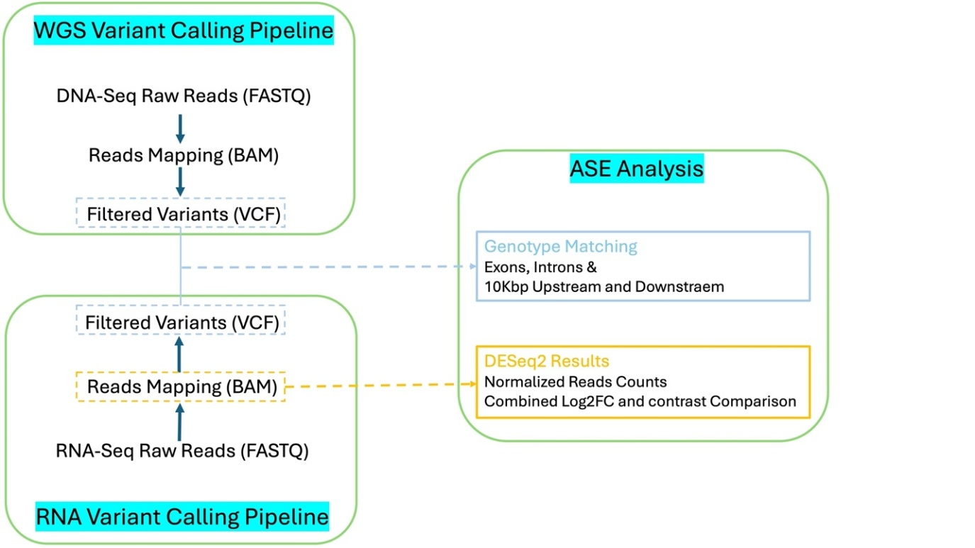
Figure S.1: Pipeline overview. Calling variants from both RNA-seq and WGS. WGS in the noncoding region was used to define cis-regulatory elements. RNA-seq was also used to create a read count matrix.

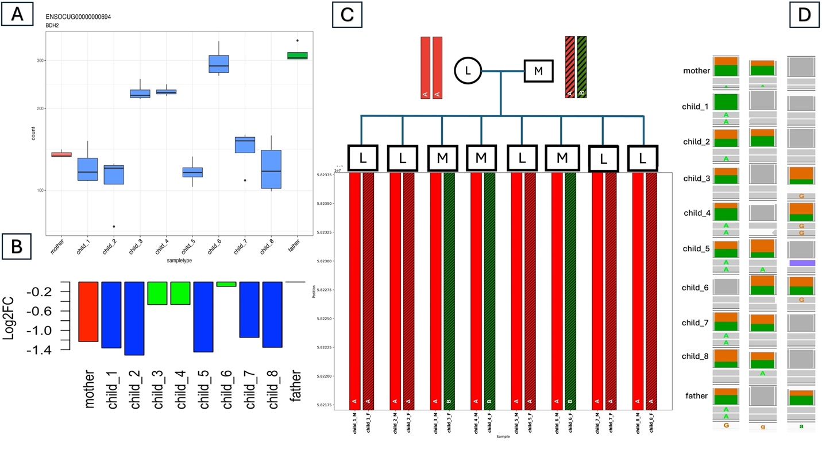
Figure S.2: BDH2 gene with allele-specific expression analysis across the family members. A) Normalized read counts for all family members. The mother is shown first, in red; the father is shown last, in green; and the offspring are shown in between. B) Log2FC comparison in the family relative to the father as the 0 baseline. The mother is shown in red, and offspring with <= - 0.8 log2FC are in blue. C) Haplotype phasing in the family; low expression (L) is homozygous (AA), and moderate expression (M) is heterozygous (AB). D) IGV snapshots for three different genotype combinations of variants in the same gene; only the last variant matches the expression pattern of the mother (AA) and father (AG).

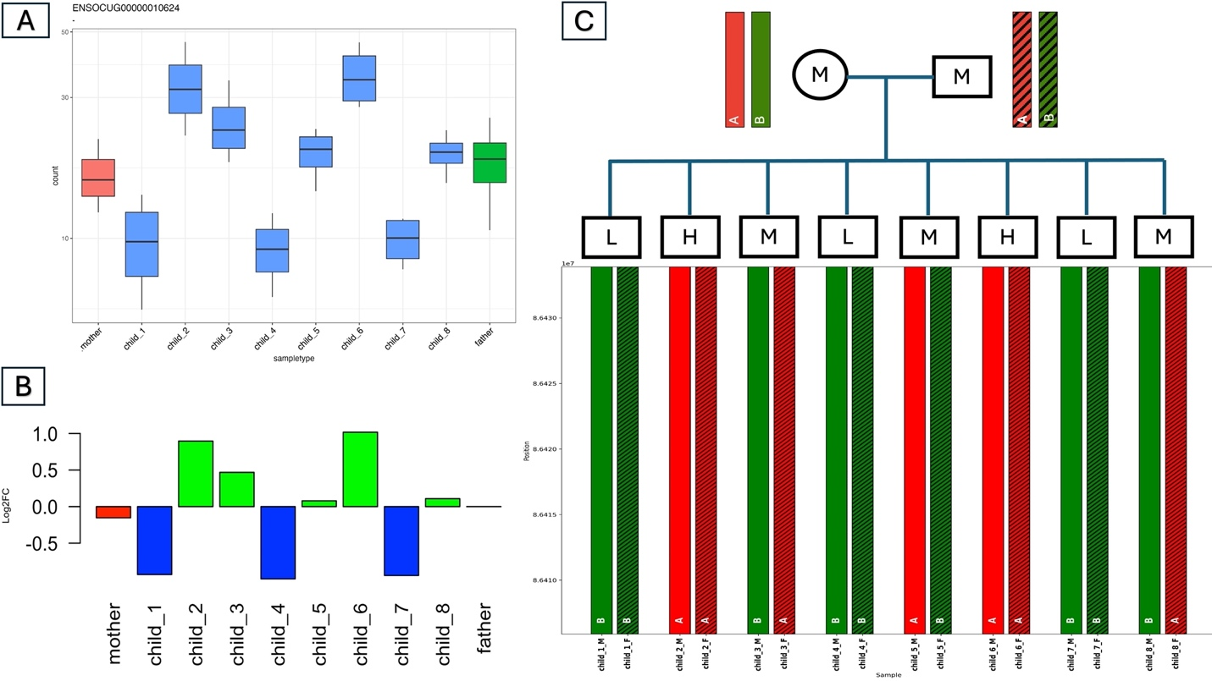
Figure S.3: Novel gene (ENSOCUG00000010624) expression analysis across family members. A) Normalized read counts for all family members. The mother is shown first, in red; the father is shown last, in green; and the offspring are shown in between. B) Log2FC comparison in the family relative to the father as the 0 baseline. The mother is shown in red; offspring <= -0.8 are in blue and reflect (L). C) Haplotype phasing at the gene region. Heterozygosity (AB) is in accordance with (M) expression in offspring (3,5&8); (AA) reflects (H) expression in offspring (2&6); and (BB) reflects (L) expression in offspring (1,4&7).

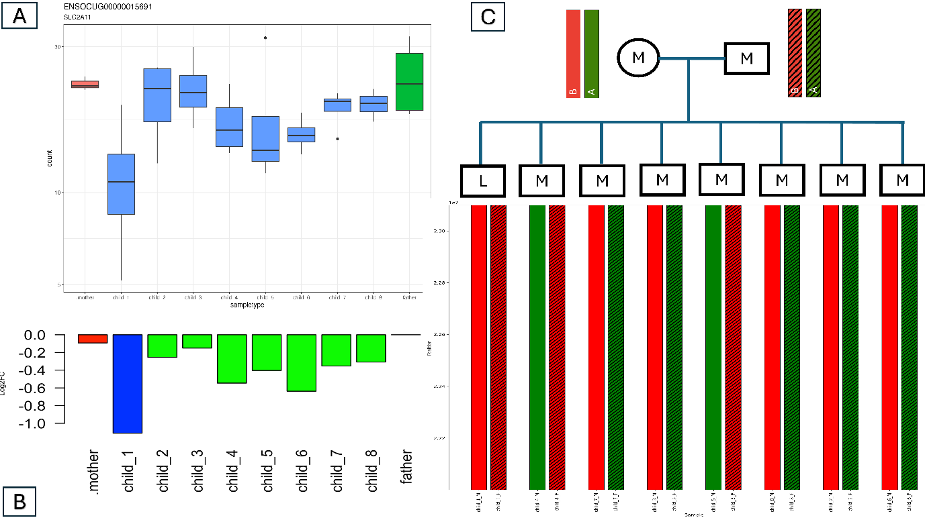
Figure S4: SLC2A11 gene ASE analysis in the family model. A) Normalized read counts for all family members. The mother is shown first, in red; the father is shown last, in green; and the offspring are shown in between. All the offspring have an (M) expression, except for offspring_1 with (L) gene expression. B) Log2FC comparison in the family relative to the father as the 0 baseline. The mother is shown in red, and offspring_1 is shown in blue, with low expression and log2FC values (<= - 0.8). C) Extended haplotype phasing beyond the gene region. Only offspring_1 is homozygous (BB) consistent with the L expression, and heterozygosity in the remaining offspring is consistent with the M expression.

