Additional file 2: Figure S.1

We eliminated the sample mother_2 from the DEG analysis between the parents because of its outlier gene expression values. Figure S.1 shows the following: A, Heatmap of the complete set of differentially expressed genes before elimination of mother_2. This clearly shows the outlier expression in mother_2, as they are a brighter red. In addition, the number of upregulated genes was significantly greater than that in the final analysis without the mother_2 sample. B, Correlation matrix showing a linear relationship among the samples. The correlation matrix was constructed for each individual using the cor and corrplot functions in R after variance stabilizing transformation (VST) was performed in R using the DESeq2 library. This figure illustrates the low correlation of the mother_2 sample compared with the other replicates.

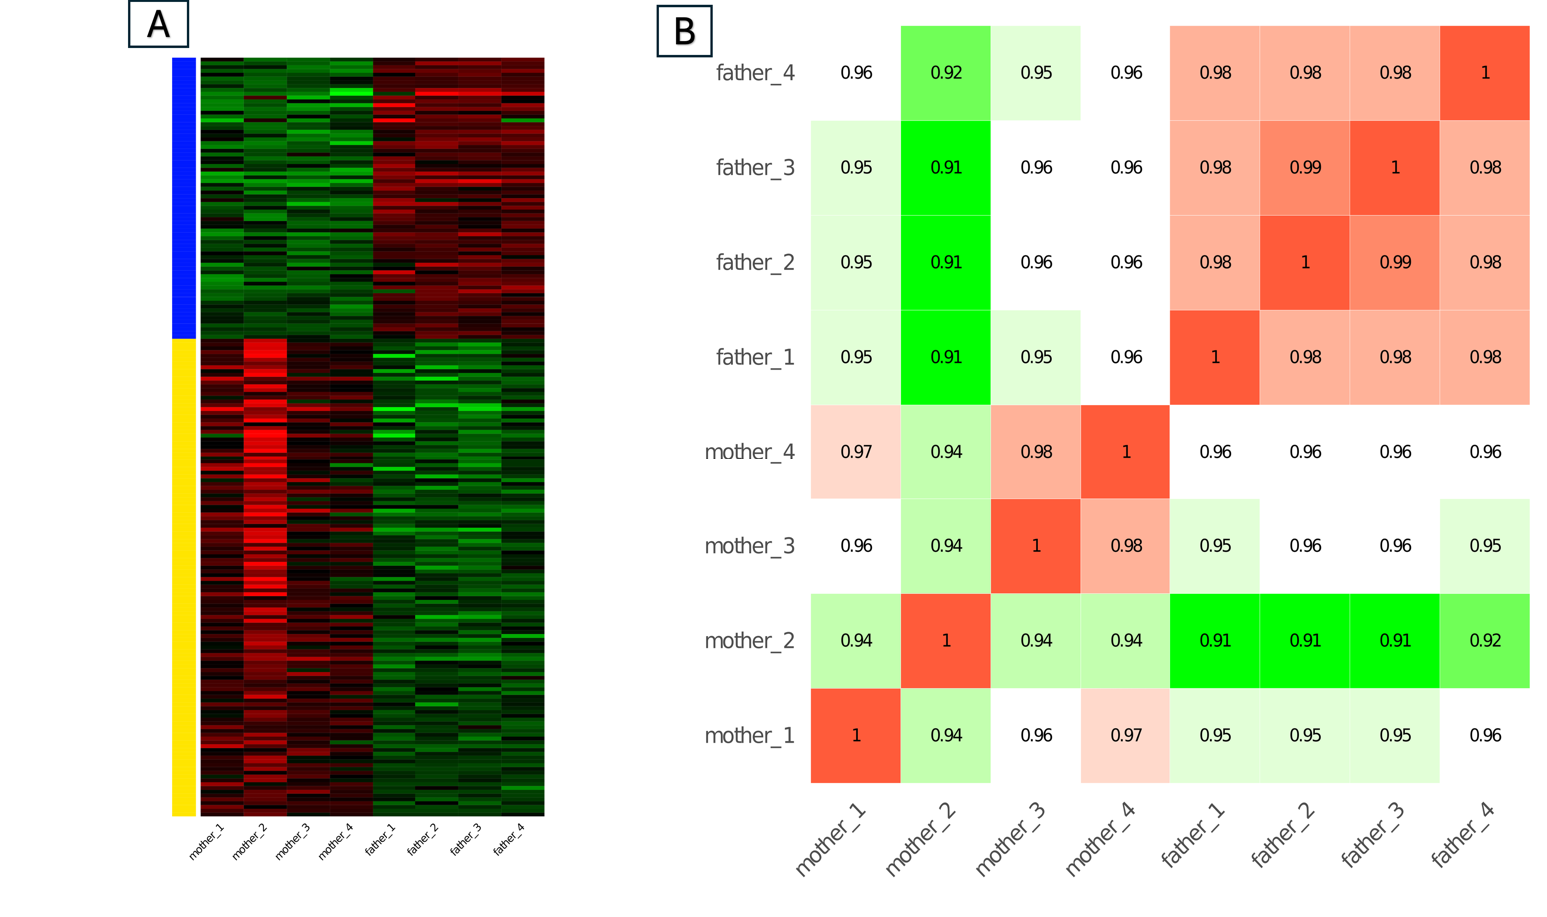
Figure S1: Initial DEG analysis before the removal of the mother_2 sample. A: Heatmap of the DEGs, red indicates upregulated genes and green indicates downregulated genes in the mother vs. father comparison. B: Correlation matrix between the parent samples. Red indicates the highest correlation, and green indicates the lowest correlation.

