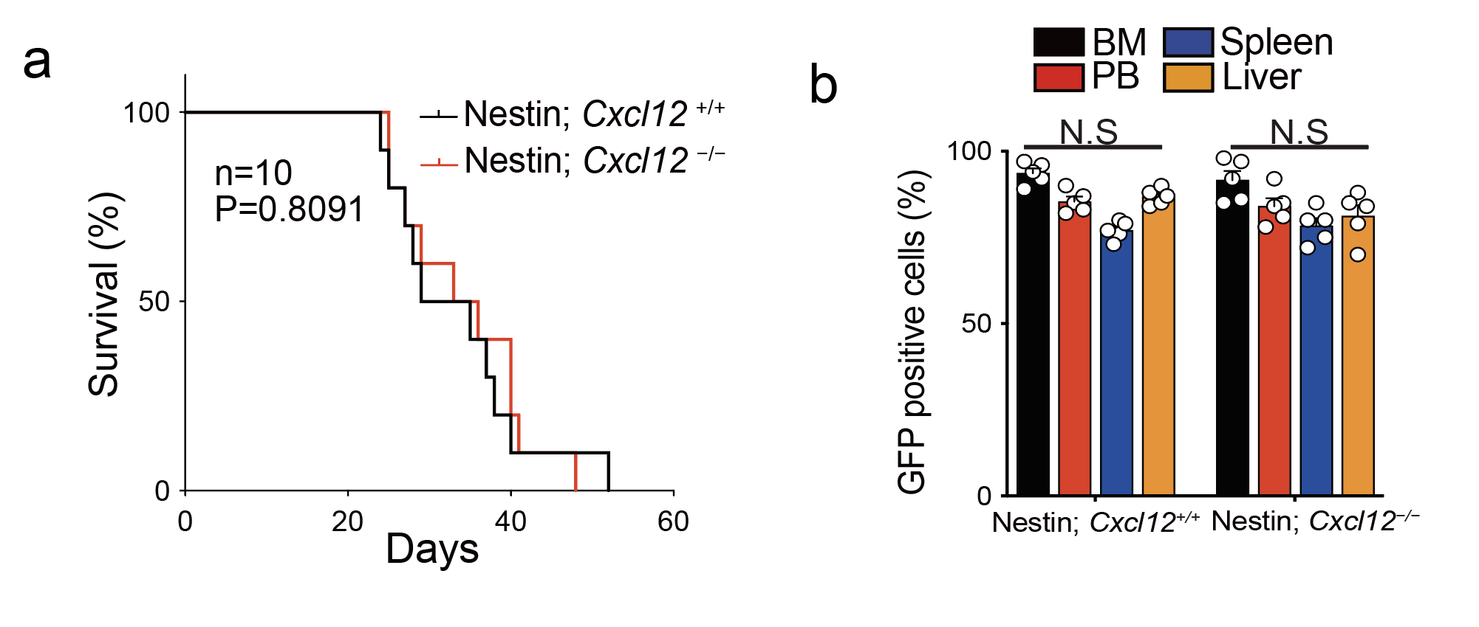
Supplementary Figure 1. Nestin⁺ MSCs are dispensable for CXCL12-mediated AML retention
(a) Survival curve of 500 control L-GMPs transplanted recipient Nestin; Cxcl12^{+/+} or Nestin; Cxcl12^{−/−} mice (n= 10 mice; P=0.8091, log-rank test). (b) Comparison of the proportions of GFP⁺ Nestin; Cxcl12^{+/+} or Nestin; Cxcl12^{−/−} AML cells in BM, PB, spleen, and liver 5 weeks post transplantation (n=5 mice).

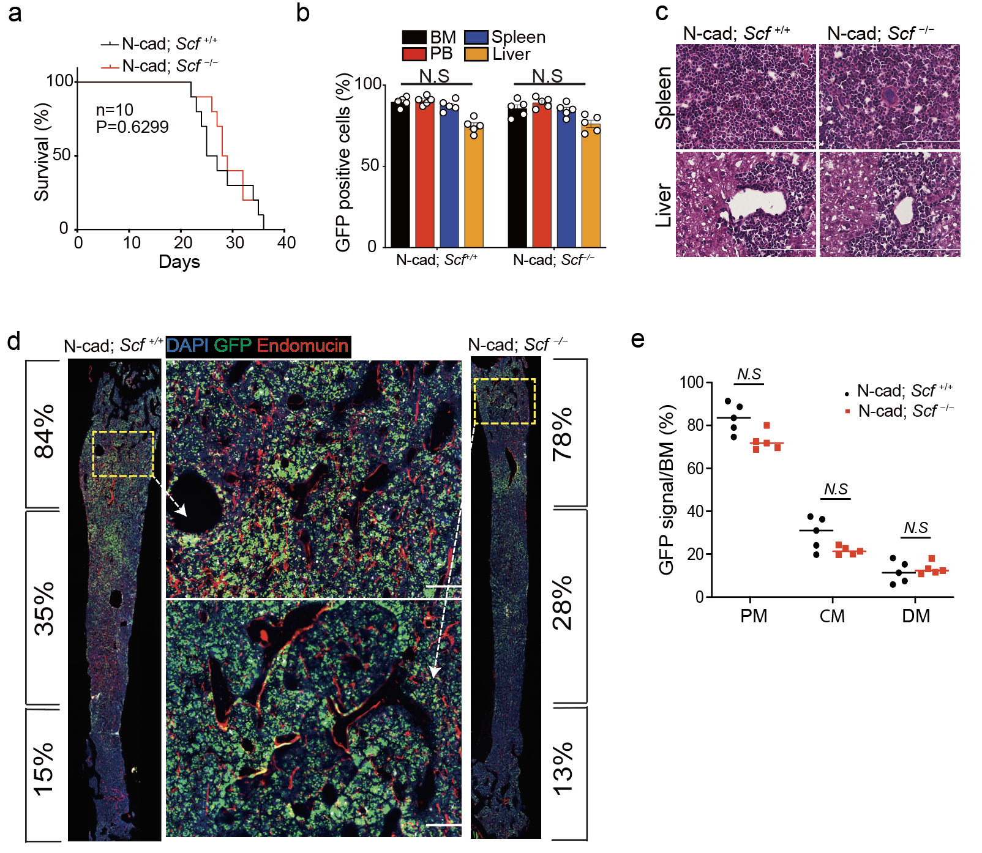

Supplementary Figure 2. SCF from N-cad⁺ MSCs is dispensable for niche effects
(a) Survival curve of 500 control L-GMPs transplanted recipient N-cad; Scf ^{+/+} or N-cad; Scf ^{−/−} mice (n= 10 mice; P=0.6299, log-rank test). (b) Comparison of the proportions of GFP⁺ -cad; Scf ^{+/+} or N-cad; Scf ^{−/−} AML cells in BM, PB, spleen, and liver 5 weeks post transplantation (n=5 mice). (c) H&E staining for spleen and liver at 5-week post transplantation. (d) Representative images of BM sections from N-cad; Scf ^{+/+} (left) or N-cad; Scf ^{−/−} (right) AML mice model at week 6 respectively after transplantation. Green, GFP⁺ AML cells; red, endomucin staining blood vessels; blue, DAPI for nuclei. The calculated proportion of GFP⁺ signals in each of the three anatomical BM areas is listed to the left/right of the images. The dashed box indicates the area of focus. Scale bars, 100μm. (e) Summary of GFP⁺ signals in each BM area (PM, CM, DM). n = 5, BM sections from 5 mice, BM sections were collected at day 28,30,32,34,36.

