Thermohalobaculum xanthum gen. nov., sp. nov., a novel moderately thermophilic bacterium isolated from mangrove sediment
Authors: Xinli Pan¹, Fei Li², Zhe Li¹, Yuanlin Huang¹, Qiaozhen Wang¹, Shushi Huang¹, Wenjin Hu^{3*}.
Affiliations: ¹ Guangxi Key Laboratory of Marine Natural Products and Combinatorial Biosynthesis Chemistry, Beibu Gulf Marine Research Center, Guangxi Academy of Sciences, Nanning 530007, PR China;
² Guangxi Key Laboratory of Marine Environmental Science, Beibu Gulf Marine Research Center, Guangxi Academy of Sciences, Nanning 530007, PR China;
³ State Key Laboratory of Non-Food Biomass Energy and Enzyme Technology, National Engineering Research Center for Non-Food Biorefinery, Guangxi Bioscience and Technology Research Center, Guangxi Academy of Sciences, Nanning 530007, China.

*Correspondence: Wenjin Hu, wenjinhu@gxas.cn.

Figure S1. The cell morphology of strain M0105^{T} was observed under scanning electron microscopy (SEM). Bar, 3 μm (A) and 2 μm (B).
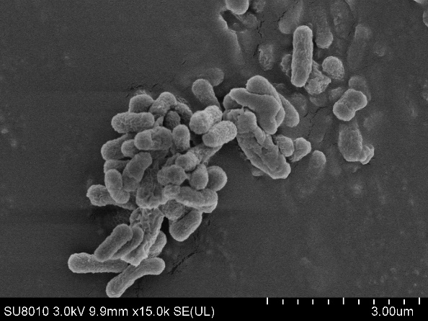
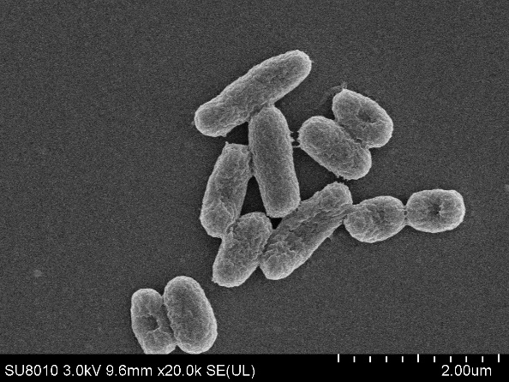
B
A
Figure S2. Growth curve of strain M0105^{T}, A. brevis 34079^{T}, D. nitratireducens 25810_4^{T} and L. halophilum CAU 1123^{T} at the different temperature.

Figure S3. Neighbor-joining phylogenetic tree based on the 16S rRNA gene sequences analysis. Bootstrap values more than 50% are shown. Bar, 0.02 nucleotide acid substitutions per site. The tree was rooted by Methylobacillus methanolivorans Z^{T} (NR156096) as the outgroup.
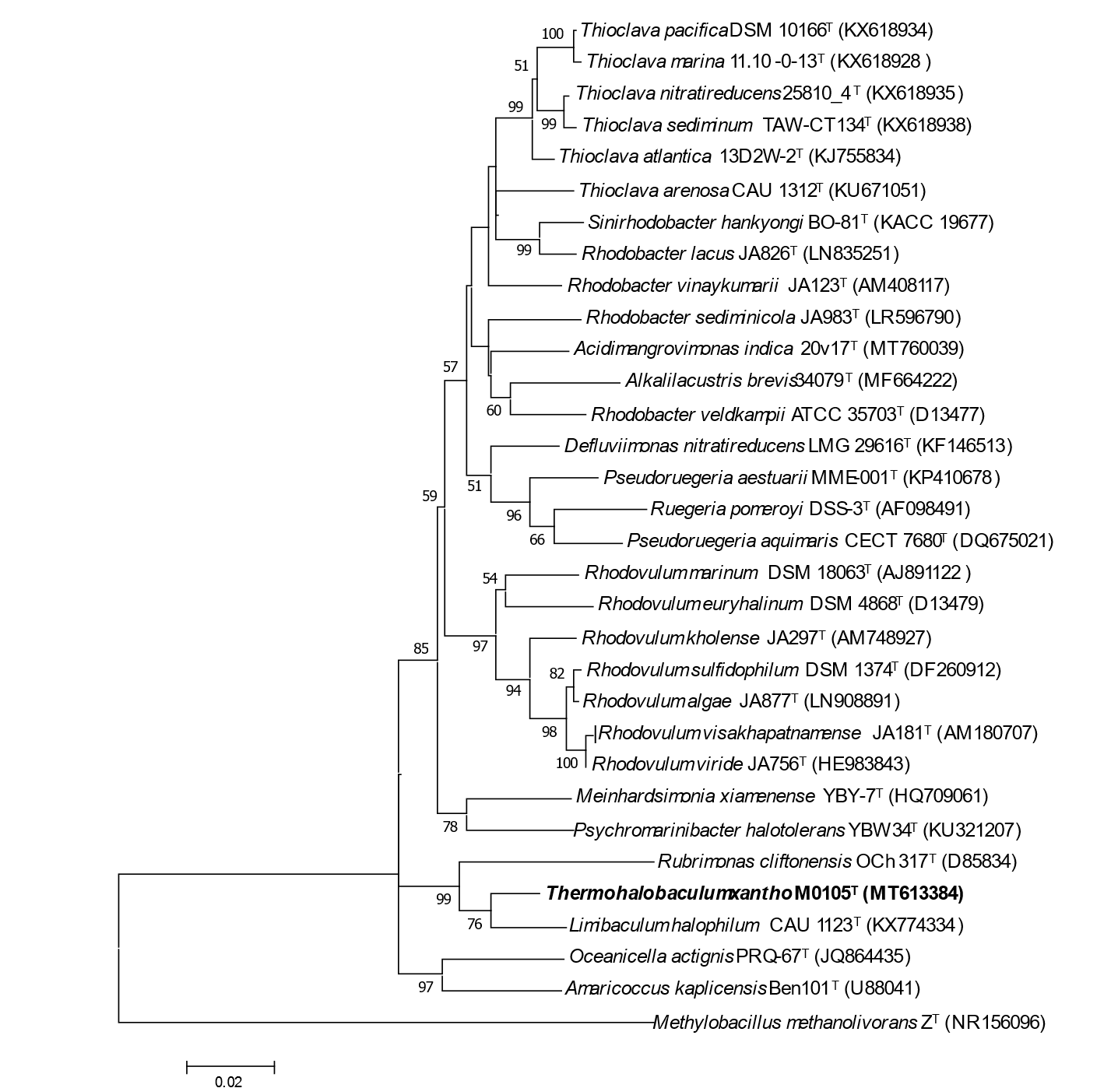

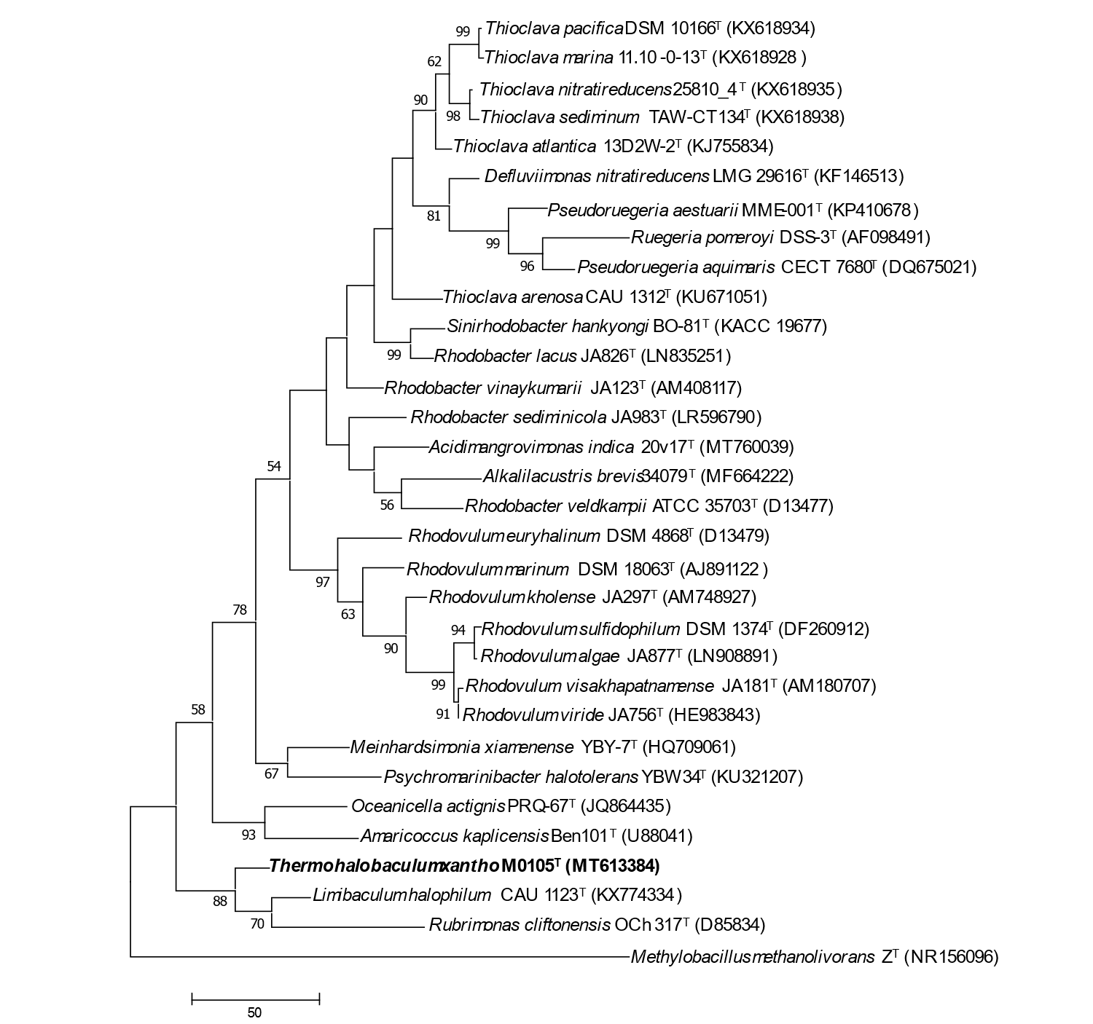
Figure S4. Maximum parsimony phylogenetic tree based on the 16S rRNA gene sequences analysis. Bootstrap values more than 50% are shown. The tree was rooted by Methylobacillus methanolivorans Z^{T} (NR156096) as the outgroup.

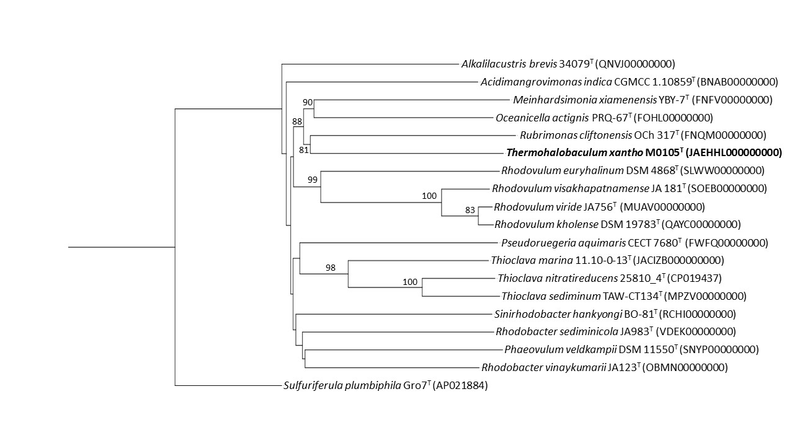
Figure S5. Phylogenomic tree based on genome sequences of strains M0105^{T} and closely related species. Genome BLAST Distance Phylogeny approach (GBDP) pseudo-bootstrap support values (> 70%) based on 1000 replications are shown above branches. The tree was rooted by the strain Sulfuriferula plumbiphila Gro7^{T} (AP021884).

Figure S6. Two-dimensional thin-layer chromatograms of polar lipids profile of strain M0105^{T} (a) and three strains (b, A. brevis 34079^{T}, c, M. xiamenense YBY-7^{T}; d, D. nitratireducens 25810_4^{T}.).
Separation was performed using Merck silica gel 60 F254 glass-backed plates, chloroform/methanol/water (64:27:5) in the first direction (I) and chloroform/acetic acid/ methanol/water (80:18:12:5) in the second direction (II). DPG, diphosphatidylglycerol; PC, phosphatidylcholine; PE, phosphatidylethanolamine; PG, phosphatidylglycerol; PL, unidentified phospholipid; GL, unidentified glycolipid; L, unidentified lipid; AL, unidentified amino lipid.
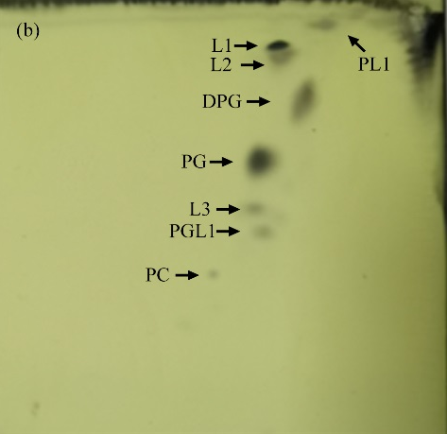
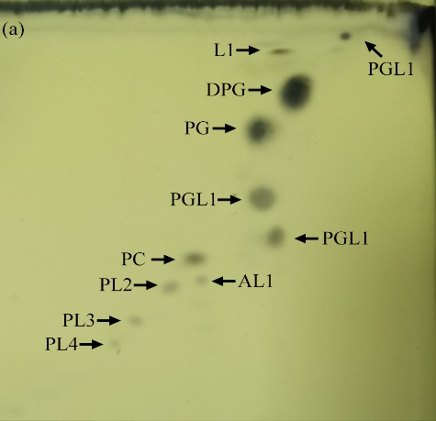

I
II
II
I

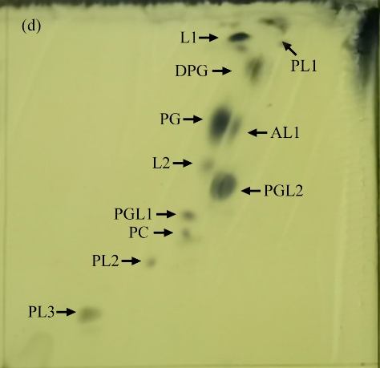
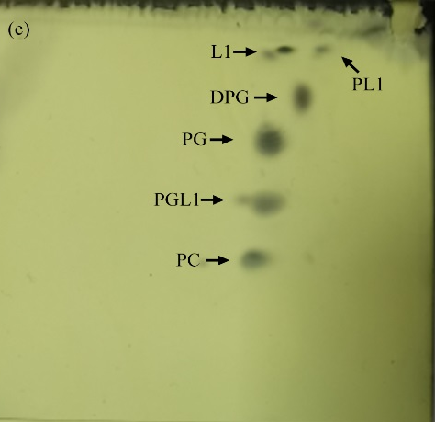

I
II
II
I

Table S1 Cellular fatty acid composition (%) of strain M0105^{T} and other type strains. 1, strain M0105^{T}; 2, A. brevis 34079^{T}; 3, M. xiamenense YBY-7^{T}; 4, D. nitratireducens 25810_4^{T}; 5, L. halophilum CAU 1123^{T}. -, not detected.
Fatty acids (%) | 1 | 2 | 3 | 4 | 5
C_{18:1}ω7c | 52.6 | 52.1 | 27.6 | 46.2 | 42.9
C_{16:0} DMA | 12.5 | 34.2 | - | 17.2 | 15.9
C_{16:0} | 8.6 | 5.3 | 11.5 | 1.0 | 5.3
C_{18:1}ω7c 10-methyl | 6.0 | - | - | - | 15.1
C_{18:0} | 3.8 | - | 18.1 | 2.5 | 1.5
C_{16:4}ω3c | 2.3 | - | 2.5 | - | 1.4
C_{15:1} isoω9c | 1.9 | 6.1 | 5.4 | - | 2.8
C_{15:1} isoω6c | 1.8 | - | - | 2.2 | 2.6
C_{16:2} DMA | 1.1 | - | 3.6 | - | 2.4
anteisoC_{15:0} | 1.0 | - | 4.9 | 0.9 | 0.8
C_{12:0} | 1.0 | - | 5.2 | 2.7 | -
C_{14:0} | 0.9 | - | 2.2 | 1.0 | 1.4
C_{18:2}ω6c | 0.8 | - | 2.6 | - | -
anteisoC_{14:0} | 0.8 | - | 3.4 | 2.7 | 2.5
C_{18:1}ω9c | 0.8 | - | 1.9 | 1.4 | 0.8
anteisoC_{11:0} | 0.7 | - | 2.3 | - | -
C_{18:3}ω3c | 0.7 | - | 2.7 | - | -
anteisoC_{13:0} | 0.7 | - | 1.8 | 1.2 | -
C_{14:1}ω8c | - | - | 1.6 | 1.1 | 1.1

Table S2. Heat-shock-related proteins in strain M0105^{T} and closely related species. 1, strain M0105^{T}; 2, M. xiamenensis YBY-7^{T}; 3, R. vinaykumarii JA123^{T}; 4, O. actignis PRQ-67^{T}; 5, R. cliftonensis OCh 317^{T}; 6, A. brevis 34079^{T}.

Name | Gene count
Name | 1 | 2 | 3 | 4 | 5 | 6
DnaK | 1 | 1 | 1 | 1 | 1 | 1
DnaJ | 1 | 1 | 1 | 1 | 1 | 1
GrpE | 1 | 1 | 1 | 1 | 1 | 1
ClpP | 1 | 1 | 1 | 1 | 1 | 1
HspQ | 1 | 3 | 3 | 4 | 1 | 1
HslO | 1 | 1 | 1 | 2 | 1 | 1
HtpX | 1 | 2 | 1 | 6 | 1 | 1
HslJ | 0 | 0 | 0 | 3 | 0 | 0
Hsp15 | 0 | 2 | 2 | 1 | 1 | 0
Hsp20 | 4 | 1 | 1 | 2 | 1 | 1
Hsp33 | 0 | 1 | 1 | 1 | 1 | 1
DegP | 3 | 1 | 1 | 2 | 1 | 1

