Supplementary Information

Applied Microbiology and Biotechnology

Functional and structural insights into a thermostable (S)-selective amine transaminase and its improved substrate scope by protein engineering

Stefania Patti^{1,2}, Simone A. De Rose³*, Michail N. Isupov³, Ilaria Magrini Alunno¹, Sergio Riva¹, Erica Elisa Ferrandi¹*, Jennifer A. Littlechild³*, Daniela Monti¹*

¹ Istituto di Scienze e Tecnologie Chimiche “G. Natta” (SCITEC), CNR, Milano, Italy
² Department of Pharmaceutical Sciences, University of Milan, Milano, Italy
³ Henry Wellcome Building for Biocatalysis, Biosciences, Faculty of Health and Life Sciences, University
of Exeter, Exeter, United Kingdom

E-mail: Simone A. De Rose, S.A.De-Rose@exeter.ac.uk; Erica Elisa Ferrandi, erica.ferrandi@scitec.cnr.it; Jennifer A. Littlechild, J.A.Littlechild@exeter.ac.uk; Daniela Monti, daniela.monti@scitec.cnr.it.

Index
Site-directed mutagenesis | p. 2
Table S1. Primers used in this study | p. 3
Table S2. Mutants expression yields | p. 3
Table S3. Sbv333-ATA stability to water-miscible co-solvents | p. 4
Table S4. Sbv333-ATA stability in biphasic systems (1:1) | p. 4
Table S5. Amine donor screening with wild-type Sbv333-ATA and engineered variants. | p. 5
Table S6. Detailed crystallization conditions for all the Sbv333-ATA structures | p. 6
Figure S1. Chemical structure of the substrate phenylacetylcarbinol (PAC) and the product analogue norephedrine tested in Sbv333-ATA co-crystallization experiments. | p. 6
Figure S2. Chemical structure of aromatic (R)-amines with increasing side-chain lengths tested as substrates with Sbv333-ATA variants | p. 6
Figure S3. Screening of Sbv333-TA mutants designed for reverse enantioselectivity. | p. 7
Figure S4. Deamination of selected aromatic (R)-amines catalyzed by W89A Sbv333-ATA variant at different pH values. | p. 7
Figure S5. Transaminase amino acid structural alignments of the active site area of Sbv333-ATA, Silicibacter sp. tm1040 (PDB: 3FCR), Silicibacter pomeroyi (PDB: 3HMU) and Vibrio fluvialis (PDB: 4E3Q). | p. 8

- Site-directed mutagenesis
Sbv333-TA variants carrying up to two-point mutations were created by a Q5® Site-Directed Mutagenesis Kit (New England BioLabs) and a QuikChange II XL site-directed mutagenesis kit (Agilent) according to the manufacturer’s protocols. Mutagenesis primers (Table S1) were designed using the primer design program suggested by the respective manufacturer (https://international.neb.com/tools-and-resources/video-library/nebasechanger-designing-primers-for-use-with-the-q5-site-directed-mutagenesis-kit; https://www.agilent.com/store/primerDesignProgram.jsp).
A typical PCR mixture (25 µL) for the Q5® Site-Directed Mutagenesis Kit consisted of 12.5 µL of Q5 Hot Start High-Fidelity 2X Master Mix, 1.25 µL of 10 µM Forward Primer, 1.25 µL of 10 µM Reverse Primer; 1-25 ng of Template DNA and 9 µL of Nuclease-free Water. After initial denaturation for 30 sec at 98 °C, the cycling program was followed for 25 cycles: 10 sec, 98 °C, denaturation; 10-30 sec, primer annealing at the primer specific optimal annealing temperature; and 20-30 sec/kb, 72 °C. elongation. The final extension step was performed for 2 min at 72 °C. After PCR, the amplified material is added directly to a Kinase-Ligase-DpnI (KLD) enzyme mix for rapid, room temperature circularization and template removal. The mixture was composed of 1 µL of PCR product; 5 µL of 2X KLD Reaction Buffer; 1 µL of 10X KLD enzyme mix and 3 µL of Nuclease-free water. The mixture was then incubated at room temperature for 5 min, then transformation into NEB 5-alpha Competent E. coli cells was performed. Clones from an overnight growth on agar plates supplemented with kanamycin were inoculated into a 5 mL overnight cultivation (LB media, kanamycin complemented). Plasmids were isolated from the overnight culture using GeneJET Plasmid Miniprep Kit (Thermo Scientific™). To verify the presence of the single point mutation plasmids were sequenced by Eurofins (UK).
A typical PCR mixture (50 µL) for the QuikChange II XL site-directed mutagenesis kit consisted of 5 µL of 10x reaction buffer (12.5 µL), 1 µL of a mixture of deoxynucleoside triphosphates, 3 µL of QuickSolution, 1 µL of PfuTurbo DNA polymerase (2.5 U/µL), 10 ng of plasmid DNA and the forward and reverse primers (0.5 µM) and ddH₂O to a final volume of 50 µL. After initial denaturation for 1 min at 95°C, the cycling program was followed for 18 cycles: 50 sec, 95°C, denaturation; 50 sec, primer annealing at the primer specific optimal annealing temperature; and 1 min/kb (4 min), 68°C, elongation. The final elongation step was performed for 7 min at 68°C. After PCR, the reaction mixtures were digested for 1 h at 37°C with Dpn I (10 U/µL), followed by transformation into XL10-Gold ultracompetent cells. Clones from an overnight growth on agar plates supplemented with kanamycin were used for inoculation of a 5 mL overnight cultivation (LB media, kanamycin complemented). Plasmids were isolated from the overnight culture using HiSpeed® Plasmid Midi Kit (Qiagen, Hilden, Germania). To verify the presence of the single point mutation plasmids were sequenced by Bio-Fab Research (Rome).

Table S1. Primers used in this study
Position and mutation | Primer Sequence
F61A (forward) | GGCGGGCCTCgcgGTCGTGCAGG
F61A (reverse) | AGTCCGTCCAGGTACCGC
W89A (forward) | CTTCCCCATCgcgTCGTACGCCCACC
W89A (reverse) | AAGGCCAGGTCCTGTGCC
L60A (forward) | ACTGGCGGGCgcgTTCGTCGTGCAGGCC
L60A (reverse) | CCGTCCAGGTACCGCCGC
W89Y (forward) | CTTCCCCATCtacTCGTACGCCCACCC
W89Y (reverse) | AAGGCCAGGTCCTGTGCC
F61C (forward) | CTGCACGACgcaGAGGCCCGCCAGTC
F61C (reverse) | GACTGGCGGGCCTCtgcGTCGTGCAG
F61V (forward) | CCTGCACGACgacGAGGCCCGCCAG
F61V (reverse) | CTGGCGGGCCTCgtcGTCGTGCAGG
F23V (forward) | CGACATGCGCGTgacGTGCATCCACAGGT
F23V (reverse) | ACCTGTGGATGCACgtcACGCGCATGTCG
L60V (forward) | GCACGACGAAgacGCCCGCCAGTCC
L60V (reverse) | GGACTGGCGGGCgtcTTCGTCGTGC
F23W (forward) | GACATGCGCGTccaGTGCATCCACAGGTGGTCGT
F23W (reverse) | ACGACCACCTGTGGATGCACtggACGCGCATGTC
D421E (forward) | CGCCGCGGTCctcGGCGCGGC
D421E (reverse) | GCCGCGCCgagGACCGCGGCG
D421W (forward) | GGTCGCCGCGGTCccaGGCGCGGCAGTAG
D421W (reverse) | CTACTGCCGCGCCtggGACCGCGGCGACC
F61W (forward) | CGGCCTGCACGACccaGAGGCCCGCCAG
F61W (reverse) | CTGGCGGGCCTCtggGTCGTGCAGGCCG

For heterologous protein production, the isolated plasmids were transformed into E. coli BL21(DE3) cells containing plasmid pGRO7 (Takara Bio Inc., Kyoto, Japan) coding for co-chaperons GroES and GroEL. Protein expression yields are reported in Table S2.
Table S2. Mutants expression yields
Mutation | Protein expression yield (mg L_{culture}⁻¹)
F23V | 99
L60A | -
L60V | 56
F61A | -
F61V | 119
F61C | 99
W89A | 54
W89Y | -
Y153W | 38
W89Y/ Y153W | 66
W89A/ F23W | -
W89A/ F61W | 68
W89A/ D421E | 82
W89A/ D421W | 97
- Sbv333-TA functional characterization
Table S3. Sbv333-ATA stability to water-miscible co-solvents
Time (h) | Co-solvents | U mL⁻¹ | Residual activity (%)
0 | None | 1.34 | 100
5 | None | 1.38 | 103
24 | None | 0.73 | 54
0 | MeOH 5% | 1.11 | 100
5 | MeOH 5% | 0.95 | 86
24 | MeOH 5% | 0.62 | 56
0 | MeOH 10% | 1.11 | 100
5 | MeOH 10% | 1.23 | 111
24 | MeOH 10% | 0.73 | 66
0 | MeOH 20% | 0.98 | 100
5 | MeOH 20% | 1.08 | 110
24 | MeOH 20% | 0.63 | 64
0 | EtOH 5% | 1.29 | 100
5 | EtOH 5% | 1.29 | 100
24 | EtOH 5% | 0.51 | 40
0 | EtOH 10% | 1.24 | 100
5 | EtOH 10% | 1.27 | 102
24 | EtOH 10% | 0.57 | 46
0 | EtOH 20% | 1.05 | 100
5 | EtOH 20% | 1.37 | 109
24 | EtOH 20% | 0.56 | 53
0 | ACN 5% | 1.16 | 100
5 | ACN 5% | 1.08 | 93
24 | ACN 5% | 1.02 | 88
0 | ACN 10% | 1.16 | 100
5 | ACN 10% | 1.20 | 103
24 | ACN 10% | 0.77 | 66
0 | ACN 20% | 1.14 | 100
5 | ACN 20% | 1.28 | 112
24 | ACN 20% | 0.76 | 67
0 | DMSO 5% | 1.20 | 100
5 | DMSO 5% | 1.31 | 109
24 | DMSO 5% | 1.10 | 92
0 | DMSO 10% | 1.28 | 100
5 | DMSO 10% | 1.33 | 104
24 | DMSO 10% | 1.06 | 83
0 | DMSO 20% | 1.30 | 100
5 | DMSO 20% | 1.06 | 82
24 | DMSO 20% | 1.00 | 77

Table S4. Sbv333-ATA stability in biphasic systems (1:1)
Time (h) | Solvents | U mL⁻¹ | Residual activity (%)
0 | None | 1.00 | 100
5 | None | 0.81 | 81
24 | None | 0.65 | 65
5 | PE | 0.95 | 95
24 | PE | 0.51 | 51
5 | Tol | 1.12 | 112
24 | Tol | 0.71 | 71
5 | EtOAc | 1.19 | 109
24 | EtOAc | 0.68 | 68

Table S5. Amine donor screening with wild-type Sbv333-ATA and engineered variants.
Enzyme | Substrate | ΔmAbs min⁻¹ | mU mL⁻¹ | mg mL⁻¹ | mU mg⁻¹
WT | (S)-1 | 12.49 | 375.64 | 11.5 | 32.66
WT | (S)-5 | 12.49 | 375.64 | 11.5 | 32.66
WT | 7 | 1.66 | 49.92 | 11.5 | 4.34
WT | 10 | 1.92 | 57.62 | 11.5 | 5.01
WT | 11 | 21.45 | 645.11 | 11.5 | 56.10
WT | 12 | 15.88 | 477.59 | 11.5 | 41.53
WT | 15 | 3.40 | 102.17 | 11.5 | 8.88
WT | (S)-20 | 7.99 | 240.57 | 11.5 | 20.92
WT | 21 | 7.86 | 236.24 | 11.5 | 20.54
F23V | (S)-5 | 0.61 | 18.22 | 16 | 1.14
F23V | 11 | 1.29 | 38.83 | 16 | 2.43
L60V | (S)-1 | 0.33 | 10.03 | 7.4 | 1.36
L60V | 10 | 0.13 | 4.00 | 7.4 | 0.54
L60V | 12 | 0.41 | 12.47 | 7.4 | 1.69
L60V | 19 | 0.13 | 4.14 | 7.4 | 0.56
F61C | (S)-1 | 20.46 | 615.34 | 19.9 | 30.92
F61C | (S)-3 | 1.25 | 37.71 | 19.9 | 1.90
F61C | (S)-5 | 22.98 | 691.13 | 19.9 | 34.73
F61C | 7 | 3.47 | 104.39 | 19.9 | 5.25
F61C | 10 | 2.47 | 74.17 | 19.9 | 3.73
F61C | 11 | 10.83 | 325.71 | 19.9 | 16.37
F61C | 12 | 23.16 | 696.54 | 19.9 | 35.00
F61C | 15 | 6.97 | 209.65 | 19.9 | 10.54
F61C | (S)-20 | 7.81 | 234.86 | 19.9 | 11.80
F61C | 21 | 6.46 | 194.20 | 19.9 | 9.76
W89A | (S)-1 | 3.35 | 100.78 | 12 | 8.40
W89A | (S)-3 | 2.17 | 65.32 | 12 | 5.44
W89A | 4 | 7.31 | 219.76 | 12 | 18.31
W89A | (S)-5 | 4.54 | 136.51 | 12 | 11.38
W89A | 7 | 2.80 | 84.06 | 12 | 7.01
W89A | 10 | 0.19 | 5.69 | 12 | 0.47
W89A | 11 | 17.32 | 520.90 | 12 | 43.41
W89A | 12 | 15.91 | 478.50 | 12 | 39.87
W89A | 15 | 2.77 | 83.16 | 12 | 6.93
W89A | 21 | 2.99 | 90.20 | 12 | 7.52
W89A/L60V | (S)-1 | 0.22 | 6.70 | 9.52 | 0.70
W89A/L60V | (S)-3 | 0.51 | 15.32 | 9.52 | 1.61
W89A/L60V | (S)-5 | 0.34 | 10.27 | 9.52 | 1.08
W89A/L60V | 7 | 0.14 | 4.19 | 9.52 | 0.44
W89A/L60V | 10 | 0.29 | 8.82 | 9.52 | 0.93
W89A/L60V | 11 | 1.20 | 36.21 | 9.52 | 3.80
W89A/L60V | 19 | 0.17 | 5.18 | 9.52 | 0.54

Table S6. Detailed crystallization conditions for all the Sbv333-ATA structures
Sbv333-ATA | Crystallization conditions
Native | 0.2 M potassium thiocyanate; 0.1 M Bis Tris propane 6.5; 20 % w/v PEG 3350
Gabaculine | 10 mM Gabaculine 0.2 M potassium thiocyanate 0.1 M Bis Tris propane 6.5 20 % w/v PEG 3350
Phenylacetylcarbinol (PAC) | 10 mM PAC; 0.1 Imidazole; MES monohydrate (acid) pH 6.5; 30% Precipitant mix (40% v/v (PEG 500* MME; 20 % w/v PEG 20000); Additives: 0.2M D-Glucose; 0.2M D-Mannose; 0.2M D-Galactose; 0.2M L-Fucose; 0.2M D-Xylose; 0.2M N-Acetyl-D-Glucosamine
Norephedrine | 10 mM 1s2s Pseudoephedrine; 0.1 M Bis-Tris propane, pH 6.5; 20 % w/v PEG 3350; 0.2 M Sodium iodide
W89A | 0.3M Diethylene glycol; 0.3M Triethylene glycol; 0.3M Tetraethylene glycol; 0.3M Pentaethylene glycol; Tris (base) BICINE pH 8.5; 30% Precipitant mix (40% v/v PEG 500* MME; 20% w/v PEG 20000)
F61C | 0.2 M Magnesium chloride hexahydrate; 0.1 M Tris 7.5; 25 % w/v PEG 2000 MME

Figure S1. Chemical structure of the substrate phenylacetylcarbinol (PAC) and the product analogue norephedrine tested in Sbv333-ATA co-crystallization experiments.

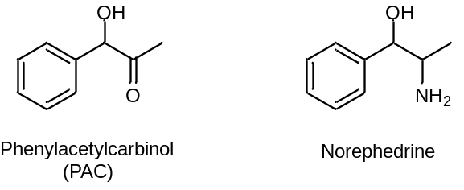

Figure S2. Chemical structure of aromatic (R)-amines with increasing side-chain lengths tested as substrates with Sbv333-ATA variants.

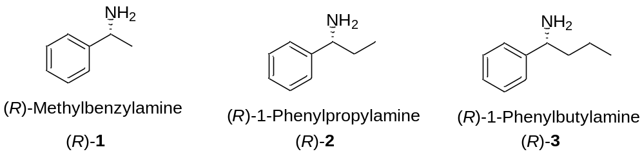

Figure S3. Screening of Sbv333-TA mutants designed for reverse enantioselectivity.
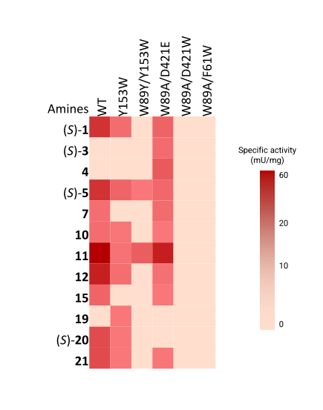
Figure S4. Deamination of selected aromatic (R)-amines catalyzed by W89A Sbv333-ATA variant at different pH values.
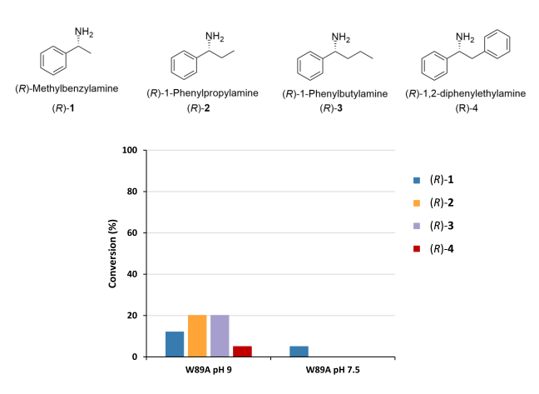

Figure S5. Transaminase amino acid structural alignments of the active site area of Sbv333-ATA, Silicibacter sp. tm1040 (PDB: 3FCR), Silicibacter pomeroyi (PDB: 3HMU) and Vibrio fluvialis (PDB: 4E3Q). The proteins Sbv333-ATA, 3FCR, 3HMU and 4E3Q are shown as cyan, green, yellow and purple sticks, respectively. The oxygen and nitrogen atoms of different residues are coloured red and blue, PLP is shown as a grey ball and stick model.
